OZone Portal

Functional Specification

Document history:

Version | Date | Author | Comments
1.0 | 15/08/11 | Ermal Aliraj | First Release
1.0.1 | 26/01/12 | Ermal Aliraj | Added 2.13-Newsletters

Table of Contents

1 Introduction 5
1.1 Overwiew 5
1.2 Purpose 5
1.3 Out of scope 5
2 System Specifications 5
2.1 Homepage 5
2.1.1 Header 5
2.1.2 Content 6
2.1.3 Footer 6
2.2 Log-in 6
2.3 Register 7
2.4 Forgot password 7
2.5 User details 7
2.6 User credit 8
2.7 User purchases 8
2.8 Purchase a deal 8
2.9 Recently deals 8
2.10 How it works 8
2.11 Invite friends 8
2.11.1 Invite friends - logged user 8
2.11.2 Invite friends – not logged user 9
2.12 Subscribe to the newsletter 9
3 External Interface Specifications 10
3.1 Credit Card payment 10
3.2 Table of external services 10
4 Data Model 10
4.1 Database schema 10
4.2 Databe tables 12
5 Authorization Concept 12
6 Infrastructure Specifications 13
7 FS estimation time 13
8 References / Glossary 14

Introduction

Overwiew
ZONE SH.P.K is a “One deal a day” web-based business, in which a single type of product is offered for sale for a period of 24 hours. OZone is the system used for handling the business activities. The system will publish each day a different deal. Registered clients will receive a daily newsletter through the email with the day's deal. If the user is interested for the published good, he can login and purchase the good. At the publishing expires time, the system will count if the number of purchases has reached the minimum asked from the partner in order that the deal can be considered done. In this case the deal is considered done, so the coupons will be sent through email to the users. In case the minimum numbers of purchases is not been reached, the system will send a notification message to all users (that purchased the good) confirming that the money used in the purchased time will be recharged in the same credit card used for the purchase. To permit this goal OZone will be composed by two modules:

- OZone, the portal www.ozone.al
- OZoneAdmin, Back-end tool for administrators.

Purpose
This document is the Functional Specification for the project OZone. In this document will be explained all specifications that the portal (Front-End) OZone should support.

Out of scope
Back-end functional specifications are described in the appropriate document OZone_Functional_Specification_ADMIN.doc

System Specifications
In this chapter will be explained all specifications that the portal www.ozone.al should support.

Homepage
The home page of OZone will be the showcase of the ZONE Sh.p.k activity. Must be simple, user friendly and visually pleasing.
The homepage must be subdivided in three areas:
- Header
- Content
- Footer

The content part will change during the navigation while Header and Footer will not change.

Header

The header will contain the logo, Invite friends button, Subscribe to the newsletter button and the Menu.

- Invite friends button must open a new page with the form to fulfill for inviting friends.
- Subscribe to the newsletter will be a input field in which a user will insert the email and a submit button to send the email to the system. A format check will be done about the correctness of the inserted email (ex. xxxx@yyy.zzz)

The menu should contains three static items:
- Deal of the day (default as homepage)
- Recently deals
- How it works

And 2 dynamic items:
- Register
- Login

When a user is logged in, the two dynamic items will disappear and will be shown the follows:
- name of logged user, with a link to logout (instead of Register)
- My Account (instead of Login)

My account will contain the data related to the logged user represented in the three sub items:
- User details ( My data)
- User credit (My credit)
- User purchases (My purchases)

Any click in one of the items of the menu will open the appropriate page in the Content area.

Content
The content area will contains the main part of the page. Here will be shown the deal with its details by default. The click on My account item will render in the content area a tabbed panel with three tabs respectively for My data, My credit, My purchases.

Footer
About
Contact
FAQ
Terms of Use
Privacy Statement
All Rights Reserved.
A description about ZONE
Follow Us: Facebook, Twitter, Feeds, Subscribe etc

Log-in
Clicking the menu item Login a new page must be rendered in the content area containing the login form. The login form must have the following fields:

- email
- password
- remember me check-box
- Submit button
- Forgot password link

After the submit the system will check if the user with the specified email is present in DB.
In case the email inserted is not present or the user associated to the email is not active, the system must show appropriately the error messages.
Forgot password link will open the page “Forgot password”

Register
Clicking in the menu item Register, a new page must be rendered in the content area containing the register form. Data needed for the user are the follows:

- Name
- Birthdate
- Address
- Telephone
- Email
- Password
- Submit botton

The field must be validated before the submit. After the submit, the system must insert the new user in database and check if the new user has been invited from an exiting user in precedence. In that case the system will increase the bonus to the user and will register the event in database.

Forgot password

This page will permit the user to insert the email and send the request to the system.
The system will send an email to the user with the steps to reset the new password.
This form will be composed by the follows:

- email input field
- submit button

User details
This tab shows and allows the modification of the user's data.
The fields representing a user are the follows:
- Name
- Birthdate
- Address
- Telephone
- Email
- Password

System must validate the fields before the submit. A validation to be done in server side, is to check last time that this user changed his name. For security reasons, the user cannot change the name more than 1 time in 6 months.

User credit
This tab will show through a table all credits added in the past to the logged user. The table must have the following fields:
- Date
- Credit Value
- Valid until
- State (in case of bonus already used, a message with the date of usage)

In the top of this page(tab) must be shown the actual bonus for the logged user.

User purchases
In this tab must be shown all past purchases of the logged user. This data can be shown as a table where a single row represent a purchased deal. Each purchase must contain a summary of the deal with the detail, coupons purchased and for each coupon if it is already consumed or not. The page must be paged after a maximum row number specified in the admin side.

Purchase a deal
This functionality allows the logged user to insert the data of the credit card/paypal account and go on with the purchase. The system must use all necessary certificates for making the payment safe. After the purchase the user must see a success message in case the transaction was positive, or an error message otherwise. In case of an success purchase, the user must see the deal in the User purchases section.

Recently deals
This page must show all expired deals. A click to any deal will open the information page of the deal but the user can not purchase it. In admin module can be specified the measure of “old”.
All past deals, deal of this year, of this month, of this week etc.

How it works
In this page will contains an overview of OZone website. Which is the scope of this site and how is the correct process. This page must be visually pleasing and the idea's focus must be helped with the usage of images or animations.

Invite friends
This page permits the user to send an invitation to another person.
The email to send to the new user must be well formed and the idea of the OZOne must be very clear. This page act not the same if the user is logged in, or not logged in.

Invite friends - logged user
This page will permit the invitation of new users from the logged user. The system must use an appropriate approach in way to keep trace of the logged user when the invited user will be registered to the site.

Consider the scenario:
The new user Y receive an invitation from an existent user X through the email. The click to the link must open the registration page. After the registration of the user, the system must increase the bonus to the user X. In case user Y close the page, open it again, and register himself, the system must be able to recognize that the user Y has been invited from X.

This approach must be used in case the user publish our link in his Facebook, Twitter profile.

All the different ways used by this page to invite pages will be:

  - inviting through the emails (emails separated by the comma)
  - inviting ALL email contacts. User must insert email and password and the system must be able to send the invitation to all users present in the contact list. The system will not store user email password and this must notified to the user.
  - Publishing the link in Facebook space or other social networks.
  - Coping and passing a link produced by the system. A new user can click the link and get registered in the site. The system must be able to recognize who sent the invitation.

Invite friends – not logged user
If this functionality is asked from a not logged user the page will contain in simply and clear way the idea of Inviting friends and how the user will have the bonus if he get registered in the site and invites friend. The page must have images for making the idea more simple and user friendly.

Subscribe to the newsletter
This functionality permits a user to insert his email in the system. The automatic procedures will include the new email when sending the next newsletter with the new deal.

- input email text
- submit button

The system must validate the email, xxx@yyy.zzz format, before store it in the system.

Newsletters
The user by default will be added to the newsletters of all active cities. The email format of the newsletters will be grouped by cities. In case a user do not like to receive information for all cities he can go in his profile and uncheck the cities he don’t want to receive newsletters. At least one city must be checked.

External Interface Specifications

Credit Card payment
OZone will interact in two phases with the credit card payment system:
- Every time a user purchase a deal (portal functionality)
- In case of a not concluded deal, the system (admin module) will send a notification to the credit card system with the list of Credit Cards and the value to reverse.

Table of external services

FS-ID | Interface / Feature | Description | Specification
FS -3.2.1 | Newsletter service | System send email to registered users with the deal of the day. | An automatic job send the email after each deal publishing
FS -3.2.2 | Publication Expires Time | When a publishing time expires, the system calculates if the minimum number of purchases has been reached. In this case the deal will be considered done and the coupons will be sent to each user. An email will be sent to the partner for notification. If not, the system should use an appropriate system to give back the money to the users. | An automatic job that implements the requirements in all possible scenarios.
FS -3.2.3 | Credit card payment | The system will interact in two phases with credit card system. 1. each time a user purchase a deal. 2. in case of a not concluded deal our system will send a notification to the credit card system with the list, and value of CC to reverse. | An automatic job that implements point 2.
FS -3.2.4 | OZone admin | This is not a real interaction since OZone will NEVER communicate with OZone admin in a direct way. OZone Admin will use directly the DB for handling the data needed for OZone.

Data Model

Database schema

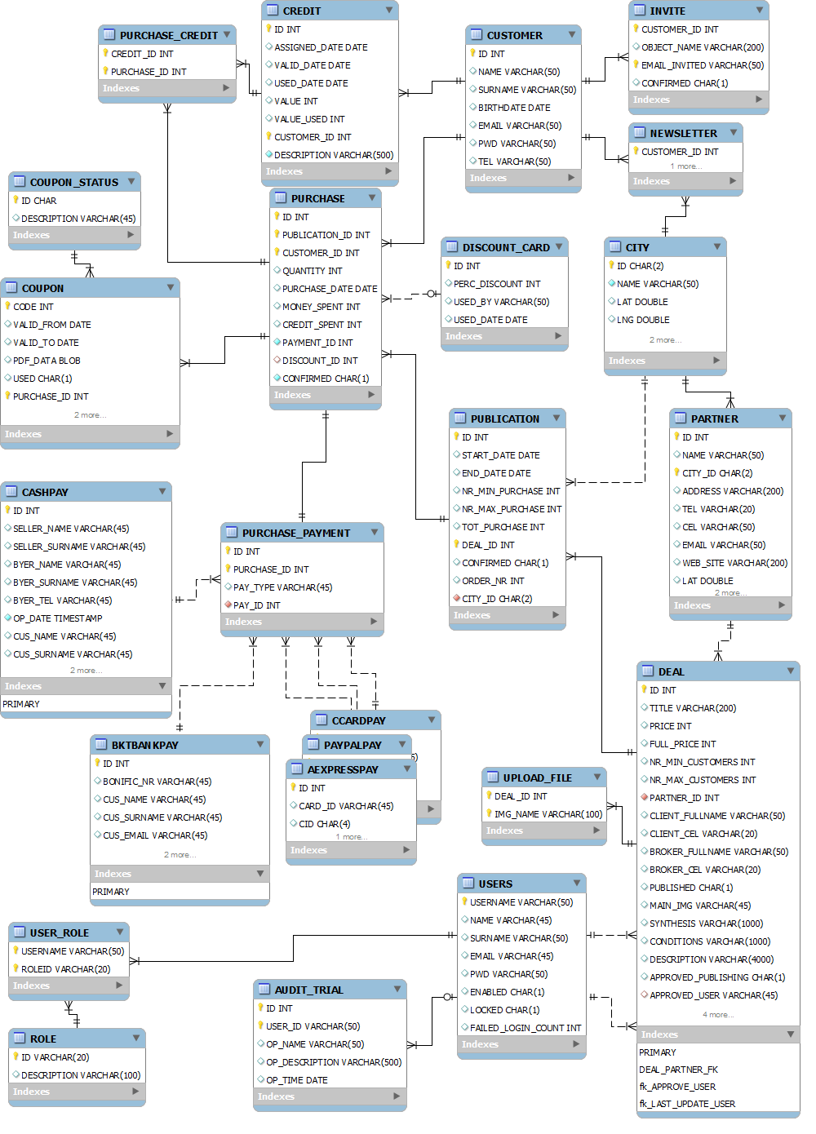

Databe tables

Table Name | Description
AUDIT_TRIAL
BONUS
CITY
CLIENT
DEAL
DISCOUNT
INVITE
PARTNER
PAYMENT
PUBLICATION
PURCHASE
PURCHASE_BONUS
ROLE
USER_ROLE
USERS
To add the missing….

Authorization Concept

Not Logged User | - Homepage (deal of the day)  - Deal of the day  - Recent deals  - How it works  - Subscribe to the newsletter  - Invite friends – not logged user  - Register  - Login
Logged User | - Homepage (deal of the day)  - Deal of the day  - Recent deals  - How it works  - Subscribe to the newsletter  - Invite friends – logged user  - My Account  - My purchases  - My bonus  - My data  - Logout

Infrastructure Specifications
The portal will be a web application based on .NET technology.

Web app will be deployed in application Server

Database used
- MySql

FS estimation time

In the table below are traced all functionalities followed by an approximated estimation time needed for implementation using technologies described in Cap 6.

FS-ID | Interface / Feature | Estimated days | Description
FS-2.1 | HomePage
FS-2.2 | Login
FS-2.3 | Register
FS-2.4 | Forget Password
FS-2.5 | User details
FS-2.6 | User credits
FS-2.7 | User purchase
FS-2.8 | Purchase a deal
FS-2.9 | Recently Deals
FS-2.10.1 | How it works
FS-2.10.2 | Invite Friends -logged user
FS-2.11 | Invite Friends -not logged user
FS-2.12 | Subscribe to the Newsletter
Project Set-up
Test
Design document

References / Glossary
References and terms used in the document.

