Sidney Sanders

Prof. Rob Sloane

ACS 3000-1002

11/25/2021

Title??

Peter pan was one of Disney’s early productions released in 1953. Before the production of the film, Disney had wanted to create a new children’s film and was looking for a story to produce. Disney had a few options under consideration and settled in on Peter Pan, but he could not secure the rights to produce for a substantial amount of time (“Peter and Wendy”). Peter pan was originally a story written by James M. Barrie. Walt Disney ended up getting the rights to the story about 4 years later and then needed to decide how he was going to interpret the story. The original story was quite dark to produce into a children’s film, so Disney decided to change a few aspects and begin the story when Peter visits the house of the Darlings to listen to Wendy’s stories. To Disney, this is where the story picks up (“Peter Pan (Film)”).

During the initial production of Peter Pan, Disney intended for the film to be aired after Snow White. But unfortunately, at this time, World War II had just begun and that had put a hold on the production (“Peter Pan (1953 Film)”). Many versions of the film were thought out. The plot originally started with going through Peter’s back story and then continuing to the story. Disney also explored the idea that Peter Pan would come to listen to Wendy’s stories and end up kidnapping her to bring her back to never land with him but chose to go back to Barrie’s version because he figured that kidnapping may be a little too dark for the film aimed for children (“Peter Pan (Film)”). He finally settled on the plot where Peter Pan comes to hear the stories and to get his shadow back.

When the film was released, the audiences’ reception of the film was mainly positive. Most of the feedback from the audience was that the film was good on its own, but there were some that compared the film to the original story by Barrie. They were disappointed it wasn’t true to the original story line. Those differences were not dwelled on and very quickly the popularity of Disney’s Peter Pan rose (“Peter Pan (Film)”). Peter Pan was considered one of Disney’s classics and became very popular to a wide audience, this stories creation followed with a sequel and Tinker bell even getting a few spin-off movies for herself, the first one airing in 2008. Not until recently has Peter Pan began to get some backlash from the portrayal of Indians. The film begins with an overview of the Darling Family with the mom and dad getting ready for a party, we then see the boys John and Michael role playing the story of Peter and captain hook’s fight. Once the father, George, comes in to look for his cufflinks and overlooks the boys playing.

He becomes increasingly upset when searching for his attire, I think it’s a good addition to the scene that the more frustrated George becomes, the more outrageous he looks with his clothes. Every time he becomes upset about something, even though he keeps fixing his clothes, it starts to come undone each time. His hair sticks up in some scenes, and even after he fixes his bowtie, his sleeves start falling or even after he falls over the toys, his sleeves come completely unfolded, and his bowtie undone which can be seen in figure 1. He blames the dog for his misfortune and blames Wendy for filling the boys’ heads with the stories he believes are untrue and states that Wendy needs to grow up and will be moving out of the nursery. I think this way of belittling Wendy can be compared to the in-class viewing of Cinderella where we see the Stepmother belittle Cinderella and make her clean up everything in their home, while she sits back in her bed waving off Cinderella’s feelings.

Figure 1 George Darling (Deja).

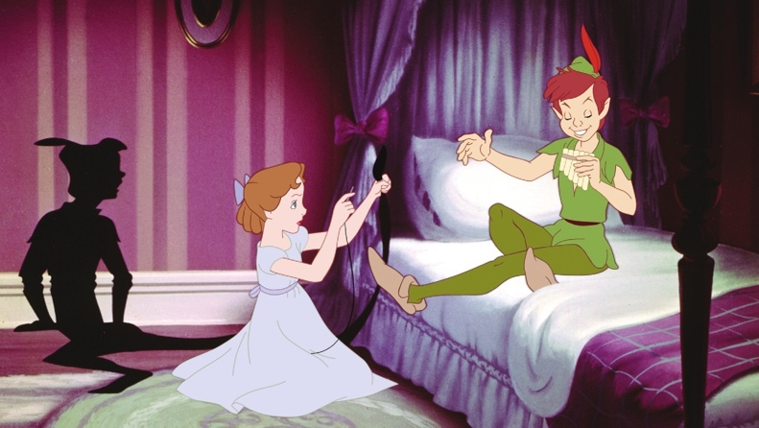Wendy is again blown off with Peter in the following scene when he comes searching for his shadow, he comes in their room and finds his shadow, and wakes up Wendy in the process. She sees him struggling on trying to put his shadow back his foot trying to use soap. She starts talking to him, excitedly, and brings his to sit down to help him reattach his shadow. Figure 2 shows us the point where Peter sits there staring at her for a while before looking away to say “girls talk too much” afterwards you can see where on Wendy’s face she is upset that he says that to her and looks away upset but continues to help him with his shadow. He then tells her to “get on with it,” for her to finish putting his shadow back on. I think Davis makes a good point about how the women are seen as homemakers where very common in the early Pop culture animation, and we didn’t start seeing a change to this stereotype until 70s and 80s (Davis, pg. 169). Wendy is seen through the entire movie to be a sort of mother figure to her brothers and the lost boys on neverland.

Figure 2 Peter Pan speaking with Wendy (Alexa).

Wendy was brought to neverland to be the mother to the lost boys and continue telling her stories to them. Even taking care of the boys when they got tired and helping them clean their faces for bed and singing them to sleep as a mother might to her children. In the Snow White showing from class in scene 14 Snow White is also shown taking care of all the dwarves by having their house all cleaned up for them and having dinner made from them. Both Snow white and Wendy are shown as domesticated women who are taking care of everyone around them.

We see Wendy is also cast aside for being a woman in the Indians celebration after Peter Pan rescues Tiger Lilly, the Chiefs daughter. A woman from the tribe stopped Wendy from dancing and celebrating with the others to go fetch firewood for the fire. I think that’s a big stereotype to place onto Wendy because in the same scene you see Tiger Lilly dancing along with all the others in the celebration. Michael her younger brother even stops Wendy to give him his bear to hold which surprises Wendy on his behavior towards her.

Disney’s representation of the Indians became quite controversial as time has passed since its release. The Indians are shown with a very deep red skin tone and with large footprints when the lost boys were tracking them. Karl Cohen from the readings said that racial stereotypes like these have almost no repercussions because when these stories were created, the themes we see, and stereotypes shown weren’t seen as wrong at the time it was created (Cohen)

-Indians perceived as savages. Racial stereotyping (Cohen)

- audience reaction to these stereotypes.

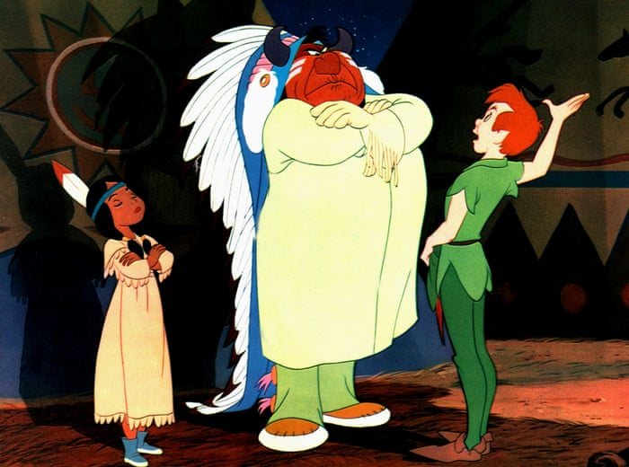

- Disney now includes a warning in the beginning before the movie plays about the depictions of cultures.

* Conclusion?

Works Cited

Alexa, Laurén. “Principal Photography Begins on 'Peter Pan & Wendy'.” *Animation World Network*, 18 Mar. 2021, https://www.awn.com/news/principal-photography-begins-peter-pan-wendy.

Cinderella (Disney, 1950, dir. Clyde Geronimi, Wilfred Jackson, and Hamilton Luske) [excerpt]

Cohen, Karl F. "Racism and Resistance: Stereotypes in Animation." *Forbidden Animation: Censored Cartoons and Blacklisted Animators in America*. Jefferson, NC: MacFarland & Company, 1997. 49-75.

Davis, Amy M. "Disney Films 1989-2005: The 'Eisner' Era." Good Girls & Wicked Witches: Women in Disney's Feature Animation. Eastleigh (UK): John Libbey Publishing, 2006. 169-219

Deja, Andreas. “George Darling.” *Deja View*, Blogger, 1 Jan. 1970, http://andreasdeja.blogspot.com/2017/05/george-darling.html.

“Peter and Wendy.” *Neverpedia RSS*, <http://neverpedia.com/pan/Peter_and_Wendy>.

“Peter Pan (1953 Film).” *Neverpedia RSS*, <http://neverpedia.com/pan/Peter_Pan_%281953_film%29>.

“Peter Pan (Film).” *Disney Wiki*, <https://disney.fandom.com/wiki/Peter_Pan_(film)>.

Snow White & the Seven Dwarfs (Disney, 1937, dir. David Hand) [excerpts]

Yuhas, Alan. “What's up, Tiger Lily? One Native American Stereotype Has Certainly Grown Old.” *The Guardian*, Guardian News and Media, 7 Dec. 2014, https://www.theguardian.com/world/2014/dec/07/tiger-lily-peter-pan-native-american-stereotype.