**CS 2010 Lab11**

**Due: Friday, April 6, 2018**

**\*arrays/for loop/functions/File I/O**

**5 Points Fishers**

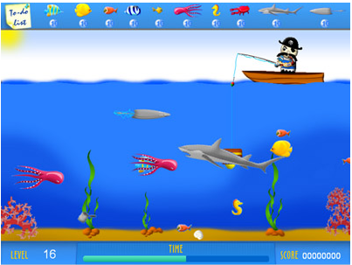

(http://www.freegamesway.com/screenshots/fisherman01m.jpg)

**Purpose:** In this lab, you will write a complete C++ program, called Fishers program. This lab helps you to practice the *use of arrays, for loops, functions, and File I/O* in C++ program. (In this lab, you will exercise Pair Programming- work with a partner.)

**Assignment**

1. Create an empty project named **Lastname1Lastname2Lab11.**
2. Add a C++ file and name it as **lab11_fishers.cpp**
3. Write a banner (comments at the top) as following:

// File Name : lab11_fishers.cpp

// Description : Lab 11– This program tracks fishers

// Author : **Put BOTH of your names here**!

// Date : 04/08/16

1. Write a complete C++ program for the following program description.

Your instructor and his friends just came from a fishing trip and he is asking you to write a program to determine how many fish they caught and the fisher that caught the most fish. He has a file (i.e., “**fish.txt**”, available on Canvas) which includes the number of fish caught by each fisher. The input file contains no more than 25 numbers. (Hint: use this information to declare a global constant (**maxfishers**) and declare your array (**fish**) by using **maxfishers** in the main.)

In the main program, call a series of three functions, **get_fish**, **show_fish and find_best_fisher**. The main function should pass the **fish** array and the number of array elements (**numfishers**) to each function. Each task should be performed by a separate function as described below. (Note that all function calls should be made from the main function.)

1. Call **get_fish()** to read the data from the input file and store it in the array. Use a sentinel loop with **eof( )**. Inside the loop, Read the values into the array **inside** the loop and also keep track of the number of fishers **(numfishers)** which will be returned as a reference parameter to the main function. You will declare the file variable locally inside of this function (***ifstream infile;***), open, use and close the data file all in the function.

***\*\* Your next two functions must use for loops.***

2. Call **show_fish**()function to display the number of fish caught by each fishers on the screen.

3. Call **find_best_fisher**()function to find the fisher that caught the most fish.

- the function will return the **subscript** of the fisher that caught the most fish

4. Have the main function display the fisher that caught the most fish and the number of fish caught.

Output Example:

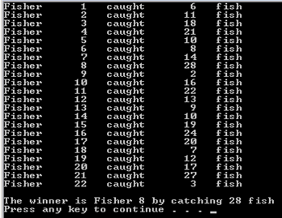

**To earn credit for your lab assignment**:

1. Once your program is completed debugged and tested, turn in your .cpp file on Canvas.

**Grading Rubric**

**.cpp** file turned in on Canvas, named with your last names.

_____ 1 main() calls functions correctly and print out the winner.

_____ 1get_fish function works correctly.

_____ 1show_fish function works correctly..

_____ 2the subscript of best fisher is returned from find_best_fisher correctly.

_____ 5  **Total Points**