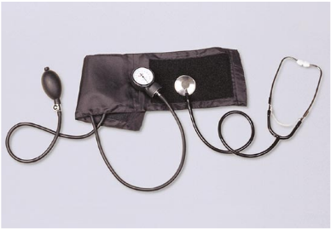**CS2010 Lab 8**

**Due: Fri., March 16, 2018**

Overview: This lab assignment is designed to give you practice calling functions that pass argument(s) by value and return a value using the *return* statement. For this lab you are asked to work with a partner to write a program to interpret and assess a person's health risk based on his/her blood pressure.

Create a Visual Studio C++ program to implement your solution to the problem. Use your last names and **Lab8** for your project folder and .cpp file names (e.g., **WessonMarzola_Lab8** and **WessonMarzola_Lab8.cpp**). Be sure to include both of your names in a comment in the .cpp file.

Your program should include a main function that calls three other functions. Remember that for each function you add, you need a function prototype, a function call and a function definition.

1. First, the *main*function should prompt the user to enter two integers representing a patient's systolic pressure (the pressure generated when the heart contracts) and diastolic pressure (the blood pressure when the heart is relaxed).

2. Then the *main* function should call a function named **calcMAP**. This function will have two parameters and return a value of type integer.

a. Parameters: the systolic and diastolic values entered by the user – pass these values to the function.

b. Return value: the Mean Arterial Pressure (MAP) – the function should calculate the MAP using this formula: **MAP = diastolic + (1/3 (systolic - diastolic))** and return it to the *main* function.

3. After the call to the **calcMAP** function, the *main* function should display the MAP value.

4. Next, the *main* function should call a function named **checkMAP**. This function will have one parameter and return a string value.

a. Parameter: the Mean Arterial Pressure (MAP) calculated by the **calcMAP** function – pass this value to the function.

b. Return value: interpretation message – the function should return one of the interpretation values shown in the table below, depending on the value of the mean arterial blood pressure. This message should be returned to the *main* function using a return statement.

**Mean Arterial Pressure Interpretation Message**

< 70 Hypotension

< 100 Normal

< 120 Stage 1 hypertension

< 135 Stage 2 hypertension

>= 135 Stage 3 hypertension

5. After the call to the **checkMAP** function, the *main* function should display the interpretation message.

6. Next the *main* function should call a function named **checkRisk**. This function will have one parameter and return a string value.

a. Parameter: the Mean Arterial Pressure (MAP) – pass this value to the function.

b. Return value: risk indicator message – the function should return one of the risk indicator values from the table below to the *main* function.

**Mean Arterial Pressure Risk Indicator Message**

< 70 Moderate

< 110 Low

>= 110 High

7. The *main* function should display the risk indicator message returned by **checkRisk**.

**Turning in your lab:**

1. Test your program using different values for the systolic and diastolic blood pressures (e.g. 135 and 70; 175 and 90) and make sure the MAP value and messages displayed are correct.

2. Turn in your .cpp file on Canvas.

**CS2010 Lab 8: Grading Rubric**

Due: Fri., March 16, 2018

___ .cpp file turned in on Canvas, named with your last names.

2 *main* function calls each function, passes correct argument(s) and displays result returned by each function as specified.

Prototype and definition included for each function, correct parameters defined,

3 *return* statement used to return correct result to *main* function.

**5 Total Points**