**Group Activity 12; CS 3060**

**Names** of students in your group: Sidney Sanders, Amanda Collert, Quinci Drain, Emily Endlish

Points: 10

**Goal**: To make us familiar with Haskell programming environment.

**Task 1**: (5 points) See slide 36 in Haskell ppt 1. Follow the instructions to install minimal Haskell system i.e. Glasgow Haskell Compiler (or ghc) and ghc interpreter(or ghci) on your computer. If you already did so, then nothing much to do. Anyway, after the installation, paste below a screenshot of ghci window as available on your computer.

An example is shown below.

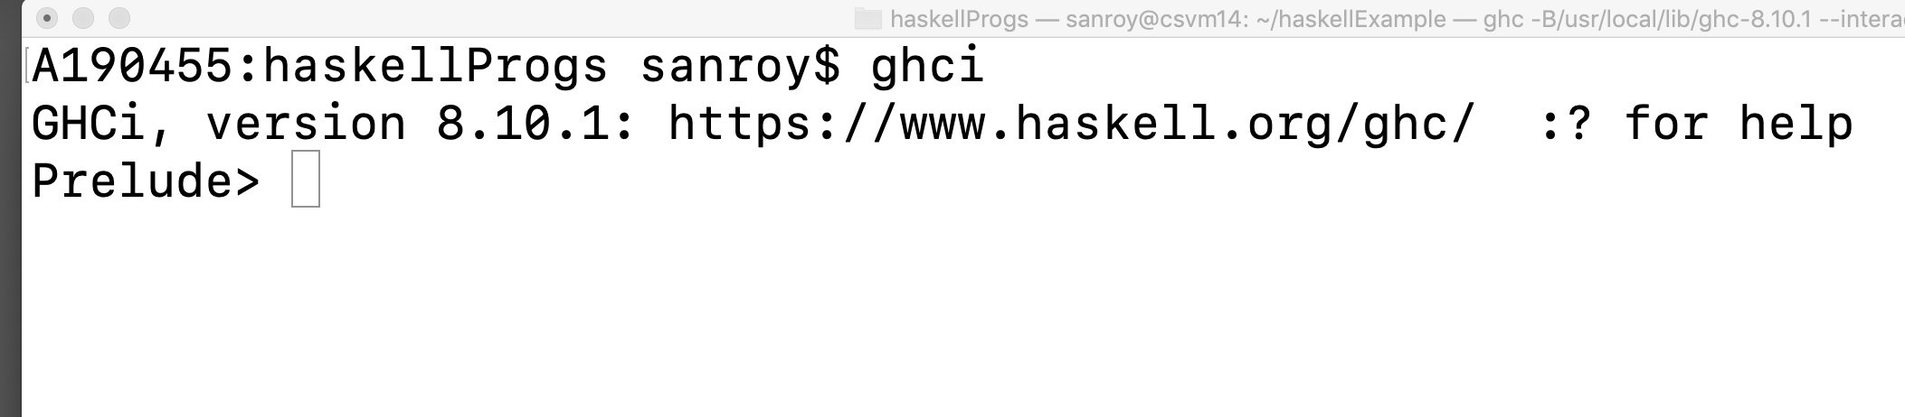

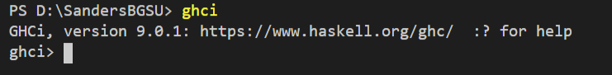

**Task 2**: (5 points) Start Haskell interpreter ghci . Type *print(“your name”)* with your actual name. Take a screenshot (showing your name on ghci window) and paste it below.

An example is shown below.

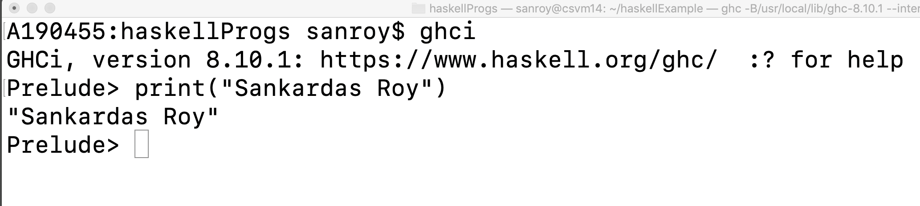

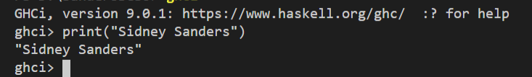

Submission: Submit one copy per each student via Canvas.