Circle Term: [ **Spring** | Fall | Summer] Year: __2021__

Course Number - Section: CS 3160 - 1

Name (**PRINT**): ___Sidney Sanders________ Student ID #: ____0020308307_____

Seeking degree (check **ONE**): _**_X_**_ BS in CS ____ BS in SE ___ BA in CS ___ Other

PLEASE check all that apply to you:

[ X ] I have taken CS2020. If at BGSU, provide instructor’s name ______Carlson_____ Grade: ___D__

[ X ] I have taken CS2020. If at BGSU, provide instructor’s name _______Unsure____ Grade: ___A___

Special needs you want the instructor to be aware of:

________________________________________________________________________

________________________________________________________________________

________________________________________________________________________

________________________________________________________________________

I understand that my grade in this class will be determined by the points I earn during the semester doing **MY OWN WORK**. Furthermore, I understand that in this class, attendance is REQUIRED, and if I miss class, it is **MY RESPONSIBILITY** to find out what I missed and to study the material on my own time. I understand that some missed classwork cannot be made up (i.e., quizzes/bonus attendance points/assignments that students have several days to complete, etc.).

**I understand that LATE assignments are not accepted in this class.**

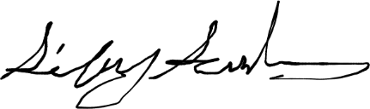

Signature: _____________________________________ Date: ________1/11/2021_____