DATA STRUCTURES LAB TASK 2
Name : Mahad Ashraf
Roll no: 20P-0563
Q1.
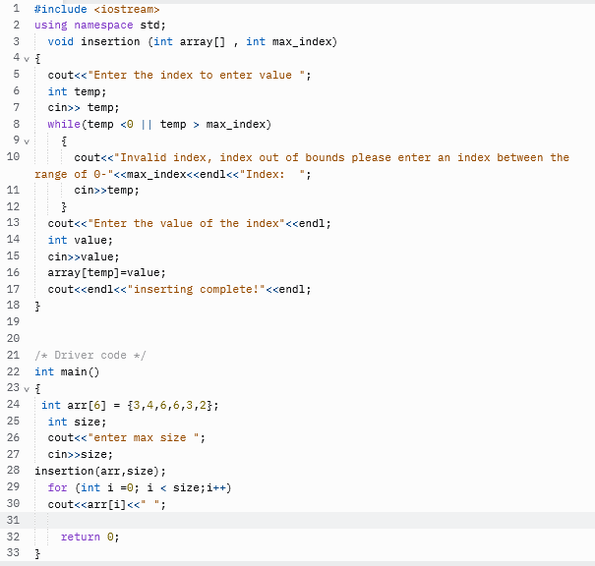
Output:
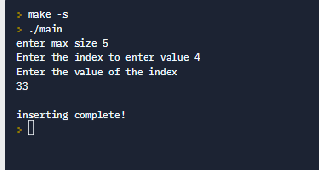
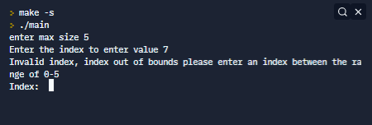
Q2.
Find the error in each of the following segments. If the error can be corrected, explain how.
a) int *number;
cout << number << endl;

ANS : #include<iostream>
using namespace std;
int main(){
int *number;
number = NULL;
cout << number << endl;
return 0;
}

b) double *realPtr;
long *integerPtr;
integerPtr = realPtr;
ANS : different data type double and long
#include <iostream>
using namespace std;
int main() {

double *realPtr;
double *integerPtr;
integerPtr = realPtr;

}
c) int * x, y;
x = y;
ANS : #include <iostream>
using namespace std;
int main() {

int * x, y;
x = &y;

}
d) char s[] = "this is a character array";
for (;*s != '\0'; ++s)
cout << *s << ' ';
ANS : #include <iostream>
using namespace std;

int main(){
char string [] = "this is a character array";
char *s;
for (;*s != '\0'; ++s);

cout << string << ' ';
}
e) short *numPtr,
result; void *genericPtr = numPtr;
result = *genericPtr + 7;
ANS : #include <iostream>
using namespace std;
int main() {
short *numPtr,result;
short **genericPtr = &numPtr;
result = **genericPtr + 7;

}
f) double x = 19.34;
double xPtr = &x;
cout << xPtr << endl;
ANS : #include <iostream>
using namespace std;
int main() {
double x = 19.34;
double *xPtr = &x;
cout << *xPtr << endl;

}
Q3
Part A :
#include <iostream>
using namespace std;
void mystery1(char*, const char*); // prototype
int main()
{
char string1[80];
char string2[80];
cout << "Enter two strings: ";
cin >> string1 >> string2;
mystery1(string1, string2);
cout << string1 << endl;
} // end main
// What does this function do?
void mystery1(char* s1, const char* s2)
{
while (*s1 != '\0')
++s1;
for (; *s1 = *s2; ++s1, ++s2)
; // empty statement
} // end function mystery1

In this function we write a prototype of the function Mystery 1 and give two input one *char and const *char then we use generic code to enter the 2 strings after that we call the function and use while loop unless the string 1 is not equal to zero increment string 1 and at the end we use for loop

Part b)
#include <iostream>
using namespace std;
int mystery2(const char*); // prototype
int main()
{
char string1[80];
cout << "Enter a string: ";
cin >> string1;
cout << mystery2(string1) << endl;
} // end main
// What does this function do?
int mystery2(const char* s)
{
int x;
for (x = 0; *s != '\0'; ++s)
++x;
return x;
} // end function mystery2

Explanation of code : in this code we declare a prototype of the function and we enter the string after that we call the function const* char and we declare the variable x and use for loop and we then increment the const char s and after the loop ends we increment the int x and return x
Q4
#include<iostream>
using namespace std;
int main()
{
Int a = 5, b = 10;
Int c;
int* p1, * p2;
p1 = &a;
p2 = &b;
c = *p1;
Cout << "*(p1++) =" << *(p1++) << endl;
Cout << "value of p1 " << p1 << endl;
Cout << "*(++p1) =" << *(++p1) << endl;

cout << "value of p1 " << p1 << endl;
cout << "(*p1) ++ =" << (*p1)++ << endl;
Cout << "value of p1” << p1 << endl;
Cout << "++(*p1) =" << ++(*p1) << endl;
Cout << "value of p1” << p1 << endl;
Return 0;
}
Code explanation:
In this we declare 3 int variable a b and c we put 5 in a and 10 in b then we declare 2 pointers p1 and p2 and we put address of a in p1 and address of b in p2 and c is equal to *p1 value at the end we print them

Q6:
Write a function using pointer notation that accepts following arguments; A pointer char array and Two
Integer that indicates the indexes (startIndex and stopIndex). Function will return a string which holds
The section between the two indexes and Return the null if it’s not possible.

ANS:
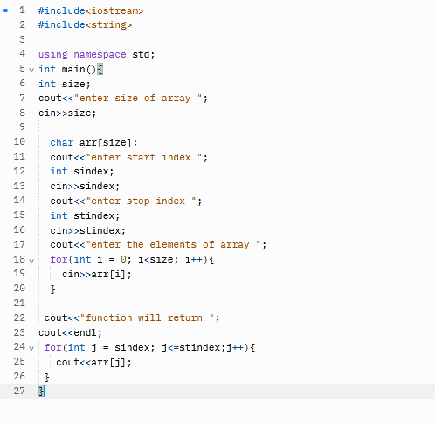
Output :
