Lab Exam: Final!

—————————786——————————

Name: Muhammad Sherjeel Akhtar

Roll No: 20p-0101

Subject: Computer Networks Lab

Submitted To Respected
Ma’am: Hurmat Hidayat

Section: BCS-5B

Question: 1
Answer:
Given Topology:
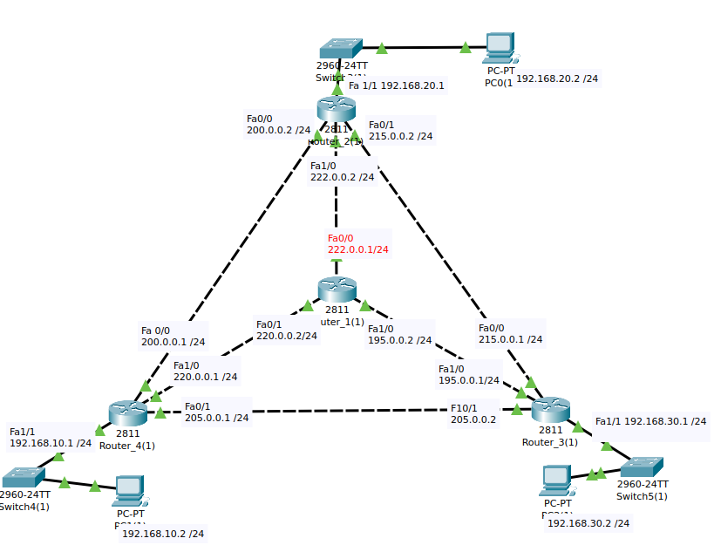
.
We’ve given above topology for our network.
Connection Testing Between PC’s And Routers:
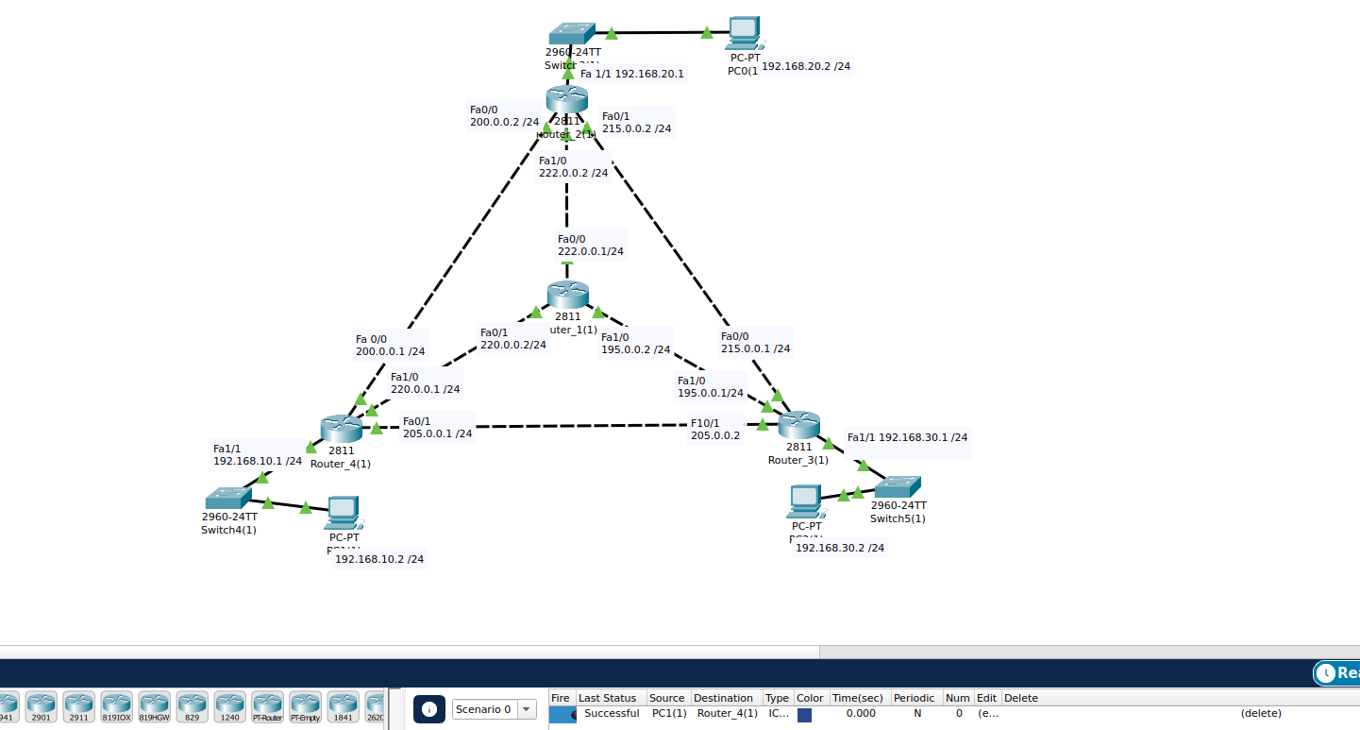
.
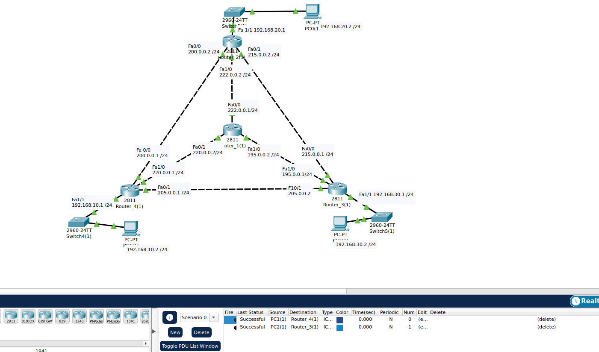
.
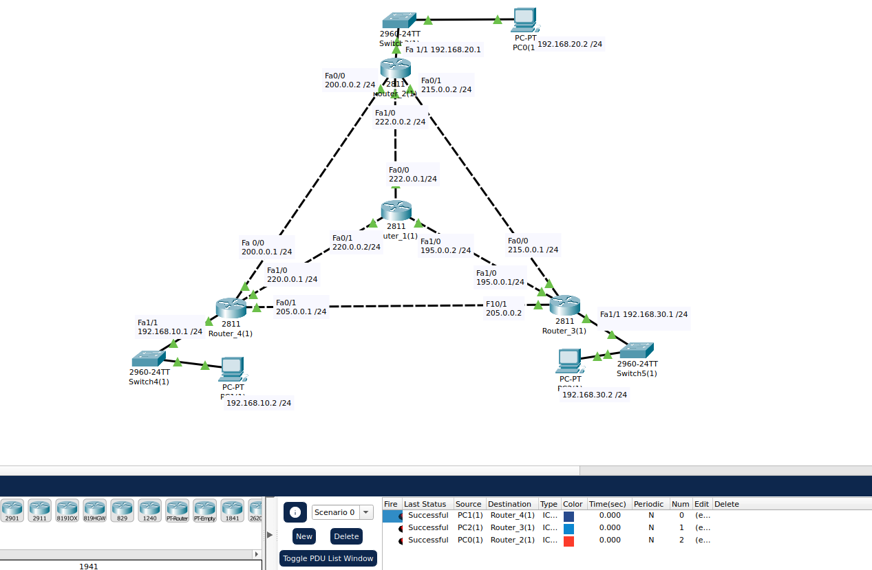
.
Connection Testing Between Routers:
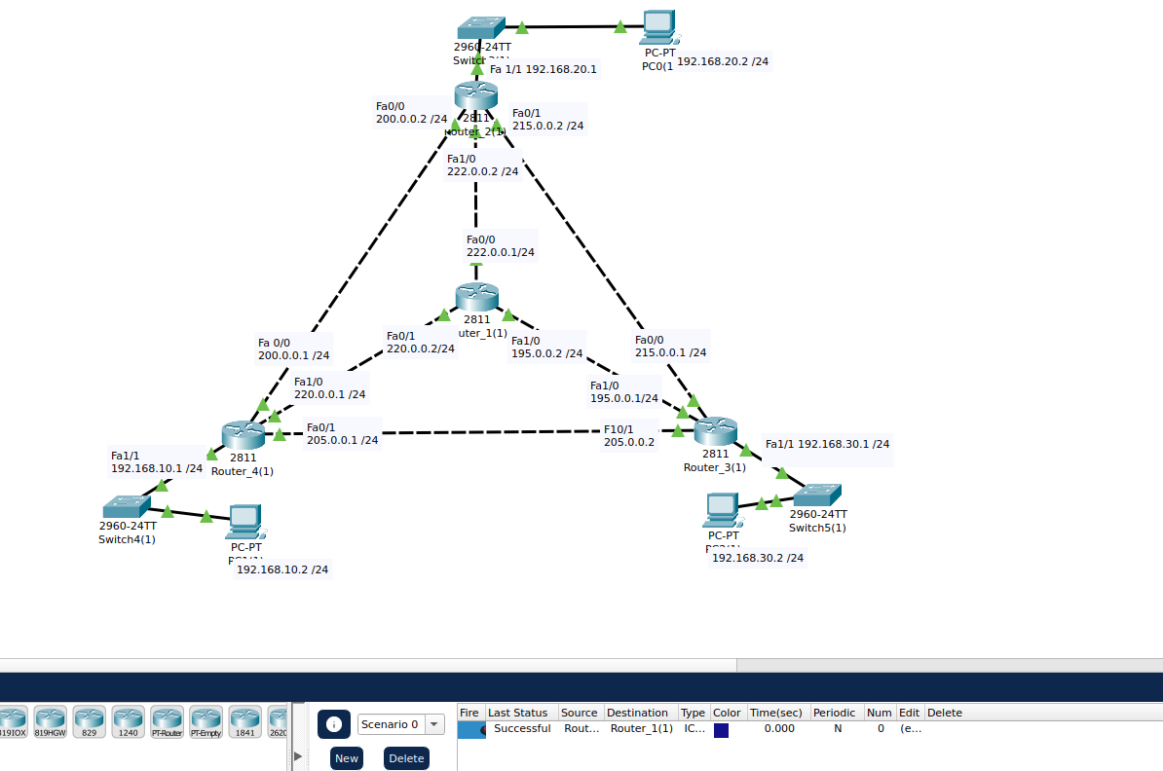
.
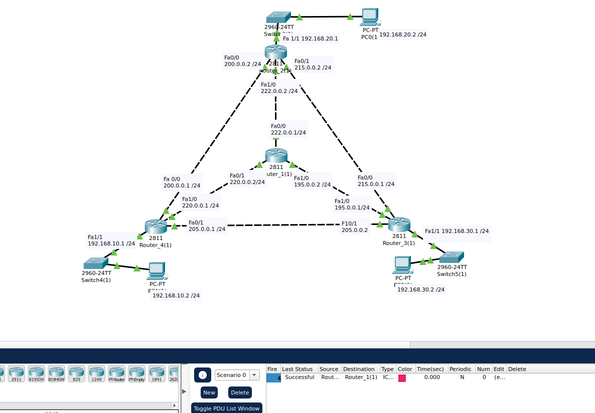
.
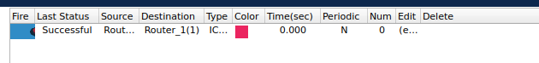
.
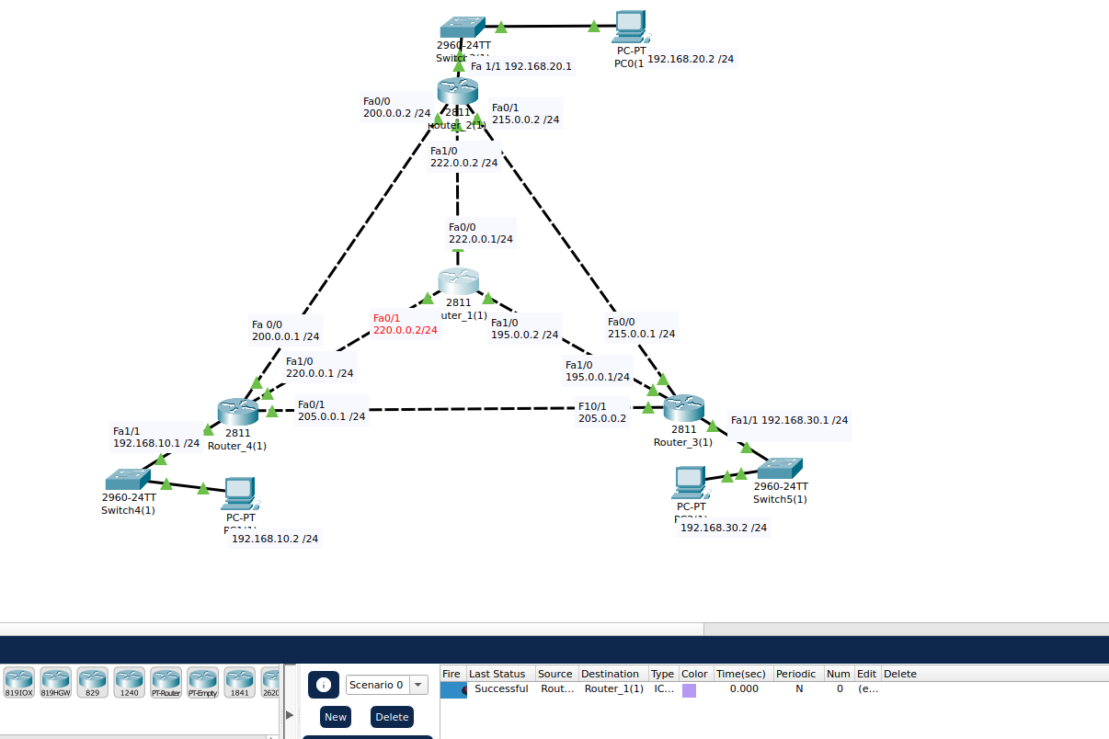
.
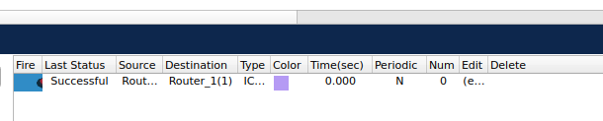
.
Successful Connection Testing between Routers.
Testing Router 1 Connection Again with the central Router.
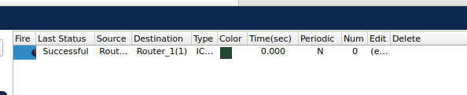
.
All The Router Configurations are Working.
Next Step:
Now, we will check if we can transfer data from One Network To The Other. For this purpose, we will send a packet between the PC’s of the different Networks.
Testing b/w Router 4 and Router 2:
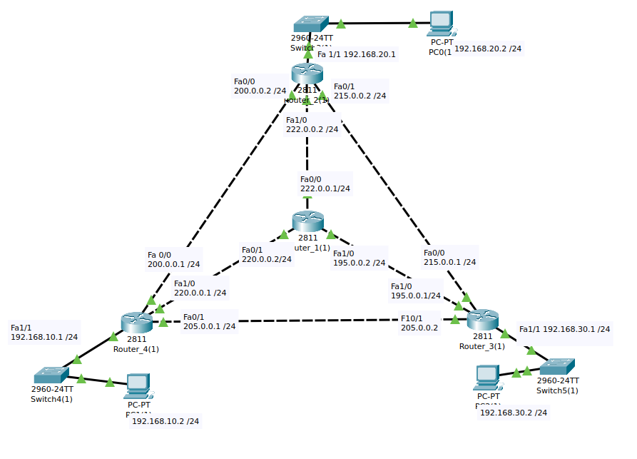
.
.
Testing b/w Router 3 And Router 2:
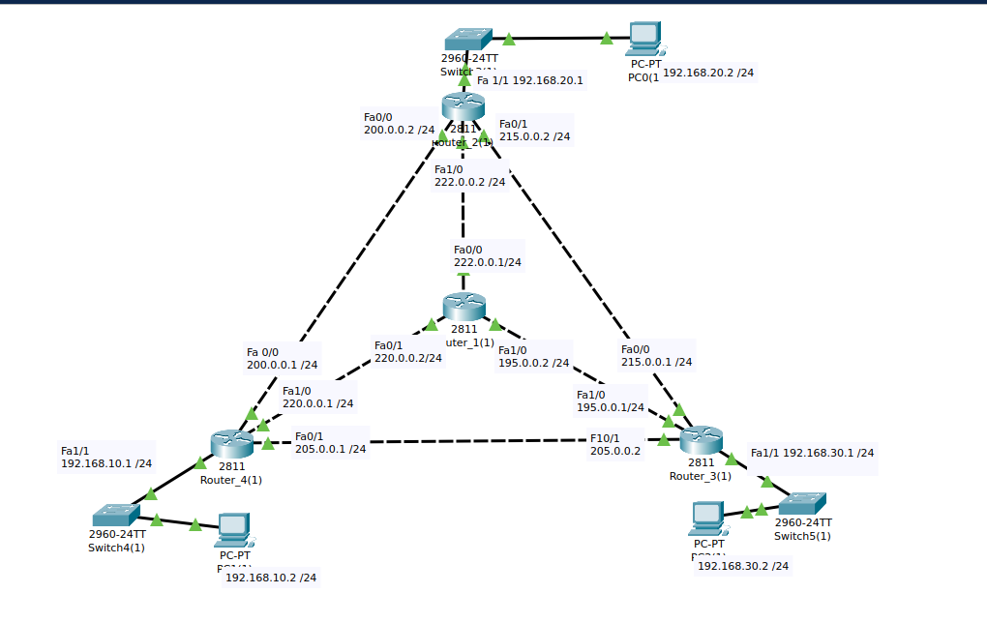
.
.
Testing b/w Router 3 And Router 4:
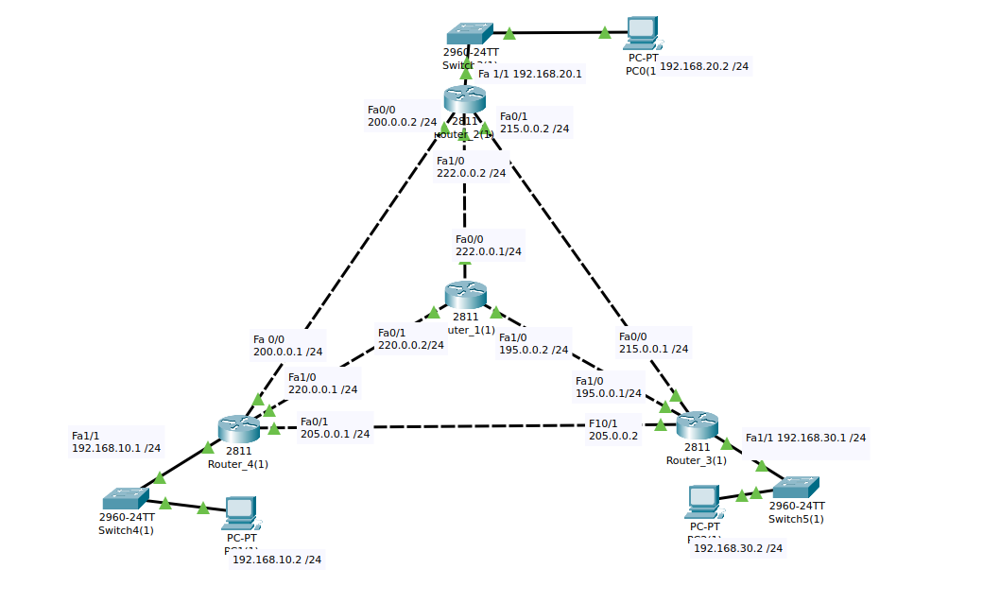
.
.
Conclusion: We can see, we cannot transfer files between different Networks. For this purpose, we will do STATIC ROUTING between the Networks.
Static Routing between Router 4 And Router 2:
Router 2:
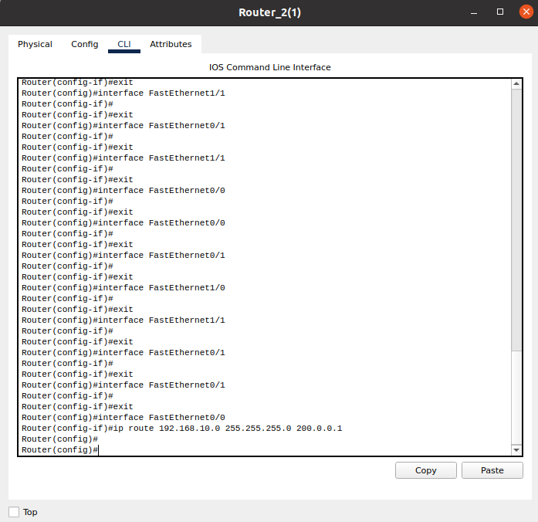
.
Here is the Router 2 CLI Configuration.
Router 4:
Below is the Router 4 Configuration.
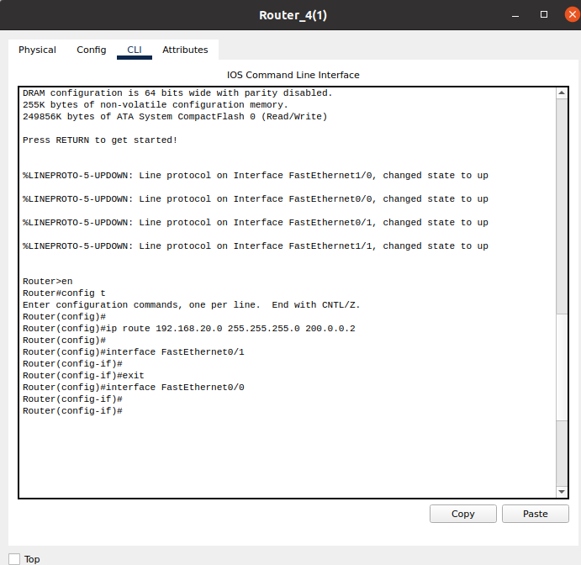
.
Testing:
Packet Send successfully after the Static Routing between the Routers.
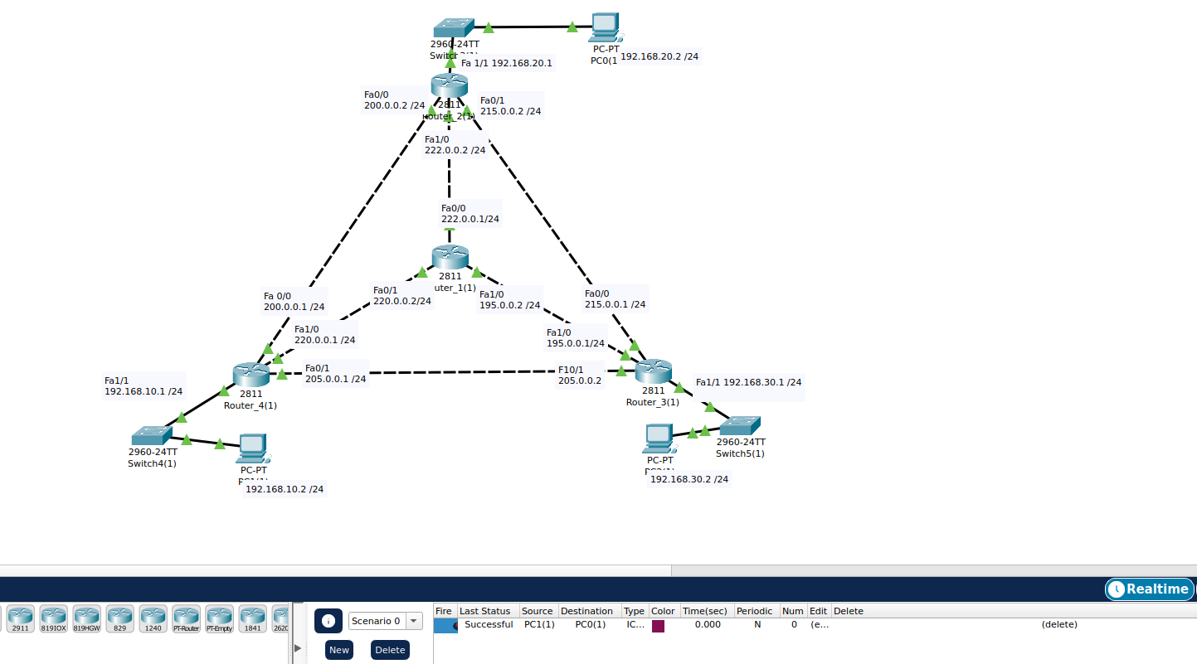
.
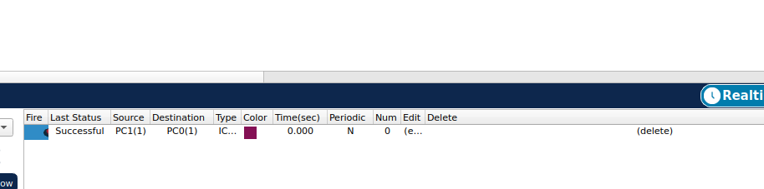
.
Static Routing between Router 4 And Router 3:
Router 4:
Below is the Router 4 Configuration.

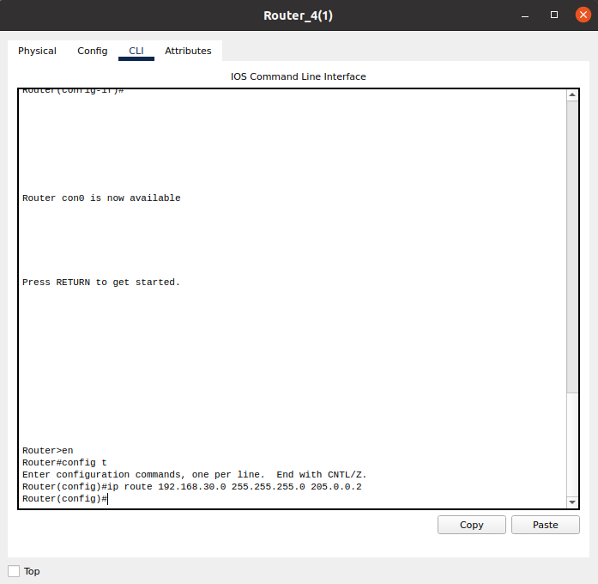
.
Router 3:
Below is the Router 3 Configuration.
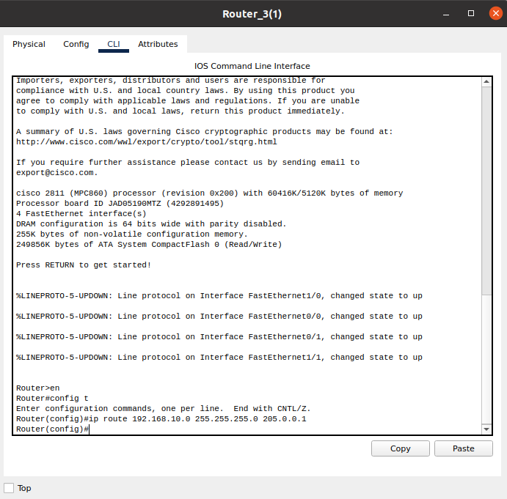
.
Testing:
Packet Send successfully after the Static Routing between the Routers.
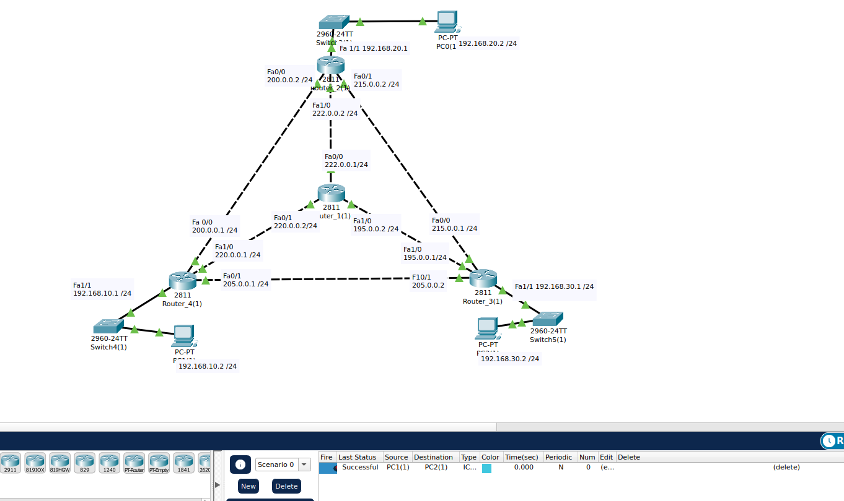
.
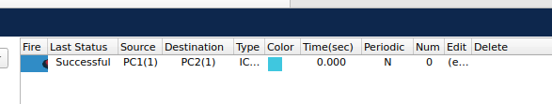
.
Static Routing between Router 2 And Router 3:
Router 2:
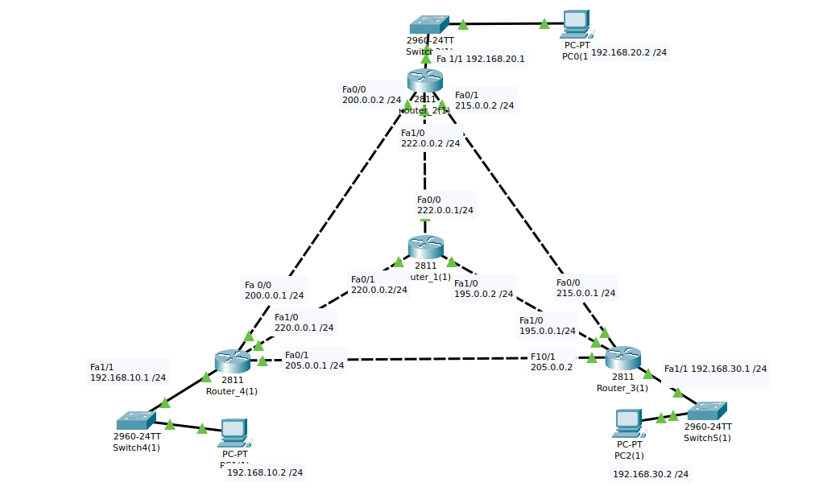
.
Below is the Router 2 Configuration.
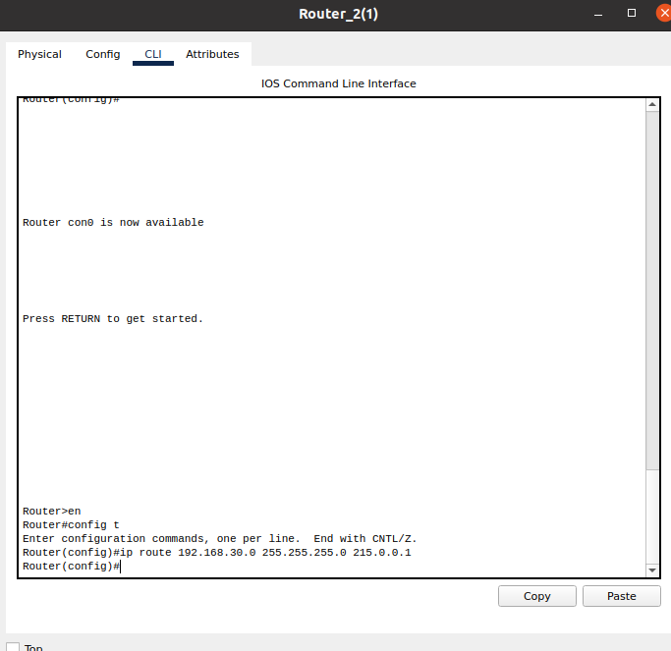
.
Router-3:
Below is the Router-3 Configuration.
..
.
.
.
.
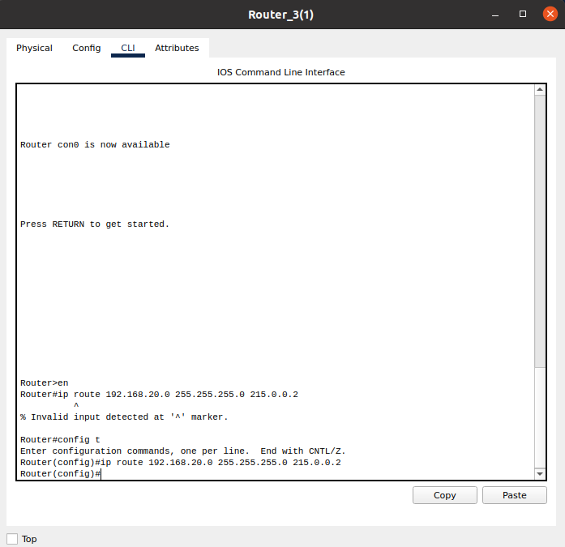
.
.
.
.
.
.
Testing:
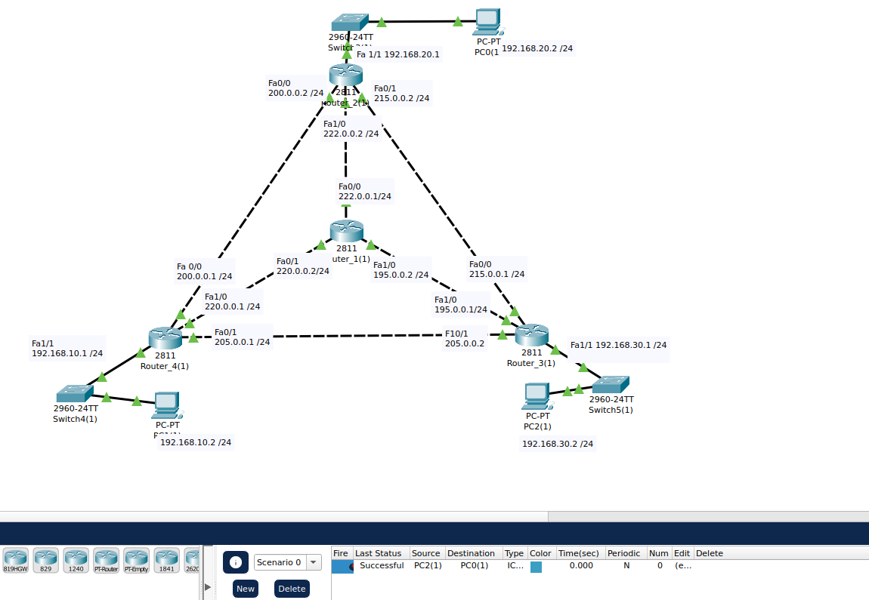
.
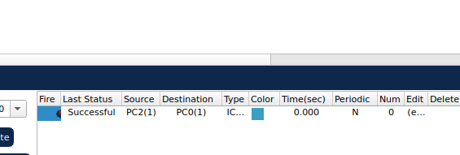
.
Successfully all router configured via Static Routing.
Conclusion:
Now you can transfer any packet between any networks of the given Topology.
Demonstration:
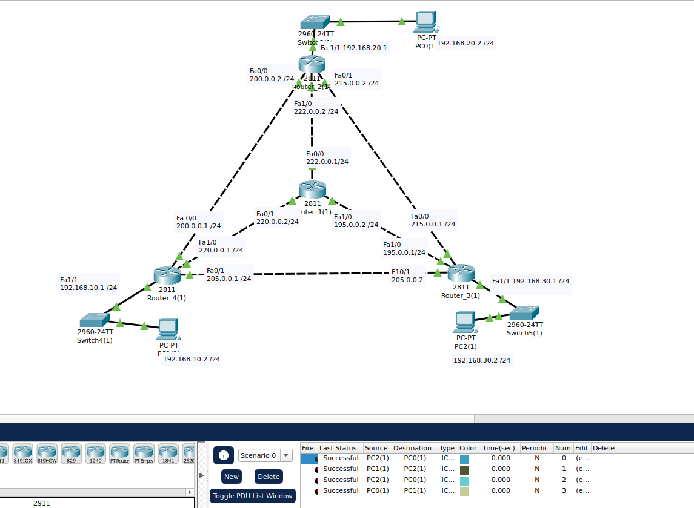
.
.
.
.
.
.
.
.
.
.
PART B.
Answer:
We’re required create a server that will assign the IP’s to all the devices of the Network.
Initial Step:
For this purpose, we are going to add a DHCP Server to the Topology.
Topology:
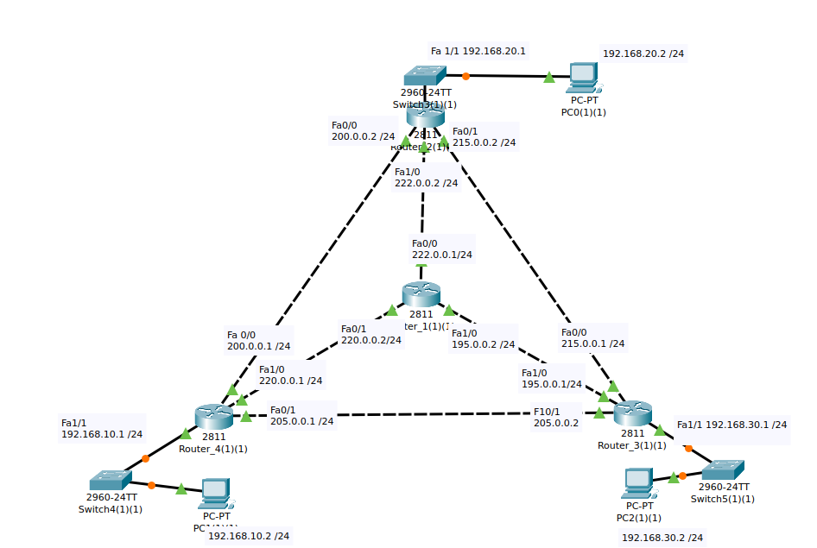
.
Adding Server:
The initial step is of,
- Adding of the Server to our Topology.
Demonstration:
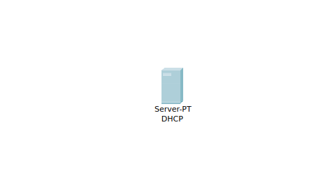
.

.
Connection:
Now we are going to connect it to Router Using Copper-Straight-Through wire.
.
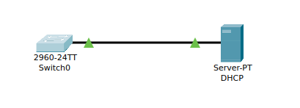
.

.
Next Step:
Now connect this, server to the Centralized Router via the Wire.
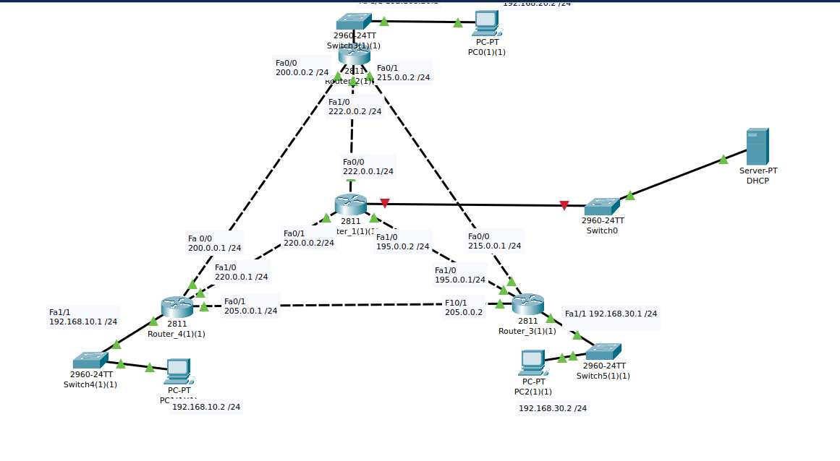
.
Assigning IP To The Server:
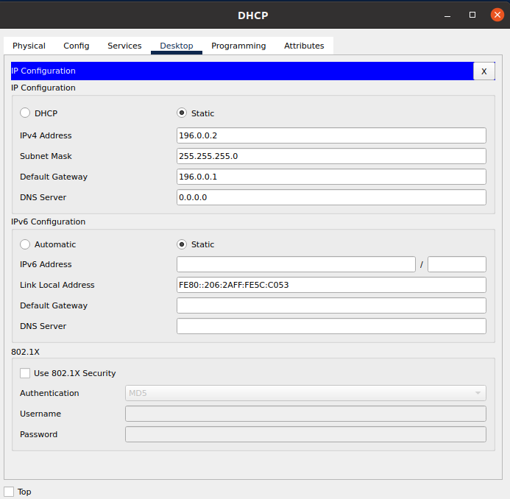
.
Router Configuration For The Server:
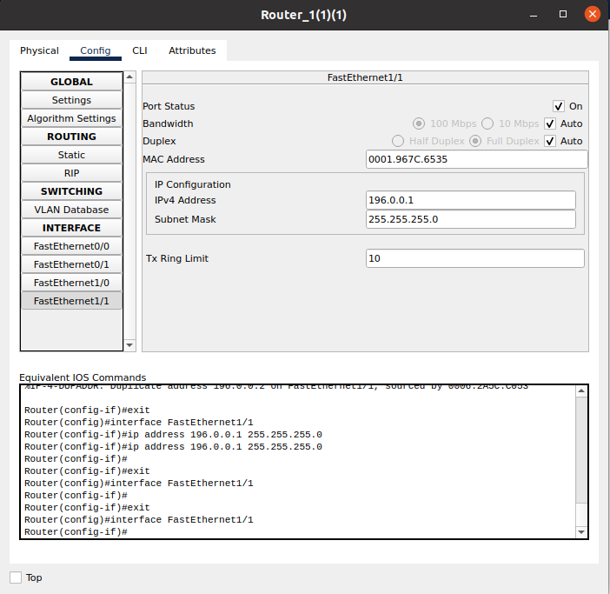
.

Connection Testing:
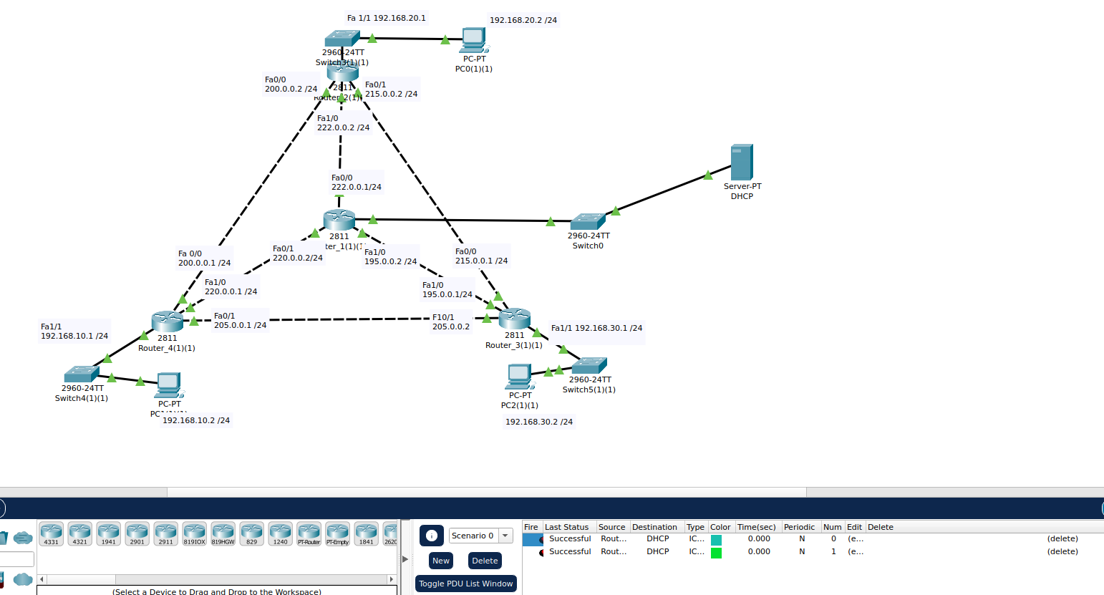
.
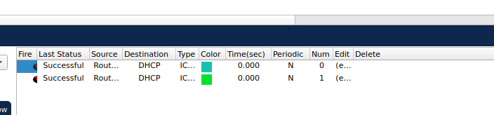
.
DHCP Server Configuration Of DHCP Services:
Adding Pool.
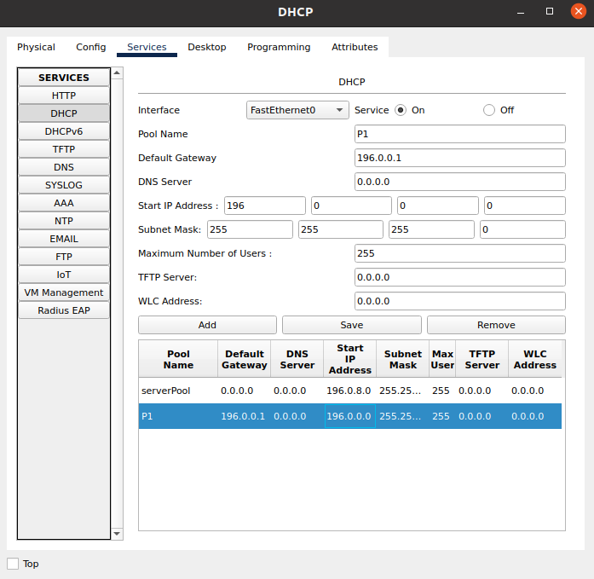
.
Switching On DHCP Services:
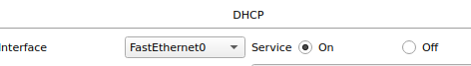
.
.
.
Tesing DHCP Server Working:
Adding A PC:
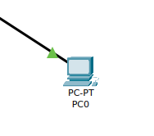
.

.
.
.
Connecting It To Server:
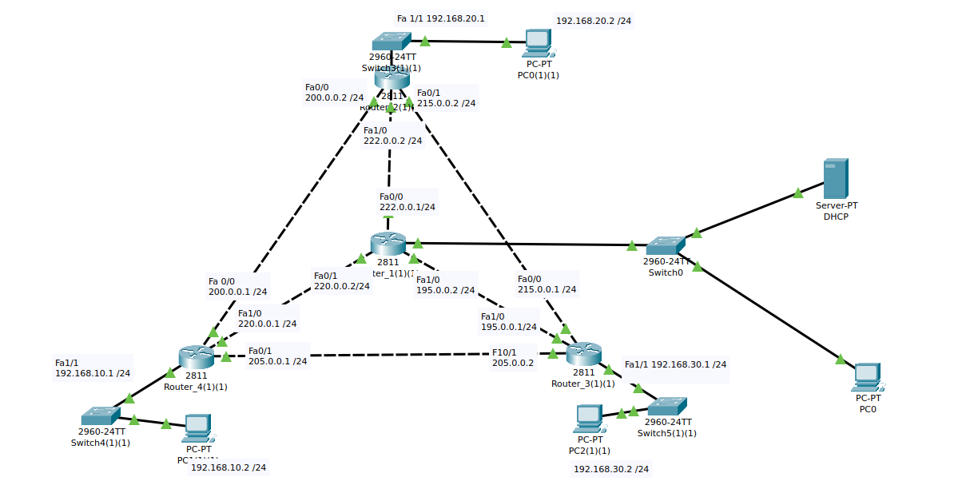
.
Testing DHCP IP Addressing:
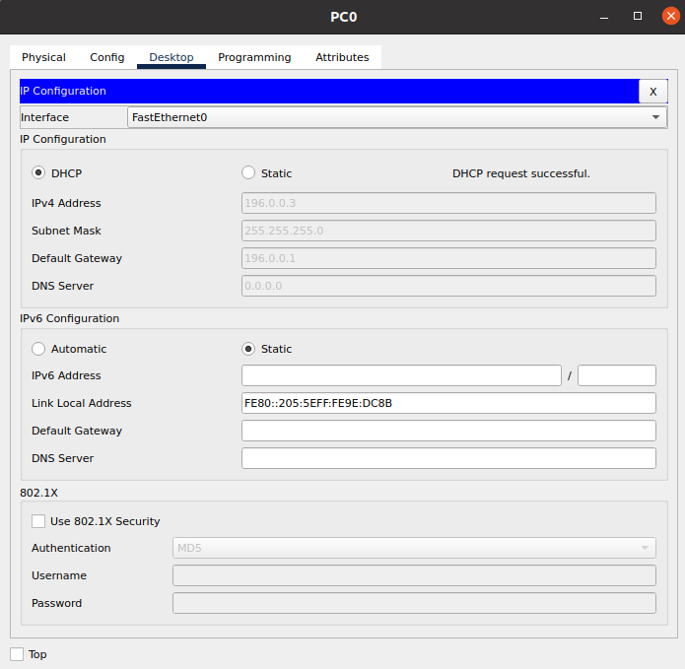
.
Adding Pools For The Whole Network:
For Router 3:
We are adding Pool P9 for router 3.
Demonstration:
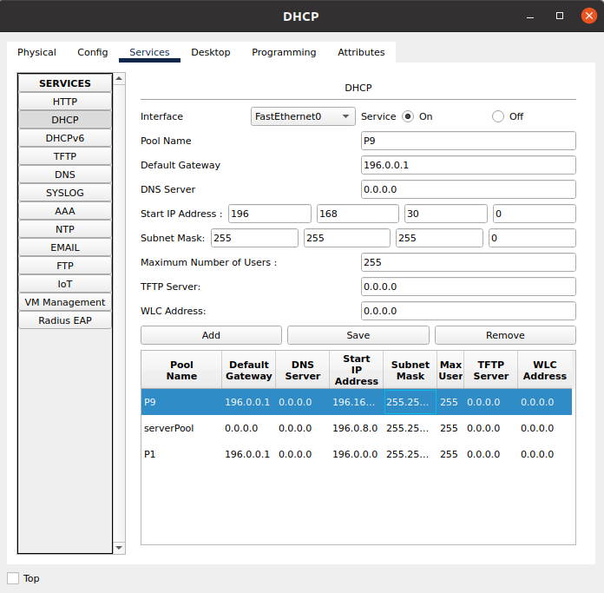
.
Testing DHCP IP Assignment For Router 3:
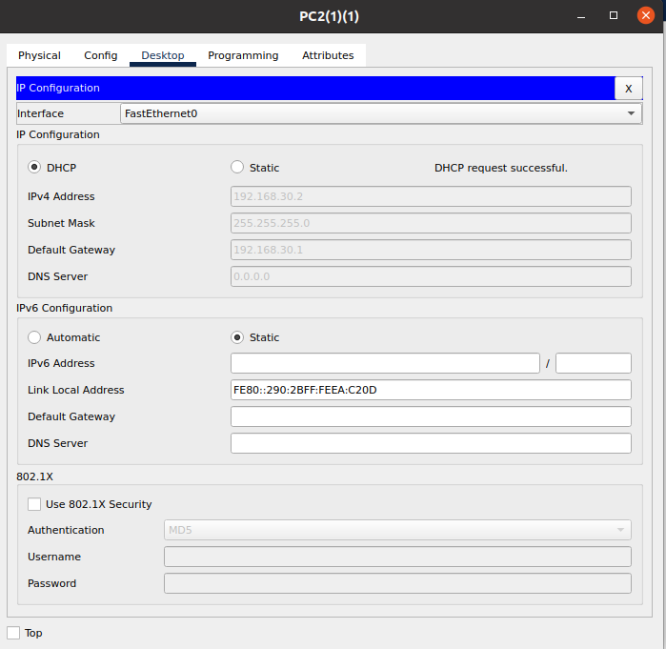
.
Adding Pool P8 For Router 4:
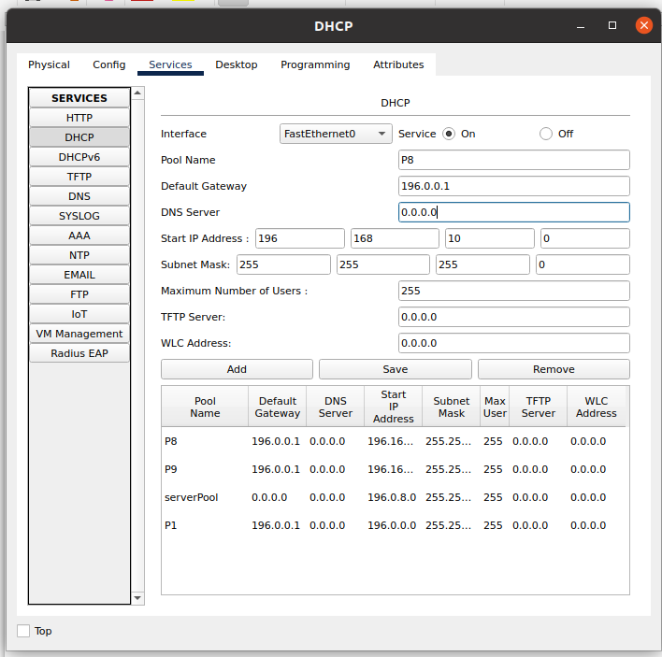
.
Testing DHCP Auto IP Assigning On Router 4:
.
.
.
.
.
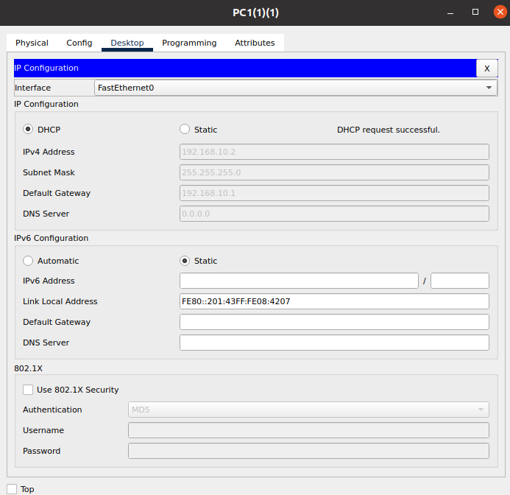
.
.

Adding Pool P7 For Router 2:
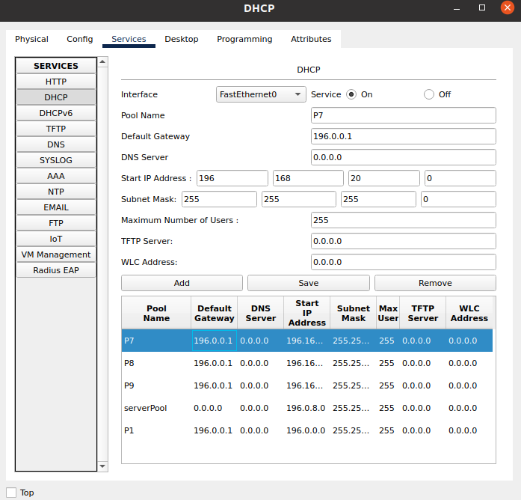
.
Testing DHCP Auto IP Assigning On Router 2:
.
.
.
.
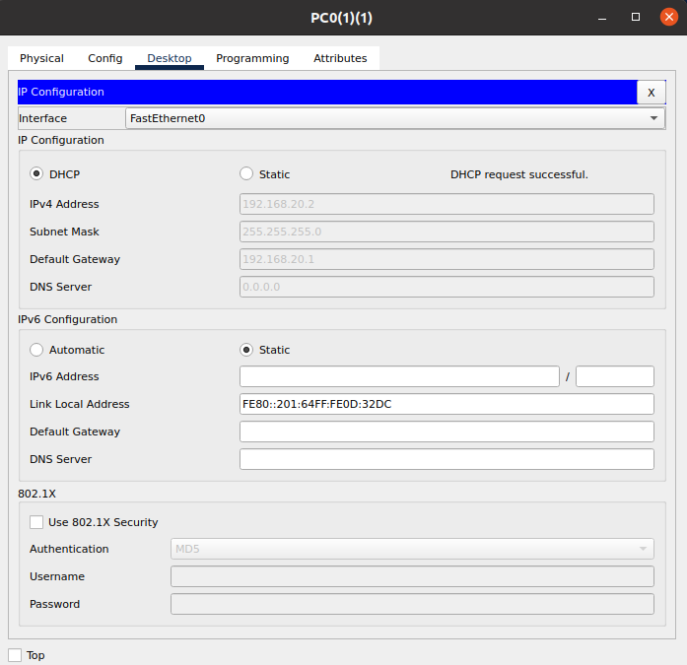
.
.
Testing DHCP IP Assignment By Adding A New Device On Each Network:

.
1st:
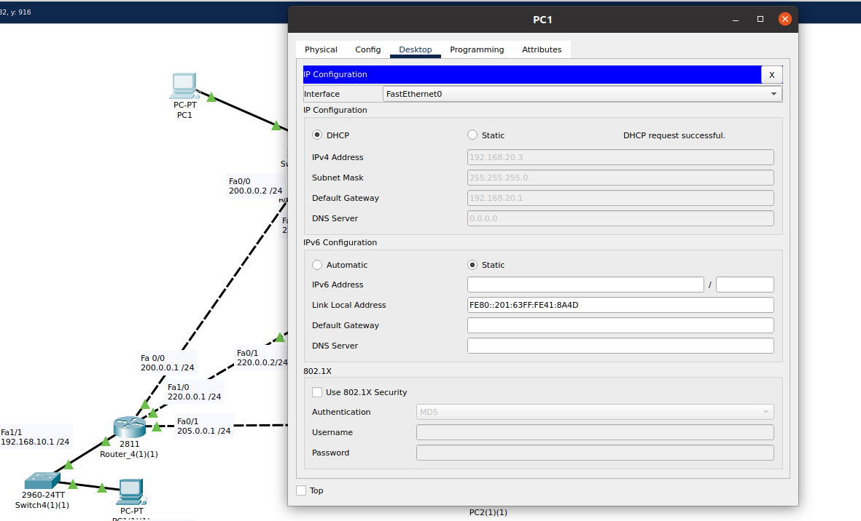
.
2nd:
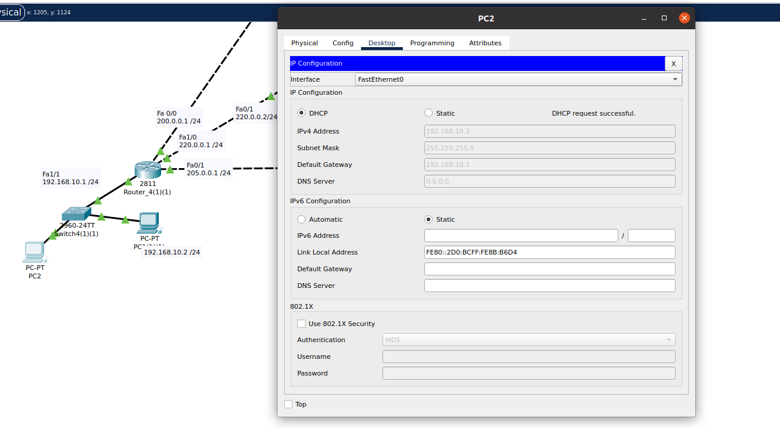
.
3rd:
.
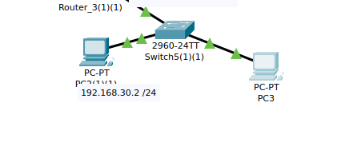
.
.
.
.
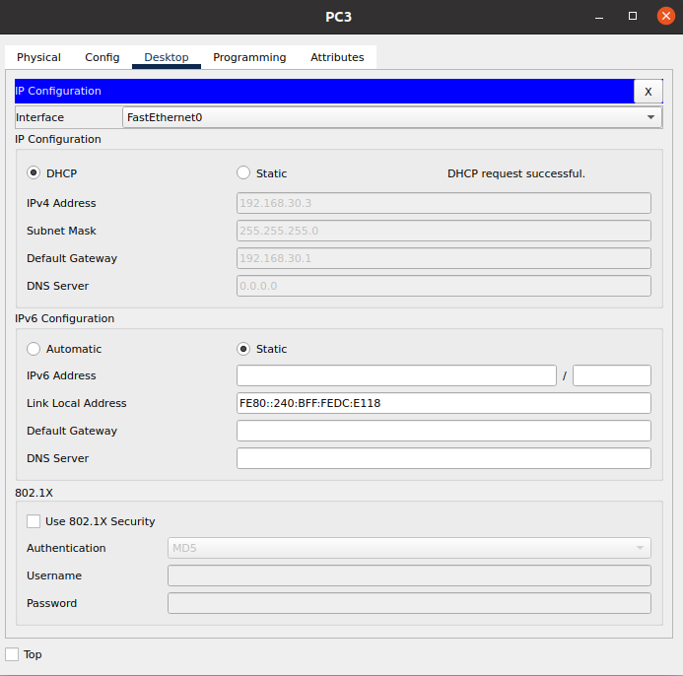
.
.
Here Our B For The Centralized DHCP Server is Also Completed.
Q3:
Answer:
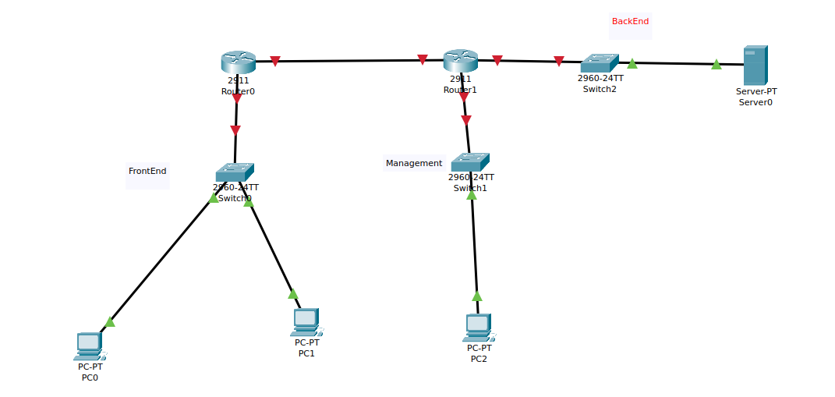
.
This is our. Topology,
We’ve,
FrontEnd:.
.
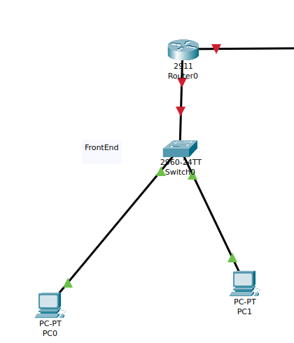

.
.
.
.
.
.
.
.
.
.Management:
.

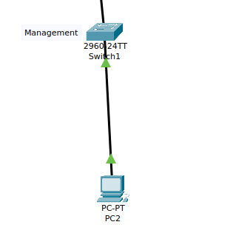
.
.
.
.
.
.
.
.
BackEnd(Server):
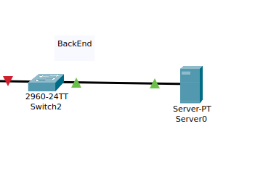
.
.
.
.
..
.
.
Router Configuration:
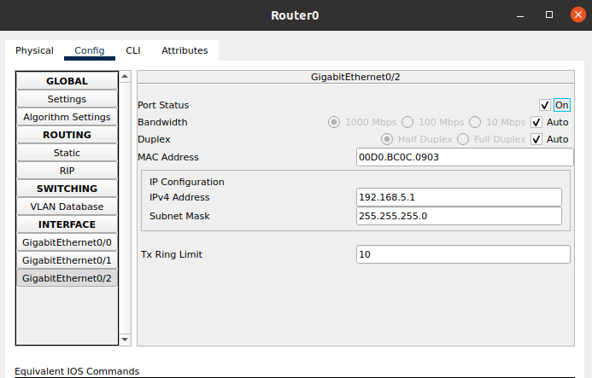
..
.
.
..
2nd Router Configuration:
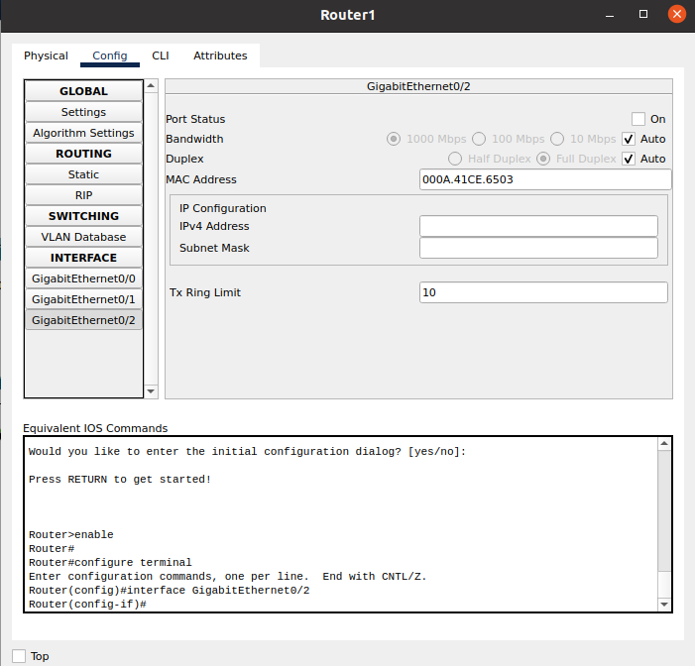
.
.
.
.
.
.
Front End Dept Config:
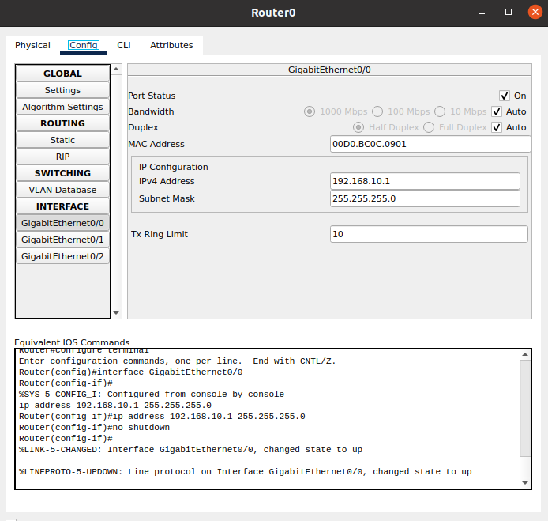
.
Management Dept Config:
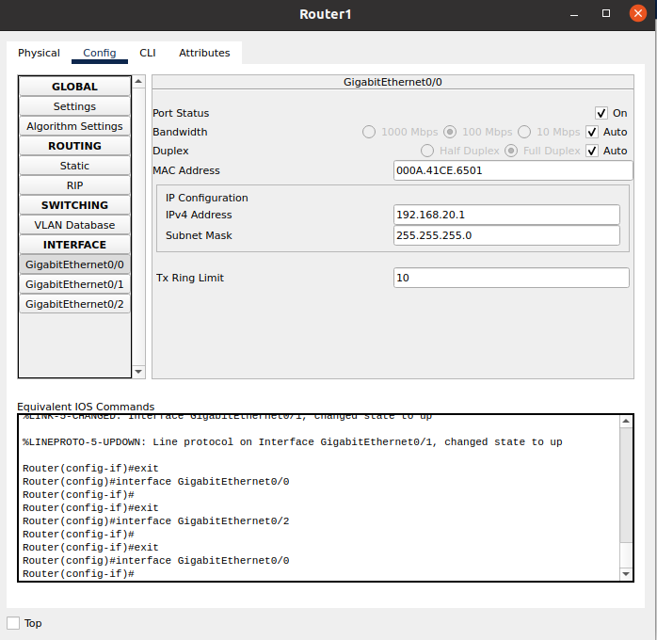
.
.
.
.
..
.
.
Back End Dept Configuration:
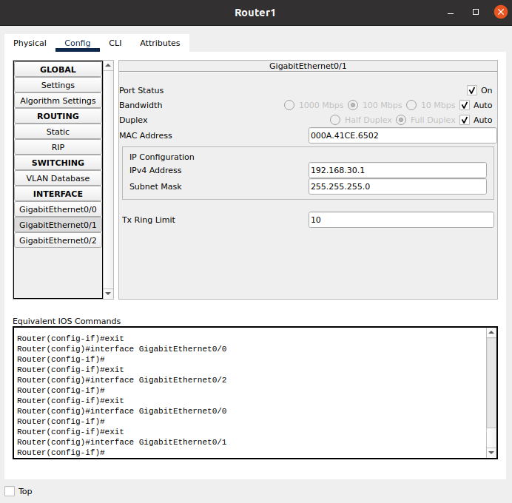
.
.
.
.Connection Test B/w Routers:
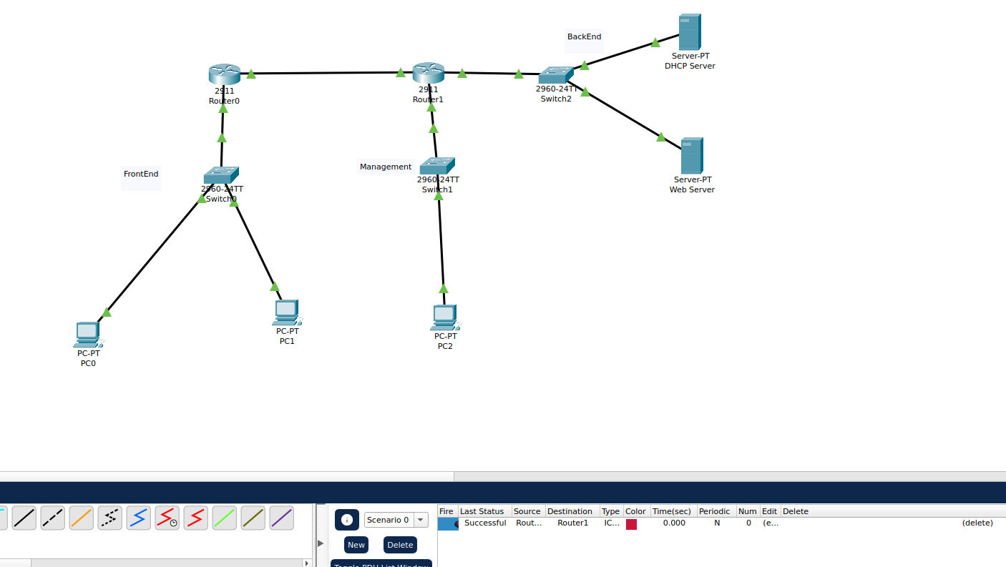
.
.
.
.
.
.
.
.
.
.
.
.
.
.
DHCP Server Config:
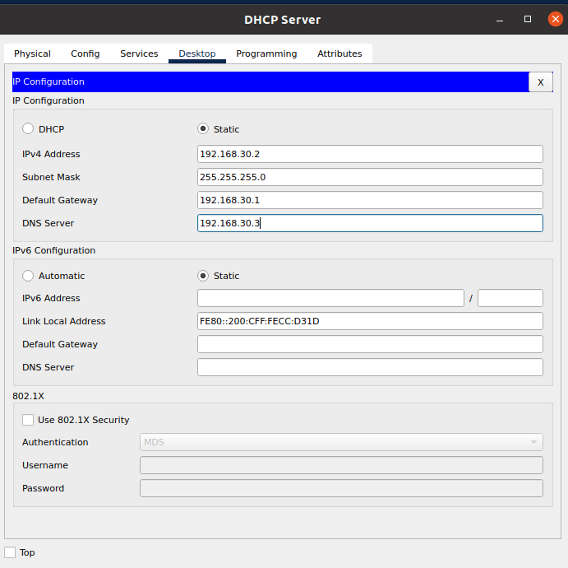
.
DNS:
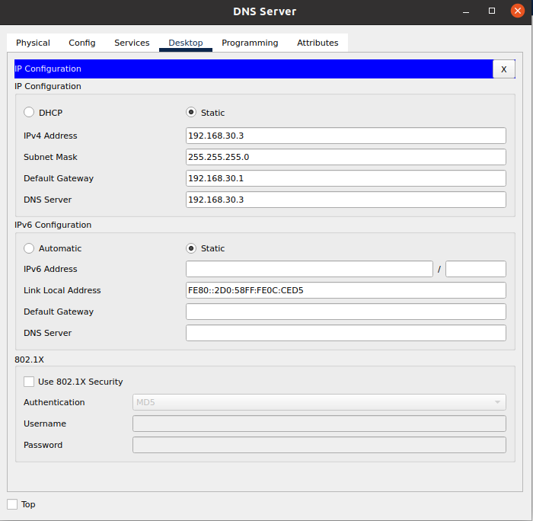
.
.
.
.
.
.
.
.
Web Server Config:
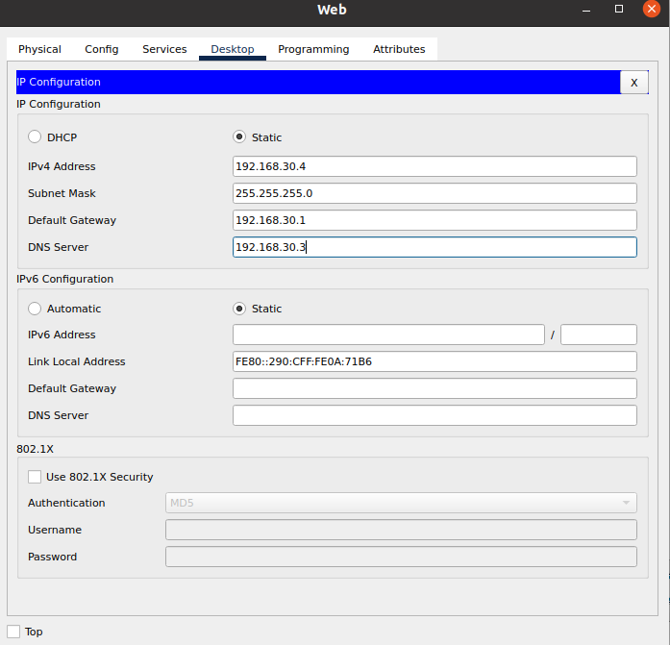
.
.
.
Whole Topology:
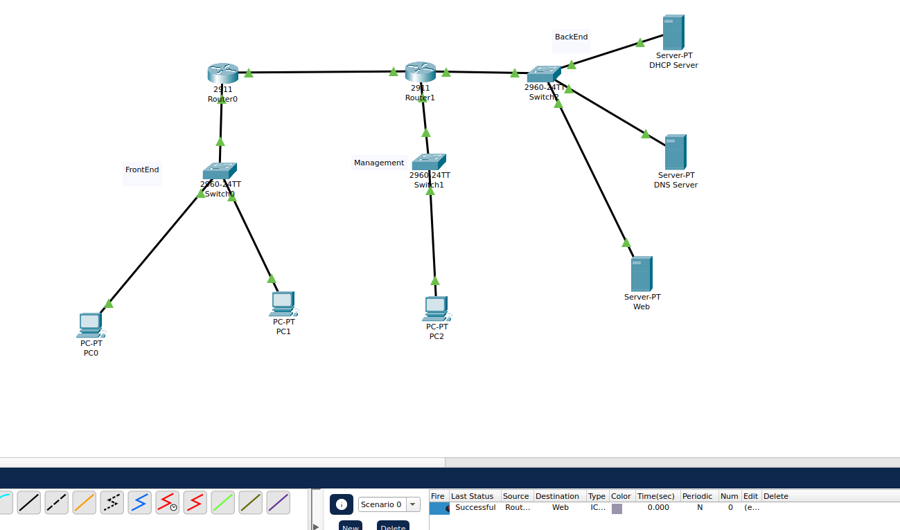
.
Connection Is Successful With Testing.
DHCP Config:
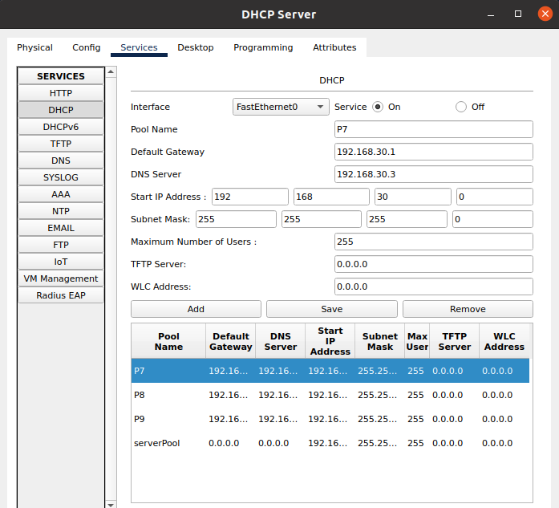
.
.
.
.
.
.
.
..
.
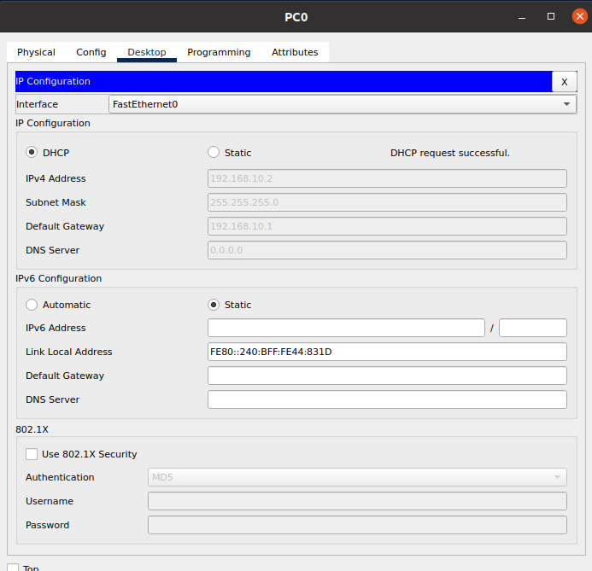
.
.
.
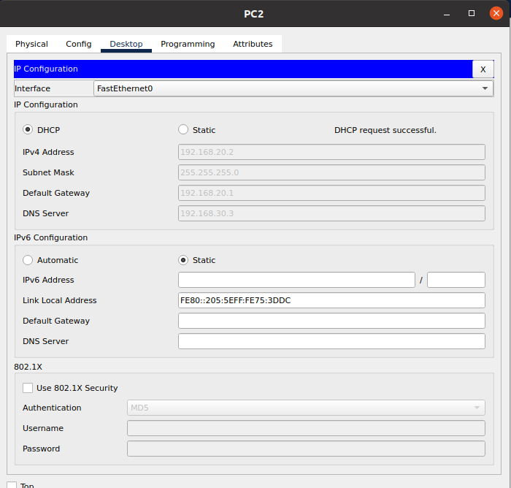
..
.
.
.
.
.
.
.
.
DNS Services:

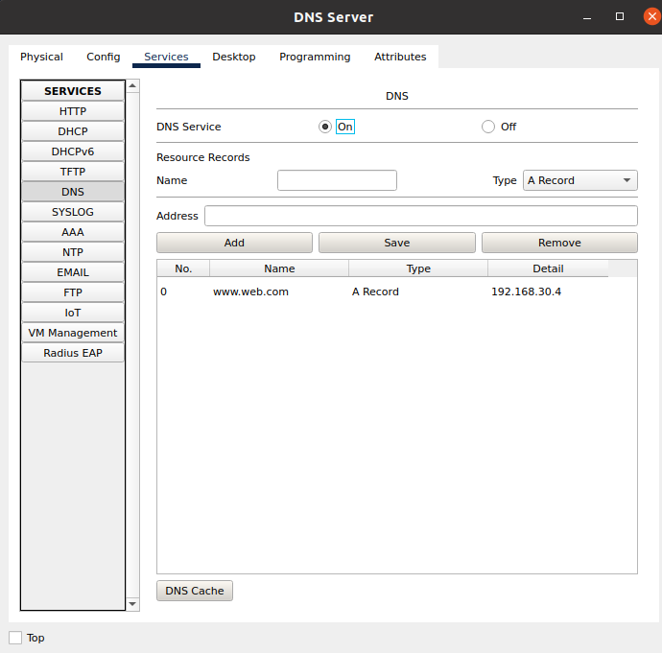
.
.
.
.
.Q:
a.
How many subnet?
Answer: 4
b.
2
c.
4
d.
62
e.
220.10.10.192
f.
220.10.10.192

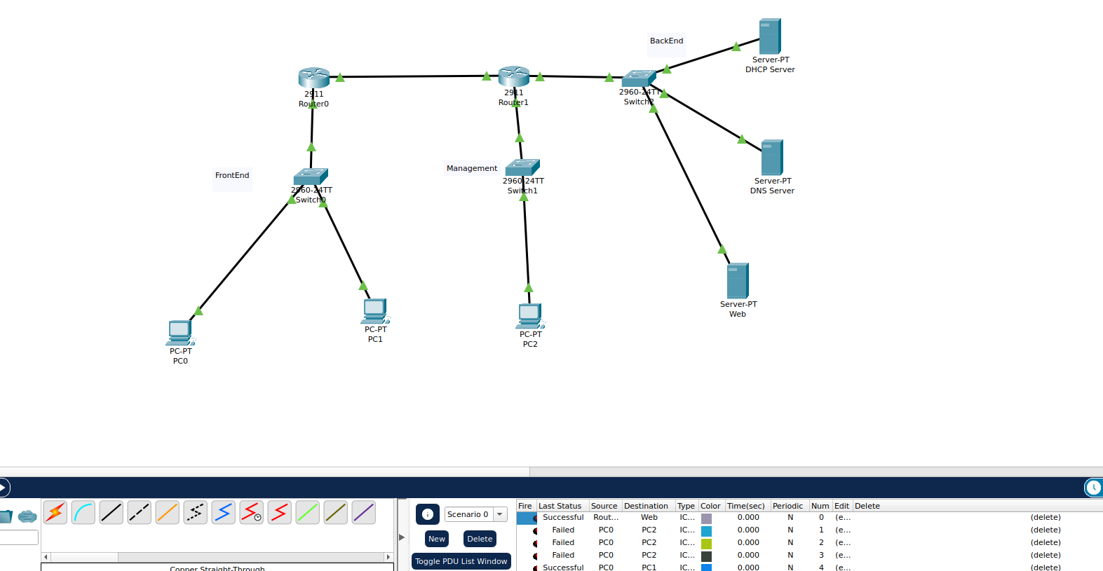
.
Successful Connection.
Maam Im sorry I forget the IP is given, so I’ve used Another IP. Really Sry for inconvience
Same procedure will be followed by the IP given in the Paper.
Part g due to time shortage.Sry

