

Name: Muhammad Sherjeel Akhtar

Roll No: 20P-0101

Subject: Technical Business Writing

Assignment No: 4 Re-Submission

Submitted To Respected Maam: Noreen Shah

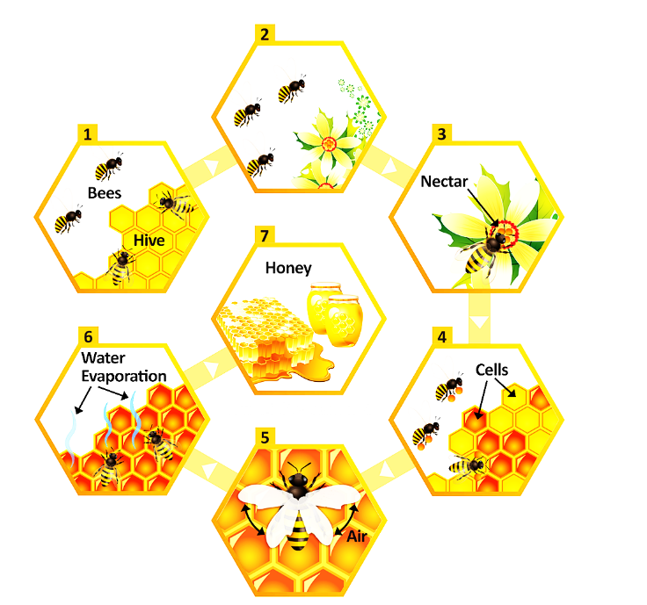

In the above diagram, we can clearly see the close relation between the Honey Bees and the Hives. Honey bees as compared to other insects use the hives as their shelter.

There is a close relation between Bees and Flowers. Honey bees use the flowers to get the nectre through it, Nectre is a commonly a fluid present in the petals of the Flowers. The more bright flowers or plants are more attractive to the bees. Honey bee are highly involved in the formation of Honey Combs and Honey.

The process of creation of Honey Comb starts with a Nectar. A bees chooses a flower and try to get some nectar from it using its tail. After filling up the tail with nectar. The Bee form small combs or cells. After the creation of Cells, Nectar is poured into the cells. Then as usual, bees uses its wings in order to provide some air to the cells. Due to this flapping of wings, the water present in the cells starts evaporated. When all the moisture or water is removed from the comb.

The thing left behind is honey. People then uses machines and tools in order to get the combs and extract the honey from the comb. This was the whole process of creation of Honey in the Combs by the Honey Bees.

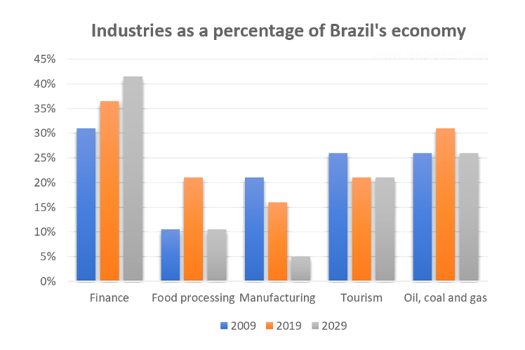

The bar graph present above is representing the figures of Finance, Food Processing, Manufacturing, Tourism, Oil And Gas. These figures are between the time period of 2009 to 2029. On the left side, the percentages are mentioned. As a whole this graph is representing the Industries As A Percentage Of Brazil’s Economy. Starting off with the finance. You can see that the percentage of Finance is one rise in brazil since 2019, and it will be 5 percent more than it is in 2019. Similarly it was 30 percent in 2009.

Now Coming to Food Processing Sector, this sector was at its peak in the period 2019 as it was presenting the 20 percent of the economy. And it’s almost the same in the region 2009 and it will be same in 2029 as 10 percent.
Moving on to Manufacturing sector, Manufacturing sector was contributing the highest in percentage in the region 2009, by 2019 it decreased to 15 percent. And by the end of 2029, it will be only 5 percent.

Next is the Tourism Sector. Tourism has contributed a lot in the Brazil’s economy. The percentage was highest in the region 2009 but it reduced to 20 percent in the region 2019 and now it’ll be same up to 2029.

The last sector is the OIL and Gas, the oil and gas percentage was a relatively low in 2009 as compared to 2019. The percentage was 25 percent in 2009. In 2019, it increased to 30 percent but now the conditions are showing that upto 2029, the percentage will be dropped to 25 percent. These were all the Figures that were being presented in the Diagrams

