***The diagram illustrates how bees produce honey. Summarize the information by selecting and reporting the main features, and make comparisons where relevant.***

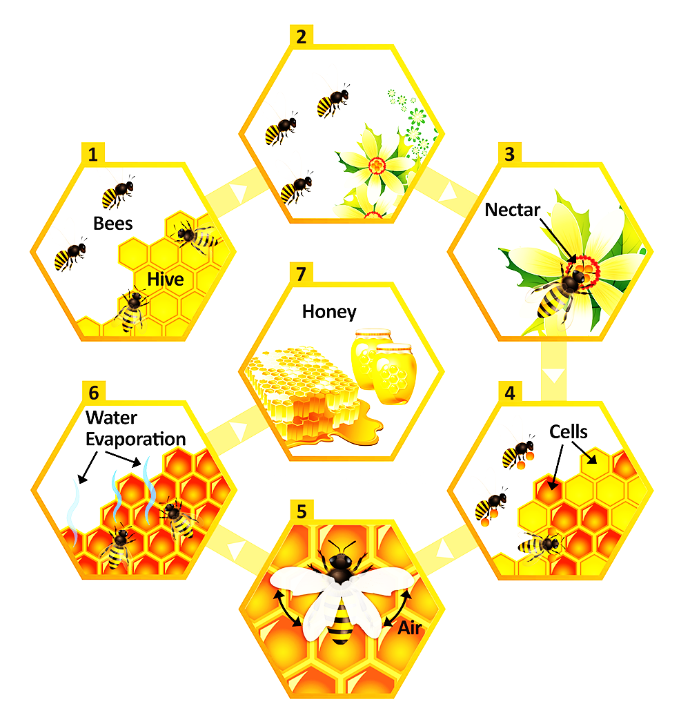

***The bar chart below illustrates five different industries’ percentage share of Brazil’s economy in 2009 and 2019 with a forecast for 2029. Summarize the information by selecting and reporting the main features, and make comparisons where relevant.***

