Q1: package Q_01;  
import javax.swing.*;  
  
public class Welcome {  
 public static void main(String[] args) {  
 JFrame WWindow;  
 WWindow=new JFrame();  
 WWindow.setSize(800,600);  
 WWindow.setTitle("Weloce to java");  
 WWindow.setVisible(true);  
  
 }  
}

Q2:

package Q_02;  
import java.util.*;  
import javax.swing.*;  
  
  
public class UserWindow {  
 public static void main(String[] args) {  
 Scanner Scanner=new Scanner(System.*in*);  
 String Firstnane;  
 String SecoundName;  
 System.*out*.println("Enter First Name:");  
 Firstnane=Scanner.next();  
 System.*out*.println("Enter Your Secound Name:");  
 SecoundName=Scanner.next();  
 String FullName=Firstnane+" "+SecoundName;  
 JFrame window=new JFrame();  
 window.setSize(800,600);  
 window.setTitle(FullName);  
 window.setVisible(true);  
 }  
}

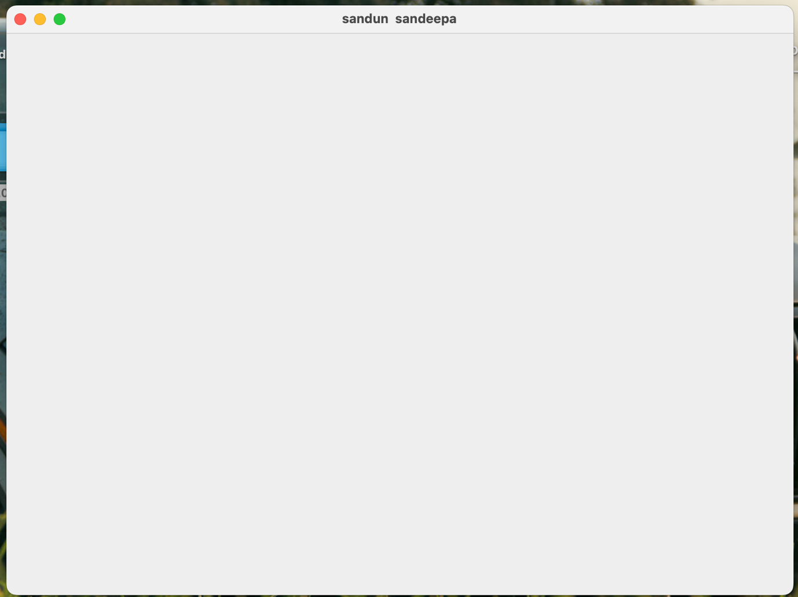

Q3:

package Q_03;  
import javax.print.DocFlavor;  
import java.util.Scanner;  
  
public class Name {  
 public static void main(String[] args) {  
 Scanner Scanner=new Scanner(System.*in*);  
 String FirstName;  
 String MiddleName;  
 String LastName;  
 System.*out*.println("Enter your Firstname:");  
 FirstName=Scanner.next();  
 System.*out*.println("Enter your Middlename:");  
 MiddleName=Scanner.next();  
 System.*out*.println("Enter your Last Name:");  
 LastName=Scanner.next();  
 char[]middle=MiddleName.toUpperCase().toCharArray();  
 String fullname=FirstName+" "+middle[0]+" "+LastName;  
 System.*out*.println(fullname);  
  
 }

Q4:

package Q_04;  
import java.util.Date;  
import java.text.SimpleDateFormat;  
  
public class SimpleDate {  
 public static void main(String[] args) {  
 Date today=new Date();  
 SimpleDateFormat formatter=new SimpleDateFormat(" d MMM yyyy");  
 System.*out*.println("Tody's Date: " + formatter.format(today));  
  
 }  
}

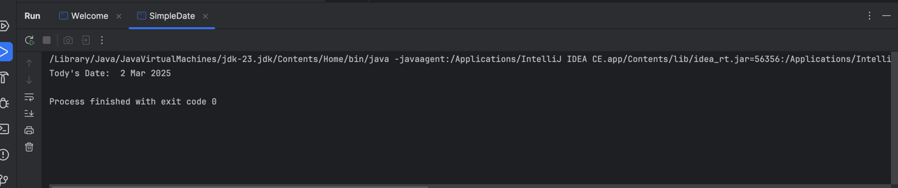

Q5:

package Q_05;  
import java.util.Date;  
import java.text.SimpleDateFormat;  
  
  
public class DayDissplay {  
 public static void main(String[] args) {  
 SimpleDateFormat formatter=new SimpleDateFormat("EEEE, d MMM,yyyy");  
 Date today=new Date();  
 System.*out*.println("Todsy's date :"+formatter.format(today)+".");  
  
  
 }  
  
}

Q6:

package Q_06;  
import java.util.*;  
import javax.swing.*;  
  
public class CustomerWindow {  
  
 public static void main(String[] args) {  
 Scanner scanner=new Scanner(System.*in*);  
 String title;  
 int Width;  
 int Height;  
 System.*out*.println("Enter your window title:");  
 title=scanner.nextLine();  
 System.*out*.println("Enter your window width:");  
 Width=scanner.nextInt();  
 System.*out*.println("Enter Window Height:");  
 Height=scanner.nextInt();  
 JFrame window=new JFrame();  
 window.setSize(Width,Height);  
 window.setTitle(title);  
 window.setVisible(true);  
 }  
}

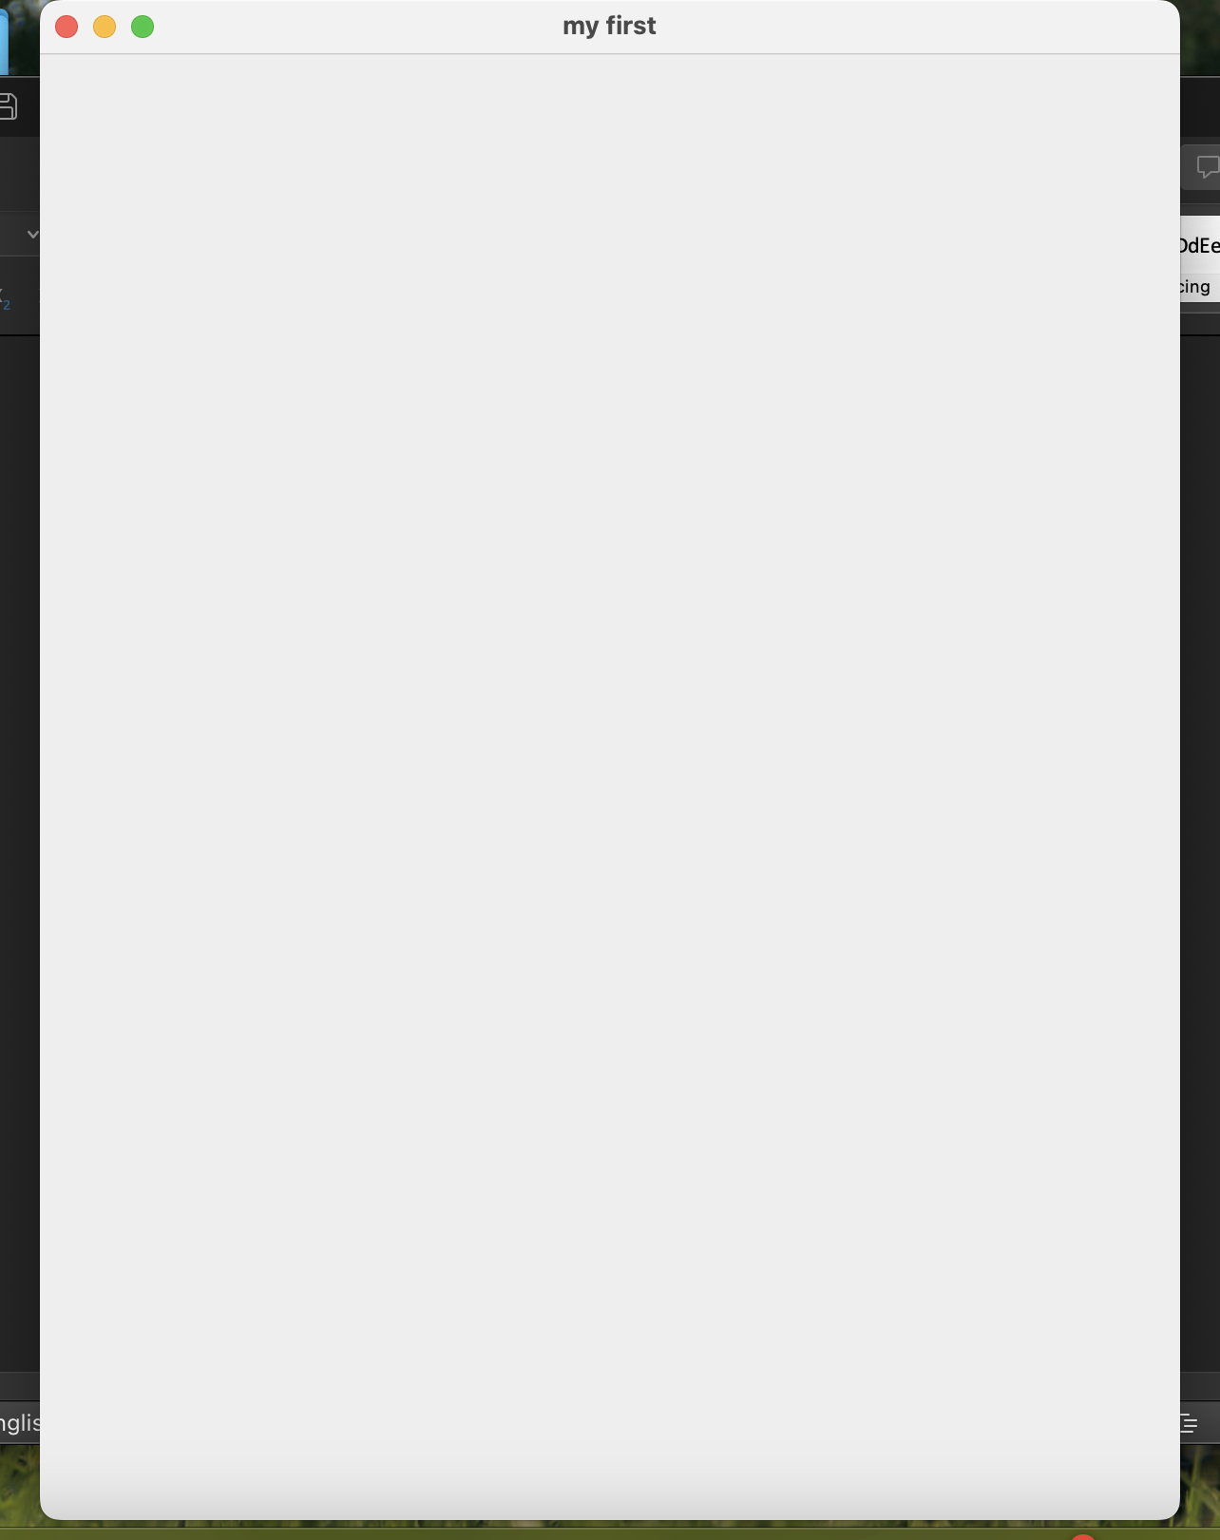

Q7:

package Q_07;  
import javax.swing.*;  
import java.time.LocalTime;  
import java.time.format.DateTimeFormatter;  
import java.util.Date;  
  
  
public class TimeWindow {  
 public static void main(String[] args) {  
 LocalTime currentTime=LocalTime.*now*();  
 DateTimeFormatter formatter=DateTimeFormatter.*ofPattern*("hh:mm:ss a");  
 String formattime=currentTime.format(formatter);  
 JFrame timeWindow=new JFrame();  
 timeWindow.setSize(400,500);  
 timeWindow.setTitle(formattime);  
 timeWindow.setVisible(true);  
  
 }  
  
}

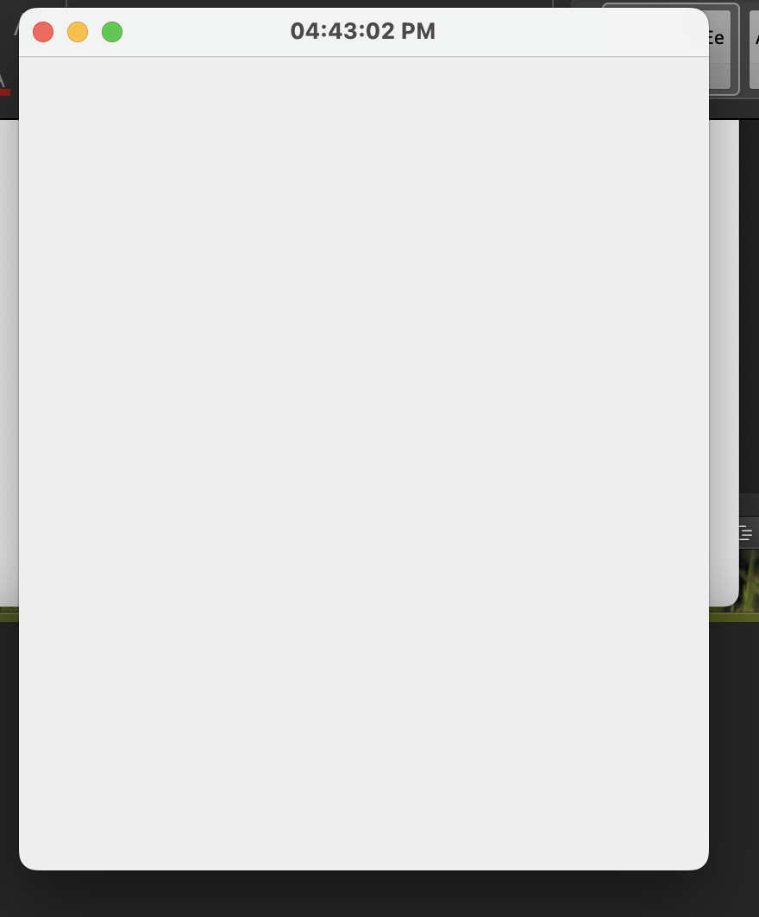

Q08:

package Q_08;  
import java.util.Scanner;  
  
public class ExclamationMark {  
 public static void main(String[] args) {  
 Scanner scanner = new Scanner(System.*in*);  
  
 System.*out*.println("Enter a sentence with exclamation marks:");  
 String sentence = scanner.nextLine(); // Read full input  
  
 // Split sentence by "!"  
 String[] words = sentence.split("!");  
  
 // Print each part of the sentence separately  
 for (String word : words) {  
 System.*out*.println(word.trim()); // Trim removes extra spaces  
 }  
  
 scanner.close(); // Close the scanner to prevent resource leaks  
 }  
}

Q09:

package Q_09;  
import java.util.*;  
  
public class StrLenth {  
 public static void main(String[] args) {  
 Scanner scan=new Scanner(System.*in*);  
 System.*out*.println("Enter here:");  
 String sentence=scan.nextLine();  
 System.*out*.println(sentence.length());  
 System.*out*.println(sentence.charAt(0));  
 System.*out*.println(sentence.charAt(sentence.length()-1));  
  
  
  
 }  
}

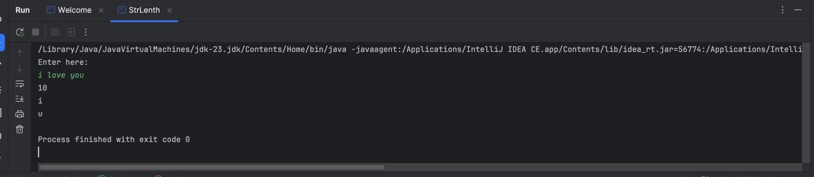

Q10:

package Q_10;  
import java.util.*;  
  
  
public class Midchar {  
 public static void main(String[] args) {  
 Scanner scan=new Scanner(System.*in*);  
 System.*out*.println("Enter Here:");  
 String sentence= scan.next();  
 System.*out*.println(sentence.charAt(sentence.length()/2));  
  
 }  
}

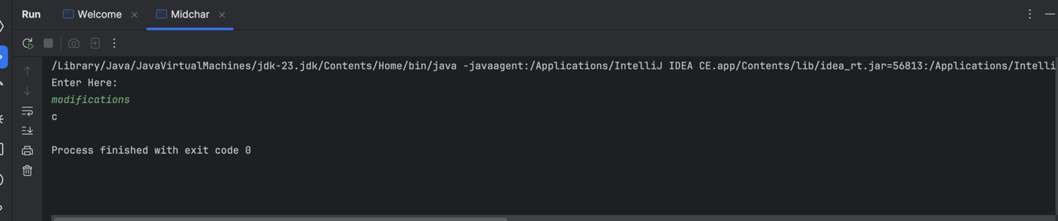

Q11:

package Q_11;  
import java.util.Scanner;  
  
public class NameStyle {  
 public static void main(String[] args) {  
 Scanner scan = new Scanner(System.*in*);  
 System.*out*.println("Enter your full name:");  
 String fullName = scan.nextLine().trim(); // Trim to remove leading/trailing spaces  
  
 String[] name = fullName.split(" ");  
  
 // Ensure at least a first and last name are entered  
 if (name.length < 2) {  
 System.*out*.println("Error: Please enter at least a first and last name.");  
 } else {  
 String formattedName = name[name.length - 1] + ", " + name[0];  
  
 // Add middle initial if available  
 if (name.length > 2) {  
 formattedName += " " + name[1].charAt(0) + ".";  
 }  
  
 System.*out*.println(formattedName);  
 }  
  
 scan.close(); // Close scanner  
 }  
}

Q12:

package Q_12;  
  
import javax.swing.*;  
  
public class MyFirstframe {  
 public static void main(String[] args) {  
 // Create a JFrame object  
 JFrame frame = new JFrame("My First Frame");  
  
 // Set the size of the frame (width = 300, height = 200)  
 frame.setSize(300, 200);  
  
 // Set the location of the frame (x = 100, y = 50)  
 frame.setLocation(100, 50);  
  
 // Ensure the program exits when the window is closed  
 frame.setDefaultCloseOperation(JFrame.*EXIT_ON_CLOSE*);  
  
 // Make the frame visible  
 frame.setVisible(true);  
 }  
}

