**01.**

public class Expression {  
 public static void main(String[] args) {  
 double A,B,C,X,Y;  
 A=5; //INICIALICE RANDOM NUMBER  
 B=8; //INICIALICE RANDOM NUMBER  
 C=3; //INICIALICE RANDOM NUMBER  
 X=2; //INITIALICE RANDOM NUMBER  
 Y=1; //INITIALICE RANDOM NUMBER  
 int radious;  
 radious=2; //initialice random value  
  
 double result1=Math.*sqrt*(B*B+4*A*C);  
 double result2=Math.*sqrt*(X*4*Math.*pow*(Y,3));  
 double result3=Math.*cbrt*(X*Y);  
 double result4=Math.*PI* *Math.*pow*(radious,2);  
 }  
}

**02**

02. package Q_02;  
import java.util.Scanner;  
  
public class Convert {  
 public static void main(String[] args) {  
 Scanner scanner = new Scanner(System.*in*);  
  
 //input  
 System.*out*.print("Enter your length in cm:");  
 Double Length=scanner.nextDouble();  
  
 //calculation  
  
 double inches=(int)(Length / 2.54);  
 int Feet=(int)(inches/12);  
 inches=(Feet%12);  
  
 System.*out*.println(Length+" cm ="+Feet+" ft " +inches +" inch");  
 }  
}

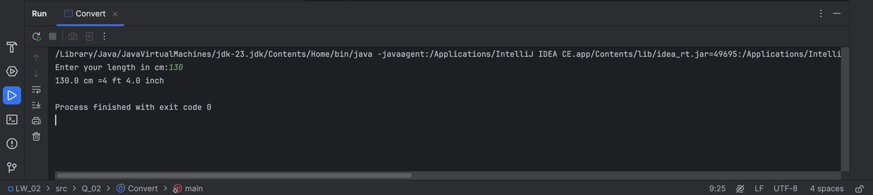

**03.**

package Q_03;  
import java.util.Scanner;  
  
public class Temperature {  
 public static void main(String[] args) {  
 Scanner scanner=new Scanner(System.*in*);  
  
 System.*out*.print("Enter your Temperature in celsius:");  
 double celsius=scanner.nextFloat();  
  
 double fahrenheit=(1.8*celsius)+32;  
  
 System.*out*.println("Temperature in F:" +fahrenheit);  
 }  
}

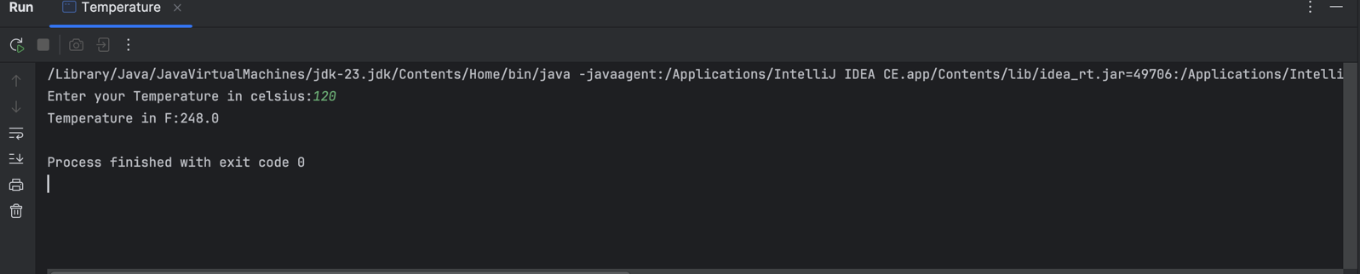

**04.**

package Q_04;  
import java.util.Scanner;  
  
public class Calories {  
 public static void main(String[] args) {  
  
 Scanner scanner=new Scanner(System.*in*);  
  
 System.*out*.print("Enter your Weight in Pounts:");  
 Double Weight=scanner.nextDouble();  
  
 Double calories=(Weight *19);  
  
 System.*out*.println("Daily Calaries Needs:"+calories+" calaries");  
  
 scanner.close();  
  
 }  
}

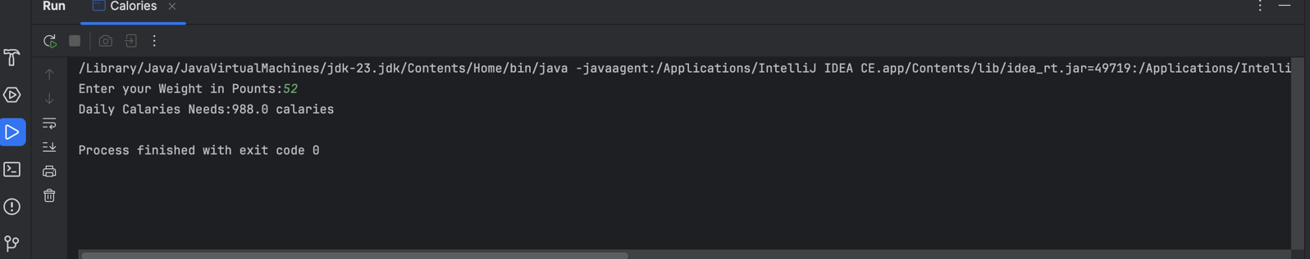

**05.**

package Q_05;  
import java.util.Scanner;  
  
public class Faran_to_cel {  
 public static void main(String[] args) {  
 Scanner scanner = new Scanner(System.*in*);  
  
 // Input: Temperature in Fahrenheit  
 System.*out*.print("Enter temperature in Fahrenheit: ");  
 double fahrenheit = scanner.nextDouble();  
  
 // Conversion formula  
 double celsius = (5.0 / 9) * (fahrenheit - 32);  
  
 // Output result  
 System.*out*.println("Temperature in Celsius: " + String.*format*("%.2f", celsius));  
  
 scanner.close();  
 }  
 }

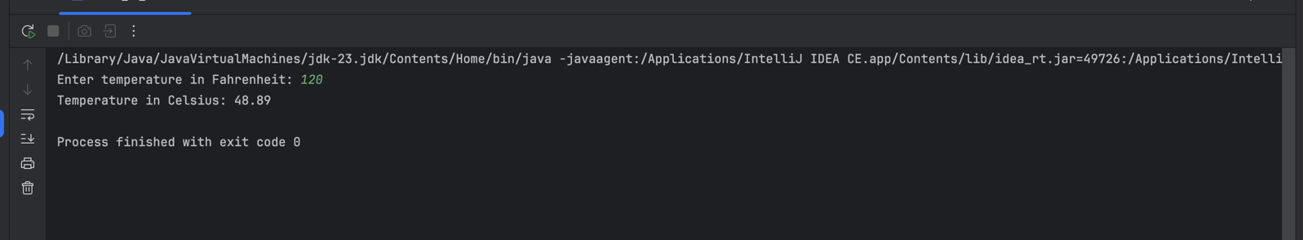

**06.**

package Q_06;  
import java.util.Scanner;  
import java.time.Year;  
  
public class Age {  
  
 public static void main(String[] args) {  
 Scanner scanner = new Scanner(System.*in*);  
  
  
 System.*out*.print("Enter your birth year: ");  
 int birthYear = scanner.nextInt();  
  
  
 int currentYear = Year.*now*().getValue();  
  
  
 int age = currentYear - birthYear;  
  
 System.*out*.println("You were born in " + birthYear + " and will be (are) " + age + " this year.");  
  
 scanner.close();  
 }  
 }

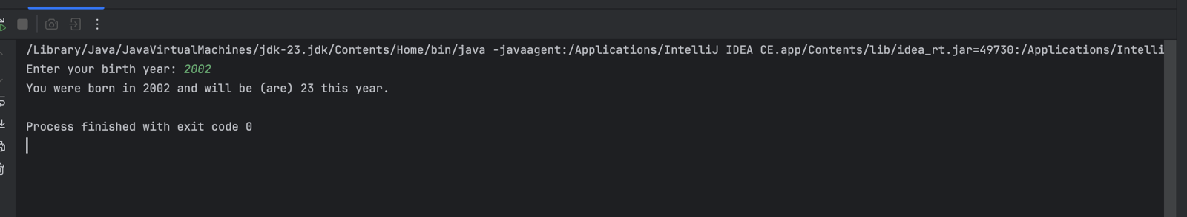

**07.**

package Q_07;  
import java.util.Scanner;  
  
public class BmiCalculater {  
 public static void main(String[] args) {  
 Scanner scanner = new Scanner(System.*in*);  
  
 System.*out*.print("Enter your weight in kg: ");  
 double weight = scanner.nextDouble();  
  
 System.*out*.print("Enter your height in cm: ");  
 double height = scanner.nextDouble();  
  
 double bmi = weight / Math.*pow*(height / 100.0, 2);  
  
  
 System.*out*.printf("Your BMI is: %.2f\n", bmi);  
  
 scanner.close();  
 }  
 }

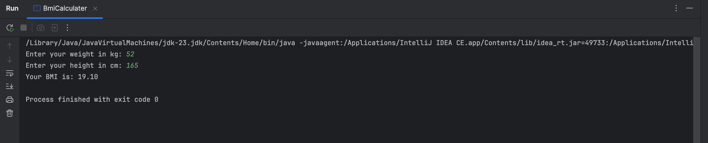

**08.**

package Q_08;  
import java.util.Scanner;  
  
public class Volume {  
 public static void main(String[] args) {  
 Scanner scanner = new Scanner(System.*in*);  
  
 // input  
 System.*out*.print("Enter the radius of the sphere: ");  
 double radius = scanner.nextDouble();  
  
 // Compute the volume  
 double volume = (4.0 / 3.0) * Math.*PI* * Math.*pow*(radius, 3);  
  
 // output  
 System.*out*.printf("The volume of the sphere is: %.2f cubic units\n", volume);  
   
 scanner.close();  
 }  
 }

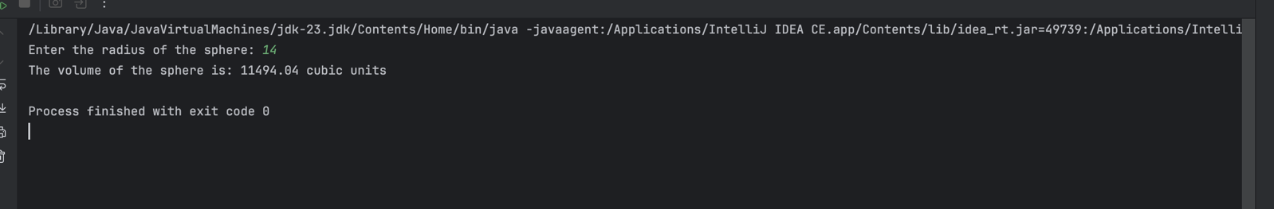

**09.**

package Q_09;  
import java.util.Scanner;  
  
public class InvesmentCalculater {  
 public static void main(String[] args) {  
 Scanner scanner = new Scanner(System.*in*);  
  
 // Get inputs from the user  
 System.*out*.print("Enter the principal amount (P): ");  
 double principal = scanner.nextDouble();  
  
 System.*out*.print("Enter the annual interest rate (R) in percentage: ");  
 double rate = scanner.nextDouble();  
  
 System.*out*.print("Enter the number of years (N): ");  
 int years = scanner.nextInt();  
  
 // Compute future value using the formula: P(1 + R/100)^N  
 double futureValue = principal * Math.*pow*((1 + rate / 100), years);  
  
 // Display the result  
 System.*out*.printf("The future value of the investment is: %.2f\n", futureValue);  
  
 // Close scanner  
 scanner.close();  
 }  
 }

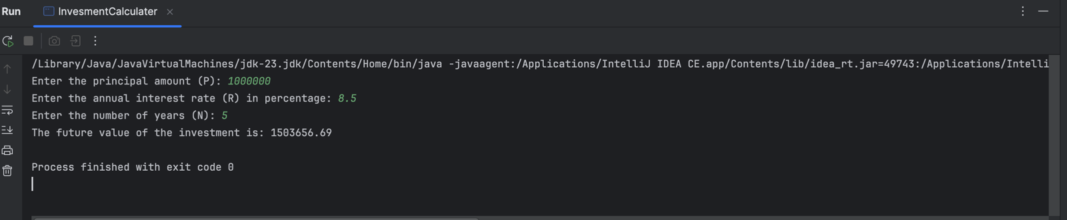

**10.**

package Q_10;  
import java.util.Scanner;  
  
public class LoneCalculater {  
 public static void main(String[] args) {  
 Scanner scanner = new Scanner(System.*in*);  
  
 final int MONTHS_IN_YEAR = 12;  
  
  
 System.*out*.print("Enter the loan amount: ");  
 double loanAmount = scanner.nextDouble();  
  
 System.*out*.print("Enter the annual interest rate (in %): ");  
 double annualInterestRate = scanner.nextDouble();  
  
 System.*out*.print("Enter the loan period (in years): ");  
 int loanPeriod = scanner.nextInt();  
  
 // Convert annual interest rate to monthly interest rate  
 double monthlyInterestRate = annualInterestRate / 100.0 / MONTHS_IN_YEAR;  
  
 // Calculate the number of payments (months)  
 int numberOfPayments = loanPeriod * MONTHS_IN_YEAR;  
  
 // Calculate monthly payment using the formula  
 double monthlyPayment = (loanAmount * monthlyInterestRate) /  
 (1 - Math.*pow*(1 + monthlyInterestRate, -numberOfPayments));  
  
 // Calculate total  
 double totalPayment = monthlyPayment * numberOfPayments;  
  
  
 System.*out*.printf("Monthly Payment: %.2f\n", monthlyPayment);  
 System.*out*.printf("Total Payment: %.2f\n", totalPayment);  
  
  
 scanner.close();  
 }  
 }

