Project Proposal Academic Year 2010/2011

Candidate Details

Index No: R051257

Name of candidate: M Sandun Dhammika Perera.

Adress: No 29,
Dias Place,
Panadura,
Sri Lanka.
Contract telephone numbers: (+94)382236254

Email: sandundhammikaperera@yahoo.com

supervisor details:

 | supervisor 1(IT Related) | Supervisor 2 (Optional)
Name

Designation

Workplace address

Academic/
Professional/
qualifications
and
memberships

Work experience

Email:

Phone number/s

Note: Any deviation of the final project from the project described in this proposal should be explained by the candidate in the dissertation.
Project Details

Title of Project: R051257 A General Purpose Test Engine.

Repeat Student:
Number of Attempt:

Earlier Project Title:

Name and address of client:

MATRIX Institute of Information Technology (Pvt) Ltd
http://www.matrix-edu.com

Motivation for project:
1. To complete the final year project and put the software engineering academic knowledge into a real project.

2.Automate the process of student assignment taking for a educational institute.Computerize the process of assignments and testing of a particular academic institute.

3.Provide students a highly user friendly easy to operate light weight application to take their tests/assignments.

4.Provide teachers a highly user friendly and simple interface to make their own assignments and publish them as files to be used by students.

5. Provide extensibility to the software to make it easily extendible for future extensions and ideas.

Objectives and scope of proposed project:
1. Targeting only the windows environment (win32)
Giving up the other environments for performance.

2. Supports MCQ type assignments only.

3. Targeting for a one client , not for general public. However client can decide whether let or not to let it for general use.

4. Owner of the copyright is the client that documented in the name of the client section.

Critical functionalities for project:

1.integrity of the data structures and file formats and temporary data.

2. Validation of the input texts.

3. Easy to learn user interfaces.

4. Compatibility of windows 2000 or higher.

5. Support extensibility.

Itemized list of deliverables of the system:

1. QuestionMaker standalone application.

2. Test Taker (main test engine).

3. Documentation.

4. Bugzilla.

5. Project Web Page.

Work Breakdown Structure for the project:

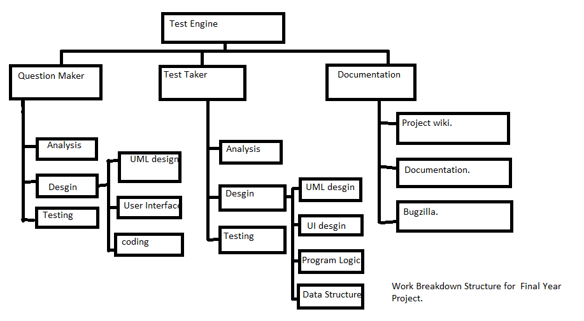

Resource requirements for project(eg- software/hardware,...).

Hardware: x86 i686 or above.
Originally designed for 1360x768 HD screen dimensions,but others may be compatible.
standard PC keyboard/mouse or other HID.

Software: Microsoft windows 2000 or higher or wine under linux.
Internet connection(TCP/IP protocol stack ) and web browser.

Purposed Way of Evaluation the success of your system:

Alpha testing: validating the system using the following test cases.
* validating the file formats and data structures for data integrity.
* validate user interfaces using different ppl’s ideas about user interfaces. Validate against bellow properties.
- user friendlyness
- Functionalities
- Length of the learning curve
(purpose to create a survey for this).
Beta Testing: Deploy the application inside the solution space and test with real users in real time.And collect their ideas/comments about the system and also invite them to submit the bugs to the bugzilla and the wiki page.

apologies: please kindly apologize that this documents is opened by ABI-word and there may be compatibility issues for the microsoft format when I convert this to a microsoft doc format.

