**Software engineering assignment**

**Module-1 (software)**

**Q.1) What is software? Explain types of software.**

**Ans. SOFTWARE :** Software is a set of instructions, that tells a computer what to do. How to perform tasks. So without software computer doesn’t know what to do.

**TYPES OF SOFTWARE :** There are two types of software (1) System software (2) Application software

**(1) System software :** system software is a foundation that makes a computer work, managing all the hardware and telling other programs what to do. System software is essential because without it computer wouldn’t know how to run other programs, like browsers, ms office etc.

* **Operating software (OS) :** Operating system is the most important program of computer. It’s manage all the hardware and allow software to run.

Examples : Windows xp,7,10,11 , linux, Mac , Android .

* **Device drivers :** It allows operating system to communicate with hardware devices like network adaptor, printer, camera speakers etc.
* **Utilities :** Its used to perform specific tasks related to managing computer resources. These are the tools that helps computer to running well.

Examples : Disk cleanup tool, Antivirus etc.

**(2) Application software :** Application software is the kind of software we used to do everyday tasks on computer, this types of software is built to solve specific problems or provide tools for particular activities.

Examples : word processor like ms office, web browsers like firefox, communication tools app like whatsapp etc.

**Q.2) Explain the SDLC each phase process.**

**Ans. SDLC** is stands for Software Development Life Cycle.

SDLC is a structured process that is used to design, develop, and test good-quality software. The SDLC model involves seven phases while developing any software

**Phase 1 : Planning** – figuring out what the project is about and how to go about.

* Decide you want to achieve.
* Check if it’s possible within your time and budget
* Make a plan

Now you have a clear project plan.

**Phase 2 : Requirement Analysis** – Understanding exactly what the software should do. All the requirements for the target software are specified.

* Talk to people who will use this software, to know what they need.
* Write down the features the software should have

Now you have a list of requirements.

**Phase 3 : Design** – Planning how software will look and work

* Design the overall structure of the software.
* Decide on the details like how data will be organized set button and what the screen will look like.

Now you have design blueprint for the software.

**Phase 4 : Development** – At this stage, the fundamental development of the product starts. Building the software by writing code (programming).

* Developers write the code based on design. ( compilers, interpreters, and some popular languages are put into use as per the software regulations.)
* They create the software and test small parts of it.

**Phase 5 : Testing** – Checking to make sure the software works correctly, After the development of the product, testing of the software is necessary to ensure its smooth execution.

* Test the software to find and fix the problems or bugs.
* Make sure it does what it suppose to do.

Now you have a working reliable software.

**Phase 6 : Deployment** – Releasing the software to users.

* Install the software where it will be used.
* Teach users how to use it.

Now the software is live and in use.

**Phase 7 : Maintenance** – Keeping the software running smoothly after it’s released.

* Fixed any issues that come up.
* Update the software that needed.

The software stays up to date and functional.

**Q.3) Create the DFD and use case for ATM system.**

**Ans. DFD for ATM system (level 0)**

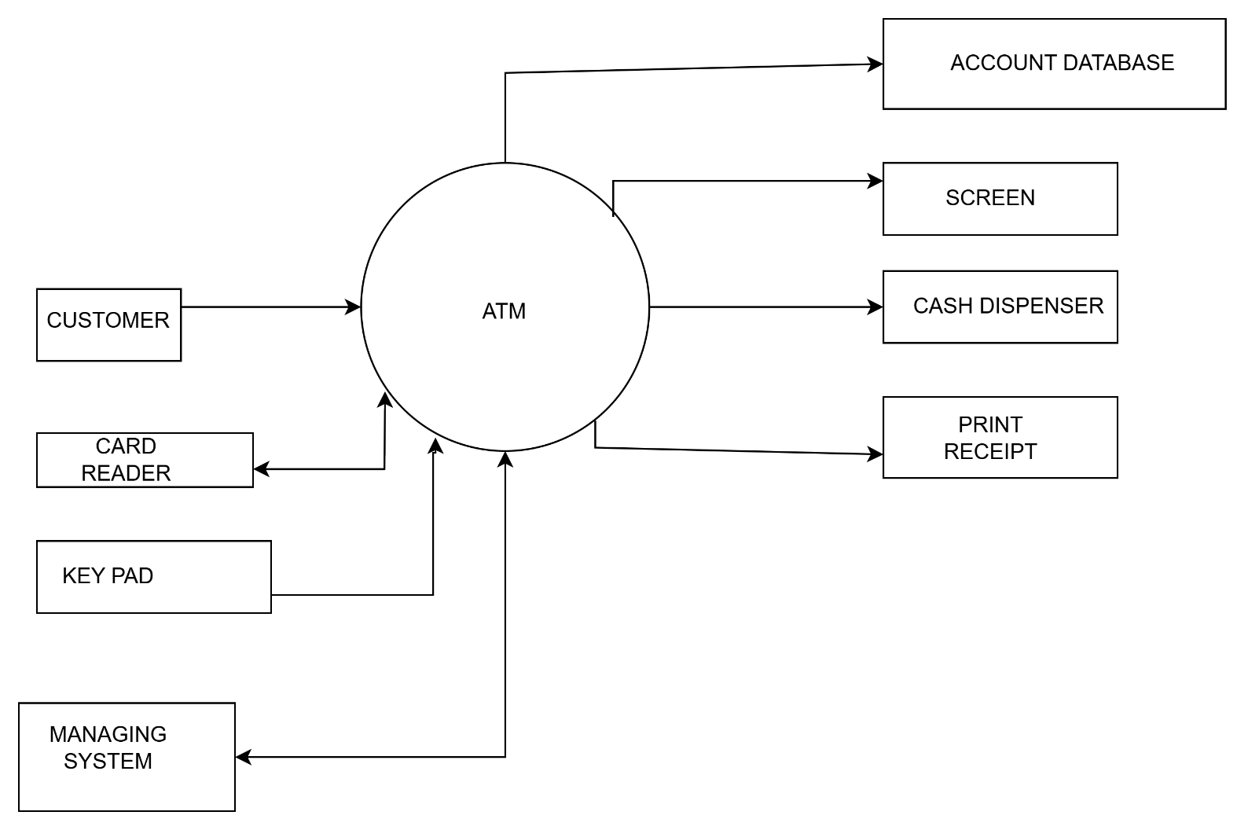

**Level 1 DFD for ATM system**

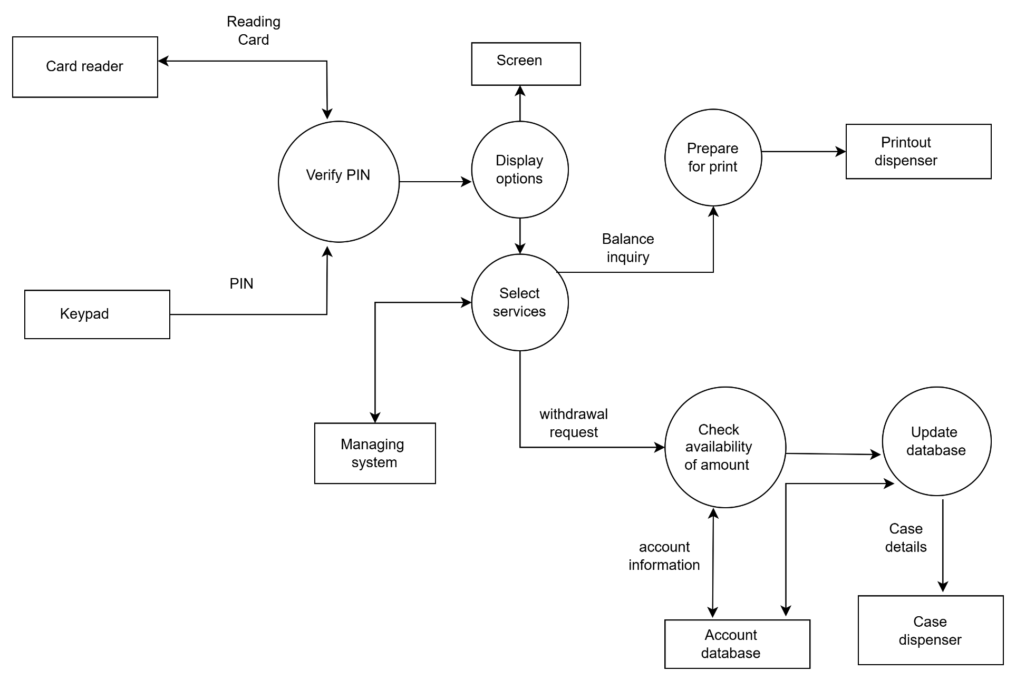

**USE CASE for ATM system**

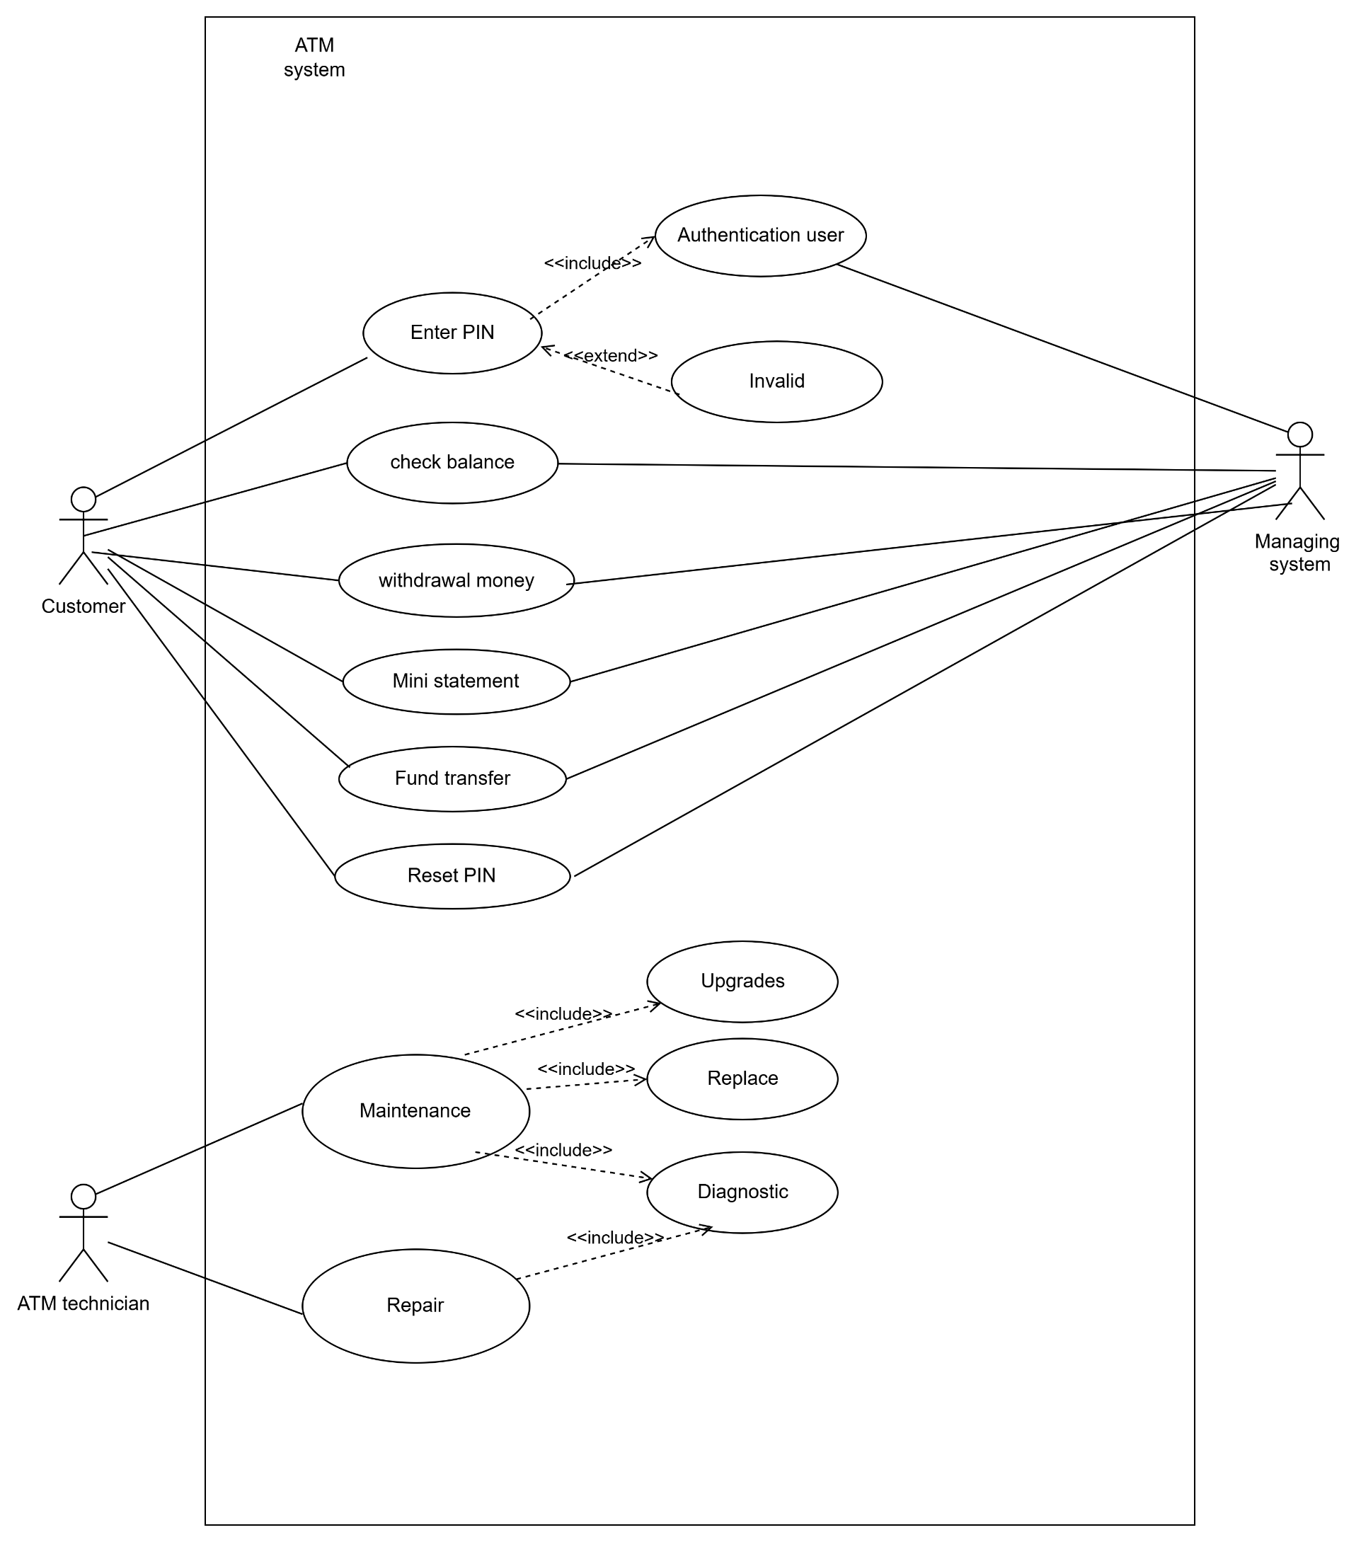

**Q.4) Create DFD and use case of Flipkart.**

**Ans. Level 0 DFD diagram:**

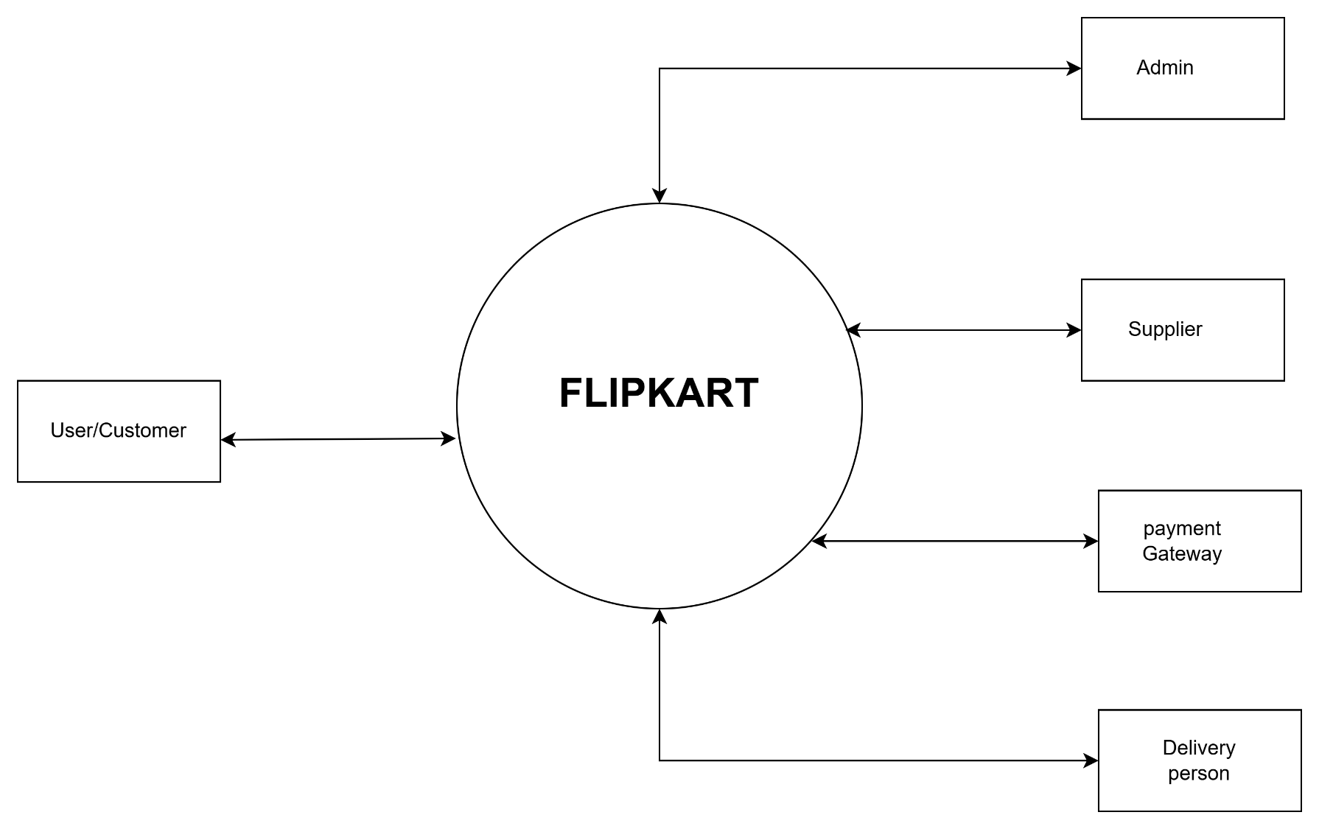

**Level 1 DFD diagram:**

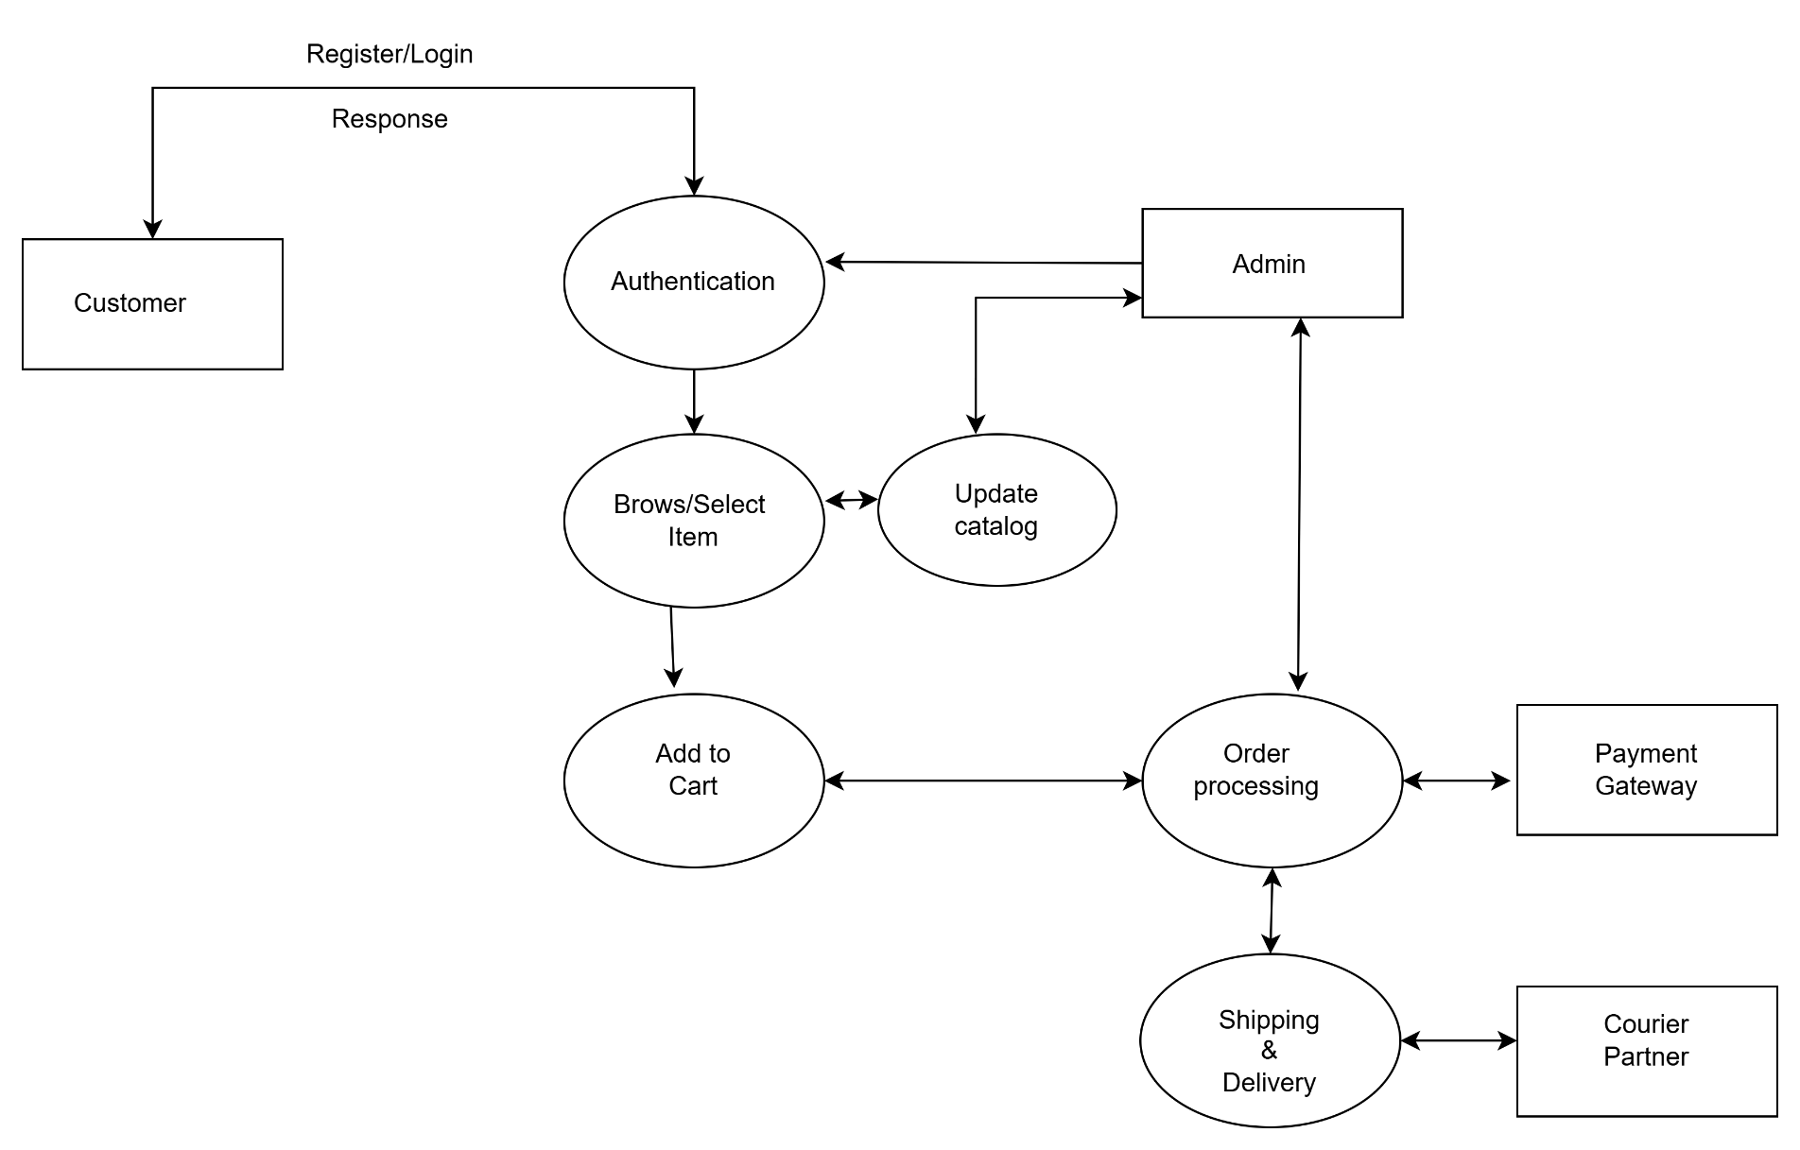

**Level 2 DFD Diagram**

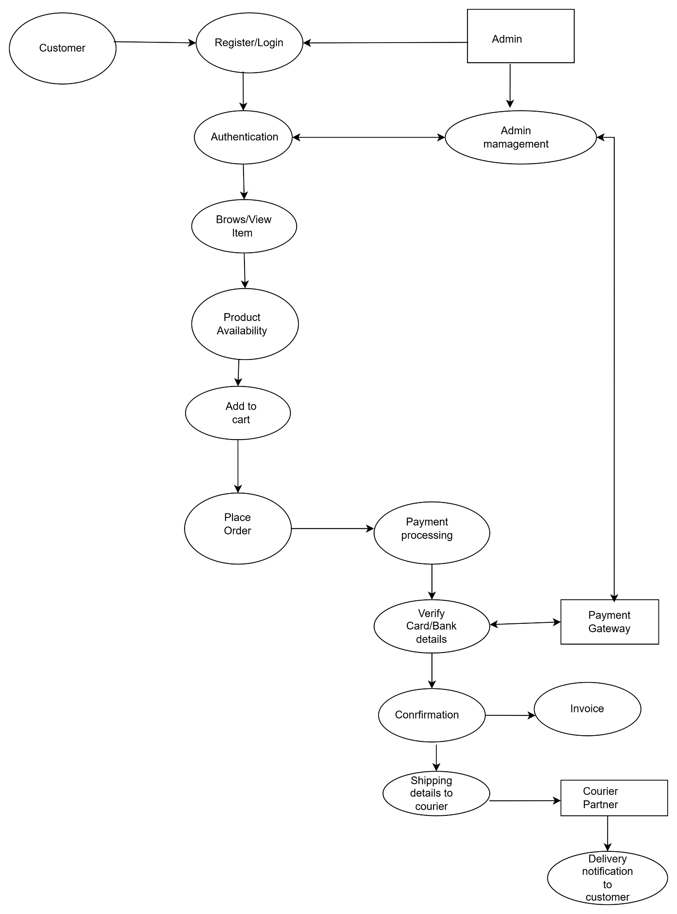

**Use case diagram:**

