Start - up
Upon opening the program, you will be greeted by this menu, where you can either choose to create a new Schedule file, or open an existing one.
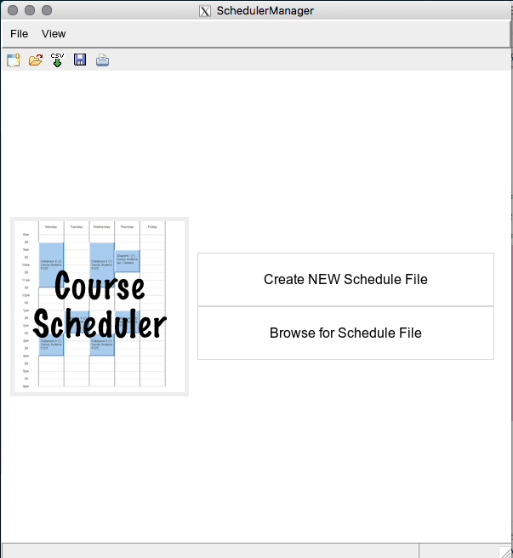
1 2 3 4 5
Task bar
Tool bar
Create NEW Schedule File:
Creates a blank schedule file and proceeds to the main menus

Browse for Schedule File
Allows you to open a previously saved schedule file to continue editing.

If you previously used the program, you will have an option to open the Schedule you last worked on.

Import CSV
Takes in a correctly formatted CSV file and creates a new Schedule file base on what is inside.

The tool and task bar will be explained in the Main Window Section
(Page 6)

Getting Started
You can
- Open Existing Saved Schedule
  - Saved schedules include everything,
- Start a new Schedule
  - This requires manually creating teachers, courses, resources (labs), and streams. See documentation for further instructions
- Import a CSV file
  - A CSV file can contain information for the courses/teachers/labs.
  - It does not include information for streams
  - It cannot currently support multiple teachers or labs for same time block... If you have this situation, you must adjust manually (see documentation for editing courses, blocks, sections , etc.)

CSV Format For Importing

The input file must have...
The CSV top row must have these EXACT words in any order with each other row filling in the respective required data for EACH BLOCK
Course Name required
Course No. required
Section required
Ponderation
Start Time required(Time must be in military time with no break 1:30pm -> 1330)
End Time required(Time must be in military time with no break 1:30pm -> 1330)
Day required
Type
Max
Teacher First Name required
Teacher Last Name required
Teacher ID required if multiple teachers with same name
Room
Other Room
Restriction
Travel Fees
Approx. Material Fee

An example can be found on the following page

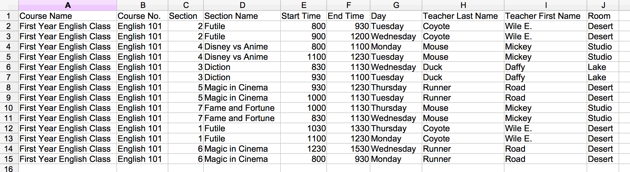

Task Bar
This is the task bar you will be seeing for most of the time while working on your schedule.
It is important to know where everything is, and this is how you will get there.
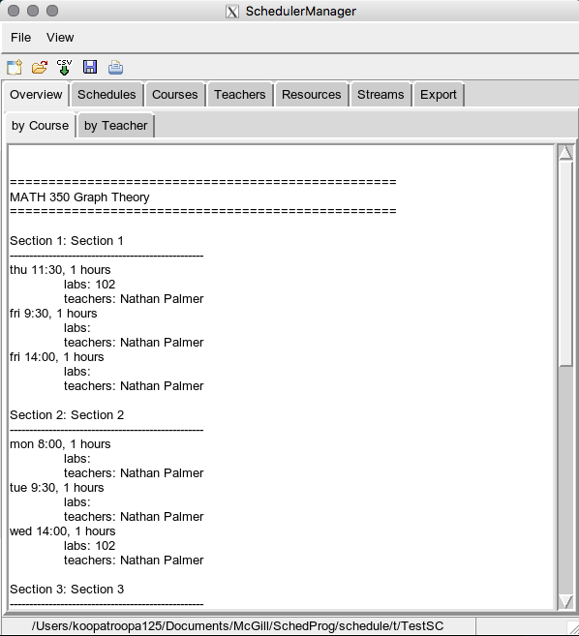
Task and Tool Bar:
Task bar
Tool bar

File → New:
Creates an empty Schedule to start anew*

File → Open:
Opens an already existing Schedule file to edit.*

File → Import CSV:
Takes in a correctly formatted CSV file and creates a new Schedule file base on what is inside *

File → Save:
Save the Schedule you are currently working on to a file.

File → Save As:
Save the Schedule you are currently working on to a new file with a different name.

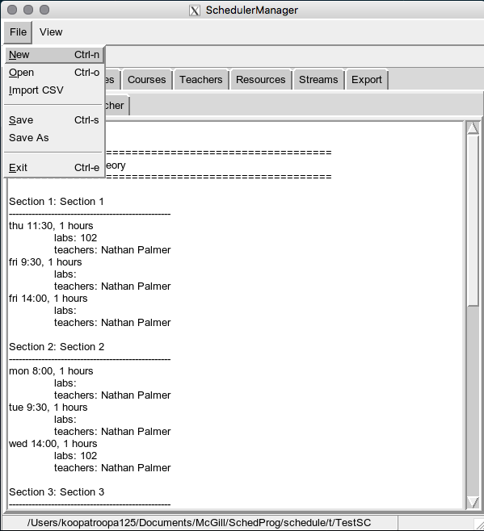
File → Exit:
Quits the program*

:
Currently does nothing

View:
Currently does nothing

*unsaved changes to the schedule you were working on previously will be lost

TABS:

Overview:
Shows all the information about the Schedule in one place, organized either by course or by teacher.
(Page 8)

Schedules:
After course data is added, here is where you can move the time slots around to create a schedule.
(Page Error: Reference source not found)

Courses:
Here is where you can create/edit Courses, Sections, and/or Blocks.
-Assign Teacher/Resource/Stream etc.
(Page 9)

Teachers:
Create or delete teacher from list of teachers
(Page 15)

Resources (Rooms, Lab, Equipment):
Create or delete resource from list of resources
(Page 15)

Streams:
Create or delete stream from list of streams
(Page 15)

Export:
Export a specific teacher/resource/stream schedule to an Microsoft Excel file, to the entire schedule to a formatted CSV. (Page 16) ... NOTICE: Still a bit buggy

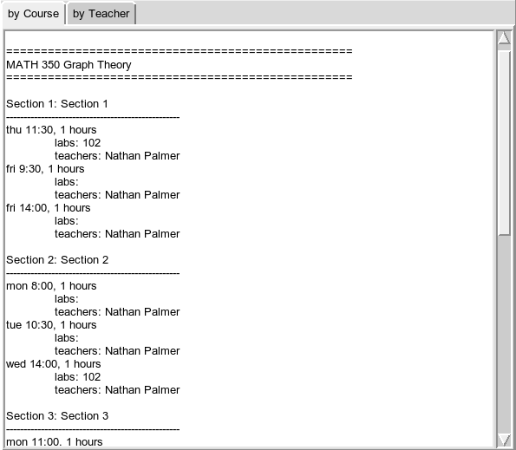
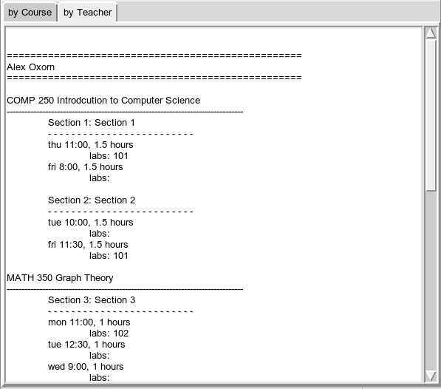
Overview
The overview simply gives a rundown of all the information of a course, organized either by course or by Teacher.
By Course:
List the Courses with all the sections and their blocks, along with the teacher, labs, start time, and duration of each block.

By Teacher:
List the Teachers followed by only the Courses, Sections, and Blocks that are being taught by that teacher.

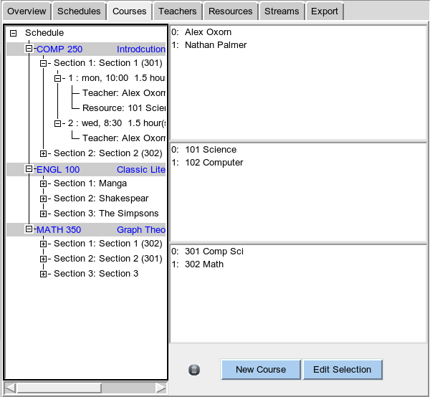
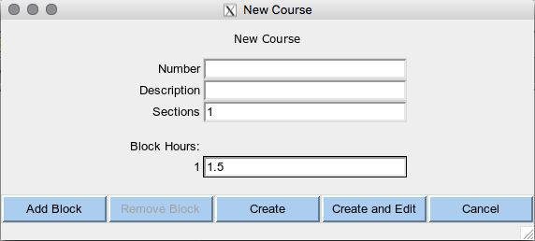
Courses
This page is where all the information about a course can be created and edited.
This manual will go over how to create all the information from scratch so you can get an idea of how to create your own.

Adding Courses
To start off, simply press the New Course button at the bottom of the screen. The following window will pop up.
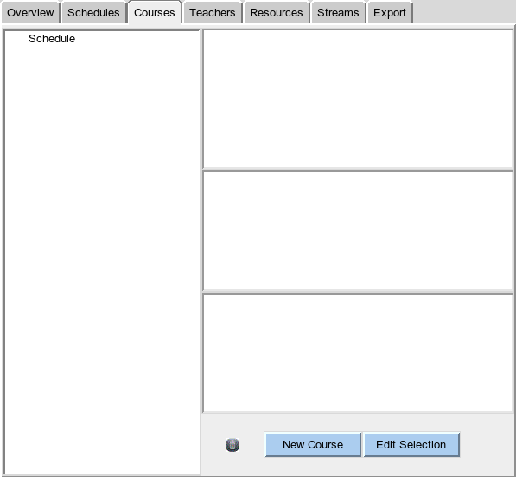
At this point, you have to input the desired Course Number, Name, the number of Sections, as well as the number of blocks per section as well as their duration in hours
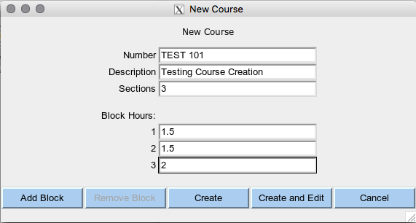
Add Block:
Adds a block as well as add a field to input the new block's duration

Remove Block:
Remove a block from the new course
(KNOWN BUG, button never becomes active)

Create:
Creates a new course with the provided information

Create and Edit:
Creates a new course with the provided information, then immediately opens the Course Edit menu. (Page 11)

Cancel:
Close the new course menu without creating a course

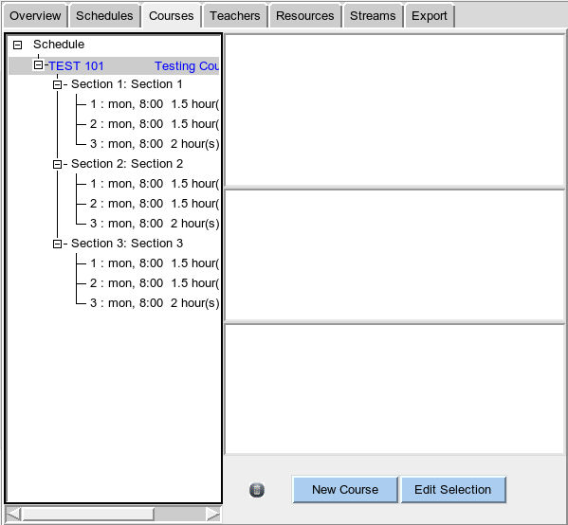
After creating the course, that course will be added to the tree on the left, allowing us to edit a course further.

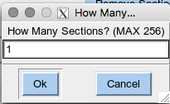
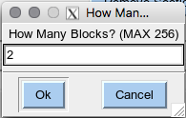
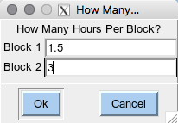
Edit Courses
Broadly speaking there are 3 main ways to edit a course:
- Edit Course Menu
- Right Click Menu
- Drag and Drop

Firstly to get to the edit courses menu, you either double click the course you want to edit, or you can select the course to edit, and click the 'edit selection' on the bottom right. This will open up the following menu.
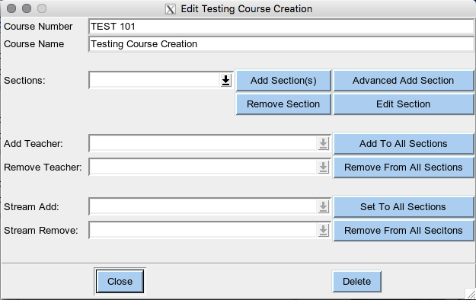
From here you can change the name and number of the course

After using the drop Sections' down menu to choose a section,
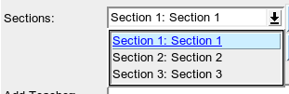
“Remove Section” will delete that section from the course, and “Edit Section” will open the Edit Section window (Edit Section, Page 13) for that section

Alternatively you can add many sections in bulk to the course, by pressing the “Add Section(s)” button. After pressing this, the program will prompt you to ask how many sections you want to add, then how many blocks to add per section, and lastly the duration of each block:

If a teacher is added to the schedule (Teachers, Page 15), you can select the teacher from the Add Teacher drop down menu, and click the “Add To All Sections” button to assign the selected teacher to all sections and blocks in the course

If a teacher is assigned to any block in the course, you can select that teacher from the Remove Teacher drop down menu, and click the “Remove From All Sections” button to remove that teacher from the course entirely

The same thing can be done with streams as with teachers.

After all is said and done, you can either click the “Close” button to apply the changes, or click the “Delete” button to remove the course from the schedule

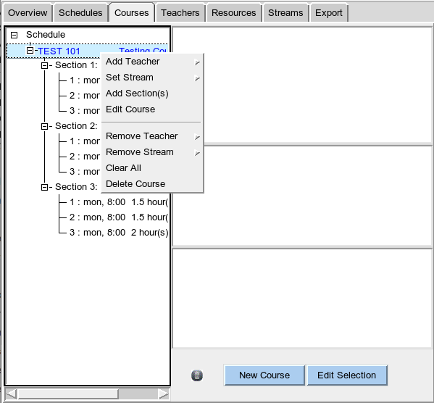

The right click menu for Courses does much the same thing as the edit course menu

“Add Teacher” shows a list of teachers to add to the course and adds the selected teacher

“Set Stream” show a list of streams to set to the sections of the course and sets the selected stream

“Add Section(s)” does the same thing as in the edit course menu

“Edit Course” opens the edit courses menu

Remove Teacher (BUGGED) lists the teachers currently assigned to the course and removes the selected teacher
Remove Stream (BUGGED) lists the streams currently set to the course and removes the selected stream from the course

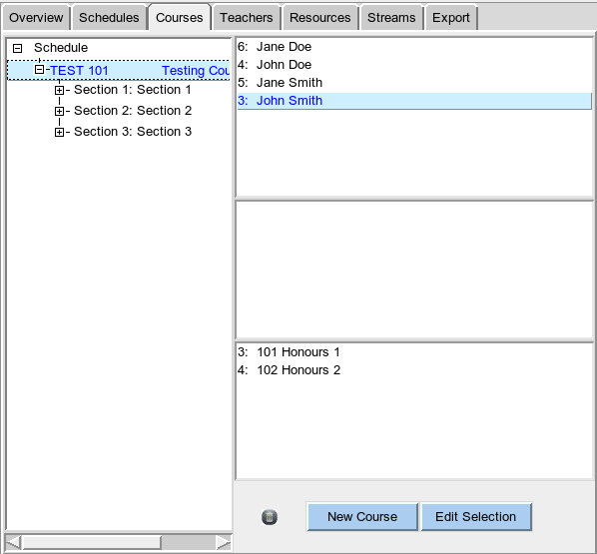
Delete Course removes the course from the schedule.

Delete Course
Add Teacher

For Dragging and dropping, by simply drag a teacher to a course, you can add it to the entire course.

Same thing with setting streams.

To remove a teacher, stream, or even the course in its entirety, just drag the corresponding object to anywhere on the right side of the window

Edit Sections and Block
The same three ways to edit a section are the same as with courses
- Edit Menus
- Right Click Menu
- Drag and Drop

In fact, that is not the only thing that is similar, a lot the edit menu are almost identical to the edit courses menu, as such I will not be giving in depth detail.
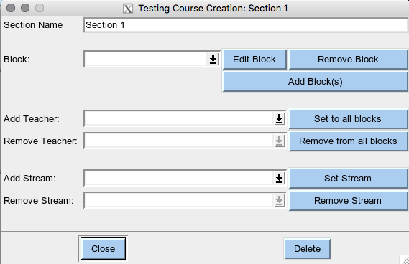
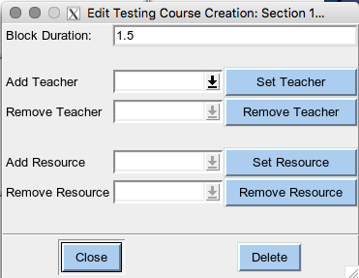
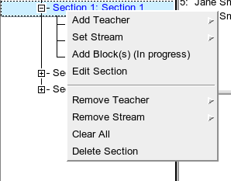
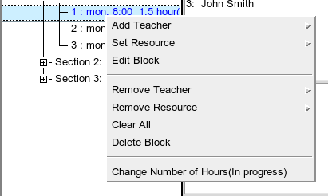

Edit Blocks

Adding Teachers/Resources/Streams
Once you've added Teacher (Page _), Resources (Page _), or Streams (Page _), you can set/remove any one of them from a course by either dragging and dropping to or from the tree.
The valid Drag Drops are
Teacher -> Course / Section / Block
Resource -> Section / Block. (Dragging to course causes a bug where the resources can't be selected)
Stream -> Course / Section / Block. (Dragging to a Block will assign the stream to the section it belongs to

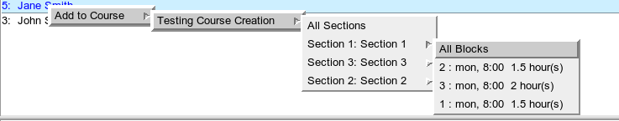
Alternatively all 3 have a right click menu to assign themselves to a course, section, or block

Teacher Stats
By double clicking on a teacher you can get a very quick summary of what they are teaching
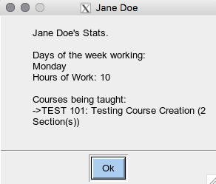

Teachers, Streams, Resources
All of the three of these tabs have the same format, and are used to add Teachers, Streams and Resources to the Schedule.
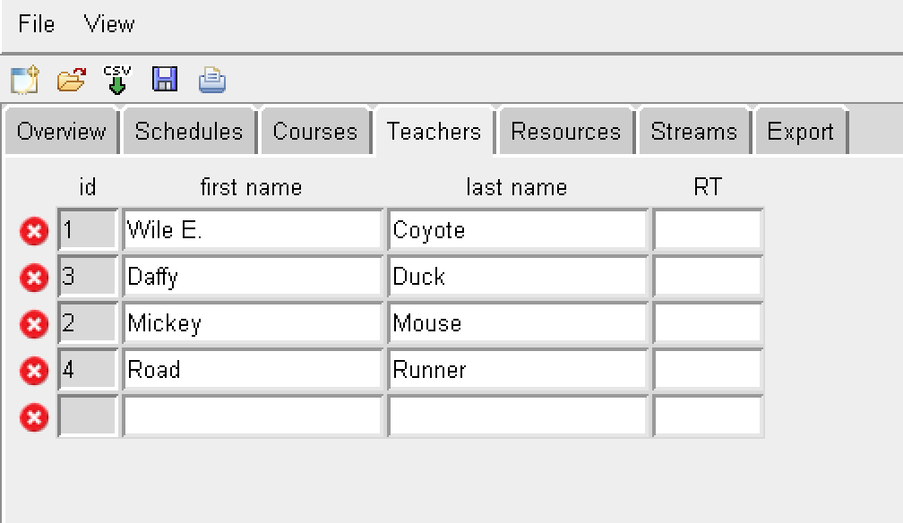
From there, to add a an object, fill in the required information to the blank space and hit enter.
Navigation
'tab' - goes to next cell
'arrow key' – as expected
To edit an existing object, simply change the fields that are already filled in.
To delete an course, click the x icon to the left of the object you want to delete.
Changes will be saved when you leave the page, or if you delete an object.

*Keep in mind that IDs are not entered by the user and instead of assigned by the program automatically
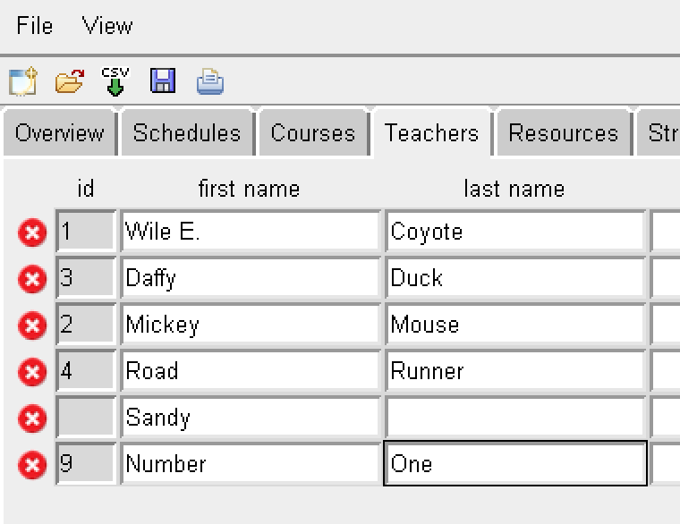
** If the data is invalid, then no ID will be created, and the object will not be accepted
In this example, teacher “Sandy” will not be saved because the required last name was not submitted.

No error messages will be given

Export
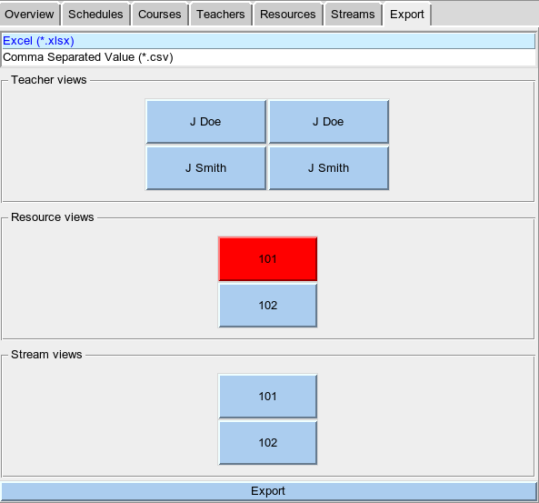
Here is where you can export the schedule into a Excel spreadsheet, or to a formatted CSV
To export it into an Excel, select Excel from the top list**, then select which schedules to export, and hit export
To export a CSV of the whole schedule, select Comma Separated Value from the top list**, the hit export
(Doesn't work if multiple teachers in one block)
**KNOWN BUG: Selecting an option that is already selected will break the Export Tab. To fix, go to another tab and return to the Export tab

Scheduling
This is where you can start adjusting the class hours to create a schedule.
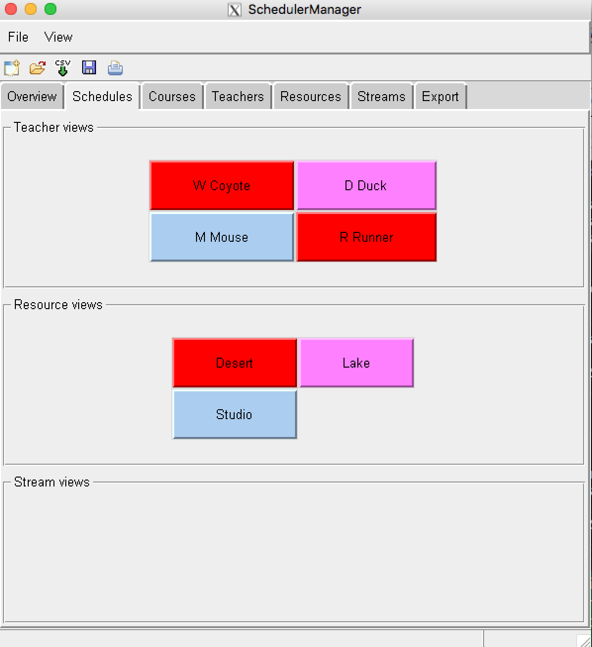
On this page, you can see that our schedule has some sort of conflicts.

Firstly, blue means no conflicts

Pink means that Daffy does not have 4 days with contact hours. To fix this (or ignore it, your choice), you can add release time (RT) under the “teacher's tab” for Daffy

Brown means that someone doesn't have a proper lunch break

Red, means that there is a conflict.

In this case, Wile and Road are both competing for the same 'desert' class room (Resource)

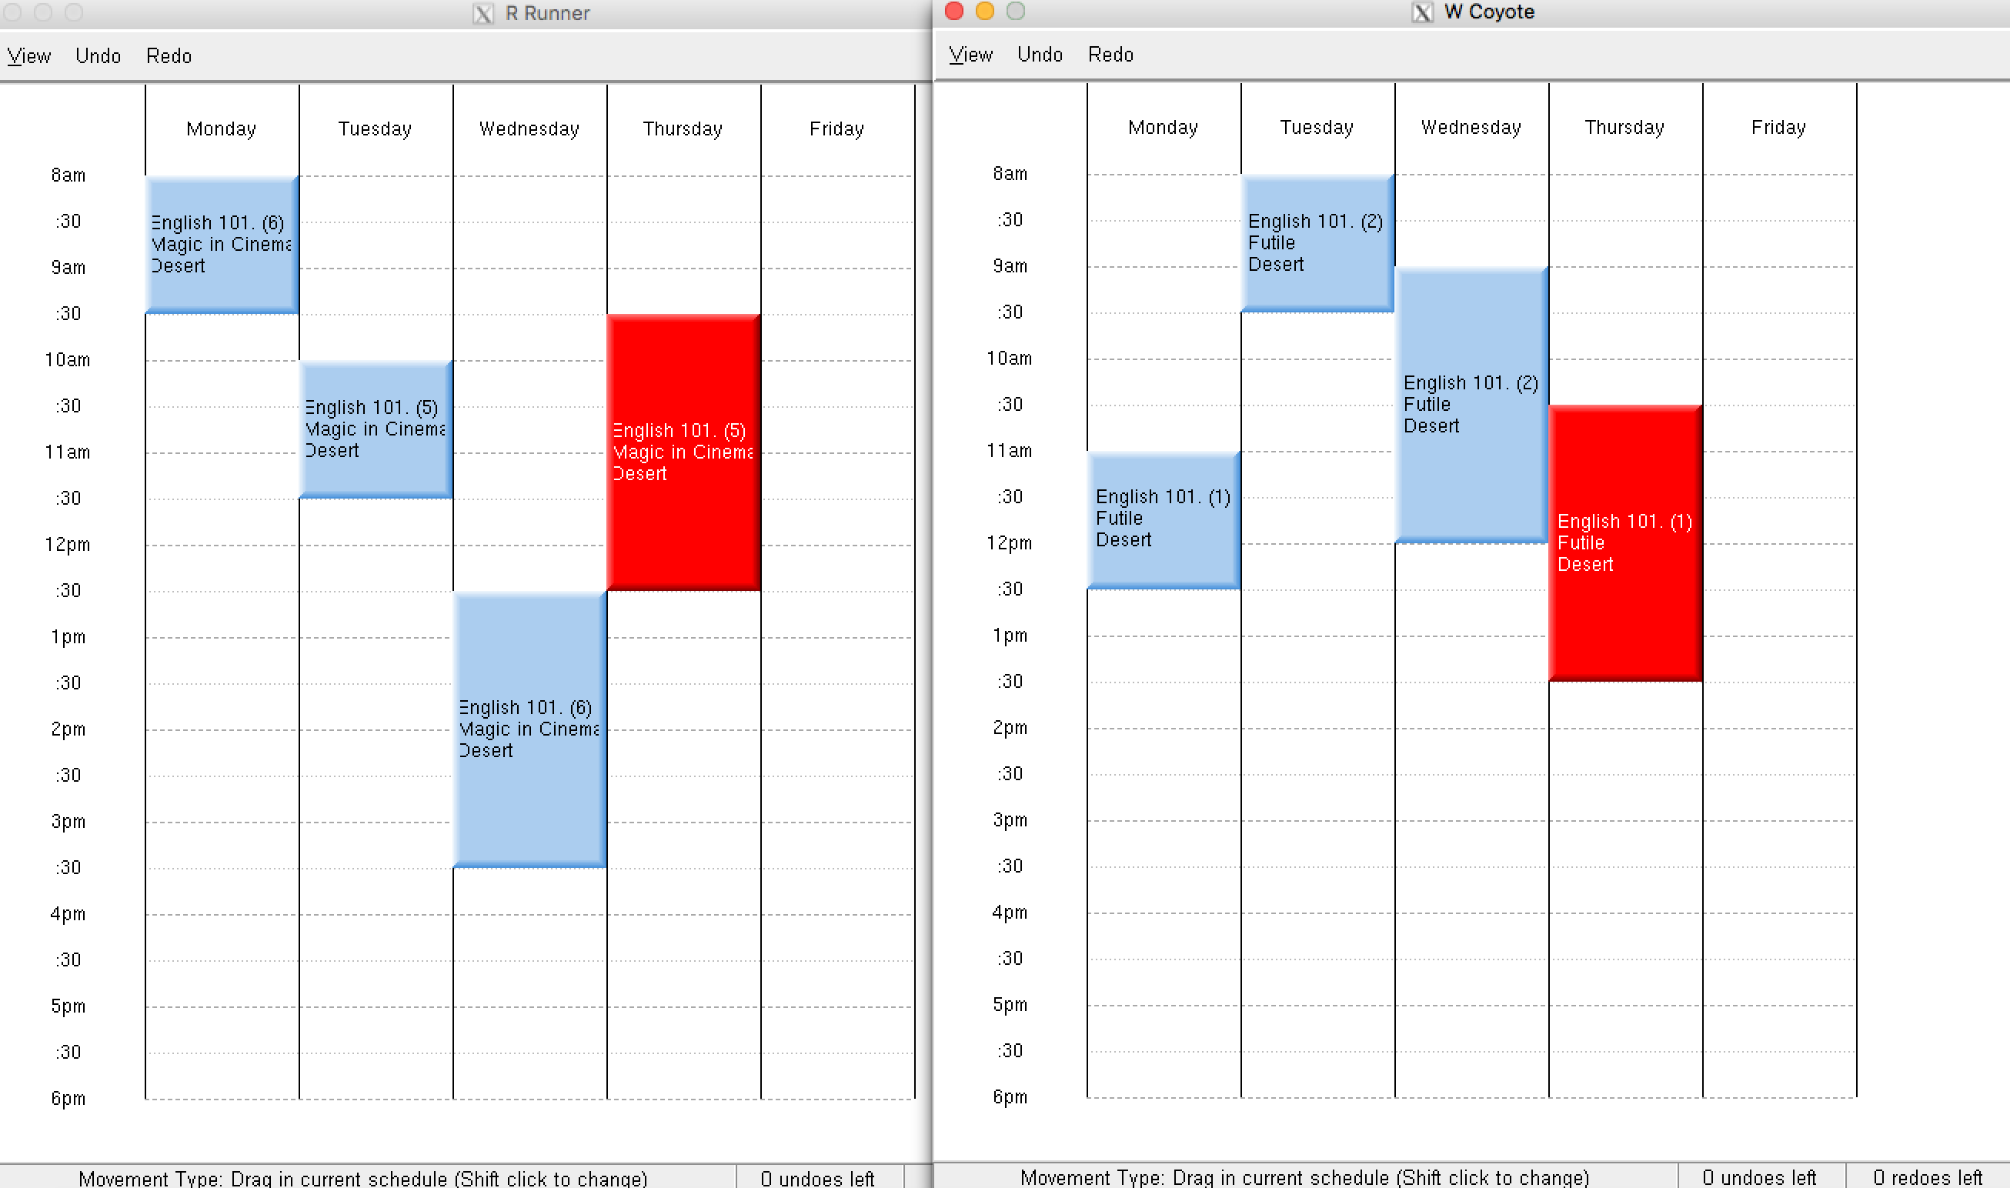

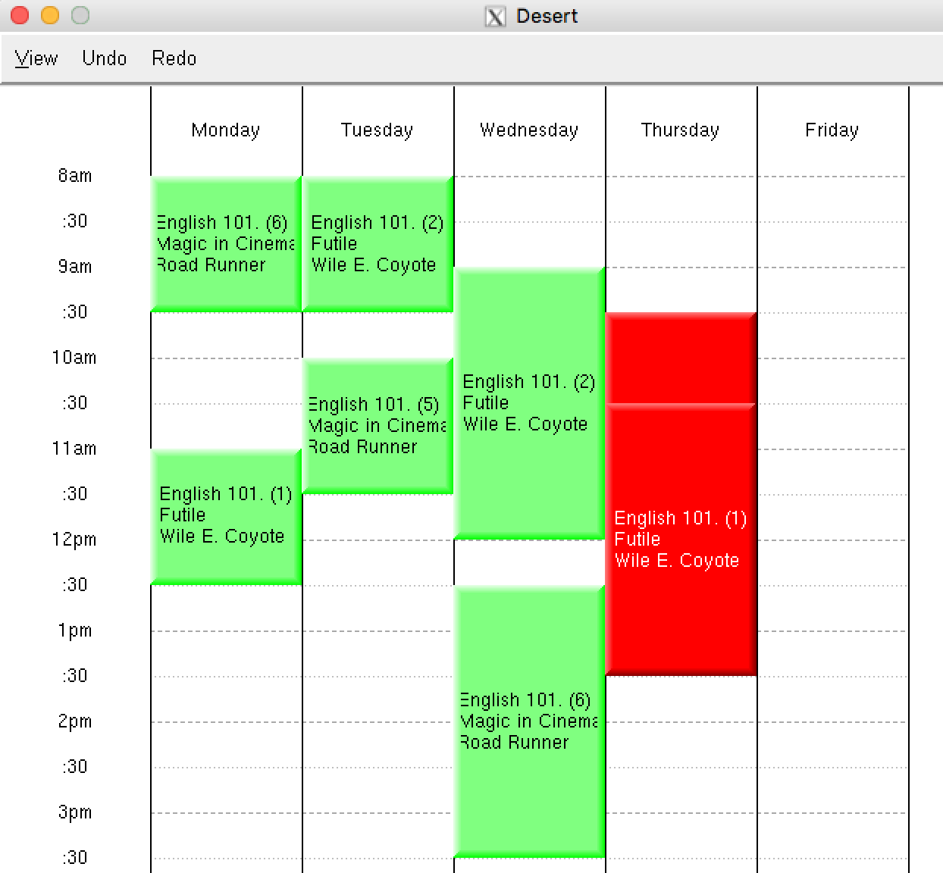
If we wanted to fix this, it would be quite easy to simply move one of Wile's or Road's classes around.
However, assume for the moment that we can't and we decide to put Wile's class in his Cave.
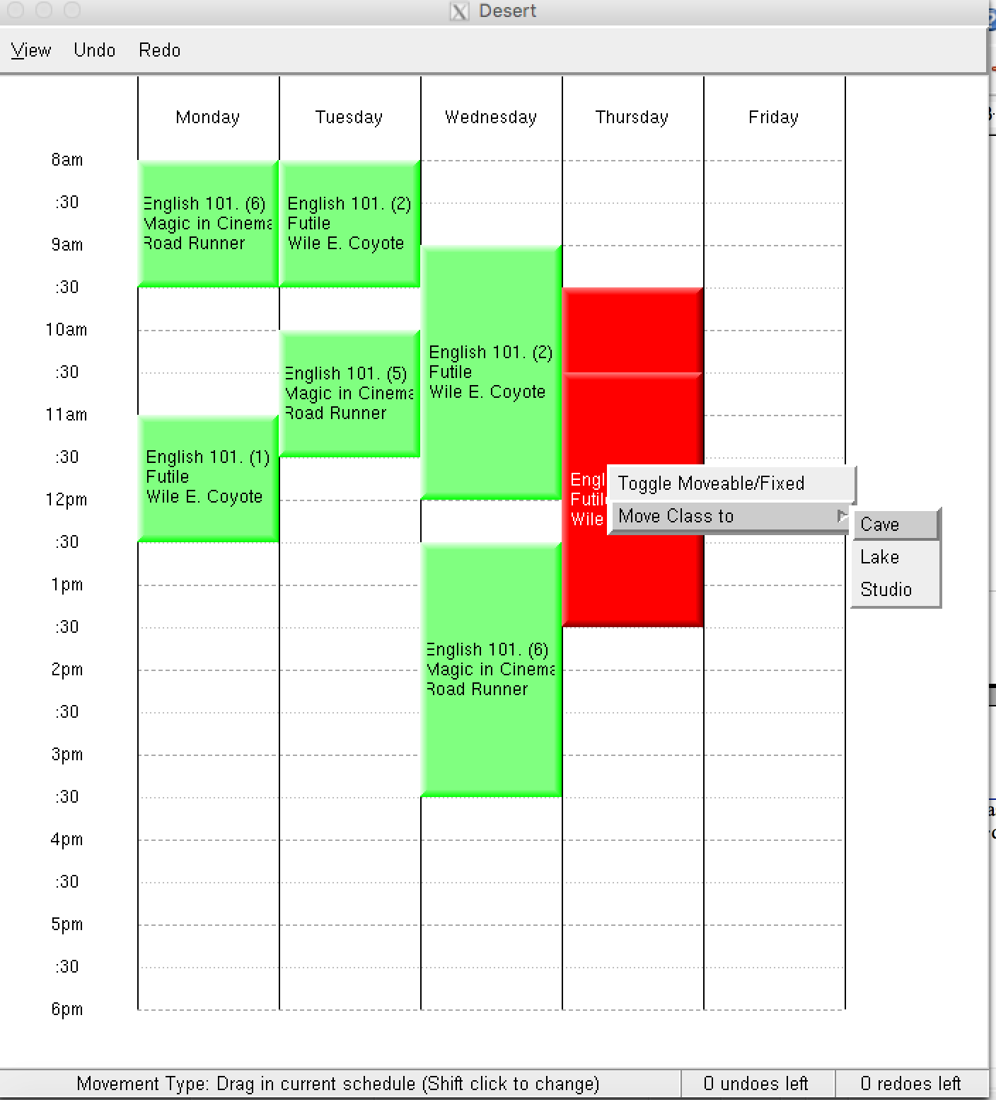
We do not need to go back to the “Edit Courses” page and fiddle there,

we can use a drop down menu to move the course from one lab to another.

Assigning Blocks to Teachers or Resources by Selecting Time Range

Step 1.
Open a Teacher or Resource View (does not work in Stream View)

Step 2.
Select a range of times where you want your new block to be located (click and drag mouse)
Upon release of the mouse button, a window will pop up allowing you to :
- choose which course / section / teacher / resource to assign it to.
- create a new block, or assign the selected hours to an existing block
- Assign this block to the existing view
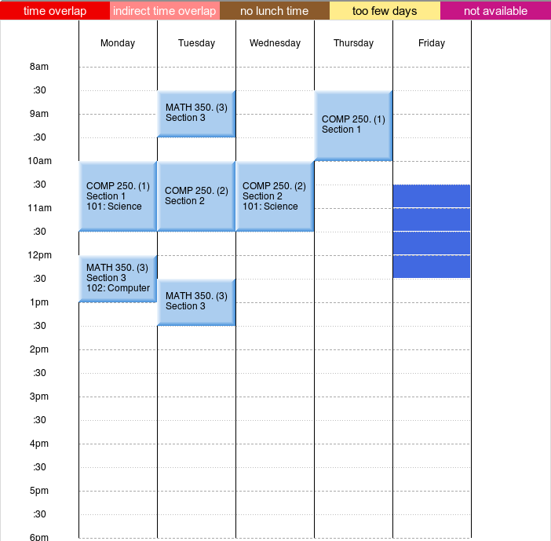

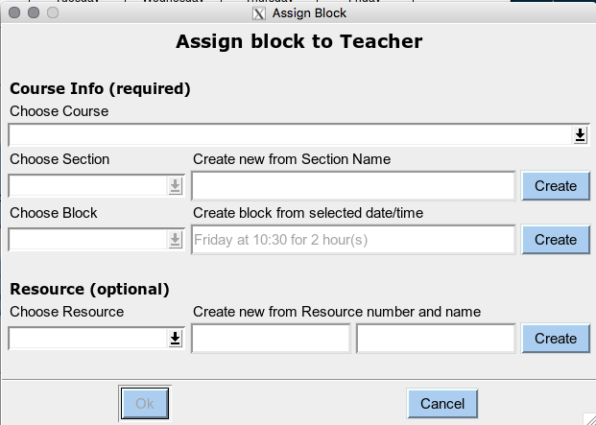
I
Step 3 – Choose a course (all blocks belong to course)
Step 4 – Select a section
Either
- Select an existing selection from that course, or
- Create a new section by entering a name in the text box, and clicking Create
NOTE the new section will be created immediately, and is independent of the “Ok” button at bottom of dialog box.

Step 5 – Choose Block
Either
- Select an existing block from that section,
NOTE: the day, start and DURATION will be modified according to what was selected, or
- Create a new block using selected day, start, duration by clicking Create
NOTE the new section will be created immediately, and is independent of the “Ok” button at bottom of dialog box

Optional Step 6 – Add Resource (or Teacher) depending on context
Either
- Select an existing resource, or
- Create a new resource using number and name, click Create button
NOTE the new resource will be created immediately, and is independent of the “Ok” button below

