**CONTENTS**

|  |  |  |
| --- | --- | --- |
| **CHAPTER NO.** | **TITLE** | **PAGE NO.** |
| **1** | **INTRODUCTION** |  |
|  | 1.1 Over view | 1 |
|  | 1.2 Problem Statement | 2 |
|  | 1.3 Objectives | 2 |
|  | 1.4 Need of power Quality | 2 |
| **2** | **INVERTERS** |  |
|  | 2.1 DC-AC converters | 4 |
|  | 2.2 Circuit Description | 4 |
|  | 2.3 Types of INVERTERS | 5 |
|  | 2.4 Single Phase Voltage Source Inverter | 6 |
|  | 2.5 Types of VSI | 6 |
|  | 2.6 Current Source Inverter | 7 |
|  | 2.7 Applications | 8 |
|  | 2.8 Parallel Connection of INVERTERS | 10 |
| **3** | **RENEWABLE ENERGY SOURCES** |  |
|  | 3.1 Introduction | 17 |
|  | 3.2 Block Diagram | 17 |
|  | 3.3 Solar Photovoltaics | 18 |

|  |  |  |
| --- | --- | --- |
|  | 3.4 Wind System | 21 |
|  | 3.5 Hydro Power | 24 |
| **4** | **GENERAL THEORY OF ACTIVE POWER FILTERS** |  |
|  | 4.1 Introduction | 26 |
|  | 4.2 Classification of Active Power Filters | 27 |
|  | 4.3 Operation of Three Phase Active Power Filters | 32 |
| **5** | **CLARK’S AND INVERSE CLARK TRANSFORMATION** |  |
|  | 5.1 Clark’s Transformation | 36 |
|  | 5.2 Inverse Clark’s Transformation | 41 |
| **6** | **PROPOSED SYSTEM** | 42 |
| **7** | **MATLAB AND SIMULINK** |  |
|  | 7.1 MatLab | 45 |
|  | 7.2 Simulink | 46 |
|  | 7.3 The Power System Block Set | 49 |
|  | 7.4 Simulink Blocks used in Simulation | 50 |
| **8** | **SIMULATION RESULTS** | 54 |
|  | **FUTURE SCOPE** | 56 |
|  | **CONCLUSION** | 57 |
|  | **REFERENCES** | 58 |

**LIST OF FIGURES**

|  |  |  |
| --- | --- | --- |
| **FIGURE NO.** | **TITLE** | **PAGE NO.** |
| 2.1 | Half bridge VSI | 6 |
| 2.2 | Full bridge VSI | 7 |
| 2.3 | Three phase full bridge CSI | 8 |
| 2.4 | Parallel connection of two Three phase Inverters | 11 |
| 2.5 | Modes of operation | 14 |
| 3.1 | Block diagram of Power source | 17 |
| 3.2 | Solar cell | 18 |
| 4.1 | Current fed type Active Filter | 27 |
| 4.2 | Voltage fed type Active Filter | 27 |
| 4.3 | Types of Active filters | 29 |
| 4.4 | Configuration of 3ph-3 wire AF system | 33 |
| 5.1 | Voltage waveforms before and after Clark’s Transformation | 38 |
| 6.1 | Stand-alone hybrid power generation system with a SHAPF | 42 |
| 6.2 | 3-ph Equivalent circuit of proposed SAPF | 43 |
| 6.3 | Tw0-level ,four leg PWM-VSI topology | 43 |
| 6.4 | Block diagram of proposed system | 44 |
| 7.1a | SHAPF connection to grid | 46 |
| 7.1b | Controller | 46 |
| 8.1a | %THD of voltage without filter | 54 |
| 8.1b | % THD of voltage with filter | 54 |
| 8.2a | %THD of current without filter | 54 |
| 8.2b | %THD of voltage with filter | 54 |
| 8.3 | Output scope | 55 |

**LIST OF TABLES**

|  |  |  |
| --- | --- | --- |
| **Table no.** | **Name of the Table** | **Page no.** |
| 4.1 | IEEE 519 Voltage Limits | 26 |
| 4.2 | IEEE 519 Current Limits | 27 |

**CHAPTER-1**

**INTRODUCTION**

**1.1 Over view**

Renewable generation affects power quality due to its nonlinearity, since solar generation plants and wind power generators must be connected to the grid through high-power static PWM converters . The nonuniform nature of power generation directly affects voltage regulation and creates voltage distortion in power systems. This new scenario in power distribution systems will require more sophisticated compensation techniques.

Although active power filters implemented with three-phase four-leg voltage-source inverters (4L-VSI) have already been presented in the technical literature, the primary contribution of this paper is a predictive control algorithm designed and implemented specifically for this application. Traditionally, active power filters have been controlled using pre-tuned controllers, such as PI-type or adaptive, for the current as well as for the dc-voltage loops. PI controllers must be designed based on the equivalent linear model, while predictive controllers use the nonlinear model, which is closer to real operating conditions. An accurate model obtained using predictive controllers improves the performance of the active power filter, especially during transient operating conditions, because it can quickly follow the current-reference signal while maintaining a constant dc-voltage.

So far, implementations of predictive control in power converters have been used mainly in induction motor drives. In the case of motor drive applications, predictive control represents a very intuitive control scheme that handles multivariable characteristics, simplifies the treatment of dead-time compensations, and permits pulse-width modulator replacement. However, these kinds of applications present disadvantages related to oscillations and instability created from unknown load parameters. One advantage of the proposed algorithm is that it fits well in active power filter applications, since the power converter output parameters are well known. These output parameters are obtained from the converter output ripple filter and the power system equivalent impedance. The converter output ripple filter is part of the active power filter design and the power system impedance is obtained from well-known standard procedures. In the case of unknown system impedance parameters, an estimation method can be used to derive an accurate *R–L* equivalent impedance model of the system.

This paper presents the mathematical model of the 4L-VSI and the principles of operation of the proposed predictive control scheme, including the design procedure. The complete description of the selected current reference generator implemented in the active power filter is also presented. Finally, the proposed active power filter and the effectiveness of the associated control scheme compensation are demonstrated through simulation.

**1.2 Problem Statement**

Power quality is becoming a very serious and profound issue in the world of electrical engineering. Due to the huge spread of non-linear loads across all power grids, the non-linear current is forcing a non-linear supply voltage to be created which causes immense power quality problems ranging from dips and sags to harmonics and fluctuations. As the concern about power quality grows, electric utilities are always trying to find a way to provide pure power to the consumer, especially if the latter has equipment and processes that are sensitive to power fluctuations. The problem at hand is to investigate and assess the effectiveness of Shunt Hybrid Active Power filter (SHAPF) in mitigating these power quality issues within PV-integrated distribution networks.

**1.3 OBLECTIVES**

* The objectives and functions of active power filters have expanded from reactive power compensation, voltage regulation, etc. to harmonic isolation between utilities and consumers, and harmonic damping throughout the distribution as harmonics propagate through the system.
* Active power filters are either installed at the individual consumer premises or at substation and/or on distribution feeders.
* Depending on the compensation objectives, various types of active power filter topologies have evolved.

**1.4 NEED OF POWER QUALITY**

There is an increased concern of power quality due to the following reasons

**Equipment Reliability:** Poor power quality can damage or reduce the lifespan of sensitive equipment like computers, servers, medical devices, and industrial machinery. Fluctuations in voltage or frequency can cause overheating, malfunctions, or complete failure.

**Operational Efficiency:** In industries, fluctuations in power quality can disrupt production processes, leading to downtime and loss of productivity. Consistent power quality ensures smooth operations and optimal efficiency.

**Data Integrity:** In the age of digitalization, many systems rely on stable power to function correctly. Power disturbances can corrupt data, leading to financial losses or compromising critical information.

**Energy Efficiency:** High-quality power leads to better energy efficiency. Unstable power can result in inefficiencies, as equipment may not operate optimally under such conditions, leading to higher energy consumption.

**Safety Concerns:** Poor power quality can pose safety hazards, especially in sensitive environments like healthcare facilities, where medical equipment relies on stable power to function correctly. Voltage fluctuations, surges, or sags can endanger both equipment and personnel.

**Regulatory Compliance:** Many industries are subject to regulations regarding power quality. Compliance ensures safety, reliability, and efficiency, and failure to meet these standards can result in penalties or legal issues.

**Customer Satisfaction:** Utilities and service providers must deliver high-quality power to maintain customer satisfaction. Residential customers may experience issues like flickering lights or damaged appliances due to poor power quality, leading to dissatisfaction.

**CHAPTER-2**

**inverters**

**2.1 DC- AC CONVERTER (INVERTER)**

An inverter is an electrical device that converts [direct current](http://en.wikipedia.org/wiki/Direct_current) (DC) to [alternating current](http://en.wikipedia.org/wiki/Alternating_current) (AC); the converted AC can be at any required voltage and frequency with the use of appropriate [transformers](http://en.wikipedia.org/wiki/Transformer), switching, and control circuits.

Solid-state inverters have no moving parts and are used in a wide range of applications, from small [switching power supplies](http://en.wikipedia.org/wiki/Switched-mode_power_supply) in computers, to large [electric utility](http://en.wikipedia.org/wiki/Electric_utility) [high-voltage direct current](http://en.wikipedia.org/wiki/High-voltage_direct_current) applications that transport bulk power. Inverters are commonly used to supply AC power from DC sources such as [solar panels](http://en.wikipedia.org/wiki/Solar_panel) or [batteries](http://en.wikipedia.org/wiki/Battery_(electrical)).

There are two main types of inverter. The output of a modified sine wave inverter is similar to a [square wave](http://en.wikipedia.org/wiki/Square_wave) output except that the output goes to zero volts for a time before switching positive or negative. It is simple and low cost (~$0.10USD/Watt) and is compatible with most electronic devices, except for sensitive or specialized equipment, for example certain [laser printers](http://en.wikipedia.org/wiki/Laser_printer). A pure sine wave inverter produces a nearly perfect sine wave output (<3% [total harmonic distortion](http://en.wikipedia.org/wiki/Total_harmonic_distortion)) that is essentially the same as utility-supplied grid power. Thus it is compatible with all AC electronic devices. This is the type used in grid-tie inverters. Its design is more complex, and costs 5 or 10 times more per unit power (~$0.50 to $1.00USD/Watt).[[1]](http://en.wikipedia.org/wiki/Inverter_(electrical)#cite_note-powerelectronics-0) The electrical inverter is a high-power [electronic oscillator](http://en.wikipedia.org/wiki/Electronic_oscillator). It is so named because early [mechanical AC to DC converters](http://en.wikipedia.org/wiki/Mechanical_rectifier) was made to work in reverse, and thus was "inverted", to convert DC to AC. The inverter performs the opposite function of a [rectifier](http://en.wikipedia.org/wiki/Rectifier).

## 2.2 Circuit description

### 2.2.1 Basic designs

In one simple inverter circuit, DC power is connected to a [transformer](http://en.wikipedia.org/wiki/Transformer) through the centre tap of the primary winding. A switch is rapidly switched back and forth to allow current to flow back to the DC source following two alternate paths through one end of the primary winding and then the other. The alternation of the direction of current in the primary winding of the transformer produces [alternating current](http://en.wikipedia.org/wiki/Alternating_current) (AC) in the secondary circuit.

[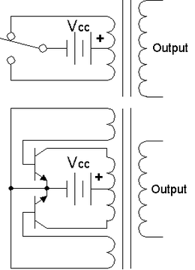](http://en.wikipedia.org/wiki/File:Inverter_ckt_01cjc.png)

*Top:* Simple inverter circuit shown with an [electro-mechanical switch](http://en.wikipedia.org/wiki/Electromechanical_switch)  
*and automatic equivalent*  
auto-switching device implemented with two transistors and split winding auto-transformer in place of the mechanical switch.

[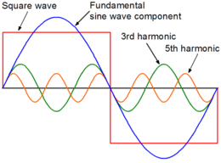](http://en.wikipedia.org/wiki/File:Squarewave01CJC.png)

Square waveform with fundamental sine wave component, 3rd harmonic and 5th harmonic

The electromechanical version of the switching device includes two stationary contacts and a spring supported moving contact. The spring holds the movable contact against one of the stationary contacts and an electromagnet pulls the movable contact to the opposite stationary contact. The current in the electromagnet is interrupted by the action of the switch so that the switch continually switches rapidly back and forth. This type of electromechanical inverter switch, called a [vibrator](http://en.wikipedia.org/wiki/Vibrator_(electronic)) or buzzer, was once used in [vacuum tube](http://en.wikipedia.org/wiki/Vacuum_tube) automobile radios. A similar mechanism has been used in door bells, buzzers and [tattoo guns](http://en.wikipedia.org/wiki/Tattoo_gun).

As they became available with adequate power ratings, [transistors](http://en.wikipedia.org/wiki/Transistors) and various other types of [semiconductor](http://en.wikipedia.org/wiki/Semiconductor) switches have been incorporated into inverter circuit designs.

**2.3 Types of inverters:**

Generally inverters are of Two Types:

1. VOLTAGE SOURCE INVERTER (VSI)

2. CURRENT SOURCE INVERTER (CSI)

**2.4 Single-phase voltage source inverters (VSI):**

Single-phase voltage source inverters (VSIs) can be found as half-bridge and full-bridge topologies. Although the power range they cover is the low one, they are widely used in power supplies, single-phase UPSs, and currently to form elaborate high-power static power topologies, such as for instance, the multi cell configurations that are reviewed. The main features of both approaches are reviewed and presented in the following.

**2.5 Types of VSI:**

**2.5.1 Half-Bridge VSI:**

The power topology of a half-bridge VSI, where two large capacitors are required to provide a neutral point N, such that each capacitor maintains a constant voltage=2. Because the current harmonics injected by the operation of the inverter are low-order harmonics, a set of large capacitors (C. and Cÿ) is required. It is clear that both switches S. and Sÿ cannot be on simultaneously because short circuit across the dc link voltage source vi would be produced. There are two defined (states 1 and 2) and one undefined (state 3) switch state as shown. In order to avoid the short circuit across the dc bus and the undefined ac output voltage condition, the modulating technique should always ensure that at any instant either the top or the bottom switch of the inverter leg is on.



Fig2.1: Half bridge VSI

Shows the ideal waveforms associated with the half-bridge inverter shown in Fig. 14.2. The states for the switches S. and Sÿ are defined by the modulating technique, which in this case is a carrier-based PWM.

**2.5.2 Full-Bridge VSI:**

This inverter is similar to the half-bridge inverter; however, a second leg provides the neutral point to the load. As expected, both switches S1 and S1ÿ (or S2. and S2ÿ) cannot be on simultaneously because a short circuit across the dc link voltage source Vi would be produced. There are four defined and one undefined .

The undefined condition should be avoided so as to be always capable of defining the ac output voltage. In order to avoid the short circuit across the dc bus and the undefined ac output voltage condition, the modulating technique should ensure that either the top or the bottom switch of each leg is on at any instant. It can be observed that the ac output voltage can take values up to the dc link value vi , which is twice that obtained with half-bridge VSI topologies. Several modulating techniques have been developed that are applicable to full-bridge VSIs. Among them are the PWM (bipolar and unipolar) techniques.



Fig2.2 :Full bridge VSI

**2.6 Current Source Inverters** **(CSI):**

The main objective of these static power converters is to produce ac output current waveforms from a dc current power supply. For sinusoidal ac outputs, its magnitude, frequency, and phase should be controllable. Due to the fact that the ac line currents ioa, iob, and ioc (Fig. 14.23) feature high di=dt, a capacitive filter should be connected at the ac terminals in inductive load applications (such as ASDs).

Thus, nearly sinusoidal load voltages are generated that justifies the use of these topologies in medium-voltage industrial applications, where high-quality voltage waveforms are required.



Fig2.3 :Three phase full bridge CSI

Should be closed at any time; the dc bus is of the current-source type and thus it cannot be opened; therefore, there must be at least one top switch and one bottom switch (closed at all times. Note that both constraints can be summarized by stating that at any time, only one top switch and one bottom switch must be closed.

There are nine valid states in three-phase CSIs produce zero ac line currents. In this case, the dc link current freewheels through either the switches S1 and S4, switches S3 and S6, or switches S5 and S2.

The remaining states produce nonzero ac output line currents. In order to generate a given set of ac line current waveforms, the inverter must move from one state to another. Thus, the resulting line currents consist of discrete values of current, which are ii , 0, and ÿii . The selection of the states in order to generate the given waveforms is done by the modulating technique that should ensure the use of only the valid states.

## 2.7 Applications

### 2.7.1 DC power source utilization

An inverter converts the DC electricity from sources such as batteries, solar, or [fuel cells](http://en.wikipedia.org/wiki/Fuel_cell) to AC electricity. The electricity can be at any required voltage; in particular it can operate AC equipment designed for mains operation, or rectified to produce DC at any desired voltage.

[Grid tie inverters](http://en.wikipedia.org/wiki/Grid_tie_inverter) can feed energy back into the distribution network because they produce alternating current with the same wave shape and frequency as supplied by the distribution system. They can also switch off automatically in the event of a [blackout](http://en.wikipedia.org/wiki/Power_outage).

[Micro-inverters](http://en.wikipedia.org/w/index.php?title=Micro-inverters&action=edit&redlink=1) convert direct current from individual solar panels into alternating current for the electric grid. They are grid tie designs by default.

### 2.7.2 Uninterruptible power supplies

An [uninterruptible power supply](http://en.wikipedia.org/wiki/Uninterruptible_power_supply) (UPS) uses batteries and an inverter to supply AC power when main power is not available. When main power is restored, a [rectifier](http://en.wikipedia.org/wiki/Rectifier) supplies DC power to recharge the batteries.

### 2.7.3 Induction heating

Inverters convert low frequency main AC power to a higher frequency for use in [induction heating](http://en.wikipedia.org/wiki/Induction_heating). To do this, AC power is first [rectified](http://en.wikipedia.org/wiki/Rectifier) to provide DC power. The inverter then changes the DC power to high frequency AC power.

### 2.7.4 HVDC power transmission

With [HVDC](http://en.wikipedia.org/wiki/High-voltage_direct_current) power transmission, AC power is rectified and high voltage DC power is transmitted to another location. At the receiving location, an inverter in a [static inverter plant](http://en.wikipedia.org/wiki/Static_inverter_plant) converts the power back to AC.

### 2.7.5 Variable-frequency drives

A [variable-frequency drive](http://en.wikipedia.org/wiki/Variable-frequency_drive) controls the operating speed of an AC motor by controlling the frequency and voltage of the power supplied to the motor. An inverter provides the controlled power. In most cases, the variable-frequency drive includes a [rectifier](http://en.wikipedia.org/wiki/Rectifier) so that DC power for the inverter can be provided from main AC power. Since an inverter is the key component, variable-frequency drives are sometimes called inverter drives or just inverters.

### 2.7.6 Electric vehicle drives

Adjustable speed motor control inverters are currently used to power the [traction motors](http://en.wikipedia.org/wiki/Traction_motors) in some [electric](http://en.wikipedia.org/wiki/Railway_electrification_system) and [diesel-electric](http://en.wikipedia.org/wiki/Diesel-electric_transmission) rail vehicles as well as some [battery electric vehicles](http://en.wikipedia.org/wiki/Battery_electric_vehicles) and [hybrid electric](http://en.wikipedia.org/wiki/Hybrid_vehicle) highway vehicles such as the [Toyota Prius](http://en.wikipedia.org/wiki/Toyota_Prius) and [Fisker Karma](http://en.wikipedia.org/wiki/Fisker_Karma). Various improvements in inverter technology are being developed specifically for electric vehicle applications.[[2]](http://en.wikipedia.org/wiki/Inverter_(electrical)#cite_note-1) In vehicles with [regenerative braking](http://en.wikipedia.org/wiki/Regenerative_braking), the inverter also takes power from the motor (now acting as a generator) and stores it in the batteries.

### 2.7.7 Air conditioning

An [air conditioner](http://en.wikipedia.org/wiki/Air_conditioner) bearing the inverter tag uses a [variable-frequency drive](http://en.wikipedia.org/wiki/Variable-frequency_drive) to control the speed of the motor and thus the compressor.

### 2.7.8 The general case

A [transformer](http://en.wikipedia.org/wiki/Transformer) allows AC power to be converted to any desired voltage, but at the same frequency. Inverters, plus rectifiers for DC, can be designed to convert from any voltage, AC or DC, to any other voltage, also AC or DC, at any desired frequency. The output power can never exceed the input power, but efficiencies can be high, with a small proportion of the power dissipated.

**2.8 PARALLEL CONNECTION OF INVERTERS:**

In parallel operation, two or more inverters are tied together to share the load. In this project, a system of two units will be discussed for convenience. Figure 4 shows two inverters which are directly connected at input and output ends. The parallel connection done for the two bridges such that the dc side filters and the ac side filter are common for the two parallel inverters. Inverters with different ratings sometimes encountered to increase the power capability of the system; it is desirable to share the currents according to the rated power of each module. If the bridges inverter used non-identical IGBT's, current sharing and circulating current are to be considered.

To study the current sharing and circulating current one mode of operation is to be considered. Figure 5 shows the mode of operation when the current IdA+ flowing through Q1A and Q1B, however the current IdA- flowing back to the source through Q6A and Q6b. the Figure shows the current sharing between Q1A and Q1B with two series resistors included.



Fig2.4: Parallel Connection of Two Three-Phase Inverters

The current sharing depends on the IGBT’s Q1A and Q1B, If VCE1A not equal to VCE1B as a result IdA+ will not be equal to IdB+.



Fig: Circulating Current during One Switching Cycle

To maintain similar current sharing between the two inverters series resistor R1 and R2 added between each leg of the six legs and the common point as shown in Figure 8. R1 box consists of three resistors R11, R12, and R13. Similarly R2 consists of R21, R22, and R23. Including the resistances R11A and R11B as shown in Figure 8 must satisfy the following condition:



To select the right value of R1 and R2 each of them suppose to be much smaller than the load resistance. The circuit will experience similar current sharing in all the modes of operation as a result the circulating current will be small.

**2.8.1 MODES OF OPERATION**

The proposed configuration can be discussed in six modes of operation as shown in Table 1 considering the three-phase waveform shown in Figure 6. The modes of operation are discussed below:



Three-phase waveform with six modes of operation



Table 2.1: The state of switches over 2pi interval

**Mode1**

Phase a and phase c are in a positive cycle whereas phase b is in negative cycle. The DC voltage VDC applied to the inverter output through six switches Q1A, Q1B, Q4A, Q4B, Q5A, and Q5B as shown in Figure 2.5a.

**Mode 2**

Phase a is in a positive cycle whereas phase b and phase c are in the negative cycle. The DC voltage VDC applied to the inverter output through six switches Q1A, Q1B, Q4A, Q4B, Q6A, and Q6B as shown in Figure 2.5b.

**Mode 3**

Phase a and phase b are in a positive cycle whereas phase c is in negative cycle. The DC voltage VDC applied to the inverter output through six switches Q1A, Q1B, Q3A, Q3B, Q6A, and Q6B as shown in Figure 2.5c.

**Mode 4**

Phase a and phase c are in a negative cycle whereas phase b is in positive cycle. The DC voltage VDC applied to the inverter output through six switches Q3A, Q3B, Q2A, Q2B, Q6A, and Q6B as shown in Figure 2.5d.

**Mode 5**

Phase a is negative in a cycle whereas phase b and phase c are in positive cycle. The DC voltage VDC applied to the inverter output through six switches Q3A, Q3B, Q2A, Q2B, Q5A, and Q5B as shown in Figure 2.5e.

**Mode 6**

Phase a and phase b are in a negative cycle whereas phase c is in positive cycle. The DC voltage VDC applied to the inverter output through six switches Q5A, Q5B, Q2A, Q2B, Q4A, and Q4B as shown in Figure 2.5f.



Figure 2.5a: The current path during Mode 1



Figure 2.5b: The current path during Mode 2.



Figure 2.5c: The current path during Mode 3.



Figure 2.5d: The current path during Mode 4



Figure 2.5e: The current path during Mode 5.



Figure 2.5f: The current path during Mode 6.

**2.8.2 EFFICIENCY OF PARALLEL CONNECTED INVERTER**

The power dissipation (PD) and the efficiency () in the three phase inverter can be calculated as follows:



Where PD is the power dissipation of the inverter, PDC is the DC source power, and PAC is the inverter output power. Assuming ripple free current on the DC source, and unity power factor on the AC side the input power and the output power are calculated as:



**CHAPTER-3**

**renewable energy sources**

**3.1 INTRODUCTION**

In this chapter, the nonconventional energy sources in the project are discussed briefly just likes Wind system, Hydro system, PV system, & Battery’s etc... with necessary definitions and basic information about them.

**3.2 BLOCK DIAGRAM**

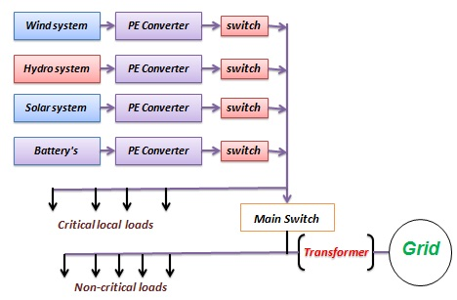

Fig: 3.1Block diagram for power sources

**3.3 SOLAR PHOTOVOLTAICS**

**3.3.1 Introduction**

The conversion of solar radiation occurs by the photovoltaic effect which was first observed by Becquerel. It is quite generally defined as the emergence of an electric voltage between two electrodes attached to a solid or liquid system upon shining light onto this system. Energy conversion devices which are used to convert sunlight to electricity by the use of the photo-voltaic effect are called solar cells. Single converter cell is called a solar cell or more generally photovoltaic cell and combination of such cells designed to increase the electric power output is called a solar module or solar array and hence the name ‘Photovoltaic Arrays’. Solar cells can be arranged into large groupings called arrays. These arrays, composed of many thousands of individual cells, can function as central electric power stations, converting sunlight into electrical energy for distribution to industrial, commercial and residential users. Solar cells in much smaller configurations are commonly referred to as solar cell panels or simply panels. Practically, all photovoltaic devices incorporate a P-N junction in a semiconductor across which the photo voltage is developed. The solar panels consist mainly of semiconductor material, with Silicon being most commonly used.

**3.3.2 Basics of Solar Cells**

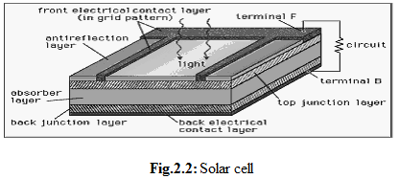

Fig 3.2: solar cell

The overwhelming majority of [solar cells](http://www.britannica.com/eb/article-9106046##) are fabricated from [silicon](http://www.britannica.com/eb/article-9067764/silicon) with increasing efficiency and lowering cost as the materials range from amorphous (non-crystalline) to polycrystalline to crystalline (single [crystal](http://www.britannica.com/eb/article-9110297/crystal)) silicon forms. Unlike [batteries](http://www.britannica.com/eb/article-9106044/battery) or [fuel cells](http://www.britannica.com/eb/article-9106045/fuel-cell), solar cells do not utilize [chemical reactions](http://www.britannica.com/eb/article-9110109/chemical-reaction) or require fuel to produce electric power and unlike [electric generators](http://www.britannica.com/eb/article-9106042/electric-generator), they do not have any moving parts.

Light enters the device through an optical coating, or antireflection layer that minimizes the loss of light by reflection; it effectively traps the light falling on the solar cell by promoting its transmission to the energy-conversion layers below. The antireflection layer is typically an oxide of [silicon](http://www.britannica.com/eb/article-9067764/silicon), [tantalum](http://www.britannica.com/eb/article-9071207/tantalum) or [titanium](http://www.britannica.com/eb/article-9072643/titanium) that is formed on the cell surface by spin coating or a vacuum deposition technique.

The three energy-conversion layers below the antireflection layer are the top junction layer, the absorber layer, which constitutes the core of the device, and the back junction layer. Two additional electrical contact layers are needed to carry the electric current out to an external load and back into the cell, thus completing an electric circuit. The electrical contact layer on the face of the cell where light enters is generally present in some grid pattern and is composed of a good [conductor](http://www.britannica.com/eb/article-9025132/conductor) such as a metal. Since metal blocks light, the grid lines are as thin and widely spaced as is possible without impairing collection of the current produced by the cell. The back electrical contact layer has no such diametrically opposed restrictions. It needs to simply function as an electrical contact and thus cover the entire back surface of the cell structure. Because the back layer also must be a very good electrical conductor, it is always made of metal. Since most of the energy in sunlight and artificial light is in the visible range of [electromagnetic radiation](http://www.britannica.com/eb/article-9106046##), a solar cell absorber should be efficient in absorbing radiation at those wavelengths. Materials that strongly absorb visible radiation belong to a class of substances known as semiconductors. Semiconductors in thicknesses of about one-hundredth of a centimeter or less can absorb all incidents visible light; since the junction-forming and contact layers are much thinner, the thickness of a solar cell is essentially that of the absorber. Examples of semiconductor materials employed in solar cells include Silicon, Gallium Arsenide, Indium Phosphide and Copper Indium Selenide.

When light falls on a solar cell, electrons in the absorber layer are excited from a lower-energy “ground state,” in which they are bound to specific atoms in the solid, to a higher “excited state” in which they can move through the solid. In the absence of the junction-forming layers, these “[free](http://www.britannica.com/eb/topic?idxStructId=218218&typeId=13" \o "free)” electrons are in random motion and so there can be no oriented [direct current](http://www.britannica.com/eb/article-9030595/direct-current). The addition of junction-forming layers, however, induces a built-in [electric field](http://www.britannica.com/eb/article-9032278/electric-field) that produces the [photovoltaic effect](http://www.britannica.com/eb/article-9059826/photovoltaic-effect). In effect, the electric field gives a collective motion to the electrons that flow past the electrical contact layers into an external circuit where they can do useful work.

There are several approaches to manufacturing solar cells, including the kind of semiconductor used and the crystal structure employed, with each different factor affecting the efficiency and cost of the cell. Other external factors such as the ambient weather conditions like temperature, illumination, shading, etc., also affect the solar panel’s output. The aim is to design a system that will extract the most possible power regardless of ambient weather conditions or solar cell efficiency.

**3.3.3 Solar Cell Characteristics**

The current-to-voltage characteristic, power-to-voltage characteristics of a solar cell are non-linear, which make it difficult to determine the maximum power point. It is straightforward to determine the maximum power point on a linear curve as maximum power is transferred at the midpoint of the current-voltage characteristic. A typical V-I characteristic of solar cell is shown in Fig .

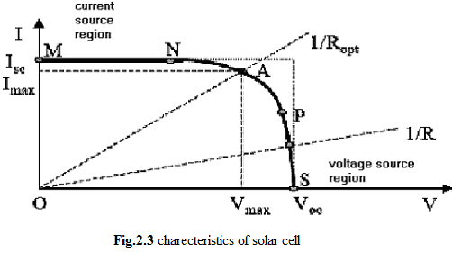

For a solar cell, the non-linear relationship means the maximum power point has to be determined by calculating the product of the voltage and output current. In order to extract maximum power from the solar cell, the solar cell must always be operated at or very close to where the product of the voltage and output current is the highest. This point is referred to as the maximum power point (MPP) and it is located around the ‘bend’ or ‘knee’ of the I-V characteristic.

The operating characteristic of a solar cell consists of two regions: the current source region and the voltage source region. In the current source region, the internal impedance of the solar cell is high and this region is located on the left side of the current-voltage curve. The voltage source region, where the internal impedance is low, is located on the right side of the current-voltage curve. As can be observed from the characteristic curve, in the current source region, the output current remains almost constant as the terminal voltage changes and in the voltage source region, the terminal voltage varies only minimally over a wide range of output current.

According to the maximum power transfer theory, the power delivered to the load is maximum when the source internal impedance matches the load impedance. For the system to operate at or close to the MPP of the solar panel, the impedance seen from the input of the MPPT needs to match the internal impedance of the solar panel. Since the impedance seen by the MPPT is a function of voltage (V = I * R), the main function of the MPPT is to adjust the solar panel output voltage to a value at which the panel supplies the maximum energy to the load. However, maintaining the operating point at the maximum power point can be quite challenging as constantly changing ambient conditions such as irradiance and temperature will vary the maximum power operating point. Hence, there is a need to constantly track the power curve and keep the solar panel operating voltage at the point where the most power can be extracted.

**3.4 WIND SYSTEM**

**3.4.1 Introduction**

GRID-connected wind electricity generation is showing the highest rate of growth of any form of electricity generation, achieving global annual growth rates in the order of 20 - 25%. It is doubtful whether any other energy technology is growing, or has grown, at such a rate. Global installed capacity was 47.6 GW in the year 2004 and 58.9 GW in 2005. Wind power is increasingly being viewed as a mainstream electricity supply technology. Its attraction as an electricity supply source has fostered ambitious targets for wind power in many countries around the world.

Wind power penetration levels have increased in electricity supply systems in a few countries in recent years; so have concerns about how to incorporate this significant amount of intermittent, uncontrolled and non-dispatchable generation without disrupting the finely-tuned balance that network systems demand.

Grid integration issues are a challenge to the expansion of wind power in some countries. Measures such as aggregation of wind turbines, load and wind forecasting and simulation studies are expected to facilitate larger grid penetration of wind power.

**3.4.2 Power from Wind**

The power that can be captured from the wind with a wind energy converter with effective area *Ar* is given by

 ….(1)

Where pair is the air mass density [kg/m3], *Vw* is the wind speed and *Cp* is the so-called power coefficient which depends on the specific design of the wind converter and its orientation to the wind direction. Its theoretical maximum value is 16/27 = 0.593 (Betz limit). For a wind turbine with given blades it can be shown that the power coefficient *Cp* basically depends only on the tip speed ratio *l*, which equals the ratio of tip speed *Vt* [m/s] over wind speed *Vw* [m/s] and the so-called blade pitch angle *q* [deg]. This pitch angle is defined as the angle between the cord of the blade and the plane of the wind rotor. So, for a wind rotor with radius *r*, (1) can be rewritten as:

 …..(2)

As an example, Fig. shows the dependency of the power coefficient *Cp* on the tip speed ratio *l* and the blade pitch angle *q* for a specific blade. For this blade maximum energy capture from the wind is obtained for *q* =0 and *l* just above 6. To keep *Cp* at its optimal value for varying wind speed, the rotor speed should be proportional to the wind speed. In practice both constant *l* (variable speed) and constant speed operation is applied.



Power coefficient Cp as a function of tip speed ratio l and pitch angle q for a specific blade.

For on shore turbines, the blades are designed such that the optimal tip speed is limited to roughly 70 m/s. This is done because the blade tips because excessive acoustical noise at higher tip speeds. For offshore turbines, the noise does not play an important role, and higher speeds are used leading to slightly higher optimal values of *Cp*.

The relation between wind speed and generated power is given by the power curve, as depicted in below Fig. The power curve can be calculated from eq(2) where the appropriate value of *l* and *q* should be applied. In the power curve, four operating regions can be distinguished, that apply both to constant speed and variable speed turbines:

1. No power generation due to the low energy content of the wind.
2. Less than rated power generation. In this region, optimal aerodynamic efficiency and energy capture is aimed at. The wind speed at the boundary of region 2 and 3 is called the rated wind speed and all variables with the subscript rated refer to design values at this wind speed.
3. Generation of rated power, because the energy content of the wind is enough. In this region, the aerodynamic efficiency must be reduced, because otherwise the electrical system would become overloaded.
4. No power generation. Because of high wind speeds the turbine is closed down to prevent damage.



Typical power curve of a constant speed stall (dotted) and a variable speed pitch (solid) controlled wind turbine.

**3.5 Mini-Hydro Power**

**3.5.1. Introduction**

Hydropower is energy from water sources such as the ocean, rivers and waterfalls. “Minihydro” means which can apply to sites ranging from a tiny scheme to electrify a single home, to a few hundred kilowatts for selling into the National Grid. Small-scale hydropower is one of the most cost-effective and reliable energy technologies to be considered for providing clean electricity generation. The key advantages of small hydro are:

* High efficiency (70 - 90%), by far the best of all energy technologies.
* High capacity factor (typically >50%)
* High level of predictability, varying with annual rainfall patterns
* Slow rate of change; the output power varies only gradually from day to day (not from minute to minute).
* A good correlation with demand i.e. output is maximum in winter
* It is a long-lasting and robust technology; systems can readily be engineered to last for 50 years or more.

It is also environmentally benign. Small hydro is in most cases “run-of-river”; in other words any dam or barrage is quite small, usually just a weir, and little or no water is stored. Therefore run-of-river installations do not have the same kinds of adverse effect on the local environment as large-scale hydro.

**3.5.2. Hydro Power Basics:**

**3.5.2.1.** **Head and Flow**

Hydraulic power can be captured wherever a flow of water falls from a higher level to a lower level. The vertical fall of the water, known as the “head”, is essential for hydropower generation; fast-flowing water on its own does not contain sufficient energy for useful power production except on a very large scale, such as offshore marine currents. Hence two quantities are required: a Flow Rate of water **Q**, and a Head **H**. It is generally better to have more head than more flow, since this keeps the equipment smaller. **The Gross Head** (H) is the maximum available vertical fall in the water, from the upstream level to the downstream level. The actual head seen by a turbine will be slightly less than the gross head due to losses incurred when transferring the water into and away from the machine. This reduced head is known as the Net Head. **Flow Rate (Q)** in the river is the volume of water passing per second, measured in m3/sec. For small schemes, the flow rate may also be expressed in litres/second or 1 m3/sec.

**3.5.2.2. Power and Energy**

**Power** is the energy converted per second, i.e. the rate of work being done, measured in watts (where 1watt = 1 Joule/sec. and 1 kilowatt = 1000 watts).

In a hydro power plant, potential energy of the water is first converted to equivalent amount of kinetic energy. Thus, the height of the water is utilized to calculate its potential energy and this energy is converted to speed up the water at the intake of the turbine and is calculated by balancing these potential and kinetic energy of water.

Potential energy of water Ep = m*g*H

**Capacity Factor** is a ratio summarizing how hard a turbine is working, expressed as follows:

Capacity factor (%) = Energy generated per year (kWh/year) / {Installed capacity (kW) x 8760 hours/year}

**Energy** is the work done in a given time, measured in Joules. **Electricity** is a form of energy, but is generally expressed in its own units of kilowatt-hours (kWh) where 1 kWh = 3600 Joules and is the electricity supplied by 1 kW working for 1 hour. The annual energy output is then estimated using the Capacity Factor (CF) as follows:

Energy (kWh/year) = P (kW) × CF × 8760

**CHAPTER-4**

**GENERAL THEORY OF ACTIVE POWER FILTERS**

**4.1 Introduction**

The various nonlinear loads like Adjustable Speed Drives (ASD’s), bulk rectifiers, furnaces, computer supplies, etc. draw non sinusoidal currents containing harmonics from the supply which in turn causes voltage harmonics. Harmonic currents cause increased power system losses, excessive heating in rotating machinery, interference with nearby communication circuits and control circuits etc.

It has become imperative to maintain the sinusoidal nature of voltage and currents in the power system. Various international agencies like IEEE and IEC have issued standards, which put limits on various current and voltage harmonics. The limits for various current and voltage harmonics specified by IEEE-519 for various frequencies are given in Table 4.1 and Table 4.2.

**Table 4.1**

**IEEE 519 Voltage Limits**

|  |  |  |
| --- | --- | --- |
| ***Bus Voltage*** | **Minimum**  **Individual**  **Harmonic**  **Components (%)** | **Maximum**  **THD (%)** |
| 69 kV and below | 3 | 5 |
| 115 kV to 161 kV | 1.5 | 2.5 |
| Above 161 kV | 1 | 1.5 |

The objectives and functions of active power filters have expanded from reactive power compensation, voltage regulation, etc. to harmonic isolation between utilities and consumers, and harmonic damping throughout the distribution as harmonics propagate through the system. Active power filters are either installed at the individual consumer premises or at substation and/or on distribution feeders. Depending on the compensation objectives, various types of active power filter topologies have evolved.

**Table 4.2**

**IEEE 519 Current Limits**

|  |  |  |  |  |  |  |
| --- | --- | --- | --- | --- | --- | --- |
| **SCR=Isc/Il** | **h<11** | **11 to 17** | **17 to 23** | **23 to 35** | **35<h** | THD |
| <20 | 4.0 | 2.0 | 1.5 | 0.6 | 0.3 | 5.0 |
| 20 - 50 | 7.0 | 3.5 | 2.5 | 1.0 | 0.5 | 8.0 |
| 50 -100 | 10.0 | 4.5 | 4.0 | 1.5 | 0.7 | 12.0 |
| 100 - 1000 | 12.0 | 5.5 | 5.0 | 2.0 | 1.0 | 15.0 |
| >1000 | 15.0 | 7.0 | 6.0 | 2.5 | 1.4 | 20.0 |

**4.2 Classifications of Active Power Filters**

**4.2.1 Converter based classification**

Current Source Inverter (CSI) Active Power Filter (Fig 4.1) and Voltage Source Inverter Active Power Filter (VSI) (Fig 4.2) are two classifications in this category. Current Source Inverter behaves as a nonsinusoidal current source to meet the harmonic current requirement of the nonlinear loads. A diode is used in series with the self-commutating device (IGBT) for reverse voltage blocking. However, GTO-based configurations do not need the series diode, but they have restricted frequency of switching. They are considered sufficiently reliable, but have higher losses and require higher values of parallel ac power capacitors. Moreover, they cannot be used in multilevel or multistep modes to improve performance in higher ratings.

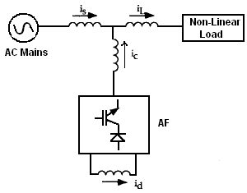 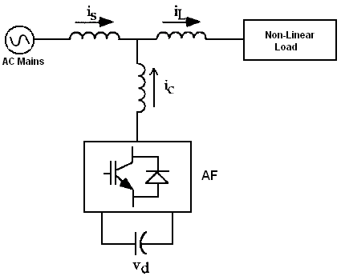

Fig 4.1 Current fed type AF Fig 4.2 Voltage fed type AF

The other converter used as an AF is a voltage-fed PWM inverter structure, as shown in Fig 4.2. It has a self-supporting dc voltage bus with a large dc capacitor. It has become more dominant, since it is lighter, cheaper, and expandable to multilevel and multistep versions, to enhance the performance with lower switching frequencies. It is more popular in UPS-based applications, because in the presence of mains, the same Inverter bridge can be used as an AF to eliminate harmonics of critical nonlinear loads.

**4.2.2 Topology based Classification**

AF’s can be classified based on the topology used as series or shunt filters, and unified power quality conditioners use a combination of both. Combinations of active series and passive shunt filtering are known as hybrid filters. Fig 4.3 is an example of an active shunt filter, which is most widely used to eliminate current harmonics, reactive power compensation (also known as STATCOM), and balancing unbalanced currents. It is mainly used at the load end, because current harmonics are injected by nonlinear loads. It injects equal compensating currents, opposite in phase, to cancel harmonics and/or reactive components of the nonlinear load current at the point of connection. It can also be used as a static VAR generator (STATCOM) in the power system network for stabilizing and improving the voltage profile.

Fig 4.3b shows the basic block of a stand-alone active series filter. It is connected before the load in series with the mains, using a matching transformer, to eliminate voltage harmonics, and to balance and regulate the terminal voltage of the load or line. It has been used to reduce negative-sequence voltage and regulate the voltage on three-phase systems. It can be installed by electric utilities to compensate voltage harmonics and to damp out harmonic propagation caused by resonance with line impedances and passive shunt compensators.

Fig 4.3c shows the hybrid filter, which is a combination of an active series filter and passive shunt filter. It is quite popular because the solid-state devices used in the active series part can be of reduced size and cost (about 5% of the load size) and a major part of the hybrid filter is made of the passive shunt L–C filter used to eliminate lower order harmonics. It has the capability of reducing voltage and current harmonics at a reasonable cost.

Current Source Inverter (CSI) Active Power Filter (Fig 4.1) and Voltage Source Inverter Active Power Filter (VSI) (Fig 4.2) are two classifications in this category. Current Source Inverter behaves as a nonsinusoidal current source to meet the harmonic current requirement of the nonlinear loads. A diode is used in series with the self-commutating device (IGBT) for reverse voltage blocking.

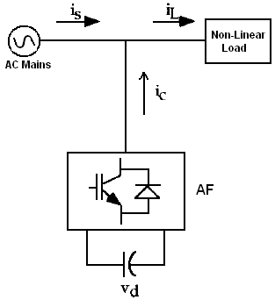 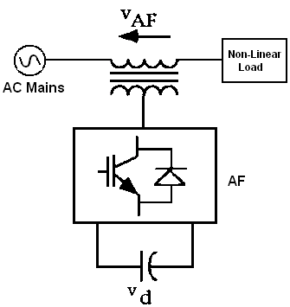

Fig 4.3a Shunt-type AF Fig 4.3b Series-type AF

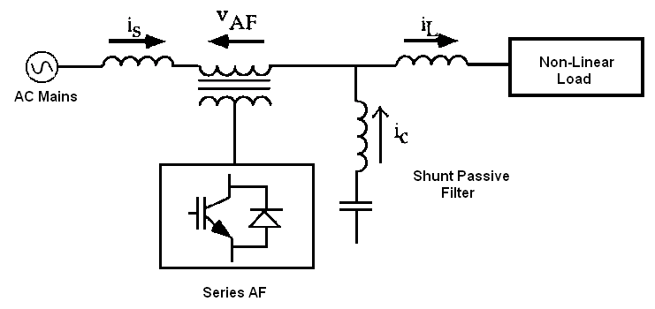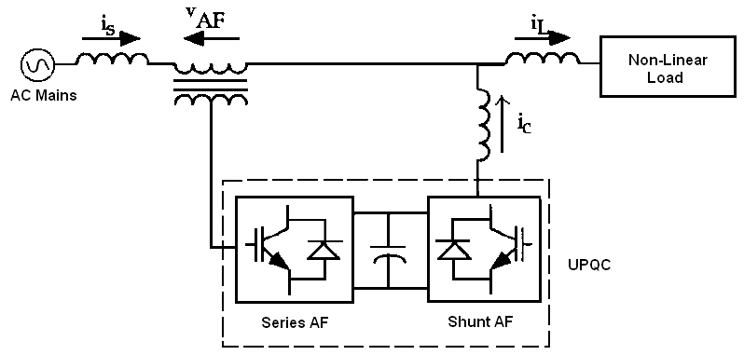

Fig 4.3c Hybrid filter Fig 4.3d Unified Power Quality Conditioner

**Fig 4.3 :** Types of Active Filter

Fig 4.3d shows a unified power quality conditioner (also known as a universal AF), which is a combination of active shunt and active series filters. The dc-link storage element (either inductor or dc-bus capacitor) is shared between two current-source or voltage-source bridges operating as active series and active shunt compensators. It is used in single-phase as well as three-phase configurations. It is considered an ideal AF, which eliminates voltage and current harmonics and is capable of giving clean power to critical and harmonic-prone loads, such as computers, medical equipment, etc. It can balance and regulate terminal voltage and eliminate negative-sequence currents. Its main drawbacks are its large cost and control complexity because of the large number of solid-state devices involved.

**4.2.3 Supply-System-Based Classification**

This classification of AF’s is based on the supply and/or the load system having single-phase (two wire) and three-phase (three wire or four wire) systems. There are many nonlinear loads, such as domestic appliances, connected to single-phase supply systems. Some three-phase nonlinear loads are without neutral, such as ASD’s, fed from three-wire supply systems. There are many nonlinear single-phase loads distributed on four-wire three-phase supply systems, such as computers, commercial lighting, etc. Hence, AF’s may also be classified accordingly as two-wire, three-wire, and four-wire types.

1. **Two-Wire AF’s:**

Two-wire (single phase) AF’s are used in all three modes as active series, active shunt, and a combination of both as unified line conditioners. Both converter configurations, current-source PWM bridge with inductive energy storage element and voltage-source PWM bridge with capacitive dc-bus energy storage elements, are used to form two-wire AF circuits. In some cases, active filtering is included in the power conversion stage to improve input characteristics at the supply end.

1. **Three-Wire AF’s*:***

Three-phase three-wire nonlinear loads, such as ASD’s, are major applications of solid-state power converters and, lately, many ASD’s, etc., incorporate AF’s in their front-end design. A large number of publications have appeared on three-wire AF’s with different configurations. All the configurations shown in Figs 3.1–3.6 are developed, in three-wire AF’s, with three wires on the ac side and two wires on the dc side. Active shunt AF’s are developed in the current-fed type (Fig 3.1) or voltage-fed type with single-stage (Fig 3.2) or multi-step/multilevel and multi-series configurations. Active shunt AF’s are also designed with three single-phase AF’s with isolation transformers [18] for proper voltage matching, independent phase control, and reliable compensation with unbalanced systems. Active series filters are developed for stand-alone mode (Fig 3.4) or hybrid mode with passive shunt filters (Fig 3.5). The latter (hybrid) has become quite popular to reduce the size of power devices and cost of the overall system. A combination of active series and active shunt is used for unified power quality conditioners (Fig 3.6) and universal filters.

All the configurations shown in Figs 3.1–3.6 are developed, in three-wire AF’s, with three wires on the ac side and two wires on the dc side.

**3) Four-Wire AF’s:**

A large number of single-phase loads may be supplied from three-phase mains with neutral conductor. They cause excessive neutral current, harmonic and reactive power burden, and unbalance. To reduce these problems, four-wire AF’s have been attempted. They have been developed as: 1) active shunt mode with current feed and voltage feed; 2) active series mode; and 3) hybrid form with active series and passive shunt mode.

**4.2.4 Compensated Variable Based Classification**

(1) Harmonic Compensation

(2) Multiple Compensation

This is the most important system parameter requiring compensation in power systems and it is subdivided into voltage- and current-harmonic compensation. The compensation of voltage and current harmonics is interrelated.

Different combinations of the above systems can be used to improve the effectiveness of filters. The following are the most frequently used combinations.

· Harmonic currents with Reactive power compensation.

· Harmonic voltages with Reactive power compensation.

· Harmonic currents and voltages.

· Harmonic currents and voltages with reactive-power compensation.

**4.2.5 Voltage Type Vs Current Type APF’s**

A clear trend for preferred type of APF’s does not exist. A choice depends on source of distortion at the specified bus, equipment cost, and amount of correction desired.

Voltage-type has an advantage in that they can be readily expanded in parallel to increase their combined rating. Their combined switching rate can be increased if they are carefully controlled so that their individual switching times do not coincide. Therefore, using parallel voltage-type converters without increasing individual converter switching rates can eliminate higher order harmonics. Voltage type converters are lighter and less expensive than current-type converters.

The main drawback of voltage-type converters lies in the increased complexity of their control system. For systems with several connected in parallel, this complexity is greatly increased.

Current-type converters have advantages of excellent current controllability, easy protection and high reliability over Voltage source APF. More over CSI topology has superior characteristics compared to VSI topology in terms of direct injected current, which result in a faster response in time varying load environment and lower dc energy storage requirement. The drawback of the current source APF is larger power losses of the dc-link inductor. However, the current-type active power filter will become more attractive when the super conducting coils are available in the future. Losses are less important in low- power applications but very important in high power applications.

Since they are easily expandable, voltage type APF’s are likely to be used for network wide compensation. Current type APF’s will continue to popular for single-node distortion problems. In other words, electric utility interest will likely to be focused on voltage type converters, while industrial users likely to use both type of converters.

**4.3 Operation of Three Phase Active Power Filters**

In recent years, the power quality of the AC main system has become a great concern due to the rapidly increased number of electronic equipment. In order to reduce the harmonic contamination in power lines and improve the transmission efficiency Active power filters become essential. A current source is connected in parallel with nonlinear load and controlled to generate the harmonic currents needed for the load.

The basic configuration of a three-phase three-wire active power filter is shown in Fig 4.7. The diode bridge rectifier is used as an ideal harmonic generator to study the performance of the Active filter. The current-controlled voltage-source inverter (VSI) is shown connected at the load end. This PWM inverter consists of six switches with anti-parallels diode across each switch. The capacitor is designed in order to provide DC voltage with acceptable ripples. In order to assure the filter current at any instant, the DC voltage Vdc must be at least equal to 3/2 of the peak value of the line AC mains voltage.



Fig 4.4 Configuration of the three phase, three wire Active filtering system.

Three aspects have to be considered in the design of APF.

a) The parameters of the inverter such as inverter switches and the values of the link inductances.

b) Modulation method used and

c) The control method used to generate the harmonic reference template.

**4.3.1 Sample and Hold circuit’s method for harmonic reference template**

This method is simple, eliminates complicated transformations and mathematical operations such as multiplications and divisions, and permits good transient response. Fig 4.8 shows implementation of Sample and Hold method.



Control block of Sample and Hold circuit's harmonic reference template

The current in each phase of the load is filtered to get the fundamental phase current. A "Sample and Hold" circuit, synchronized with the peak value of the phase-to-neutral voltage, allows to get three dc signals, which are proportional to the amplitude of the active component of the current for each phase. Three dc signals, with the information of the total active power in the load, are averaged to balance the system. Then, by multiplying the averaged dc signal for a set of balanced reference waveforms (in phase with the mains voltages), three in phase balanced currents for each phase are obtained. Finally, these currents are subtracted from the real load currents to get the compensation currents. These harmonic are then able to correct the harmonic distortion, the power factor and the unbalances of the load.

Let to assume that IL is the total load current in one phase. This current contains basically three components.

IL = IP + IQ + IH

Where IP, IQ and IH are the fundamental active, reactive and harmonic currents respectively. The APF will eliminate IQ and IH by subtracting IP from IL.

**Extraction of IP :**

First the load currents sensed and filtered to eliminate the (IH) and then the total fundamental currents (one for each phase) are obtained. These currents have to be separated in their active and reactive components.

I = IP + IQ

Where

IP = I cosφ

However the angle "φ" does need to be known, because the term "I cosφ" can be obtained from the time function of the fundamental when the main voltage reaches its maximum value. Fig 4.9 explains graphically the idea.

The basic configuration of a three-phase three-wire active power filter is shown in Fig 4.7. The diode bridge rectifier is used as an ideal harmonic generator to study the performance of the Active filter. The current-controlled voltage-source inverter (VSI) is shown connected at the load end. This PWM inverter consists of six switches with anti-parallels diode across each switch.



Method used to capture IP.

IP is captured and "stored" until the next sample of IP is obtained to replace the old one. This action is executed with the help of "Sample and Hold" circuits, which are synchronized with the synchronization pulses to trigger the S&H are generated through the "zero-crossing" signals, obtained from the set of "in-quadrature voltages". These "in-quadrature voltages" are generated in the control block with the DZ0 connection, signal transformer.

The control circuit is also has the capability to avoid flickers and transient phenomena in the source, produced by sudden changes in load current. To do this, control system makes soft variation of IP during these moments. However, this action will require to have the energy storage components in the APF. Hence the design of the control system has to take in account the characteristics of the power filter.

**CHAPTER-5**

**CLARK’S TRANSFORMATION AND**

**INVERSE CLARK’S TRANSFORMATION**

**5.1 Clark’s Transformation**

The Clarke transformation is a mathematical technique used in the field of power systems to convert a three-phase system into a two-dimensional orthogonal reference frame. It's particularly useful in analyzing and controlling three-phase systems, especially in contexts like motor control and power quality assessment.

The Clarke transformation takes the three-phase quantities (voltages or currents) and transforms them into two components: one representing the positive sequence and another representing the negative and zero sequence components. This transformation is often employed in conjunction with other transformations, such as the Park transformation, to simplify analysis and control algorithms in three-phase systems**.**

Three-phase voltages varying in time along the axes a, b, and c, can be algebraically transformed into two-phase voltages, varying in time along the axes 𝛼 and 𝛽by the following transformation matrix:

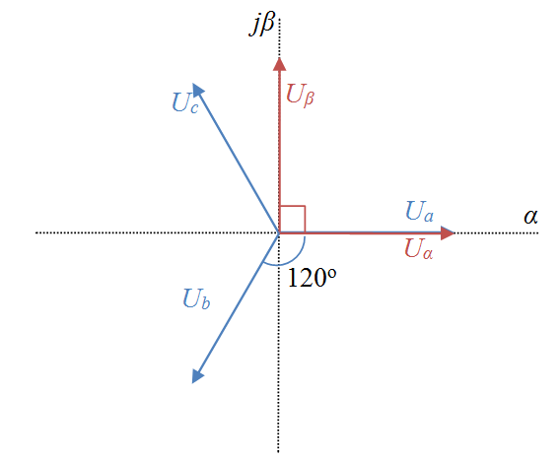

**5.1.1 Clarke’s Transformation of Balanced Three-Phase Voltages**

Consider the following balanced Three-phase voltage waveforms :

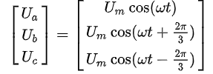

Taking Clarke transform , we get

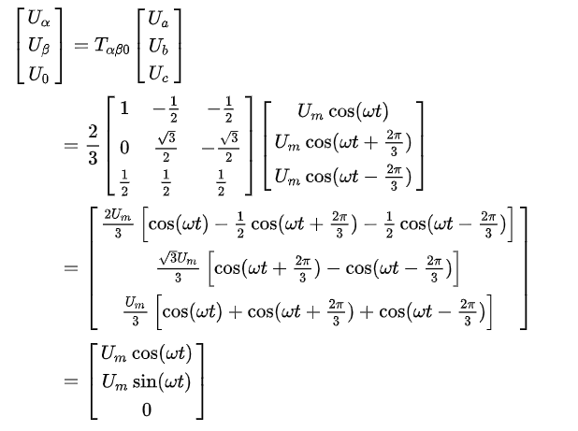

Taking domain simulation result of transform from three-phase stationary into two-phase stationary coordinated system is shown in figure .

The current in each phase of the load is filtered to get the fundamental phase current. A "Sample and Hold" circuit, synchronized with the peak value of the phase-to-neutral voltage, allows to get three dc signals, which are proportional to the amplitude of the active component of the current for each phase. Three dc signals, with the information of the total active power in the load, are averaged to balance the system.

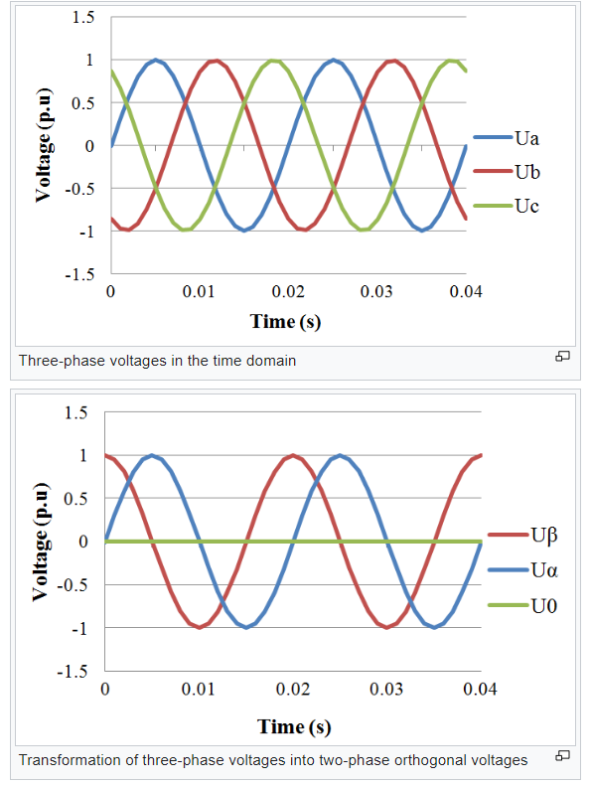

Fig 5.1 :Voltage wave forms before and after Clark’ transformation

**5.1.2 Derivation of Clarke Transformation**

As Three-phase voltages can be represented in 2D complex plane like vectors, the transformation can be done by using same idea. If vector decomposition is used, it can be seen that:

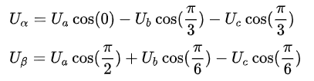

To obtain zero component, every phase voltage can be summed with equal weights to revel any imbalances between phases or DC component. Therefore



If these are written in matrix form

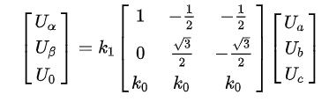

Here a different constant k1 is added as a correction factor to remove scaling errors that occurred due to multiplication. These constants are scaled as k1=2/3 and k0=1/2 above as standard values . However there are also another possibilities to select these coefficients. Another approach can be reduction of gain in matrix to 1.

Let us calculate gain caused by the matrix for first row

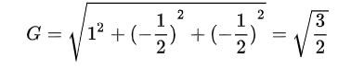

The same result can be obtained for second row if the necessary calculations are done. To reduce this gain to unity value, a coefficient should be added as

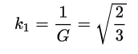

And value of k0 can be calculated from using

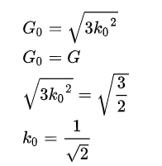

In matrix form

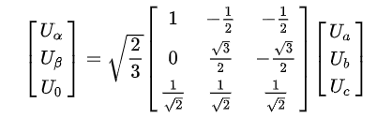

Use of different approaches have different advantages and disadvantages. Advantage of this different selection of coefficients brings the power invariancy.

In first method power can be written as

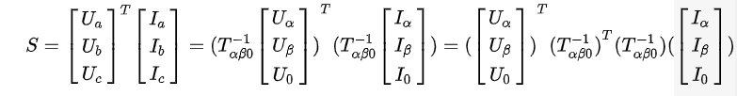

Here the multiplication of 2 transformation matrices can be found as following in the first approach;

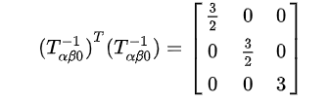

Which causes power to be ;



However, in the second approach where the coefficients are reduced to unity;

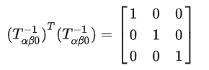

And the power :



Let us consider a three phase source with voltages Va, Vb and Vc .

If Clark Transformation applied ,

Vd=2/3[Vasin(ωt)+Vdsin(ωt-2π/3)+Vcsin(ωt+2pπ/3)]

Vq=2/3[Vacos(ωt)+Vbcos(ωt-2π/3)+Vccos(ωt+2π/3)]

V0=1/3[ Va +Vb+Vc]

Where ω=rotation speed (rad/s) of the rotating frame.

**5.2 Inverse Clarke Transformation**

The inverse Clarke transformation is the process of converting a set of two-phase stationary coordinates (usually represented as α-β coordinates) back into a three-phase set of coordinates (usually represented as a-b-c coordinates). This transformation is the reverse process of the Clarke transformation.

The Clarke transformation converts three-phase quantities to two-phase stationary quantities, typically used in control algorithms for three-phase systems, especially in the context of electric machines and power systems.

Va=[Vdsin(ωt)+Vqcos(ωt)+V0]

Vb==[Vdsin(ωt-2π/3)+Vqcos(ωt-2π/3)+V0]

Vc==[Vdsin(ωt+2π/3)+Vqcos(ωt+2π/3)+V0]

Where ω=rotation speed (rad/s) of the rotating frame.

Note :This Clark’s Transformation also known as Park Transformation

**CHAPTER-6**

**PROPOSED MODEL**

Fig. 6.1 shows the configuration of a typical power distribution system with renewable power generation. It consists of various types of power generation units and different types of loads. Renewable sources, such as wind and sunlight, are typically used to generate electricity for residential users and small industries. Both types of power generation use ac/ac and dc/ac static PWM converters for voltage conversion and battery banks for long term energy storage. These converters perform maximum power point tracking to extract the maximum energy possible from wind and sun. The electrical energy consumption behavior is random and unpredictable, and therefore, it may be single- or three-phase, balanced or unbalanced, and linear or nonlinear.

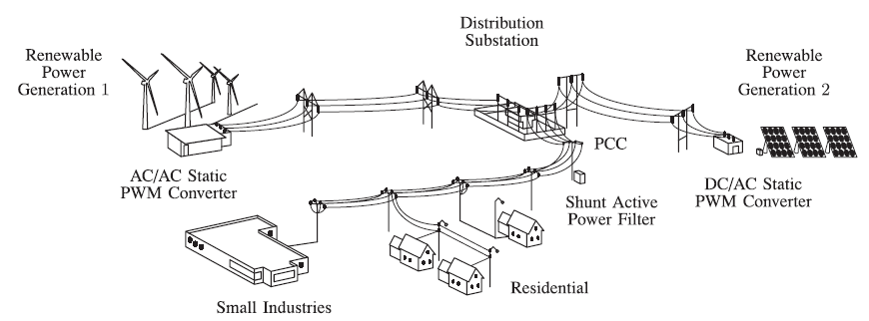

Fig 6.1: Stand-alone hybrid power generation system with a shunt active power filter

An active power filter is connected in parallel at the point of common coupling to compensate current harmonics, current unbalance, and reactive power. It is composed by an electrolytic capacitor, a four-leg PWM converter, and a first-order output ripple filter, as shown in Fig. 2. This circuit considers the power system equivalent impedance *Zs,* the converter output ripple filter impedance *Zf,* and the load impedance *ZL.*

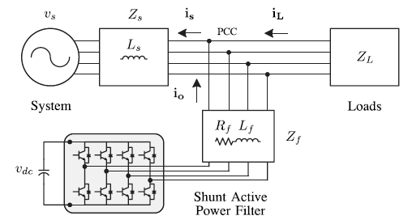

Fig 6.2 Three-phase equivalent circuit of the proposed shunt active power filter

The four-leg PWM converter topology is shown in Fig. 3. This converter topology is similar to the conventional three-phase converter with the fourth leg connected to the neutral bus of the system. The fourth leg increases switching states from 8 (23) to 16 (24), improving control flexibility and output voltage quality, and is suitable for current unbalanced compensation.

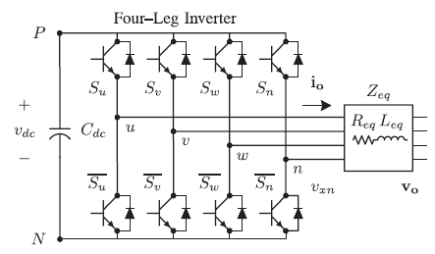

Fig 6.3 Two-level four-leg PWM-VSI topology

The voltage in any leg *x* of the converter, measured from the neutral point (*n*), can be expressed in terms of switching states, as follows:



The mathematical model of the filter derived from the equivalent circuit shown in Fig. 2 is



Where *R*eq and *L*eq are the 4L-VSI output parameters expressed as Thevenin impedances at the converter output terminals *Z*eq . Therefore, the Thevenin equivalent impedance is determined by a series connection of the ripple filter impedance *Zf* and a parallel arrangement between the system equivalent impedance *Zs* and the load impedance *ZL*



For this model, it is assumed that *ZL>>Zs* , that the resistive part of the system’s equivalent impedance is neglected, and that the series reactance is in the range of 3–7% p.u., which is an acceptable approximation of the real system. Finally, in (2) *R*eq = *Rf* and *L*eq = *Ls* + *Lf.*

**BLOCK DIAGRAM**

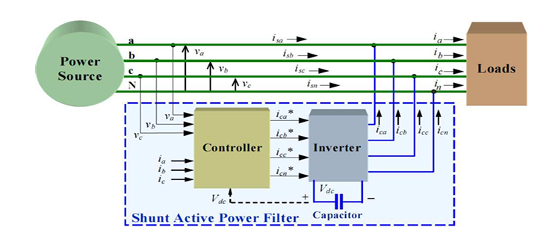

Fig 6.4 :Block Diagram of proposed system

**CHAPTER-7**

**MATLAB & SIMULINK**

**7.1 MATLAB**

**7.1.1 Introduction**

MATLAB® is a high-level technical computing language and interactive environment for algorithm development, data visualization, data analysis, and numeric computation. Using the MATLAB product, you can solve technical computing problems faster than with traditional programming languages, such as C, C++, and FORTRAN.

MATLAB is used in wide range of applications, including signal and image processing, communications, control design, test and measurement, financial modeling and analysis, and computational biology. Add-on toolboxes (collections of special-purpose MATLAB functions, available separately) extend the MATLAB environment to solve particular classes of problems in these application areas.

MATLAB provides a number of features for documenting and sharing your work. You can integrate your MATLAB code with other languages and applications, and distribute your MATLAB algorithms and applications.

**7.1.2 Key Features**

* High-level language for technical computing
* Development environment for managing code, files, and data
* Interactive tools for iterative exploration, design, and problem solving
* Mathematical functions for linear algebra, statistics, Fourier analysis, filtering, optimization, and numerical integration
* 2-D and 3-D graphics functions for visualizing data
* Tools for building custom graphical user interfaces
* Functions for integrating MATLAB based algorithms with external applications and languages, such as C, C++, Fortran, Java, COM, and Microsoft Excel

**7.2 SIMULINK**

**7.2.1 Introduction**

Simulink® is an environment for multi-domain simulation and Model-Based Design for dynamic and embedded systems. It provides an interactive graphical environment and a customizable set of block libraries that let you design, simulate, implement, and test a variety of time-varying systems, including communications, controls, signal processing, video processing, and image processing.

Add-on products extend Simulink software to multiple modeling domains, as well as provide tools for design, implementation, and verification and validation tasks.

Simulink is integrated with MATLAB®, providing immediate access to an extensive range of tools that let you develop algorithms, analyze and visualize simulations, create batch processing scripts, customize the modeling environment, and define signal, parameter, and test data.

**7.2.2 Key Features**

* Extensive and expandable libraries of predefined blocks
* Interactive graphical editor for assembling and managing intuitive block diagrams
* Ability to manage complex designs by segmenting models into hierarchies of design components
* Model Explorer to navigate, create, configure, and search all signals, parameters, properties, and generated code associated with your model
* Application programming interfaces (APIs) that let you connect with other simulation programs and incorporate hand-written code
* Embedded MATLAB™ Function blocks for bringing MATLAB algorithms into Simulink and embedded system implementations
* Simulation modes (Normal, Accelerator, and Rapid Accelerator) for running simulations interpretively or at compiled C-code speeds using fixed- or variable-step solvers
* Graphical debugger and profiler to examine simulation results and then diagnose performance and unexpected behavior in your design
* Full access to MATLAB for analyzing and visualizing results, customizing the modeling environment, and defining signal, parameter, and test data

**7.2.3 Block Diagram**

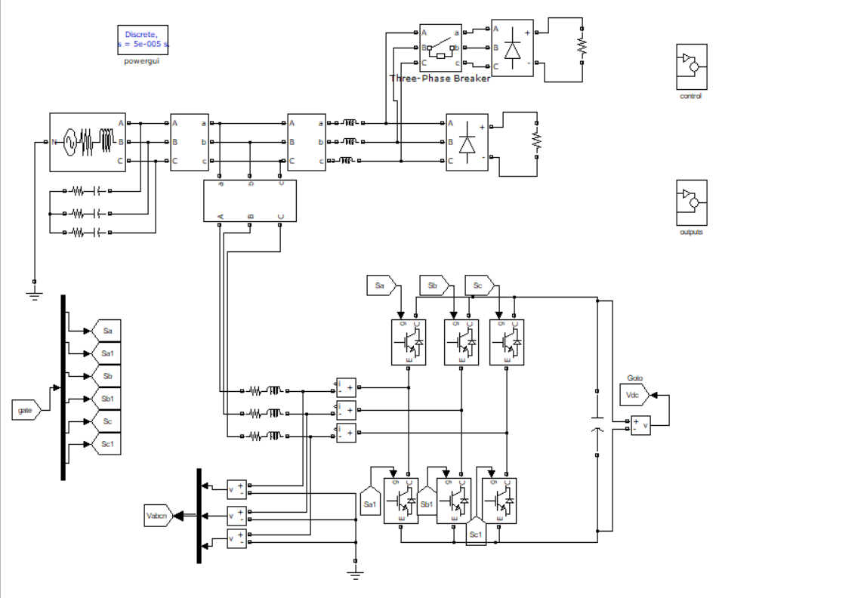

Fig7.1a :SHAPF connected to Grid

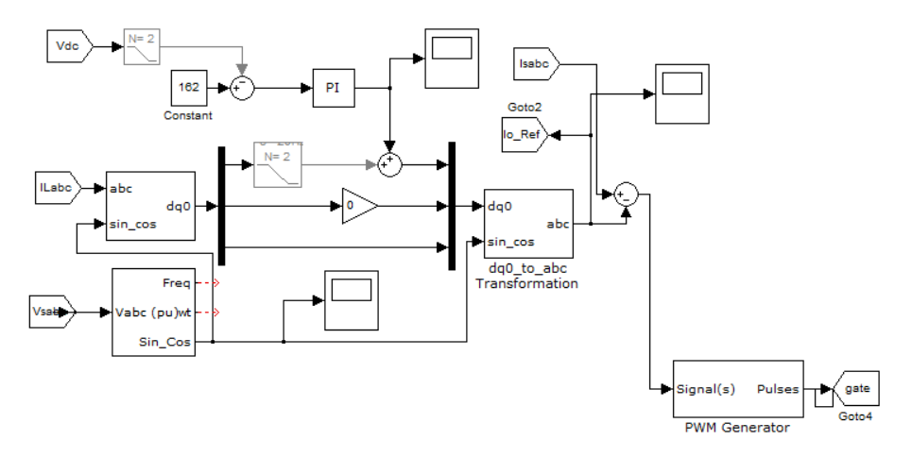

Fig 7.1b :controller

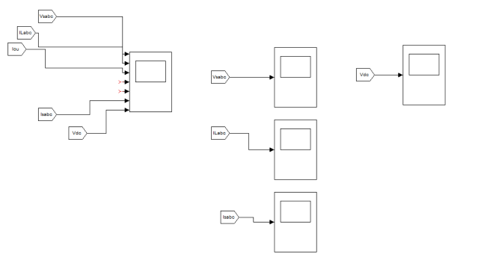Fig 7.1c :Scopes

**7.2.4 Simulink Block Libraries**

Simulink organizes its blocks into block libraries according to their behavior:

1. The Sources library contains blocks that generate signals.
2. The Sinks library contains blocks that display or write block output.
3. The Discrete library contains blocks that describe discrete-time components.
4. The Continuous library contains blocks that describe linear functions.
5. The Math library contains blocks that describe general mathematics functions.
6. The Functions & Tables library contains blocks that describe general functions and table look-up operations.
7. The Nonlinear library contains blocks that describe nonlinear functions.
8. The Signal & Systems library contains blocks that allow multiplexing and de-multiplexing, implement external input/output, pass data to other parts of the model, and perform other functions.
9. The Subsystems library contains blocks for creating various types of subsystems.
10. The Block sets and Toolboxes library contains the Extras block library of specialized blocks.

**7.2.5 Sub Systems**

Simulink allows to model a complex system as a set of interconnected subsystems each of which is represented by a block diagram. We create a subsystem using Simulink's Subsystem block and the Simulink model editor. We can embed subsystems with subsystems to any depth to create hierarchical models. We can create conditionally executed subsystems that are executed only when a transition occurs on a triggering or enabling input.

**7.2.6 Solvers**

Simulink simulates a dynamic system by computing its states at successive time step solver a specified time span, using information provided by the model. The process of computing the successive states of a system from its model is known as solving the model. No single method of solving a model suffices for all systems. Accordingly, Simulink provides a set of programs, known as solvers, that each embody a particular approach to solving a model. The Simulation Parameters dialog box allows us to choose the solver most suitable for our model.

**7.2.6.1 Fixed-Step Solvers**

Fixed-step solvers solve the model at regular time intervals from the beginning to the end of the simulation. The size of the interval is known as the step-size. We can specify the step size or let the solver choose the step size. Generally decreasing the step size increases the accuracy of the results while increasing the time required to simulate the system.

**7.2.6.2 Variable-Step Solvers**

Variable-step solvers vary the step size during the simulation, reducing the step size to increase accuracy when a model's states are changing rapidly and increasing the step size to avoid taking unnecessary steps when the model's states are changing slowly. Computing the step size adds to the computational overhead at each step but can reduce the total number of steps, and hence simulation time, required to maintain a specified level of accuracy for models with rapidly changing or piecewise continuous states.

**7.2.6.3 Continuous Solvers**

Continuous solvers use numerical integration to compute a model's continuous states at the current time step from the states at previous time steps and the state derivatives. Continuous solvers rely on the model's blocks to compute the values of the model's discrete states at each time step. Mathematicians have developed a wide variety of numerical integration techniques for solving the ordinary differential equations (ODEs) that represent the continuous states of dynamic systems. Simulink provides an extensive set of fixed-step and variable-step continuous solvers, each implementing a specific ODE solution method. Some continuous solvers subdivide the simulation time span into major and minor steps, where a minor time step represents a subdivision of the major time step. The solver produces a result at each major time step. It uses results at the minor time steps to improve the accuracy of the result at the major time step.

**7.2.6.4 Discrete Solvers**

Discrete solvers exist primarily to solve purely discrete models. They compute the next simulation time-step for a model and nothing else. They do not compute continuous states and they rely on the model's blocks to update the model's discrete states. We can use a continuous solver, but not a discrete solver, to solve a model that contains both continuous and discrete states. This is because a discrete solver does not handle continuous states. If you select a discrete solver for a continuous model, Simulink disregards your selection and uses a continuous solver instead when solving the model.

Simulink provides two discrete solvers, a fixed-step discrete solver and a variable-step discrete solver. The fixed-step solver by default chooses a step size and hence simulation rate fast enough to track state changes in the fastest block in our model. The variable-step solver adjusts the simulation step size to keep pace with the actual rate of discrete state changes in our model. This can avoid unnecessary steps and hence shorten simulation time for multirate models.

**7.3 The Power System Block Set**

Electrical power systems are combinations of electrical circuits and Electro-mechanical devices, like motors and generators. Engineers working in this discipline are frequently tasked to improve the performance of the systems. Requirements for drastically increased efficiency have forced power system designers to use power electronic devices and sophisticated control system concepts that tax traditional analysis tools and techniques. Further complicating the analyst’s role is the fact that the system is often so nonlinear that the only way to understand it is through simulation. Land-based power generation from hydroelectric, steam, or other devices is not the only use of power systems. A common attribute of these systems is their use of power electronics and control systems to achieve their performance objectives. The Power System Block set was designed to provide a modern design tool that will allow scientists and engineers to rapidly and easily build models that simulate power systems. The block set uses the Simulink® environment allowing a model to be built using simple click and drag procedures. Not only can the circuit topology be drawn rapidly, but the analysis of the circuit can include its interactions with mechanical, thermal, control, and other disciplines. This is possible because all the electrical parts of the simulation interact with Simulink’s extensive modeling library. Because Simulink uses MATLAB® as the computational engine, you can use MATLAB’s toolboxes as you design your simulation.

The block set can be put to work rapidly. The libraries contain models of typical power equipment, such as transformers, lines, machines, and power electronics. These models are proven ones coming from textbooks, and their validity is based on the experience of the Power Systems Testing and Simulation Laboratory of Hydro-Québec, a large North American utility located in Canada. The capabilities of the block set for modeling a typical electrical grid are illustrated in demonstration files. The block set fits well with other specialized analytical tools you use in the power system community.

**7.4 Simulink Blocks used in the Simulation:**

**1. Three-Phase Source:**

Description: iconnewf

**Purpose:** Implement three-phase source with internal R-L impedance

**Description:** The Three-Phase Source block implements a balanced three-phase voltage source with internal R-L impedance. The three voltage sources are connected in Y with a neutral connection that can be internally grounded or made accessible. You can specify the source internal resistance and inductance either directly by entering R and L values or indirectly by specifying the source inductive short-circuit level and X/R ratio.

**2. in port:**



Purpose: **Provide a link to an external input and for linearization.**

**Description:** In ports are the links from the outside world into a system. Inside a subsystem block, there is an in port corresponding to each input port on the block. A signal that arrives at an input port on a subsystem block flows out of the corresponding in port within that block. The imports within a subsystem block must be numbered consecutively, starting with1.

**3.** **out port:**



Purpose: **provide a link to an external output and for linearization.**

**Description:** The Out port block provides a mechanism for labeling a system’s outputs. In a subsystem, output ports correspond to outputs on the subsystem block.

**4. Subsystem:**



**Purpose:** Group blocks into a subsystem

**Description:** Subsystem blocks represent one system within another system. Any set of blocks and lines can be converted to a Subsystem block with the Group command on the options menu. The Group command removes all selected objects from the active window and replaces them within a Subsystem block. This new block, when opened, redisplays all of the grouped objectives.

**5. Gain:**



**Purpose:** Multiply its input by a constant.

Description:The Gain block implements Y=KU, where Y is the output, U is the input, and K is the specified gain. The Gain block displays scalar gain data entered as variable or a constant. The block displays the text as it appears in the dialog box.

**6. Scope:**



Purpose: **Display signals during simulation.**

**Description:** While the simulation is running, the Scope block displays the output of the block driving it. Opening a scope block produces a scope window. The title of this window matches the name of the block.

**7. Three Phase VI Measurement :**

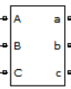

**Purpose:** Measure 3 phase voltage and current

**Description:** When connected in series with a three-phase element, it return the three phase- to-ground voltage and line current.

**8. Voltage Measurement:**

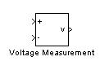

**Purpose:** Measure a voltage in a circuit

**Description:** The Voltage Measurement block is used to measure the instantaneous voltage between two electric nodes. The output is a Simulink signal that can be used

by other Simulink blocks.

**9. Breaker:**

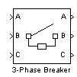

**Purpose:** Implement a circuit breaker opening at current zero crossing

**Description:** The Breaker block implements a circuit breaker that is controlled by a Simulink signal applied on its second input. The control signal must be 0 or 1, 0 for open and 1 for closed. The arc extinction process is simulated by opening the breaker when the current passes through zero (first current zero-crossing following the transition of the Simulink control input from 1 to 0). When the breaker is closed, it behaves as a series RL circuit. The R and L values can be set as small as necessary in order to be negligible compared with external components (typical values Ron=10m?, Lon=10µH). When the breaker is open, it has infinite impedance. If the breaker’s initial state is set to 1 (closed), initializes all the states of the linear circuit and breaker initial current so that the simulation starts in steady-state.

**10. Bus bar:**



**Purpose:** Implement a labeled network node

**Description**: The Bus Bar block is used to interconnect components. It allows multiple electrical block outputs and inputs to be connected together.

**11. Current Measurement:**

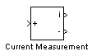

**Purpose:** Measure a current in a circuit

**Description:** The Current Measurement block is used to measure the instantaneous current flowing in any electrical block or connection line. The first output provides a Simulink signal that can be used by other Simulink blocks.

**12. IGBT :**

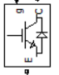

**Purpose:** It is a power semi-conductor device used in power drives applications.

**Description :**IGBT used in formation of Voltage Source Inverter in Active Power Filter, six similar IGBT’s are used for it.

**13. abc to dq0 Transformation :**

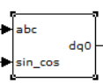

**Purpose :**Transformation of Three Phase quantities to Synchronous Rotating Frame Quantities

**Description :**This block performs that the abc-to-dq0 on a set of three phase signals. It computes the direct axis Vq, quadratic axis Vq and zero sequence V0 quantities in two axis rotating frame.

**14. PI controller :**



**Purpose:** This block implements a discreate PI controller

**Description :** The proportional controller commonly known as PI controller is an essential part of the Industrial Automation and Control system. It is a closed-loop feedback control mechanism that aims to adjust the process variable by manipulating the variable based on the error between the setpoint and the process variable.

**CHAPTER-8**

**SIMULATION RESULTS**

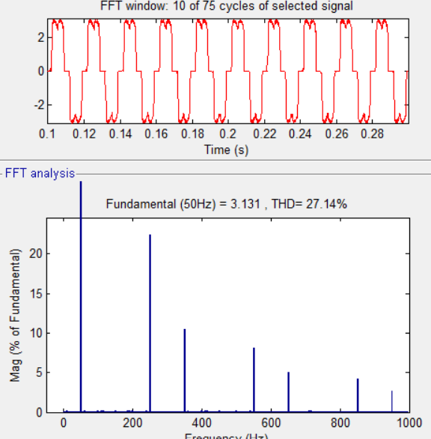

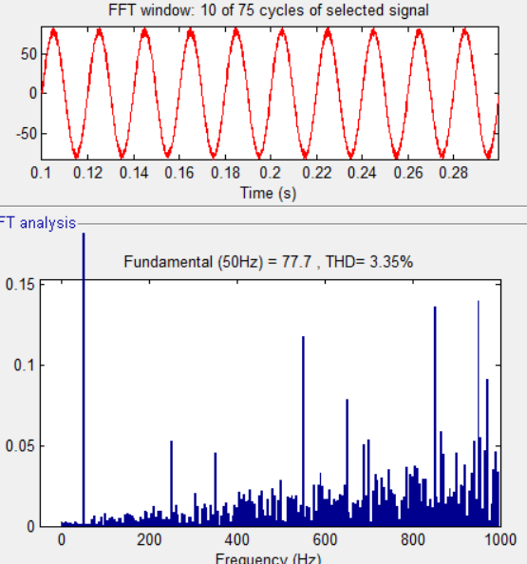

Fig 8.1a :%THD of voltage without filter Fig 8.1b :%THD of voltage with filter

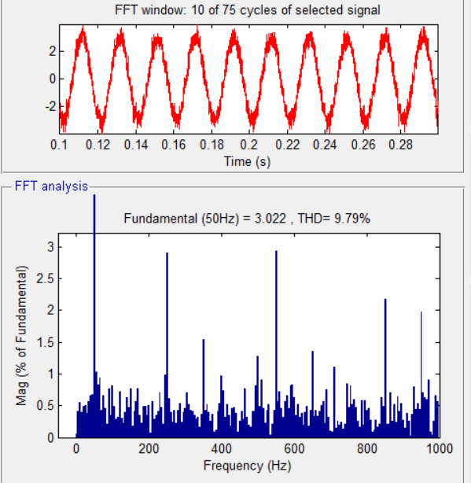

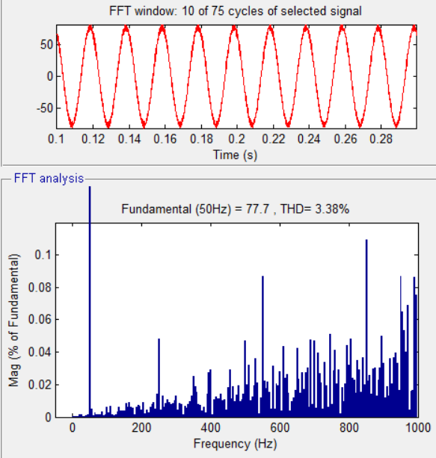

Fig 8.2a :%THD of current without filter fig 8.2b : %THD of current with filter

**Scope Data**

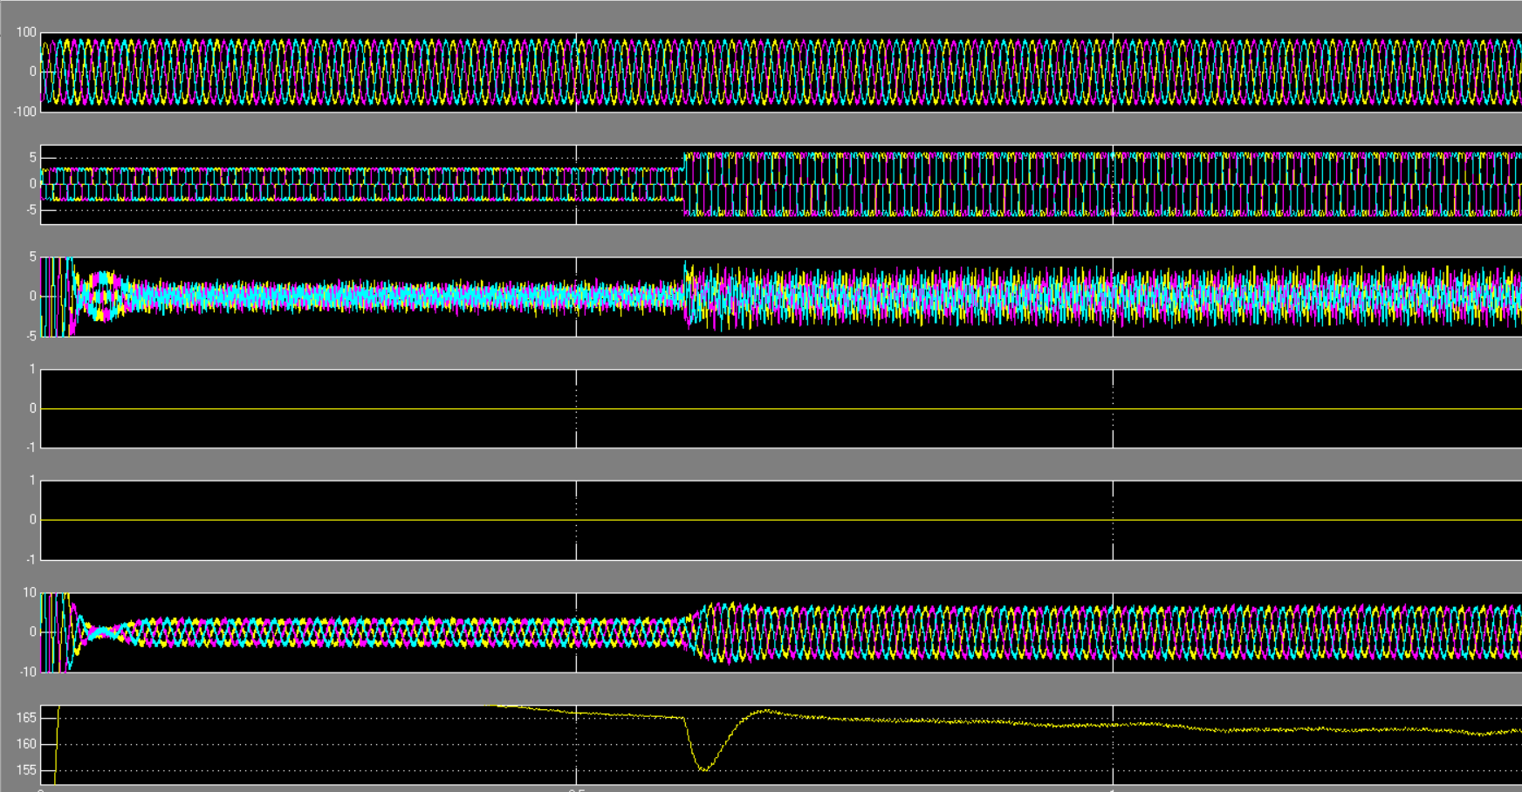

Fig 8.3: Scope Data

**FUTURE SCPOE**

The scope of Shunt Hybrid Active Power Filters for non-linear loads is vast, encompassing various industries, applications , and regulatory requirements. By addressing harmonic distortion, reactive power issues, and voltage regulation challenges, SHAPF’s contribute to improving power quality, enhancing system efficiency, and ensuring reliable operation of electrical systems in diverse environments.

**CONCLUSION**

In this paper based on SRF method, a control technique for shunt hybrid active power filter (SHAPF) has been designed to improve power quality. A modified PLL is developed and effectively employed in order to grid voltage synchronization under balanced and unbalanced conditions. For two different source conditions (balanced & unbalanced) the THD has been found 3.50%. The load current is found linear after using SHAPF for both different sources. Therefore, with the combination of PI and modified SRF theory approach, SHAPF can be considered as a reliable harmonic reducer for its fast response and high quality of filtering.

**REFERENCES**

* 1. IEEE Standard: 519-2014, "IEEE Recommended Practice and Requirements for Harmonic Control in Electric Power Systems".
  2. George J. Wakileh, "Power System Harmonics: Fundamentals, Analysis and Filter Design," Springer India Pvt. Ltd., 2007.
  3. Cividino L, , et al., “Power Factor, Harmonic distortion Cause, effects and Considerations”, IEEE telecommunications Energy Conference, INTELEC PZ, 14th International, 4-8 Oct.1992, pp 506 -513.
  4. H. AKAGI, “Modern active filters and traditional passive filters”, Bulletin of the polish Academy of Sciences, Technical Sciences, Vol. 54, No.3, 2006.
  5. Rivas, D.; Moran, L.; Dixon, J.W.; Espinoza, J.R., "Improving passive filter compensation performance with active techniques", IEEE Transactions on Industrial Electronics , vol.50, no.1, pp.161,170, Feb. 2003 doi: 10.1109/TIE.2002.807658.
  6. D. M. Soomro, S. C. Chong, Z. A. Memon, F. Abbasi, “Power Quality Improvement in QUCEST Larkana Campus by Using Three Types of Power Filters”, International Journal of Power Electronics and Drive Systems (IJPEDS), 10.11591/ijpeds.v8.i4.pp1876-1885, 2017.
  7. Akhilesh Kumar Panigrahi, R.D. Kulkarni, Dipankar Sadhu, "Design and simulation of innovative hybrid filter for Harmonic compensation", Power Electronics Intelligent Control and Energy Systems (ICPEICES) IEEE International Conference on, pp. 1-6, 2016.
  8. P. Salmeron and S.P. Litran, "A Control Strategy for Hybrid Power Filter to Compensate Four-Wire Three-Phase Systems", IEEE Transactions on Power Electronics, Vo1.25, Issue 7, pp.I923-1931, July 2010.