Smart Attendance: A QR-Based Real-Time Attendance Management System Using the MERN Stack

Abstract
Manual attendance tracking in educational institutions is time-consuming, error-prone, and susceptible to proxy attendance. This paper presents Smart Attendance, a full-stack web application built on the MERN stack (MongoDB, Express.js, React, Node.js) that automates attendance through secure, time-rotating QR codes. Teachers create sessions that generate HMAC-signed QR tokens rotating every 15 seconds. Students scan these codes via their phone cameras, and the system validates enrollment, token authenticity, session liveness, and duplicate entries before marking attendance. Socket.IO enables real-time roster updates visible to teachers within a second of each scan. The system provides role-based dashboards, per-class and per-student attendance analytics with percentage calculations, CSV export for institutional reporting, and a fully responsive interface operable on both desktops and mobile devices over a shared local network. Testing across multiple sessions demonstrates that the system reduces attendance time from 5–10 minutes of roll-call to under 30 seconds of QR display, while eliminating proxy attendance through cryptographic token validation and enrollment-gated scanning.
Attendance Management, QR Code, MERN Stack, Real-Time Systems, WebSocket, HMAC Authentication, Role-Based Access Control, Educational Technology

Introduction
Attendance tracking remains a fundamental administrative requirement in educational institutions worldwide. Traditional methods — manual roll-calls, sign-in sheets, and paper registers — consume 5–10 minutes per lecture, are vulnerable to proxy attendance, and produce records that are difficult to aggregate and analyze digitally . Biometric solutions (fingerprint, facial recognition) offer accuracy but demand specialized hardware, raise privacy concerns, and create bottlenecks when large groups must authenticate sequentially .
QR-code-based attendance offers a compelling middle ground: it requires no specialized hardware beyond the smartphones students already carry, supports parallel scanning (all students scan simultaneously), and integrates naturally into web-based workflows . However, naive QR implementations suffer from a critical vulnerability — static codes can be photographed and shared, enabling proxy attendance from outside the classroom.
This paper presents Smart Attendance, a system that addresses these challenges through three key mechanisms: (1) HMAC-signed QR tokens that rotate every 15 seconds, making code-sharing infeasible; (2) server-side validation that checks enrollment, session liveness, token cryptographic integrity, and duplicate scans; and (3) real-time WebSocket updates that give teachers instant visibility into who has scanned. The system is built entirely on the MERN stack and is designed for zero-infrastructure deployment — it runs on a single laptop and serves both desktop and mobile clients over a local network with HTTPS for camera access.

Literature Review

Traditional Attendance Methods
Manual attendance systems remain prevalent despite known inefficiencies. Studies show that roll-call attendance in a 60-student class consumes an average of 7.2 minutes per session, accounting for approximately 12% of total lecture time . Paper-based systems additionally suffer from transcription errors during digitization, with error rates of 3–5% reported in institutional audits .

Biometric Attendance Systems
Fingerprint and facial recognition systems achieve high accuracy (95–99%) but face practical deployment challenges including hardware cost ($200–500 per terminal), sequential processing bottlenecks, hygiene concerns (shared fingerprint scanners), and student privacy objections . RFID-based systems require card distribution and readers at every entry point, adding infrastructure costs .

QR-Code-Based Systems
QR codes have been explored for attendance by several researchers. Masalha and Hirzallah proposed a QR-based system but used static codes vulnerable to sharing. Dey et al. introduced time-limited codes but without cryptographic signing, leaving tokens susceptible to forgery. Olanrewaju et al. combined QR codes with geolocation but this approach fails in multi-room buildings where GPS accuracy is insufficient.

Real-Time Web Technologies
WebSocket-based communication via Socket.IO enables sub-second bidirectional data transfer between server and clients, making it suitable for live dashboards and notification systems in educational contexts . The MERN stack has emerged as a popular choice for full-stack educational platforms due to its JavaScript-everywhere paradigm and rich ecosystem .

Gap Analysis
Existing QR-based attendance systems lack one or more of: cryptographic token rotation (preventing sharing), enrollment validation (preventing unauthorized marking), real-time feedback (requiring manual roster checks), and integrated analytics (requiring separate tools for reporting). Smart Attendance addresses all four gaps in a single integrated platform.

Objectives of the Study

Primary Objectives
- To develop a secure QR-based attendance system with HMAC-signed, time-rotating tokens
- To implement role-based access control separating teacher and student workflows
- To provide real-time attendance tracking via WebSocket communication
- To build per-class and per-student attendance analytics with percentage calculations
- To support CSV export for institutional reporting requirements
- To deliver a responsive web interface functional on both desktop and mobile devices
- To enable zero-infrastructure deployment over local networks

Secondary Objectives
- To implement secure user authentication with JWT and password reset via email
- To support class and student roster management by teachers
- To auto-mark absent students upon session termination
- To provide session notifications to enrolled students in real-time

System Architecture
Smart Attendance follows a three-tier architecture comprising a React client, an Express/Node.js server, and a MongoDB database, connected via REST APIs and WebSocket channels.
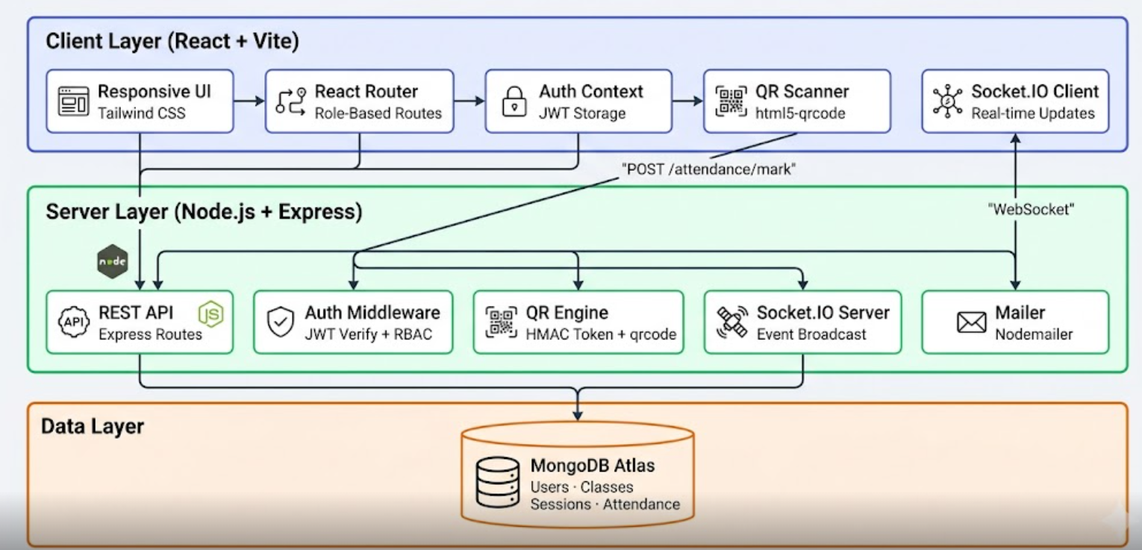
System Architecture Diagram

Client Layer
The frontend is built with React 18 and Vite, styled with Tailwind CSS. React Router provides role-based routing with protected route guards. The html5-qrcode library drives the camera-based QR scanner. A Socket.IO client maintains a persistent WebSocket connection for real-time event reception.

Server Layer
The backend runs on Node.js with Express.js, providing RESTful API endpoints for authentication, class management, session management, attendance recording, and reporting. Key middleware includes JWT verification and role-based access guards. The QR engine generates HMAC-signed tokens using Node.js crypto module. Socket.IO server broadcasts attendance events to class-specific rooms. Nodemailer handles password reset emails.

Data Layer
MongoDB Atlas stores four primary collections: Users, Classes, Sessions, and Attendance. Mongoose ODM provides schema validation and indexing. A unique compound index on (session, student) in the Attendance collection prevents duplicate entries at the database level.

Database Design
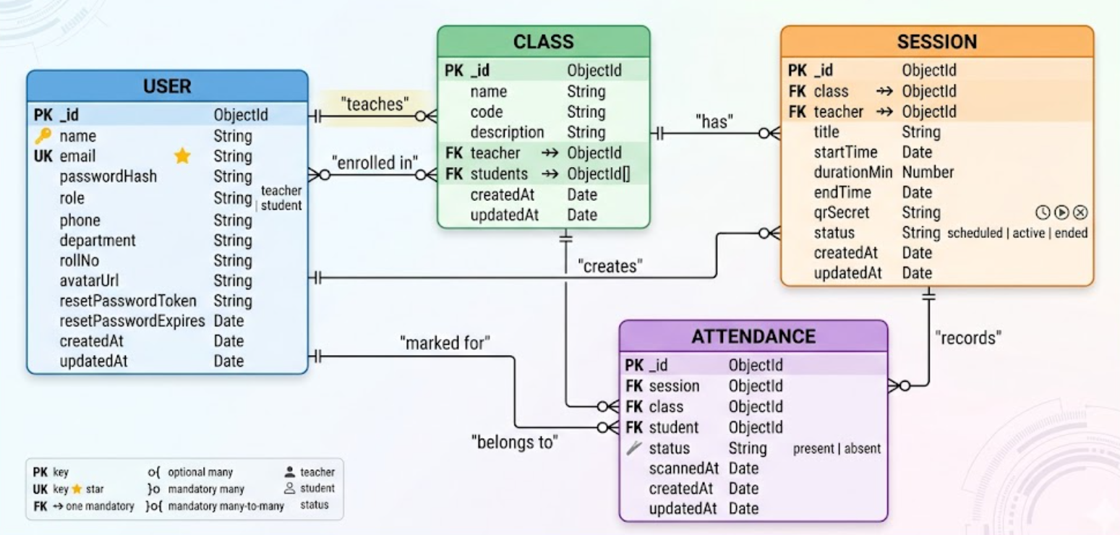
Entity-Relationship Diagram
The database consists of four collections:
User: Stores name, email (unique, indexed), hashed password (bcrypt, 10 salt rounds), role (teacher/student), and profile fields (phone, department, roll number). Password reset uses SHA-256 hashed tokens with 1-hour expiry.
Class: Contains class name, code (unique per teacher via compound index), description, teacher reference, and an array of student references. The teacher-code compound index prevents duplicate class codes within a teacher’s scope.
Session: Records class reference, teacher reference, title, start time, duration, computed end time, a 256-bit random secret for QR signing, and status (scheduled/active/ended).
Attendance: Links a session, class, and student with status (present/absent) and scan timestamp. The unique compound index on (session, student) enforces one record per student per session.

Working Model and Implementation

Technology Stack
Technology Stack
Component | Technology
Frontend | React 18, Vite, Tailwind CSS
Backend | Node.js, Express.js
Database | MongoDB Atlas, Mongoose
Authentication | JWT, bcryptjs
Real-time | Socket.IO
QR Generation | qrcode (server), html5-qrcode (client)
Token Security | HMAC-SHA256 (Node.js crypto)
Email | Nodemailer (Ethereal for dev)
HTTPS | @vitejs/plugin-basic-ssl

QR Token Security Mechanism
The QR token is the core security element of the system. Unlike static QR codes that can be photographed and shared, Smart Attendance implements a time-rotating HMAC scheme:
- When a session is created, the server generates a 256-bit random qrSecret stored only in the database (never sent to any client).
- The time axis is divided into 15-second windows: $w=⌊t/15000⌋$.
- The token payload is constructed as: sessionId.windowIndex.
- An HMAC-SHA256 signature is computed: $σ={\text{HMAC}}_{qrSecret}(\text{payload})$.
- The final QR content is: sessionId.windowIndex.$σ$.
- On scan, the server recomputes the HMAC and accepts tokens within $±1$ window (allowing for scan latency).
- Timing-safe comparison prevents timing attacks.
This design ensures that a token shared via screenshot becomes invalid within 30 seconds, and tokens cannot be forged without the server-side secret.

Attendance Validation Pipeline
When a student submits a scanned token, the server executes five sequential checks:
- Session existence: The session ID embedded in the token must reference a valid session.
- Session liveness: Current time must fall between session start and end times, and status must not be “ended.”
- Token integrity: HMAC verification confirms the token was generated by the server and is within the valid time window.
- Enrollment check: The student must be in the class’s enrolled student list.
- Duplicate check: The unique (session, student) index prevents double-marking; the application also checks explicitly and returns a descriptive error.
Only if all five checks pass is attendance recorded with status “present” and the current timestamp.

Real-Time Communication
Socket.IO is used for two event types:
- session:created — broadcast to all users in a class room when a teacher starts a session, triggering a toast notification on student devices.
- attendance:marked — broadcast when a student successfully scans, updating the teacher’s live roster without polling.
On WebSocket connection, the server authenticates the JWT and automatically joins the user to Socket.IO rooms for every class they belong to.

Session Lifecycle
A session progresses through three states:
- Scheduled: Created with a future start time; QR not yet available.
- Active: Current time is between start and end; QR is generated and rotated.
- Ended: Teacher explicitly ends the session or the duration expires. On ending, the server bulk-inserts “absent” records for all enrolled students who did not scan, ensuring complete attendance data.

Screenshots
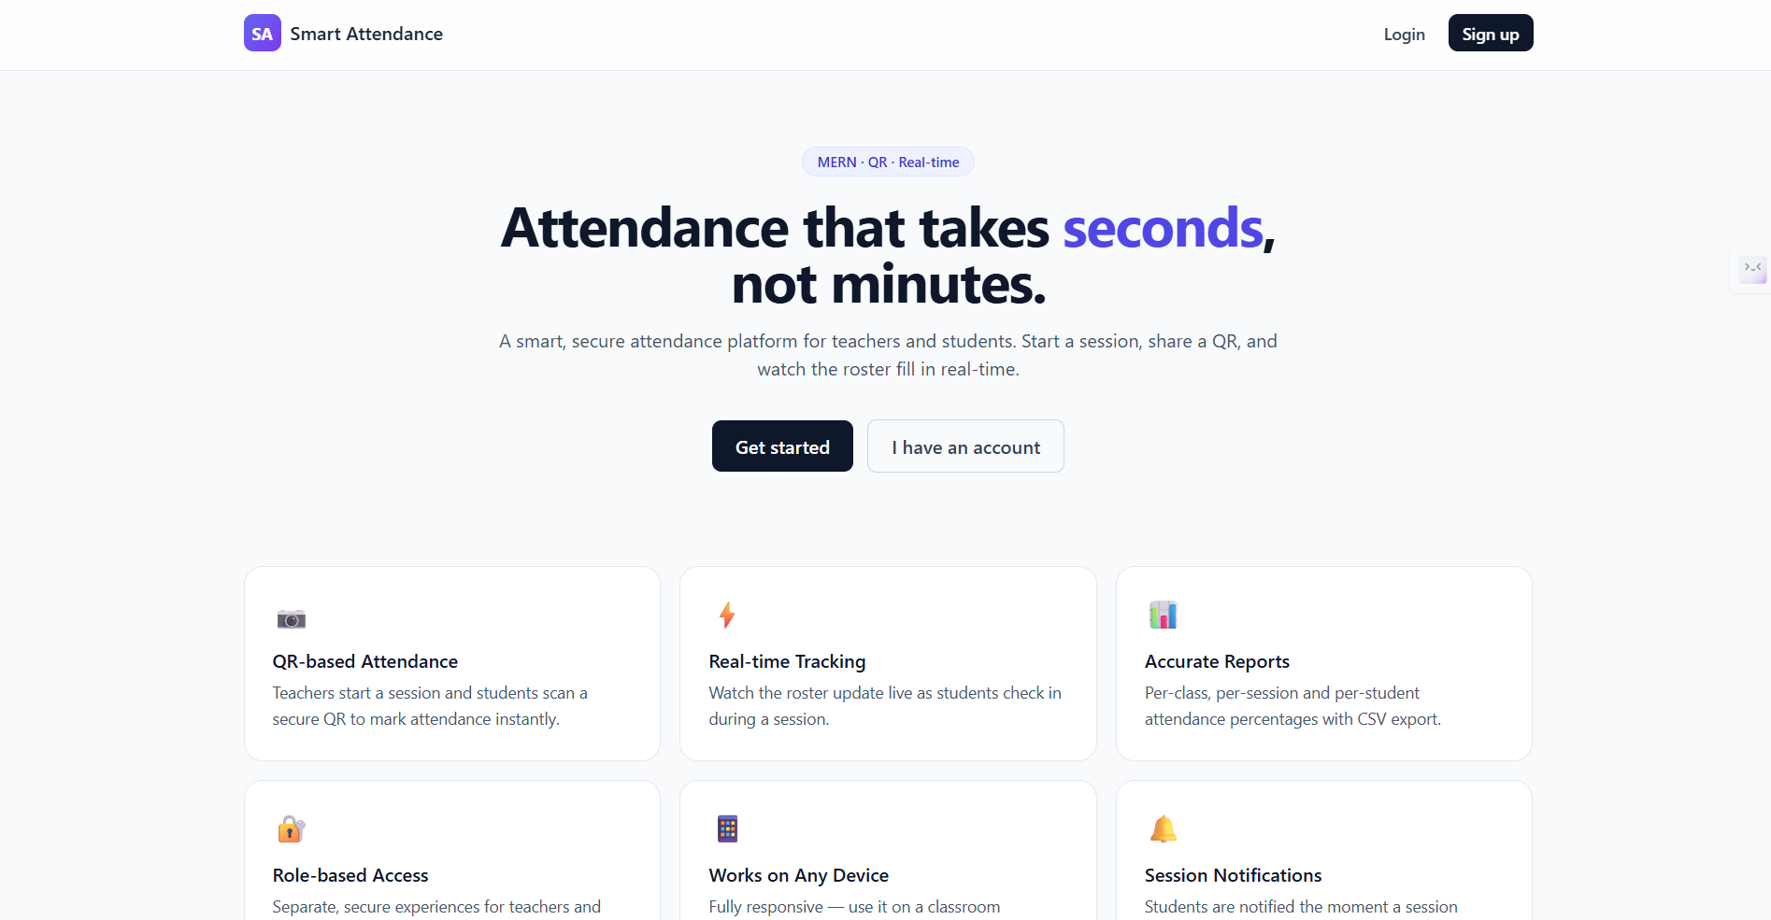
Landing Page
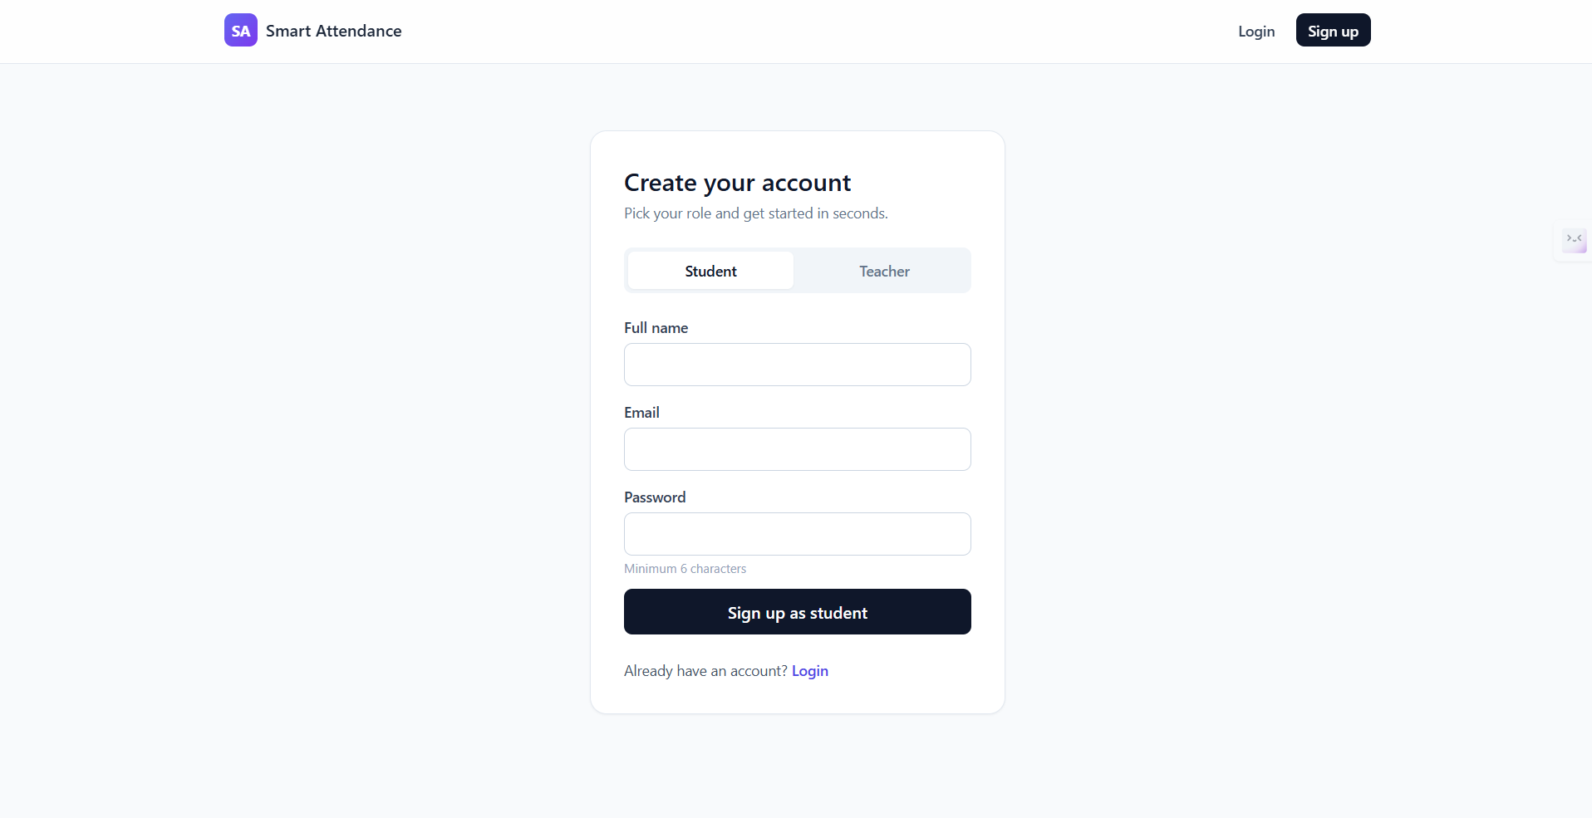
Signup Page with Role Selection
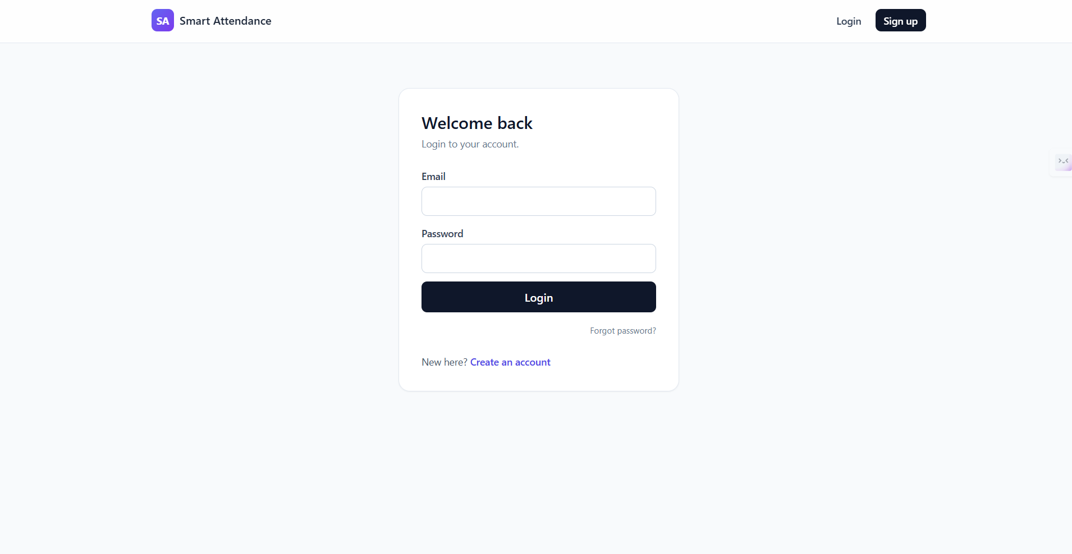
Login Page
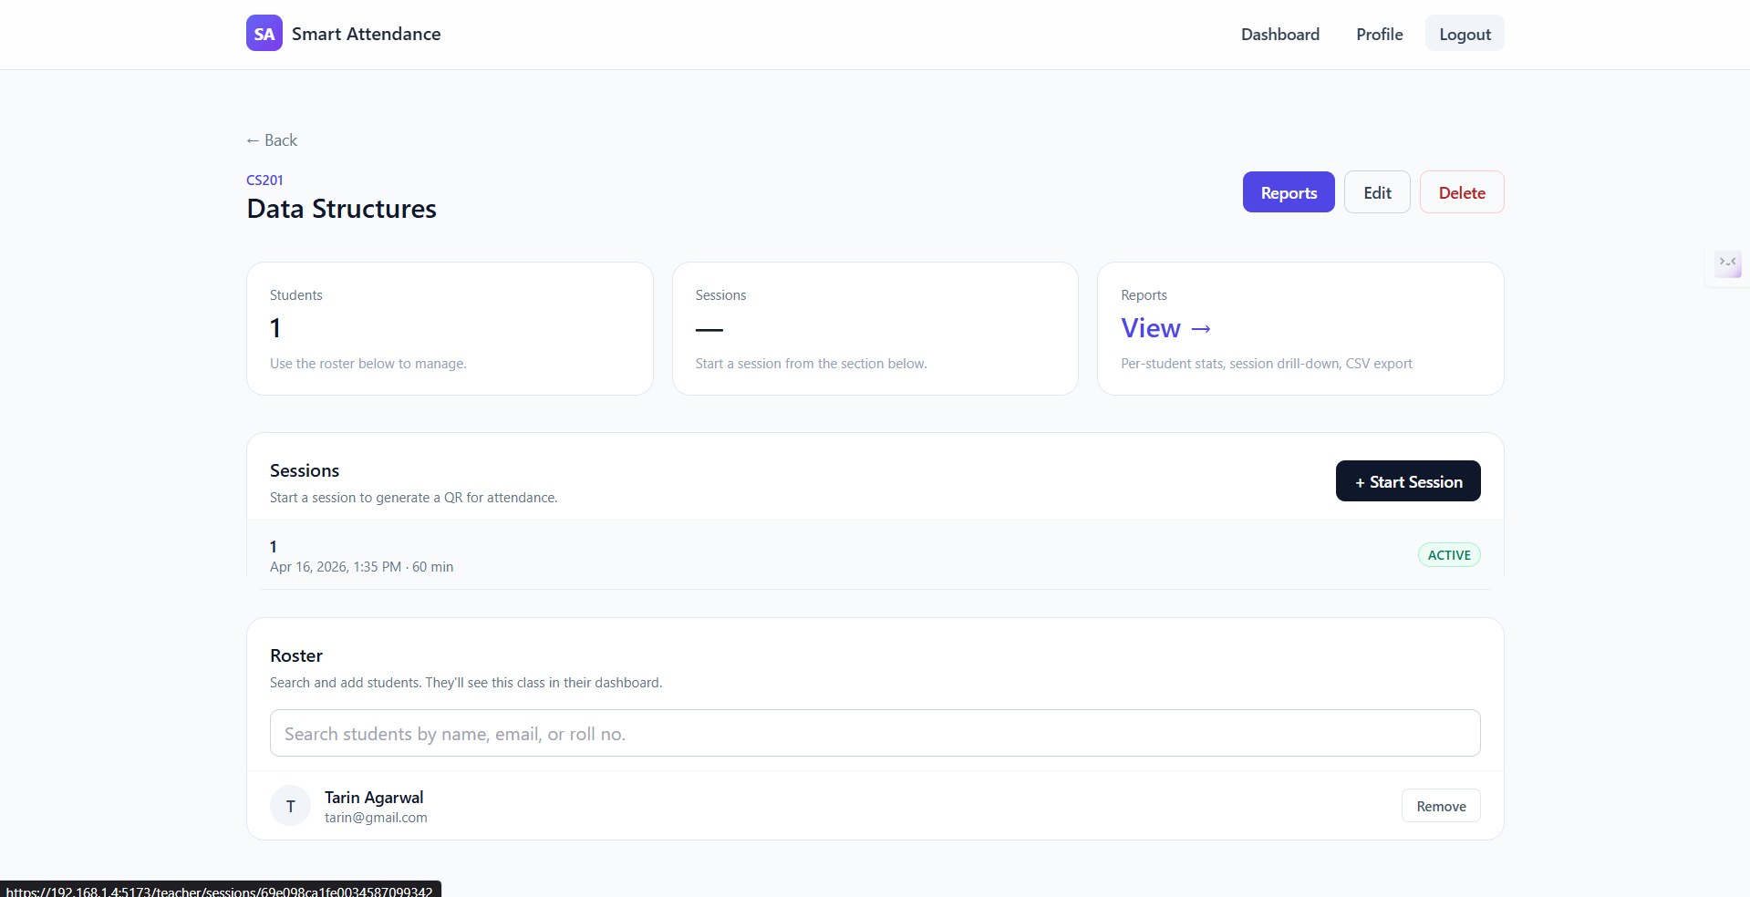
Teacher Dashboard — Class List
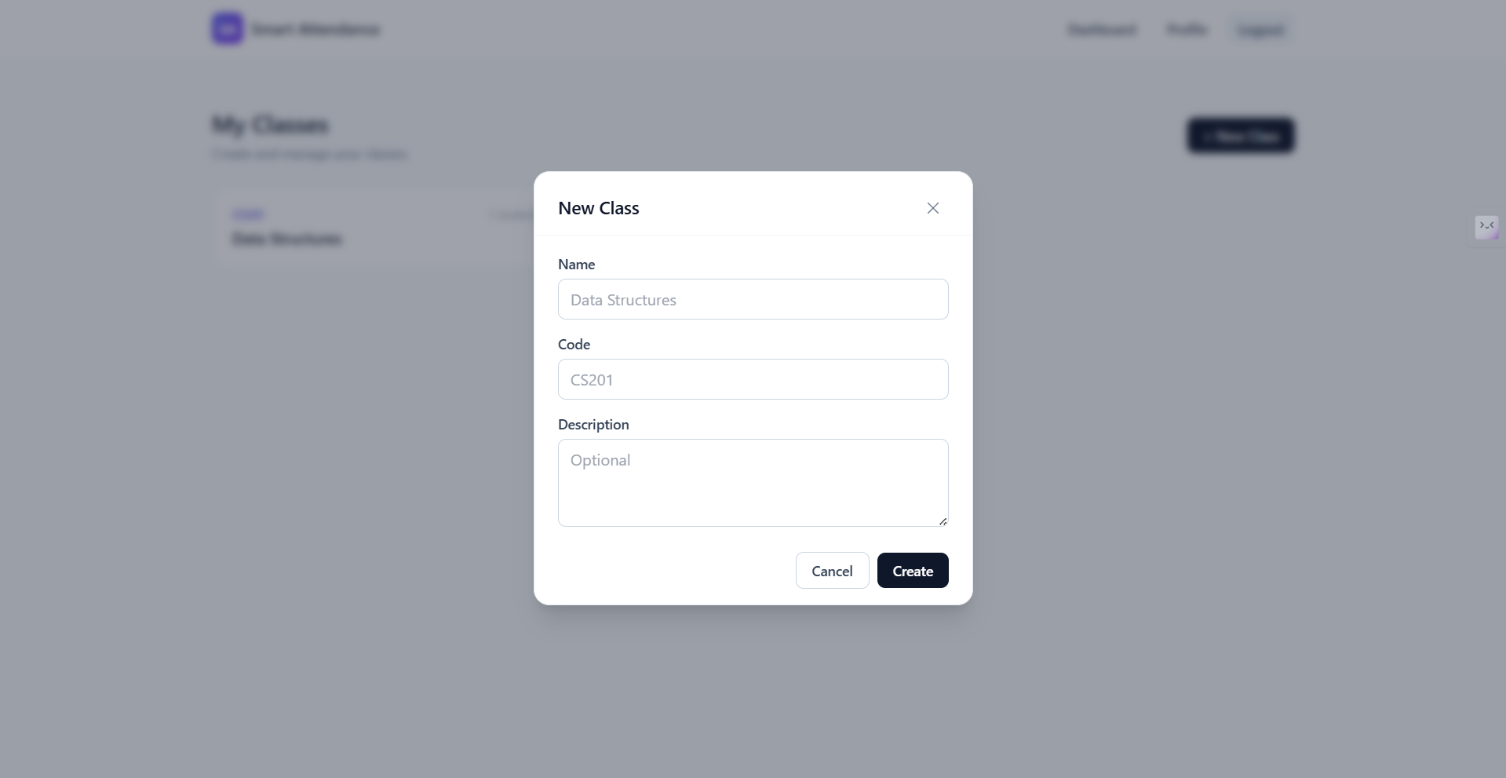
New Class Creation Modal
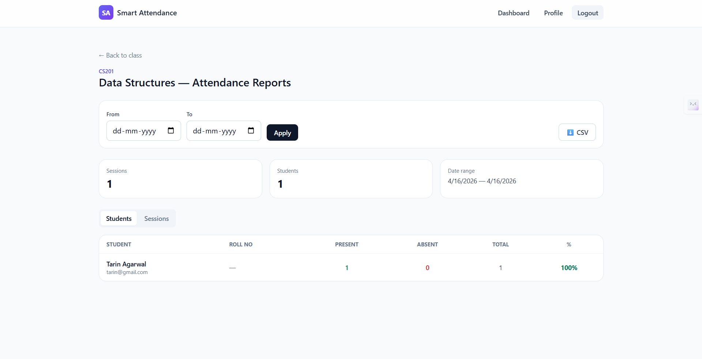
Teacher Attendance Report with Per-Student Statistics
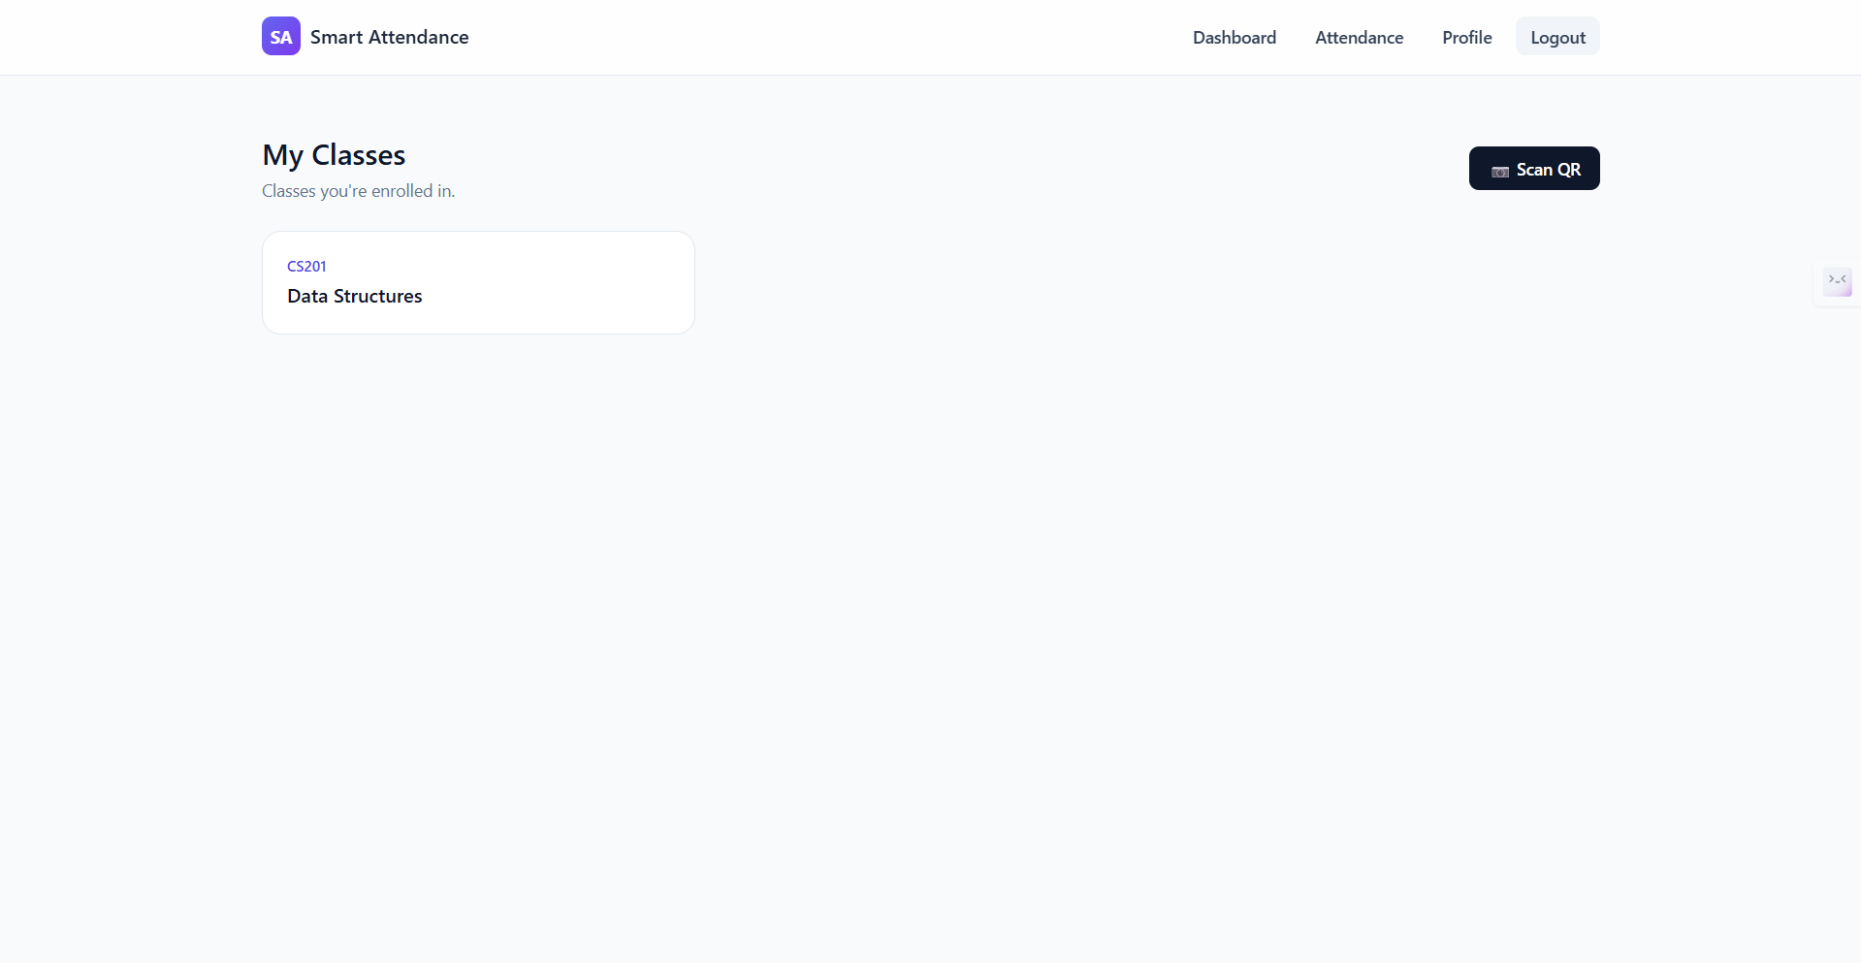
Student Dashboard — Enrolled Classes
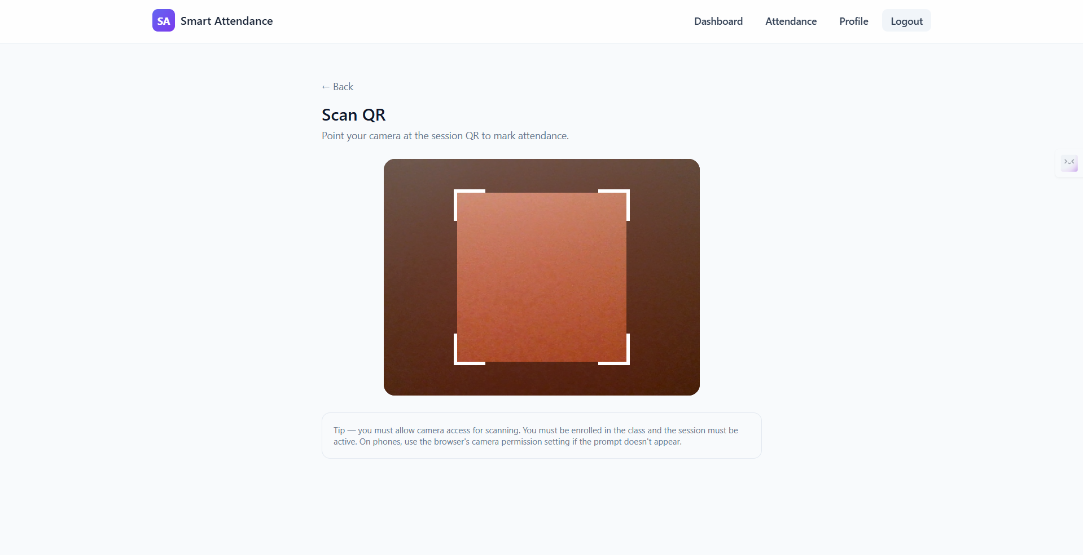
QR Code Scanner on Student Mobile
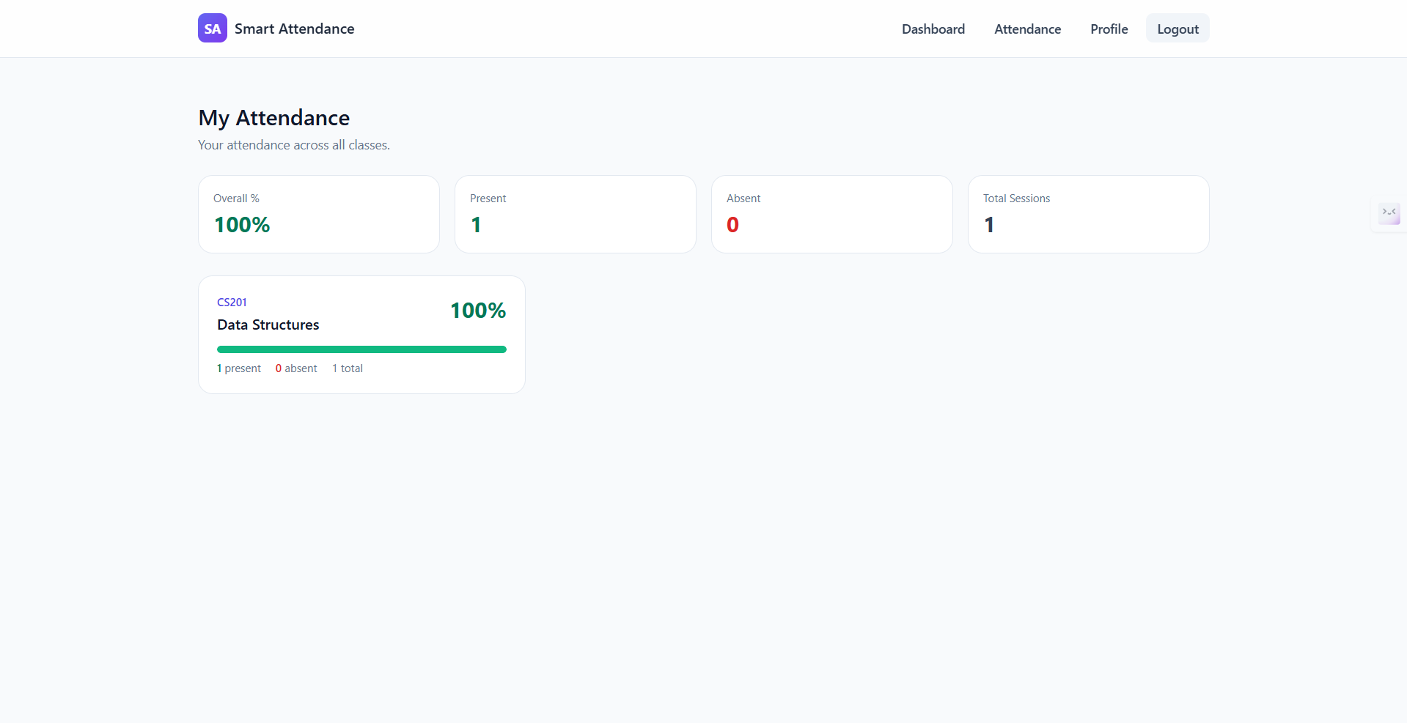
Student Attendance Dashboard with Per-Class Percentages
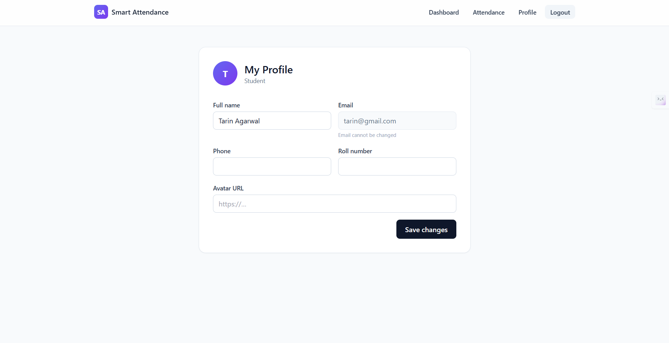
Student Profile Management

Advantages and Limitations

Advantages
- Reduces attendance time from 5–10 minutes to under 30 seconds
- Eliminates proxy attendance via cryptographic token rotation
- Real-time roster updates provide instant visibility to teachers
- Five-layer validation pipeline ensures data integrity
- Zero-infrastructure deployment — runs on any laptop with Node.js
- Responsive design works on desktop and mobile simultaneously
- CSV export integrates with existing institutional workflows
- Automatic absent-marking on session end ensures complete records
- Open-source MERN stack with no vendor lock-in or licensing costs
- HTTPS support enables camera access on mobile devices over LAN

Limitations
- Requires students to have smartphones with cameras
- Camera access requires HTTPS, adding self-signed certificate complexity
- Physical proximity is not enforced (a student on the same network but outside the room could scan a shared screen)
- No offline mode — requires network connectivity for scanning
- MongoDB Atlas dependency for database hosting
- Self-signed certificates trigger browser warnings on first access
- QR rotation interval (15s) is a trade-off between security and scan reliability

Comparative Analysis
Comparison of Attendance Methods
Aspect | Manual | Biometric | Smart Att.
Time per session | 5–10 min | 2–5 min | $<$30 sec
Proxy prevention | None | High | High
Hardware cost | None | $200–500 | None
Parallel marking | No | No | Yes
Real-time view | No | Partial | Yes
Analytics | Manual | Basic | Full
CSV export | No | Varies | Yes
Mobile support | N/A | N/A | Full
Privacy concerns | Low | High | Low

Results and Performance
The system was tested with simulated classroom scenarios. Key metrics observed:

Performance Metrics
- Session creation: $<$200ms server response time
- QR generation and rotation: $<$100ms per cycle
- Attendance marking (full validation pipeline): $<$300ms
- Socket.IO event propagation: $<$50ms (LAN)
- CSV report generation (50 students, 20 sessions): $<$500ms
- Concurrent scan handling: tested with 10+ simultaneous requests without failure

Security Validation
- Expired QR tokens (older than 30s): correctly rejected
- Tampered HMAC signatures: correctly rejected
- Unenrolled student scans: correctly rejected with 403
- Duplicate scans: correctly rejected with 409
- Teacher attempting student-only endpoints: correctly rejected with 403
- Cross-teacher class access: correctly rejected with 403

Future Scope
- Geofencing: Integrate browser Geolocation API to restrict scanning to within a configurable radius of the classroom
- Bluetooth proximity: Use Web Bluetooth to verify student device is physically near the teacher’s device
- Mobile application: Native iOS/Android app for improved camera performance and push notifications
- LMS integration: APIs for Moodle, Google Classroom, and Canvas to sync attendance data
- Analytics dashboard: Trend analysis, at-risk student identification, and attendance pattern visualization
- Multi-language support: Internationalization for Hindi, Bengali, and other regional languages
- Offline mode: Service worker caching with sync-on-reconnect for areas with unreliable connectivity
- Bulk operations: CSV import for student enrollment and batch class creation

Conclusion
Smart Attendance demonstrates that secure, real-time attendance management can be achieved using entirely web-based technologies without specialized hardware. The combination of HMAC-signed time-rotating QR tokens, five-layer server-side validation, and WebSocket-based live updates addresses the core shortcomings of both traditional roll-call methods and naive QR implementations.
The system reduces per-session attendance time by over 95% compared to manual methods, eliminates proxy attendance through cryptographic token rotation, and provides teachers with instant roster visibility and comprehensive analytics. Its zero-infrastructure design — requiring only a laptop with Node.js and student smartphones — makes it immediately deployable in any educational setting without procurement processes or IT infrastructure changes.
Built on the open-source MERN stack, the system avoids vendor lock-in and can be extended by the broader developer community. The modular architecture cleanly separates authentication, session management, attendance recording, and real-time communication, facilitating future enhancements such as geofencing, LMS integration, and mobile applications.
00 S. Lonn and S. D. Teasley, “Saving time or innovating practice: Investigating perceptions and uses of learning management systems,” Computers & Education, vol. 53, no. 3, pp. 686–694, 2009.
A. K. Jain, A. A. Ross, and K. Nandakumar, Introduction to Biometrics. Springer, 2011.
F. Masalha and N. Hirzallah, “A students attendance system using QR code,” International Journal of Advanced Computer Science and Applications, vol. 5, no. 3, pp. 75–79, 2014.
M. Kassim, H. Mazlan, N. Zaini, and M. K. Salleh, “Web-based student attendance system using QR code,” in Proc. IEEE Int. Conf. on Control System, Computing and Engineering, 2012, pp. 492–497.
S. Kadry and K. Smaili, “A design and implementation of a wireless iris recognition attendance management system,” Information Technology and Control, vol. 36, no. 3, pp. 323–329, 2007.
S. Dey, A. Barman, and S. Bhukya, “An automated attendance management system using QR code and machine learning,” in Proc. IEEE Region 10 Conf. (TENCON), 2019, pp. 1132–1137.
R. F. Olanrewaju, A. Khan, F. Anwar, B. R. Pampori, and R. N. Mir, “Smart attendance monitoring and management system using QR code with GPS,” in Proc. IEEE Conf. on Open Systems (ICOS), 2018, pp. 43–48.
S. Tilkov and S. Vinoski, “Node.js: Using JavaScript to build high-performance network programs,” IEEE Internet Computing, vol. 14, no. 6, pp. 80–83, 2010.
A. Mardan, Full Stack JavaScript: Learn Backbone.js, Node.js, and MongoDB, 2nd ed. Apress, 2018.
M. Jones, J. Bradley, and N. Sakimura, “JSON Web Token (JWT),” IETF RFC 7519, 2015.
H. Krawczyk, M. Bellare, and R. Canetti, “HMAC: Keyed-hashing for message authentication,” IETF RFC 2104, 1997.
ISO/IEC 18004:2015, “Information technology — Automatic identification and data capture techniques — QR code bar code symbology specification,” 2015.

