**Amarkantak Honey**

“Beekeeping as a livelihood” the study was carried out in MSME, GoI Sponsored Livelihood Business Incubation Training Centre (LBI) IGNTU Amarkantak, in the year of 2019 was used as base year for the establishment of apiculture as employment in the Amarkantak Region of District Anuppur, Madhya Pradesh. The Amarkantak having a Biosphere reserve dense forest area covers of about 80% of total geographical area. This district comprises of 78% tribal population and they are typically dependent on the forest produced, agriculture and smallholders farming. LBI has initiated an effort with support of NABARD, MP as Beekeeping in order to provide employment to the rural people and doubling their income as well. Beekeeping has proven to be such an alternative livelihood option with potential of providing alternative income security to smallholder farmers living in forest area. More than 200 Beneficiaries of Women SHG’s of 10 villages were showing her interest and engaged with Beekeeping & Honey Production.

They provide, revising the historical role of the self-employed beekeeper and favoring large scale commercial operations. Today, beekeeping is an important, sustainable, integral agricultural activity and opportunity for the farmers to adopt as an enterprise. It provides nutritional, economic, and ecological security and balance. The knowledge of agro-climatic conditions, the diversified flora, changing Agri/ horticultural pattern of the crop, the types of Bees, the management practices etc. play a pivotal role in transforming the Beekeeping industry in the Amarkantak. Rural poor dependent on subsistence agriculture and small farm lands often rely on alternative sources of income for their livelihoods.

Amarkantak Honey: AIMS

**Acceptability**

Amarkantak Honey; 100 % naturally processed and rich quality Honey collected by Bee hives.

**Integrity**

Amarkantak Honey; MSME Sponsored LBI, Department of Agriculture & ATMA, SRLM Anuppur & NABARD support the Tribes product.

**Means of support**

Amarkantak Honey; one of the way to support Tribes, who lives decades in dense forest with poverty.

**Sustainability**

Amarkantak Honey; we work with a huge aims of Government of India ‘Aatma Nirbhar Bharat’ Mission.

**Benefits of Amarkantak Honey**

**Amarkantak Kodo**

The study was conducted in Bahpur Village of Pushprajgrh Tehsil at Madhya Pradesh. The branding of Kodo Millet was conducted here with the help of two Women self-help group Laxmi and Satguru. The research is both descriptive and applied in nature as the secondary data was used to understand the basics of branding and the same was applied in launching a brand of Kodo Millet. The proposed research work aims to reckon Amarkantak as a synonym of natural and high medicinal indigenous products by transforming commodities into reliable brands. Cumulative efforts by two Women self-help group, Indira Gandhi National Tribal University has resulted in a nutritional Product ‘Amarkantak Kodo’ on the auspicious occasion of 150th Birth Anniversary (2nd October 2019) of Mahatma Gandhi. With brand ‘Amarkantak’.

**Scope of the Study**

One of the major problems of tribal regions in general and this area in particular is low level of agricultural production and productivity. Most of the tribes are dependent on agriculture for their livelihood. Low agricultural productivity and production has resulted into their economic deprivation. New agricultural technology can improve the production and productivity of agricultural sector of this tribal region and can thus cause the improvement in economic condition of the people living in this region with a view to-

* To build an effective team of self-help groups
* To provide training to the self-help groups about trade and commerce
* To provide training to the self-help groups regarding branding and marketing
* To assist self-help groups in developing market linkages
* To launch a proper brand of Kodo Millet capable of standing in the market

**About Kodo**

Kodo millet, one of the ancient grains of the world, originated from Africa and domesticated in India few thousand years ago is a draught resistant plant. In India, Kodo millet grown mostly in the Deccan region and the cultivation extends to the foothills of Himalayas. Kodo millet is rich in dietary fiber and minerals like iron, antioxidant. Several traditional Indian food items have been prepared solely from Kodo or blended with other cereal and legume flours to enhance the nutritional value, palatability and functionality.

**Nutritional Information**

Kodo millet is a nutritious grain and a good substitute to rice or wheat. The protein, fiber and mineral content are much higher than the major cereals like rice. The kodo millet grain is composed of 8 % protein. The major protein fraction in Kodo millet is glutelin (Sudharshana et al., 1988). Kodo millet is an excellent source of fiber (9%), as opposed to rice (0.2%), and wheat (1.2%). Kodo millet contains 66.6g of carbohydrates and 353 kcal per 100g of grain, comparable to other millets. The nutritional composition of various cereal crops is shown in following Table.

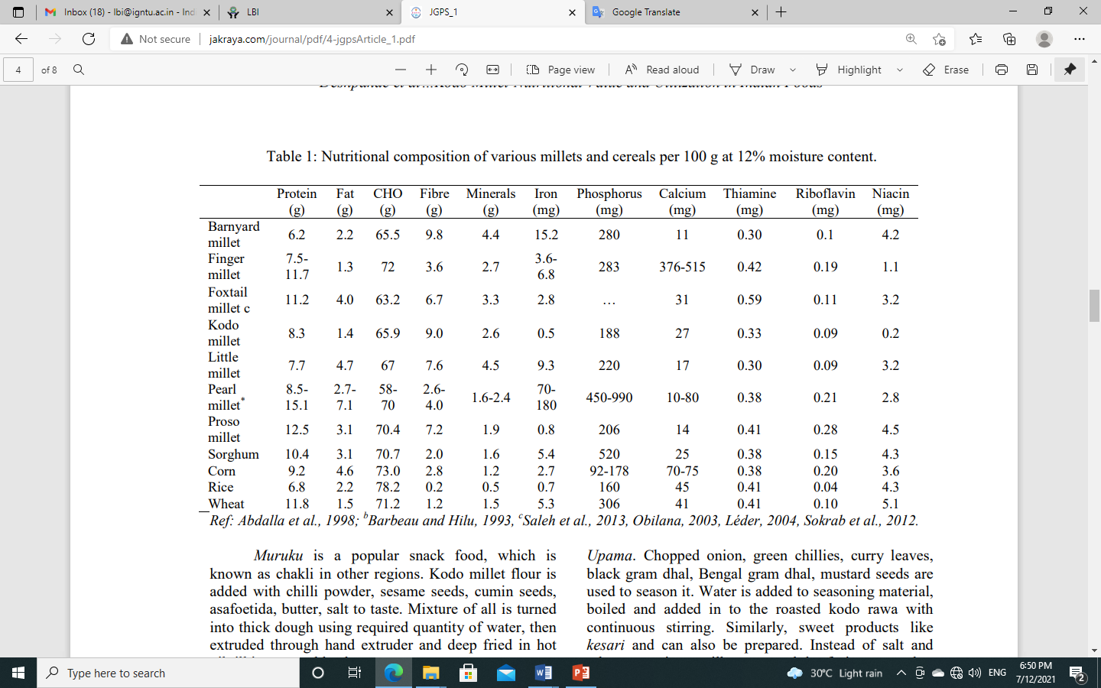

**Soya Milk & Tofu**

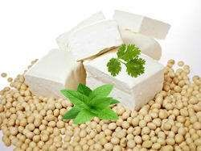Soybean is the cheapest and best health food. Soya milk and related food products are becoming popular throughout the world due to their good nutritional values and medicinal qualities. Soya milk is high in protein, low in fat and carbohydrate and contains no cholesterol. It is an excellent food for babies, children, elderly people and pregnant and lactating women since it contains vegetable protein which is very nutritious and easy to digest. Besides possessing high nutritional values, Soya milk is best for people suffering from diabetes and lactose-intolerance. It can be said that Soybean is a valuable gift of Mother Nature to human beings. With the increasing health consciousness among the general people, the use of Soybean is getting acceptance in the form of textured vegetable protein (popularly known as Soya bodi or Soya nuggets), Soya fortified wheat flour, Soya milk, Tofu and Soya curd etc. Being mainly the country of vegetarians, India has indeed a very great potential for Soya products.

**Tofu**

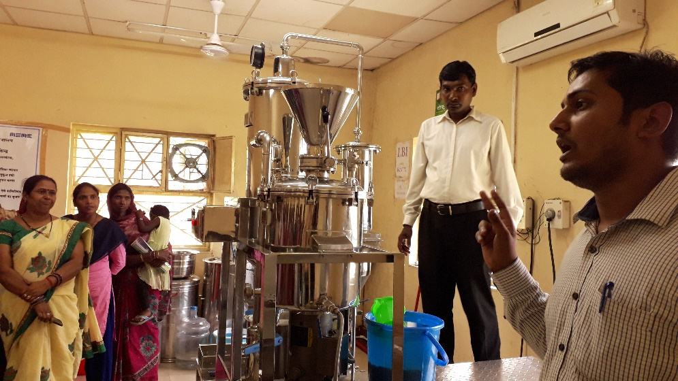Tofu, also known as bean curd is a food prepared by coagulating soy milk and then pressing the resulting curds into solid white blocks of varying softness; it can be silken, soft, firm, or extra firm. Beyond these broad categories, there are many varieties of tofu. Soya paneer is commonly called as Tofu. While normal paneer is a dairy product, soya paneer manufacturers make use of soy milk to create this healthier version of paneer. The texture of tofu or soya paneer is very similar to that of cottage cheese or paneer. "Tofu is a much healthier option than paneer. 100 grams of tofu has about 60-65 calories, while 100 grams of paneer may have about 260 calories. Iron content in tofu is more than that of paneer. Both have sufficient amount of protein content.”

Soybeans are crushed and ground into a milk like substance to form tofu. This soy milk is used for making Soya paneer in the similar manner. The best part about soya paneer or tofu is that it is totally vegan, perfect for all the vegan people. This soya paneer is good for all the health-lovers. It is rich in a number of healthy items like iron, manganese, copper, selenium, phosphorous, and magnesium.

**Market Potential**

Tofu is considered as healthy and gluten-free food. Growing demand for tofu is its predominant usage as a high protein source and vegetarian alternative to meat and dairy products. Tofu is incorporated in the preparation of a variety of foods such as burgers, hot dogs, sauces, ice creams, shakes, and desserts among others. Growing consumer preference for premium products is anticipated to significantly impact the demand for organic tofu. Due to the outbreak of the coronavirus disease (COVID-19), there has been a rise in the demand for plant-based, protein-rich food products, such as tofu. The global tofu market grew at a CAGR of around 5% during 2014-2019. On the other hand, India Soy Products Market is projected to record a CAGR of 3.8% during the forecast period (2020-2025).

**Product Benefits & Uses**

* Promotes Weight Loss: One of the major reason why people opt for tofu over paneer is that it promotes weight loss. If you are also planning to lose your extra kilos, you should replace the dairy paneer with tofu. Majority of the people going to gyms or planning to get a leaner body look for soya paneer manufacturers to get high quality tofu and include it in their everyday life.
* Prevents Risk Of Stroke: Another amazing health benefit of tofu is that it can help you secure yourself from getting a stroke attack. If you are consuming tofu regularly, there are very high chances that you may be safe from any type of cardiovascular disease. It can reduce the bad cholesterol level in the body along with decreasing the amount of triglycerides to protect you from stroke.
* Helpful for Diabetic: If you are suffering from diabetes, tofu could be a super food for you. As tofu is known to be very low in fat and calories, one can include tofu in the diet without thinking twice. In fact, if a person, who is at the risk of getting Type-2 diabetes consumes at least 200 grams of tofu every day, he/she might have high chances of reducing this risk. Tofu should be a regular item on the everyday diet menu if you plan to reduce your risks of getting diabetes.
* Rich in Protein: The biggest reason why one should have tofu is that it is rich in proteins. As tofu or soya paneer is made from soy milk, it is rich in protein content. This protein can be helpful in a number of ways like preventing ageing, keeping the skin’s elasticity intact, and much more.

**Mushroom**

Indira Gandhi National Tribal University, Amarkantak under its ‘Livelihood Business Incubation Training Centre’ LBI has strived to empower women by providing income generation opportunities in and around its operational areas. In line with its commitment for women and rural development, LBI mobilized over 300 tribal women across 15 villages in Pushprajgarh Block to promote commercial farming. Through this initiative, women generate a smart income by cultivating Mushrooms, a seasonal crop. In order to maintain a secured customer base for the produce, the cultivators are provided marketing linkages with local eateries, dhabas and haats. By inter loaning each other, women of these SHGs also support each other by providing expertise & marketing knowledge.

Mushroom cultivation is a minimum input maximum output venture proving to be an additional source of income. The vegetarian population residing in the urban areas of our country has now accepted mushrooms in their diet because of its nutritional values so the mushroom produced from the nearby rural areas has a good market of selling their products easily and at a good price. Thus, the mushroom is a boon to both producer and consumer giving it the status of super food. Mushroom cultivation can also be a way to empower the rural women, provide additional income for the sustenance of farming families and tackle the problem of lack of nutritional requirement of the rural people. Rural women are the most productive workforce in the economy, raising the need to strengthen and improve their socio-economic status. A low-cost small-scale mushroom production unit can generate income through the sale of spawns, in addition to the sale of fresh mushroom in a sustainable approach by utilizing farm by-products as their raw material.

**Health Benefits**

Mushroom is a nutrient rich product. It is rich in Vitamin B Niacin, biotin, riboflavin, copper, chromium and selenium and also a good source of Vitamin D. Mushroom provide that type of minerals that are difficult to obtain in the diet. It contain highest amount of Antioxidant. It stimulate the Immune system. Mushroom have so many other compound which are helpful to prevent the diseases and nutrients that provide health to the human.

Mushrooms have been consumed since earliest history. The word Mushroom is derived from the french word for Fungi and Mold. Now-a-days, Mushroom are popular valuable food because they are low in calories, carbohydrate, Fat, sodium and also cholesterol free. Besides this, Mushroom provides important nutrients, including salenium, potassium, riboflavin, niacin, Vitamin D, proteins and fiber. All together with a long history as food source. Mushroom are important for their healing capacity and properties in traditional medicine. It has reported beneficial effects for health and treatment of some disease. Many nutraceutical properties are described in Mushroom like cancer and antitumor attributes. Mushroom act as antibacterial, immune system enhancer and cholesterol lowering Agent. Additionally, they are important source of bio-active compounds.