* ADO.NET is a data access technology from the Microsoft .NET Framework that provides communication between relational and non-relational systems through a common set of components. ADO.NET is a set of computer software components that programmers can use to access data and data services from a database

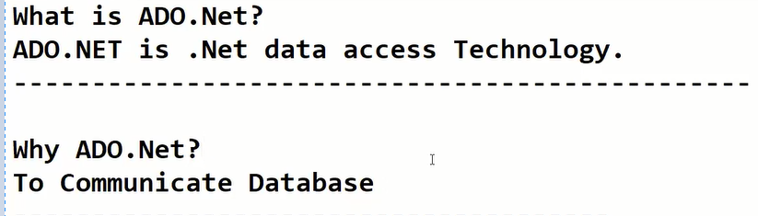

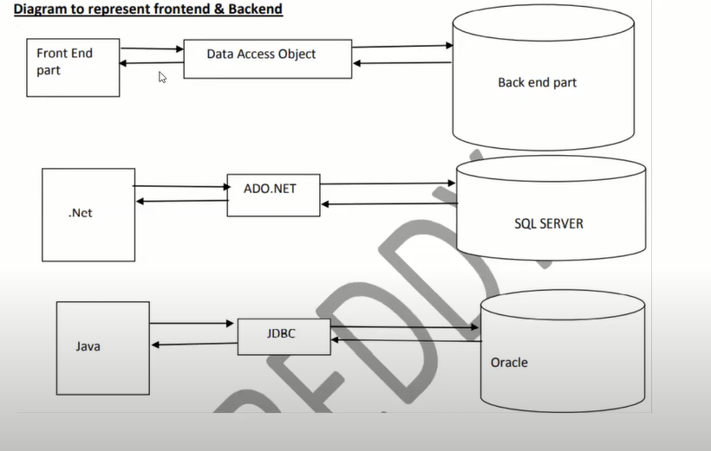

---------------------------------------------------------------------------------------------------------

* System.Data.SqlClient (used while working with below)

1. **SqlConnection**  - useful to connect with database.

**Working with sql connection**

1.create object

2.Define object

3.Add the parameters to the object()

4.Open the connection

1. **SqlCommand**  - CRUD operation

**Working with sql command**

1.create an object: SqlCommand cmd;

2.Define object: Cmd=new sqlCommand();

3.Pass the query:

a.CommandText -Supply the query.

b.Connection - connection object

c.CommandType -Text,TableDirect,Storeprocedure

4.Exec

a.ExecuteNonQuery - Working Action and Non Action example

Insert,Update,Delete -Returns Integer

b.ExecuteScalar -Aggregate function i.e sum,max,count Returns -object

c.ExecuteReader -DataReader -Returns DataReader

3.)**SqlAdapter**  - useful to fetch data(Disconnected Oriented Architecture) ex:Gmail

DataAdapter-

DataSet-frontend Database(i.e collection of tables we can identify by table name or index) .

**-------------------working with** **SqldataAdapter**

1.Sql connection

2.Create an object to the dataAdapter and DataSet

SqlDataAdapter da;

DataSet ds;

3.Define Data Adapter

Da=new SqlDataAdapter(“query”.connection object);

4.fill the dataset

da.Fill(ds.”tablename”);

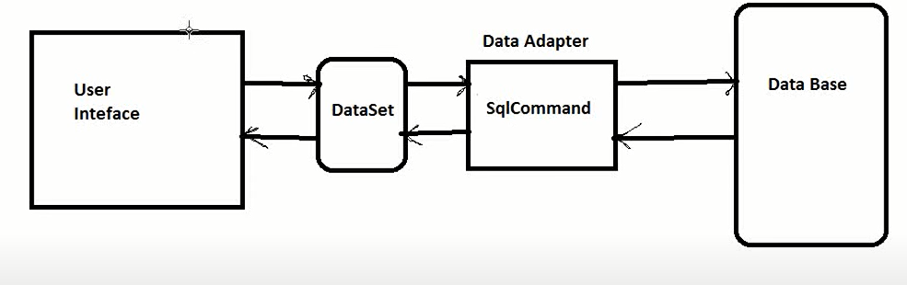

4.) **SqlDataReader** - (Connected Oriented Architecture) ex. IRCTC more load is the drawback

DataReader

**-----About Reader-------------**

1.can read only one record.

2.can move forward only

It has **Read()-**Returns Boolean type,Close()

**Working with Connected Oriented Architecture**

1. Fill Dropdown on user selected sno.

2. Fill data depends on user selected sno.

3. Write the query for update

5.) **SqlParameter** - useful when working with the store procedure.

------------------------------------------------------------------------------------------------

* System.Data(Use for below ones)

DataSet - Frontend database

DataTable -

DataColumn -

DataRow -

-----------------------------------------------------------------------------------------------

* ASP.NET Core is **a cross-platform, high-performance, open-source framework for building modern, cloud-enabled, Internet-connected apps**. With ASP.NET Core, you can: Build web apps and services, Internet of Things (IoT) apps, and mobile backends. Use your favorite development tools on Windows, macOS, and Linux.

**Note**

* A framework in programming is **a tool that provides ready-made components or solutions that are customized in order to speed up development**. A framework may include a library, but is defined by the principle of inversion of control (IoC).
* **ASP**.**NET** Core is a **redesign of ASP**.**NET 4**.**x**.

**ASP.NET core Benefits and features:**

1. **CROSS Platform:**

* **ASP**.**NET** Core applications can be developed and run across different platforms like Windows,Mac, linux.
* **ASP**.**NET** Core applications can be hosted on

1. IIS
2. DOCKER
3. APACHE
4. SELF-HOST in your own processor.
5. one unified programming model for mvc and web API:Both the MVC Controller class and the ASP.net Web API controller class inherit from the same **controller** base class and returns **IActionResult(**interface- ViewResult and JSONresult)
6. Dependency Injection.
7. Testability.
8. Open-Source.
9. Modular:

* ASP.NET core provides Modularity with middleware components.
* Both the request and response pipelines are composed using the middleware components.
* Rich set of built –in middleware components are provided out of the box.
* Custom middleware components can also be created.

**Prerequisites**

* Basic HTML,CSS and C#.
* Prior MVC Knowledge is helpful but not required.

**ASP.NET Project File**

* .csproj or .vbproj depending on the programming Lang used.
* No need to unload the project to edit the project file.
* File or folder references are no longer included in the project file.
* The File System determines what files and folders belong to the project.

Target Frame Work

* Specifies the target framework for the application.
* To specify a target framework we use Target Framework Moniker(TFM).

**NAME ABBREVIATION TFM**

.Net Framework net net451

net472

.Net Core netcoreapp netcoreapp1.0

Netcoreapp2.0

**AspNetCoreHostingModel**

* Specifies how the application should be hosted.
* InProcess or OutOfProcess.
* InProcess hosts the app inside of the IIS worker process(w3wp.exe).
* OutOfProcess hosting model forward web requests to a backend ASP.NET Core app running the kestrel server.
* The default is OutOfProcess hosting.

**Package Reference**

**Used to include a reference to the Nuget package that isinstalled for the application.**