**Wine Quality Prediction**

**Introduction**

**Problem Statement**

Wine is the fermented juice of grapes, made in many varieties, such as red, white, sweet, dry, still, and sparkling, for use as a beverage, in cooking, in religious rites, etc., and usually having an alcoholic content of 14 percent or less. The wine industry shows a recent exponential growth as social drinking is on the rise. Nowadays, industry players are using product quality certifications to promote their products. This is a time-consuming process and requires the assessment given by human experts, which makes this process very expensive. Also, the price of wine depends on a rather abstract concept of wine appreciation by wine tasters, opinion among whom may have a high degree of variability. Another vital factor in wine certification and quality assessment is physicochemical tests, which are laboratory-based and consider factors like acidity, pH level, sugar, and other chemical properties. The wine market would be of interest if the human quality of tasting can be related to wine’s chemical properties so that certification and quality assessment and assurance processes are more controlled. This project aims to determine which features are the best quality wine indicators and generate insights into each of these factors to our model’s wine quality.

**Technical Approach**

The Cross-Industry Standard Process for Data Mining (CRISP-DM). This process model has 6 phases that naturally describe the data science life cycle for this project.

1. Business Understanding
2. Data Understanding
3. Data Preparation
4. Modeling
5. Evaluation
6. Deployment

During every phase of this project lifecycle, we might discover new aspects/finding which we will incorporate them in ways to improve the efficiency of our model.

**Data Sources**

The dataset that is selected has all the details that are needed for a model to predict the wine quality

* **fixed acidity**
* **volatile acidity**
* **citric acid**
* **residual sugar**
* **chlorides**
* **free sulfur dioxide**
* **total sulfur dioxide**
* **density**
* **pH**
* **sulphates**
* **alcohol**
* **quality**

**Analysis**

We are planning to perform feature reduction and dimensionality reduction to select the most relevant variables for our model.  Many predictive algorithms assume the model variables follow a normal distribution. There are inherent advantages to using normally distributed variables, so our approach will focus on columns that closely follow this distribution. We will determine which variables are normally distributed by conducting the following analyses:

* Summary statistics on all variables: concentrating on mean and SD values.
* Identify the best model.

**Requirement Development**

For this project, we are planning to use python. To complete this project in python the following are required for our development:

IDE: Jupyter Notebook

Libraries:

1. Numpy – extensively used for data analysis to handle multidimensional arrays.
2. Pandas – high-performance data structures and analysis tools for the labeled data.
3. Matplotlib –powerful visualizations which create several stories with the data visualized.
4. SciPy – used for high-level technical computations.
5. Seaborn – interface for drawing attractive and informative statistical graphics.

**Model Deployment**

We will use feature selection techniques to finalize our feature list for models. Using the results from this step, we will build a couple of classification models and evaluate their performance. Below are some example models.

* **Random forest:** It builds multiple decision trees and merges them to get a more accurate and stable prediction. One big advantage of random forest is that it can be used for both classification and regression problems, which form the majority of current machine learning systems.
* **Decision Tree:** It belongs to the family of supervised learning algorithms. It can be used for solving regression and classification problems. The goal of using a Decision Tree is to create a training model that can use to predict the class or value of the target variable by learning simple decision rules inferred from training data. In Decision Trees, for predicting a class label for a record we start from the root of the tree. We compare the values of the root attribute with the record’s attribute. Based on the comparison, we follow the branch corresponding to that value and jump to the next node.

**Testing and Evaluation**

We will be splitting the data into 70% training and 30% test dataset. Using the test dataset, we will test the model. confusion matrix, AUC, and F1 scores will be used for the evaluation. cross-validation will also be used to decide the best model.

**Expected Results**

Using this model we can predict the quality of wine.

**Ethical Considerations**

Ethical considerations in research are a set of principles that guide our research designs and practices. We must always adhere to a certain code of conduct when collecting data from people. The goals of human research often include understanding real-life phenomena, studying effective treatments, investigating behaviors, and improving lives in other ways. What you decide to research and how you conduct that research involve key ethical considerations.

These considerations work to

* Protect the rights of research participants
* Enhance research validity
* Maintain scientific integrity

**Challenges/Issues**

The biggest challenge is remove the features that are not required to improve the efficiency of the model.

**Reference:**

* <https://www.kaggle.com/yasserh/wine-quality-dataset>
* <https://towardsdatascience.com/red-wine-quality-prediction-using-regression-modeling-and-machine-learning-7a3e2c3e1f46>
* <https://www.scirp.org/journal/paperinformation.aspx?paperid=107796>

Illustration:

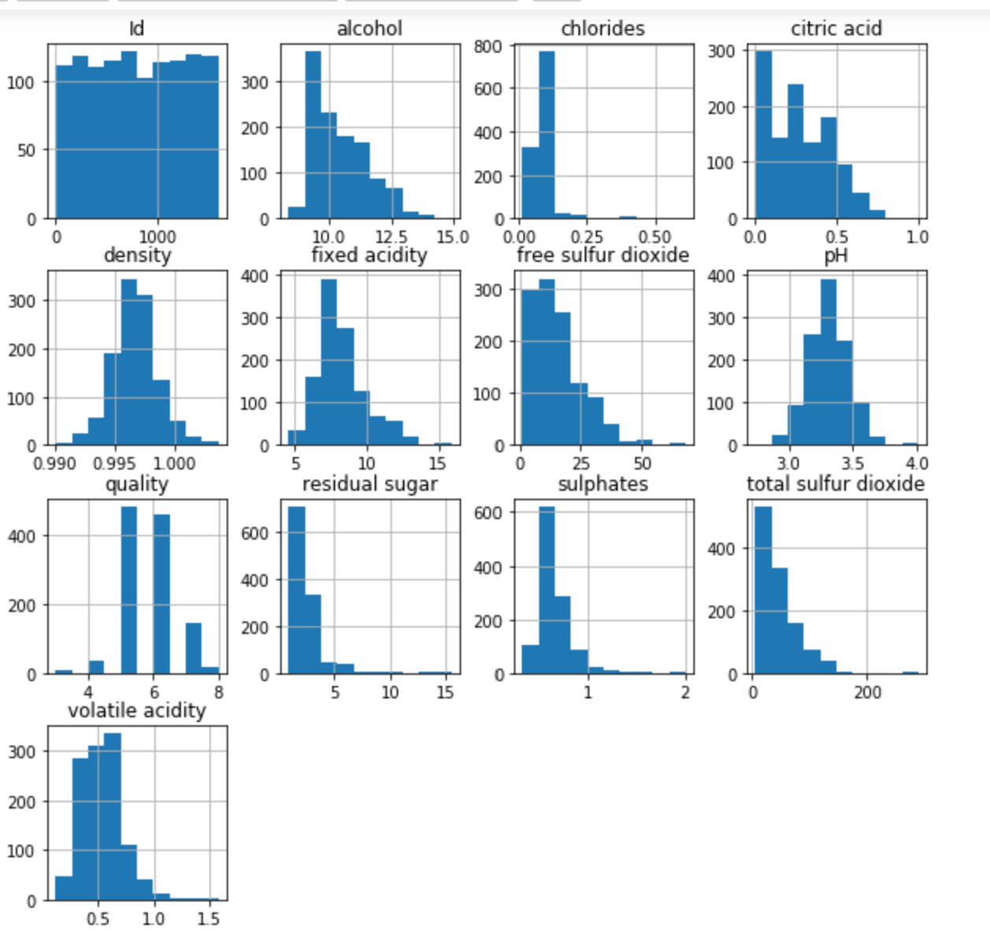

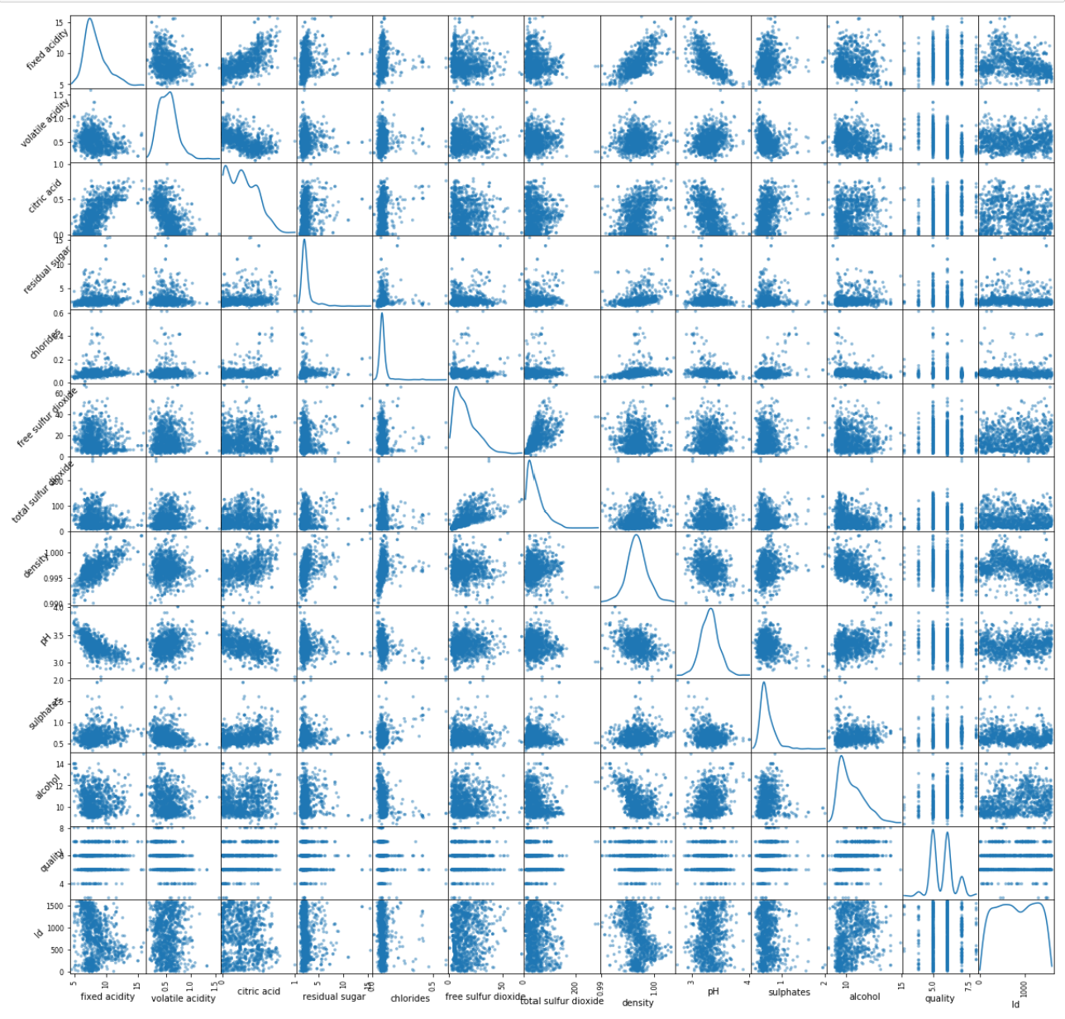

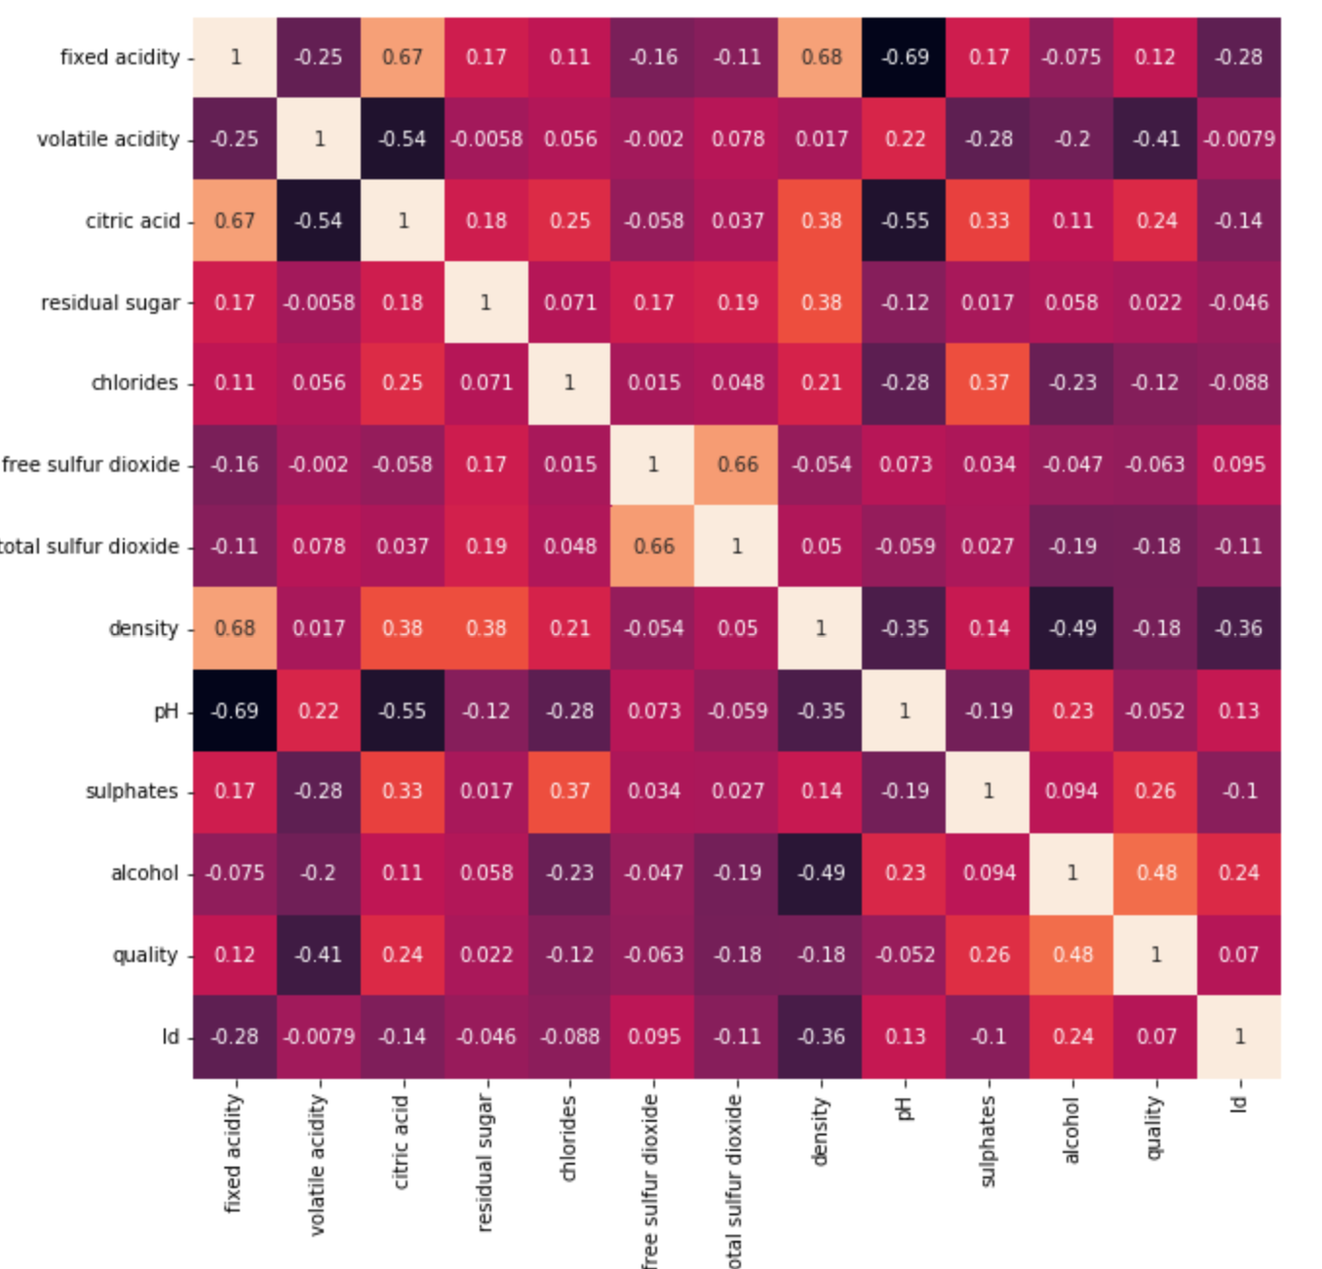

Appendix:

• Random forest: It builds multiple decision trees and merges them to get a more accurate and stable prediction. One big advantage of random forest is that it can be used for both classification and regression problems, which form the majority of current machine learning systems.

• Logistic regression: It is the appropriate regression analysis to conduct when the dependent variable is binary. Logistic regression is used to describe data and to explain the relationship between one dependent binary variable and one or more nominal, ordinal, interval, or ratio-level independent variables.

• Linear Regression: Linear regression is a linear approach for modelling the relationship between a scalar response and one or more explanatory variables. The case of one explanatory variable is called simple linear regression; for more than one, the process is called multiple linear regression.

• Random Forest Regression: Random Forest Regression is a supervised learning algorithm that uses ensemble learning method for regression. A Random Forest operates by constructing several decision trees during training time and outputting the mean of the classes as the prediction of all the trees.

• Leave One Out: The Leave-One-Out Cross-Validation, or LOOCV, procedure is used to estimate the performance of machine learning algorithms when they are used to make predictions on data not used to train the model.

• Box Cox Transformation: A Box Cox transformation is a transformation of non-normal dependent variables into a normal shape. Normality is an important assumption for many statistical techniques; if your data isn’t normal, applying a Box-Cox means that you are able to run a broader number of tests.

• Decision Tree: It belongs to the family of supervised learning algorithms. It can be used for solving regression and classification problems. The goal of using a Decision Tree is to create a training model that can use to predict the class or value of the target variable by learning simple decision rules inferred from training data. In Decision Trees, for predicting a class label for a record we start from the root of the tree. We compare the values of the root attribute with the record’s attribute. Based on the comparison, we follow the branch corresponding to that value and jump to the next node.

• Pandas DataFrame is two-dimensional size-mutable, potentially heterogeneous tabular data structure with labeled axes (rows and columns). A Data frame is a two-dimensional data structure, i.e., data is aligned in a tabular fashion in rows and columns. Pandas DataFrame consists of three principal components, the data, rows, and columns.

• A numpy array is a grid of values, all of the same type, and is indexed by a tuple of nonnegative integers. The number of dimensions is the rank of the array; the shape of an array is a tuple of integers giving the size of the array along each dimension.

**Questions:**

1.) How accurate is the model?

2.) How did you identify and handled the NA fields

3.) Why did you use Linear Regression model?

4.) What are the libraries that are used for the visualization?

5.) How did you convert the variables so that everything is of same data type?

6.) Are there any drawbacks using this model?

7.) What is a scikitplot library?

8.) Where did you get that this data?

9.) How much percentage of data is used from the dataset for training the model?

10.) What kind of visualizations are implemented in this project?