1. Alg = “RSA-SHA256”

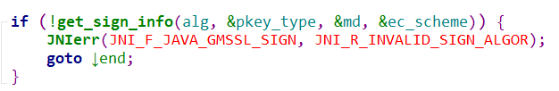

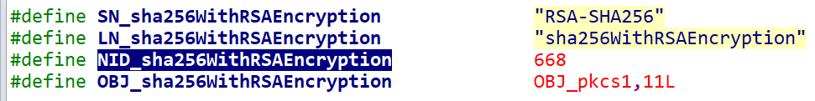



int pkey_type;

const EVP_MD *md = NULL;

int ec_scheme = -1;

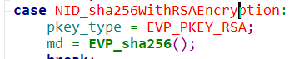

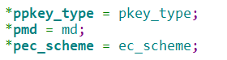

1. keybuf

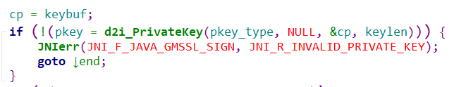

ret = EVP_PKEY_new()

EVP_PKEY_set_type(ret, type)

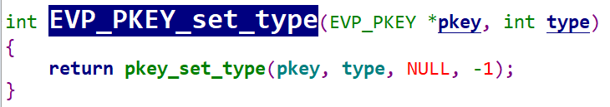

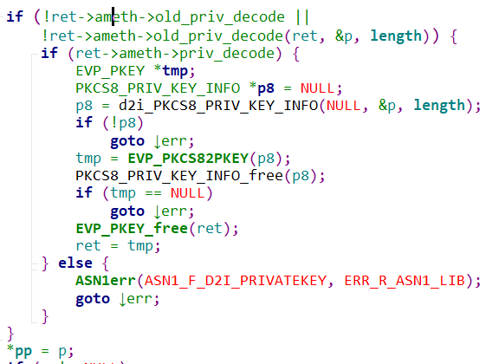

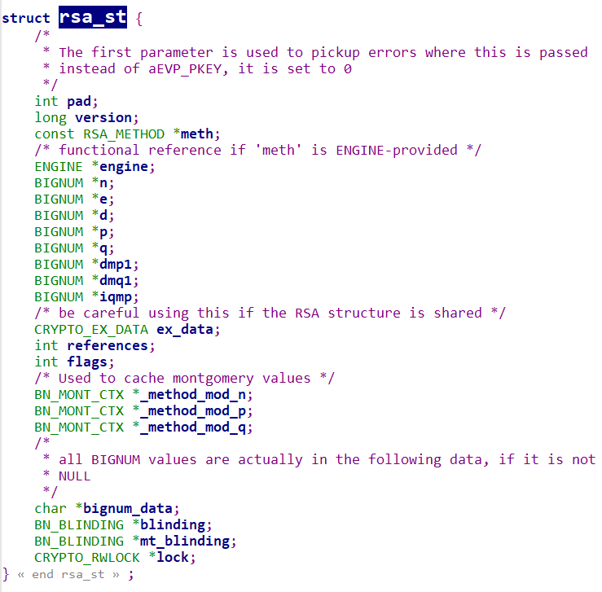

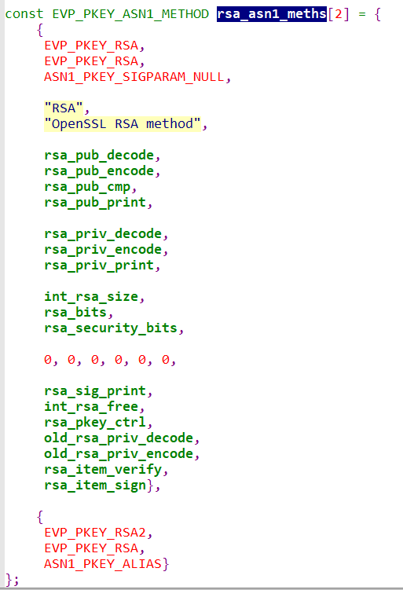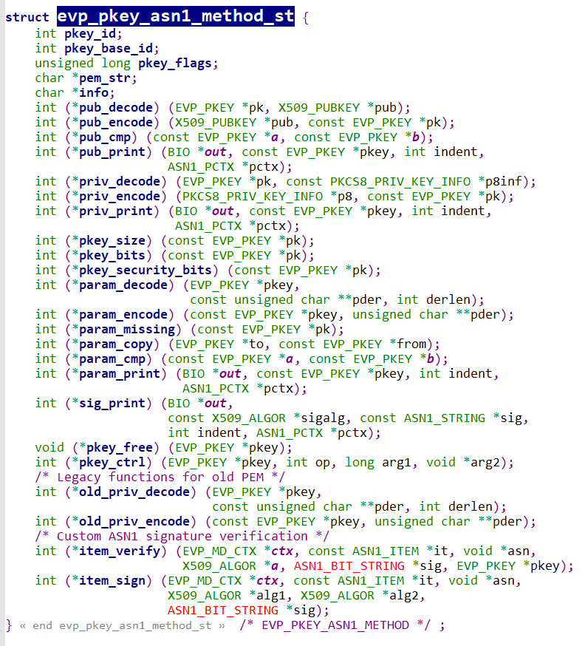

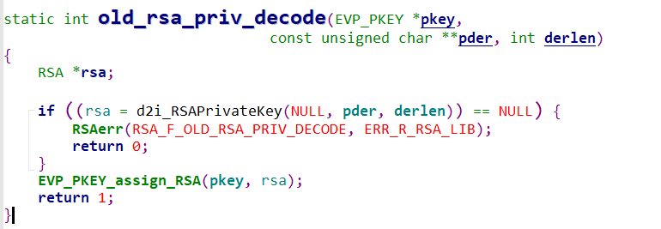

*d2i_RSAPrivateKey()*, *i2d_RSAPrivateKey()* decode and encode a PKCS#1 RSAPrivateKey structure.

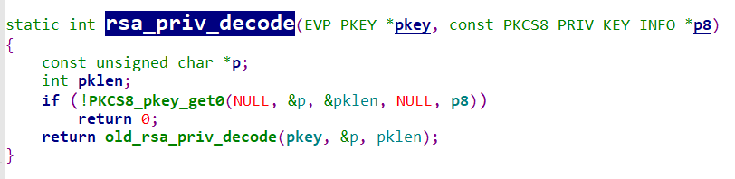

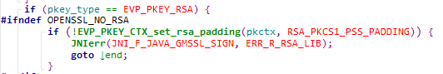

## PKCS1 vs PKCS8

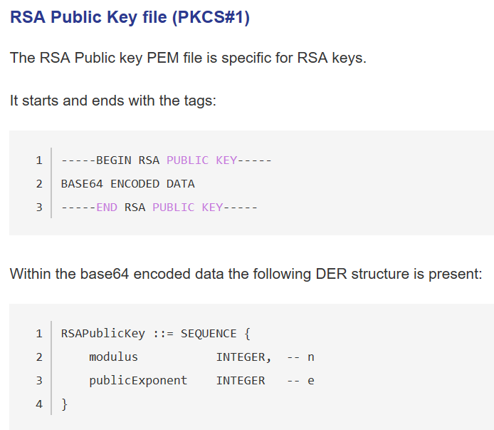

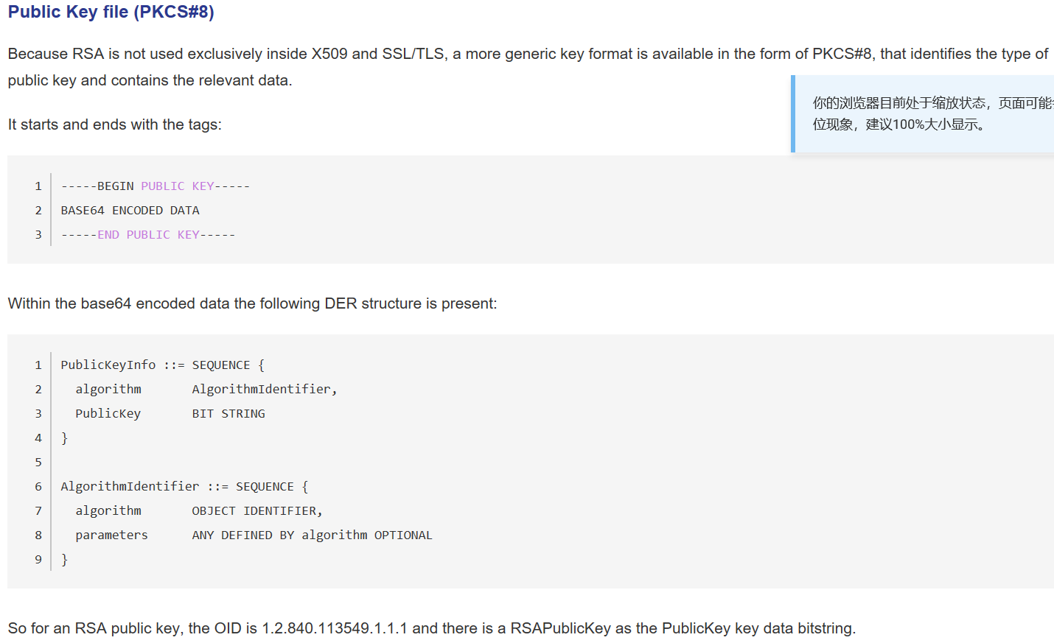

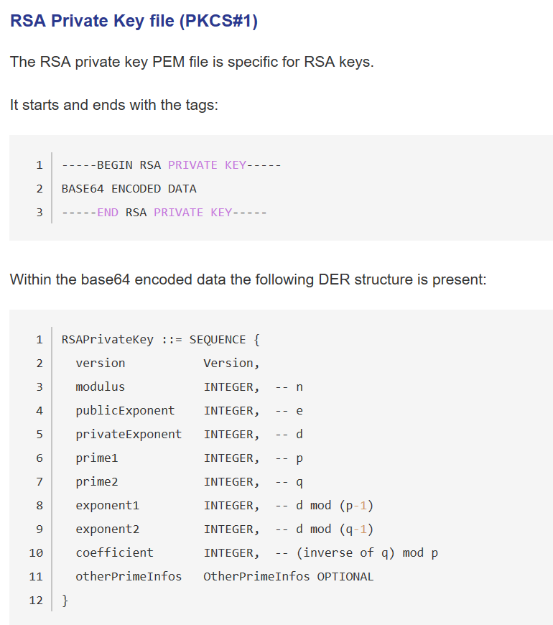

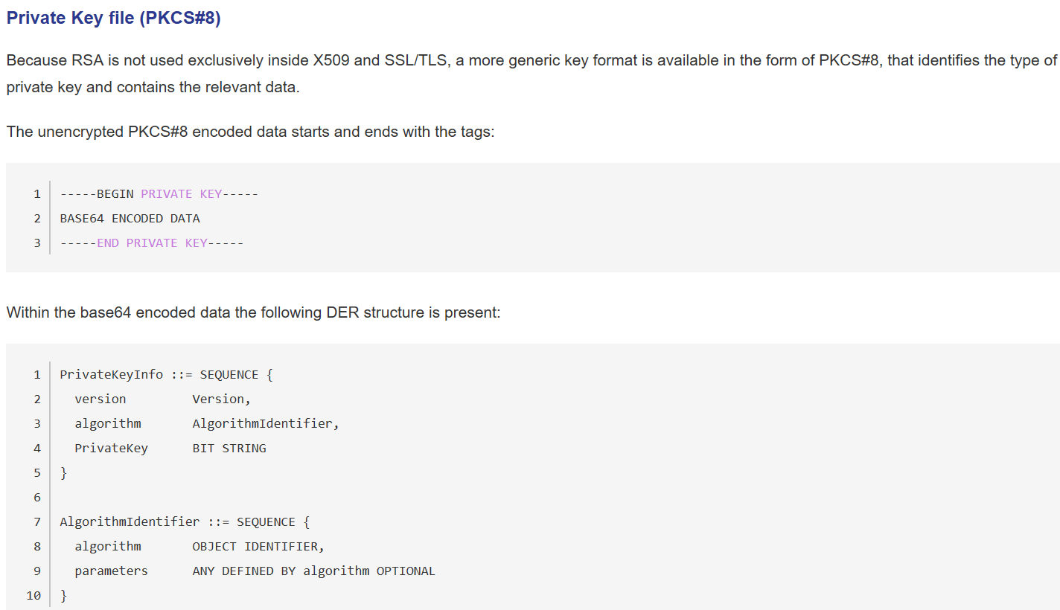

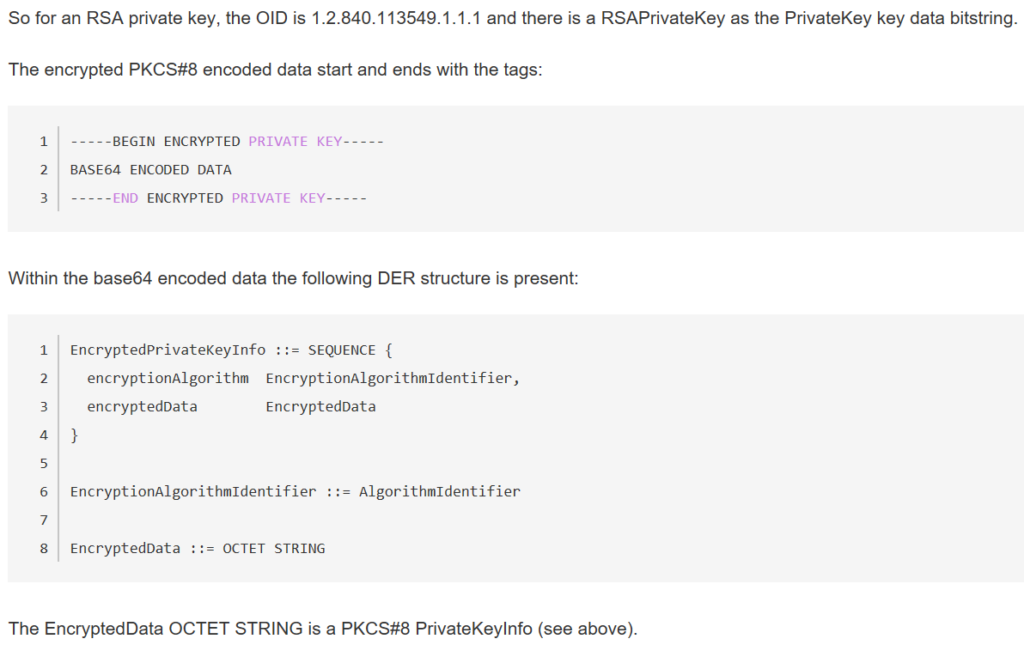

pkcs_pri

privateKey

pkcs_pub

d

n

e: 010001