BUILDORA

SOFTWARE ENGINEERING PROJECT REPORT

Customer and Project Portal for Construction Services
A project report submitted in partial fulfilment of the requirements for the award of the degree of Bachelor of Science in Computer Science
University: [NAME OF UNIVERSITY]
College / Department: [NAME OF COLLEGE / DEPARTMENT]
Academic Year: [ACADEMIC YEAR]
Submitted by: [STUDENT NAME]
Roll Number: [ROLL NUMBER]
Project Guide: [GUIDE NAME]
Project repository reviewed: Buildora, repository state inspected on 14 October 2026
Document version: Final academic draft, 1.0
Project characteristic | Specification details
System name | Buildora Customer and Project Portal
Software baseline | Repository package version 0.1.0; release status not independently established
Target domain | Construction and interior service enquiry and project coordination
Core technology | Next.js 16, React 19, TypeScript, Prisma 6
Database architecture | PostgreSQL via Prisma; database is the authoritative business-data store
Identity and access | HMAC-signed application session; Firebase Authentication is optional
External integrations | Resend / Postmark / SMTP email and S3-compatible storage are configuration-dependent
Prepared by | [STUDENT NAME]
Academic standard | [DEPARTMENT / UNIVERSITY REPORT FORMAT]
This report describes the implementation evidenced in the repository. The supplied Extreme Sales & Services report was used as a structural reference for software-engineering diagrams and analysis sections only. Its HVAC-specific features, claims, and results do not describe Buildora. Replace bracketed fields with verified institutional and student details before submission.

CERTIFICATE
This is to certify that the project report entitled “Buildora: Customer and Project Portal for Construction Services” has been prepared by [STUDENT NAME], Roll Number [ROLL NUMBER], of [DEPARTMENT / COLLEGE], during the academic year [ACADEMIC YEAR]. The work is submitted in partial fulfilment of the requirements for the award of the Bachelor of Science in Computer Science degree of [UNIVERSITY NAME].
To the best of our knowledge, this report describes the project work carried out by the student. The implementation claims in this draft are based on inspection of the available source code, schema, project configuration, and test suite. Institutional acceptance, originality certification, signatures, and final assessment are matters for the college and must be completed by the authorised persons.
Project Guide
Name: [GUIDE NAME]
Signature: ____________________
Date: ____________________
Head of Department
Name: [HOD NAME]
Signature: ____________________
Date: ____________________
External Examiner
Name: [EXAMINER NAME]
Signature: ____________________
Date: ____________________

DECLARATION

I, Sandeep Kami, declare that this report titled “Buildora: Customer and Project Portal for Construction Services” is prepared for academic submission. The software and the report are presented with an effort to distinguish implemented behaviour from optional integrations, incomplete coverage, and future work.
I understand that this declaration must not be signed until the institution's authorship, citation, and academic-integrity rules have been reviewed. Any borrowed technical material, standards, package documentation, images, or institutional templates used in the submitted version must be cited according to the prescribed format. Repository evidence and the measured validation results recorded in this report should be rechecked against the exact version submitted for assessment.

ACKNOWLEDGEMENT

I express my sincere gratitude to [PROJECT GUIDE NAME] for guidance, review, and constructive feedback during the study and preparation of this report. I also thank the Head of the Department, faculty members, and [COLLEGE NAME] for the academic environment and resources provided for the project.
I acknowledge the open-source communities and maintainers of Next.js, React, TypeScript, Prisma, PostgreSQL, Playwright, and the other tools identified in this report. Their documentation and software make it possible to build and validate a modern web application.
The current application source, database model, migrations, automated test definitions, and project documentation were inspected to ground the report in evidence. The report does not claim that optional external services were deployed or that unexecuted database and browser tests passed. I thank the reviewers who will verify this work and identify areas for further improvement.
This acknowledgement is a draft. The student should personalise it and obtain any required permissions before submission.

ABSTRACT

Buildora is a web application for presenting construction and interior services and coordinating enquiry and project information between customers and administrators. The project combines public service and portfolio pages with customer authentication, enquiry capture, customer project views, administrative lead and project workflows, quotation and manual payment records, approval and messaging endpoints, and a PostgreSQL-backed relational domain model.
The application is implemented with Next.js 16, React 19, and TypeScript. Prisma provides access to PostgreSQL. A signed, HTTP-only session cookie supports application sessions; Firebase Authentication is an optional sign-in integration. Object storage uses S3-compatible presigned URLs when configured, while transactional email can use Resend, Postmark, or SMTP. These integrations are configuration-dependent and are not represented as deployed services in this report. The cost estimator is an indicative client-side calculation and is not treated as a binding quotation.
The repository review included the data schema, application routes and services, project setup and CI definitions, and automated tests. At the recorded verification point, `npm test` reported 19 passing tests, one skipped PostgreSQL persistence test, and no failures; `npm run typecheck` completed successfully. `npm run lint` completed with zero errors and 17 warnings. Browser tests, database-backed integration, production deployment, real email delivery, and external object storage were not verified. The report therefore provides an evidence-based account of the implemented system, its boundaries, and a prioritised future work plan.
Keywords: construction services, customer portal, project management, Next.js, PostgreSQL, Prisma, web application

CONTENTS
Section | Page
Certificate | 2
Student Declaration | 3
Acknowledgement | 4
Abstract | 5
Contents and lists | 6
Acronyms and scope conventions | 7
1. Introduction and problem statement | 8
2. Existing process and feasibility | 11
3. Software Requirements Specification | 13
4. System analysis and design | 17
5. Implementation | 21
6. Testing and verification | 24
7. Estimation, schedule, operation and security | 27
8. Conclusion and future roadmap | 30
References | 31
Appendices | 32–34

List of figures
- Figures 3.1–3.3. Context, use-case and level-1 data-flow models
- Figures 4.1–4.4. Architecture, domain model, structured chart and lifecycle
- Figures 5.1–5.3. Enquiry activity, sequence and component/deployment models
- Figure 7.1. Indicative schedule
- Figure B.1. Synthetic object snapshot
- Figure C.1. PERT/CPM dependency model
List of tables
- Table 2.1. Feasibility summary
- Tables 3.1–3.3. Functional, quality and use-case specifications
- Table 4.1. Principal data entities
- Tables 6.1–6.2. Verification record and representative test cases
- Tables 7.1–7.3. Function-point measurement plan, schedule and risk register

ACRONYMS AND SCOPE CONVENTIONS
API — Application Programming Interface
CI — Continuous Integration
CRUD — Create, Read, Update, Delete
DB — Database
ERD — Entity-Relationship Diagram
HMAC — Hash-based Message Authentication Code
HTTP — Hypertext Transfer Protocol
INR — Indian Rupee
OTP — One-Time Password
ORM — Object-Relational Mapping
RBAC — Role-Based Access Control
RDBMS — Relational Database Management System
S3 — Simple Storage Service-compatible object storage
UI — User Interface
URL — Uniform Resource Locator
The labels below are used consistently. Implemented means visible in the inspected source and wired into an application route or view. Configuration-dependent means code exists but requires external settings or credentials and was not exercised here. Partial means the schema or user interface models an idea but the complete operational workflow is not evidenced. Not verified means the available inspection or test run does not establish working behaviour in a live environment. Future work means a proposed enhancement, not a present capability.
This report is based on the repository state reviewed on 14 October 2026. It does not claim independent user acceptance, production availability, security certification, or performance benchmarks.

CHAPTER 1 — INTRODUCTION

1.1 Background and context
Construction and interior projects involve a sequence of conversations, estimates, decisions, document exchanges, progress updates, and financial records. When that information is spread across email, calls, spreadsheets, and isolated files, customers may not know the current status and staff may need to reconstruct decisions from several sources. A focused web portal can provide one place to introduce services, submit an enquiry, and access a project workspace, while giving administrators tools to manage incoming leads and project records.
Buildora addresses this coordination problem as a web application. The public experience communicates construction-related services and example projects. The authenticated experience organises selected project information around a customer account. Administrative functions support the handling of leads, projects, quotations, and manually recorded payment information. The portal is a coordination layer; it is not a building-design engine, accounting ledger, payment processor, or substitute for professional construction supervision.
The software engineering challenge is to connect a public-facing web experience to protected, persistent business data while keeping customer access appropriately scoped. The design therefore combines server-rendered web routes, typed application logic, a relational schema, session verification, validation, and optional external services.

1.2 Problem statement
The project addresses the absence of a unified digital interface for prospective customers to discover services and send a structured project enquiry, and for customers and administrators to consult selected project records. The system must keep public content separate from authenticated data, support a practical enquiry lifecycle, and make project information persist in a structured database.
The present scope is deliberately narrower than an end-to-end construction ERP. The codebase establishes a foundation for leads, projects, quotations, approvals, documents, messages, milestones, and activity records, but the existence of a data model does not prove that every workflow is fully implemented or operational. Real payment collection, procurement, contractor scheduling, and external communication delivery are outside the verified baseline.

1.3 Aim, objectives and scope
Aim: To develop a maintainable web portal that connects service discovery and lead capture with authenticated customer and administrator project workflows.
Objectives
- Present construction services and portfolio information through public web pages.
- Accept and validate structured customer enquiries and persist them as lead records.
- Provide customer and administrator sign-in with role-specific access boundaries.
- Support selected customer project and administrator lead/project operations.
- Model related project, quotation, payment-record, approval, document, and communication data in PostgreSQL.
- Validate important input and ownership rules using automated tests and TypeScript checking.
- Document configuration requirements and distinguish optional integrations from deployed capabilities.
In scope: public service and project presentation; account registration/login and session handling; enquiry submission; selected customer workspace functions; selected administrative management routes; indicative estimate calculation; schema/migration-backed persistence; optional email, Firebase, and S3-compatible integration code.
Out of scope or unverified: live project deployment; payment gateway settlement; production email delivery; configured cloud storage; complete construction scheduling/procurement; exhaustive workflow completeness; load, accessibility, and security certification; browser E2E success in this verification run.

1.4 Intended users
Prospective customers use public pages and enquiry forms. Registered customers use authenticated project-related views and actions associated with their own account. Administrators use protected management functions to review incoming leads and maintain selected project and commercial records. System operators configure the database, session secret, email, storage, and optional identity provider.
These roles reflect code and schema evidence: the `UserRole` enumeration contains `customer` and `admin`. Additional fine-grained staff roles are not evidenced. The actual administration policy and account provisioning process should be confirmed by the project owner before production use.

1.5 Significance, assumptions and constraints
The project is significant as an applied example of combining a modern web framework, a relational data model, role-sensitive application routes, and third-party service boundaries in a coherent business portal. Its maintainable value depends on explicit scope: a project dashboard can improve visibility, but its displayed data must be accurate and operational processes still require responsible staff.
Assumptions: the business supplies accurate service information; an administrator reviews and acts on new leads; project records are maintained by authorised users; a deployed instance has a supported Node.js runtime and PostgreSQL database; customers have access to a modern browser.
Constraints: external integrations require credentials and service configuration; build and test results depend on the runtime and database environment; data quality depends on user input; a single application and relational database introduce operational availability and backup responsibilities. The current client-side estimate is indicative, based on fixed multipliers and a base rate, and requires business validation before being presented as a quote.
Report organisation: Chapter 2 considers the existing-process problem and feasibility. Chapter 3 presents requirements and use cases. Chapter 4 describes architecture and data design. Chapter 5 documents the implemented workflows. Chapter 6 reports verification evidence and limitations. Chapter 7 covers planning, operations, security, and risks. Chapter 8 summarises the result and proposes future work.

CHAPTER 2 — EXISTING SYSTEM AND FEASIBILITY

2.1 Existing process and proposed improvement
In a manual or fragmented process, a customer may discover a provider on a website and then exchange requirements through calls or messages. Internal staff may separately track the enquiry, estimate, schedule, documents, and status. Such a process can create duplicated entry, stale updates, and uncertainty about which record is authoritative. These are the motivating process risks; no formal field study or measured baseline was provided, so this report does not quantify their frequency or cost.
Buildora introduces a public-to-private digital path: service discovery leads to a structured enquiry; a lead record can be reviewed by an administrator; a customer may see project information in an account; selected project records are stored in PostgreSQL. The model also includes records for quotations, payments, approvals, documents, messages, milestones, and activity. Where a full screen-to-persistence workflow is not verified, the model is described as a foundation rather than a completed feature.
The improvement is centralisation and clearer access to selected records, not automatic management of construction work. Staff remain responsible for reviewing enquiries, validating estimates, recording financial status, and communicating authoritative project updates.

2.2 Feasibility analysis
Table 2.1. Feasibility summary
Area | Assessment grounded in evidence
Technical | The stack and migrations are present; local checks include tests and typecheck. Production operation remains unverified.
Operational | Customer and admin roles and selected workflows exist; staffing and business processes need owner validation.
Economic | Open-source framework and database components reduce licensing dependency; hosting, email, storage, support, and backups still incur cost. No cost study was supplied.
Schedule | The repository contains staged migrations, automated tests, and a CI workflow definition. No verified project schedule or effort log was supplied.
Legal / privacy | Personal contact and project information are processed. A privacy notice, retention policy, lawful basis, and jurisdiction review are deployment prerequisites.

Technically, Next.js, React, TypeScript, Prisma, and PostgreSQL form a conventional web application stack. The README specifies Node.js 22 or newer and PostgreSQL 16 or newer. Whether these dependencies are available on a target server, and whether operational controls meet an organisation's standards, must be evaluated before deployment.

2.3 Development approach and project boundaries
An iterative lifecycle is appropriate because the product combines user-facing pages, domain workflows, data persistence, and optional integrations. A suitable iteration starts with user needs and an acceptance condition, updates the schema or interface, implements the server-side rule, validates it with focused tests, and reviews the change before integration. The checked-in CI workflow describes automated validation with an ephemeral PostgreSQL service; the presence of that workflow is not evidence that any particular run succeeded.
The available artefacts indicate that the project has evolved through schema migrations, tests, and application code. This report does not attribute a particular methodology, meeting cadence, or individual contribution history without records. For academic submission, the student should add a truthful development timeline and personal contribution statement if required by the institution.
System boundary: users interact through a browser; the Next.js application serves pages and API routes; Prisma connects to PostgreSQL; optional email, Firebase identity, and S3-compatible object storage sit outside the application boundary. The database is the authoritative store for business records. Firebase is optional and does not replace PostgreSQL as the system of record.

2.4 Limitations of the existing baseline
The implementation has important boundaries. The estimate tool is formula-based and client-side; it is not evidence of a persisted estimator workflow or a commercial offer. Payment records describe manually entered status and methods; no gateway integration or transaction settlement was found. Email code supports several providers but actual delivery depends on configuration. Storage helpers support presigned operations, but no live bucket was verified. Some dashboard navigation or display counts can be presentational and should not be mistaken for complete administrative functions.
The baseline also needs stronger operational evidence: a successful database-backed integration run, browser E2E results, accessibility review, privacy/retention decisions, and a production-readiness review. Those tasks are explicit future validation rather than assumed outcomes.

CHAPTER 3 — REQUIREMENTS ANALYSIS

3.1 Stakeholders and elicitation basis
Primary stakeholders are prospective customers, registered customers, administrators, and the operator responsible for deployment. The requirements in this chapter are derived from the existing interface, route names and implementations, service functions, database schema, README, and tests. They should be reviewed with actual business users; no interview transcripts, questionnaire results, or formal acceptance record were available for this report.
The design prioritises three user goals: understand the offered services, communicate a project requirement, and consult selected records after authentication. Administrators need to review leads and maintain selected project/commercial records. Operators need to provision the database, configure secrets and optional providers, deploy migrations safely, and observe application health.

3.2 Functional requirements
Table 3.1. Functional requirements
ID | Requirement | Evidence / status
FR-01 | Display public service and portfolio information. | Public routes and local content sources are present.
FR-02 | Validate required enquiry fields and reject malformed email. | Implemented and covered by unit tests.
FR-03 | Persist a valid lead in PostgreSQL. | Implemented in the action/service; DB persistence test exists but was skipped in this run.
FR-04 | Apply a lead submission rate limit. | Limiter is invoked; distributed backend depends on configuration.
FR-05 | Register and authenticate user accounts. | Routes and validation exist; full production identity workflow needs deployment testing.
FR-06 | Maintain signed application sessions and role-sensitive navigation. | HMAC session and customer/admin role checks are present.
FR-07 | Let administrators review/update leads and convert a lead to a project. | Administrative routes exist; exercise against a configured database.
FR-08 | Support customer-owned project views and selected operations. | Customer routes/services include ownership checks; end-to-end coverage remains required.
FR-09 | Create and update project/quotation/payment records. | Selected admin routes and schema exist; payment is a manual record, not a gateway.
FR-10 | Model approval, documents, messages, milestones, and notifications. | Schema and selected customer routes exist; workflow breadth varies by feature.
FR-11 | Calculate a rough cost estimate from user selections. | Client-side formula is implemented; it is indicative, not a quote.
FR-12 | Send account/enquiry email and store project files. | Provider integrations are configuration-dependent and not verified live.

Public, authenticated, and configuration-dependent behaviours are separated deliberately in the status column. A requirement marked implemented describes code evidence and does not imply that the corresponding production service has been deployed.

3.3 Use cases and acceptance outcomes
Figure 3.2. Use-case model

Figure 3.2. Buildora actors and representative use cases
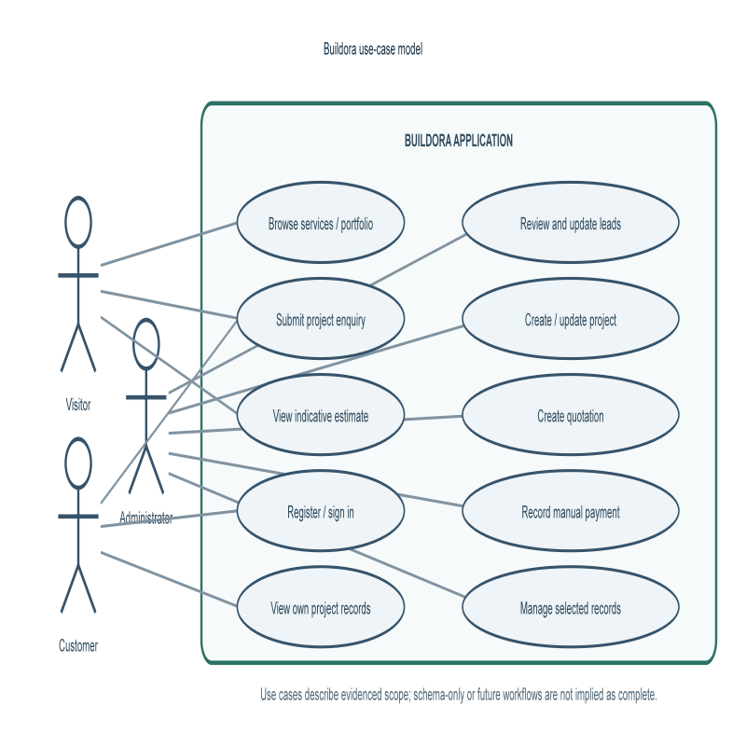

Table 3.3. Detailed use-case specifications
ID / use case | Actor and precondition | Main flow and postcondition | Alternate / boundary flow
UC-01 Submit enquiry | Visitor; public form available | Enter details → validate/rate-limit → create lead; return lead ID. | Invalid input returns field errors; persistence failure returns safe error.
UC-02 Review or convert lead | Admin session; lead exists | Review lead → update status or convert; project may link to originating lead. | Non-admin/unauthenticated operation must be rejected; verify in DB integration test.
UC-03 View own project | Customer session; project belongs to account | Resolve session → check ownership → read permitted project records. | Non-owner is forbidden; ownership helper has unit coverage.
UC-04 Estimate cost | Visitor/customer; estimate form available | Choose parameters → client formula returns indicative range. | Unknown option defaults are implementation detail; result is not a binding quote.
UC-05 Record payment | Admin session; project exists | Record amount/status/method as a manual project record. | No payment gateway, card capture, or settlement is implied.
UC-06 Upload project file | Customer/admin access and storage configuration | Validate file → obtain presigned URL → transfer to configured storage. | Missing provider config or invalid file must be handled; live provider is unverified.

Preconditions and alternate outcomes above are derived from code boundaries and recommended acceptance criteria. Cases that require database-backed route execution remain unverified.

3.4 Non-functional requirements
Table 3.2. Quality requirements
ID | Quality attribute | Requirement / evidence
NFR-01 | Security | Protect session cookies; validate identities, roles, and resource ownership on the server.
NFR-02 | Data integrity | Use relational constraints, typed data access, and reviewed migrations for persistent records.
NFR-03 | Availability | Configure production database, secrets, email, storage, backups, and monitoring; no uptime target is established.
NFR-04 | Usability | Use clear forms, validation messages, role-specific views, and responsive public pages; usability testing is pending.
NFR-05 | Maintainability | Use TypeScript, Next.js conventions, modular services, Prisma schema, migrations, and automated checks.
NFR-06 | Performance | Set measurable response-time objectives and test with representative data before production; no benchmark is claimed.
NFR-07 | Privacy | Restrict personal information to authorised purposes and define retention/deletion policy before launch.
NFR-08 | Compatibility | Develop for supported browsers and Node.js 22+ / PostgreSQL 16+ as stated in project setup documentation.
NFR-09 | Observability | Expose health/configuration status through `/api/health`; protect logs from sensitive data.
NFR-10 | Recovery | Back up PostgreSQL, test restoration, and preserve object-storage references and recovery procedures.

These are target qualities or repository-supported controls, not claims that every quality has been measured. In particular, responsive layout, accessibility conformance, performance, uptime, and recovery objectives require explicit tests and acceptance criteria.

3.5 Business rules and data validation
The application defines customer and admin roles. New application accounts default to customer. A project is related to a customer; customer-facing service code checks ownership before selected operations. Leads have a status lifecycle including new, contacted, qualified, converted, and closed. Projects have planning, in-progress, on-hold, completed, and cancelled states. Quotation and payment status values are modeled as enumerations.
The lead lifecycle diagram later in Chapter 4 is a state model of schema values rather than a complete finite-state validation engine. The project status enum similarly defines planning, in-progress, on-hold, completed, and cancelled; permitted transitions and approval rules remain business decisions.
Input validation covers registration/login and contact enquiry fields. Domain helpers validate email, positive numeric quantities, money precision, and project-customer access. Rate limiting is implemented for lead and authentication flows, with Redis configuration optional and an in-memory backend otherwise. The production policy should define acceptable budgets, file types/sizes, rate thresholds, and retention periods centrally.

3.6 Context and data-flow models
The context model treats Buildora as one system with visitor, customer, and administrator actors, PostgreSQL as the persistent business-data store, and optional external services. The level-1 view decomposes the system into enquiry capture, authentication/authorisation, customer project access, and selected administrator operations. These logical data-flow models describe scope and trust boundaries, not a measured network topology.
Acceptance approach: every high-priority requirement should have an observable condition. For example, an invalid enquiry is rejected without a lead row; a valid enquiry is persisted and returns a stable identifier; a non-owner is denied project access; and an admin-only mutation rejects other roles. UI acceptance must additionally cover loading, empty, success, validation-error, and server-error states.
Prioritisation: lead submission, account/session correctness, and customer-data isolation are essential. Public content and administrative lead review are important. Optional email and file storage are configuration-dependent. Analytics, complete project scheduling, payment collection, and additional roles are not baseline release conditions because their completed workflows are not established in the inspected repository.
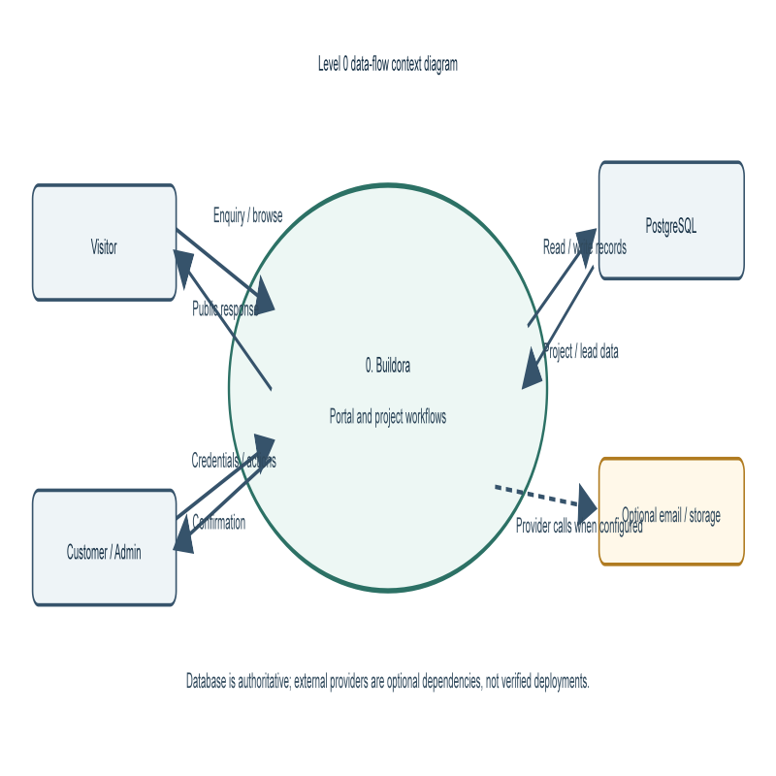
Figure 3.1. Level 0 context data-flow diagram
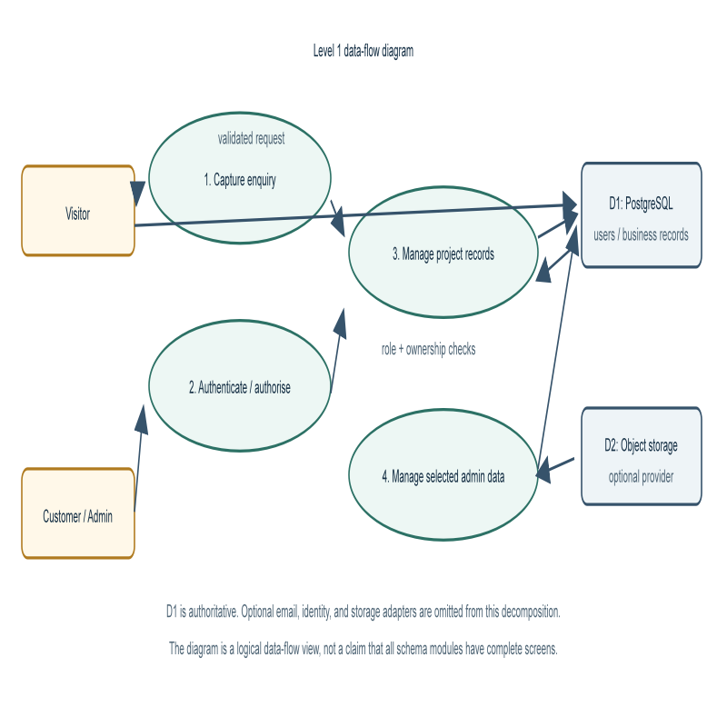
Figure 3.3. Level 1 logical data-flow diagram

CHAPTER 4 — SYSTEM DESIGN

4.1 Architecture overview
Buildora follows a web application architecture. A browser requests public pages or authenticated workflows from Next.js. Page and route handlers use application services and data-access functions; Prisma communicates with PostgreSQL. Server-side authentication derives a user identity from a signed session cookie, and routes apply role or ownership checks. Optional integrations are reached from controlled server-side boundaries: Firebase Admin verifies identity tokens when configured; email providers deliver transactional messages; S3-compatible storage receives presigned upload/download operations.
The architecture separates the user interface from durable business state. Static/local service and portfolio content may be used for presentation, while application users, leads, and project data are stored in PostgreSQL. This distinction should be maintained in future development so that a page backed by local content is not mistaken for a database-managed catalogue.
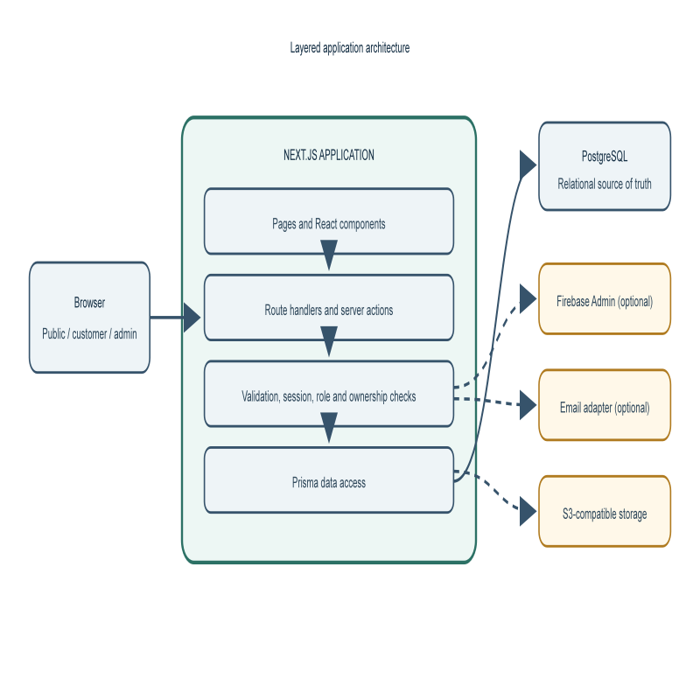
Figure 4.1. Layered application architecture and optional integrations
The design follows a structured decomposition: presentation routes call server actions or route handlers; shared validation and access rules guard domain operations; Prisma data access persists records. The diagram intentionally omits framework internals and does not claim independent microservices.

4.2 Technology selection
Next.js 16 and React 19 provide routing, server rendering, and interactive UI. TypeScript checks application code at compile time. Prisma 6 supplies generated data access and schema migrations. PostgreSQL stores relational business records. Node.js 22+ is specified in setup guidance. Playwright is configured for Chromium browser testing. Authentication, email, and storage integrations are implemented in application modules and activated through environment configuration.
This selection supports a single web application with a relational core and a practical local development workflow. It also creates version-management responsibilities: framework upgrades, Prisma migration review, dependency updates, and compatible runtime deployment should be managed and tested together.

4.3 Data design
The Prisma schema defines relational models for users, leads, services, projects, quotations and line items, payments and payment milestones, documents and versions, design assets and versions, materials, approvals, conversations, participants, messages, notifications, cost estimates, project phases, milestones, timeline events, gallery media, activity, audit logs, verification tokens, and password-reset tokens.
The `User` entity includes a role, account state, normalised unique email, optional password hash, and timestamps. `Lead` captures contact details, project brief, status, optional service/customer/assigned administrator, and lifecycle dates. `Project` belongs to a customer and can link to an originating lead. Commercial and collaboration entities refer to a project or user through foreign-key relations. Indexes support common lookup patterns such as user role/status, lead status/date, and project customer/status.
Soft-deletion timestamps appear on several business entities. Data retention and the effect of soft deletion on every query must be reviewed before production. Schema presence alone does not demonstrate user-interface completeness for all records.

Table 4.1. Principal data entities
Domain | Representative entities | Responsibility
Identity | User, EmailVerificationToken, PasswordResetToken | Account identity, state, verification, recovery
Enquiry | Lead, Service | Contact request, service classification, lead state
Project | Project, ProjectService, ProjectPhase, ProjectMilestone | Customer work and progress structure
Commercial | Quotation, QuotationLineItem, Payment, PaymentMilestone, CostEstimate | Estimates, quoted line items, manual financial records
Collaboration | Approval, Conversation, Participant, Message, Notification | Selected decisions and communication records
Files and design | Document, DocumentVersion, DesignAsset, DesignVersion, Material | Metadata and versionable project artefacts
Governance | ActivityEvent, AuditLog, TimelineEvent | Operational history and traceability
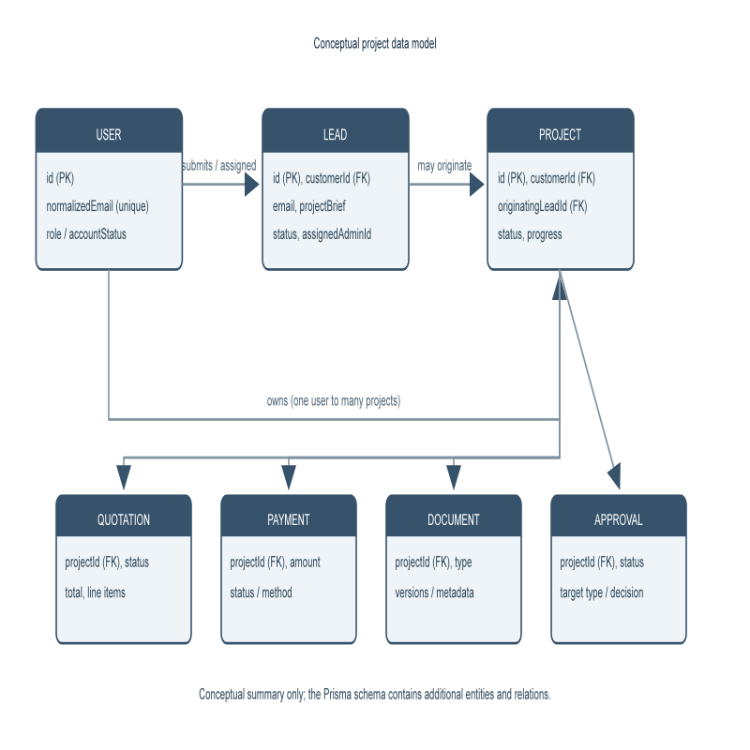
Figure 4.2. Conceptual domain class and data model

The model is analogous to a domain class diagram: it highlights representative entities and relationships, not every Prisma field or method. No live database object snapshot was queried; Appendix B instead gives an explicitly synthetic example to explain relationships.

4.4 Data integrity and persistence
Prisma models define identifiers, required fields, enumerated statuses, relationships, and indexes. Monetary values use decimal database types in commercial records; project progress is represented as a decimal. Foreign-key deletion policies express whether related records are restricted, cascaded, or detached. Those choices should be checked against retention and audit requirements.
Database changes are tracked in three checked-in migrations. The project README directs developers to apply migrations with the deployment command and warns against using schema push against production. The safe deployment sequence is to review a migration, apply it to a disposable or staging database, verify application compatibility, back up production, then deploy the migration and application in a controlled window.
The database is authoritative for user and business records. No claim is made here that the project has tested backup restoration, high availability, data export, or migration rollback. These should be included in an operational acceptance checklist.
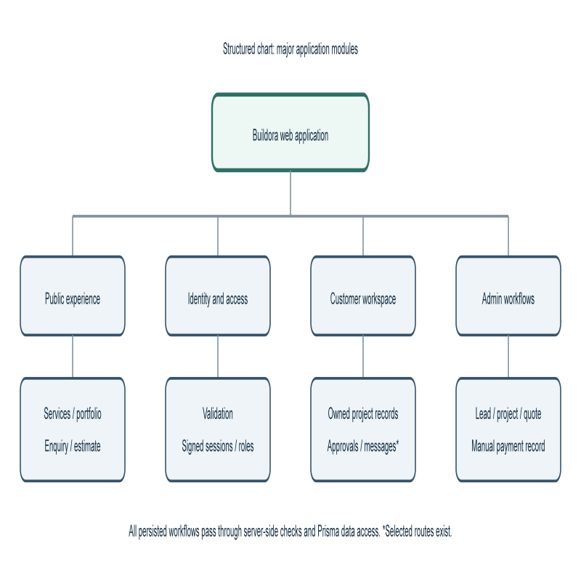
Figure 4.3. Structured chart of major application modules

4.5 Interface and navigation design
The public experience contains service, project/portfolio, process, and informational pages. Customer navigation is designed around overview, projects, progress, timeline, cost/payments, documents, approvals, messages, and notifications. Administrative navigation presents an overview and areas for projects, leads, quotations, finance, clients, milestones, and reports. Availability of a navigation item does not prove that every listed module is complete; only the implemented routes and operations described elsewhere are treated as verified.
The UI should consistently distinguish empty data from unavailable data, and indicative figures from approved commercial documents. The existing server snapshot includes fallback content for some dashboard views; future UI validation should ensure such fallback values cannot be mistaken for live database facts. Accessibility, keyboard navigation, and screen-reader behaviour were not assessed in this run.

4.6 Security design
Application sessions are signed with HMAC-SHA256 and stored in an HTTP-only, SameSite=Lax cookie; production cookies are marked Secure and sessions expire after seven days. Production configuration requires an `AUTH_SECRET` of at least 32 characters. Password handling uses Node.js scrypt in the authentication module. Firebase token exchange is optional; when Firebase Admin is configured, the token is verified and a verified email is required for that flow.
Route-level checks and service helpers enforce roles and customer/project ownership in relevant paths. Input validators and rate limiters reduce malformed submissions and repeated attempts. Storage routes handle presigned URLs and upload validation. These are implementation controls, not a security certification. The review did not perform penetration testing, dependency vulnerability assessment, threat modelling with stakeholders, or a full code security audit.
Production controls still required include secret management, HTTPS, least-privilege database and storage credentials, rate-limit backend selection, restrictive CORS/bucket policy, log redaction, session revocation policy, account recovery review, privacy and retention controls, backups, monitoring, and incident response. Administrative account provisioning must be restricted to operator-controlled identities.
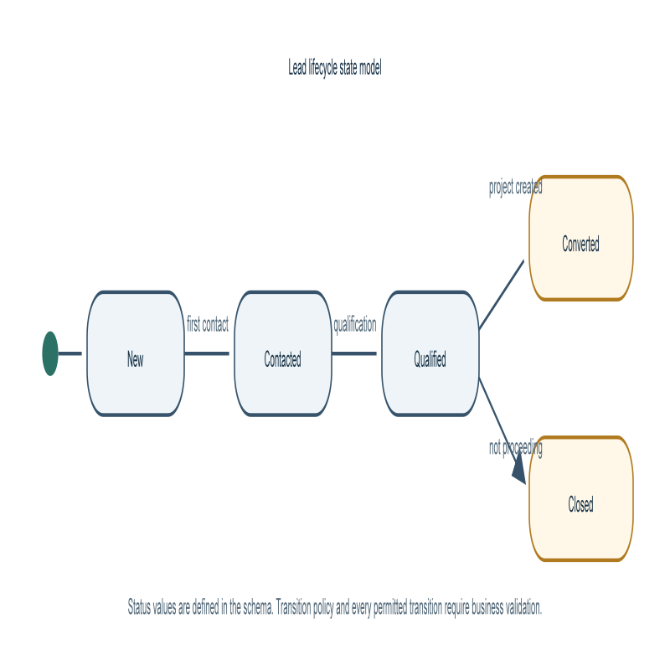
Figure 4.4. Lead lifecycle state model from schema status values
The enum values are present in the schema; transition policy, allowed reversals, and triggers for each transition need business-owner confirmation.

4.7 Deployment and external-service design
The README specifies local setup with Node.js 22+, PostgreSQL 16+, `.env.example`, `DATABASE_URL`, an `AUTH_SECRET`, Prisma client generation, and checked-in migrations. Optional Firebase, email, and object-storage variables are only needed when those integrations are enabled. `/api/health` reports database connectivity and status/configuration of selected dependencies. In production, health is degraded if the database is disconnected or required production session/email configuration is absent.
The CI workflow describes a disposable PostgreSQL service for automated validation and browser tests. A workflow definition does not establish that deployment, CI, or production monitoring has succeeded. The report does not reproduce secret values and none are needed for academic description.

CHAPTER 5 — IMPLEMENTATION

5.1 Public pages and service discovery
The application is built using Next.js route conventions with React components and TypeScript. Public pages present service and portfolio information, process content, and business information. Some display data is imported from local data modules, while database-backed operational records are accessed through Prisma. This hybrid approach is appropriate for a catalogue that changes infrequently, but the source of each displayed fact should remain explicit.
The cost estimator collects property type, construction type, area, floors, interior level, location category, and quality. It uses a base rate of INR 1,450 per square foot and multiplies the selected property, construction, location, interior, quality, and floor factors. The result is expressed as a range: 90% to 118% of adjusted area-rate total. The result is a rough, client-side indication; it is not persisted by this calculation, reviewed by an estimator, or guaranteed as a project quote.

5.2 Enquiry submission workflow
The server action reads a form or object payload, normalises whitespace and validates name, email, phone, location, and brief. If a service label is supplied, it attempts to associate a matching active service. The lead is saved with source `website_contact` through the lead service. If a logged-in customer submitted the request, project creation is attempted as a best-effort follow-up; failure is logged without discarding the already-created lead. Customer confirmation and administrator alert messages are dispatched through the email service.
The lead flow invokes an IP-based rate limiter. Header access in contexts without a request can be bypassed to support direct unit-test invocation; this is not evidence that production requests lack rate limiting. Rate limiting uses Redis only when configured; otherwise it is in-memory and therefore not shared across multiple app instances. This operational distinction must be reflected in deployment choices.
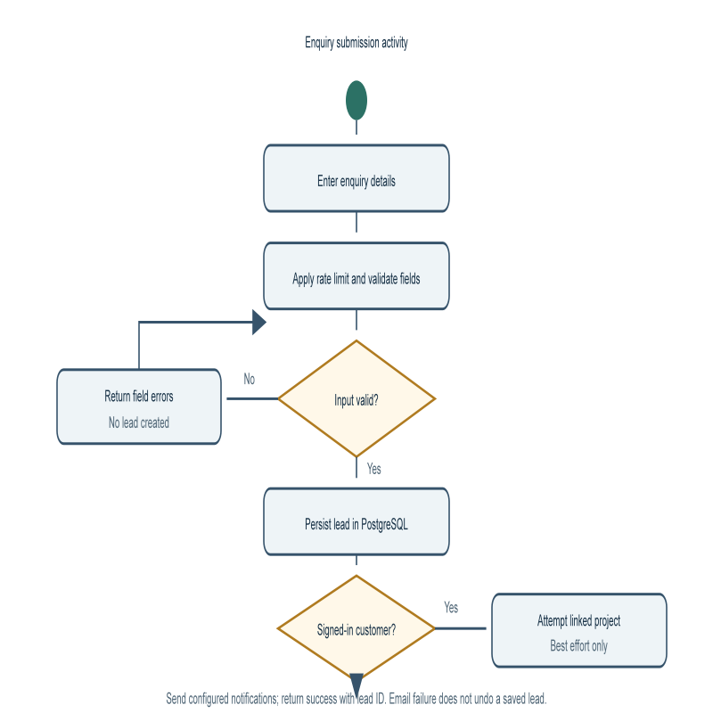

Figure 5.1. Enquiry validation and persistence activity

5.3 Identity, sessions, and roles
Registration and login validation reject missing or malformed values and constrain password length. The authentication module uses scrypt for password derivation and a signed session payload with user ID, role, optional profile information, and expiration. The browser cookie is HTTP-only, SameSite=Lax, scoped to `/`, and Secure in production. Current user resolution checks that the corresponding account is active and not deleted; production session-secret configuration is enforced.
Role enforcement redirects a user without a valid session to login and redirects authenticated users to their own role-appropriate dashboard when they attempt a mismatched role view. Additional endpoint checks are necessary for every data mutation; UI hiding alone is not a security boundary. Email verification, password reset, and optional Firebase identity routes are present, but end-to-end delivery and account-recovery correctness were not verified in this report run.

5.4 Customer and administrative workflows
Customer data-access logic retrieves projects using the current customer identifier and filters soft-deleted projects. Dashboard data includes selected project records, pending approval count, payments, quotations, documents, messages, and notifications. The service layer contains reusable project ownership checks. Relevant customer API routes include profile changes, approval responses, quotation responses, messaging, notification updates, and storage operations.
Administrative routes cover selected lead status changes, lead conversion, project creation and updates, quotation creation, and manual payment recording. This report intentionally describes selected operations instead of claiming a complete ERP. The Prisma schema includes more concepts than the verified user workflows; several areas require additional UI, validation, authorisation tests, and acceptance review before they should be marketed as complete modules.
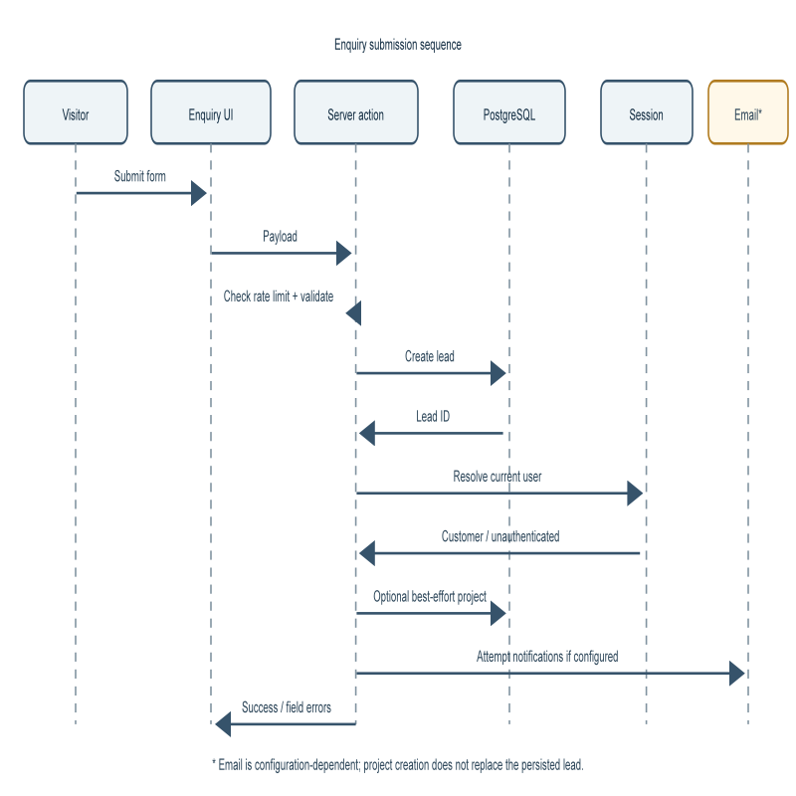
Figure 5.2. Enquiry submission and optional project creation sequence

Collaboration view (message order): (1) Browser submits to the server action; (2) action checks rate limiter and validates; (3) action creates the lead via Prisma; (4) session lookup determines whether the submitter is a customer; (5) linked project creation is attempted for a signed-in customer; (6) configured email adapters are invoked and a result is returned. The diagram and numbered messages describe one observed workflow, not a guarantee of provider delivery.

5.5 Email and file-storage integration
The email module detects Resend, Postmark, or SMTP configuration and can simulate delivery in local development when no provider is configured. Enquiry processing attempts to send a customer confirmation and administrator alert. Authentication supports verification and password-reset email. A configured provider, domain verification, templates, deliverability, retry policy, bounce handling, and data-protection terms must be established before production. No actual email delivery is claimed.
Storage code creates S3-compatible presigned URLs for direct browser uploads and downloads. Supported configuration can target AWS S3 or a compatible endpoint such as Cloudflare R2 or MinIO. The presigned upload expires after a default 15 minutes. Mock storage is restricted to non-production with an explicit flag. Credentials must remain server-side and be scoped to the required bucket and actions. A live bucket and complete production file lifecycle were not verified.

5.6 Error handling and configuration
Form and API errors should be surfaced to the user in a safe and actionable way while detailed failures are logged server-side. The enquiry workflow returns field errors for invalid submissions and a generic failure for persistence errors; optional follow-up email/project creation is logged without changing the lead-save result. Health checks distinguish configured services and database connectivity.
Configuration uses environment variables and `.env.example` as a starting point. Production secrets must come from a secret manager and must not be placed in the source repository. The README recommends reviewing migrations in staging and applying them with the deployment migration command. Configuring every optional provider is not necessary for local work but is a prerequisite for enabling its production feature.
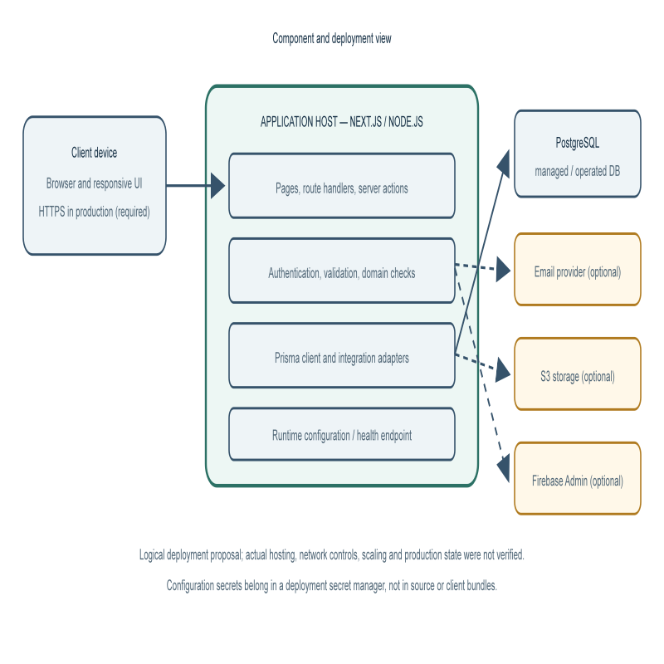
Figure 5.3. Application components and proposed deployment boundary

CHAPTER 6 — VERIFICATION AND TESTING

6.1 Verification strategy
Verification combines static type checking, focused unit tests, database-backed integration tests, browser E2E tests, linting, and deployment checks. Test data must be isolated from production. The README explicitly requires a dedicated disposable database for browser tests because the E2E global setup creates test accounts and project fixtures. A CI workflow definition provides a possible automation path but is not a result.
The current verification record is from commands run during preparation of this report. It is an environment-specific snapshot rather than a permanent quality guarantee. Tests that require a live database are identified separately, and no test is reported as passed unless the command output demonstrated success.

Table 6.1. Verification results at report preparation
Check | Result | Interpretation
`npm test` | 19 passed; 1 skipped; 0 failed | Unit/action suite passed; PostgreSQL lead-persistence test skipped because database testing was not enabled.
`npm run typecheck` | Completed successfully | `tsc --noEmit` returned without reported errors.
`npm run lint` | Completed; 0 errors, 17 warnings | Exit code 0; warnings are disclosed and were not changed as part of report preparation.
Database migrations / integration | Not run in this report session | Requires a dedicated PostgreSQL test database.
Playwright E2E | Not run in this report session | Requires disposable E2E database and browser environment.
Production integrations | Not verified | No live Firebase, email-provider, or storage-bucket validation.

6.2 Unit and domain test coverage
The `npm test` script uses `tsx --test` over `tests/*.test.ts`. Observed passing tests cover registration/login/reset/verification validation, email and positive-money domain validation, customer ownership guards, lead action invalid-input paths, sliding-window rate limiting, storage upload validation and object-key traversal prevention, presigned URL shape/expiry, and email provider status detection.
One test for persisting a valid lead in PostgreSQL was explicitly skipped unless `RUN_DATABASE_TESTS=1` is set. The observed run reports 20 tests in total, 19 passed, one skipped, zero failures. This is useful evidence for the tested functions, but does not prove that all API routes, database relationships, concurrent scenarios, or production configurations behave correctly.

6.3 Type, lint, integration and browser validation
`npm run typecheck` completed with exit status zero in the inspected project environment. This confirms the compiler reported no type errors under the repository configuration at that time; it does not establish runtime correctness. `npm run lint` also exited successfully, reporting zero errors and 17 warnings in application/test source files. The warning count is disclosed rather than treated as a clean, warning-free lint run.
The database test requires a configured test database and the explicit database-test flag. Playwright uses a Chromium project, starts a local development server, and runs a global setup that provisions fixtures; the project README requires a dedicated disposable database. These checks were not executed in this report session. They must not be run against production or valuable data.
Recommended integration acceptance tests include register/login/logout and recovery; authorised versus unauthorised admin requests; owner versus non-owner project access; lead persistence and duplicate submission behaviour; migration from an empty database; email provider failure and success; storage expiry, policy, and download access; and data deletion/retention.

6.4 Defect handling and test limitations
Table 6.2. Representative test cases and execution status
ID | Test input / scenario | Expected result | Evidence status
TC-01 | Malformed registration fields | Field validation errors | Executed; passed
TC-02 | Complete valid registration payload | No validation errors | Executed; passed
TC-03 | Non-string login/reset/OTP values | Rejected without throwing | Executed; passed
TC-04 | Empty enquiry payload | Required-field errors | Executed; passed
TC-05 | Invalid enquiry email | Email field error | Executed; passed
TC-06 | Customer attempts another customer's project | Forbidden / access false | Executed in domain helper; passed
TC-07 | Money amount with more than 2 decimals | `INVALID_INPUT` | Executed; passed
TC-08 | Fourth request after 3 allowed within window | Rate limit rejected | Executed; passed
TC-09 | Oversized / unsupported upload | File validation fails | Executed; passed
TC-10 | Valid enquiry persisted to PostgreSQL | Lead row and linked service stored | Test exists; skipped in this run
TC-11 | Customer/admin browser workflows | Expected role-specific UI and access rules | Proposed; E2E not run

The available suite covers selected validators and domain helpers; no coverage percentage is claimed. Database, browser, accessibility, load, and resilience tests remain distinct acceptance work. Use isolated fixtures and disposable databases, never production data.

CHAPTER 7 — ESTIMATION, SCHEDULE, OPERATION AND SECURITY

7.1 Preliminary function-point sizing and effort estimation
The reference report's function-point method is adopted as an estimation framework, not as a fabricated Buildora result. A defensible IFPUG count needs a complete, agreed inventory of user-recognisable transactions, data groups, DET/FTR/RET counts, complexity classifications, and general system characteristics. Those sizing inputs have not been elicited or independently reviewed for this repository.
Table 7.1. Function-point measurement worksheet (counts pending)
Function type | Examples to count in Buildora | Low / average / high weights
External inputs (EI) | Enquiry, registration, profile, approval, message, admin updates | 3 / 4 / 6
External outputs (EO) | Confirmation, project summaries, quotation and status views | 4 / 5 / 7
External inquiries (EQ) | Service catalogue, project lookup, dashboard queries | 3 / 4 / 6
Internal logical files (ILF) | User, lead, project and governed project records | 7 / 10 / 15
External interface files (EIF) | Optional identity/email/storage provider data, if counted as referenced external groups | 5 / 7 / 10

The listed weights are the traditional low/average/high weighting set; they do not supply function counts or a final total. The worksheet must be completed by counting unique functions and classifying each one. Unadjusted FP = sum(count × selected weight). If the selected method uses a value adjustment factor, document each general system characteristic and calculate it using that method's prescribed formula. No adjusted FP, productivity ratio, person-hour estimate, or cost is asserted here. Convert a validated count to effort only with a documented historical productivity rate and team capacity.

7.2 Proposed project schedule and PERT/CPM basis
The following schedule is a provisional forward plan for completing and validating the current scope. It is not a record of work already performed. It assumes an academic project team can overlap design, implementation and test preparation; the supervisor should revise the start date, staffing, deliverables and acceptance gates.

Table 7.2. Indicative 18-week work breakdown
Work package | Proposed weeks | Dependency | Exit evidence
--- | ---: | --- | ---
Scope and requirements review | 1–2 | None | Approved actors, requirements and acceptance criteria
Architecture and migration review | 2–4 | Scope baseline | Reviewed data model and staging migration
Identity and access controls | 4–7 | Architecture | Role and ownership tests
Enquiry and project workflows | 6–10 | Data model; identity in parallel | Database-backed acceptance cases
Admin workflows and integrations | 9–12 | Core workflow contracts | Provider configuration and failure-path checks
Integration, browser and security verification | 12–16 | Stable workflows | Test evidence and resolved release blockers
Release readiness and report | 18 | Verification review | Guide-approved release/submission package
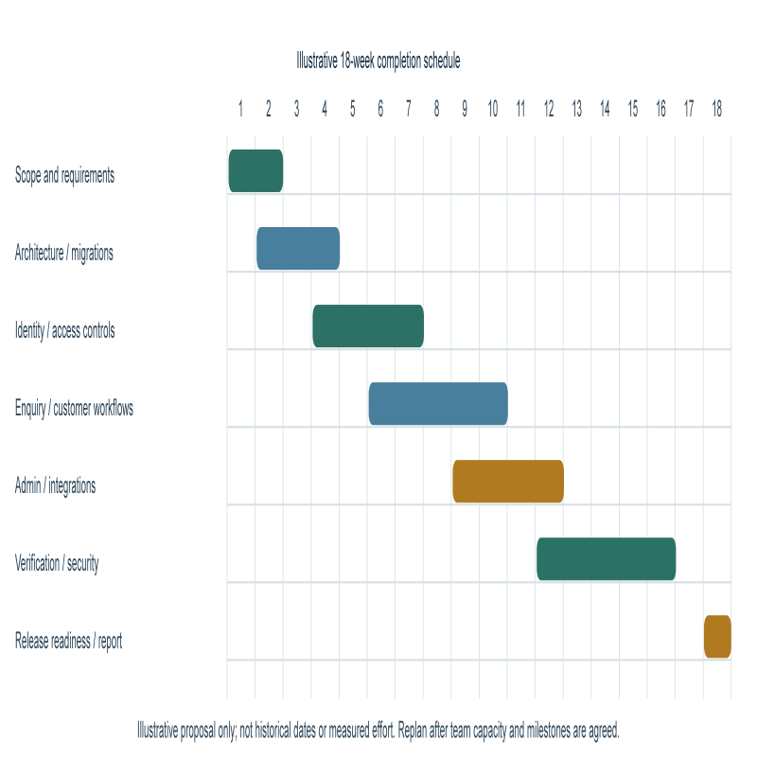
Figure 7.1. Indicative schedule; weeks are planning assumptions, not historical dates

PERT uses three-point durations: expected duration = (optimistic + 4 × most likely + pessimistic) ÷ 6. A provisional serial critical path of 2 + 3 + 4 + 5 + 3 + 1 weeks gives 18 expected weeks. Parallel work, review delays and available staff can change the real critical path; no project-specific effort log was supplied.

7.3 Risk management
Table 7.3. Risk register
Risk | Likelihood / impact | Mitigation and owner
Customer sees another customer's record | Medium / Critical | Enforce ownership in server services/routes; negative integration tests; application owner
Secrets or storage objects exposed | Medium / High | Secret manager, least privilege, private bucket, URL expiry, rotation; operator
Database unavailable or data loss | Medium / High | Managed availability, backups, restore rehearsal, health monitoring; operator
Incorrect indicative estimate interpreted as a quote | Medium / High | Clear disclaimer, review by professional, separate approved quotation workflow; business owner
Email silently fails or is marked as sent when simulated | Medium / Medium | Show provider state, monitor delivery, test failure paths; operator
In-memory rate limit insufficient across instances | Medium / Medium | Redis/shared backend and deployment-specific thresholds; operator
Schema migration harms existing data | Low / High | Review migrations, staging rehearsal, backup and rollback strategy; developer/operator
Scope overstated based on schema or navigation only | Medium / Medium | Feature-by-feature acceptance evidence; project owner

Likelihood ratings are qualitative planning judgements, not measured statistical estimates. Owners should be assigned by the deploying organisation.

7.4 Security and privacy operation
Handle customer identity, contact, project, and document data as confidential. Collect only data needed for the enquiry and project service. Publish a privacy notice, define the lawful basis and retention period, implement deletion/export procedures, restrict administrative access, and establish incident-response contacts before launch. Avoid placing personal data, session tokens, provider responses, or secrets in logs.
Production review should include dependency audit, threat model, secure-cookie and TLS checks, session lifetime/revocation policy, password and recovery review, authorisation review for every route, CSRF/origin considerations, request-size and upload restrictions, storage policy review, rate limiting, and penetration testing by an authorised assessor. The present report describes engineering controls and pending work; it does not certify the application as secure.

7.5 PERT/CPM dependency analysis
For a conservative planning baseline, the major work packages in Table 7.2 are treated as a serial critical path: requirements → design/migration → identity/access → workflows → verification → release. Using assumed optimistic/most-likely/pessimistic values of (1,2,3), (2,3,4), (3,4,5), (4,5,6), (2,3,4), and (0.5,1,1.5) weeks respectively gives expected durations of 2, 3, 4, 5, 3, and 1 week. Their sum is 18 weeks. These are planning assumptions for a proposed completion plan, not measured actuals.
The proposed network is shown in Figure C.1. The critical path should be recalculated after the project guide confirms team availability, parallel tasks, external approvals, and submission dates.

7.6 Quality assurance and maintenance
Maintainability depends on keeping domain rules in shared services, documenting API contracts, reviewing schema changes, and running automated checks in CI. Each feature should include a test for normal use, invalid input, insufficient permissions, and unavailable dependencies. Production incidents should feed back into requirements, test cases, and operational documentation.
Dependencies should be updated through a controlled process that checks release notes, security advisories, TypeScript compilation, unit tests, database migrations, and browser smoke tests. Database schema evolution should be backward-compatible where practical: add optional fields first, deploy compatible code, backfill data, then enforce constraints in a later change. Destructive changes require approved backup and recovery plans.
Operational dashboards should monitor request errors, latency percentiles, database connection pressure, background delivery failures, storage failures, and rate-limit events without exposing private information. Define service objectives and escalation paths with the business owner; none are assumed by this report.

CHAPTER 8 — CONCLUSION AND FUTURE WORK

8.1 Conclusion
Buildora provides a foundation for a construction-services customer and project portal. The inspected repository contains public service/portfolio presentation, a structured lead capture path, customer/admin roles, signed session handling, selected customer and administrative workflows, and a relational PostgreSQL/Prisma data model. It also contains code boundaries for optional transactional email, Firebase identity, and S3-compatible object storage.
The implementation is supported by a test suite and static type check. At the report verification point, the standard unit/action command completed with 19 passing and one skipped database persistence test; TypeScript checking completed without errors; lint completed with zero errors and 17 warnings. This evidence is limited to the code and checks actually run. Database integration, browser E2E, external providers, deployment, accessibility, performance, and production security were not verified.
The project therefore meets the engineering objective of establishing an integrated application foundation, while several deployment and workflow claims remain conditional. Honest release readiness depends on database-backed verification, route-by-route authorisation tests, configured integrations, user acceptance, privacy decisions, and operational recovery evidence.

8.2 Future work
Near term: resolve or explicitly accept remaining lint warnings; execute PostgreSQL integration tests against a disposable database; run Playwright E2E with isolated fixtures; review all API route access controls; test migrations from an empty and representative database; correct user-facing loading/error states; perform accessibility checks.
Before production: configure managed database, strong secrets, verified email provider, private object storage and Redis if scaled; establish backups/restore, monitoring, privacy and retention policies, incident response, security testing, domain verification, and administrator onboarding.
Later enhancements: broaden project planning and milestone workflows; add verified reporting and analytics; support configurable estimate assumptions with professional review; consider additional staff roles and audit review; evaluate payment collection only through a compliant provider and with explicit reconciliation requirements.
These are recommendations rather than implemented features. Their priority should be agreed with stakeholders.

REFERENCES
The following sources were consulted for the technology and implementation descriptions. Accessed on 14 October 2026. Confirm institutional citation style and exact release versions at final submission.
- Buildora repository, `README.md`, `package.json`, `prisma/schema.prisma`, migrations, source modules, and tests. Local project artefacts inspected for this report.
- Vercel. Next.js Documentation. https://nextjs.org/docs
- React. React Documentation. https://react.dev/learn
- Microsoft. TypeScript Documentation. https://www.typescriptlang.org/docs/
- Prisma. Prisma ORM Documentation. https://www.prisma.io/docs/orm
- PostgreSQL Global Development Group. PostgreSQL Documentation. https://www.postgresql.org/docs/
- Node.js. Node.js Documentation: Crypto. https://nodejs.org/api/crypto.html
- Playwright. Playwright Test Documentation. https://playwright.dev/docs/intro
- OWASP Foundation. Application Security Verification Standard (ASVS). https://owasp.org/www-project-application-security-verification-standard/
- OWASP Foundation. Cheat Sheet Series. https://cheatsheetseries.owasp.org/
Technical documentation supports descriptions of the respective tools, not claims that Buildora is certified or conforms to a standard. All implementation statements are based on repository evidence, not vendor marketing.

Further technical references
- Amazon Web Services. Signature Version 4 Signing Process. https://docs.aws.amazon.com/IAM/latest/UserGuide/reference_sigv.html
- Amazon Web Services. Amazon S3 User Guide. https://docs.aws.amazon.com/AmazonS3/latest/userguide/Welcome.html
- Firebase. Admin SDK: Verify ID Tokens. https://firebase.google.com/docs/auth/admin/verify-id-tokens
- Resend. Send Email API Documentation. https://resend.com/docs/api-reference/emails/send-email
- Postmark. Developer Documentation. https://postmarkapp.com/developer
- Nodemailer. Nodemailer Documentation. https://nodemailer.com/
- IEEE. IEEE Standard for Software and Systems Engineering—Life Cycle Processes—Requirements Engineering (ISO/IEC/IEEE 29148). Use the institution's licensed copy and required bibliographic format when citing a specific clause.
- Sommerville, Ian. Software Engineering. Pearson. Use the edition available through the college library and enter its publication details before final submission.
- Extreme Sales & Services. Extreme Sales & Services Documentation, version 2.0. Supplied DOCX; consulted only as a structure and diagram checklist. Its product domain and implementation claims are not evidence about Buildora.
Citation note: The standards and textbook entries are contextual references. No clause-specific or page-specific quotation is made in this report. Verify editions, access dates, and any required bibliography formatting before submission. Repository facts should be cited as project artefacts in the final version if the department requires source citations in each chapter.

APPENDIX A — VERIFICATION EVIDENCE

A.1 Commands and observed results
The following commands were executed in the project directory during report preparation:
- `npm test` — exit code 0; 20 tests reported; 19 passed; 0 failed; 1 skipped. The skipped test was the PostgreSQL lead-persistence test guarded by `RUN_DATABASE_TESTS=1`.
- `npm run typecheck` — exit code 0; runs `tsc --noEmit`.
- `npm run lint` — exit code 0; ESLint reported 0 errors and 17 warnings in existing application/test files. No documentation files were linted.
The prior health check in the earlier project session returned degraded because database configuration was unavailable in that server run. That observation is historical and does not describe all later environments. No secret values are reproduced here.

A.2 Tests not executed
The following remain unverified in this report session: migrations against a fresh database; database-backed lead and project workflows; the full Playwright suite; login and recovery through a real email provider; real Firebase token verification; S3-compatible upload/download using a real private bucket; production deployment and health; backup restoration; performance; accessibility; and security assessment.
For safe E2E execution, follow the README and use only a dedicated disposable database. Never point test setup at a production or valuable database. Record the environment, command, date, and outcome when completing these checks.

APPENDIX B — DATA AND INTERFACE DESIGN NOTES

B.1 Relationship overview
The central relationship is User → Project → Project artefacts. A project belongs to one customer and may originate from a lead. A project can have phases, milestones, quotations and line items, payments and payment milestones, documents and versions, design assets and versions, materials, approvals, conversations, notifications, cost estimates, activities, and audit history. A lead can be associated with a customer, service, assigned administrator, quotations, cost estimates, and a converted project.
Identity records include unique normalised email and account state. Most business entities use UUID identifiers and explicit timestamps. Enumerations constrain statuses at the database-client type level. The schema defines relational constraints and indexes, but the diagram should be treated as a conceptual summary rather than a complete physical ERD.
Illustrative object snapshot: all names and values in Figure B.1 are synthetic. They demonstrate possible relationships in the schema and are not database output or real customer information.
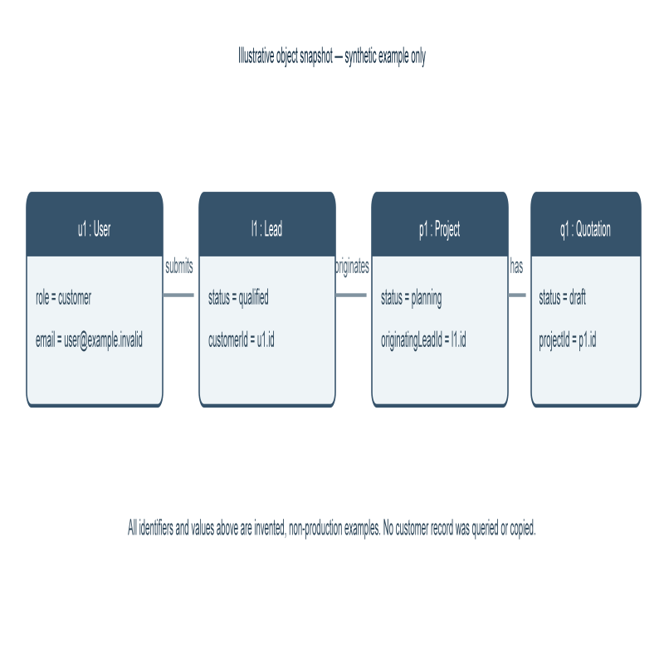
Figure B.1. Synthetic object snapshot for explanation only
The `user@example.invalid` address is reserved for examples. The project and quotation states illustrate schema enums, not a seeded test fixture or a claimed production record.

B.2 Interface and accessibility review checklist
Before release, verify that every form has an explicit label, required-field indication, keyboard order, visible focus, and accessible validation announcement. Check contrast, zoom and responsive layouts, headings, alternate text for meaningful images, error recovery, and reduced-motion behaviour. Test representative pages with keyboard-only navigation and a screen reader. Verify empty/loading/error states for both customer and administrator dashboards.

APPENDIX C — PROJECT PLAN AND SUBMISSION CHECKLIST

C.1 Proposed completion dependency network
Figure C.1 represents an illustrative serial critical path for the proposed completion and validation work: requirements, design/migrations, identity/access, core workflows, verification, and release readiness. Expected durations are assumptions explained in Chapter 7; this is not a record of historical work or a measured project baseline.
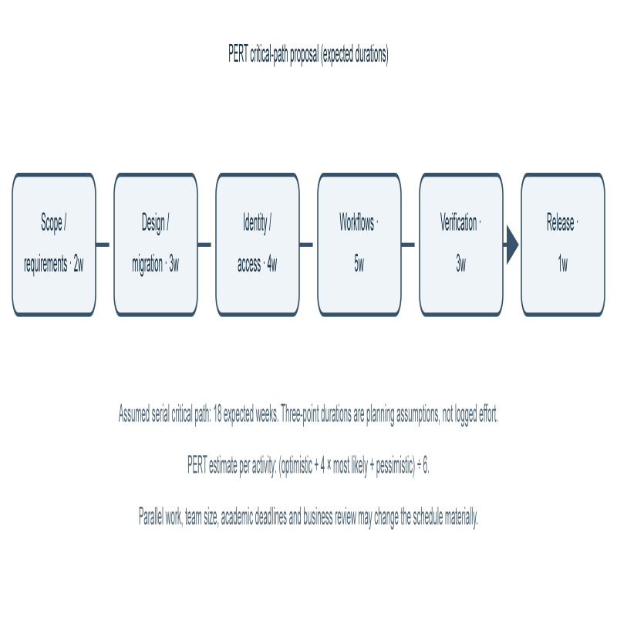
Figure C.1. PERT/CPM dependency network with assumed expected durations

