1. Since the previous version was not working for me due to connection issues, I’ve switched to the second version of Ubuntu using the cmd:

wsl --set-distribution ubuntu 2

1. Then I started each step as mentioned in the oppia-android repository.

* **sudo apt update && sudo apt upgrade**
* **sudo apt install openjdk-8-jdk-headless**
* **sudo dnf install java-1.8.0-openjdk**(This didn’t work) so I tried with apt
* **sudo update-alternatives --config java**(If you have only 8.1 installed, you don’t need this)
* **sudo apt install python**(Although I ran this command, it lead to error, I will mention it below)
* **mkdir -p $HOME/Android/Sdk**
* **cp /c/mnt/Users/<Name>/Downloads/commandlinetools*.zip $HOME/Android/Sdk**
* **cd $HOME/Android/Sdk**
* **unzip commandlinetools*.zip**
* **rm commandlinetools*.zip**(don’t remove the commandlinetools*.zip file)
* **cd cmdline-tools/**
* **mkdir tools**
* **mv -i * tools**(this will throw a warning but that’s fine)
* **cd ..**
* **echo "export ANDROID_HOME=\$HOME/Android/Sdk" >> ~/.bashrc**
* **echo "export PATH=\$ANDROID_HOME/cmdline-tools/tools/bin/:\$PATH" >> ~/.bashrc**
* **source ~/.bashrc**
* **sdkmanager**

Error (JNI error)

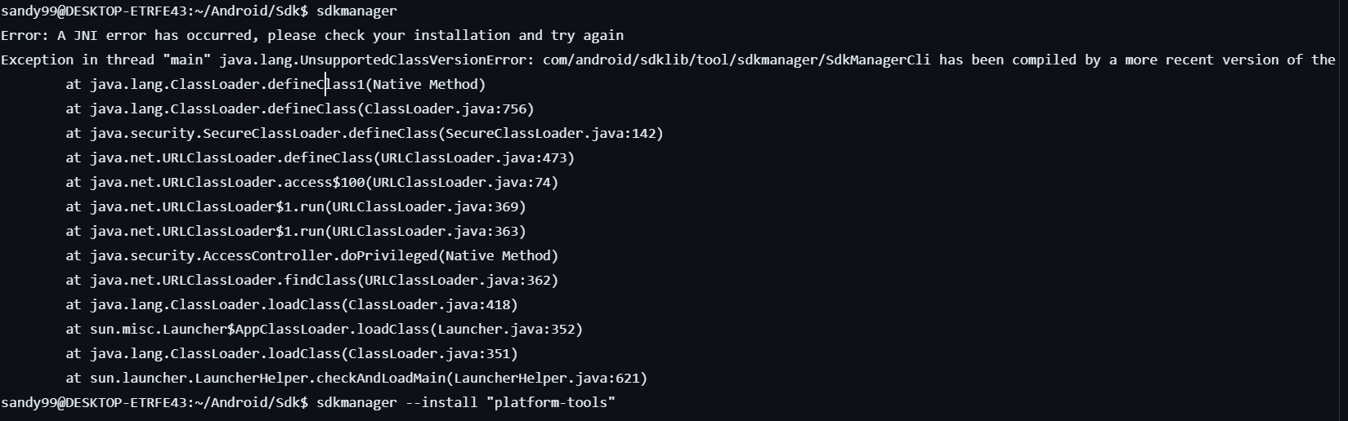

Solution : You need to set the jdk-19 using **sudo update-alternatives --config** java (or) the jdk version of your windows(I think cuz that’s my system’s JDK version)

* **sdkmanager --install "platform-tools"**
* **sdkmanager --install "platforms;android-28"**(this will cause an error in the future as the project expects android-33 so change it to 33 here itself or just follow the steps given)
* **sdkmanager --install "build-tools;29.0.2"**

**Install bazel:**

* **wget https://github.com/bazelbuild/bazel/releases/download/4.0.0/bazel-4.0.0-installer-linux-x86_64.sh**
* **chmod +x bazel-4.0.0-installer-linux-x86_64.sh**
* **./bazel-4.0.0-installer-linux-x86_64.sh –user (I used this command because the command provided in the repository didn’t work for me)**
* **export PATH="$HOME/bin:$PATH"**
* **source ~/.bashrc # or source ~/.zshrc**
* **bazel version (Check bazel version)**
* **Fedora(Bazelisk):**

**wget https://github.com/bazelbuild/bazelisk/releases/download/v1.8.1/bazelisk-linux-amd64**

**chmod +x bazelisk-linux-amd64**

**sudo mv bazelisk-linux-amd64 /usr/local/bin/bazel**

* **mkdir $HOME/opensource**
* **cd ~/opensource**
* git clone https://github.com/oppia/oppia-bazel-tools
* echo build --override_repository=android_tools="$(cd "$(dirname "$HOME/opensource/oppia-bazel-tools")"; pwd)/$(basename "$HOME/opensource/oppia-bazel-tools")" > ~/.bazelrc
* echo build --android_databinding_use_androidx >> ~/.bazelrc
* **git clone** [**https://github.com/oppia/oppia-android.git**](https://github.com/oppia/oppia-android.git)
* **bash scripts/setup.sh**
* Open a terminal and navigate to **opensource/oppia-android/**
* Run the script **bash scripts/setup.sh**
* **bazel build //:oppia**

**Here I got the error :**

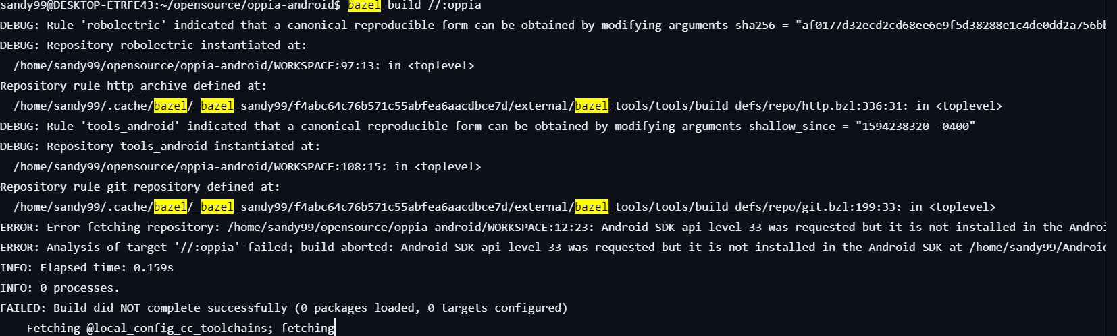

* Here I forgot to change the jdk from 19 to 8 using **“sudo update-alternatives --config java “** and also install the android sdk-33 using **:**

1. **/home/sandy99/Android/Sdk/tools/bin/sdkmanager --sdk_root=/home/sandy99/Android/Sdk**

and

1. **/home/sandy99/Android/Sdk/tools/bin/sdkmanager --sdk_root=/home/sandy99/Android/Sdk "platforms;android-33"**

This should resolve the error.

* Now try “ **bazel build //:oppia “** again so that another error will show up 😅.

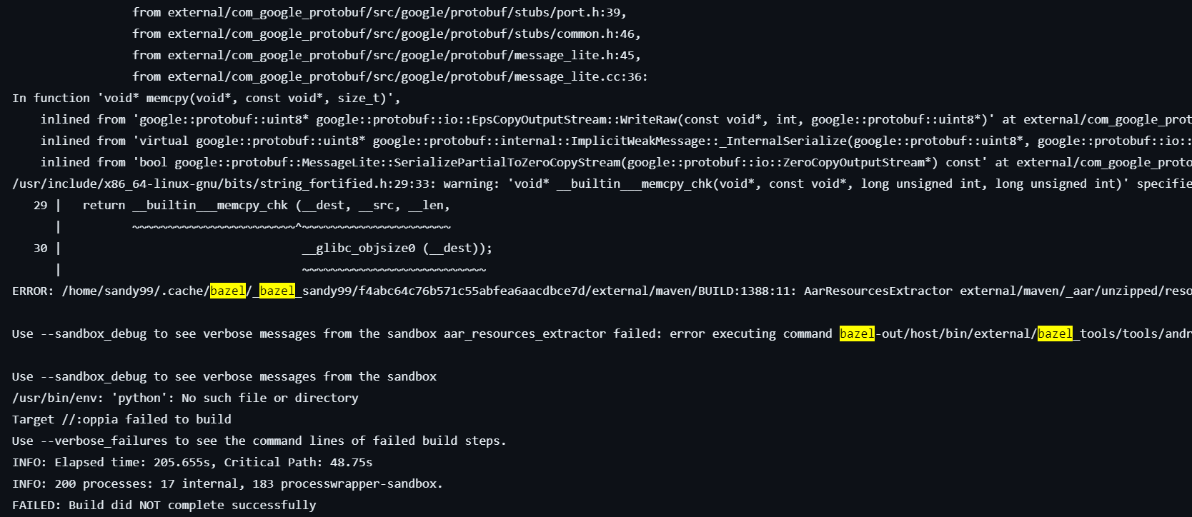

* Hang on to your hope and run this command : “**sudo apt install python-is-python3”.**

Now try “**bazel build //:oppia**” again to build it successfully🎉🎉🥳🥳🥳.