A build tool is a tool that automates everything related to building the software project. Building a software project typically includes one or more of these activities:

* Generating source code (if auto-generated code is used in the project).
* Generating documentation from the source code.
* Compiling source code.
* Packaging compiled code into JAR files or ZIP files.
* Installing the packaged code on a server, in a repository or somewhere else.

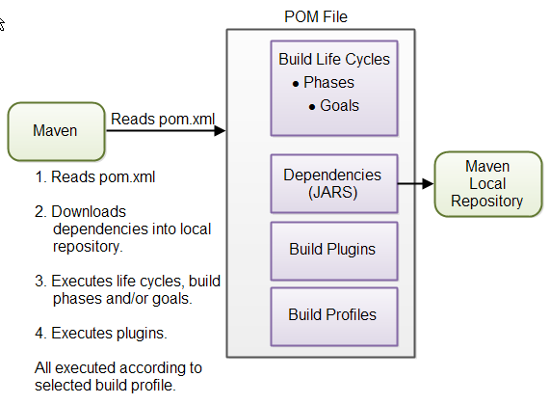

https://jenkov.com/tutorials/maven/maven-tutorial.html

build life cycle