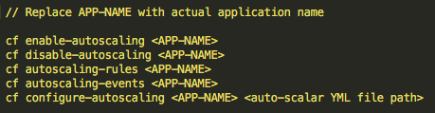

Similar to the `manifest.yml` file, auto-scaling rules can be maintained in app auto scaler YML file as seen below. *We can give any name to this file*.

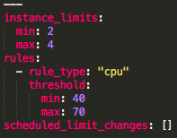

Here auto-scaling has been configured using the parameter “CPU utilization”. If CPU utilization goes below 40% then CF will scale down the application up to MIN of 2 instances whereas if CPU utilization reaches above 70% then CF will scale to the application up to MAX of 4 instances

*cf configure-autoscaling DemoMyApp demoApp-AutoScalar.yml*

App Auto scalar service determines whether to ramp up / ramp down application instance or maintain the current number of instance(s) by averaging the values of configured metric for the last 120 seconds.

After every 35 seconds, App Auto Scaler service evaluates whether to auto-scale the application or not by following the approach mentioned above.

rabbitmq queue

Schedule Application Auto Scaler

It is best to set up auto-scaling with multiple rules to handle rare scenarios, such as an overnight increase in traffic due to holiday seasons like Thanksgiving. These kinds of occurrences can be scheduled ahead of time.

PCF Auto Scaler provides functionality to schedule “auto-scaling” to handle for rare ‘known’ events which may impact application availability/performance.

This can be achieved from Apps manager. For this go to your deployed application which is bound to app-auto scalar service and select ‘Manage scaling’ and select ‘schedule Limit Change’. Below is the sample rule setup:

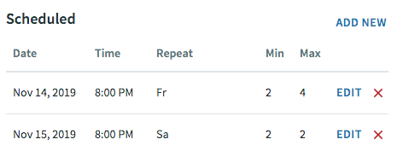

To configure App Autoscaler:

1. Create and bind the App Autoscaler service to your app. See [**Create and Bind the App Autoscaler Service**](https://docs.pivotal.io/application-service/2-8/appsman-services/autoscaler/using-autoscaler.html#create-bind-service).
2. Configure autoscaling instance limits for your app. See **[Configure Autoscaling for an App](https://docs.pivotal.io/application-service/2-8/appsman-services/autoscaler/using-autoscaler.html" \l "config)**.

https://www.bitwiseglobal.com/en-us/auto-scaling-applications-on-pivotal-cloud-foundry/#:~:text=Pivotal%20Cloud%20Foundry%20(PCF)%20provides,'auto%2Dscaling%20rules'.