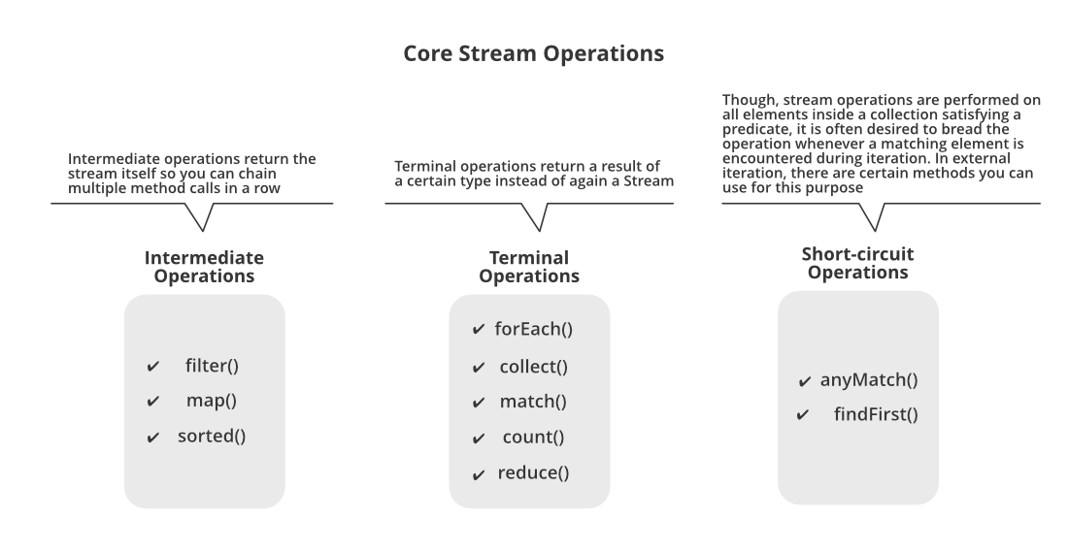

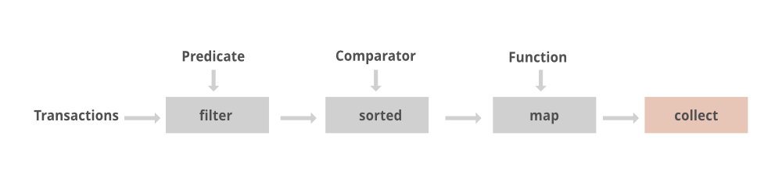

Consumer->Accept

 Consumer<List<Integer> > modify = list ->

        {

**for** (**int** i = 0; i < list.size(); i++)

                list.set(i, 2 * list.get(i));

        };

 modify.accept(list);

Predicate-> **isEqual,and,or,test,negate**

**Supplier->get**

 Supplier<Double> randomValue = () -> Math.random();

Function->apply,thenApply,Identity

Function<Integer, Integer> half = a -> a*3;

List<Integer> e= userList.stream().map(x->half.apply(x.getUid())).collect(Collectors.*toList*());