Sandy Wood

CS 410: CV&DL

21 May 2021

Program 4 Write-Up

For this programming exercise, I decided to complete the Grad-CAM portion. Grad-CAM is an algorithm that uses gradient information from a late layer in a pre-trained convolutional network to generate an activation heatmap with respect to a specific class. This, paired with class prediction, can provide insight on which portions of the input image were the most meaningful in the specific prediction. Portions of the image which contributed more to the classification appear with a greater value in the resulting heatmap.

Below are results of this project. Each input image was put through the VGG16 model trained on imagenet data. The top 3 classes selected for the image were then chosen to generate the Grad-CAM heatmaps. The results have interesting properties. Many of the predictions were correct or reasonable, and the heatmap shows a high degree of conformation to the object to be identified. However, there are some instances where the CNN focused on a “wrong” portion of the picture, such as part of the background or an insignificant detail. These often occurred when the class predictions were less confident, and the prediction was more unusual.

**Image 1, Class 1, “collie”**

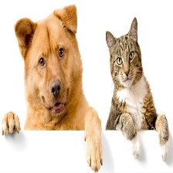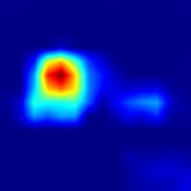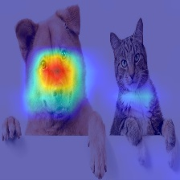

**Image 1, Class 2, “basenji”**

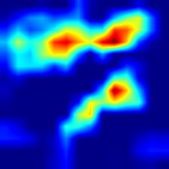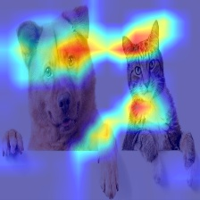

**Image 1, Class 3, “Airedale”**

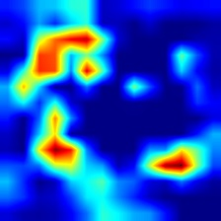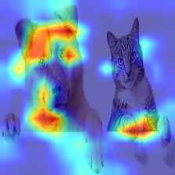

**Image 2, Class 1, “mushroom”**

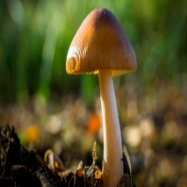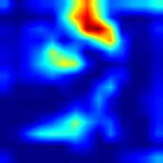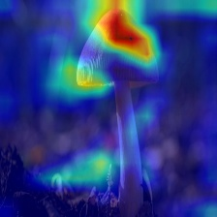

**Image 2, Class 2, “agaric”**

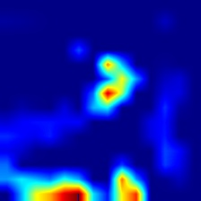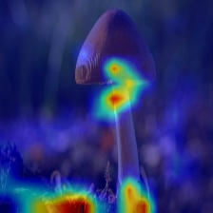

**Image 2, Class 3, “bolete”**

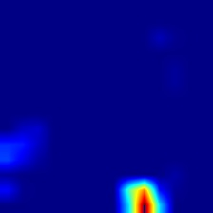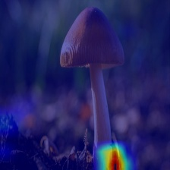

**Image 3, Class 1, “tow_truck”**

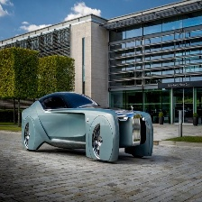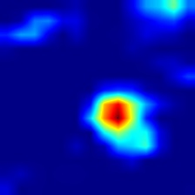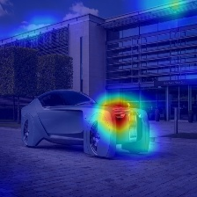

**Image 3, Class 2, “trailer_truck”**

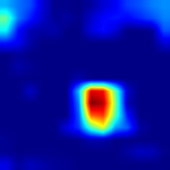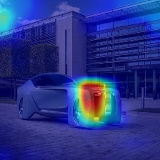

**Image 3, Class 3, “racer”**

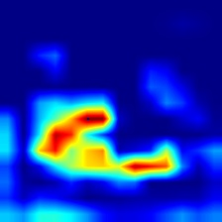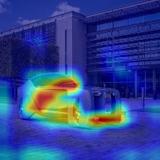

**Image 4, Class 1, “jack_o_lantern”**

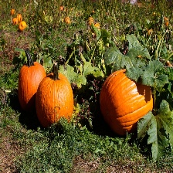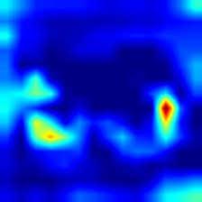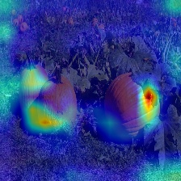

**Image 4, Class 2, “acorn_squash”**

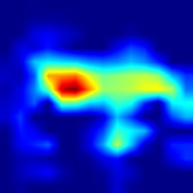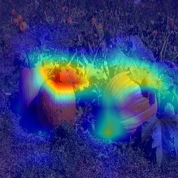

**Image 4, Class 3, “barrow”**

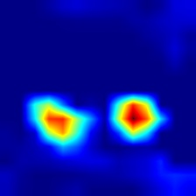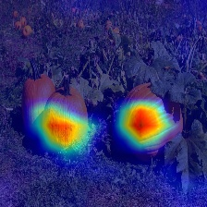

**Image 5, Class 1, “airliner”**

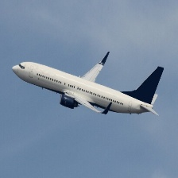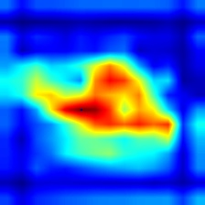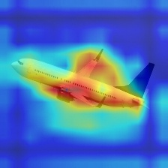

**Image 5, Class 2, “wing”**

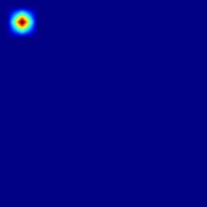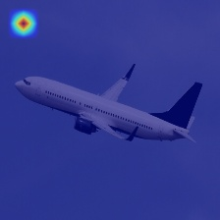

**Image 5, Class 3, “space_shuttle”**

