**Method reference**

Lambda expressions are used to create anonymous methods. Sometimes, however, a lambda expression does nothing but call existing method. In those cases it is often clearer to refer to the existing method by name. Method references enable us to do this.

Sort an arrays of Student objects based on marks of each student.

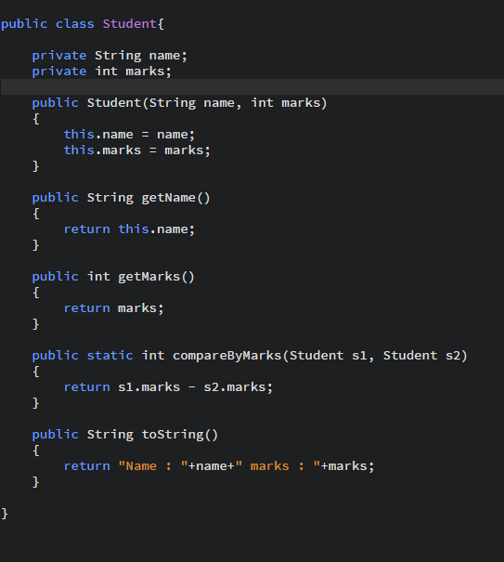

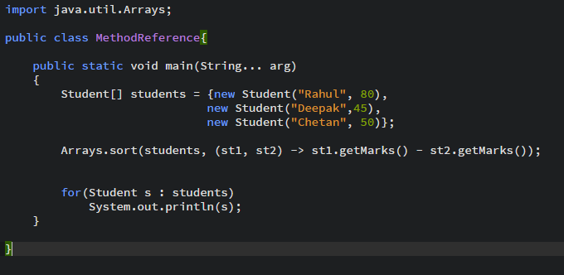

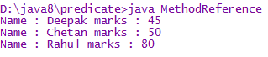

Lambda expression passed as an argument is representing the comparator.

This can be replaced by compareByMarks method of Student class. Its output would be same.

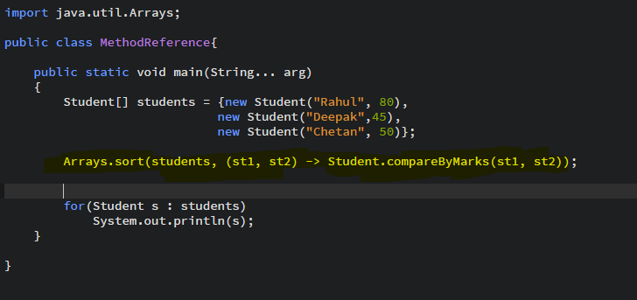

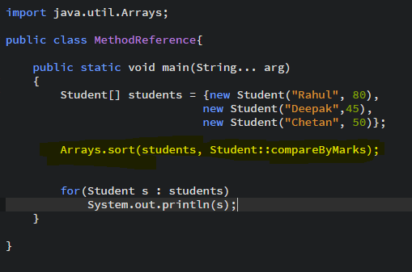

Instead of defining new method, existing method is being used.

**If method is instance method**

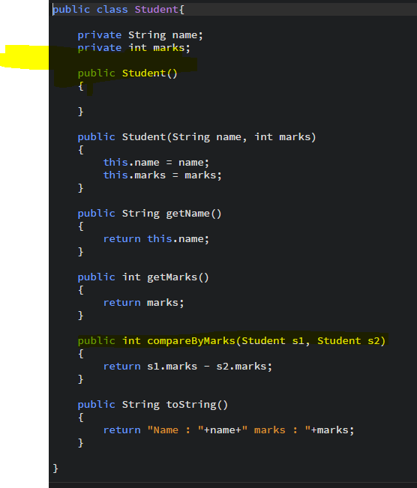

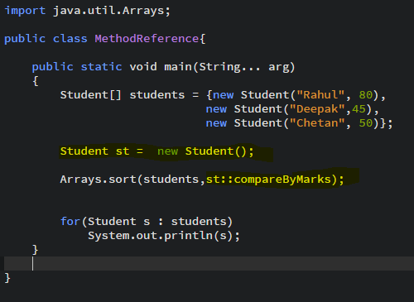

You can reference a constructor in the same way as a static method by using the name new.

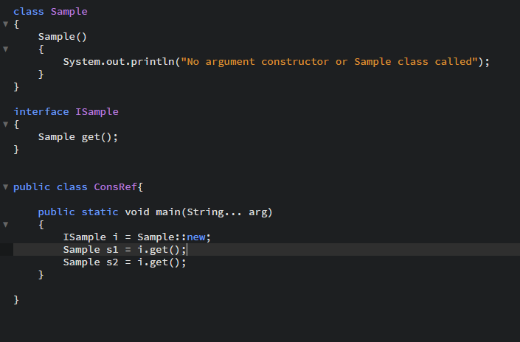

In the above code, get() method of ISample interface refers to the constructor of Sample class.



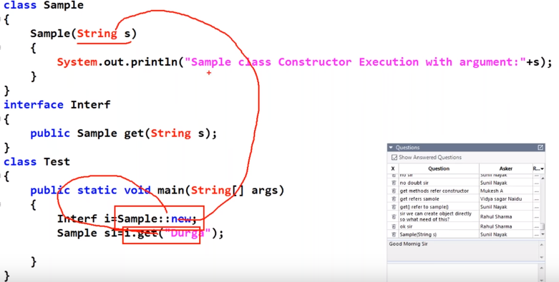

Argument in constructor reference

