**Consumer**

Consumer represents an operation that accepts a single input argument and returns no result.

@FunctionalInterface

**public** **interface** Consumer<T> {

/**

* Performs this operation on the given argument.

*

* **@param** t the input argument

*/

**void** accept(T t);

}

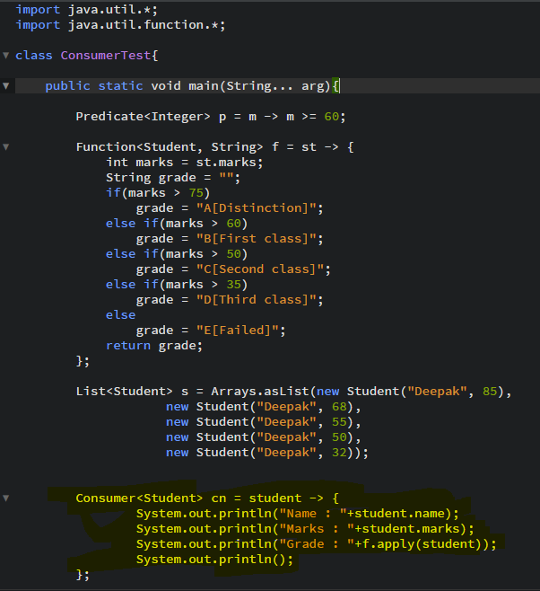

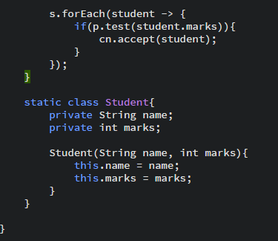

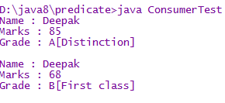

**Consumer chaining**

1. **default** Consumer<T> andThen(Consumer<? **super** T> after)

