Function

This interface represents a function which accepts one argument and produces a result. This is used when some operation is required to be performed.

@FunctionalInterface

**public** **interface** Function<T, R>{

R apply(T t);

}

Display the square of each element in a list.

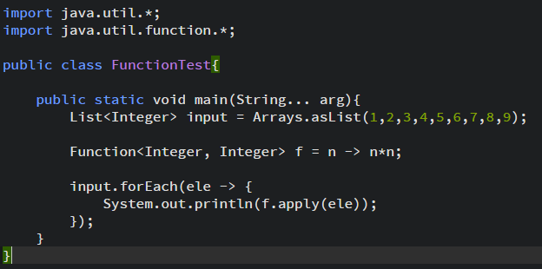

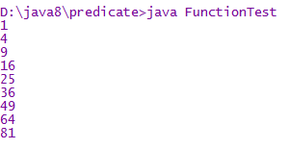

Display the grade based on marks for a student

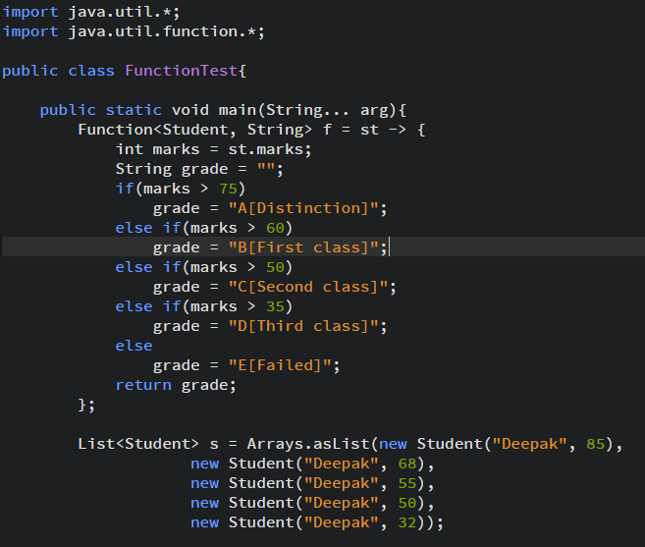

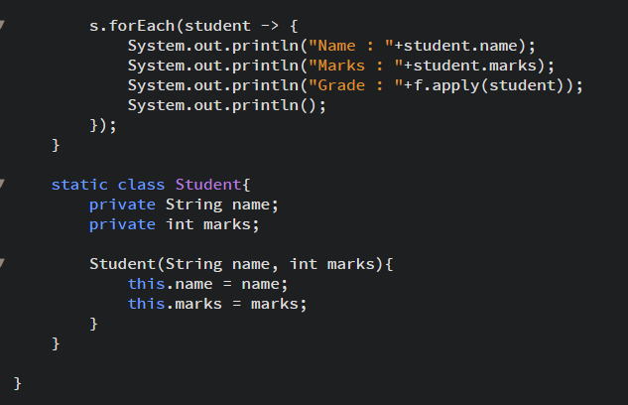

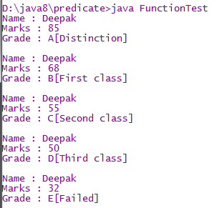

Display the information of those students only whose marks are greater than equal to 60.

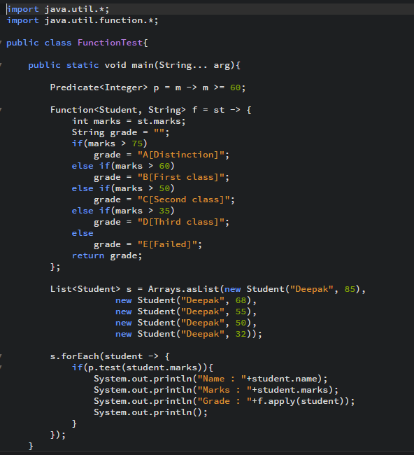

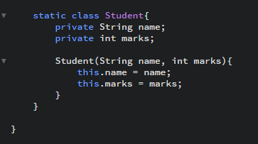

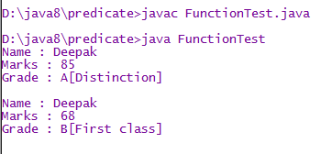

**Function chaining**

1. **default** <V> Function<T, V> andThen(Function<? **super** R, ? **extends** V> after)

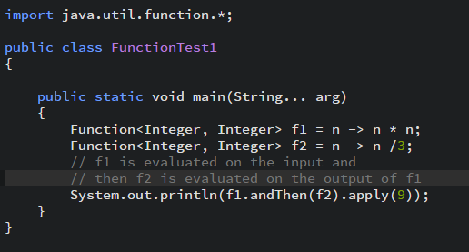



1. **default** <V> Function<V, R> compose(Function<? **super** V, ? **extends** T> before)

