**Predicate**

Predicate is a Boolean valued function of one argument. This interface is available in java.util.function package. Below method is available in this interface.

boolean test(T t);

Implementation of the above method to find the even/odd number would be

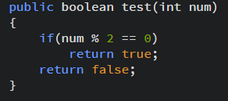

One line implementation

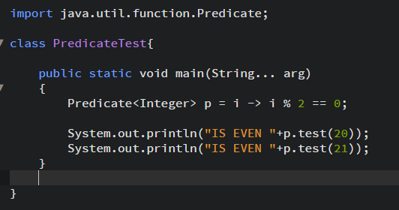

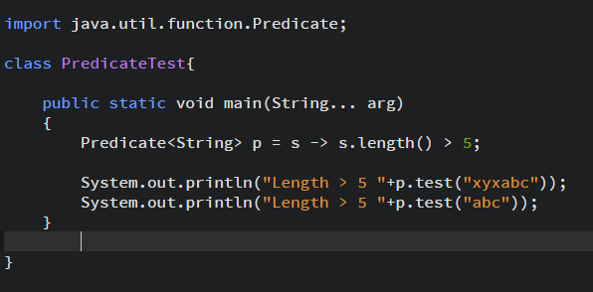

Find even number from a list and display them

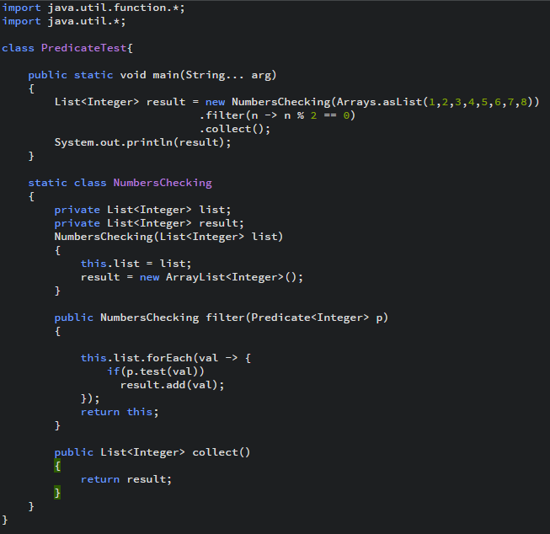



**Predicate joining**

Predicate interface provides default methods to join multiple predicates.

There methods are

1. **default** Predicate<T> negate()
2. **default** Predicate<T> or(Predicate<? **super** T> other)
3. **default** Predicate<T> and(Predicate<? **super** T> other)

