**Streams:**

Streams are used to process the objects from the collection.

Collection represents a group of objects as an entity.

Below image shows how even numbers can be filtered from a list using streams.

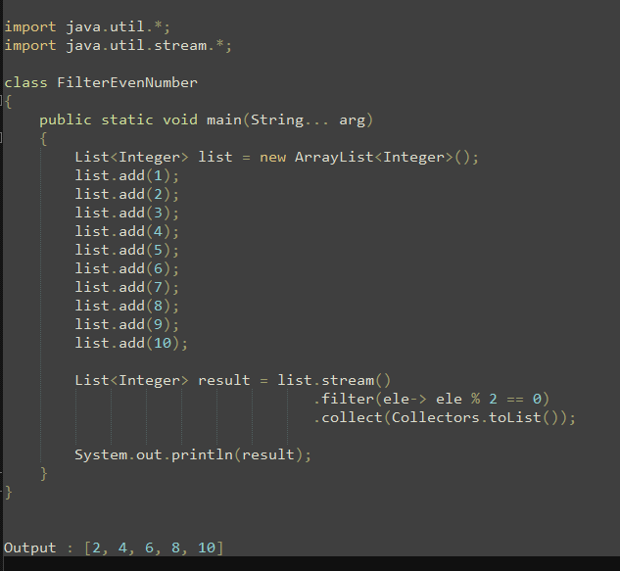

Figure 1

Stream() method is used to get the stream of the collection.

First stream is obtained on a list then filter is configured. Objects which are filtered collected in a list.

**Add some fixed value to each element of the collection**

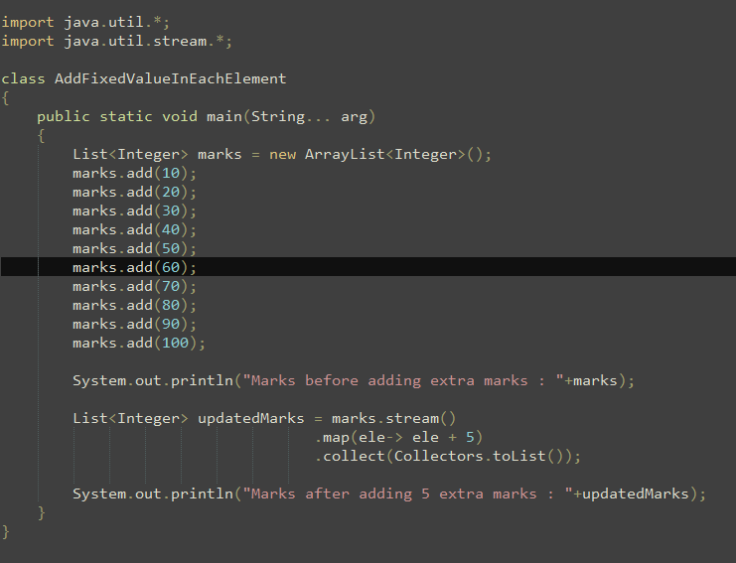

Figure 2

If new object is required after performing the operation, map() method is used.

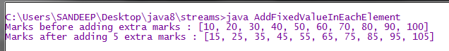

Figure 3

**Filter: filter process the objects based on a condition, if condition satisfies element is included otherwise excluded.**

Input: 10 elements.

Output: 0 to 10 elements

**Map: Map modifies the objects and creates new objects.**

Input: 10 elements

Output: 10 elements

**Count students having marks less than 35.**

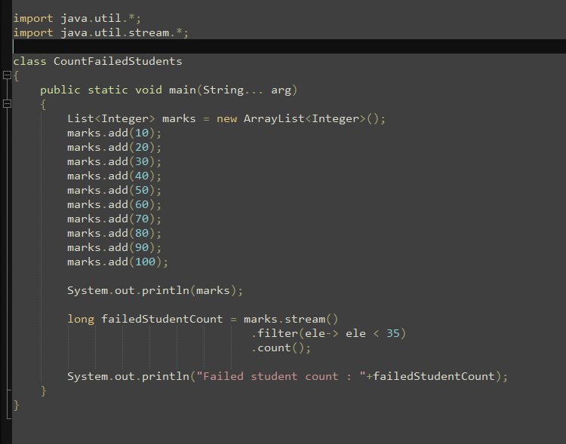



**Sort collection objects using streams**

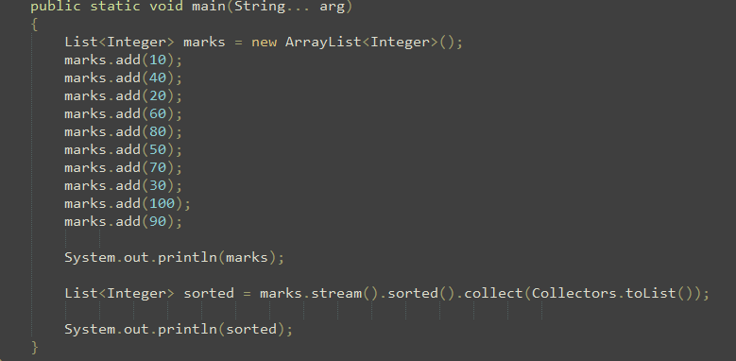



**Sort student objects based on their marks**

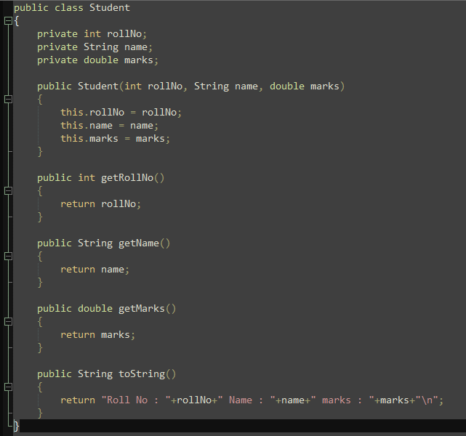

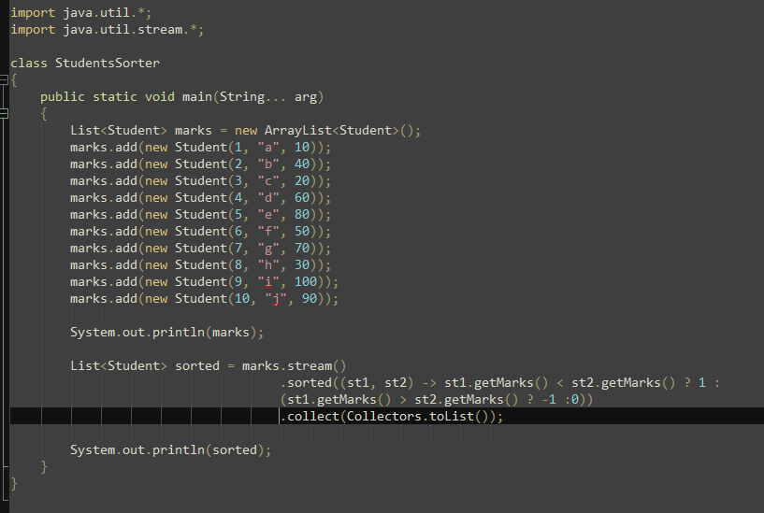

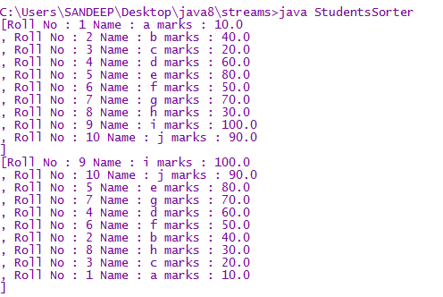

**Student with min and max marks**

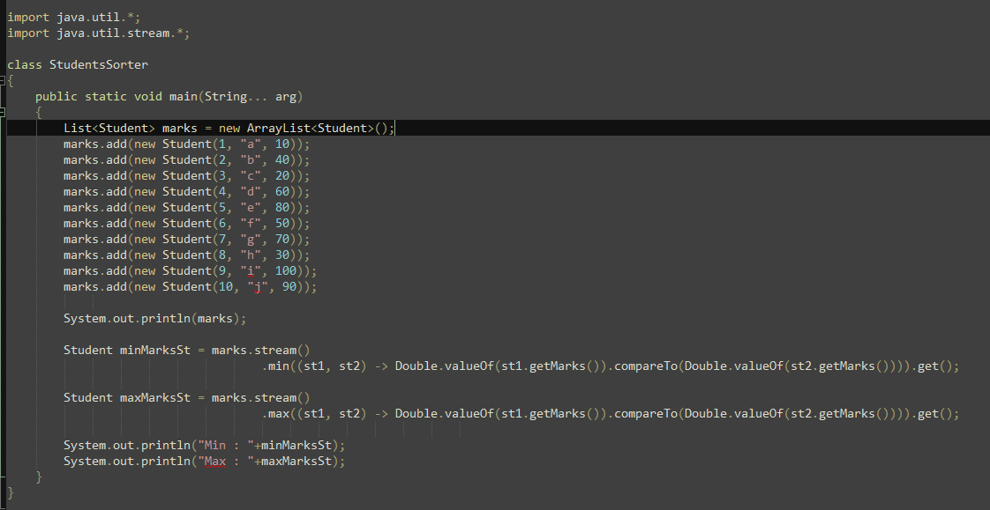

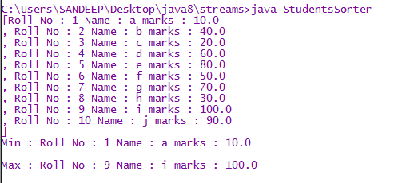

**Print the marks of each student in the list**

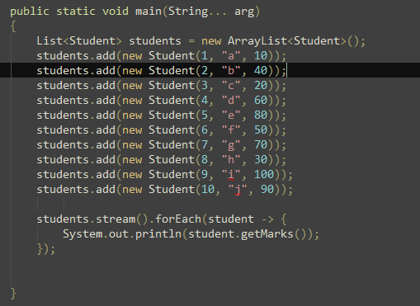



**Convert stream of objects into an array**

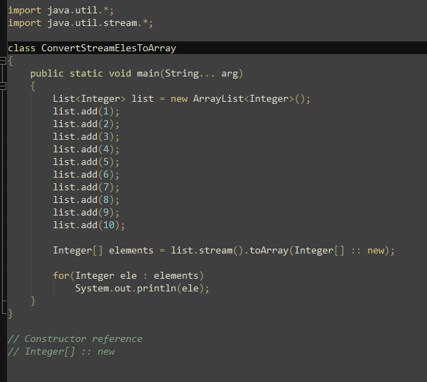



**Get stream for array**

