KAUNO TECHNOLOGIJOS UNIVERSITETAS

INFORMATIKOS FAKULTETAS

Intelektikos Pagrindai (P176B101)

Pirmojo laboratorinio darbo ataskaita

Atliko:

IFF – 6/8 gr. studentas

Tadas Laurinaitis

2019 m. vasario 18 d.

Priėmė:

Lekt. Germanas Budnikas

KAUNAS 2019

#### Darbo užduotys

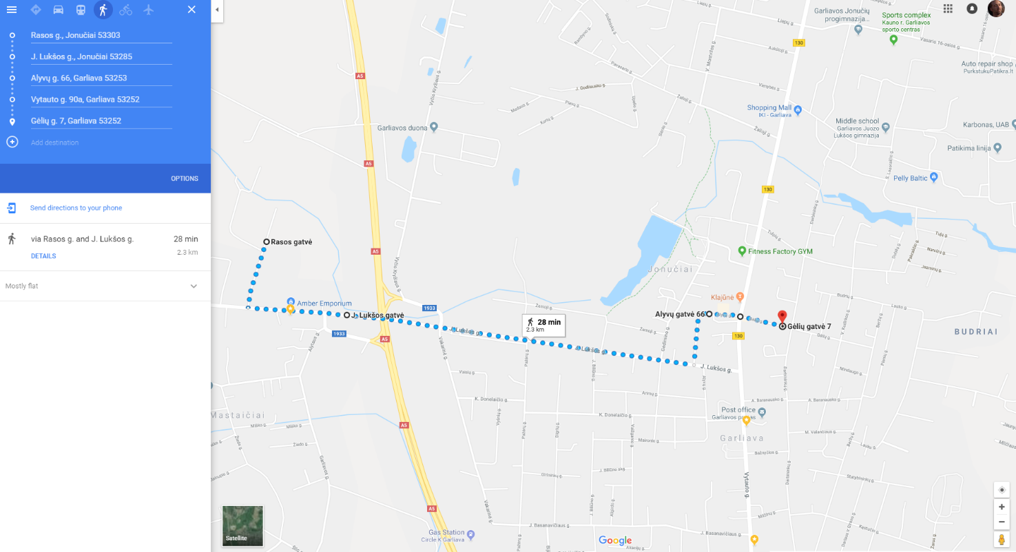Vardas – Tadas – 5 raidės, 5 sankryžos. Pradinė vieta – Rasos gatvė, galutinė – Gėlių gatvė.

#### Užduočių sprendimų ekrano iškarpos

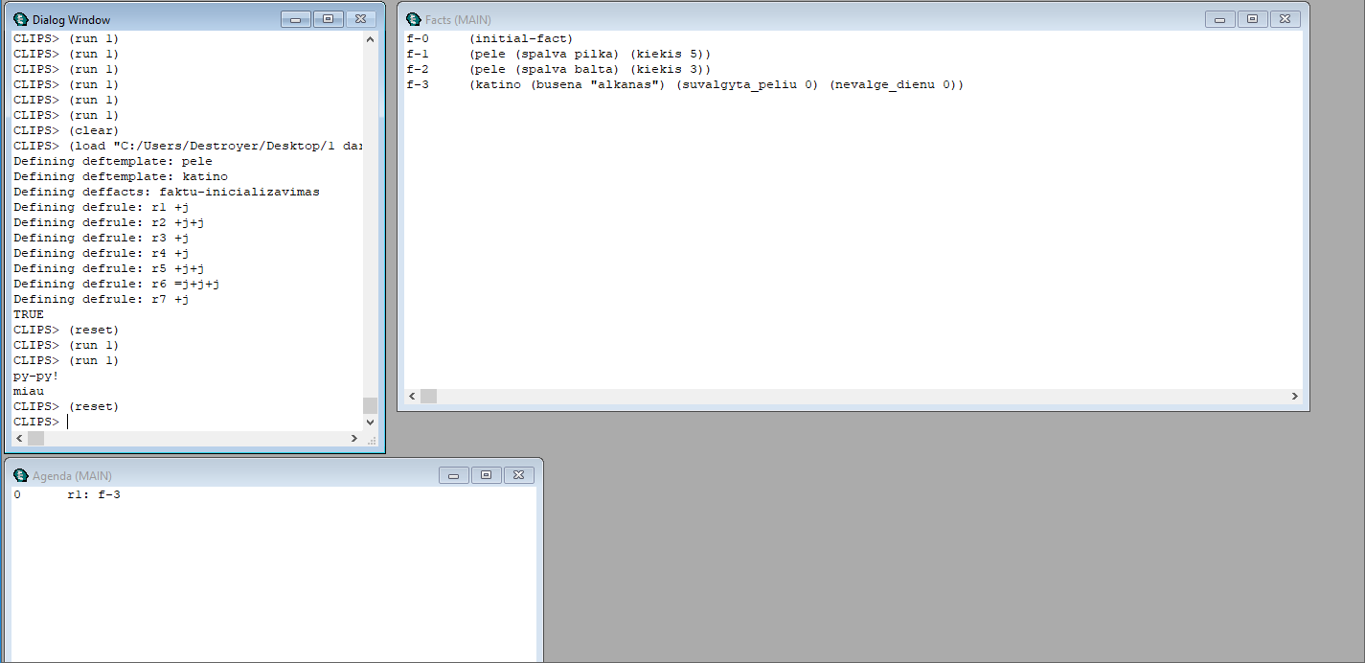Kačių ir pelių programos vykdymas:

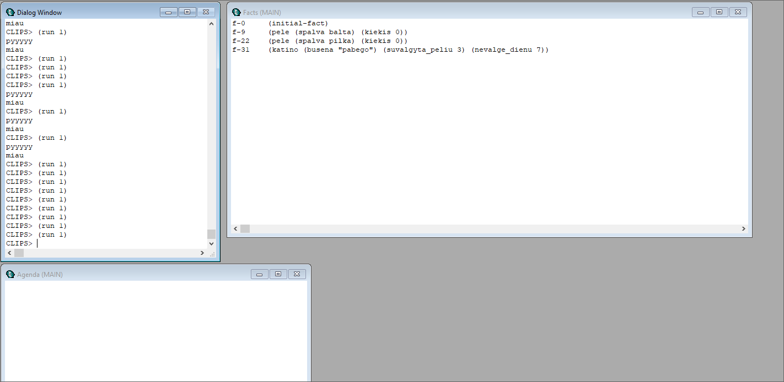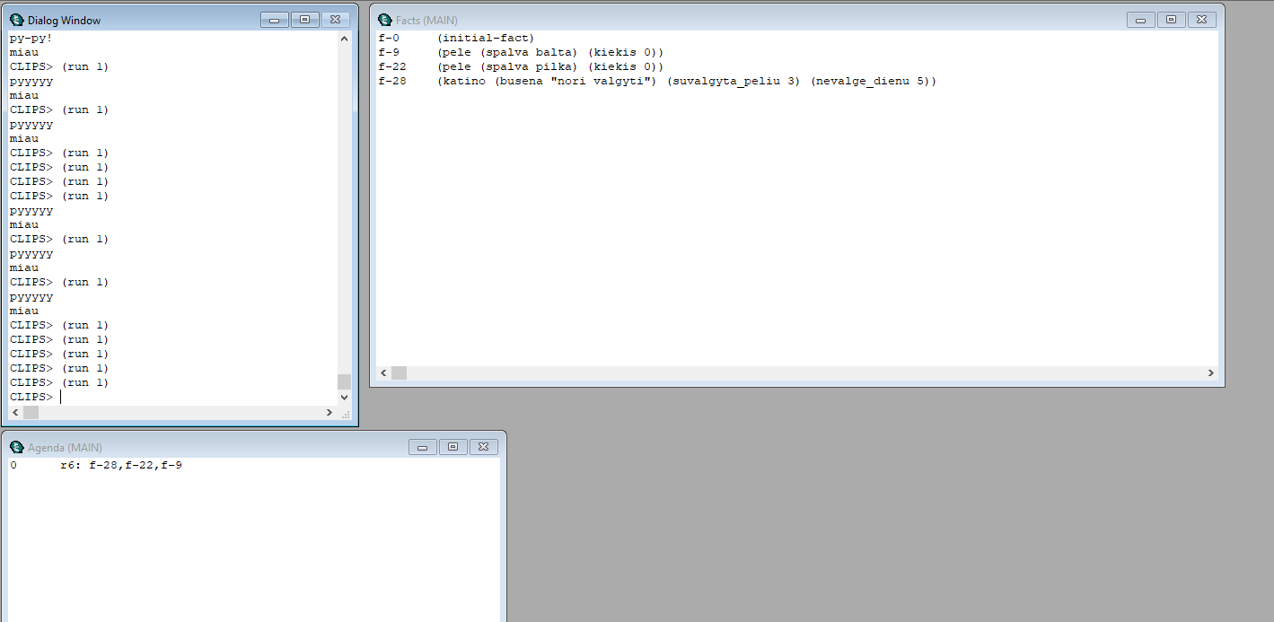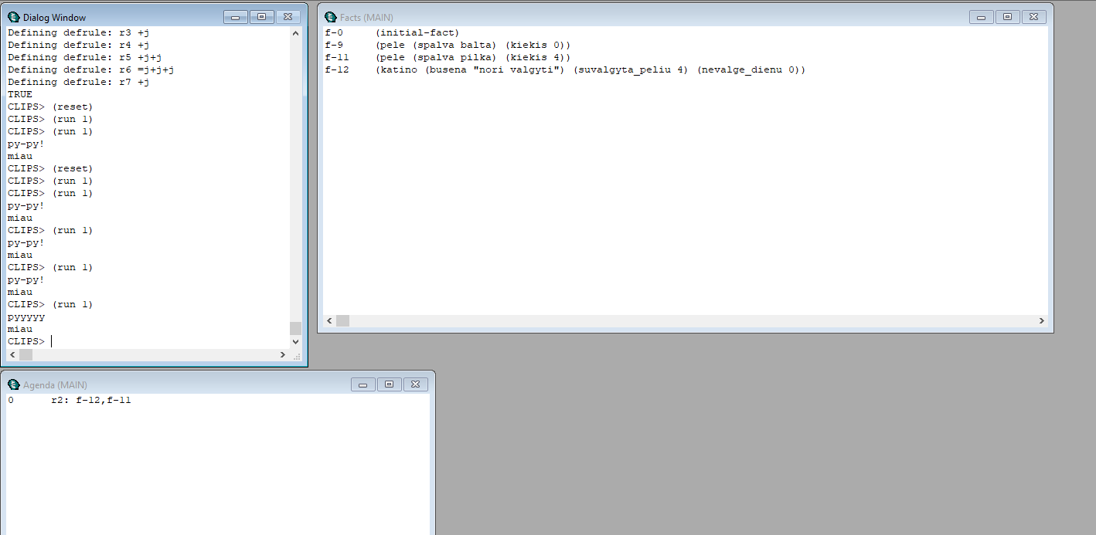

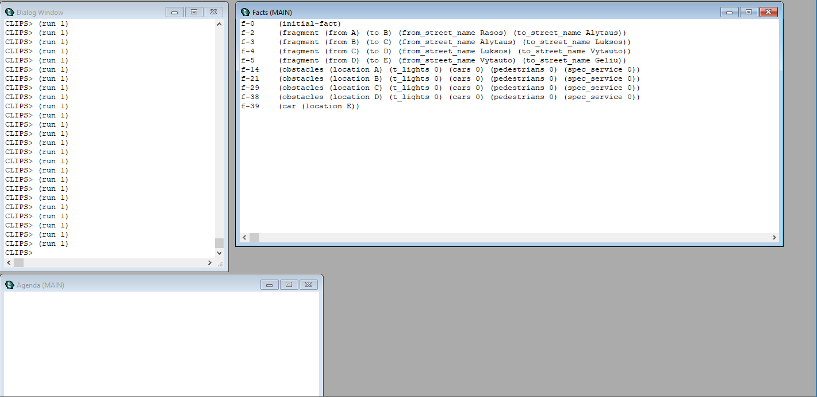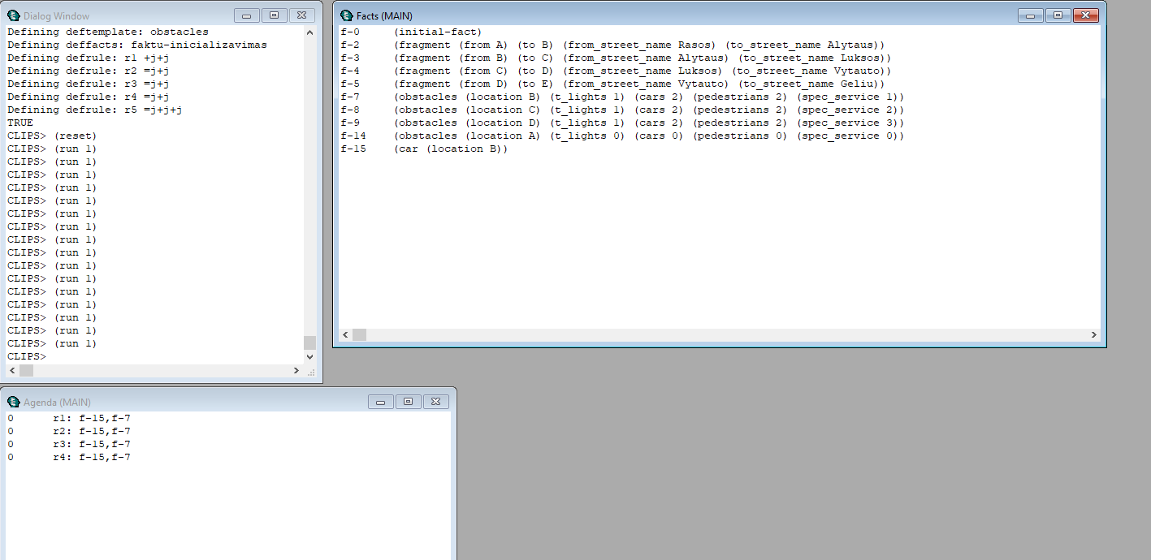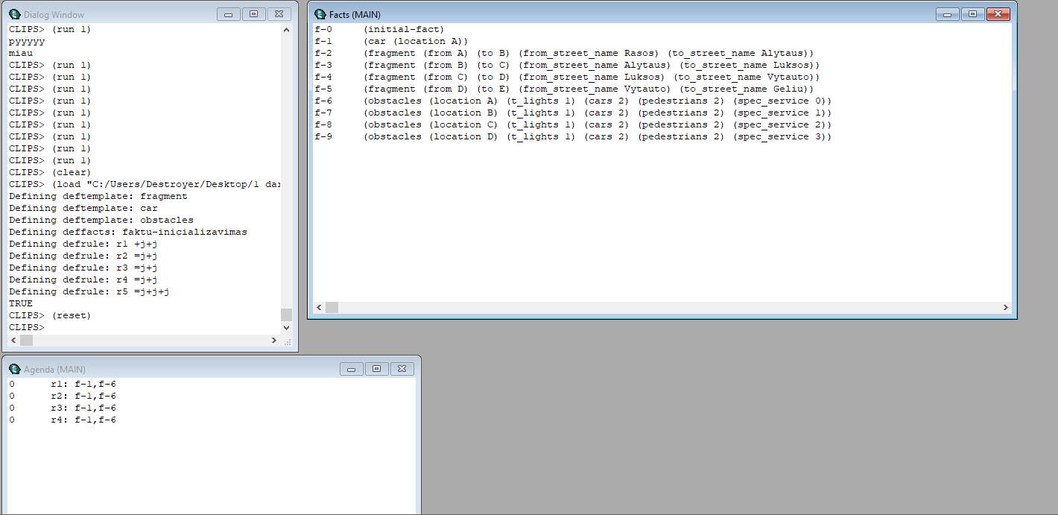Kelio radimo programos vykdymas:

#### Programų kodai

**Kačių ir pelių programos kodas:**

; JESS aplinkoje komentarus pasalinkite

;

;(clear)

(deftemplate pele (slot spalva) (slot kiekis) )

(deftemplate katino (slot busena) (slot suvalgyta_peliu) (slot nevalge_dienu) )

(deffacts faktu-inicializavimas

(pele (spalva pilka) (kiekis 5))

(pele (spalva balta) (kiekis 3))

(katino (busena "alkanas") (suvalgyta_peliu 0) (nevalge_dienu 0))

)

(defrule r1 "Kai katinas alkanas, jis nori valgyti"

?fact-id <- (katino (busena ?busena))

(test (eq ?busena "alkanas"))

=>

(modify ?fact-id (busena "nori valgyti"))

)

(defrule r2 "Kai katinas nori valgyti ir yra peliu, jis valgo peles"

?fact-id1 <- (katino (busena "nori valgyti") (suvalgyta_peliu ?suvalgyta))

?fact-id2 <- (pele (spalva ?spalva) (kiekis ?kiekis))

(test (> ?kiekis 0))

=>

(if (eq ?spalva balta) then (printout t "py-py!" crlf)

else (printout t "pyyyyy" crlf))

(modify ?fact-id2 (kiekis (- ?kiekis 1)) )

(modify ?fact-id1 (suvalgyta_peliu (+ ?suvalgyta 1)) )

(printout t "miau" crlf)

)

(defrule r3 "kai katinas suvalgo 5 peles, jis tampa storu katinu"

(declare (salience 10))

?fact-id1 <- (katino (busena "nori valgyti") (suvalgyta_peliu ?suvalgyta))

(test (= ?suvalgyta 5))

=>

(modify ?fact-id1 (busena "storas"))

)

(defrule r4 "Kai katinas storas, jis miega"

?fact-id1 <- (katino (busena ?busena))

(test (eq ?busena "storas"))

=>

(modify ?fact-id1 (busena "miega"))

)

(defrule r5 "Kai storas katinas pamiega, jis tampa alkanas"

?fact-id1 <- (katino (busena ?busena))

?fact-id2 <- (katino (suvalgyta_peliu ?suvalgyta_peliu))

(test (eq ?busena "miega"))

=>

(modify ?fact-id1 (busena "nori valgyti") (suvalgyta_peliu 0))

)

(defrule r6 "Katinas siandien nevalge"

?fact-id1 <- (katino (busena "nori valgyti") (nevalge_dienu ?nevalge_dienu))

(pele (spalva pilka) (kiekis 0))

(pele (spalva balta) (kiekis 0))

=>

(modify ?fact-id1 (nevalge_dienu (+ ?nevalge_dienu 1)))

)

(defrule r7 "Kai katinas nevalge 7 dienas, jis pabega"

(declare (salience 5))

?fact-id1 <- (katino (busena "nori valgyti") (nevalge_dienu 7))

=>

(modify ?fact-id1 (busena "pabego"))

)

; JESS aplinkoje komentarus pasalinkite

;

; (reset)

; (facts)

; (watch all)

; (run)

**Kelio radimo programos kodas:**

; JESS aplinkoje komentarus pasalinkite

;

;(clear)

(deftemplate fragment (slot from)(slot to) (slot from_street_name) (slot to_street_name))

(deftemplate car (slot location))

(deftemplate obstacles (slot location) (slot t_lights) (slot cars) (slot pedestrians) (slot spec_service))

(deffacts faktu-inicializavimas

(car (location A))

(fragment (from A) (to B) (from_street_name Rasos) (to_street_name Alytaus))

(fragment (from B) (to C) (from_street_name Alytaus) (to_street_name Luksos))

(fragment (from C) (to D) (from_street_name Luksos) (to_street_name Vytauto))

(fragment (from D) (to E) (from_street_name Vytauto) (to_street_name Geliu))

(obstacles (location A) (t_lights 1) (cars 2) (pedestrians 2) (spec_service 0))

(obstacles (location B) (t_lights 1) (cars 2) (pedestrians 2) (spec_service 1))

(obstacles (location C) (t_lights 1) (cars 2) (pedestrians 2) (spec_service 2))

(obstacles (location D) (t_lights 1) (cars 2) (pedestrians 2) (spec_service 3))

;(obstacles (location E) (t_lights 0) (cars 0) (pedestrians 0) (spec_service 0))

)

(defrule r1 "Kai esamoje sankryzoje yra sviesoforu, laukiam"

?fact-id1 <- (car (location ?location))

?fact-id2 <- (obstacles (location ?location) (t_lights ?t_lights))

=>

(if (> ?t_lights 0) then (modify ?fact-id2 (t_lights (- ?t_lights 1)))

)

)

(defrule r2 "Kai esamoje sankryzoje yra masinu, laukiam"

?fact-id1 <- (car (location ?location))

?fact-id2 <- (obstacles (location ?location) (cars ?cars))

=>

(if (> ?cars 0) then (modify ?fact-id2 (cars (- ?cars 1)))

)

)

(defrule r3 "Kai esamoje sankryzoje yra pesciuju, laukiam"

?fact-id1 <- (car (location ?location))

?fact-id2 <- (obstacles (location ?location) (pedestrians ?pedestrians))

=>

(if (> ?pedestrians 0) then (modify ?fact-id2 (pedestrians (- ?pedestrians 1)))

)

)

(defrule r4 "Kai esamoje sankryzoje yra specialiu tarnybu, laukiam"

?fact-id1 <- (car (location ?location))

?fact-id2 <- (obstacles (location ?location) (spec_service ?spec_service))

=>

(if (> ?spec_service 0) then (modify ?fact-id2 (spec_service (- ?spec_service 1)))

)

)

(defrule r5 "Kai nebeliko kliuciu, judam toliau"

?fact-id1 <- (car (location ?location))

?fact-id2 <- (fragment (from ?location) (to ?to))

?fact-id3 <- (obstacles (location ?location) (t_lights 0) (cars 0) (pedestrians 0) (spec_service 0))

=>

(modify ?fact-id1 (location ?to))

)

; JESS aplinkoje komentarus pasalinkite

;

; (reset)

; (facts)

; (watch all)

; (run)