

**KAUNAS UNIVERSITY OF TECHNOLOGY**

**FACULTY OF INFORMATICS**

**COMPUTER DEPARTMENT**

### App Development for Smart Mobile Systems Individual work

**„Morse code flashlight translator“/“Morsify“**

**Assignment completed by:**

IFF 6/8 group student

Tadas Laurinaitis

**Assignment evaluated by**:

Prof. Rytis Maskeliūnas

Table of contents:

Contents

App Development for Smart Mobile Systems Individual work 1

Description of app: 3

App mockup 3

User interface: 6

Main functionality: 7

Main functions: 7

Source code: 10

Description of app: The application which I am creating is a tool used to translate written text to morse code and then show it using flashlight. User will be able to write a sentence, which then will be translated into morse code (dots and dashes) and will have an option to communicate that code using camera‘s flashlight. User will also have an option to see information about application, change application‘s settings and will be able to close application using „Exit Application“ button.

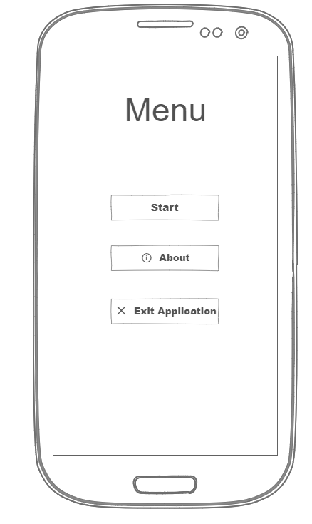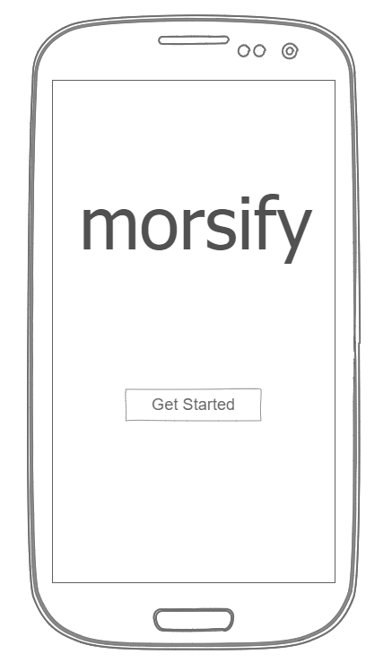App mockup:

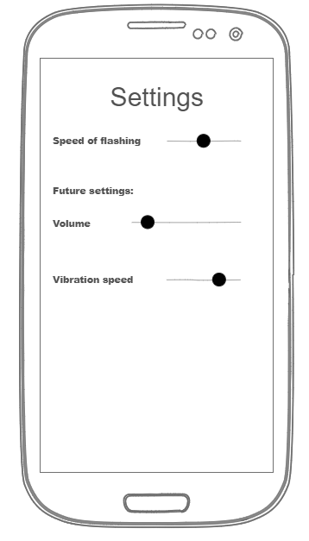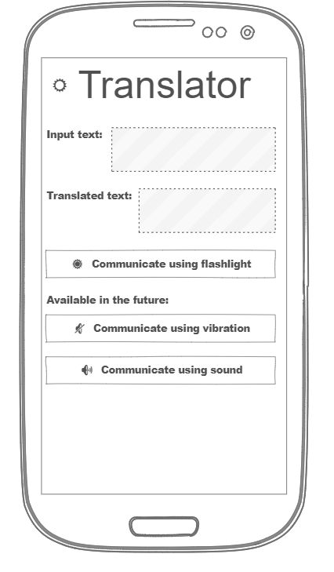

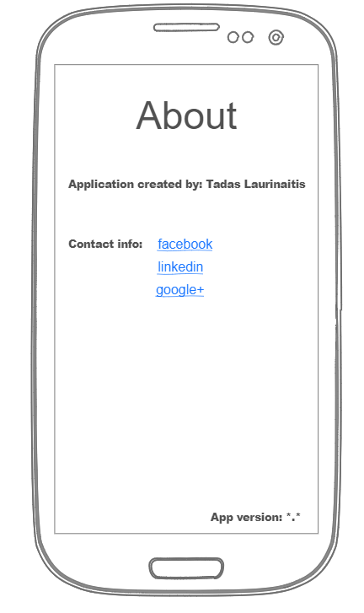

# User interface:

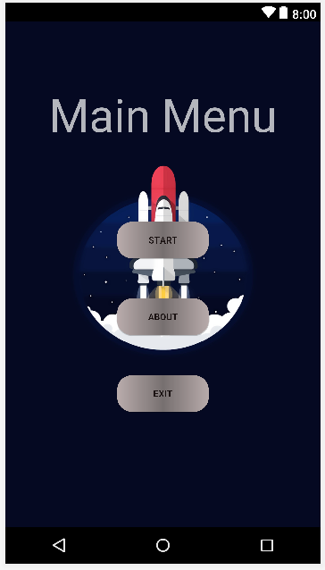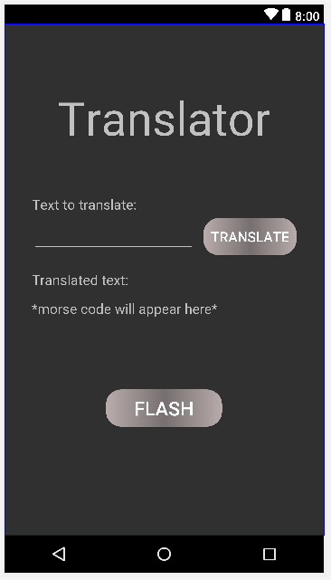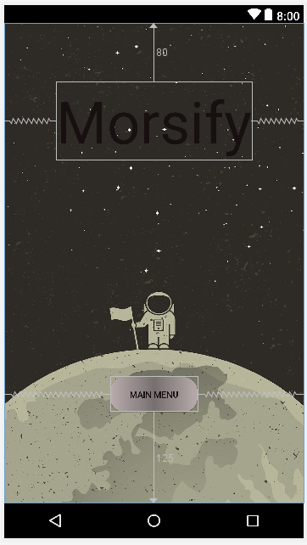

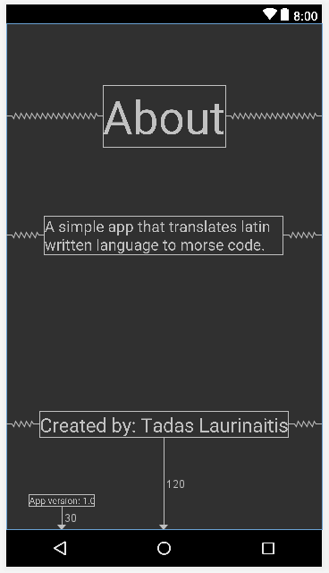

# Main functionality:

To translate the written text, I created a class named „Translator“ which is only responsible for the conversion of text to morse code in a form of string. This string is then passed on to a „for“ cycle which goes through every symbol of that same string. Inside the „for“ cycle there are 4 if statements which check if symbol meets certain requirements, for example: if symbol is equal to „-“ then it accesses the camera and turns it on and after a certain delay it turns it off. Thats the basic principle on which my app is built.

# Main functions:

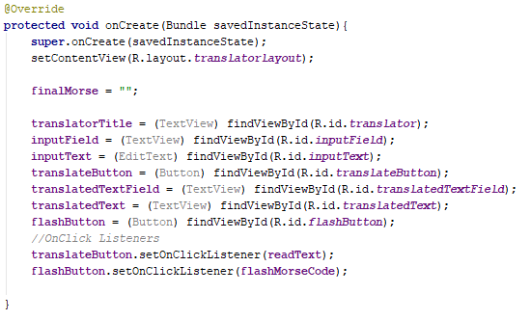

Picture #1 onCreate() method which is responsible for initialization of values

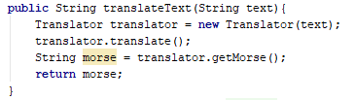

Picture #2 translateText() method which is responsible for the translation of text which is passed through the parameters.

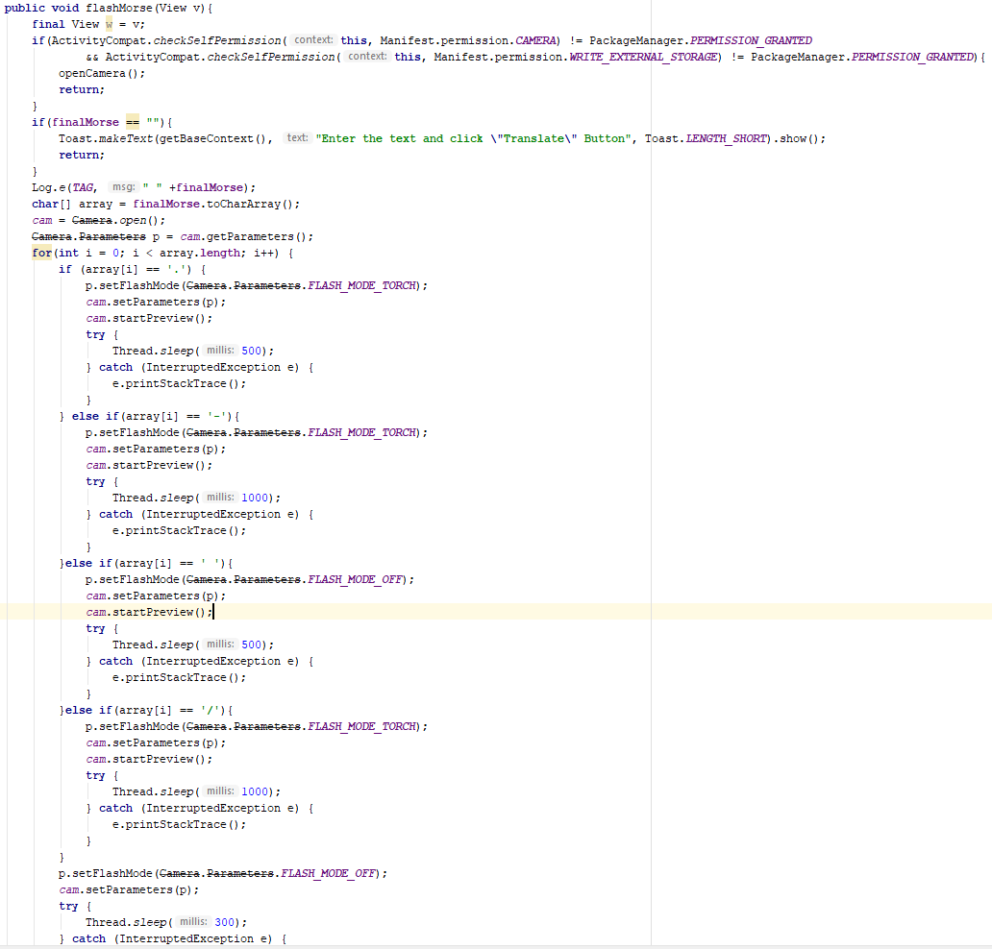

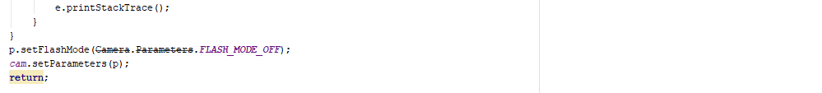

Picture #3 flashMorse() method which is responsible for the translation of morse code into camera flashes

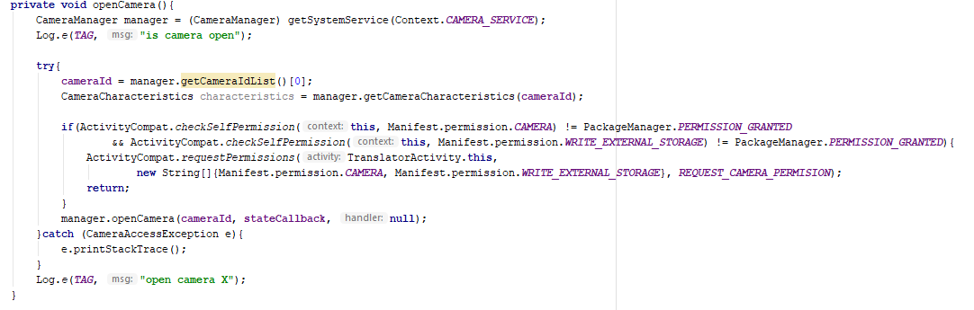

Picture #4 openCamera() method which is mainly responsible for checking the permissions to access camera and external storage.

# Literature list:

<https://stackoverflow.com/questions/6068803/how-to-turn-on-front-flash-light-programmatically-in-android>

<https://stackoverflow.com/questions/32929790/android-permission-denial-cant-use-the-camera>

<https://www.syncios.com/android/how-to-debug-samsung-galaxy-s8.html>

<https://www.tutorialspoint.com/java/util/timer_schedule_period.htm>

<https://stackoverflow.com/questions/18185384/blinking-flash-according-to-morse-code-android-how-to-avoid-anrs-due-to-sleepi>

<https://www.google.com/search?rlz=1C1CHBF_enLT815LT815&biw=1920&bih=1058&tbm=isch&sa=1&ei=cp4VXOChCMmTsgGAyY6IDQ&q=app+icon&oq=app+icon&gs_l=img.3..0i67l2j0j0i67j0j0i67j0l3j0i67.2933.3927..4108...0.0..0.71.537.8......1....1..gws-wiz-img.......35i39.ocVJUeBQYfI#imgrc=6c-SmPQcXpfQ3M>:

# Source code:

**package** com.example.destroyer.morsecodeflashlighttranslator;  
  
**import** android.app.Activity;  
**import** android.content.Context;  
**import** android.os.Bundle;  
**import** android.widget.Button;  
**import** android.widget.TextView;  
  
**public class** AboutActivity **extends** Activity {  
  
 **private** TextView **aboutField**;  
 **private** TextView **createdByField**;  
 **private** TextView **appVersionField**;  
 **private** TextView **summaryField**;  
 **private** Context **context** = **this**;  
  
 @Override  
 **protected void** onCreate(Bundle savedInstanceState){  
 **super**.onCreate(savedInstanceState);  
 setContentView(R.layout.***aboutlayout***);  
  
 **aboutField** = (TextView) findViewById(R.id.***aboutField***);  
 **createdByField** = (TextView) findViewById(R.id.***createdByField***);  
 **appVersionField** = (TextView) findViewById(R.id.***appVersionField***);  
 **summaryField** = (TextView) findViewById(R.id.***summaryField***);  
 }  
  
}

**package** com.example.destroyer.morsecodeflashlighttranslator;  
  
**import** android.app.Activity;  
**import** android.content.Intent;  
**import** android.content.Context;  
**import** android.os.Bundle;  
**import** android.view.View;  
**import** android.widget.Button;  
**import** android.widget.TextView;  
  
**public class** GettingStartedActivity **extends** Activity{  
  
 **private** TextView **title**;  
 **private** Button **toMainMenu**;  
 **private** Context **context** = **this**;  
  
 @Override  
 **protected void** onCreate(Bundle savedInstanceState){  
 **super**.onCreate(savedInstanceState);  
 setContentView(R.layout.***gettingstartedlayout***);  
  
 **title** = (TextView) findViewById(R.id.***title***);  
 **toMainMenu** = (Button) findViewById(R.id.***toMainMenuButton***);  
 **toMainMenu**.setOnClickListener(**startMainMenuActivity**);  
 }  
 **public void** runMainMenuActivity(){  
 Intent intent = **new** Intent(**context**, MainMenuActivity.**class**);  
 **context**.startActivity(intent);  
 }  
 View.OnClickListener **startMainMenuActivity** = **new** View.OnClickListener(){  
 @Override  
 **public void** onClick(View v){  
 runMainMenuActivity();  
 }  
 };  
}

**package** com.example.destroyer.morsecodeflashlighttranslator;  
  
**import** android.app.Activity;  
**import** android.content.Context;  
**import** android.content.Intent;  
**import** android.os.Bundle;  
**import** android.view.View;  
**import** android.widget.Button;  
**import** android.widget.TextView;  
  
**public class** MainMenuActivity **extends** Activity{  
  
 **private** TextView **menuField**;  
 **private** Button **startButton**;  
 **private** Button **aboutButton**;  
 **private** Button **exitButton**;  
 **private** Context **context** = **this**;  
  
 @Override  
 **protected void** onCreate(Bundle savedInstanceState){  
 **super**.onCreate(savedInstanceState);  
 setContentView(R.layout.***mainmenulayout***);  
  
 **menuField** = (TextView) findViewById(R.id.***menuField***);  
 **startButton** = (Button) findViewById(R.id.***startButton***);  
 **aboutButton** = (Button) findViewById(R.id.***aboutButton***);  
 **exitButton** = (Button) findViewById(R.id.***exitButton***);  
  
 **startButton**.setOnClickListener(**startTranslatorActivity**);  
 **aboutButton**.setOnClickListener(**startAboutActivity**);  
 **exitButton**.setOnClickListener(**exitListener**);  
 }  
  
 **public void** runTranslatorActivity(){  
 Intent intent = **new** Intent(**context**, TranslatorActivity.**class**);  
 **context**.startActivity(intent);  
 }  
 View.OnClickListener **startTranslatorActivity** = **new** View.OnClickListener(){  
 @Override  
 **public void** onClick(View v){  
 runTranslatorActivity();  
 }  
 };  
  
 **public void** runAboutActivity(){  
 Intent intent = **new** Intent(**context**, AboutActivity.**class**);  
 **context**.startActivity(intent);  
 }  
 View.OnClickListener **startAboutActivity** = **new** View.OnClickListener(){  
 @Override  
 **public void** onClick(View v){  
 runAboutActivity();  
 }  
 };  
  
 View.OnClickListener **exitListener** = **new** View.OnClickListener(){  
 @Override  
 **public void** onClick(View v){  
 finish();  
 System.*exit*(0);  
 }  
 };  
}

**package** com.example.destroyer.morsecodeflashlighttranslator;  
  
**import** android.app.Activity;  
**import** android.content.Context;  
**import** android.os.Bundle;  
  
**public class** SettingsActivity **extends** Activity {  
  
 Context **context** = **this**;  
  
 @Override  
 **protected void** onCreate(Bundle savedInstanceState){  
 **super**.onCreate(savedInstanceState);  
 setContentView(R.layout.***aboutlayout***);  
 }  
}

**package** com.example.destroyer.morsecodeflashlighttranslator;  
  
**public class** Translator {  
  
 String **primaryText**;  
 String **morseCode**;  
  
 **public** Translator(String primaryText){  
 **this**.**primaryText** = primaryText;  
 **morseCode** = **""**;  
 }  
  
 **public void** translate(){  
 String text = **primaryText**.toLowerCase();  
 **char**[] array = text.toCharArray();  
 String morse = **""**;  
 String current = **""**;  
 **for**(**int** i = 0; i < array.**length**; i++){  
 current = **""**;  
 **if**(array[i] == **'a'**){  
 current = **".-"**;  
 morse += current;  
 morse += **" "**;  
 }  
 **else if**(array[i] == **'b'**){  
 current = **"-..."**;  
 morse += current;  
 morse += **" "**;  
 }  
 **else if**(array[i] == **'c'**){  
 current = **"-.-."**;  
 morse += current;  
 morse += **" "**;  
 }  
 **else if**(array[i] == **'d'**){  
 current = **"-.."**;  
 morse += current;  
 morse += **" "**;  
 }  
 **else if**(array[i] == **'e'**){  
 current = **"."**;  
 morse += current;  
 morse += **" "**;  
 }  
 **else if**(array[i] == **'f'**){  
 current = **"..-."**;  
 morse += current;  
 morse += **" "**;  
 }  
 **else if**(array[i] == **'g'**){  
 current = **"--."**;  
 morse += current;  
 morse += **" "**;  
 }  
 **else if**(array[i] == **'h'**){  
 current = **"...."**;  
 morse += current;  
 morse += **" "**;  
 }  
 **else if**(array[i] == **'i'**){  
 current = **".."**;  
 morse += current;  
 morse += **" "**;  
 }  
 **else if**(array[i] == **'j'**){  
 current = **".---"**;  
 morse += current;  
 morse += **" "**;  
 }  
 **else if**(array[i] == **'k'**){  
 current = **"-.-"**;  
 morse += current;  
 morse += **" "**;  
 }  
 **else if**(array[i] == **'l'**){  
 current = **".-.."**;  
 morse += current;  
 morse += **" "**;  
 }  
 **else if**(array[i] == **'m'**){  
 current = **"--"**;  
 morse += current;  
 morse += **" "**;  
 }  
 **else if**(array[i] == **'n'**){  
 current = **"-."**;  
 morse += current;  
 morse += **" "**;  
 }  
 **else if**(array[i] == **'o'**){  
 current = **"---"**;  
 morse += current;  
 morse += **" "**;  
 }  
 **else if**(array[i] == **'p'**){  
 current = **".--."**;  
 morse += current;  
 morse += **" "**;  
 }  
 **else if**(array[i] == **'q'**){  
 current = **"--.-"**;  
 morse += current;  
 morse += **" "**;  
 }  
 **else if**(array[i] == **'r'**){  
 current = **".-."**;  
 morse += current;  
 morse += **" "**;  
 }  
 **else if**(array[i] == **'s'**){  
 current = **"..."**;  
 morse += current;  
 morse += **" "**;  
 }  
 **else if**(array[i] == **'t'**){  
 current = **"-"**;  
 morse += current;  
 morse += **" "**;  
 }  
 **else if**(array[i] == **'u'**){  
 current = **"..-"**;  
 morse += current;  
 morse += **" "**;  
 }  
 **else if**(array[i] == **'v'**){  
 current = **"...-"**;  
 morse += current;  
 morse += **" "**;  
 }  
 **else if**(array[i] == **'w'**){  
 current = **".--"**;  
 morse += current;  
 morse += **" "**;  
 }  
 **else if**(array[i] == **'x'**){  
 current = **"-..-"**;  
 morse += current;  
 morse += **" "**;  
 }  
 **else if**(array[i] == **'y'**){  
 current = **"-.--"**;  
 morse += current;  
 morse += **" "**;  
 }  
 **else if**(array[i] == **'z'**){  
 current = **"--.."**;  
 morse += current;  
 morse += **" "**;  
 }  
 **else if**(array[i] == **' '**){  
 current = **"/"**;  
 morse += current;  
 morse += **" "**;  
 }  
 **else  
 continue**;  
 }  
 morseCode = morse;  
 }  
  
 **public** String getMorse(){  
 **return** morseCode;  
 }  
}

**package** com.example.destroyer.morsecodeflashlighttranslator;  
  
**import** android.Manifest;  
**import** android.app.Activity;  
**import** android.content.Context;  
**import** android.content.Intent;  
**import** android.content.pm.PackageManager;  
**import** android.graphics.SurfaceTexture;  
**import** android.hardware.camera2.CameraAccessException;  
**import** android.hardware.camera2.CameraCaptureSession;  
**import** android.hardware.camera2.CameraCharacteristics;  
**import** android.hardware.camera2.CameraDevice;  
**import** android.hardware.camera2.CameraManager;  
**import** android.hardware.camera2.CaptureRequest;  
**import** android.hardware.camera2.params.StreamConfigurationMap;  
**import** android.media.ImageReader;  
**import** android.os.Bundle;  
**import** android.os.Handler;  
**import** android.os.HandlerThread;  
**import** android.support.annotation.NonNull;  
**import** android.support.v4.app.ActivityCompat;  
**import** android.util.Log;  
**import** android.util.Size;  
**import** android.util.SparseIntArray;  
**import** android.view.Surface;  
**import** android.view.TextureView;  
**import** android.view.View;  
**import** android.widget.Button;  
**import** android.widget.EditText;  
**import** android.widget.TextView;  
**import** android.hardware.Camera;  
**import** android.widget.Toast;  
  
**import** java.io.File;  
**import** java.util.Timer;  
**import** java.util.TimerTask;  
  
**public class** TranslatorActivity **extends** Activity {  
  
 Context **context** = **this**;  
 **public static** Camera *cam* = **null**;  
 TextView **translatorTitle**;  
 String **finalMorse**;  
  
 TextView **inputField**;  
 EditText **inputText**;  
 Button **translateButton**;  
  
 TextView **translatedTextField**;  
 TextView **translatedText**;  
 Button **flashButton**;  
  
 *//Part 3 - Camera* **private static final** String ***TAG*** = **"AndroidCameraApi"**;  
 **private static final** SparseIntArray ***ORIENTATIONS*** = **new** SparseIntArray();  
 **static**{  
 ***ORIENTATIONS***.append(Surface.***ROTATION_0***, 90);  
 ***ORIENTATIONS***.append(Surface.***ROTATION_90***, 0);  
 ***ORIENTATIONS***.append(Surface.***ROTATION_180***, 270);  
 ***ORIENTATIONS***.append(Surface.***ROTATION_270***, 180);  
 }  
 **private** String **cameraId**;  
 **protected** CameraDevice **cameraDevice**;  
 **private static final int *REQUEST_CAMERA_PERMISION*** = 200;  
 **private** Handler **mBackgroundHandler**;  
 **private** HandlerThread **mBackgroundThread**;  
  
 @Override  
 **protected void** onCreate(Bundle savedInstanceState){  
 **super**.onCreate(savedInstanceState);  
 setContentView(R.layout.***translatorlayout***);  
  
 **finalMorse** = **""**;  
  
 **translatorTitle** = (TextView) findViewById(R.id.***translator***);  
 **inputField** = (TextView) findViewById(R.id.***inputField***);  
 **inputText** = (EditText) findViewById(R.id.***inputText***);  
 **translateButton** = (Button) findViewById(R.id.***translateButton***);  
 **translatedTextField** = (TextView) findViewById(R.id.***translatedTextField***);  
 **translatedText** = (TextView) findViewById(R.id.***translatedText***);  
 **flashButton** = (Button) findViewById(R.id.***flashButton***);  
 *//OnClick Listeners* **translateButton**.setOnClickListener(**readText**);  
 **flashButton**.setOnClickListener(**flashMorseCode**);  
  
 }  
  
 **public** String translateText(String text){  
 Translator translator = **new** Translator(text);  
 translator.translate();  
 String morse = translator.getMorse();  
 **return** morse;  
 }  
 View.OnClickListener **readText** = **new** View.OnClickListener(){  
 @Override  
 **public void** onClick(View v){  
 String text = **inputText**.getText().toString();  
 Log.*e*(***TAG***, **"got string from box: "** +text);  
 **finalMorse** = translateText(text);  
 Log.*e*(***TAG***, **"translated string from box: "** +**finalMorse**);  
 *//System.out.println(morse);* **translatedText**.setText(**finalMorse**);  
 }  
 };  
  
 **public void** flashMorse(View v){  
 **final** View w = v;  
 **if**(ActivityCompat.*checkSelfPermission*(**this**, Manifest.permission.***CAMERA***) != PackageManager.***PERMISSION_GRANTED*** && ActivityCompat.*checkSelfPermission*(**this**, Manifest.permission.***WRITE_EXTERNAL_STORAGE***) != PackageManager.***PERMISSION_GRANTED***){  
 openCamera();  
 **return**;  
 }  
 **if**(**finalMorse** == **""**){  
 Toast.*makeText*(getBaseContext(), **"Enter the text and click \"Translate\" Button"**, Toast.***LENGTH_SHORT***).show();  
 **return**;  
 }  
 Log.*e*(***TAG***, **" "** +**finalMorse**);  
 **char**[] array = **finalMorse**.toCharArray();  
 *cam* = Camera.*open*();  
 Camera.Parameters p = *cam*.getParameters();  
 **for**(**int** i = 0; i < array.**length**; i++) {  
 **if** (array[i] == **'.'**) {  
 p.setFlashMode(Camera.Parameters.***FLASH_MODE_TORCH***);  
 *cam*.setParameters(p);  
 *cam*.startPreview();  
 **try** {  
 Thread.*sleep*(500);  
 } **catch** (InterruptedException e) {  
 e.printStackTrace();  
 }  
 } **else if**(array[i] == **'-'**){  
 p.setFlashMode(Camera.Parameters.***FLASH_MODE_TORCH***);  
 *cam*.setParameters(p);  
 *cam*.startPreview();  
 **try** {  
 Thread.*sleep*(1000);  
 } **catch** (InterruptedException e) {  
 e.printStackTrace();  
 }  
 }**else if**(array[i] == **' '**){  
 p.setFlashMode(Camera.Parameters.***FLASH_MODE_OFF***);  
 *cam*.setParameters(p);  
 *cam*.startPreview();  
 **try** {  
 Thread.*sleep*(500);  
 } **catch** (InterruptedException e) {  
 e.printStackTrace();  
 }  
 }**else if**(array[i] == **'/'**){  
 p.setFlashMode(Camera.Parameters.***FLASH_MODE_TORCH***);  
 *cam*.setParameters(p);  
 *cam*.startPreview();  
 **try** {  
 Thread.*sleep*(1000);  
 } **catch** (InterruptedException e) {  
 e.printStackTrace();  
 }  
 }  
 p.setFlashMode(Camera.Parameters.***FLASH_MODE_OFF***);  
 *cam*.setParameters(p);  
 **try** {  
 Thread.*sleep*(300);  
 } **catch** (InterruptedException e) {  
 e.printStackTrace();  
 }  
 }  
 p.setFlashMode(Camera.Parameters.***FLASH_MODE_OFF***);  
 *cam*.setParameters(p);  
 **return**;  
 }  
  
 View.OnClickListener **flashMorseCode** = **new** View.OnClickListener(){  
 @Override  
 **public void** onClick(View v){  
 flashMorse(v);  
 }  
 };  
 **public void** flashLightOn(View view) {  
 **try** {  
 **if** (getPackageManager().hasSystemFeature(  
 PackageManager.***FEATURE_CAMERA_FLASH***)) {  
 *cam* = Camera.*open*();  
 Camera.Parameters p = *cam*.getParameters();  
 p.setFlashMode(Camera.Parameters.***FLASH_MODE_TORCH***);  
 *cam*.setParameters(p);  
 *cam*.startPreview();  
 }  
 } **catch** (Exception e) {  
 e.printStackTrace();  
 Toast.*makeText*(getBaseContext(), **"Exception flashLightOn()"**,  
 Toast.***LENGTH_SHORT***).show();  
 }  
 }  
  
 **public void** flashLightOff(View view) {  
 **try** {  
 **if** (getPackageManager().hasSystemFeature(  
 PackageManager.***FEATURE_CAMERA_FLASH***)) {  
 *cam*.stopPreview();  
 *cam*.release();  
 *cam* = **null**;  
 }  
 } **catch** (Exception e) {  
 e.printStackTrace();  
 Toast.*makeText*(getBaseContext(), **"Exception flashLightOff"**,  
 Toast.***LENGTH_SHORT***).show();  
 }  
 }  
  
 *//Stuff from labaratory work* **private void** openCamera(){  
 CameraManager manager = (CameraManager) getSystemService(Context.***CAMERA_SERVICE***);  
 Log.*e*(***TAG***, **"is camera open"**);  
  
 **try**{  
 **cameraId** = manager.getCameraIdList()[0];  
 CameraCharacteristics characteristics = manager.getCameraCharacteristics(**cameraId**);  
  
 **if**(ActivityCompat.*checkSelfPermission*(**this**, Manifest.permission.***CAMERA***) != PackageManager.***PERMISSION_GRANTED*** && ActivityCompat.*checkSelfPermission*(**this**, Manifest.permission.***WRITE_EXTERNAL_STORAGE***) != PackageManager.***PERMISSION_GRANTED***){  
 ActivityCompat.*requestPermissions*(TranslatorActivity.**this**,  
 **new** String[]{Manifest.permission.***CAMERA***, Manifest.permission.***WRITE_EXTERNAL_STORAGE***}, ***REQUEST_CAMERA_PERMISION***);  
 **return**;  
 }  
 manager.openCamera(**cameraId**, **stateCallback**, **null**);  
 }**catch** (CameraAccessException e){  
 e.printStackTrace();  
 }  
 Log.*e*(***TAG***, **"open camera X"**);  
 }  
  
 @Override  
 **public void** onRequestPermissionsResult(**int** requestCode, @NonNull String[] permissions, @NonNull **int**[] grantResults){  
 **if**(requestCode == ***REQUEST_CAMERA_PERMISION***){  
 **if**(grantResults[0] == PackageManager.***PERMISSION_DENIED***){  
 Toast.*makeText*(TranslatorActivity.**this**, **"You cant use this app without granting permission"**, Toast.***LENGTH_SHORT***).show();  
 finish();  
 }  
 }  
 }  
  
 **private final** CameraDevice.StateCallback **stateCallback** = **new** CameraDevice.StateCallback() {  
 @Override  
 **public void** onOpened(CameraDevice camera) {  
 Log.*e*(***TAG***, **"onOpened"**);  
 **cameraDevice** = camera;  
 }  
  
 @Override  
 **public void** onDisconnected(@NonNull CameraDevice camera) {  
 **cameraDevice**.close();  
 }  
  
 @Override  
 **public void** onError(@NonNull CameraDevice camera, **int** error) {  
 **cameraDevice**.close();  
 **cameraDevice** = **null**;  
 }  
 };  
*/*  
 public void flashMorse(View v){  
 final View w = v;  
 openCamera();  
 if(finalMorse == ""){  
 Toast.makeText(getBaseContext(), "Enter the text and click \"Translate\" Button", Toast.LENGTH_SHORT).show();  
 return;  
 }  
 Log.e(TAG, " " +finalMorse);  
 char[] array = finalMorse.toCharArray();  
  
 for(int i = 0; i < array.length; i++){  
 Log.e(TAG, " " +i +" raide: " +array[i]);  
 Timer timer = new Timer();  
 if(array[i] == '.'){  
 flashLightOn(w);  
 TimerTask timer_task = new TimerTask() {  
 public void run() {  
 flashLightOff(w);  
 }  
 };  
 timer.schedule(timer_task, 5000);  
 timer_task.cancel();  
 }else if(array[i] == '-'){  
 flashLightOn(w);  
 TimerTask timer_task = new TimerTask() {  
 public void run() {  
 flashLightOff(w);  
 }  
 };  
 timer.schedule(timer_task, 8000);  
 timer_task.cancel();  
 }else if(array[i] == ' '){  
 TimerTask timer_task = new TimerTask() {  
 public void run() {  
 //flashLightOff(w);  
 }  
 };  
 timer.schedule(timer_task, 8000);  
 timer_task.cancel();  
 }else if(array[i] == '/'){  
 TimerTask timer_task = new TimerTask() {  
 public void run() {  
 //flashLightOff(w);  
 int sass = 0;  
 }  
 };  
 timer.schedule(timer_task, 2000);  
 timer_task.cancel();  
 }  
 timer.cancel();  
 }  
 flashLightOff(w);  
 }  
*/*}