United Parcel Service
ODSe
[On Demand System Enhancement]

Infragistics Installation Guide

Version 1.0



Oct 31, 2019

Sadik Pathan
Before you start please make sure that:
- You have valid infragistics key available with you.
- You have enough space in your drive for installation.
- You have to uninstall all your previous infragistics setups from Control Panel in case infragistics is not working.
- You have to delete infragistics folder from the path C:/Program Files(x86)/Infragistics

Infragistics Registration:
Link: https://iam.infragistics.com/Account/Register.
By using above link proceed with the infragistics registration process as shown below.
- Open link to browser, click on Create a New Account as highlighted in below screen shot.
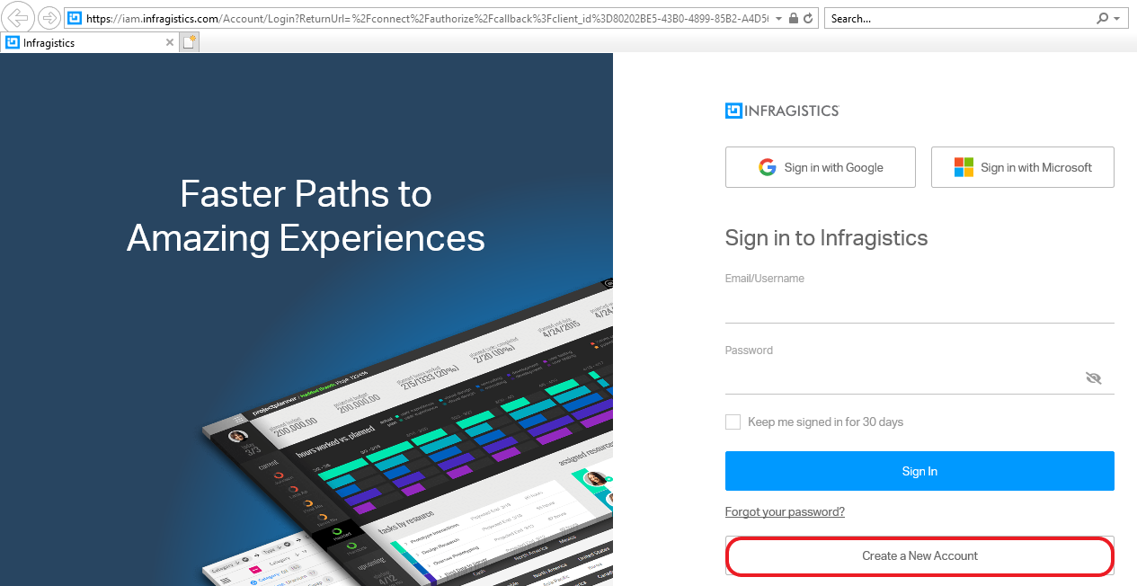

- Below screen will open and proceed with filing all the necessary details and click Create New Account.
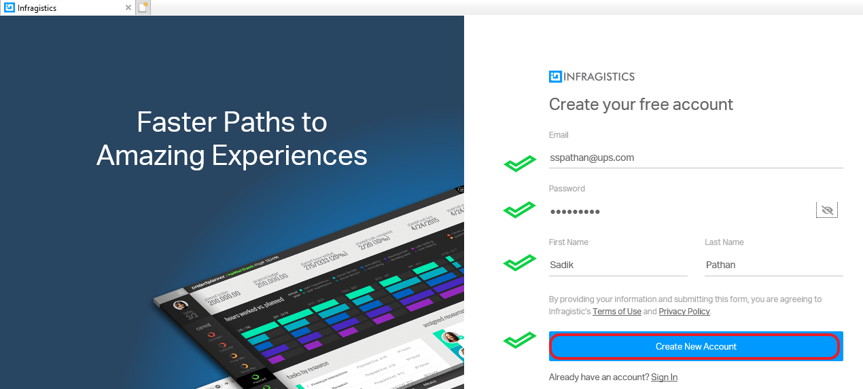
- This way you will be able to complete the registration process for the Infragistics.

Validate Account:
- You will receive a mail from Infragistics Team just to validate the account that you have already created.
- Click on Click here from the mail.

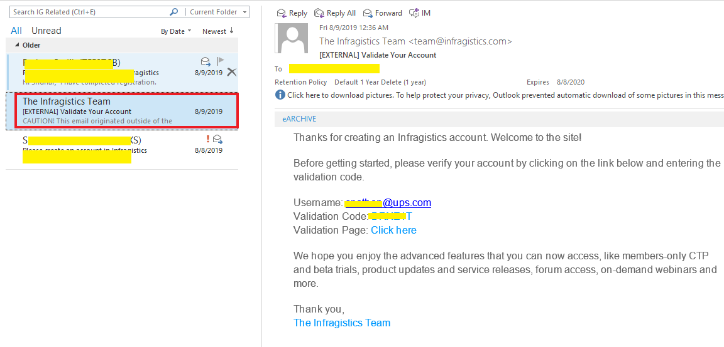
- Put the Validation Code and get done with it.
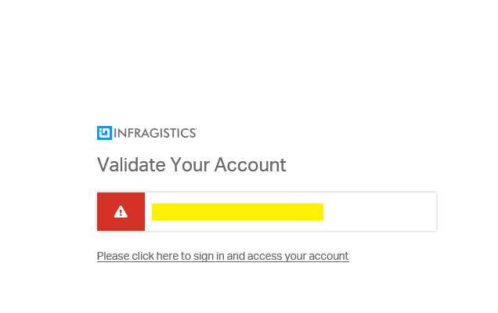

Infragistics Login:
- After registration you have to login Infragistics.
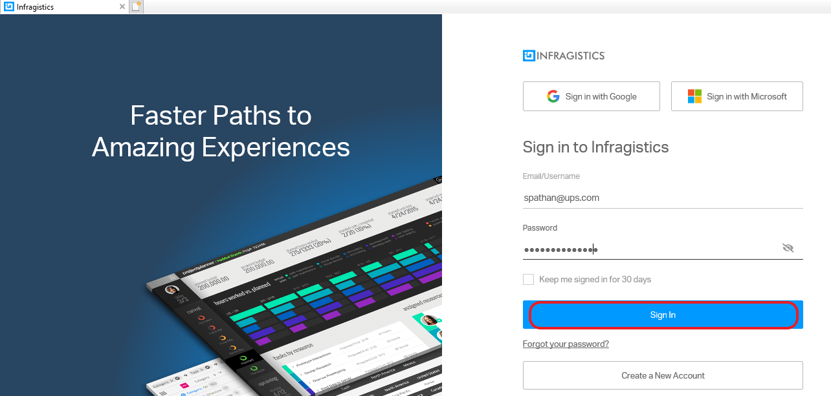

- After login, navigate to Subscription page and check you have valid key available.
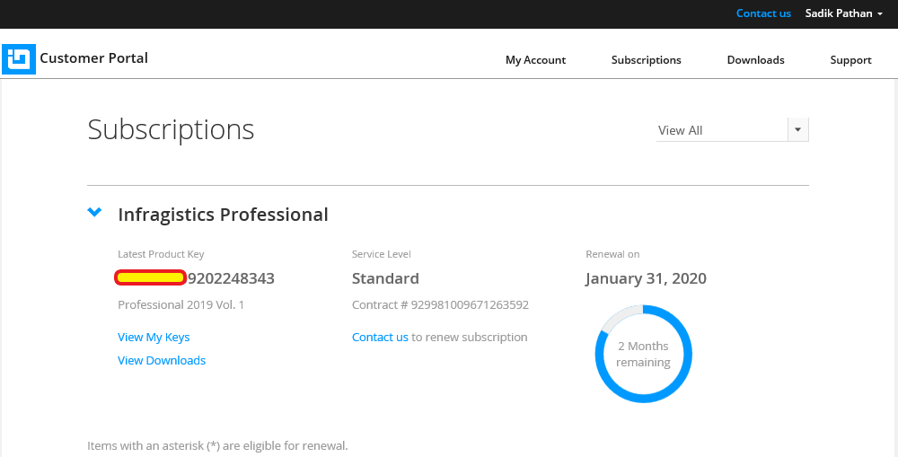
- If you have a key as shown in above screenshot then you are good to go with infragistics installation on your system.
Note: If you not seeing any key then you have contact your concern person to get it done with the key otherwise you will not be able to proceed with the Infragistics installation.
Infragistics license (Keys):
- Navigate to My Keys & Downloads page and check your keys and validity.
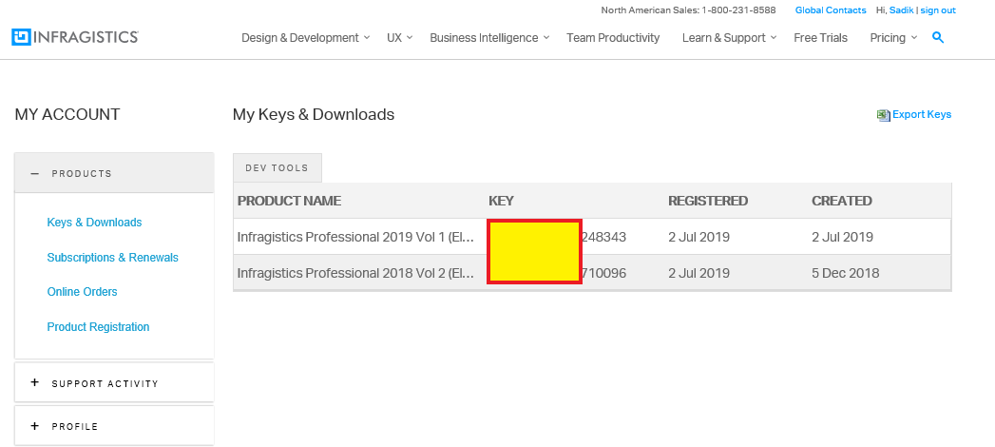

Infragistics Installation:
Prerequisites:
- Before installation we need to uninstall all infragistics related things from system if it is available.
- Please make sure you have closed all the instances of Visual Studio before Infragistics installation.
- E.g. Please open Control Panel and Uninstall Infragistics related setups.
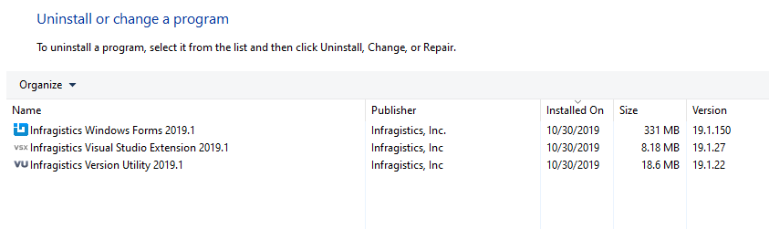
- Also check that you have deleted this instance in C:/Program Files(x86)/Infragistics. If not please delete the same.
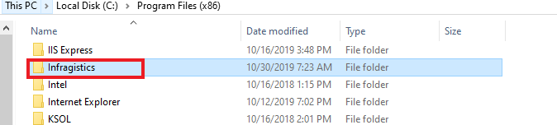

Installations:
- Navigate to below path and copy the setup folder to local system as shown below.
\\posbld-development.ismd.ups.com\DVD\Infragistics\NetAdvantage.Net2019_Vol1
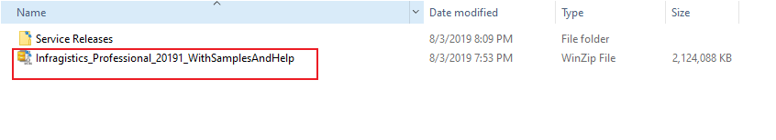
Note: Please note that the zip file is 2.0GB, so it might take a while to unzip the contents to your local machine

- Copy to your system’s local path and unzip the same.
- Run (as Administrator) the below highlighted setup from the unzipped folder location.
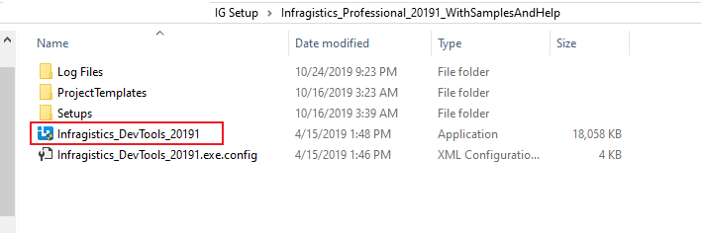
Note: Before you run the install, please make sure you login to www.infragistics.com (using your account) and get the product key for IG Professional 2019 Vol 1.

- Provide the credentials and proceed with installation.
- Below screen will open and select the Windows Forms option as shown in LICENSED section.
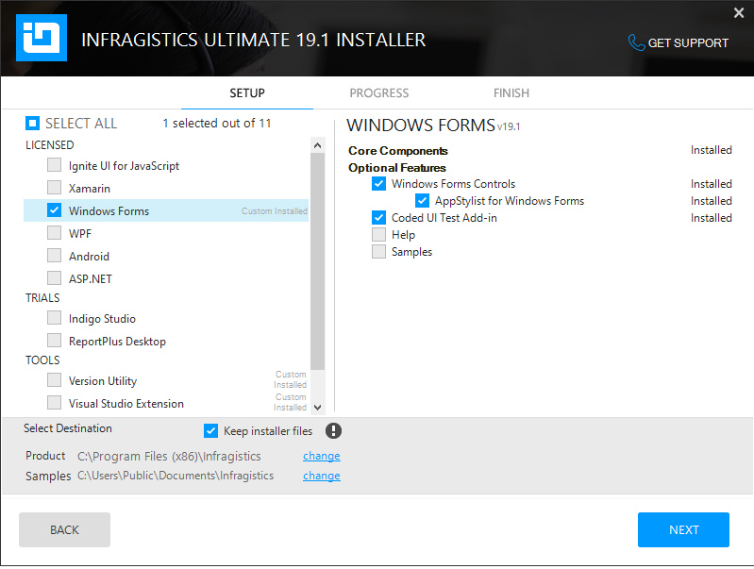
- Select the option as Version Utility from TOOLS section.
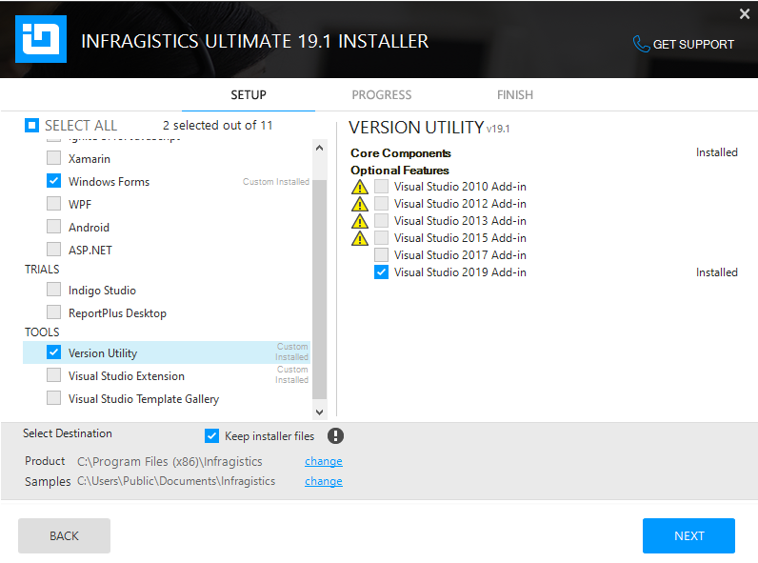

- Similarly select Visual Studio Extension from TOOLS section and click NEXT.
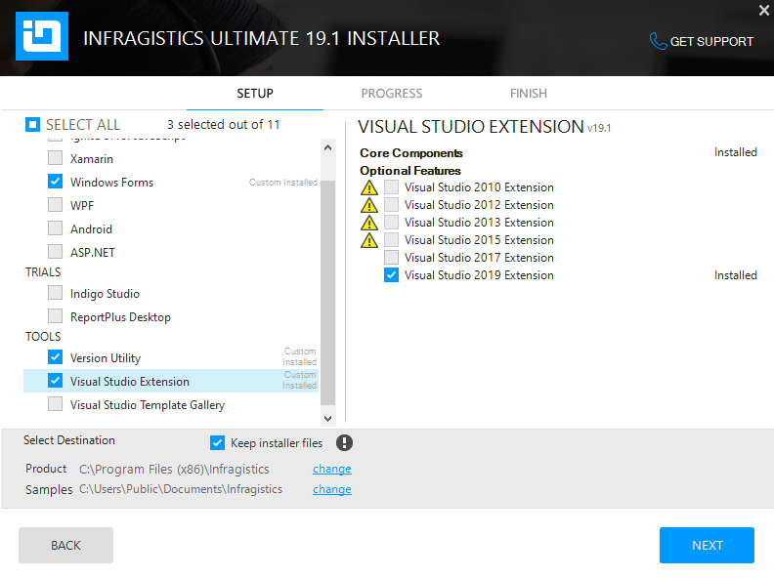

Note: This will a while to complete the setup and after the completion of setup open the control panel.
Observe what all the Infragistics have been installed.
Below screen showing the expected versions of Infragistics.
Infragistics Windows Forms 2019.1 should have version 19.1.150 installed.
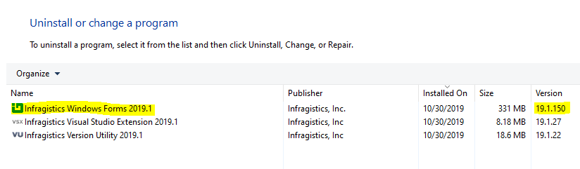
If it not like that we have one more step to finish the setup as below.
- From the below path navigate to Service Releases folder.
\\posbld-development.ismd.ups.com\DVD\Infragistics\NetAdvantage.Net2019_Vol1
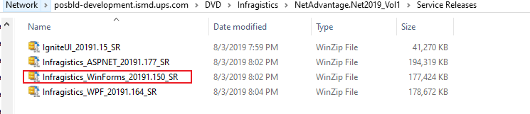
- Copy the Infragistics_WinForms_20191.150_SR file to local machine and unzip the file and install the setup.
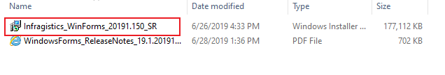
- After completion of the setup please open the control panel and have a check. IT should be like as shown below only.
Please open the VS 2019 – ODSe Client project and open the any UI designer and observe, you should get UI with START button option. If you are getting start button then we are done with the successfully installation of INFRAGISTICS.
E.g. After installation open ManageOnDemandOrderForm designer page and here as highlighted we are seeing an option START button.
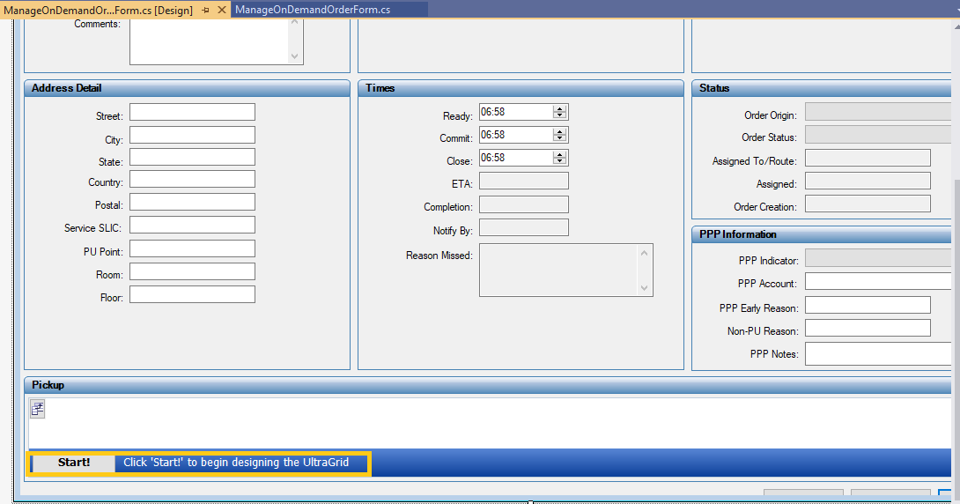
Here we done with the setup.
☺Happy Programming☺
Note: Please feel free to add or suggest any change(s) you are aware with and not mentioned in document.

