# Heading 1 – use this for the document title

Published [DD Month Year]

Contents

Heading 2 1

1. Heading 2 – numbered 2

The table of contents has been set up so that any text with the style Heading 2 will be added to the table of contents when it is updated.

To update the table of contents, click in the table of contents and press the F9 key.

## Formatting

The ‘Font’ toolbar is greyed out - locked - in the template. This is because you must use the pre-set styles to format your document.

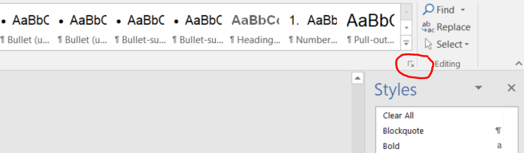The styles menu is on the Home ribbon. To see the full range of styles that can be used in the template, select the small arrow icon positioned at the bottom right of the window, or use the keyboard shortcut Ctrl+Alt+Shift+S.

## Heading 2

Paragraph text

### Heading 3

Paragraph text

* Bullet
* Bullet-sub

#### Heading 4

Paragraph text

1. Bullet – numbered list (do not use this style to number paragraphs).
2. To restart the list, right click in the paragraph and select ‘Restart at 1’ or ‘Set numbering value’.

Heading – figure, chart or table

|  |  |  |
| --- | --- | --- |
| Table – header text | Table – header text | Table – header text |
| Table – body text | Table – body text | Table – body text |
| Table – body text | Table – body text | Table – body text |
| Table – body text | Table – body text | Table – body text |

To apply the DHSC table style to an existing table:

1. Click anywhere in the table. The ‘Table Tools’ menu will appear at the top of the page.
2. Click on the ‘Design’ tab and choose ‘DHSC table’ from the menu of table styles.

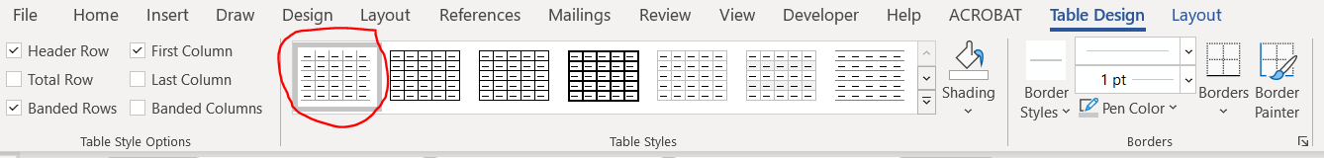

1. Apply the correct styles to your data: ‘Table - header text’ for the first row containing the column titles and ‘Table - body text’ for all other rows.
2. Use the style ‘Table - body text right aligned’ if you want the data to line up.