1, Fangji
- remove 50 highest degree,
- focus on GC
- remove by component degree 1

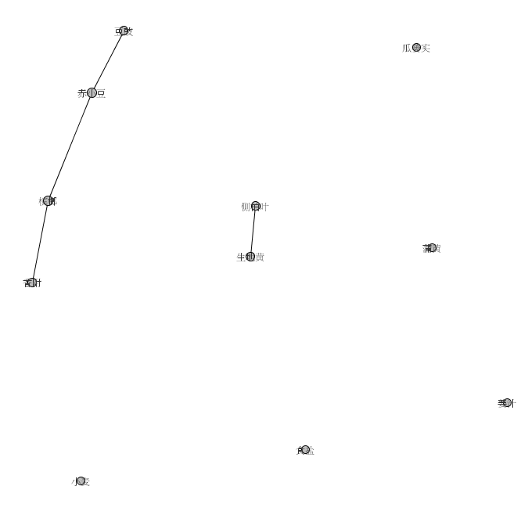

2,
- remove 100 highest degree,
- focus on GC
- remove by component degree 1

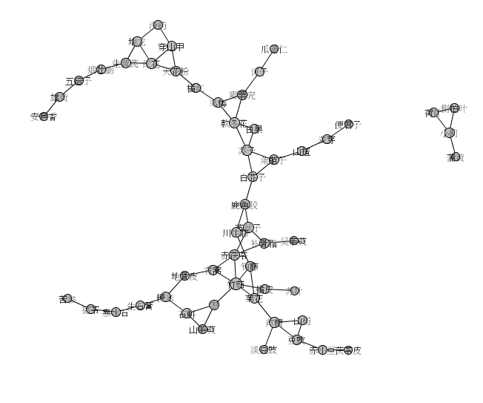
3,
- remove 120 highest degree,
- focus on GC
- remove by component degree 1

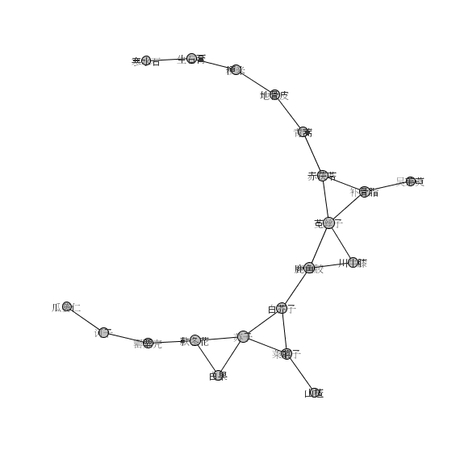
Metabolite:

- remove by component degree 1

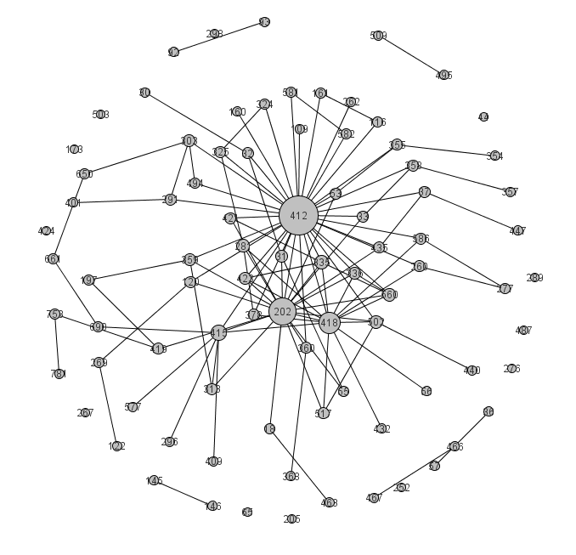

- remove 150 highest degree,
- focus on GC
- remove by component degree 1

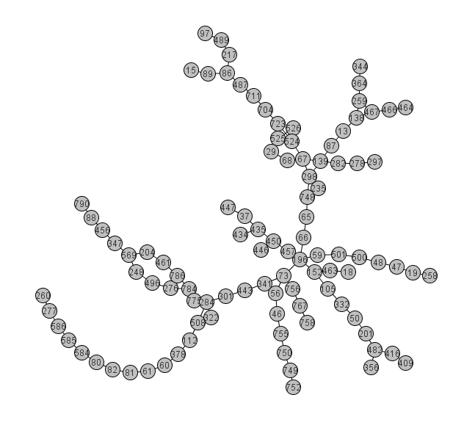
removeByVertexComponentDegreesLowest(1)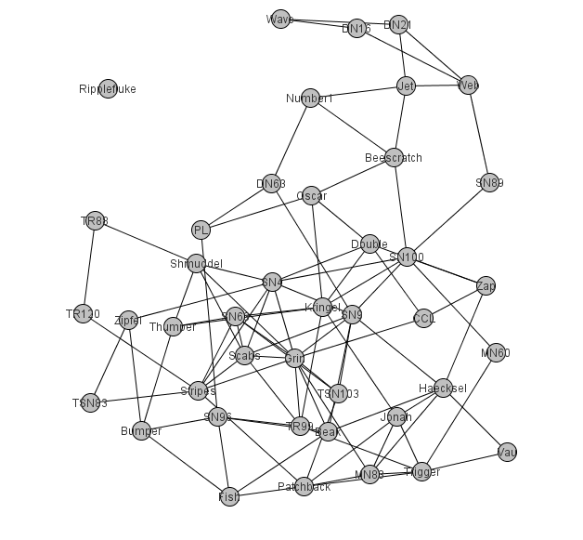

removeByVertexComponentDegreesLowest(2)
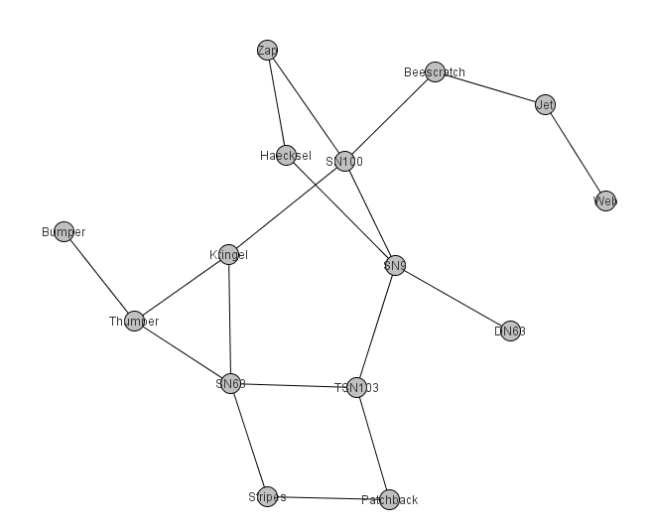

removeByVertexComponentDegreesLowest(3)
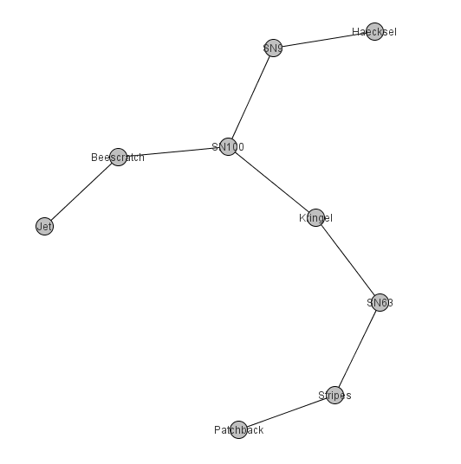

removeByVertexComponentDegreesLowest(4)

