Bombay Hospital Indore

[**Best Nursing College, giving best nurses, which are the backbone of any hospital**](http://www.bombayhospitalindore.com/)

Considered the premier private trust hospital in India which was Set up in 1950s by the great philanthropist Shri Rameshwar Das ji Birla. Every year around 2 lakh OPD patients & 28000 inpatients flock to Bombay Hospital – Bombay for various kinds of treatment.

#### Chairman’s Message



Charity and the pursuit of excellence are the two fundamental ideals that provide us impetus to focus on the well being of the patient who is our primary responsibility. We have an obligation to provide the best possible treatment, delivered most efficiently, in the shortest possible time span and at minimum cost.

On this bedrock of charity we are relentlessly building the bedrock of excellence in the hospital by continuously refurbishing its spaces, installing the most modern medical equipments and injecting professionalism and dedication in our management team, so that our world class doctors can discharge their duties and responsibilities in an academically stimulating and hassle-free environment.

### Our Facilities

* [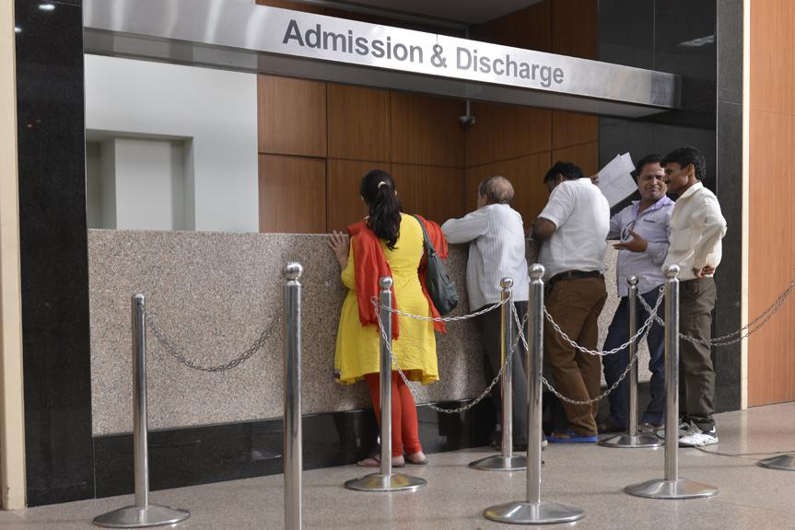](http://www.bombayhospitalindore.com/wp-content/uploads/2014/11/img1.jpg)

Admission Counter

* [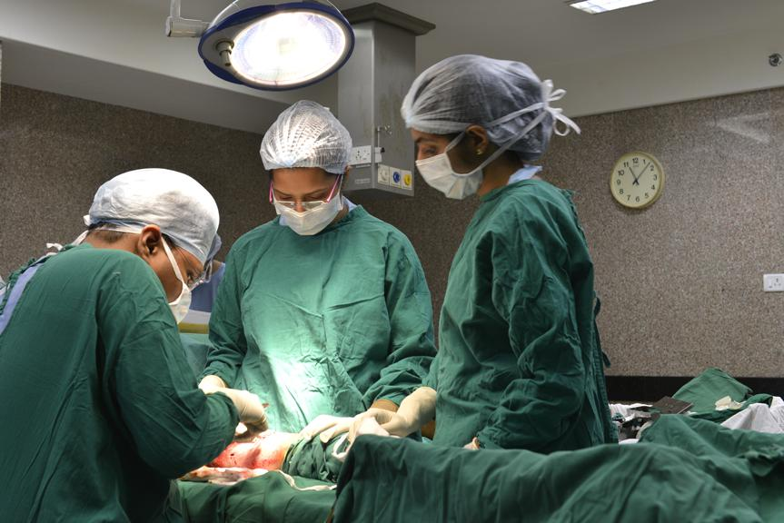](http://www.bombayhospitalindore.com/wp-content/uploads/2014/11/img2.jpg)

Operation Theatre

* [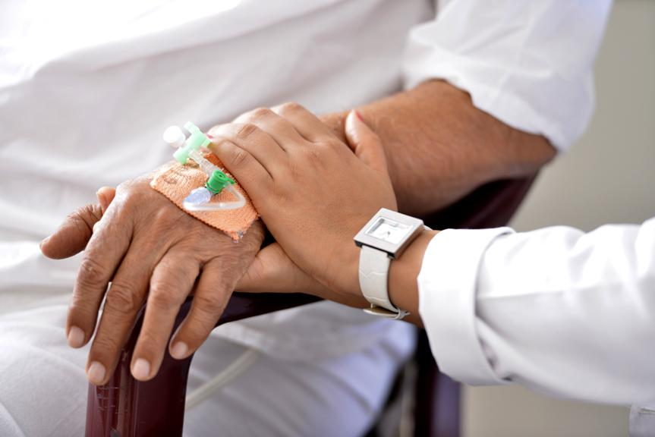](http://www.bombayhospitalindore.com/wp-content/uploads/2014/11/Picture1.jpg)

Patient Care

* [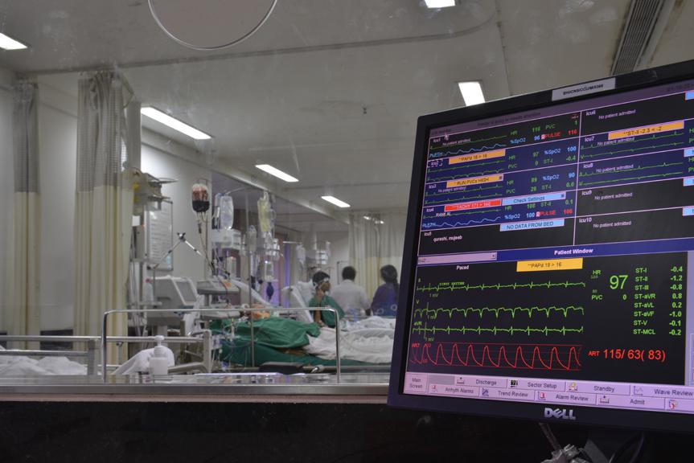](http://www.bombayhospitalindore.com/wp-content/uploads/2014/11/Picture2.jpg)

Intensive Care

* [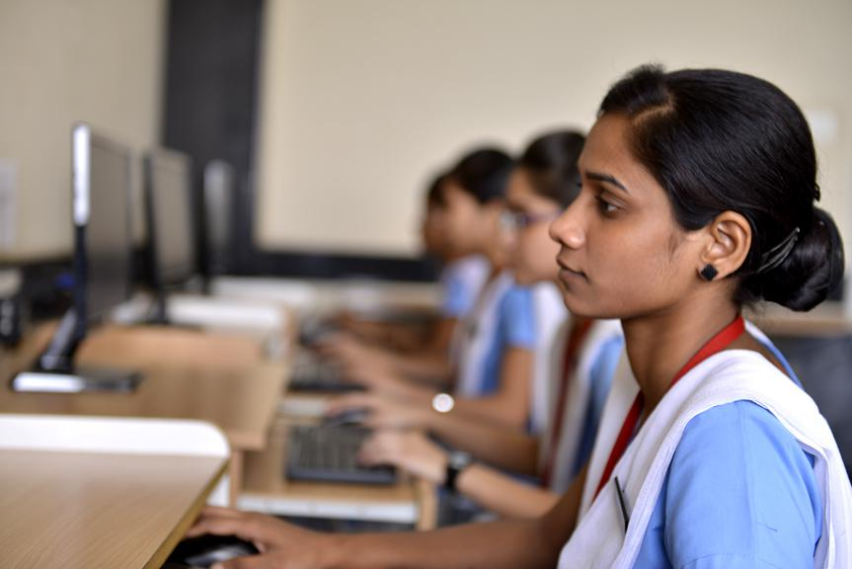](http://www.bombayhospitalindore.com/wp-content/uploads/2014/11/Picture3.jpg)

Nursing College

* [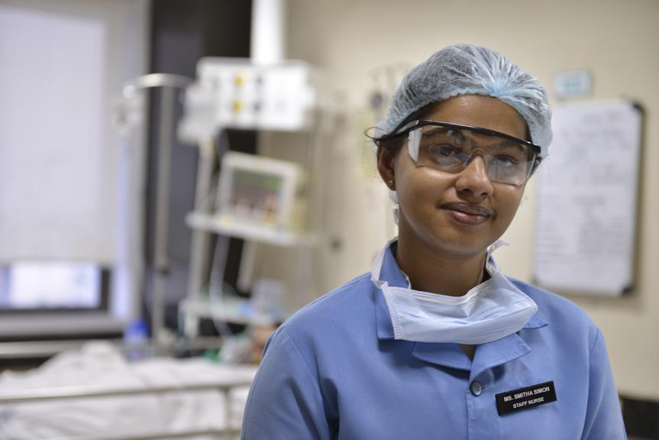](http://www.bombayhospitalindore.com/wp-content/uploads/2014/11/Picture4.jpg)

Intensive Care

* [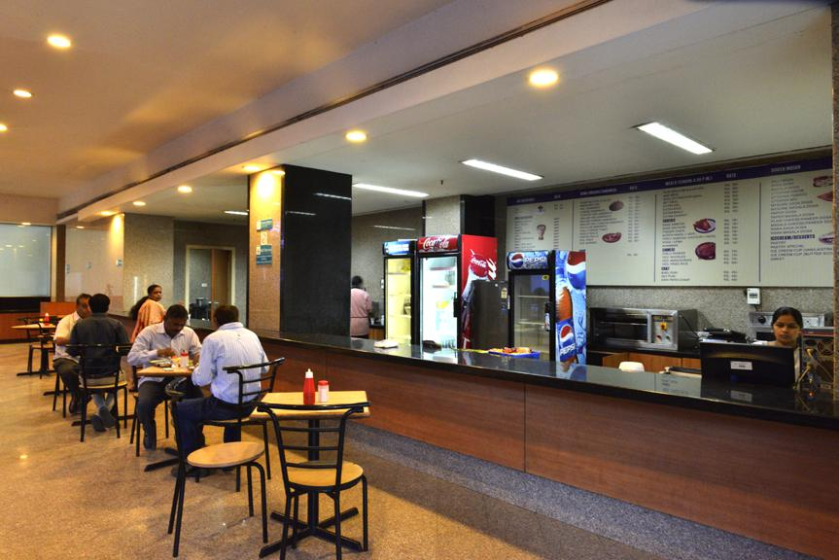](http://www.bombayhospitalindore.com/wp-content/uploads/2014/11/Picture5.jpg)

Cafeteria

* [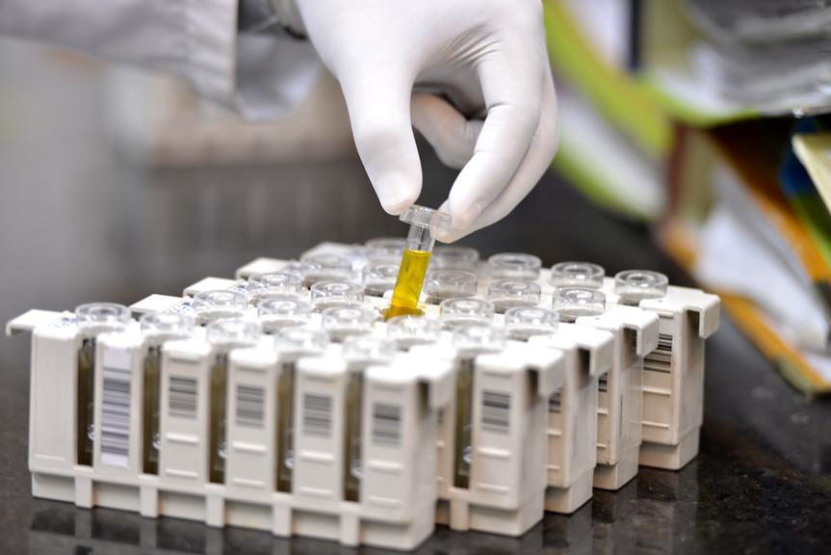](http://www.bombayhospitalindore.com/wp-content/uploads/2014/10/Picture8.jpg)

Picture8

* [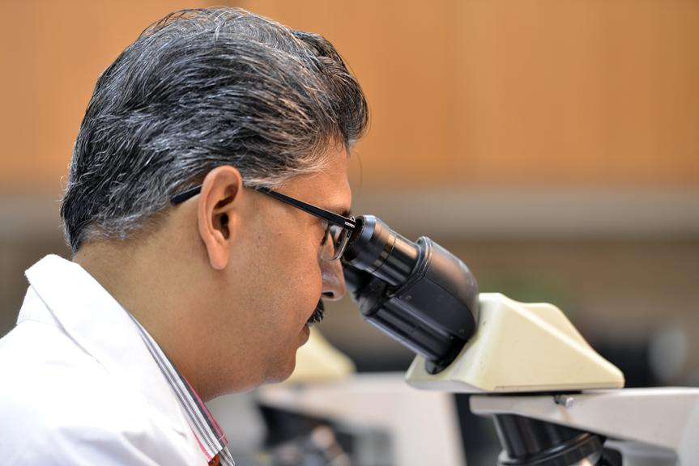](http://www.bombayhospitalindore.com/wp-content/uploads/2014/11/Picture9.jpg)

Pathology

* [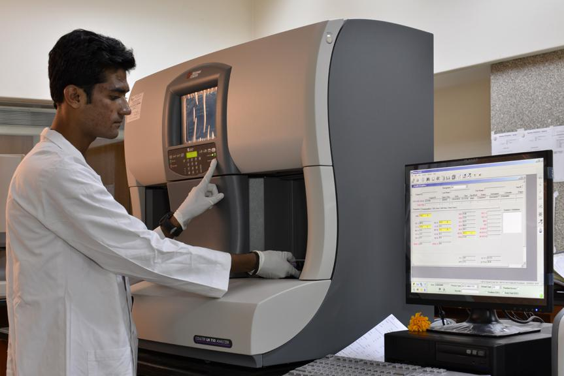](http://www.bombayhospitalindore.com/wp-content/uploads/2014/11/Picture101.jpg)

Pathology

* [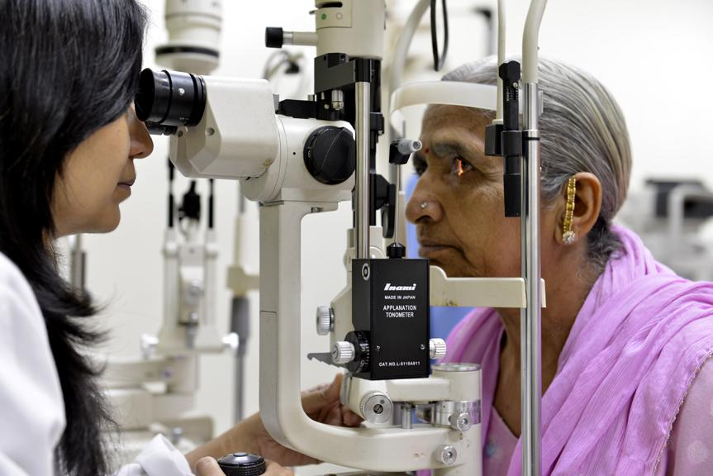](http://www.bombayhospitalindore.com/wp-content/uploads/2014/11/Picture12.jpg)

Opthalmology

[TPA / Insurance Patients](http://www.bombayhospitalindore.com/?page_id=1390)

[Corporate Patients](http://www.bombayhospitalindore.com/?page_id=1547)

[Nursing College](http://www.bhinursingcollege.com/)

[Patient Stories](http://www.bombayhospitalindore.com/patient-stories)

#### Academics

[Post Graduate Diploma in Clinical Cardiology (PGDCC)](http://www.bombayhospitalindore.com/post-graduate-diploma-in-clinical-cardiology-pgdcc-2/)

[Application Invited For IDCCM Course](http://www.bombayhospitalindore.com/application-invited-for-idccm-course/)

[Diplomate From National Board (DNB)](http://www.bombayhospitalindore.com/diplomate-from-national-board-dnb/)

#### [Health Scheme](http://www.bombayhospitalindore.com/executive-checkup-schemes/)

Urban living in the 21st Century is not the kind of living our bodies were designed for. The fast pace of life, stress, sedentary lifestyle, travel, irregular eating habits and the ever attendant toxic pollutants in air, water and food, all serve to wear out our bodies at an alarming rate. Wha

[Read More..](http://www.bombayhospitalindore.com/executive-checkup-schemes/)

#### [Visit](http://www.bombayhospital.com/)

[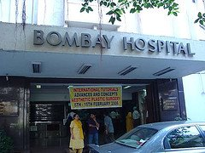](http://www.bombayhospital.com/)[www.bombayhospital.com](http://www.bombayhospital.com/)

#### Awards & Accolades

[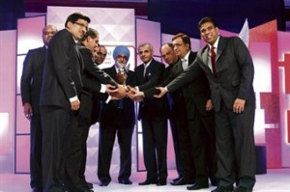](http://www.bombayhospitalindore.com/awards/)

# Doctors List in Bombay Hospital, Indore

* [Home](https://www.sehat.com/)

* [Indore](https://www.sehat.com/indore/hospitals)

* [Bombay Hospital](https://www.sehat.com/bombay-hospital-indore)

* Doctors List

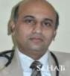

## [Dr. Rajesh Bharani Nephrologist](https://www.sehat.com/dr-rajesh-bharani-nephrologist-indore" \o "Dr. Rajesh Bharani)

*MD, DM (Nephrology)*

* Indore
* 14 Years Experience
* 1 Hospital

Ask a Doctor

[View Profile](https://www.sehat.com/dr-rajesh-bharani-nephrologist-indore" \o "Dr. Rajesh Bharani)

Call for Appointment

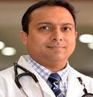

## [Dr. Manish Jain General Physician](https://www.sehat.com/dr-manish-jain-general-physician-indore" \o "Dr. Manish Jain)

*MBBS, MD, DNB, MRCP*

* Indore
* 1 Hospital

Ask a Doctor

[View Profile](https://www.sehat.com/dr-manish-jain-general-physician-indore" \o "Dr. Manish Jain)

Call for Appointment



## [Dr. Idris Ahmed Khan Cardiologist](https://www.sehat.com/dr-idris-ahmed-khan-cardiologist-indore" \o "Dr. Idris Ahmed Khan)

*MBBS, MD (Medicine), DM (Cardiology)*

* Indore
* 1 Hospital

Ask a Doctor

[View Profile](https://www.sehat.com/dr-idris-ahmed-khan-cardiologist-indore" \o "Dr. Idris Ahmed Khan)

Call for Appointment

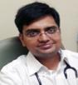

## [Dr. Ravi Rathi Gastroenterologist](https://www.sehat.com/dr-ravi-rathi-gastroenterologist-indore" \o "Dr. Ravi Rathi)

*MBBS, MD (General Medicine), DM (Gastroenterology)*

* Indore
* 1 Hospital

Ask a Doctor

[View Profile](https://www.sehat.com/dr-ravi-rathi-gastroenterologist-indore" \o "Dr. Ravi Rathi)

Call for Appointment

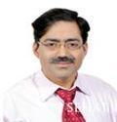

## [Dr. Abhay Jain Psychiatrist](https://www.sehat.com/dr-abhay-jain-psychiatrist-indore" \o "Dr. Abhay Jain)

*MBBS, MD (Psychiatry)*

* Indore
* 3 Hospitals

Ask a Doctor

[View Profile](https://www.sehat.com/dr-abhay-jain-psychiatrist-indore" \o "Dr. Abhay Jain)

Call for Appointment

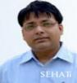

## [Dr. Vivek Jha Urologist](https://www.sehat.com/dr-vivek-jha-urologist-indore" \o "Dr. Vivek Jha)

*MBBS, MS, DNB*

* Indore
* 1 Hospital

Ask a Doctor

[View Profile](https://www.sehat.com/dr-vivek-jha-urologist-indore" \o "Dr. Vivek Jha)

Call for Appointment

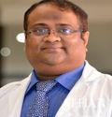

## [Dr. Anil Gwaliorkar ENT Surgeon](https://www.sehat.com/dr-anil-gwaliorkar-ent-doctor-indore" \o "Dr. Anil Gwaliorkar)

*MBBS, MS*

* Indore
* 1 Hospital

Ask a Doctor

[View Profile](https://www.sehat.com/dr-anil-gwaliorkar-ent-doctor-indore" \o "Dr. Anil Gwaliorkar)

Call for Appointment

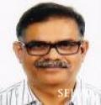

## [Dr. Ashutosh Soni General & Laparoscopic Surgeon](https://www.sehat.com/dr-ashutosh-soni-general-laparoscopic-surgery-doctor-indore" \o "Dr. Ashutosh Soni)

*MBBS, MS, FIAGES, FMAS*

* Indore
* 28 Years Experience
* 1 Hospital

Ask a Doctor

[View Profile](https://www.sehat.com/dr-ashutosh-soni-general-laparoscopic-surgery-doctor-indore" \o "Dr. Ashutosh Soni)

Call for Appointment

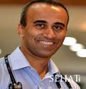

## [Dr. Rashid Hasan Orthopedic Surgeon](https://www.sehat.com/dr-rashid-hasan-orthopedic-surgeon-indore" \o "Dr. Rashid Hasan)

*MBBS, MS*

* Indore
* 1 Hospital

Ask a Doctor

[View Profile](https://www.sehat.com/dr-rashid-hasan-orthopedic-surgeon-indore" \o "Dr. Rashid Hasan)

Call for Appointment

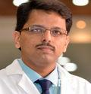

## [Dr.M. Ladhania Orthopedic Surgeon](https://www.sehat.com/dr-m-ladhania-orthopedic-surgeon-indore" \o "Dr.M. Ladhania)

*MBBS, MS*

* Indore
* 1 Hospital

Ask a Doctor

[View Profile](https://www.sehat.com/dr-m-ladhania-orthopedic-surgeon-indore" \o "Dr.M. Ladhania)

Call for Appointment

Page 2

## [Dr. Pritesh Shrimali Urologist](https://www.sehat.com/dr-pritesh-shrimali-urologist-indore" \o "Dr. Pritesh Shrimali)

*MBBS, MS, DNB(urology),MNAMS*

* Indore
* 1 Hospital

Ask a Doctor

[View Profile](https://www.sehat.com/dr-pritesh-shrimali-urologist-indore" \o "Dr. Pritesh Shrimali)

Call for Appointment



## [Dr. Kirnesh Pandey Diabetologist](https://www.sehat.com/dr-kirnesh-pandey-diabetologist-indore" \o "Dr. Kirnesh Pandey)

*MBBS, DNB (Med) Gold Medalist*

* Indore
* 11 Years Experience
* 1 Hospital

Ask a Doctor

[View Profile](https://www.sehat.com/dr-kirnesh-pandey-diabetologist-indore" \o "Dr. Kirnesh Pandey)

Call for Appointment

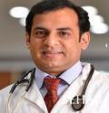

## [Dr. Ashwin Soni Pediatric Cardiac Anesthetist](https://www.sehat.com/dr-ashwin-soni-pediatric-cardiac-anesthesia-doctor-indore" \o "Dr. Ashwin Soni)

*MBBS, MD, PDCC*

* Indore
* 1 Hospital

Ask a Doctor

[View Profile](https://www.sehat.com/dr-ashwin-soni-pediatric-cardiac-anesthesia-doctor-indore" \o "Dr. Ashwin Soni)

Call for Appointment

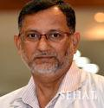

## [Dr. Prakash Raje Histopathologist](https://www.sehat.com/dr-prakash-raje-histopathologist-indore" \o "Dr. Prakash Raje)

*MBBS, DCP, MD*

* Indore
* 2 Hospitals

Ask a Doctor

[View Profile](https://www.sehat.com/dr-prakash-raje-histopathologist-indore" \o "Dr. Prakash Raje)

Call for Appointment



## [Ms. Aashna Jain Audiologist and Speech Therapist](https://www.sehat.com/ms-aashna-jain-audiologists-and-speech-therapist-indore" \o "Ms. Aashna Jain)

*BASLP, MASLP*

* Indore
* 2 Years Experience
* 1 Hospital

Ask a Doctor

[View Profile](https://www.sehat.com/ms-aashna-jain-audiologists-and-speech-therapist-indore" \o "Ms. Aashna Jain)

Call for Appointment



## [Dr. Meetesh Agrawal Dermatologist](https://www.sehat.com/dr-meetesh-agrawal-dermatologist-indore" \o "Dr. Meetesh Agrawal)

*MBBS, MD*

* Indore
* 2 Hospitals

Ask a Doctor

[View Profile](https://www.sehat.com/dr-meetesh-agrawal-dermatologist-indore" \o "Dr. Meetesh Agrawal)

Call for Appointment



## [Dr. Manish Nema Hematologist](https://www.sehat.com/dr-manish-nema-hematologist-indore" \o "Dr. Manish Nema)

*MBBS, MD, DM*

* Indore
* 2 Hospitals

Ask a Doctor

[View Profile](https://www.sehat.com/dr-manish-nema-hematologist-indore" \o "Dr. Manish Nema)

Call for Appointment



## [Dr. Alok Modi Oncologist](https://www.sehat.com/dr-alok-modi-oncologist-indore" \o "Dr. Alok Modi)

*MBBS, MD (MEDICINE)*

* Indore
* 2 Hospitals

Ask a Doctor

[View Profile](https://www.sehat.com/dr-alok-modi-oncologist-indore" \o "Dr. Alok Modi)

Call for Appointment



## [Dr.O.P. Rathi Nephrologist](https://www.sehat.com/dr-op-rathi-nephrologist-indore" \o "Dr.O.P. Rathi)

*MBBS, MD, DM*

* Indore
* 1 Hospital

Ask a Doctor

[View Profile](https://www.sehat.com/dr-op-rathi-nephrologist-indore" \o "Dr.O.P. Rathi)

Call for Appointment



## [Dr. Mayur Maheshwari Pediatric Surgeon](https://www.sehat.com/dr-mayur-maheshwari-pediatric-surgeon-indore" \o "Dr. Mayur Maheshwari)

*MBBS, MS, M.ch, DNB*

* Indore
* 2 Hospitals

# [Greater Kailash Hospital-Joint Replacement Surgery, Oncology in Indore](https://greaterkailashhospital.wordpress.com/2011/09/19/greater-kailash-hospital-joint-replacement-surgery-oncology-in-indore/)

Posted on [**September 19, 2011**](https://greaterkailashhospital.wordpress.com/2011/09/19/greater-kailash-hospital-joint-replacement-surgery-oncology-in-indore/)

[1](https://greaterkailashhospital.wordpress.com/2011/09/19/greater-kailash-hospital-joint-replacement-surgery-oncology-in-indore/#comments)

**Greater Kailash Hospital, Indore**

**Facilities**

* Cardiology And Cardiothoracic Surgery
* Obstetrics & Gynecology, Orthopedics
* Arthroscopy & Sports Medicine
* Joint Replacement Surgery
* Pediatric Orthopedic Unit
* Gastroenterology And GI Surgery
* Blood Bank / Transfusion Medicine
* Ophthalmology
* Apex Retina Centre
* Urology & Nephrology
* Physiotherapy & Rehabilitation
* Pediatrics & Pediatric Surgery
* Neurosciences
* Oncology
* Minimally Invasive Surgery
* Plastic & Cosmetic Surgery Dermatology
* Dental & Maxillofacial
* ENT (Otolaryngology)
* Endocrinology & Diabetes
* Pulmonology
* Radiology & Imaging
* Interventional Radiological Procedures
* Ambulance
* Laboratory Medicine / Pathology etc.

# Doctors List in Greater Kailash Hospital, Indore

* [Home](https://www.sehat.com/)

* [Indore](https://www.sehat.com/indore/hospitals)

* [Greater Kailash Hospital](https://www.sehat.com/greater-kailash-hospital-indore)

* Doctors List

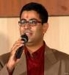

## [Dr. Siddharth Jain Gastro Surgeon](https://www.sehat.com/dr-siddharth-jain-gastro-surgeon-indore" \o "Dr. Siddharth Jain)

*MBBS, MS, DILS, FMAS, FAIS*

* Indore
* 14 Years Experience
* 8 Hospitals
* 1 Recommendation

Ask a Doctor

[View Profile](https://www.sehat.com/dr-siddharth-jain-gastro-surgeon-indore" \o "Dr. Siddharth Jain)

Call for Appointment

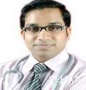

## [Dr. Srikanth Reddy Psychiatrist](https://www.sehat.com/dr-srikanth-reddy-psychiatrist-indore" \o "Dr. Srikanth Reddy)

*M.B.B.S, MD (Psychiatry)*

* Indore
* 3 Hospitals

Ask a Doctor

[View Profile](https://www.sehat.com/dr-srikanth-reddy-psychiatrist-indore" \o "Dr. Srikanth Reddy)

Call for Appointment

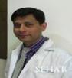

## [Dr. Vivek Shrivastava Pediatric Orthopedic Surgeon](https://www.sehat.com/dr-vivek-shrivastava-pediatric-orthopedic-surgeon-indore" \o "Dr. Vivek Shrivastava)

*MBBS, D.Orth, M.Ch*

* Indore
* 15 Years Experience
* 2 Hospitals

Ask a Doctor

[View Profile](https://www.sehat.com/dr-vivek-shrivastava-pediatric-orthopedic-surgeon-indore" \o "Dr. Vivek Shrivastava)

Call for Appointment

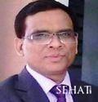

## [Dr. Hari Prasad Yadav Gastroenterologist](https://www.sehat.com/dr-hari-prasad-yadav-gastroenterologist-indore" \o "Dr. Hari Prasad Yadav)

*MBBS, MD, DM*

* Indore
* 2 Hospitals

Ask a Doctor

[View Profile](https://www.sehat.com/dr-hari-prasad-yadav-gastroenterologist-indore" \o "Dr. Hari Prasad Yadav)

Call for Appointment

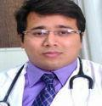

## [Dr. Abhijeet Khandelwal Pulmonologist](https://www.sehat.com/dr-abhijeet-khandelwal-pulmonologist-indore" \o "Dr. Abhijeet Khandelwal)

*MBBS, DTCD, DNB, FCCP*

* Indore
* 9 Years Experience
* 1 Hospital
* 1 Recommendation

Ask a Doctor

[View Profile](https://www.sehat.com/dr-abhijeet-khandelwal-pulmonologist-indore" \o "Dr. Abhijeet Khandelwal)

Call for Appointment

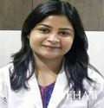

## [Dr. Heena Agrawal IVF & Infertility Specialist](https://www.sehat.com/dr-heena-agrawal-infertility-doctor-indore" \o "Dr. Heena Agrawal)

*MBBS, DGO, Fellowship in Reproductive Medicine*

* Indore
* 5 Years Experience
* 1 Hospital

Ask a Doctor

[View Profile](https://www.sehat.com/dr-heena-agrawal-infertility-doctor-indore" \o "Dr. Heena Agrawal)

Call for Appointment



## [Mr. Ritesh Physical Medicine and Rehabilitation](https://www.sehat.com/mr-ritesh-physical-medicine-and-rehabilitation-doctor-indore" \o "Mr. Ritesh)

*MPT, Masters in Orthopedic & Sports Physiotherapy*

* Indore
* 10 Years Experience
* 2 Hospitals

Ask a Doctor

[View Profile](https://www.sehat.com/mr-ritesh-physical-medicine-and-rehabilitation-doctor-indore" \o "Mr. Ritesh)

Call for Appointment

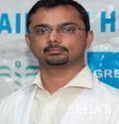

## [Dr. Shailesh Solanki Pediatric Urologist](https://www.sehat.com/dr-shailesh-solanki-pediatric-urologist-indore" \o "Dr. Shailesh Solanki)

*MS, Mch (Ped. Sur.)*

* Indore
* 1 Hospital

Ask a Doctor

[View Profile](https://www.sehat.com/dr-shailesh-solanki-pediatric-urologist-indore" \o "Dr. Shailesh Solanki)

Call for Appointment

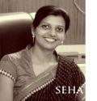

## [Dt. Vinita Jaiswal Obesity Specialist](https://www.sehat.com/dt-vinita-jaiswal-obesity-doctor-indore" \o "Dt. Vinita Jaiswal)

*M.Sc.(Food & Nutrition)*

* Indore
* 1 Hospital

Ask a Doctor

[View Profile](https://www.sehat.com/dt-vinita-jaiswal-obesity-doctor-indore" \o "Dt. Vinita Jaiswal)

Call for Appointment



## [Dr. C.P. Kothari General & Laparoscopic Surgeon](https://www.sehat.com/dr-cp-kothari-general-laparoscopic-surgery-doctor-indore" \o "Dr. C.P. Kothari)

*MS, FIAS, FIAGES*

* Indore
* 20 Years Experience
* 4 Hospitals

Ask a Doctor

[View Profile](https://www.sehat.com/dr-cp-kothari-general-laparoscopic-surgery-doctor-indore" \o "Dr. C.P. Kothari)

Call for Appointment

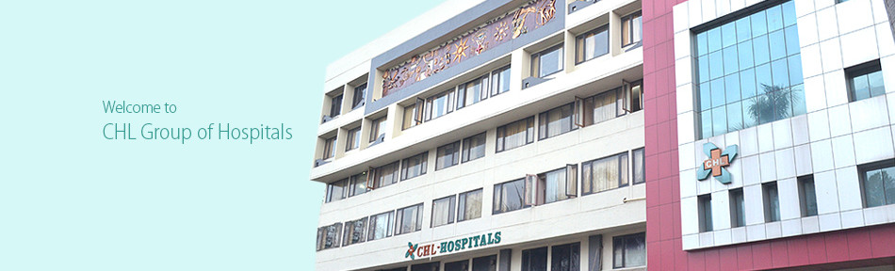

CHL-Hospitals, Indore is managed and owned by the Convenient Hospitals Ltd, Indore. CHL Hospitals is a 225-bedded Multi Specialty Critical Care Hospital located on A.B Road, Indore, Madhya Pradesh, (India) and has premium connectivity with the entire India. The hospital has gained widespread recognition being the first fully equipped center of international standard for Cardiac Interventions and Surgeries in the state. The hospital also enjoys the reputation of being the first to perform Coronary Bypass Surgeries, Coronary Angioplasty and other Catheter based interventions in Indore with a record of highest numbers in central India.

We are the first Corporate Hospital in central India and are proud to be associated with leading corporate groups and government bodies. CHL Hospitals has been a pioneer in the area of preventive healthcare through Health Checkups. A range of tailor –made packages are available to cater the needs of children, adults & corporate.

Search Results

•

[View Profile](http://www.chlhospitals.org/dr-avinash-talele/)

|  |  |
| --- | --- |
| Name | Dr Avinash Talele |
| Designation | MD,DM |
| Specialty | Medical Oncologist |
| Availability |  |

[Book an Appointment Now](http://www.chlhealthcare.com/contact/?d=Dr%20Avinash%20Talele)

•

[View Profile](http://www.chlhospitals.org/dr-suraj-verma/)

|  |  |
| --- | --- |
| Name | Dr Suraj Verma |
| Designation | MBBS, DNB |
| Specialty | Consultant Pulmonologist |
| Availability |  |

[Book an Appointment Now](http://www.chlhealthcare.com/contact/?d=Dr%20Suraj%20Verma)

•

[[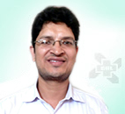](http://www.chlhospitals.org/dr-sachin-zalani/)](http://www.chlhospitals.org/dr-sachin-zalani/)

[View Profile](http://www.chlhospitals.org/dr-sachin-zalani/)

|  |  |
| --- | --- |
| Name | Dr. Sachin Zalani |
| Designation | M.PT. - Neuroscience (Sancheti Pune) |
| Specialty | Consultant Physiotherapist & Head of the department Physiotherapy |
| Availability |  |

[Book an Appointment Now](http://www.chlhealthcare.com/contact/?d=Dr.%20Sachin%20Zalani)

•

[[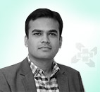](http://www.chlhospitals.org/dr-vinaykumar-bohara/)](http://www.chlhospitals.org/dr-vinaykumar-bohara/)

[View Profile](http://www.chlhospitals.org/dr-vinaykumar-bohara/)

|  |  |
| --- | --- |
| Name | Dr Vinay Kumar Bohara |
| Designation | MD, DM (Clinical Hematology |
| Specialty | Hematologist |
| Availability |  |

[Book an Appointment Now](http://www.chlhealthcare.com/contact/?d=Dr%20Vinay%20Kumar%20Bohara)

•

[[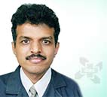](http://www.chlhospitals.org/dr-atul-karande/)](http://www.chlhospitals.org/dr-atul-karande/)

[View Profile](http://www.chlhospitals.org/dr-atul-karande/)

|  |  |
| --- | --- |
| Name | Dr. Atul Karande |
| Designation | M. D. |
| Specialty | Consultant Echocardiography |
| Availability |  |

[Book an Appointment Now](http://www.chlhealthcare.com/contact/?d=Dr.%20Atul%20Karande)

•

[[](http://www.chlhospitals.org/dr-sandeep-julka/)](http://www.chlhospitals.org/dr-sandeep-julka/)

[View Profile](http://www.chlhospitals.org/dr-sandeep-julka/)

|  |  |
| --- | --- |
| Name | Dr. Sandeep Julka |
| Designation | MBBS, MD, DM |
| Specialty | Endocrinologist |
| Availability |  |

[Book an Appointment Now](http://www.chlhealthcare.com/contact/?d=Dr.%20Sandeep%20Julka)

•

[[](http://www.chlhospitals.org/sunita-gupte-karnik/)](http://www.chlhospitals.org/sunita-gupte-karnik/)

[View Profile](http://www.chlhospitals.org/sunita-gupte-karnik/)

|  |  |
| --- | --- |
| Name | Sunita Gupte (Karnik) |
| Designation | MA |
| Specialty | Clinical Psychologist |
| Availability |  |

[Book an Appointment Now](http://www.chlhealthcare.com/contact/?d=Sunita%20Gupte%20(Karnik))

•

[[](http://www.chlhospitals.org/dr-sumeet-jaiswal/)](http://www.chlhospitals.org/dr-sumeet-jaiswal/)

[View Profile](http://www.chlhospitals.org/dr-sumeet-jaiswal/)

|  |  |
| --- | --- |
| Name | Dr Sumeet Jaiswal |
| Designation | MBBS MS MCH |
| Specialty | Plasic Surgeon |
| Availability |  |

[Book an Appointment Now](http://www.chlhealthcare.com/contact/?d=Dr%20Sumeet%20Jaiswal)

•

[[](http://www.chlhospitals.org/dr-a-k-jinsiwale/)](http://www.chlhospitals.org/dr-a-k-jinsiwale/)

[View Profile](http://www.chlhospitals.org/dr-a-k-jinsiwale/)

|  |  |
| --- | --- |
| Name | Dr A K Jinsiwale |
| Designation | MBBS MS |
| Specialty | Orthopedic Surgeon |
| Availability |  |

[Book an Appointment Now](http://www.chlhealthcare.com/contact/?d=Dr%20A%20K%20Jinsiwale)

•

[[](http://www.chlhospitals.org/dr-mukesh-jain/)](http://www.chlhospitals.org/dr-mukesh-jain/)

[View Profile](http://www.chlhospitals.org/dr-mukesh-jain/)

|  |  |
| --- | --- |
| Name | Dr Mukesh Jain |
| Designation | MBBS MS |
| Specialty | ENT |
| Availability |  |

### Specialities

* Cardiology
* Dentistry
* Dermatology (Skin)
* ENT (Otolaryngology)
* Gastroenterology
* General Surgery
* Nephrology
* Neurology
* Neurosurgery
* Obstetrics and Gynecology
* Ophthalmology
* Orthopedics
* Pediatrics
* Physiotherapy
* Plastic Surgery
* Urology

### Services

* Color Doppler
* ECG
* Laboratory
* Ultra Sound Scan
* X-ray
* OPD Services
* Blood Bank
* Preventive Cardiology Department

### Timings

24 hrs

### Doctors List

| Name | Speciality | View Profile |
| --- | --- | --- |
| Dr.A.K. Pancholia | General Medicine |  |
| Dr. Dilip Balani | General Medicine |  |
| Arihant Hospital & Research Center develop a medical facility at par with global standards, and bring together expertise and equipments to deliver the best in healthcare & providing world class healthcare to one and all at an affordable price.   [less](https://www.sehat.com/arihant-hospital-research-center-indore)   * Website : [http://www.arihanthospital.org](https://www.sehat.com/urlredirecter.php?uri=aHR0cDovL3d3dy5hcmloYW50aG9zcGl0YWwub3Jn&type=hospital&typeid=954)   Dr. Rupesh Modi | General Medicine |  |
| Dr. Rajkumari Khatri | ENT (Otolaryngology) |  |
| Dr. Anil Mangutti | Dentistry |  |

Arihant Hospital & Research Center develop a medical facility at par with global standards, and bring together expertise and equipments to deliver the best in healthcare & providing world class healthcare to one and all at an affordable price.  
  [less](https://www.sehat.com/arihant-hospital-research-center-indore)

* Website : [http://www.arihanthospital.org](https://www.sehat.com/urlredirecter.php?uri=aHR0cDovL3d3dy5hcmloYW50aG9zcGl0YWwub3Jn&type=hospital&typeid=954)