
ALLIANCE UNIVERSITY
Alliance School of Advanced Computing

Student Name: Sandeep u Reddy
Register Number: PROV/ASAC/MCA/7/26/089
Project Name: Comparative Analysis of Data Usage Among Information Technology Companies Using Data Science Techniques

ACADEMIC YEAR: 2026-2028

Department of Computer Applications

Program - Master of Computer Applications
Semester 1

ACKNOWLEDGEMENT
I would like to express my sincere gratitude to everyone who supported and guided me throughout the successful completion of this project.
I am thankful to my Project Guide for providing valuable guidance, suggestions, encouragement, and continuous support throughout the development of this project. I also express my gratitude to the faculty members and my institution for providing the necessary resources and a supportive learning environment.
I would also like to thank my friends and classmates for their cooperation and support during the completion of this project. Finally, I am deeply grateful to my family for their constant encouragement, motivation, and support.
I sincerely thank everyone who contributed directly or indirectly to the successful completion of this project.
Student Name: Sandeep u Reddy
Register Number: PROV/ASAC/MCA/7/26/089
Project Title: Which Company Uses More Data?
Signature of Student
Signature of Faculty & Project Guide
Project Faculty & Project Guide Name: Oleti Durga Bravish
TABLE OF CONTENTS
No. | Heading | Page
1 | Abstract | 4
2 | Introduction | 5
3 | Problem Statement | 6
4 | Existing System | 7
5 | Proposed System | 8
6 | About Dataset | 9
7 | Technologies Used | 10
8 | Data Flow Diagram | 11
9 | Output | 12
10 | Conclusion | 16
- Abstract:
This project, “Which Company Uses More Data?”, compares ten leading IT companies on how much data they store and process. The companies are Amazon, Apple, Cisco, Google, IBM, Meta, Microsoft, NVIDIA, Oracle and Salesforce.
A dataset of 240 records reported during 2025 was used. It holds data stored, data processed, cloud storage, on-premise storage, monthly cloud cost, employees and data centre regions for each record.
The raw file contained placeholders such as unknown, N/A and confidential, so it was cleaned in Python using Pandas in a Jupyter Notebook and saved as a cleaned Excel file. The cleaned data was then analysed in Power BI and shown through an interactive HTML and CSS dashboard.
The results show that Amazon has the highest average data stored (about 6,546 TB) and the highest average data processed (about 4,944 TB). Microsoft has the highest total data processed (about 76,212 TB) because it has more reported records.
- Introduction:
Data is the most valuable resource of modern technology companies. Cloud platforms, social media, search, AI and enterprise software all depend on storing and processing very large amounts of data every day.
Many people ask a simple question: which company uses more data? The answer is not easy to find, because figures are reported in different forms, some values are missing, and totals can be misleading when companies have a different number of records.
This project answers the question using data science. It collects records of ten IT companies, cleans the data, analyses it and presents the findings in a simple visual form.
The work is done in three stages: data cleaning in a Jupyter Notebook, analysis and visuals in Power BI, and an interactive front end built with HTML and CSS.
- Problem Statement:
The raw IT company dataset cannot be used directly to decide which company uses more data. It contains many missing and inconsistent values. For example, about 73.75% of Data_Stored_TB and 65.42% of Cloud_Storage_TB values are missing, and numeric columns contain text such as unknown, N/A and confidential.
The main objectives of this project are:
- To clean the raw dataset and make all columns usable.
- To compare the ten companies on data stored, data processed, cloud storage, on-premise storage and cloud cost.
- To build a Power BI dashboard with clear visuals.
- To create an interactive HTML and CSS page that answers the question.
- Existing System:
In the existing way of working, data about company storage and usage is kept in raw spreadsheets or CSV files. People open the file and read rows by hand or use simple Excel filters.
This approach has several limitations:
- Missing values and text placeholders stop calculations from working.
- Dates and numbers are stored in mixed formats.
- No charts, so comparing ten companies is slow.
- Totals can mislead when companies have different numbers of records.
- No interactive way to filter or compare companies.
- Proposed System:
The proposed system builds a complete pipeline from raw data to a clear answer.
- Cleaning: trim spaces, convert placeholders to empty cells, convert numbers and dates, and remove duplicates.
- Analysis: compare companies using averages and totals in Python and Power BI.
- Visualisation: a Power BI page with six visuals: bar, area, pie, line, donut and column charts.
- Front end: an HTML and CSS dashboard with ranking, company profile, head-to-head comparison, records and data completeness.
The system gives a fast, visual and fair answer and shows how complete the data is.
- About Dataset:
The dataset file it_company_data_uncleaned.csv has 240 records and 12 columns. It covers 10 companies in 10 industry segments, with report dates from 1 January 2025 to 31 December 2025. Each company has between 18 and 28 records. No duplicate rows were found.
Columns: Record_ID, Company, Industry_Segment, Report_Date, Data_Stored_TB, Data_Processed_TB, Cloud_Storage_TB, On_Premise_Storage_TB, Monthly_Cloud_Cost_USD, Employees, Data_Center_Regions and Source_Note.
Usable values after cleaning:
Column | Values
Data stored (TB) | 63
Data processed (TB) | 149
Cloud storage (TB) | 83
On-premise storage (TB) | 173
Monthly cloud cost (USD) | 88
Employees | 152
Data centre regions | 143
Out of 240 records.
- Technologies Used:
Technology | Purpose
Python 3 | Programming language
Pandas and NumPy | Data cleaning and calculation
Matplotlib and Seaborn | Charts in the notebook
Jupyter Notebook | Code and output (sandeep.ipynb)
Microsoft Excel | Cleaned data and cleaning notes
Power BI Desktop | Dashboard (sandeepcapstone.pbix)
HTML5 and CSS3 | Page structure and design
JavaScript | Interactive filters and ranking
- Data Flow Diagram:
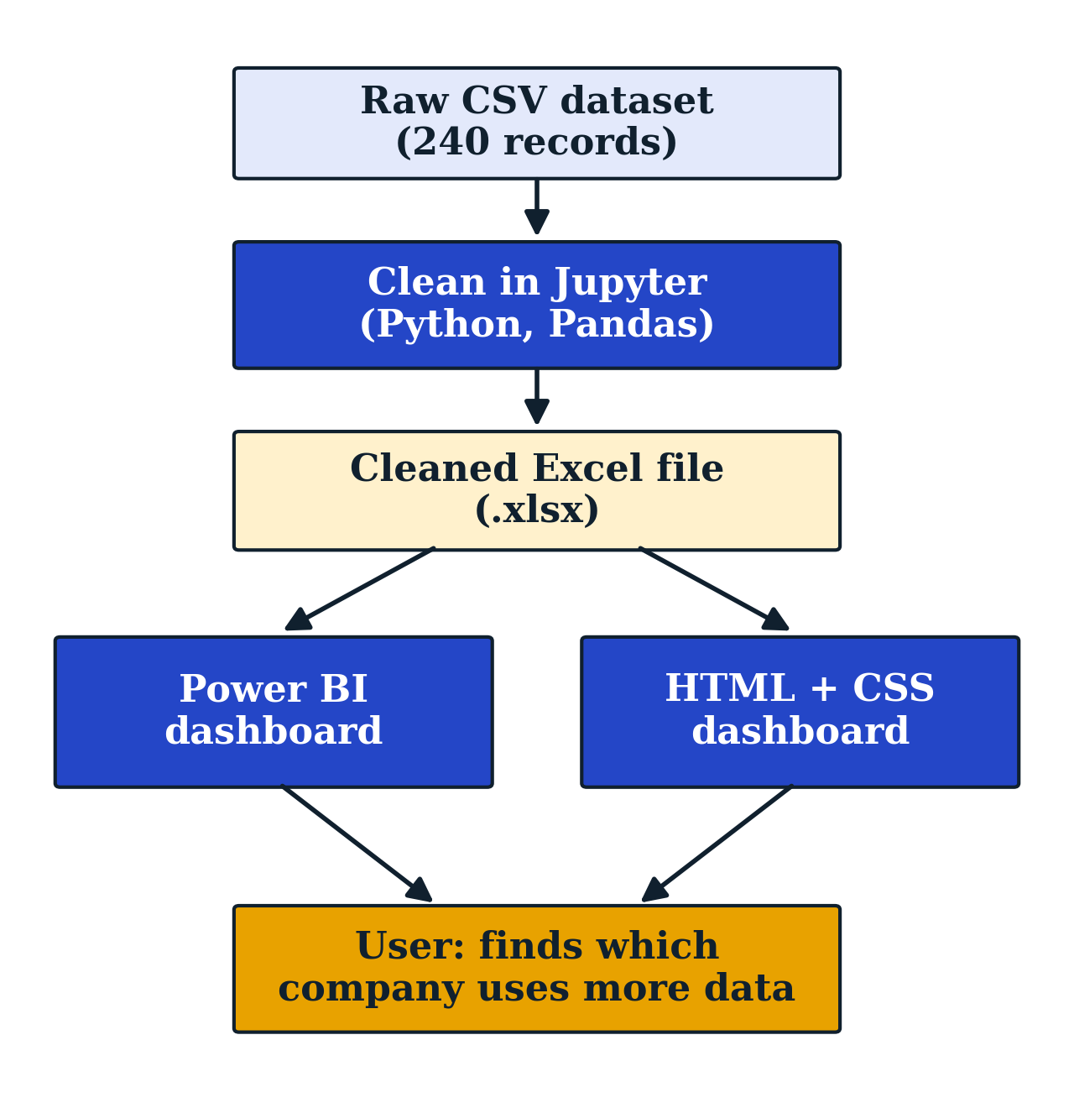
Raw data is cleaned in Jupyter, saved as an Excel file, and then used by both Power BI and the HTML and CSS dashboard.
- Output:
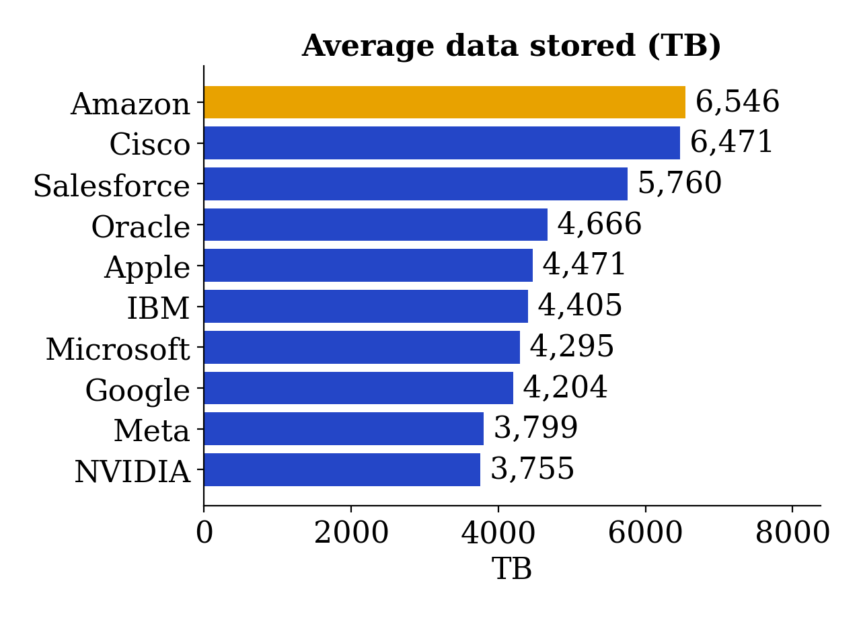
Amazon (shown in amber) has the highest average data stored at about 6,546 TB, followed by Cisco at about 6,471 TB and Salesforce at about 5,760 TB.
Output (Continued):
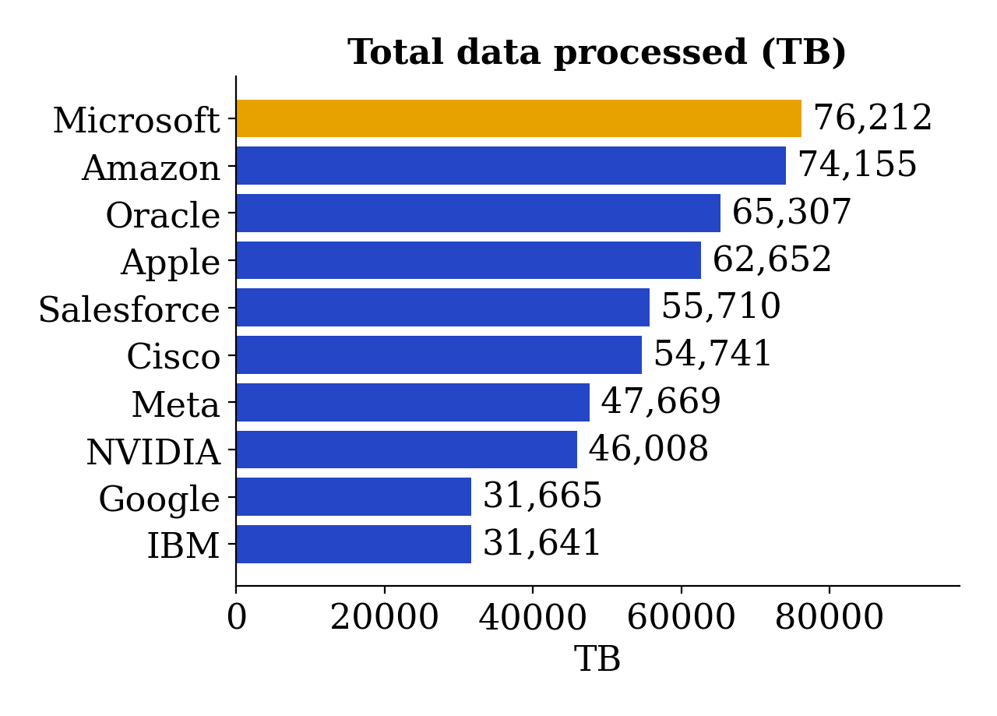
Microsoft has the highest total data processed at about 76,212 TB, ahead of Amazon at about 74,155 TB. Amazon still has the higher average per record (about 4,944 TB against 4,011 TB).
Output (Continued):
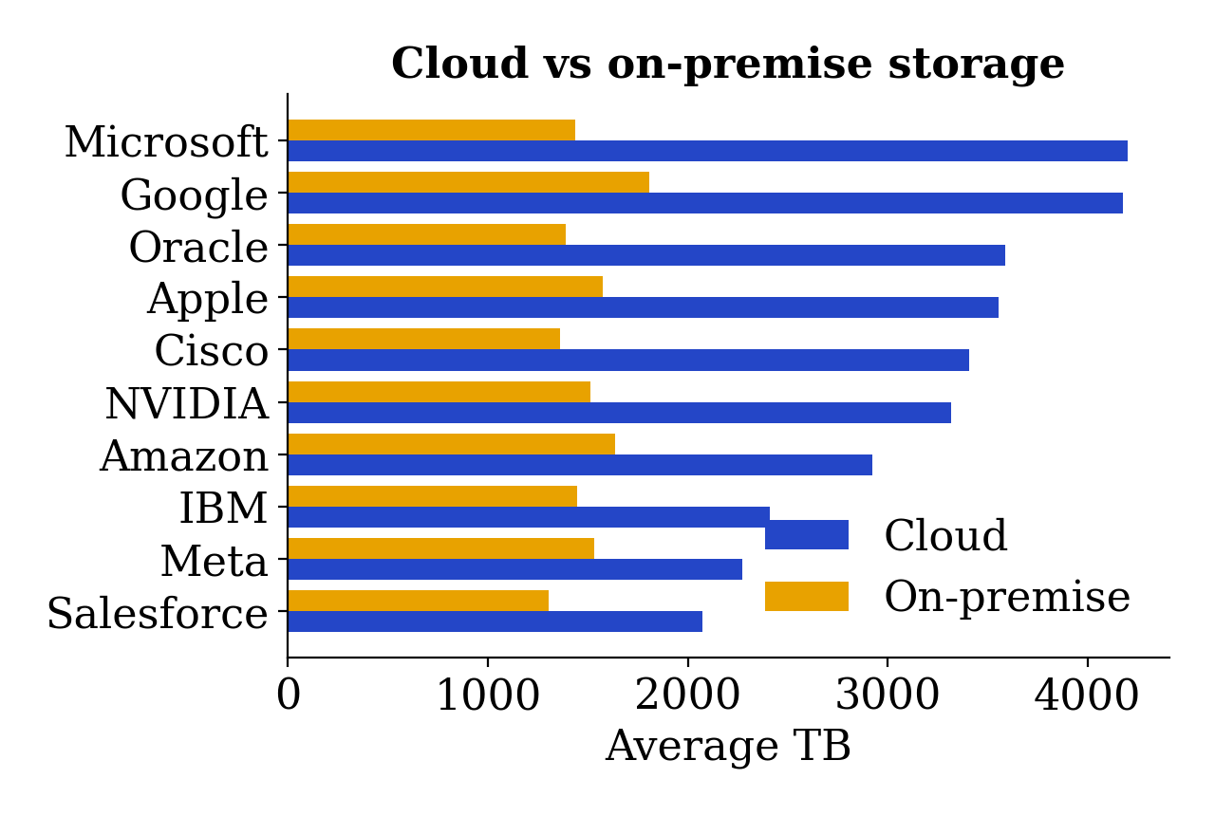
Microsoft and Google have the highest average cloud storage, at about 4,200 TB and 4,176 TB. On average, cloud storage is higher than on-premise storage for all ten companies.
Output (Continued):
Power BI page (six visuals):
Visual | Fields shown
Bar chart | Count of Company by Data Center Regions
Area chart | Sum of Employees by Monthly Cloud Cost
Pie chart | Sum of Data Processed by Company
Line chart | Count of Company by Data Center Regions
Donut chart | Count of Industry Segment by Employees
Column chart | Sum of Employees by Data Stored
HTML and CSS dashboard sections:
Ranking, Company profile, Cloud vs on-premise storage, Quarterly trend, Head-to-head comparison, Records and Data completeness.
- Conclusion:
The project answers the question “Which company uses more data?” using cleaned data from 240 records of ten IT companies.
On average per record, Amazon uses the most data, with about 6,546 TB stored and about 4,944 TB processed. In total processed data, Microsoft is first because it has more reported records. The answer therefore depends on whether average or total is used, and both are shown.
Many values in the dataset are missing, so the results are indicative. In future, more complete and verified data can be added, and the dashboard can be extended with live data and more companies.
Cleaning in Python, charts in Power BI and an HTML and CSS front end together turn messy figures into a clear and useful result.

