**1. INTRODUCTION**

Creativity refers to the phenomenon whereby something new is created which has some kind of subjective value. The creativity of human along with the help of computer science and information technology in problem solving has helped a lot over the years.

With an aim to do something better that could do away with the hustle and bustle created by the existing mechanism. This project is a milestone in showing and noting that how virtual world can help us deal and solve our real world problems.

* 1. **EXISTING AND PROPOSED SYSTEM**

The existing approach is the one with minimal use of one of the valuable tools of modern generations i.e. Computers along with internet connectivity. The counseling for the hostel is performed manually with a need of the students to gather at a particular location on the day of counseling of the allotment of desired rooms. This approach although is being carried out since long but there is a need to replace with a new system that could do away with the fuss it creates. The other drawback includes wastage of time which is one of the most valuable assets in the present world and it is rightly said that ‘Time is Money’, wastage of manpower in order to conduct the meeting or gathering which still at most of the times leads into mismanagement. Apart from all these the most embarrassing thing that is prevailing and which must be very disappointing for most of my fellow mates is the unavailability of the internal view of the hostel blocks they are going to choose which ultimately results into students choosing rooms they never intended to.

In the contemporary approach the students are allotted particular time on the basis of their University rank. All the ranks are divided into slabs and according to which students of particular slab are called for the counseling procedure. At times for one slab it takes more than the time allotted to it which leads to irritating situations for the students of next slot as they need to wait although being on time.

Now moving on to the approach that has been taken in this project. The proposed system is wholly based on the computer systems with the room counseling being brought to the world of internet which would enable each of the students to do with the counseling procedure in a matter of minutes. The whole procedure of Hostel Room Counseling would start with the user logging in to the server which on successful attempt by the user will direct him/her to the page where the selection of the hostel block is to be made. After selecting the hostel block the user is asked to choose room type i.e. he/she can choose one out of two, four or six bedded rooms. The user doing the counseling is also asked to enter the registration number(s) of his/her roommate(s). After all these selections the user is shown the floor layout of the particular block with the details of all the rooms that are vacant as well as the rooms that are yet to find a student. After the student chooses a room a Performa is displayed which can be submitted to the authorities concerned. To deal with large amount of data that the system has to deal with a database is created and which can be easily maintained with the help of available tools.

The same procedure that has been mentioned above can be carried out with the help of mobile apps on different platforms. The user who has to take the room should download the application and with a touch of buttons he can get a room allotted him for the next academic year. The main purpose that was talked about regarding the present system and the drawbacks related to it is done with the proposed system which prevents wastage of time as well as effort. It also gets rid of mismanagement and prolonged wait that is very disturbing in the present system. The best thing from the management’s point of view is that it also helps in proper management of the whole event. The graphical aspect gives an edge to the entire system which makes it as if the virtual world can at times deal in a better way than the real world.

* 1. **INTUITION TO DO THIS PROJECT**

Behind every invention and discovery there is a need to do so. Needs leads to innovative thinking. The most important aspect is difficulties and problems that are so frustrating at times. Similar is the reason and motivation behind this project. Had it been the case where most of us would have been happy with the prevailing system I bet no one would have gone down thinking of any sort of alternative. The drawback of existing system that has been already talked about led us to think of a system that would be free from any such problems and difficulties. When first of all we got to know about this opportunity that we were going to get, at that point of time only we thought of doing this project. It was the first time we thought of the idea. Initially we collected all the demerits of the existing system which we already were fed up of. Then came the positives and goals that can be achieved by doing this project. The sufferings of our fellow mates were the biggest driving force that drove us all through out project. The sole objective was to get rid of all the drawbacks which were ultimately achieved. With the prevalence of mobile apps we also developed an app for carrying out this procedure. With each step the satisfaction that we felt was immense and it was very important in order to complete the project.

Although each of them stated above are very very important as far as completion of the project is concerned but the most important one was the opportunity that we got. If there was no opportunity we would have had done nothing as such. The zeal and enthusiasm too played a very important and shaping role.

**2.** **REQUIREMENTS**

Under this heading all the requirements relating to the project is to be discussed. The tools and technologies that are involved are the most important aspects of any project and it is very important to deal with them in the best possible way.

In product development and process optimization, a requirement is a singular documented physical and functional need that a particular design, product or process must be able to perform. It is most commonly used in a formal sense in systems engineering, software engineering, or enterprise engineering. It is a statement that identifies a necessary attribute, capability, characteristic, or quality of a system for it to have value and utility to a customer, organization, internal user, or other stakeholder. A specification (often abbreviated as spec) may refer to an explicit set of requirements to be satisfied by a material, design, product, or service. **[1]**

In the classical engineering approach, sets of requirements are used as inputs into the design stages of product development. Requirements are also an important input into the verification process, since tests should trace back to specific requirements. Requirements show what elements and functions are necessary for the particular project. This is reflected in the waterfall model of the software life-cycle. However, when iterative methods of software development or agile methods are used, the system requirements are incrementally developed in parallel with design and implementation.

**2.1 TOOLS AND TECHNOLOGIES USED**

We used different type of tools which are helpful in a web project development**.**

**Notepad and Notepad++** : To write the html code and php code.

**XAMPP** : To run the php script and to manipulate the values in database.

**Mysql** : To crate the database and tables and performing different operations on tables using mysql queries.

**Google Chrome**: to check the results.

The technologies that were very helpful for completing our project are as following:

**HTML** (Hyper Text Markup Language): To create the web pages.

**CSS**(Cascading Style Sheet) : To style the web pages.

**Javascript**: To create dynamic and interactive web pages and for form validation.

**PHP** (Hypertext Pre Processor): For server side scripting.

**Mysql** : To perform operations related to database.

Ultimately the knowledge that was required for the project were all these and it was tried to use the best possible tools and technologies of the project.

**3. SYSTEM ARCHITECTURE**

Under this heading all the design as well as concept related things are conducted. The architecture of the entire system is taken care of and an efficient architecture of the system is proposed as it is a well known fact that in order to have a system of good quality, the quality of the architecture needs to be high enough.

Prior to the advent of digital computers, the electronics and other engineering disciplines used the term "system" as it is still commonly used today. However, with the arrival of digital computers and the development of software engineering as a separate discipline, it was often necessary to distinguish among engineered hardware artifacts, software artifacts, and the combined artifacts. A programmable hardware artifact or computing machine, that lacks its software program is impotent; even as a software artifact, or program, is equally impotent unless it can be used to alter the sequential states of a suitable (hardware) machine. However, a hardware machine and its software program can be designed to perform an almost illimitable number of abstract and physical tasks. Within the computer and software engineering disciplines (and, often, other engineering disciplines, such as communications), then, the term system came to be defined as containing all of the elements necessary (which generally includes both hardware and software) to perform a u

seful function. **[3]**

Consequently, within these engineering disciplines, a system generally refers to a programmable hardware machine and its included program. And a systems engineer is defined as one concerned with the complete device, both hardware and software and, more particularly, all of the interfaces of the device, including that between hardware and software, and especially between the complete device and its user (the CHI). The hardware engineer deals (more or less) exclusively with the hardware device; the software engineer deals (more or less) exclusively with the software program; and the systems engineer is responsible for seeing that the software program is capable of properly running within the hardware device, and that the system composed of the two entities is capable of properly interacting with its external environment, especially the user, and performing its intended function. **[1]**

**3.1 ER DIAGRAM**

Has a

allotted

**ROOM**

**BLOCK**

**STUDENT**

Figure 3.1: ER Diagram

In software engineering, an entity–relationship model (ER model) is a data model for describing the data or information aspects of a business domain or its process requirements, in an abstract way that lends itself to ultimately being implemented in a database such as a relational database. The main components of ER models are entities (things) and the relationships that can exist among them, and databases. **[2]**

**3.2 RELATION SCHEMA**

Room(room_no,block_name,room_type,empty)

Block(block_name)

Student(regno,room_no,block_name,name,pwd,start_time,end_time,allotted)

Figure 3.2: Relational Schema

**3.3 USE CASE DIAGRAM**

Admin

Student

Database

Hostel Block

Portal

Figure 3.3: Use Case Diagram

**3.4 CLASS DIAGRAM**

:Hostelblock

-room

-name

:Database

Record

Update()

Delete()

Add()

Modify()

:Admin

Room_record

Student_record

Update()

Delete()

Add()

Modify()

:Student

-Password

-Roommate

-Regno

Submit()

Choose()

Enterdetails()

1

1

1 1

1

1

1 1

:Portal

Web view

1

1

Figure 3.4: Class Diagram

Home Page Displays

**3.5 ACTIVITY DIAGRAM**

SYSTEM

USER

Start

Enter username

Enter password

Click submit

Authenticate user

Display welcome page

Choose room type

Click Submit

Display block and room supervisor

Choose room

Choose Block

Display the room allotted to student

Click submit

Stop

Figure 3.5: Activity Diagram

**4. MODULES**

This heading deals with different modules used in this project. Modular programming is a solution to the problem of very large programs that are difficult to debug and maintain. By segmenting the program into modules that perform clearly defined functions, you can determine the source of program errors more easily. **[1]**

**4.1 STUDENT ENTITY:**

This entity denotes the students who have to be allotted the room. The structure of this entity: is:

Student(reg_no,pwd,name,start_time,end_time,allotted,block_name,room_no)

Table No.:4.1

**reg_no**: It is the primary key of the student table which uniquely identifies each student.

**Room_no**: It is the foreign key to the student table. It shows the room no which student has been allotted otherwise its value is null.

**Block_name**: It is the foreign key to the student table. It shows the block name which student has been allotted otherwise its value is null.

**Pwd**: It is the password allotted to each student which works as a gateway to access our site.

**Name**: It is the name of the student.

**Start_time & end_time**: Each student is allotted start_time and end_time. The student can access the site only in between the start_time and end_time.

**Allotted:** If the student is allotted a room the value is ‘y’ otherwise value is ‘n’.

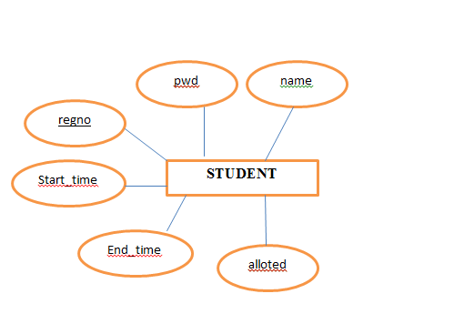

Figure 4.1: Student Entity

**4.2 BLOCK ENTITY:**

This entity denotes the hostel blocks in university campus.

block(block_name)

.

Table No.:4.2

**block_name**: It is the primary key of block entity.It denotes the name of the block.

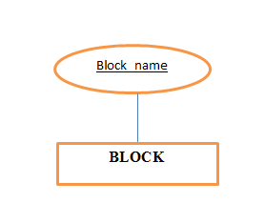

Figure 4.2: Block Entity

**4.3 ROOM ENTITY:**

This entity denotes the rooms present in each hostel blocks.

The structure of entity is:

Room(room_no,block_name,room_type,empty)

Table No.: 4.3

**room_no**: It is the primary key to the student table with block_name. It denotes the room no. (s) Of the rooms present in each hostel blocks.

**Block_name**: It is the foreign key to the student table and it forms the primary key with room_no. It shows the block name.

**room_type**: It shows the type of the room i.e. whether room is 1 bedded, 2 bedded, 4 bedded, or 6 bedded.

**Empty**: Its value is y if room is not allocated to any student otherwise n.

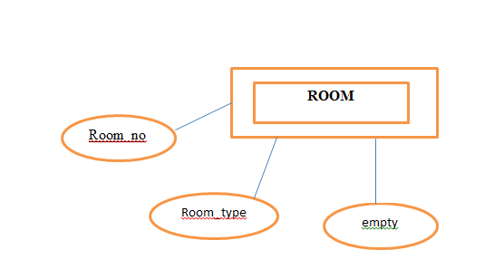

Figure 4.3: Room Entity

**5. TESTING**

Software testing is an investigation conducted to provide stakeholders with information about the quality of the product or service under test. Software testing can also provide an objective, independent view of the software to allow the business to appreciate and understand the risks of software implementation. Test techniques include, but are not limited to, the process of executing a program or application with the intent of finding software bugs (errors or other defects).

As the number of possible tests for even simple software components is practically infinite, all software testing uses some strategy to select tests that are feasible for the available time and resources. As a result, software testing typically (but not exclusively) attempts to execute a program or application with the intent of finding software bugs (errors or other defects). **[1]**

Software testing can be conducted as soon as executable software (even if partially complete) exists. The overall approach to software development often determines when and how testing is conducted. For example, in a phased process, most testing occurs after system requirements have been defined and then implemented in testable programs. In contrast, under an Agile approach, requirements, programming, and testing are often done concurrently. **[4]**

Although testing can precisely determine the correctness of software under the assumption of some specific hypotheses, testing cannot identify all the defects within software. Instead, it furnishes a criticism or comparison that compares the state and behavior of the product against oracles—principles or mechanisms by which someone might recognize a problem. These oracles may include (but are not limited to) specifications, contracts, comparable products, past versions of the same product, inferences about intended or expected purpose, user or customer expectations, relevant standards, applicable laws, or other criteria.

Software faults occur through the following processes. A programmer makes an error (mistake), which results in a defect (fault, bug) in the software source code. If this defect is executed, in certain situations the system will produce wrong results, causing a failure. Not all defects will necessarily result in failures. For example, defects in dead code will never result in failures. A defect can turn into a failure when the environment is changed. Examples of these changes in environment include the software being run on a new computer hardware platform, alterations in source data, or interacting with different software. A single defect may result in a wide range of failure symptoms.

**5.1 BLACK BOX TESTING**

Internal system design is not considered in this type of testing. Tests are based on requirements and functionality. The requirement of our project was to allot a room for each student. So we gave register number and password for different student and checked whether room was being allotted to them. **[4]**

* + 1. **Student enters the Register Number and Password**

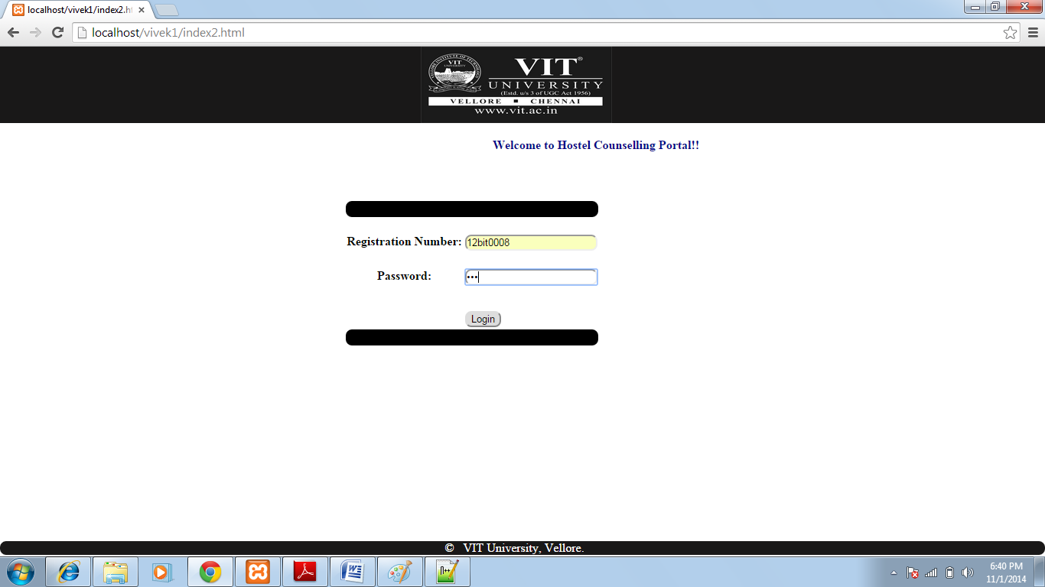

Figure 5.1: Login Page

**5.1.2** **Student got the Room Confirmation**

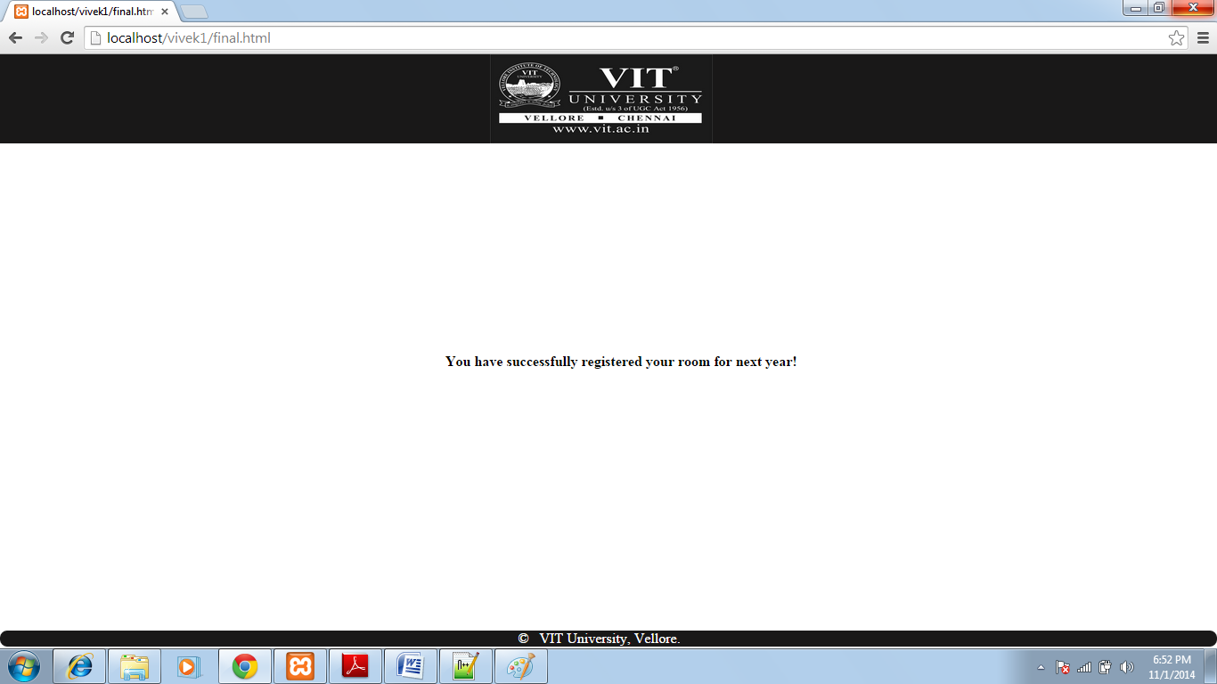

Figure 5.2: Confirmation Page

**5.1.3 Details got reflected in Database**

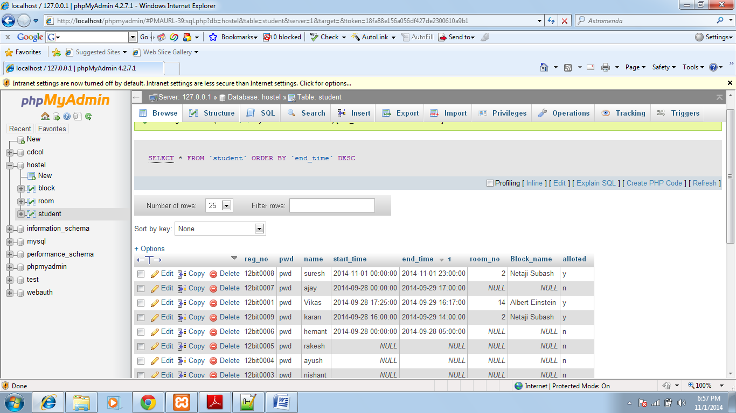

Figure 5.3: Databse

**5.2 WHITE BOX TESTING**

This testing is based on knowledge of the internal logic of an application’s code. Also known as Glass box Testing. Internal software and code working was checked for this type of testing. Tests are based on coverage of7 code statements, branches, paths, conditions.

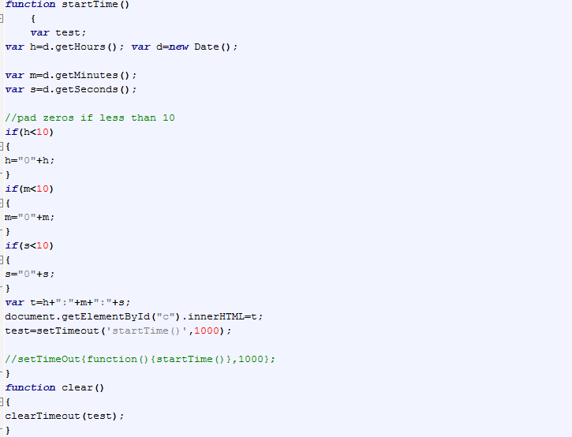

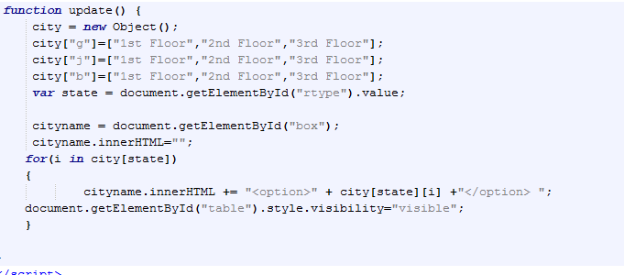

Figure 5.4: Snippet

**5.3 UNIT TESTING**

Testing of individual software components or modules was done in this type of testing. We checked different components of our project which includes registration, room type selection, roommate selection, block selection, room selection and then allocation of the selected roomcodings. **[1]**

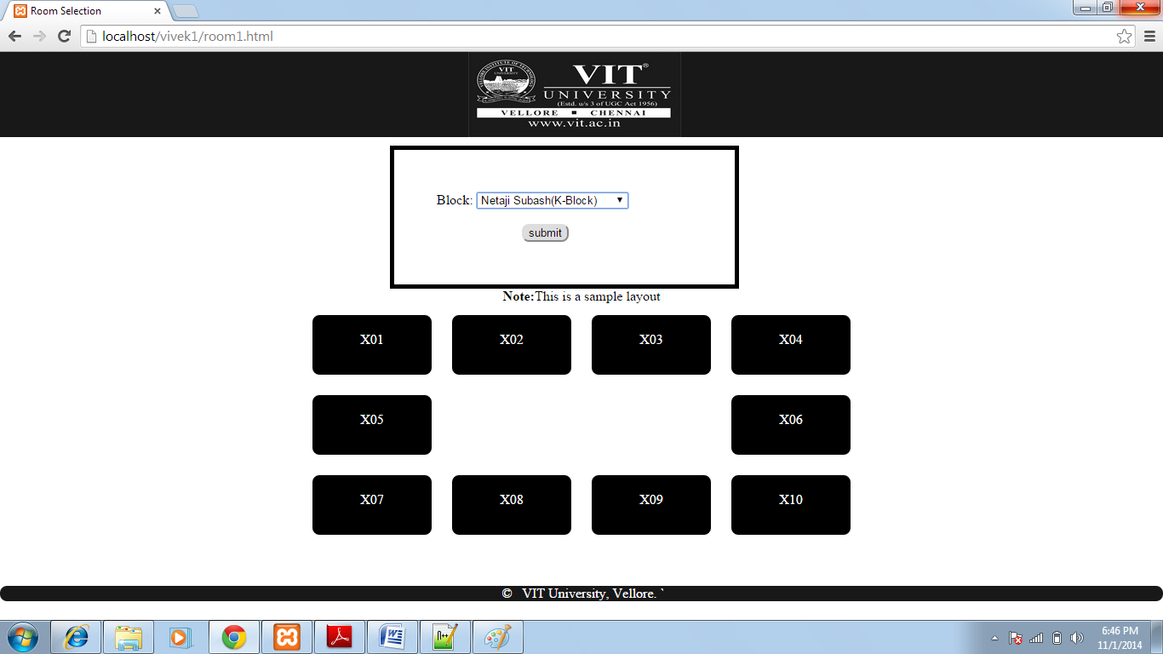

Figure 5.5:Room Layout

**5.4 INTEGRATION TESTING**

In this testing we checked integrated modules to verify combined functionality after integration. **[1]**

|  |  |  |  |
| --- | --- | --- | --- |
| **TESTID** | **SAMPLE TEST CASES** | **EXPECTED OUTPUT** | **RESULT** |
| 1. | Student’s password and register number were entered. | If time slot matches,welcome page is displayed else redirected to the same login page. | Passed |
| 2. | Room type was selected and roommates’ details were entered. | If roommates’ details are correct, directed to room selection page else same page is dispalyed. | Passed |
| 3. | Block and Room number is selected. | If room is empty, allotment is done and confirmation page is displayed. | Passed |
| 4. | Confirmation page for all the roommates in a single page. | Allotment of room got reflected in the Database. | Passed |

Table No.: 5.1

**6. SCREENSHOTS**



Figure 6.1: Welcome Page

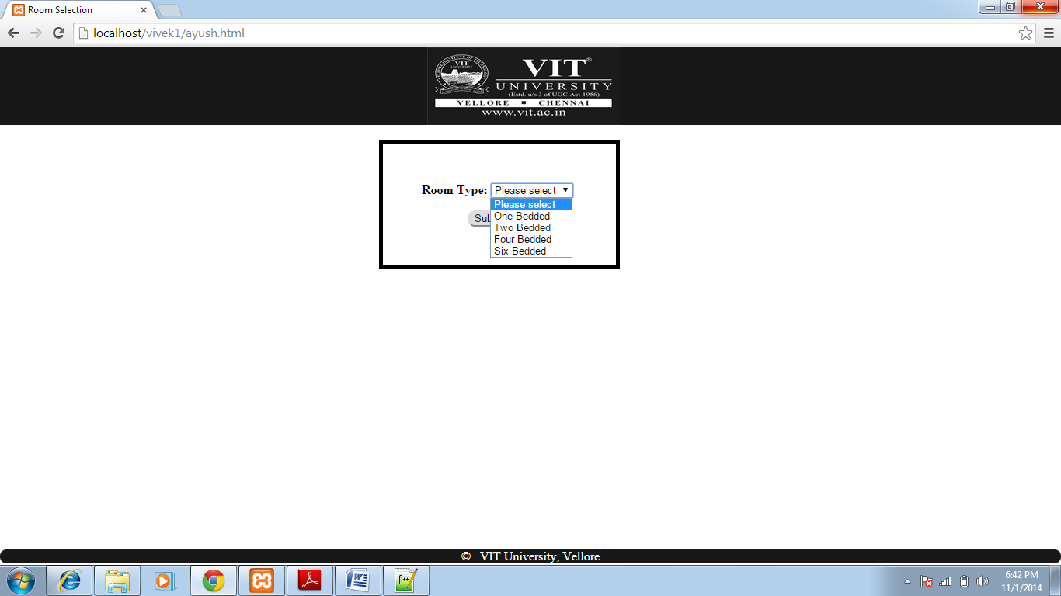

Figure 6.2: Room Type Selection

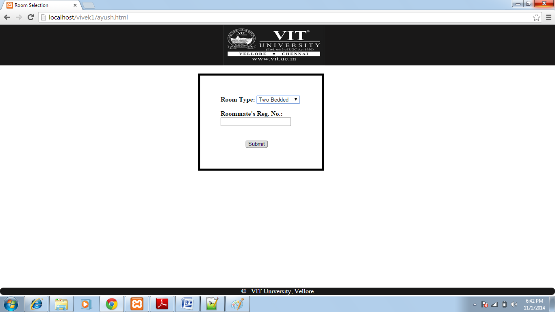

Figure 6.3: Roommate Selection

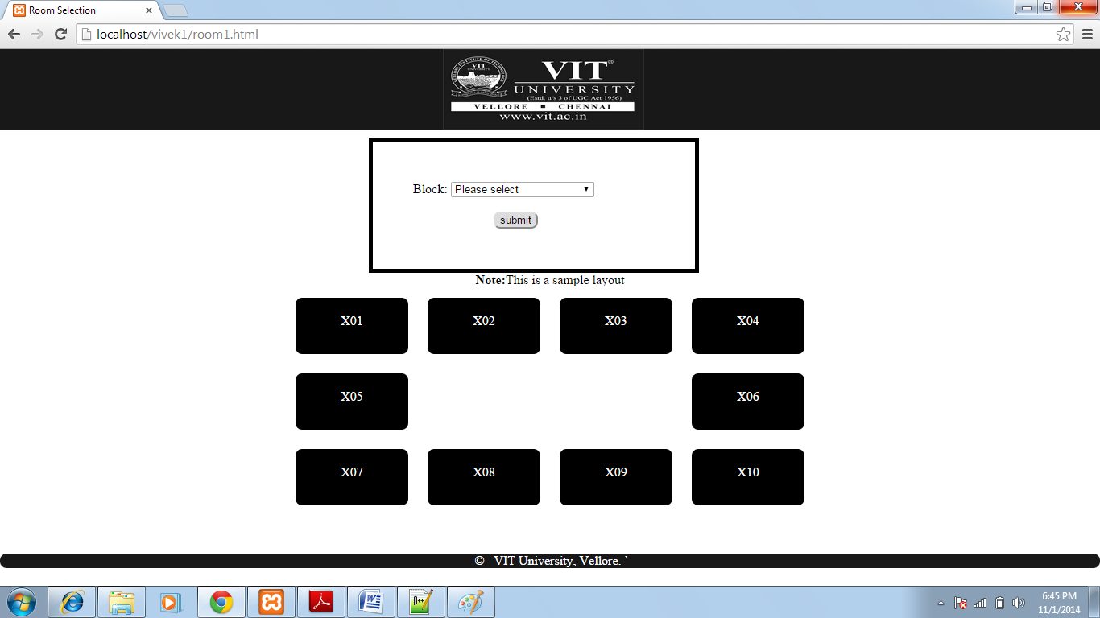

Figure 6.4: Block Selection

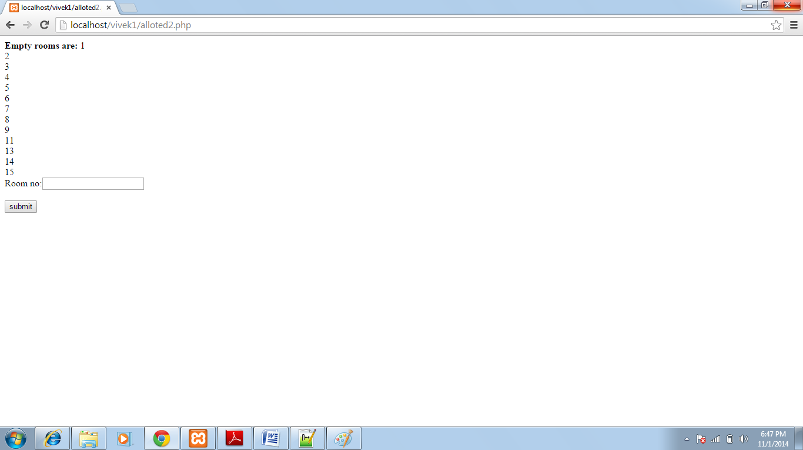

Figure 6.5: Room Selection



Figure 6.6: Confirmation Page

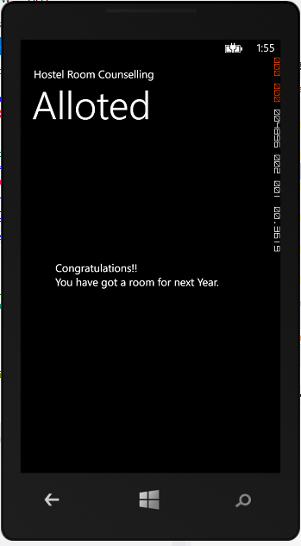

Figure 6.7: Room Allotted page

Mobile App

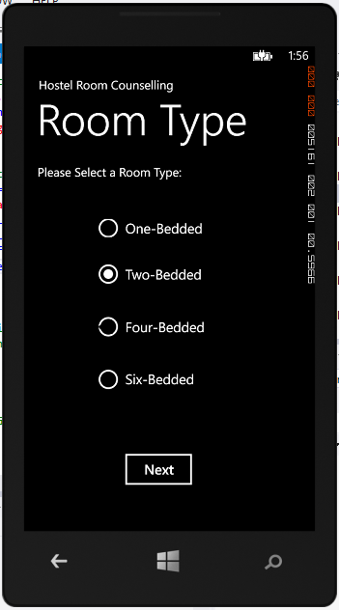

Figure 6.8: Bed selection Page

Mobile App

**7. CONCLUSION AND FUTURE ENHANCEMENT**

For a better experience of the hostel room counseling it was very important to bring the whole system to the world of internet in order to deal with the complex situations of the real time counseling procedure. The wastage of time and effort was a menace that was needed to be dealt with. The results that were achieved were stepping stones for the entire dream of effortless procedure of hostel counseling. The aim that was set at the beginning of the project to get rid of all the shortcomings of the existing system which was ultimately achieved. With the help of mobile applications it would become very easy for the users to complete the procedure in a very effortless manner with the touch of very few buttons. The proposed system apart from saving time and effort would enable to complete the procedure in a well managed way without any sort of fuss or hustle-bustle.

Although the project has done away with all the shortcomings of the existing system but in order to make it a standout one it is very important to go with future refinements. The proposed system needs to have a bit improved UI although UX is not an issue. There is a need to add details of all the students and hostel rooms in the database. It is also required to add the interior view of all the hostel blocks as for the time being we are using it for just two three blocks. As like airline reservation system there is a need to enable the clicks on room layouts that would work as links and lead the user to the next page. The webpage can also have an option to upload the fee receipts of all the room mates so that it can be verified as if the full hostel fees are paid. Until and unless the fees are paid the user must not be give any chance to book the room. The webpage can also have the photos of all the roommates involved so that no confusion is left in the case of selection of roommates. We can also use Artificial Intelligence (AI) in order to verify the user at the time of logging in with the help of webcams or microphones. The mobile app should be connected to the database so that it can make the required changes in the record of rooms and students.

**Appendix A**

**MySQL**

MySQL is (as of March 2014) the world's second most widely used open-source relational database management system (RDBMS). It is named after co-founder Michael Widenius's daughter, My. The SQL phrase stands for Structured Query Language.

The MySQL development project has made its source code available under the terms of the GNU General Public License, as well as under a variety of proprietary agreements. MySQL was owned and sponsored by a single for-profit firm, the Swedish company MySQL AB, now owned by Oracle Corporation.

MySQL is a popular choice of database for use in web applications, and is a central component of the widely used LAMP open source web application software stack (and other 'AMP' stacks). LAMP is an acronym for "Linux, Apache, MySQL, Perl/PHP/Python." Free-software-open source projects that require a full-featured database management system often use MySQL.

**Appendix B**

**XAMPP**

XAMPP is a free and open source cross-platform web server solution stack package, consisting mainly of the Apache HTTP Server, MySQL database, and interpreters for scripts written in the PHP and Perl programming languages.

Officially, XAMPP's designers intended it for use only as a development tool, to allow website designers and programmers to test their work on their own computers without any access to the Internet. To make this as easy as possible, many important security features are disabled by default. In practice, however, XAMPP is sometimes used to actually serve web pages on the World Wide Web.A special tool is provided to password-protect the most important parts of the package.

XAMPP also provides support for creating and manipulating databases in MySQL and SQLite among others.

Once XAMPP is installed, it is possible to treat a localhost like a remote host by connecting using an FTP client. Using a program like FileZilla has many advantages when installing acontent management system (CMS) like Joomla or WordPress. It is also possible to connect to localhost via FTP with an HTML editor.

The default FTP user is "newuser", the default FTP password is "wampp". The default MySQL user is "root" while there is no default MySQL password.

**Appendix C**

**HTML**

HTML is written in the form of HTML elements consisting of tags enclosed in angle brackets (like <html>). HTML tags most commonly come in pairs like <h1> and </h1>, although some tags represent empty elements and so are unpaired, for example <img>. The first tag in a pair is the start tag, and the second tag is the end tag (they are also called opening tags and closing tags).

A web browser can read HTML files and compose them into visible or audible web pages. The browser does not display the HTML tags, but uses them to interpret the content of the page. HTML describes the structure of a website semantically along with cues for presentation, making it a markup language rather than a programming language.

HTML elements form the building blocks of all websites. HTML allows images and objects to be embedded and can be used to create interactive forms. It provides a means to create structured documents by denoting structural semantics for text such as headings, paragraphs, lists, links, quotes and other items. It can embed scripts written in languages such as JavaScript which affect the behavior of HTML web pages.

**Appendix D**

**PHP**

PHP is a server-side scripting language designed for web development but also used as a general-purpose programming language. As of January 2013, PHP was installed on more than 240 million websites (39% of those sampled) and 2.1 million web servers.Originally created by Rasmus Lerdorf in 1994, the reference implementation of PHP (powered by the Zend Engine) is now produced by The PHP Group.While PHP originally stood for Personal Home Page,it now stands for PHP: Hypertext Preprocessor, which is a recursive backronym.

PHP code can be simply mixed with HTML code, or it can be used in combination with various templating engines and web frameworks. PHP code is usually processed by a PHP interpreter, which is usually implemented as a web server's native module or a Common Gateway Interface (CGI) executable. After the PHP code is interpreted and executed, the web server sends resulting output to its client, usually in form of a part of the generated web page – for example, PHP code can generate a web page's HTML code, an image, or some other data. PHP has also evolved to include a command-line interface (CLI) capability and can be used in standalonegraphical applications.

**REFERENCES**

**[1]** Wikipedia-Encyclopedia

**[2]** Introduction to Database Management Systems

**[3]** From IEEE 1220-1998 as found at their glossary

**[4]** Software Engineering and Principles

**[5]** W3Schools

**[6]** Tutorials Point