Agentic FinOps: An Autonomous Framework for Real-Time Cost Governance in AI-Infused Cloud Architectures

Sandip Patel
Microsoft
Frisco TX, United States
sandip6483@gmail.com
ORCID 0009-0003-5229-6181
Sebasis Padhi
Walmart Inc.
Bentonville AK, United States
sibasis.padhi@gmail.com or ORCID
line 1: 3rd Given Name Surname
line 2: dept. name of organization
(of Affiliation)
line 3: name of organization
(of Affiliation)
line 4: City, Country
line 5: email address or ORCID

Abstract—As enterprises in 2026 scale Generative AI from experimental pilots to mission-critical production, cloud expenditures have shifted toward highly volatile, token-based, and GPU-intensive consumption models. Traditional, reactive FinOps frameworks often fail to address the non-linear cost dynamics of large language models (LLMs) and distributed AI workloads. This paper introduces “Agentic FinOps,” an autonomous governance framework that utilizes multi-agent AI systems to move beyond simple cost reporting to proactive, real-time execution. By integrating intelligent agents directly into the cloud orchestration layer, this framework enables autonomous resource right-sizing, predictive budget enforcement through token-quota management, and cross-cloud GPU optimization. We propose a novel Unit Cost of Inference (UCI) metric to align AI engineering with business value and present an Autonomous Token-Quota Balancing (ATQB) control loop to enforce hard budget limits while preserving SLOs. A reference Multi-Agent Governance (MAG) architecture demonstrates how autonomous interventions can reduce waste while maintaining resilience.
Keywords—FinOps. Agentic AI, Multi-Agent Systems, Cost Governance, Token Economics, GPU Optimization, UCI, ATQB, FOCUS

Introduction
The enterprise landscape has transitioned from “cloud-first” to “AI-native,” where a growing share of applications embed agentic AI capabilities. In this environment, cost drivers shift from steady infrastructure baselines to non-linear consumption patterns governed by tokenized inference, recursive tool use, and GPU spot-market dynamics.
This shift has triggered a FinOps crisis: static budgeting, delayed reporting, and manual governance cannot react fast enough to token volatility and GPU scarcity. Organizations routinely underestimate AI infrastructure costs, creating a widening gap between experimentation and scaled production[2],[3].
To address this gap, this paper introduces Agentic FinOps—an autonomous, closed-loop framework that embeds specialized financial governance agents directly into the orchestration layer to sense, decide, and act in real time. The approach replaces advisory dashboards with bounded autonomous execution under explicit policy guardrails.

LITERATURE REVIEW: FROM AUGMENTED TO AGENTIC FINOPS
The traditional FinOps lifecycle—Inform, Optimize, and Operate—has evolved from retrospective reporting to AI-assisted recommendation engines and, more recently, toward autonomous execution models. The emergence of standardized cost data formats (e.g., FOCUS) improves cross-provider cost observability, enabling decision systems to operate on normalized usage and spend signals across hyperscalers [1].
In parallel, global regulation and sovereignty mandates introduce new placement constraints that directly affect cost allocation and optimization strategies for AI workloads, particularly where data residency policies restrict provider choice.

Standards and Interoperability
FOCUS-compliant (FinOps Open Cost & Usage Specification) cost and usage streams provide a vendor-agnostic substrate for cost-aware agents[1]. Agent-to-agent coordination protocols (e.g., A2A-style messaging) and context standards (e.g., MCP-like patterns) further support secure coordination between specialized governance agents, while intercloud interoperability standards address federation requirements across providers [4].

Limitations of Reactive FinOps for AI Workloads
Token-based pricing and GPU-intensive workloads create cost surfaces that change rapidly with demand. Human-in-the-loop interventions are too slow to prevent budget breaches during usage spikes or spot-market shifts, motivating autonomous control loops.

Threat Model: Denial of Wallet and Cost Abuse
AI systems introduce financial attack surfaces, including token flooding, prompt-loop recursion, tool misuse, and API key abuse (“Denial of Wallet”). Agentic FinOps mitigates these risks by correlating spend anomalies with security signals (error spikes, authentication changes, abnormal recursion depth) and applying circuit breakers: throttling, quota isolation, and step-up controls for high-spend operations. These mitigations are enforced under immutable policies to prevent unsafe cost cutting that would violate mission-critical SLOs.

THEORETICAL FRAMEWORK—AGENTIC FINOPS ARCHITECTURE
Agentic FinOps is a closed-loop control system: agents continuously observe cost, performance, security, and sustainability signals; compute decisions bounded by policy guardrails; and execute interventions through orchestration APIs. Fig. 1 depicts the end-to-end reference architecture.
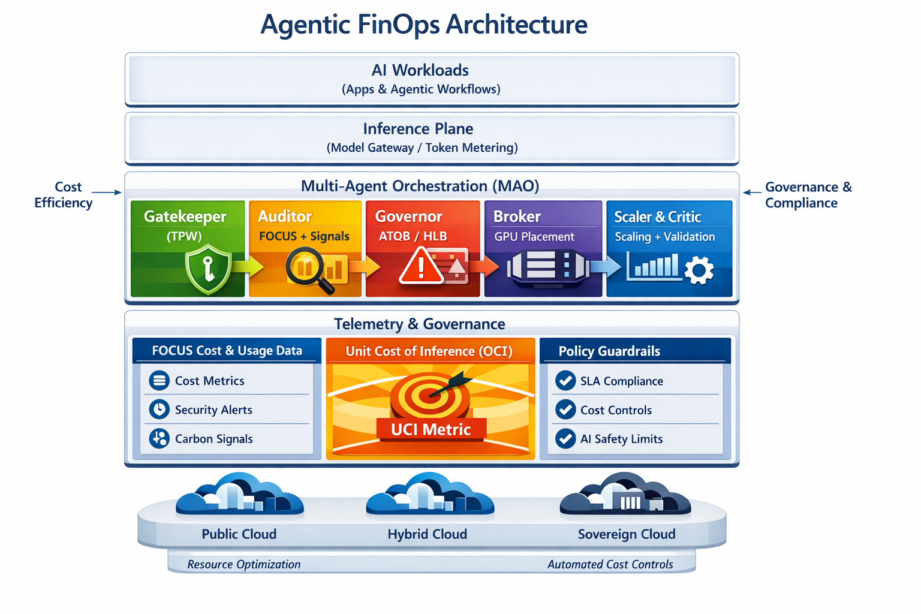
- Agentic FinOps reference architecture illustrating multi-agent orchestration (MAO), telemetry-driven governance, and autonomous execution across public, hybrid, and sovereign cloud environments.
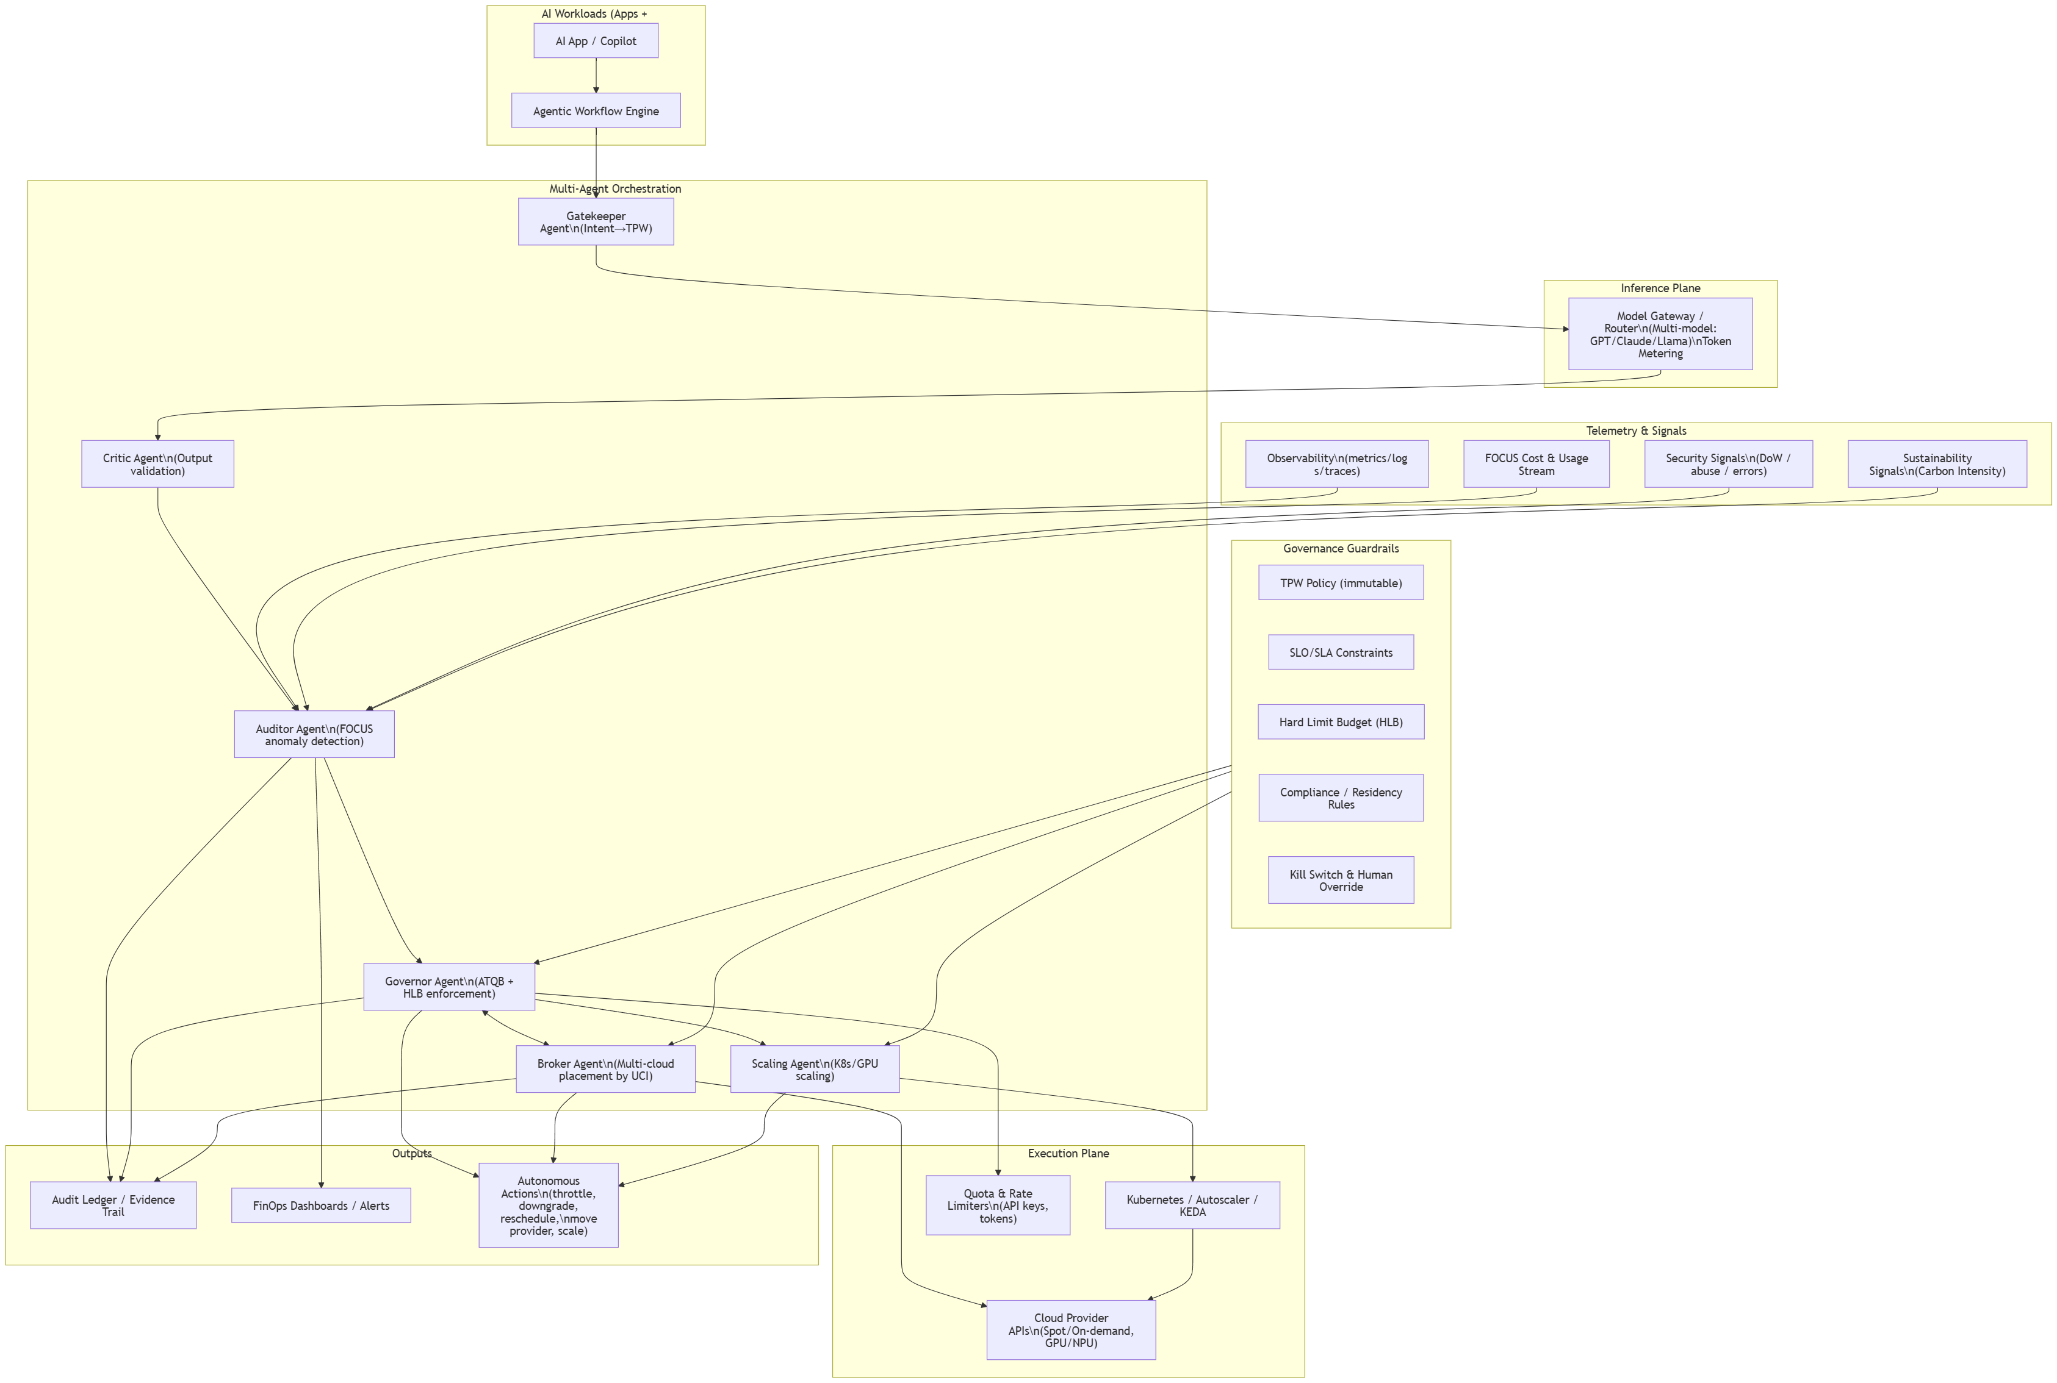
- Agentic FinOps workflow showing intent-aware request handling, multi-agent governance, telemetry-driven cost control, and autonomous optimization under policy guardrails.

Intelligence Layer: Multi-Agent Orchestration (MAO)
The framework uses modular specialized agents: Scaling Agents optimize compute procurement and release; Budget Enforcement Agents (Governors) enforce hard-limit budgets using ATQB; Broker Agents arbitrate multi-cloud placement using the Unit Cost of Inference (UCI) under sovereignty constraints; Auditor Agents detect anomalies using FOCUS-compliant cost streams; and Critic Agents validate outputs to ensure UCI reflects successful, non-hallucinatory tasks.

Real-Time Telemetry: Financial + Observability + Security + Sustainability
Effective autonomous governance requires low-latency signals combining metrics/logs/traces with normalized cost/usage data (FOCUS), security signals for DoW prevention, and carbon intensity signals for sustainability-aware scheduling.

Governance Guardrails: Operational Envelope
Autonomy is bounded by explicit guardrails including Task Priority Weighting (TPW), SLO/SLA constraints, compliance/residency policies, and human override mechanisms.
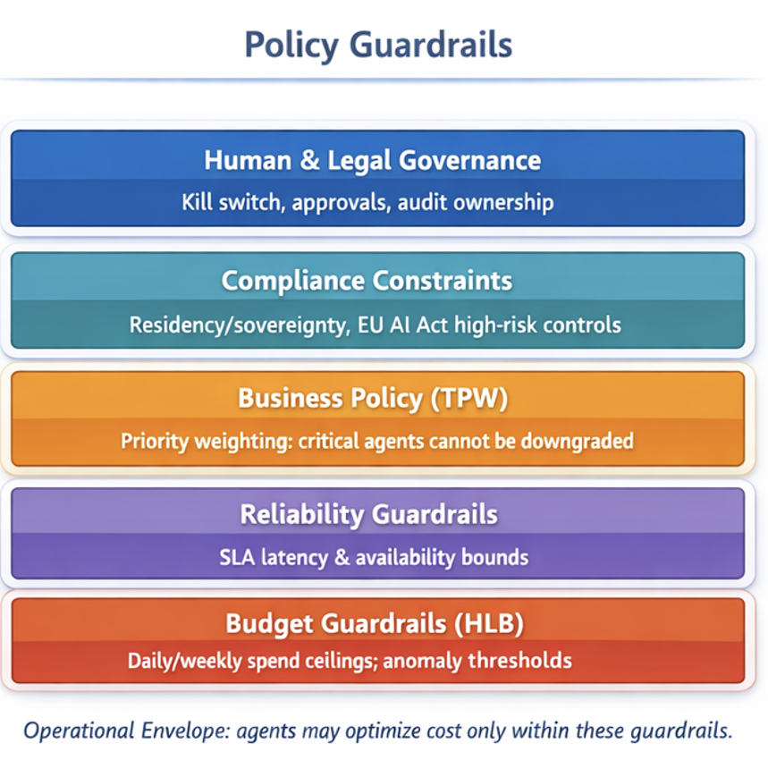
- Policy guardrails define an operational envelope for safe autonomous cost interventions.

Policy-as-Code (Guardrail Specification)
To make governance implementable, guardrails should be expressed as policy-as-code. A minimal specification includes: (i) TPW mapping rules for intents and agents; (ii) budget ceilings Hard-Limit Budget (HLB) and anomaly thresholds; (iii) Service Level Objective (SLO) constraints and minimum quality thresholds; (iv) allowed actions per agent (RBAC), including throttle, downgrade, pause, reschedule, migrate, and scale; and (v) escalation requirements for high-impact actions (e.g., model downgrades above a threshold or cross-border placement changes).

METHODOLOGY: METRICS AND OPTIMIZATION STRATEGIES

Unit Cost of Inference (UCI)
Traditional FinOps metrics, such as "Cost per Instance-Hour," are insufficient for 2026's agentic workflows where a single user request may trigger a chain of recursive model calls. We define the Unit Cost of Inference (UCI) as the foundational metric for this framework:
$$UCI=\frac{∑(C_{tokens}+C_{compute}+C_{latency_penalty})}{N_{successful_tasks}}$$
Where:
- $C_{tokens}$: The weighted cost of input/output tokens across heterogeneous models (e.g., GPT-5, Claude 4, or local Llama-4).
- $C_{compute}$: The overhead of transient GPU/NPU orchestration.
- $C_{latency_penalty}$: A calculated fiscal loss value when inference time exceeds the application’s defined Service Level Objective (SLO).
- $N_{successful_tasks}$: The count of validated, non-hallucinatory outputs verified by a secondary "Critic Agent."
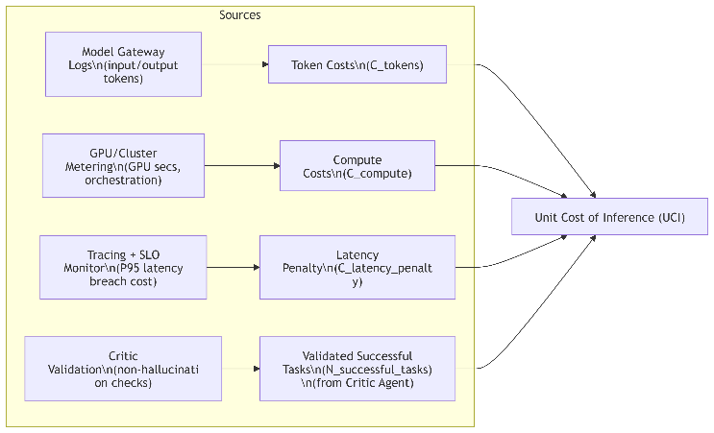
- Unit Cost of Inference (UCI) composition model illustrating how token usage, compute consumption, latency penalties, and validated task success signals are aggregated to derive an end‑to‑end inference cost metric.

Autonomous Token-Quota Balancing (ATQB) Algorithm
The core innovation of this paper is the ATQB Algorithm, a proprietary PID-inspired (Proportional-Integral-Derivative) control loop designed for multi-model environments. Unlike standard rate-limiting, ATQB treats "Token Quotas" as a liquid asset that can be reallocated in real-time between agents based on Task Priority Weighting (TPW).
The ATQB Logic Flow:

Intent Classification: A "Gatekeeper Agent" intercepts incoming requests and assigns a TPW (0.0 to 1.0) based on real-time business value (e.g., a checkout-process agent is weighted higher than a summarization agent).
Dynamic Quota Shifting: If the high-priority agent hits a rate limit or budget ceiling, the ATQB algorithm autonomously "borrows" token capacity from lower-weighted agents by switching them to smaller, quantized local models or increasing their inference latency.
Recursive Optimization: The algorithm calculates the Marginal Utility of Accuracy (MUA). If a task's success probability remains high with a cheaper model, the ATQB automatically downgrades the model tier for that specific sub-task to preserve the global budget.
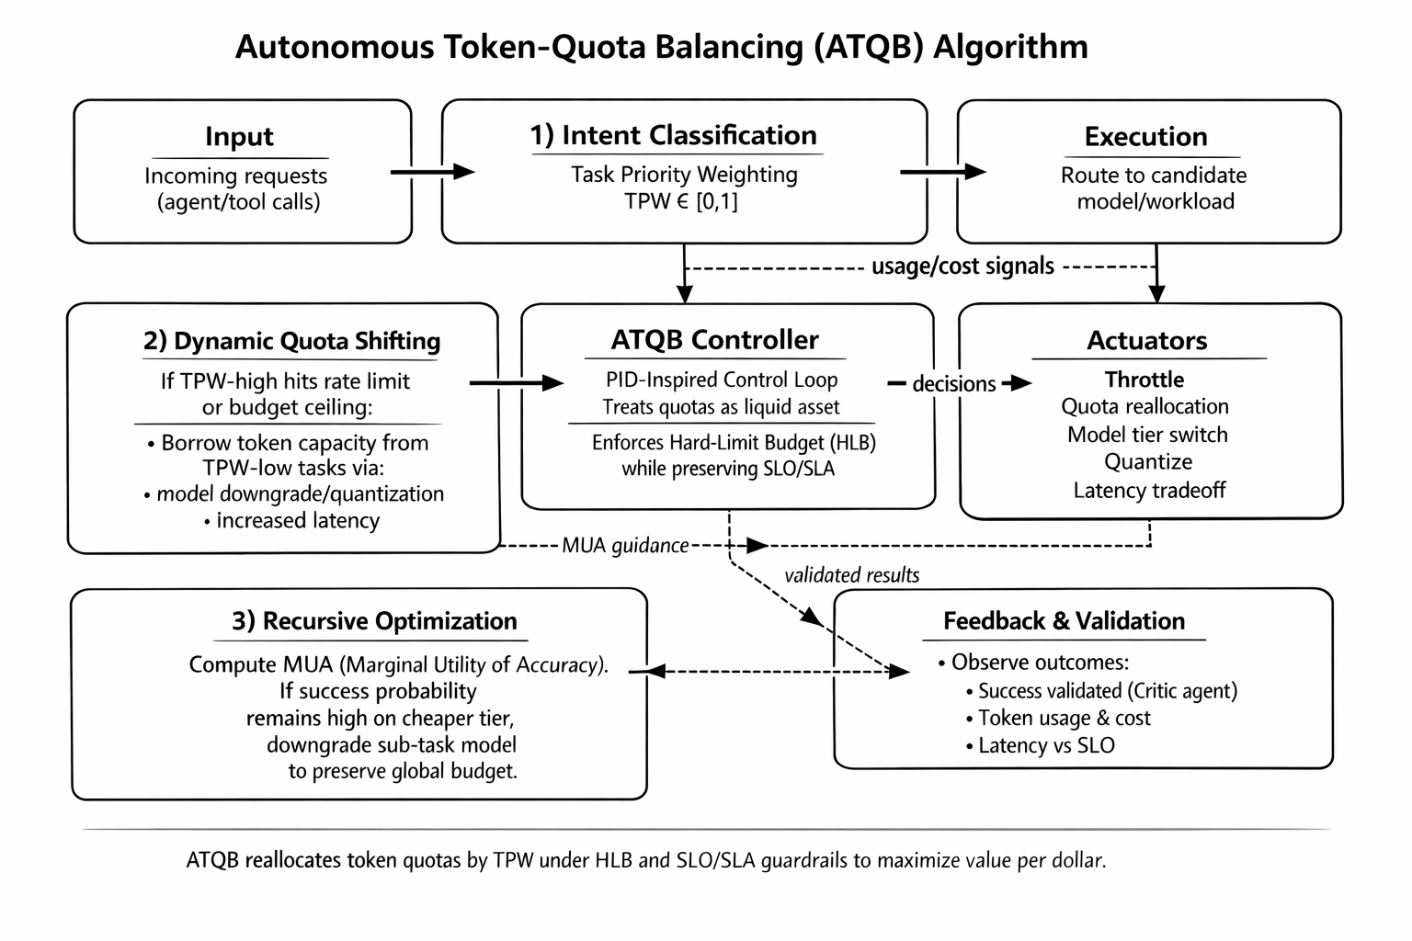
- illustrates the Autonomous Token-Quota Balancing (ATQB) algorithm. A PID-inspired control loop that assigns Task Priority Weighting (TPW), dynamically reallocates token quotas when budget or rate limits are approached, and recursively optimizes model tier selection using Marginal Utility of Accuracy (MUA), with feedback from validated outcomes under HLB and SLO/SLA guardrails.

Multi-Agent Governance (MAG) Architecture
The ATQB algorithm is executed via a tripartite Multi-Agent Governance (MAG) architecture:
- The Auditor Agent: Continuously monitors the FOCUS™ (FinOps Open Cost & Usage Specification) data streams to detect cost anomalies with sub-second latency.
- The Broker Agent: Manages the "Spot Market" for GPU compute, switching workloads between providers (e.g., Azure to AWS or a specialized GPU Neocloud) based on the lowest current UCI.
- The Governor Agent: Holds the "Kill Switch" and "Throttle" permissions. It utilizes the ATQB algorithm to enforce organizational policy without requiring human intervention, ensuring the system never exceeds the daily Hard-Limit Budget (HLB).
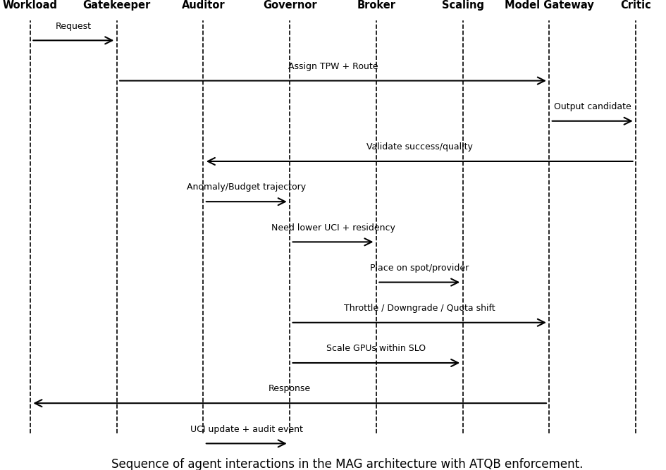
- Sequence diagram of agent interactions in the MAG architecture with ATQB enforcement.

Illustrative Case Studies and Scenario Analysis
This section evaluates the proposed Agentic FinOps framework and the Autonomous Token Quota Balancing (ATQB) algorithm through illustrative, model driven case studies. The scenarios presented are not derived from production deployments; instead, they are constructed using representative enterprise assumptions to demonstrate how the proposed Multi Agent Governance (MAG) architecture and ATQB control logic behave under realistic operating conditions. Numerical values are provided as scenario parameters to support comparative reasoning rather than as empirically measured results.

Conceptual Reference Implementation
To ground the discussion, we consider a hypothetical 2026 enterprise FinTech environment resembling a large investment bank that employs multiple AI agents for real time decision support, risk management, and customer interaction. The reference implementation is conceptual and assumes a Kubernetes orchestrated, multi cloud environment with unified telemetry normalized through FOCUS™ compliant cost and usage data streams.
Three representative agent classes are defined, each assigned a Task Priority Weighting (TPW) reflecting relative business criticality:
- AGENT ROLES Workload Criticality (TPW), and Model Resource Alignment.
Agent Role | Task Description | TPW | Base Model/Resource
Trade Execution Agent | Executes latency-sensitive, high-value trading decisions | 1.0 (critical) | High-capacity proprietary LLM
Client Service Agent | Handles routine customer queries and summarization | 0.7 (Medium) | General purpose LLM (variable cost)
Risk Auditor Agent | Performs non real time compliance and reporting tasks | 0.4 (Low) | Local or quantized open weight model

A Governor Agent, implementing the ATQB algorithm, is configured with a modeled hard daily inference budget (Hard Limit Budget, HLB) of $15,000 USD. This value is selected solely to illustrate constraint enforcement and does not correspond to a specific organization.

Scenario A: Modeled Budget Enforcement Under Demand Shock
This scenario illustrates how ATQB responds to sudden, non-linear increases in AI consumption, a common challenge in agentic AI systems.
Scenario Description
A simulated high volatility trading event causes an approximately 200% increase in token demand for the Trade Execution Agent, placing the modeled daily budget on a trajectory to exceed the defined HLB by mid-day.

Baseline (Non Agentic FinOps)
In a traditional FinOps model, the budget anomaly would trigger an alert routed to a human operations team. Manual analysis and intervention would occur with non-negligible delay, increasing the likelihood of budget overrun or blunt service throttling.

Agentic FinOps (ATQB Driven Response)
Under the proposed framework, the Auditor Agent is assumed to detect the budget breach trajectory using near real time telemetry. The Governor Agent activates the ATQB control loop and autonomously executes the following bounded interventions:
- Dynamic quota reallocation: Token quotas are reduced for the medium priority Client Service Agent, which is temporarily switched to a lower cost model configuration for non-critical summarization tasks.
- Workload deferral: The low priority Risk Auditor Agent is paused during the demand spike, freeing its allocated token budget.
- Placement optimization: The Broker Agent reallocates eligible high priority inference workloads to lower cost compute capacity (e.g., spot or alternative provider resources), subject to policy constraints.
Illustrative Outcome
Under these modeled conditions, the system remains within the assumed $15,000 daily HLB while preserving full availability and latency objectives for TPW critical trading tasks. The reallocation is transparent to end users, illustrating how agentic, closed loop budget enforcement can outperform alert based approaches during demand shocks.

Scenario B: Modeled Optimization of Unit Cost of Inference (UCI)
This scenario demonstrates how the proposed Unit Cost of Inference (UCI) metric supports value oriented optimization under steady state conditions.
Scenario Description
The focus is placed on the Risk Auditor Agent, which executes batch oriented, non latency critical workloads. The ATQB algorithm is applied to dynamically select model tiers, quantization levels, and execution placement based on real time cost signals.
Illustrative Comparison
- summarizes representative modeled outcomes before and after ATQB driven optimization.
Metric | Static Configuration | ATQB-Driven Configuration | Relative Change
Average UCI | $0.045 per successful report | $0.022 per successful report | 51% reduction
Idle GPU Waste | 22% | 4% | 18% reduction
Latency Penalty | $120/day (modeled) | $0/day | Eliminated

These reductions are achieved through autonomous model downgrading and quantization when the Marginal Utility of Accuracy (MUA) remains high, combined with opportunistic placement on lower cost compute resources. While the exact values are illustrative, the scenario demonstrates the qualitative effect of aligning model fidelity with business value rather than static performance targets.

Scope and Limitations of Scenario Analysis
The case studies presented are illustrative and conceptual and do not replace empirical validation. Actual system behavior will depend on workload characteristics, telemetry latency, pricing volatility, and cloud provider dynamics. Nevertheless, these scenarios demonstrate the causal correctness and internal consistency of the proposed framework. Future work will focus on controlled experiments and real world pilots to quantitatively validate the ATQB algorithm under production conditions.

VI. DISCUSSION

From Reactive Reporting to Autonomous Execution
The illustrative scenarios in Section V help clarify a broader shift implied by the proposed framework. Traditional FinOps practices are largely retrospective: costs are analyzed after the fact, and corrective actions depend on delayed human intervention. This model becomes increasingly ineffective in AI native systems, where token consumption, model selection, and GPU utilization can change within seconds.
As shown through the ATQB driven scenarios, embedding financial governance directly into the execution path enables a fundamentally different operating model. By allowing specialized agents within the Multi Agent Governance (MAG) architecture to make bounded, policy aware decisions in real time, cost control moves from reporting to execution. High frequency decisions—such as reallocating token quotas or adjusting model tiers—can be handled autonomously, while humans retain control through explicit guardrails and override mechanisms.
This shift does not eliminate human oversight; instead, it repositions human decision making at the policy and intent level. In this sense, Agentic FinOps supports a form of just in time financial control, where interventions occur precisely when needed, rather than after cost overruns have already materialized.

The Strategic Role of the Unit Cost of Inference (UCI)
The Unit Cost of Inference (UCI), introduced in Section IV and applied in Section V, plays a central role in aligning technical decisions with business outcomes. Existing cost metrics—such as cost per instance hour or per request—do not adequately capture the recursive and multi-step nature of agentic AI workflows. A single user request may trigger multiple model calls, tool invocations, and validation steps, each contributing to overall cost and latency.
By combining token usage, compute overhead, and latency penalties into a single value, UCI provides a shared frame of reference for both engineering and finance stakeholders. Rather than optimizing for accuracy or performance in isolation, teams can reason about whether a given level of model fidelity is economically justified for a specific task.
The illustrative optimization scenario demonstrates how this perspective enables practical tradeoffs. When the marginal utility of accuracy remains high at a lower cost model tier, ATQB can safely reduce spend without degrading task outcomes. In this way, efficiency is no longer defined solely by technical correctness, but by economical correctness—delivering acceptable results at the lowest reasonable marginal cost.

Regulatory and Ethical Implications
As discussed in earlier sections, AI systems in 2026 operate under increasing regulatory and sovereignty constraints. Requirements stemming from frameworks such as the EU AI Act and data residency mandates introduce new dimensions to financial governance, where cost optimization must coexist with safety, compliance, and traceability.
The Agentic FinOps framework addresses these concerns by design. The Auditor Agent continuously records cost related decisions, workload movements, and policy evaluations, creating an auditable trail of autonomous actions. This traceability ensures that cost driven interventions—such as model downgrades or workload replacement remain explainable and accountable.
More broadly, the use of explicit guardrails ensures that autonomous optimization does not override business priorities or regulatory constraints. By constraining what agents are allowed to do, rather than requiring humans to approve every action, the framework balances autonomy with responsibility. As AI systems grow more complex, this combination of autonomy, transparency, and bounded control becomes essential for maintaining both fiscal and ethical accountability.

Limitations and Scope
The proposed framework and ATQB algorithm are subject to several practical considerations. Their effectiveness depends on the availability and quality of near real time telemetry, including cost, usage, and performance signals. Delayed or noisy telemetry may reduce the responsiveness of autonomous interventions. In addition, the accuracy of outcome validation performed by the Critic Agent directly influences the reliability of recursive optimization decisions. Finally, some optimization strategies, such as leveraging spot or preemptible compute resources, assume a degree of predictability in cloud pricing and availability that may vary across providers and regions. In practice, these risks can be mitigated through conservative policy guardrails, staged rollout, and gradual expansion of agent autonomy as system confidence increases.

CONCLUSION AND FUTURE WORK
This paper introduced Agentic FinOps, a theoretical framework for autonomous cost governance in AI native cloud environments. At the core of the framework is the Autonomous Token Quota Balancing (ATQB) algorithm, which treats token budgets as a dynamic resource and reallocates them in real time based on task priority, cost signals, and outcome validation.
Through illustrative, model driven scenarios, we showed how combining multi agent orchestration with the Unit Cost of Inference (UCI) enables organizations to manage AI costs proactively rather than reactively. While the scenarios are not empirical evaluations, they demonstrate how the proposed architecture and control logic can reduce waste, protect mission critical workloads, and decouple AI scaling from linear cost growth.
The broader contribution of this work lies in reframing FinOps for the AI native era. As generative and agentic systems become deeply embedded across enterprise workflows, the ability to govern cost autonomously—within clearly defined policies—will be a key differentiator between sustainable AI adoption and accumulating technical financial debt.
Future work will focus on extending the framework in two directions. First, controlled experiments and real world pilots will be used to empirically validate the ATQB algorithm under production conditions. Second, the framework will be expanded toward decentralized and edge AI environments, where cost observability, trust, and control must operate across highly distributed and heterogeneous infrastructures.

References
- FinOps Foundation, “FOCUS™: FinOps Open Cost & Usage Specification,” Ver. 1.3, Dec. 2025. [Online]. Available: https://focus.finops.org/
- J. R. Storment and M. Fuller, “FinOps for AI: Applying Traditional Frameworks to Generative AI Spend,” in FinOps X 2025 Keynote Proceedings, Jun. 2025.
- Stanford Institute for Human-Centered Artificial Intelligence (HAI), “AI Index Report 2025: Efficient, Affordable, and Accessible Agentic Models,” Apr. 2025.
- IEEE Standard for Intercloud Interoperability and Federation, IEEE Std 2302-2021, 2021.

