*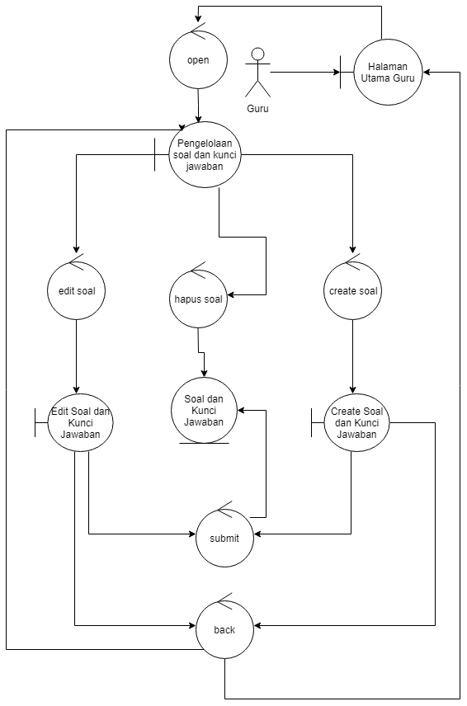*

*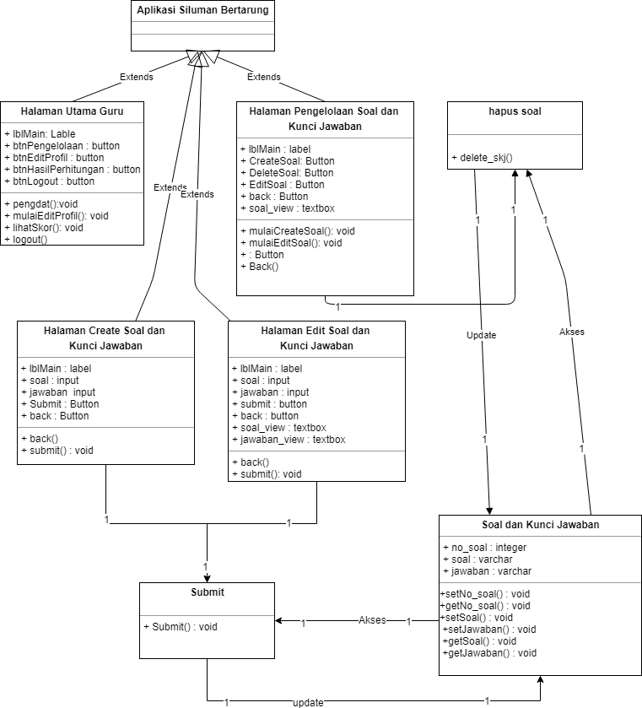*

\*Class Diagram Soal dan Kunci Jawaban

Flowgraph 2

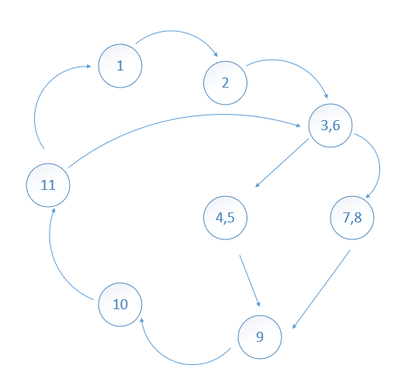

Cyclomatic Complexity

V(G) = Jumlah minimum path yang diperlukan agar melintasi semua node

N = Jumlah node

E = edge (garis penghubung antara node)

V(G) = E – N + 2

V(G) = 9 – 6 + 2 = 4 Path

Tes

Path 1 = 1-2-3-6-4-5-9-10-11-1

Path 2 = 1-2-3-6-7-8-9-10-11-1

Path 3 = 1-2-3-6-4-5-9-10-11-3-6-4-5-9-10-11-1

Path 4 = 1-2-3-6-7-8-9-10-11-3-6-7-8-9-10-11-1