*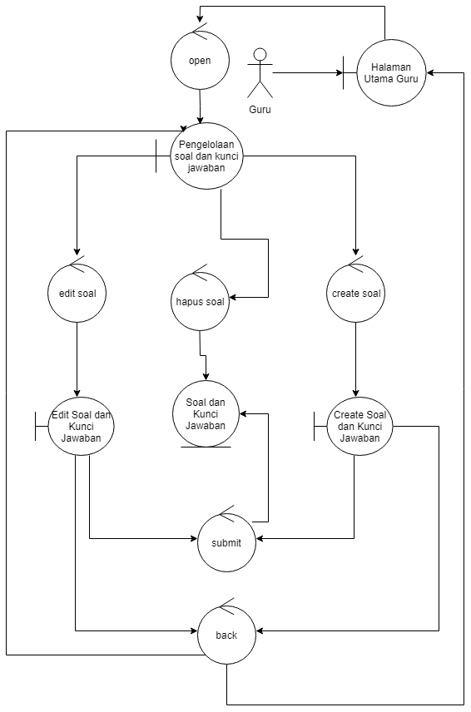*

*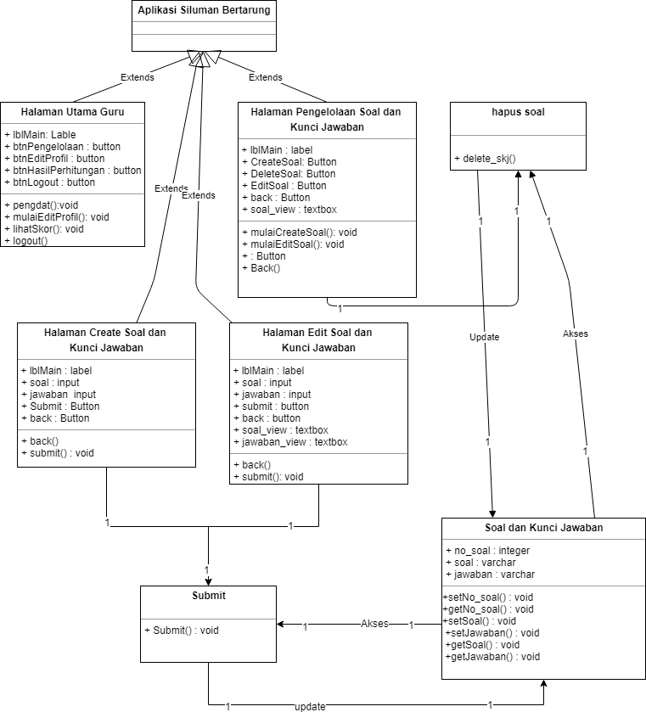*

\*Class Diagram Soal dan Kunci Jawaban

Flowgraph bentuk ke 2

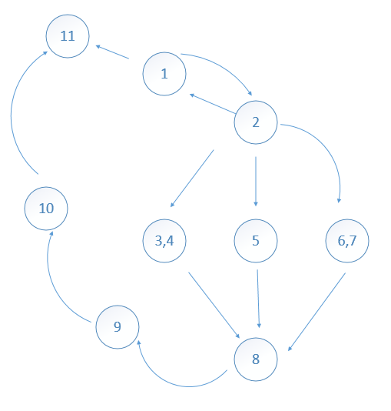

Cyclomatic Complexity

V(G) = Jumlah minimum path yang diperlukan agar melintasi semua node

N = Jumlah node

E = edge (garis penghubung antara node)

V(G) = E – N + 2

V(G) = 12 – 9 + 2 = 5 Path

Tes Case :

Path 1 = 1-11

Path 2 = 1-2-1-11

Path 3 = 1-2-3-4-8-9-10-11

Path 4 = 1-2-5-8-9-10-11

Path 5 = 1-2-6-7-8-9-10-11