CaseStudy Tech
Software Design Document (SDD)
CSCI 5520 - AI-Driven Software Development
Student Name | Sandy Thomas
Date | October 4, 2026
Document Version | v1.0
Project Repository / URL (if available) | https://github.com/sandythomas1/Case-Study-Tech

1 Problem & Users

1.1 Problem Description
Counseling and clinical psychology students often begin client-facing case work with limited opportunities to rehearse difficult conversations in a safe, repeatable setting. Classroom discussion and written case studies teach concepts, but they do not consistently give students experience responding in real time to varied personalities, presenting problems, and emotionally sensitive situations. This gap can leave students uneasy and underprepared before working with actual people.
Students may also lack timely, specific, and consistent feedback on their performance. Without clear evidence of what they handled well and what they should improve, they can struggle to evaluate skills such as active listening, questioning, empathy, and adherence to professional frameworks. Training programs must expose students to varied cases while protecting privacy and following discipline-specific ethical and safety expectations.

1.2 Target Users & Stakeholders
Primary user - Counseling and clinical psychology students: Students are the first users for the CaseStudy Tech (CST) MVP. They need a private, low-stakes way to practice client conversations, experience a range of vetted scenarios, and understand how their performance aligns with published counseling frameworks before working with real clients.
Future end user - Instructors and clinical supervisors: In a later phase, instructors will assign scenarios and review individual or cohort progress. They need trustworthy, explainable scoring and scenarios that align with course objectives and professional standards.
Stakeholder - University counseling and psychology programs: Programs are prospective institutional purchasers and approvers. They care about student readiness, curricular fit, consistent assessment, safe scenario design, accessibility, and evidence that the system supports their learning goals.
Stakeholder - University technology, privacy, accessibility, and compliance reviewers: These reviewers influence adoption because the system may process sensitive voice and text during a session. They need verifiable retention, security, accessibility, and vendor data-use terms, including the requirement that third parties do not retain session data or use it for training.
Stakeholder - Professional and accrediting organizations: Their published ethics codes, counseling skill frameworks, and accreditation expectations influence the scenarios, guardrails, and scoring criteria that programs will consider acceptable.

2 Proposed Solution & Scope

2.1 Proposed Solution
CaseStudy Tech is a voice-first practice application that lets counseling and clinical psychology students rehearse structured client conversations before working with real people. A student signs in, selects one of three vetted scenarios, reviews the learning objective and any content notice, and completes a time-bounded conversation by voice or text. The simulated client follows a predefined persona and case so that the experience remains consistent enough for meaningful feedback.
After the student ends the session or the time limit expires, the system analyzes the completed transcript and produces a developmental report. The report contains an overall score, six category scores, transcript-grounded examples, strengths, and recommended improvements. The categories cover empathic engagement; active listening and responding; purposeful questioning and exploration; collaboration, autonomy, and cultural humility; session structure and professionalism; and scenario-specific competence. The report supports practice and reflection, but it does not diagnose a client, certify clinical competence, replace supervision, or provide a clinical decision.
This approach addresses the practice gap by combining repeatable role-play with evidence-based feedback in a private, low-stakes setting. Students can encounter routine, resistant, and safety-sensitive situations while programs gain a foundation that could support instructor and cohort features in a later phase.

2.2 Minimum Viable Product (MVP) Scope
The MVP is the smallest complete version that allows a student to conduct a simulated session and receive trustworthy, evidence-linked feedback. It includes the following capabilities.
• Student access and cross-platform delivery: A student can sign in and use the React Native application through supported web, iOS, and Android builds.
• Three-scenario library: The application includes a routine intake, a conversation with an emotionally resistant client, and an opt-in crisis-risk scenario. Students cannot create or modify personas in the MVP.
• Session preparation: Before a session begins, the student sees the scenario objective, expected session format, time limit, and any applicable content notice. Crisis content appears only after the student deliberately selects that scenario.
• Voice-first simulation with text fallback: The student conducts a responsive conversation with the simulated client by voice or text, can end the session manually, and receives an automatic end when the time limit is reached. If voice or transcription fails, the application offers a retry or a switch to text.
• Safety and conduct controls: A simulated disclosure of self-harm, abuse, or imminent danger does not end the crisis scenario because the student must be able to demonstrate an appropriate response. Targeted threats, slurs, sexual harassment, or repeated demeaning language from the student automatically end the session without a performance score. Safeguards distinguish directed abuse from quoted case material, nondirected frustration, and uncertain speech recognition.
• Post-session scoring: Only a completed session is scored. The overall score is a weighted combination of empathic engagement (20 percent), active listening and responding (20 percent), purposeful questioning and exploration (15 percent), collaboration, autonomy, and cultural humility (15 percent), session structure and professionalism (10 percent), and scenario-specific competence (20 percent). Each category uses a 1-to-5 developmental rating.
• Evidence-based feedback: The report identifies strengths and improvements with examples grounded in the session transcript. For the resistant-client scenario, feedback applies selected motivational interviewing principles without presenting the result as an official MITI score. For the crisis scenario, a critical safety failure overrides the numerical average and is reported as a safety requirement not demonstrated.
• Failure handling: The application does not generate or save a partial score when audio capture, transcription, the simulated client, or the grading process fails. It explains the problem and offers a safe retry path instead of fabricating missing feedback.
• Limited retention and local export: The completed feedback report is displayed immediately and may be exported to the student's device. The server retains only the overall and category scores. Audio, transcripts, excerpts, and narrative feedback are deleted after report generation and are not available for replay.
• Required supporting services: The MVP includes basic authentication, secure score storage, speech processing, a hosted language model for the simulated client, and a separate grading pass. Any third-party AI or speech service must operate under terms that prohibit retention of session data and its use for model training.

2.3 Out of Scope / Non-Goals
The following capabilities are intentionally excluded from the MVP so that the six-week, solo-development effort remains focused on the student practice loop.
• Instructor and institutional tools: No instructor dashboard, scenario assignment, cohort management, progress analytics, supervisor review workflow, or administrative reporting.
• Content authoring and customization: No student-created personas, custom scenarios, instructor-defined rubrics, custom score weights, or expanded scenario marketplace.
• Live intervention: No live coaching, hints, corrections, visible real-time scoring, or instructor participation during a session.
• Persistent session records: No server-side storage or replay of audio, full transcripts, transcript excerpts, or narrative feedback reports.
• Model development and hosting: No model fine-tuning, training on student sessions, custom foundation model, or self-hosted speech or language model infrastructure.
• Clinical and emergency use: The product does not serve real clients, diagnose conditions, recommend treatment, conduct a validated suicide-risk assessment, contact emergency services, certify readiness for practice, or replace a licensed instructor or clinical supervisor.
• Enterprise and commercial features: No institutional single sign-on, learning-management-system integration, electronic health record integration, billing, subscriptions, payment processing, or purchasing workflow.
• Additional disciplines and localization: No initial scenario libraries for social work or other behavioral science disciplines, multilingual content, or jurisdiction-specific clinical and legal guidance beyond the counseling and clinical psychology MVP focus.

3 User Stories & Acceptance Criteria
These stories define the complete student-facing MVP flow. Each pass/fail check is intended to support implementation and functional testing.

3.1 Access and Scenario Preparation
US-01 - Sign In with Google
User Story: As a student, I can sign in with my Google account so that I can securely access my practice sessions and score history without managing another password.
Pass/Fail Check: Pass if a valid Google sign-in opens the protected scenario library and the student can sign out; fail if an unauthenticated user reaches protected screens or the MVP presents email/password, password-reset, Microsoft, or another sign-in method.
US-02 - Select and Review a Scenario
User Story: As a student, I can select one of the three vetted scenarios and review its objective, format, time limit, and content notice so that I understand the exercise before it begins.
Pass/Fail Check: Pass if the routine intake, resistant-client, and crisis-risk scenarios are available and each shows its preparation information before the session starts; fail if a scenario begins without that information. The crisis-risk scenario also fails if it can begin without an explicit opt-in after its content notice.

3.2 Practice Session
US-03 - Choose Voice or Text
User Story: As a student, I can begin a session in voice or text mode so that I can practice using the input method available to me.
Pass/Fail Check: Pass if the student can start in either mode on a supported, network-connected build; fail if text mode requires microphone permission, voice mode starts after microphone permission is denied, or the interface suggests that sessions work offline.
US-04 - Complete or End a Session
User Story: As a student, I can conduct a responsive, time-bounded conversation and end it when I am finished so that I can complete a realistic practice attempt.
Pass/Fail Check: Pass if the simulated client responds within the selected scenario, the student can end the session manually, and the session ends automatically at its configured time limit; fail if the conversation continues after either end condition.
US-05 - Recover from a Technical Failure
User Story: As a student, I can recover safely from an audio or transcription failure so that missing conversation data is never treated as completed performance.
Pass/Fail Check: Pass if the student can retry or continue the same session in text when the complete conversation remains in temporary app memory. If any conversation content was lost, pass only if the attempt ends unscored, creates no score-history entry, and offers a new text session from the beginning; fail if a partial attempt is scored or saved.
US-06 - Apply Session Conduct Safeguards
User Story: As a student, I receive clear conduct boundaries so that the simulation remains safe and suitable for learning.
Pass/Fail Check: Pass if high-confidence targeted threats, slurs, or sexual harassment end the session immediately without a score, and repeated demeaning language ends the session after one warning. Fail if quoted case material, nondirected frustration, or uncertain speech recognition automatically triggers termination without further evaluation.

3.3 Feedback, Export, and History
US-07 - Receive Developmental Feedback
User Story: As a student, I can receive evidence-linked feedback after a completed session so that I can recognize strengths and decide what to improve.
Pass/Fail Check: Pass if a completed session produces an overall score, all six category scores on the 1-to-5 scale, transcript-grounded examples, strengths, and recommended improvements. Fail if an example is not supported by the session. For the crisis scenario, a critical safety failure must override the numerical average and state that the safety requirement was not demonstrated.
US-08 - Export a Feedback Report
User Story: As a student, I can export the completed feedback report to my device so that I can retain it for private reflection without storing the narrative report on the server.
Pass/Fail Check: Pass if the report view provides a local export whose contents match the displayed report; fail if export requires server-side retention of the transcript, excerpts, or narrative feedback.
US-09 - View Score History
User Story: As a student, I can view my past overall and category scores so that I can review my progress across completed sessions.
Pass/Fail Check: Pass if the signed-in student can view only their own retained overall and category scores from completed sessions; fail if the history exposes another user's scores or includes audio, transcripts, transcript excerpts, or narrative feedback.

4 Requirements, Constraints & Design Rules
The following requirements constrain every MVP implementation and take precedence when a later technical choice conflicts with them.

4.1 Security and Privacy
RC-01 - Authentication: Google Sign-In is the only MVP authentication method. The product must not implement local passwords, password resets, Microsoft sign-in, or additional identity providers.
RC-02 - Authorization: Authenticated students may access only their own score history. Unauthenticated users may view only public sign-in or informational screens.
RC-03 - Session Data Minimization: Audio, transcripts, excerpts, and narrative feedback may exist only in transient processing or temporary app memory long enough to run the session and generate the report. They must not be written to the application database, analytics, crash reports, or general-purpose logs, and must be deleted after report generation or an abandoned attempt.
RC-04 - Score Retention and Account Deletion: The server may retain only the student's overall and category scores. Scores remain until the student requests account deletion. The product must require confirmation for that destructive action and delete the account and retained scores within 30 days.
RC-05 - Third-Party Data Use: A hosted speech or AI provider may process session content only under verified terms and account settings that prohibit provider retention and use of the content for model training. The provider must be rejected if these protections cannot be established for the chosen API and deployment.
RC-06 - Transport and Secrets: All application, authentication, database, speech, and model traffic must use encrypted transport. API keys and service credentials must remain in server-side secrets or protected deployment configuration and must never be embedded in the React Native client bundle.

4.2 Reliability and Failure Handling
RC-07 - Network Requirement: AI sessions require an active internet connection on web, iOS, and Android. The interface must detect an unavailable connection before a session begins and must not claim offline session support.
RC-08 - Transient Recovery: The app may continue a failed voice session in text only when the complete conversation is still available in temporary memory. If any content was lost, the app must end the attempt unscored and offer a new text session from the beginning. Recovery must not require database storage of the partial session.
RC-09 - Scoring Integrity: Only a completed session with a complete transcript may enter the grading step. Speech, simulated-client, grading, timeout, or connectivity failures must not produce a partial, estimated, or fabricated score.
RC-10 - Separated Evaluation: The simulated-client response process and the post-session grading process must remain separate. The grader evaluates the completed transcript after the session ends and must not display live scores, hints, or corrections during the conversation.

4.3 Accessibility and User Experience
RC-11 - Accessible Interface: The web experience must target WCAG 2.2 Level AA, and native builds must expose equivalent platform accessibility semantics. Interactive controls require programmatic names, logical focus order, keyboard access where applicable, sufficient contrast, and status messages that do not rely on color alone.
RC-12 - Screen Readers and AI Speech: The interface must work with Apple VoiceOver and Android TalkBack. These screen readers are independent of the simulated client's AI-generated voice; text mode and accessible controls must remain usable when spoken AI output or microphone access is unavailable.
RC-13 - Informed Session Start: Before a session starts, the product must show the scenario objective, format, configured time limit, and relevant content notice. The crisis-risk scenario requires an explicit student opt-in after the notice.

4.4 Platform and Service Constraints
RC-14 - Supported Builds: The MVP must use React Native to deliver supported web, iOS, and Android builds from a shared project. Each build must support the same core session, feedback, export, and score-history flow.
RC-15 - iOS Distribution: The Google-only iOS MVP is limited to TestFlight or internal distribution. Public App Store distribution is outside the MVP unless the project documents an applicable education exception or adds an Apple-compliant equivalent sign-in option.
RC-16 - Speech Provider Selection: OpenAI is the leading hosted speech candidate, but the implementation must keep the provider replaceable. Final selection requires a prototype evaluation of voice quality, end-to-end session cost, latency, availability, and compliance with RC-05; the design must not assume OpenAI until those checks pass.

4.5 Domain and Safety Rules
RC-17 - Scoring Model: Each report must use six 1-to-5 category ratings and a weighted overall score: empathic engagement 20 percent; active listening and responding 20 percent; purposeful questioning and exploration 15 percent; collaboration, autonomy, and cultural humility 15 percent; session structure and professionalism 10 percent; and scenario-specific competence 20 percent.
RC-18 - Grounded Feedback: Every quoted or paraphrased performance example must be traceable to the completed session transcript. Resistant-client feedback may apply selected motivational interviewing principles but must not be labeled an official MITI score.
RC-19 - Crisis Scenario: A simulated disclosure of self-harm, abuse, or imminent danger must not automatically end the exercise; the student must be allowed to demonstrate a response. Ignoring explicit risk, encouraging harm, promising secrecy, or failing to prioritize immediate help is a critical safety failure that overrides the numerical average.
RC-20 - Abusive Student Conduct: High-confidence targeted threats, slurs, and sexual harassment must end the session immediately without a score. Repeated demeaning language receives one warning before termination. The safeguard must distinguish directed abuse from quoted case material, nondirected frustration, and uncertain speech recognition.
RC-21 - Educational Boundary: The product is a practice and reflection tool. It must state that it does not serve real clients, diagnose a condition, recommend treatment, provide emergency services, conduct a validated suicide-risk assessment, certify clinical competence, or replace a licensed instructor or clinical supervisor.
RC-22 - Vetted Content Scope: The MVP is limited to the routine intake, resistant-client, and opt-in crisis-risk scenarios. Students cannot create or modify personas, scenarios, grading rubrics, or category weights.

5 Platform & Architecture

5.1 System Components & Technology Choices
The student device presents the practice session and report. Google Cloud authenticates requests, runs the simulated client, grades a completed session, and retains scores. Session content is temporary; the report returns to the device for display and local export.
React Native client. Rationale: One shared project supports the required web, iOS, and Android builds. Usage: Shows the scenario library, voice and text conversation, feedback, score history, and local report export; keeps recoverable turn state in temporary device memory. Residency: Student device or web browser.
Identity Platform with Google Sign-In. Rationale: Provides the MVP's single sign-in method without application passwords. Usage: Authenticates students and issues identity tokens for protected requests. Residency: Google Cloud identity service.
API Gateway. Rationale: Gives the client one managed HTTPS entry point. Usage: Verifies identity tokens and routes authorized requests to backend services; score-history access remains limited to the signed-in student. Residency: Google Cloud.
Cloud Run session service. Rationale: Managed, on-demand compute suits a small MVP and keeps credentials out of the client. Usage: Orchestrates persona turns, speech processing, time limits, conduct safeguards, and transient session state. It sends only a complete session to grading. Residency: Google Cloud.
Vertex AI persona inference. Rationale: A hosted model supports vetted personas without training or operating a model. Usage: Produces simulated-client turns from the selected scenario and conversation context. The model and account must satisfy the no-retention and no-training requirement before use. Residency: Google Cloud.
Speech-to-Text and Text-to-Speech APIs. Rationale: Hosted speech services enable voice practice while the same flow remains available in text. Usage: Transcribe student speech and synthesize persona replies through a replaceable provider interface in the session service. The figure shows Google Cloud Speech APIs as a candidate; RC-16 identifies OpenAI as the leading candidate. Selection depends on verified data-use terms, latency, quality, cost, and availability. Residency: Selected hosted provider.
Cloud Run grading and report service. Rationale: Separating evaluation from persona generation prevents live scoring from shaping the role-play. Usage: Accepts a complete transcript after the session ends, applies the six-category rubric and crisis safety override, and returns scores with evidence-linked feedback. It rejects incomplete or failed attempts. Residency: Google Cloud.
Vertex AI rubric scoring. Rationale: A separate hosted inference pass can assess the completed conversation against the fixed rubric. Usage: Supports the grading service with category ratings and transcript-grounded evidence; the service validates the result before reporting it. The selected model must satisfy the same data-use terms as persona inference. Residency: Google Cloud.
Firestore. Rationale: Managed data storage supports a small authenticated score history. Usage: Stores only completed-session overall and category scores, scoped to their student; it never stores audio, transcripts, excerpts, or narrative feedback. Residency: Google Cloud.
Secret Manager and Cloud Logging. Rationale: Managed secrets and operational telemetry support secure deployment. Usage: Secret Manager holds provider credentials; Cloud Logging records operational metadata and errors without session content or report text. Residency: Google Cloud.

5.2 Architecture Diagram & Explanation
A student signs in through Google Sign-In, then the React Native client sends an identity token and session requests over HTTPS to API Gateway. The gateway verifies the token and routes the request to the Cloud Run session service. That service calls Vertex AI for persona turns and the selected speech APIs for voice input and output. Text mode follows the same session path without microphone or speech calls.
When the student ends a complete session or reaches its time limit, the session service sends the complete transcript to the separate Cloud Run grading and report service. The grader uses Vertex AI for rubric scoring, applies the fixed weights and any crisis safety override, and returns the report to the client. Firestore receives only the overall and six category scores. The student can display or export the narrative report locally; a failed or incomplete attempt produces no score record.
The dashed path in Figure 1 represents temporary conversation state, not persistent storage. Audio, transcript, excerpts, and narrative feedback are discarded after report generation or an abandoned attempt. Neither Firestore nor Cloud Logging may capture them. Secret Manager supplies provider credentials to server-side services. The architecture depends on verified zero-retention and no-training terms for every hosted AI and speech API.
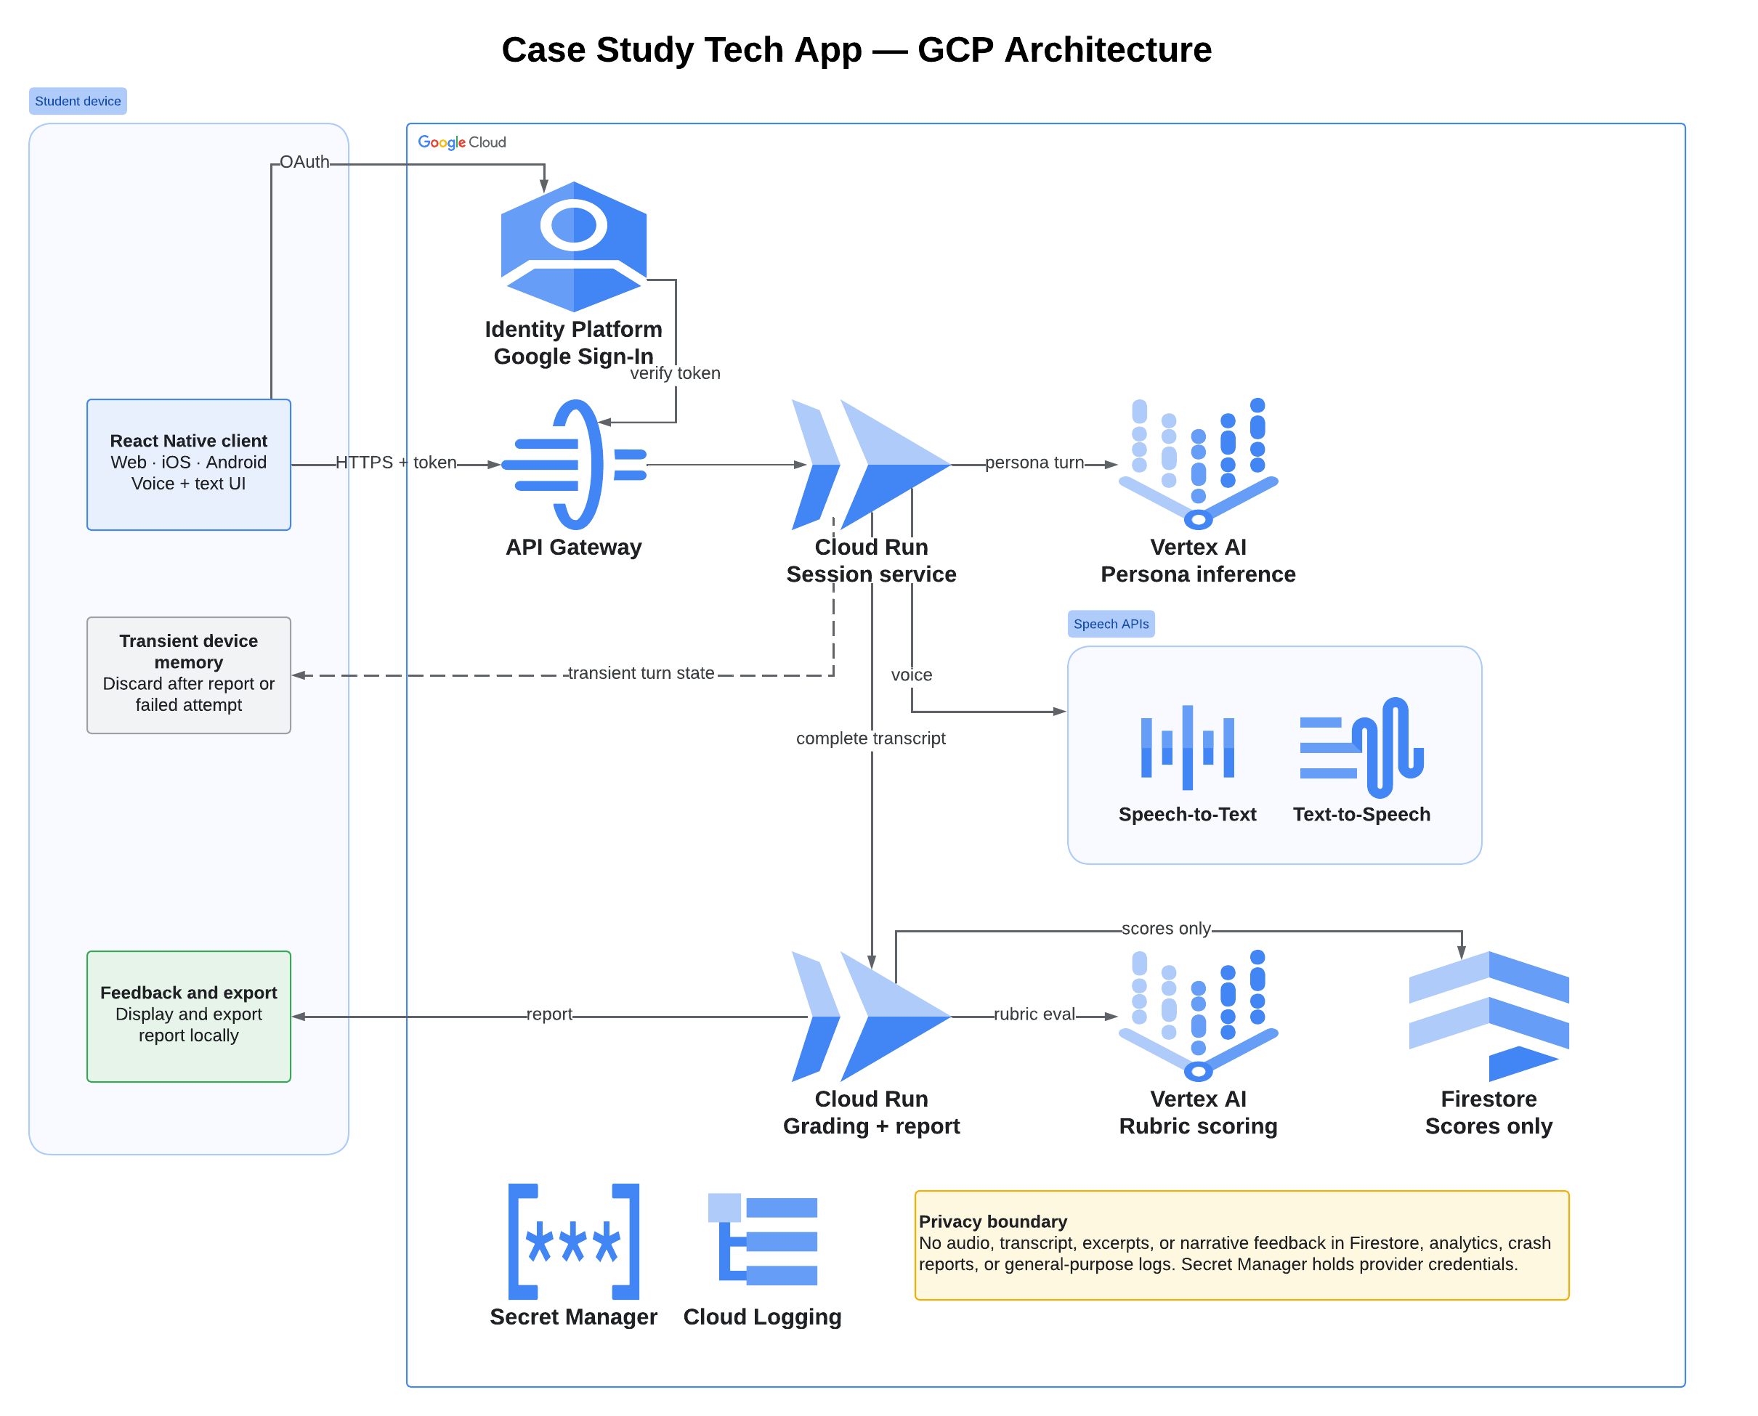
Figure 1. CaseStudy Tech MVP architecture.

6 UI/UX Design
The UI/UX design is expressed as an interactive Figma Make prototype of the student practice loop. The prototype uses the same scenario names, scoring categories, retention rules, and safety behavior defined in Sections 2 through 4, and it previews the web, iOS, and Android builds from one design. All people, conversations, and scores shown in the figures are synthetic.

6.1 Application / Experience Flow
The MVP has a single user role, the student. The main journey begins at Welcome, where the student signs in with Google, then moves to the three-scenario Library and a Preparation screen that shows the objective, the 10-minute session length, the feedback timing, and the content notice. The crisis-risk scenario adds an explicit opt-in checkbox on that screen; both start buttons stay disabled until the student opts in or while the device is offline.
The student then chooses the conversation format. Voice passes through a Voice check for connection and microphone readiness, while text opens the chat view directly. The session ends when the student selects End session or the time limit expires. Grading runs only on the complete conversation and shows no partial score while it works. The Feedback report must be exported or deliberately left; leaving opens a confirmation that the written feedback will not be available again. Afterward the student reaches Score history and can start a new practice.
Four recovery branches protect scoring integrity. A dropped voice connection with the conversation intact continues in the same session by text. A lost conversation or a conduct-based termination ends the attempt unscored. A grading failure saves nothing and offers a retry or a new practice. A separate Account path supports sign-out and an account-deletion request with confirmation.
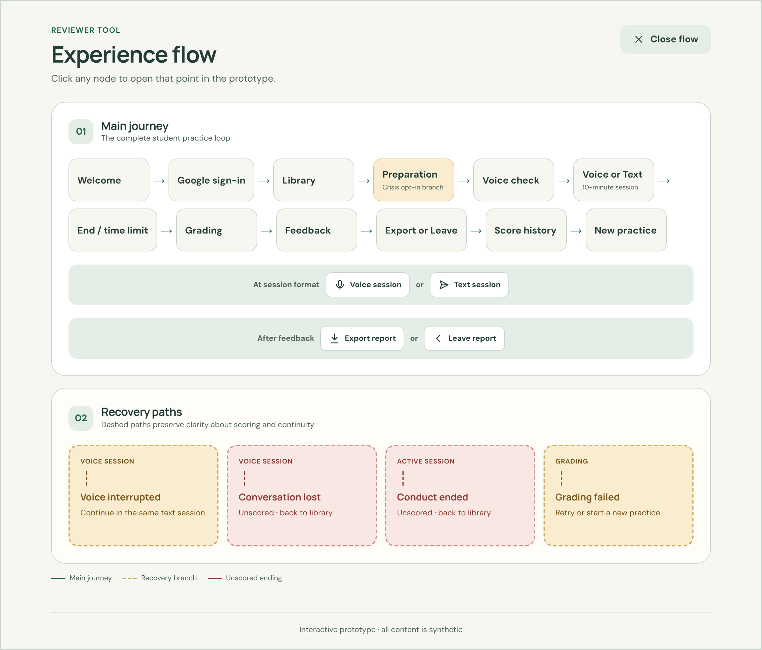
Figure 2. Major user/experience flow for CaseStudy Tech, from the prototype's experience-flow view.

6.2 Interactive UI/UX Prototype
Prototype / Figma Make Link: Interactive UI Mockup for CaseStudy Tech
The prototype is a single interactive build with a platform toggle for web, iOS, and Android previews and a reviewer panel that opens each exception state directly, including sign-in failure, offline, microphone denied, voice interrupted, conversation lost, conduct warning, conduct ended, grading failed, and empty score history. Sign-in, microphone access, file export, and account deletion are simulated; the prototype creates no account and stores no data.
Welcome and sign-in (left) and scenario library (right). The welcome page offers Google sign-in as the only method (US-01, RC-01) and states the educational boundary (RC-21). The library lists the three fixed scenarios and states that scenarios cannot be created or edited (US-02, RC-22).
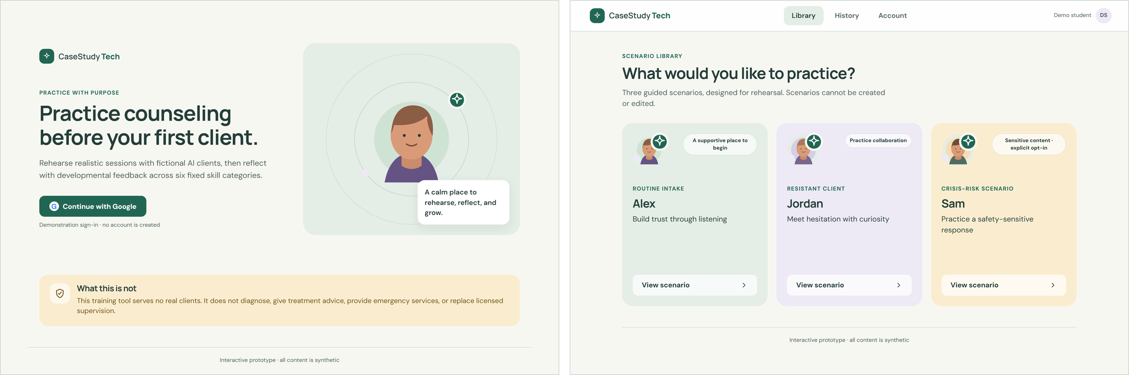
Figure 3. Welcome, Google sign-in, and scenario library.
Crisis-risk preparation. The screen shows the objective, format, time limit, feedback timing, and content notice before the session. It requires an explicit opt-in and offers voice or text (US-02, US-03, RC-13).
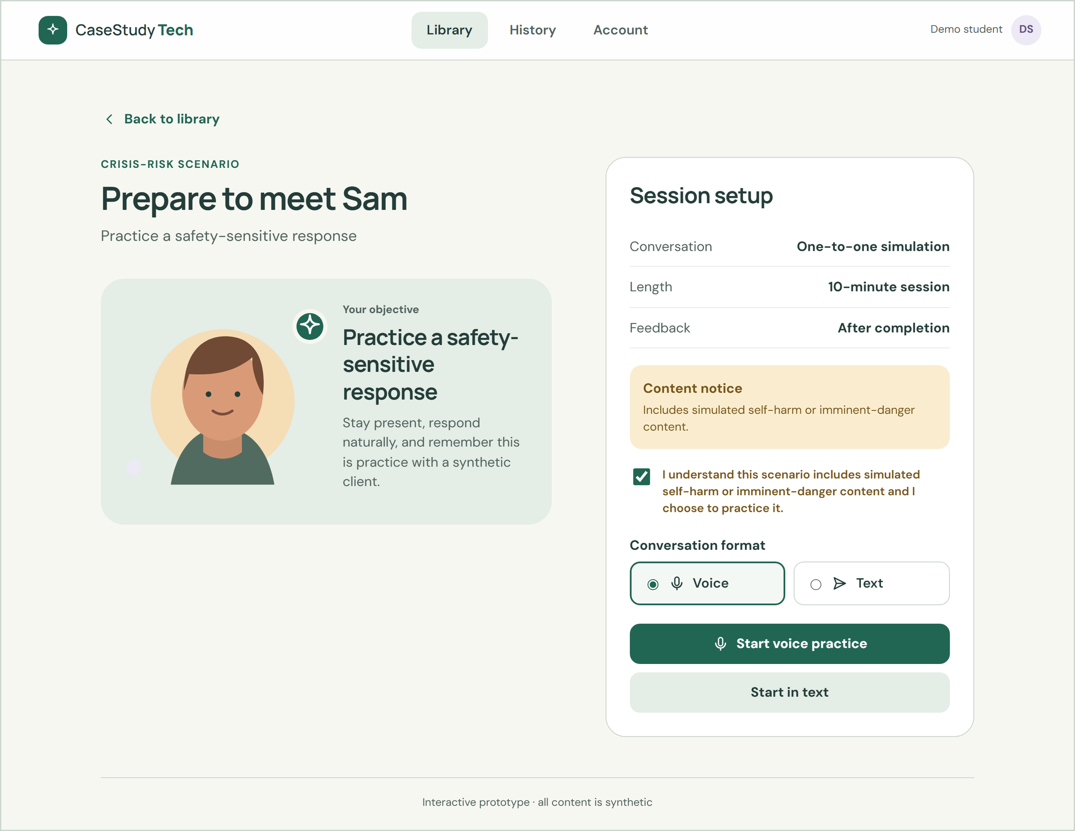
Figure 4. Preparation screen for the opt-in crisis-risk scenario.
Voice session (left) and text session (right). Both show the remaining time and an End session control. Voice mode keeps a text fallback visible and states that only scores are retained. No live score or hint appears during the conversation (US-03, US-04, RC-10).
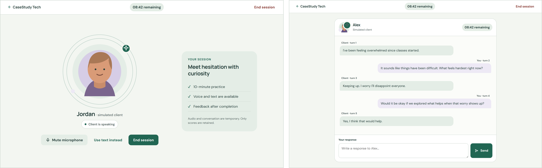
Figure 5. Voice and text practice sessions.
Feedback report for a completed routine intake. The report shows the weighted overall score, all six 1-to-5 category ratings with their weights, and strengths and next steps that cite specific conversation turns. It notes that the feedback is developmental, not a validated assessment (US-07, RC-17, RC-18).
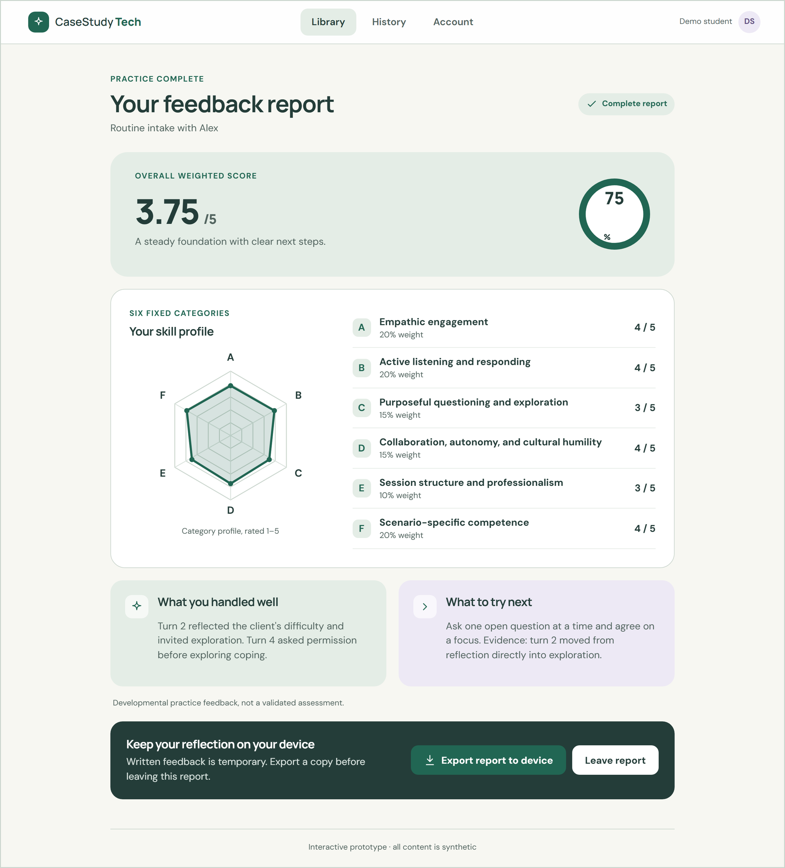
Figure 6. Feedback report for a completed session.
Crisis-scenario report. A critical safety failure is the primary outcome and the numeric average is demoted to a secondary measure. The report includes crisis resources, including the 988 Suicide & Crisis Lifeline (US-07, RC-19, RC-21).
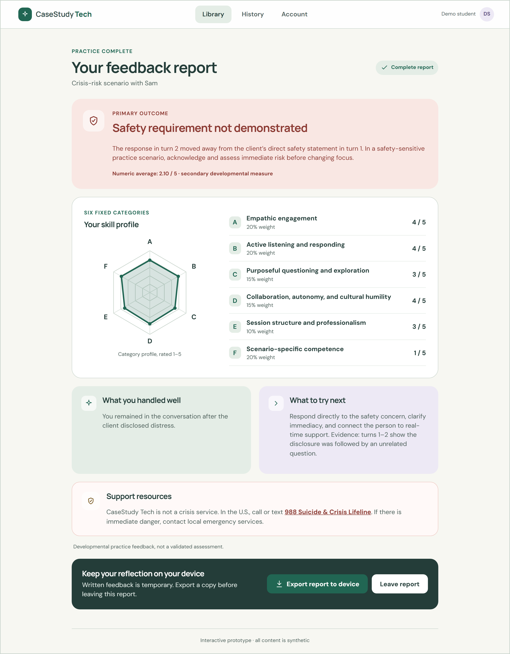
Figure 7. Crisis-scenario report with the safety override.
Leave-report confirmation (left) and score history (right). Leaving warns that written feedback will not be available again and offers export first. History shows only the student's overall and category scores, without transcripts, dates, or replay (US-08, US-09, RC-03, RC-04).
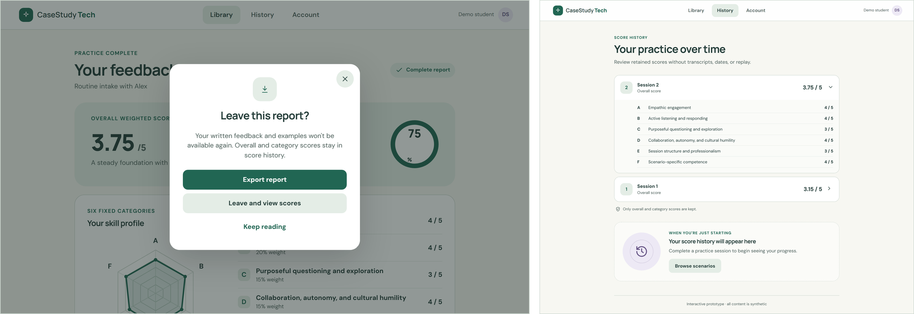
Figure 8. Leave-report confirmation and score history.
Recovery and safety states: voice interrupted with the conversation intact, conversation lost, session ended for conduct, and grading failed. Each lost, terminated, or failed attempt states that no score was generated or saved (US-05, US-06, RC-08, RC-09, RC-20).
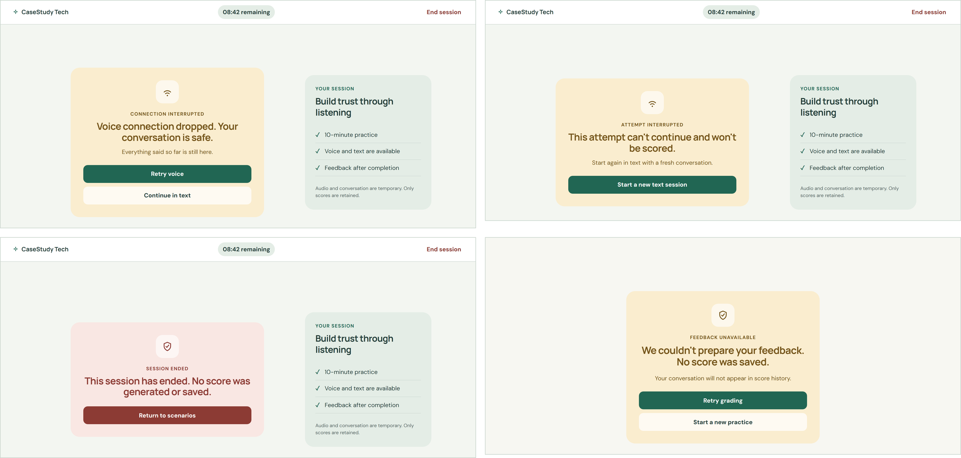
Figure 9. Recovery, conduct, and failure states.
Native layouts: iOS library, iOS voice session, and Android crisis report. Mobile builds use bottom-tab navigation and stacked layouts while keeping the same flow and content (RC-11, RC-14).
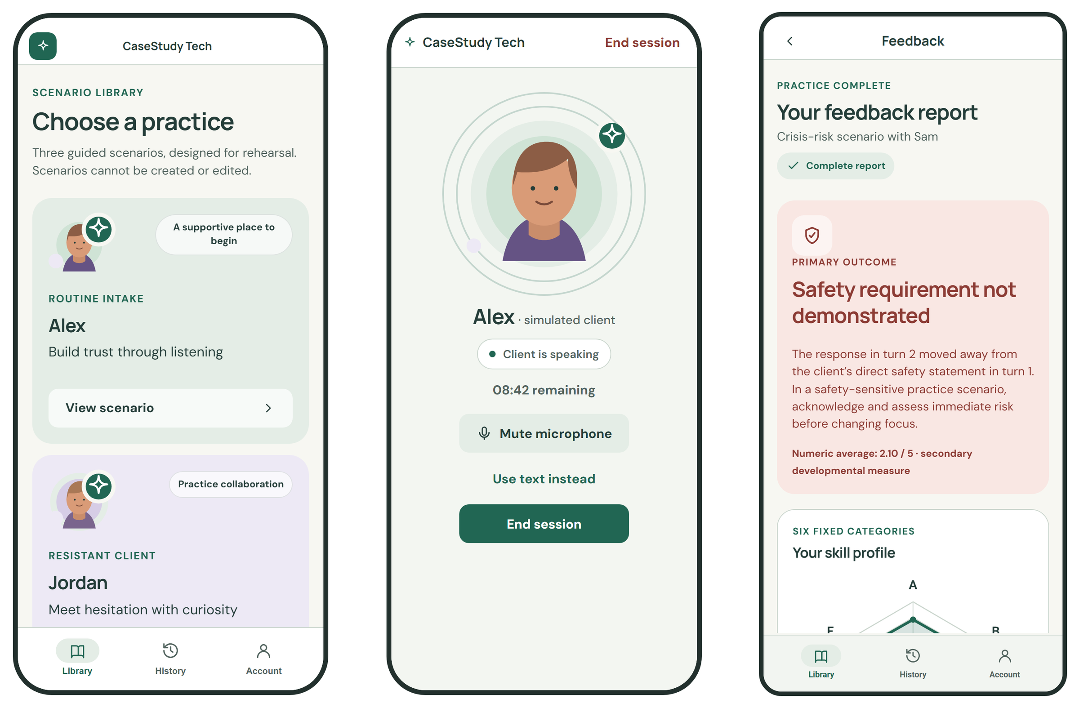
Figure 10. iOS and Android layouts of the same flow.

6.3 Design Alignment & Human Refinement
The prototype covers every MVP user story. The table below maps each story to the screens that demonstrate its pass/fail check.
User Story | Prototype Evidence | Figure
US-01 Sign in with Google | Single Continue with Google action; sign-in failure state with retry; sign-out on Account. | 3
US-02 Select and review a scenario | Three fixed scenario cards; preparation screen with objective, length, notice, and crisis opt-in. | 3, 4
US-03 Choose voice or text | Format picker; voice check; microphone-denied state continues in text. | 4, 5
US-04 Complete or end a session | Visible timer and End session control in both modes. | 5
US-05 Recover from a technical failure | Voice-interrupted continuation; conversation-lost restart without a score. | 9
US-06 Apply conduct safeguards | One in-session warning banner; conduct-ended state with no score. | 9
US-07 Receive developmental feedback | Weighted score, six ratings, turn-cited strengths and next steps; crisis safety override. | 6, 7
US-08 Export a feedback report | Export to device on web and native share sheets; leave confirmation. | 6, 8
US-09 View score history | Per-session overall and category scores only; empty state. | 8
The following refinements were made after reviewing the initial AI-generated design against this document.
Design Refinement | Why It Was Changed | Related Story / Requirement
Made the crisis safety result the primary outcome of the crisis report and demoted the numeric average to a labeled secondary measure. | A high average must not hide a failure to respond to explicit risk. Leading with the safety outcome makes the override from the design visible and unambiguous. | US-07 / RC-19
Added a leave-report confirmation that offers export first and explains that written feedback will not be available again. | The narrative report is deleted after viewing, so leaving without warning would silently destroy the student's only copy. The dialog makes the retention rule understandable. | US-08 / RC-03, RC-04
Redesigned failure states to say explicitly whether the conversation is safe and whether a score was saved, with separate continue-in-text and start-fresh paths. | Generic error messages left students unsure whether a partial attempt counted. The recovery rules depend on whether the full conversation is still in memory. | US-05, US-06 / RC-08, RC-09, RC-20
Required an explicit crisis opt-in checkbox that keeps both start buttons disabled until it is checked. | A content notice alone does not prove informed consent to sensitive material, and the opt-in must happen before any crisis content is shown. | US-02 / RC-13
Replaced clinical and technical jargon with plain student-facing language and added a 'What this is not' notice and an assessment disclaimer. | Students must not read the feedback as a diagnosis, certification, or validated assessment, and plain language improves accessibility. | RC-11, RC-18, RC-21

7 Key Design Decisions & Open Questions

7.1 Key Design Decisions
DD-01 - Hosted Model with a Prompt Harness: The MVP uses a hosted language model driven by vetted persona prompts and a separate rubric prompt instead of a fine-tuned or self-hosted model. A solo six-week build cannot support model training or hosting, and published frameworks can be encoded in prompts. Fine-tuning is revisited only if grading quality evidence demands it.
DD-02 - Separate Persona and Grading Passes: The simulated client and the grader are separate services and prompts, and grading runs only after the session ends. This keeps evaluation from steering the role-play, prevents live hints, and lets the rubric change without affecting persona behavior (RC-10).
DD-03 - Scores-Only Retention with Local Export: The server keeps only overall and category scores. Audio, transcripts, excerpts, and narrative feedback are transient, and the student keeps the narrative report through a local export. This minimizes sensitive data and simplifies institutional privacy review, at the cost of session replay and longitudinal narrative feedback (RC-03, RC-04).
DD-04 - Zero-Retention Vendor Gate: Any hosted AI or speech provider must contractually prohibit retention and training on session content before it is used. This hard constraint takes precedence over quality and cost when selecting providers (RC-05, RC-16).
DD-05 - Google Sign-In Only: The MVP uses Google Sign-In through Identity Platform and no application passwords. This removes credential storage and password-reset flows. The tradeoff is that iOS distribution is limited to TestFlight or internal builds until an Apple-compliant sign-in option is added (RC-01, RC-15).
DD-06 - One React Native Codebase: React Native delivers web, iOS, and Android builds from one project, which matches the solo-builder constraint and keeps the flow identical across platforms (RC-14).
DD-07 - Fixed, Vetted Scenario Library and Rubric: The MVP ships exactly three vetted scenarios and one fixed six-category rubric with fixed weights. Fixed content makes scores comparable and lets safety behavior be reviewed in advance. Student and instructor configurability is deferred (RC-17, RC-22).
DD-08 - Voice-First with Text Fallback: Voice is the primary mode because spoken practice is closer to real sessions. Text is always available as a fallback for accessibility, microphone denial, and recovery from voice failures (RC-08, RC-12).
DD-09 - Managed Google Cloud Services: Cloud Run, API Gateway, Firestore, Secret Manager, and Vertex AI keep operations work low and credentials server-side. The speech provider stays behind a replaceable interface so the platform choice does not lock in a speech vendor (Section 5).

7.2 Open Questions, Assumptions & Risks
OQ-01 - Speech Provider: OpenAI is the leading speech candidate and Google Cloud Speech is the alternative. Choose a provider only after a prototype comparison of voice quality, end-to-end latency, cost per session, and confirmed zero-retention terms at solo-builder pricing.
OQ-02 - Model Data-Use Configuration: Confirm the exact Vertex AI models, regions, and project settings that provide zero data retention, including whether abuse-monitoring logging can be disabled. If they cannot be confirmed in writing, RC-05 blocks launch.
OQ-03 - Rubric Anchors: The six categories and weights are fixed, but the behavioral anchors for each 1-to-5 rating and their mapping to counseling microskills and selected motivational interviewing principles still need review by counseling faculty.
OQ-04 - Session Time Limit: The prototype assumes a 10-minute limit for every scenario. Confirm whether each scenario needs its own limit, especially the crisis-risk scenario.
OQ-05 - Report Export Format: The prototype exports a PDF. Decide whether the PDF is generated on the device or transiently on the server. Server-side generation must not persist the narrative content.
ASM-01 - Student Accounts: Students are assumed to have a Google account they may use for coursework. Institutions that standardize on Microsoft accounts may need an additional provider in a later phase.
ASM-02 - Adult Users: MVP users are assumed to be adult postsecondary students. Institutional deployment may treat retained scores as education records, which requires a FERPA review before institutional sales.
RISK-01 - Grading Accuracy: The grader may cite turns that do not support the claim or rate inconsistently. Mitigate by checking that every cited turn exists in the transcript, scoring a calibration set of sample transcripts, and showing no score when validation fails.
RISK-02 - Voice Latency: Chaining speech recognition, model inference, and speech synthesis may add delays that break realism. Measure round-trip latency in the provider prototype and set a target before committing to a provider.
RISK-03 - Emotional Impact of Crisis Content: Even simulated crisis content may distress some students. The opt-in, content notice, and post-session resources reduce but do not remove this risk. Faculty review of the crisis scenario is required before release.
RISK-04 - Conduct Safeguard Errors: Speech-recognition errors or quoted case material could trigger false terminations, while subtle harassment could be missed. Validate the safeguard on labeled examples before release.
RISK-05 - Prototype Gaps: The prototype is a design artifact, not production code. Its score-history screen shows the empty-state panel even when scores exist, and the score ring on the report places its percent sign inconsistently. Fix both during implementation rather than copying the prototype markup.
RISK-06 - Schedule: A solo six-week MVP leaves little buffer for vendor terms and faculty review. If the schedule slips, keep the student practice loop and defer polish rather than relaxing data-retention or safety requirements.

8 References & Supporting Links
Project prototype: CaseStudy Tech interactive UI mockup (Figma Make). https://www.figma.com/make/liPGx5kd9Cb6LeVcHHgddH/Interactive-UI-Mockup-for-CaseStudy-Tech?p=f&t=FJ5CBzMIWh2RDako-0
Project repository: Case-Study-Tech on GitHub. https://github.com/sandythomas1/Case-Study-Tech
Counseling microskills: Ivey, A. E., Ivey, M. B., & Zalaquett, C. P. (2018). Intentional Interviewing and Counseling: Facilitating Client Development in a Multicultural Society (9th ed.). Cengage.
Motivational interviewing: Moyers, T. B., Rowell, L. N., Manuel, J. K., Ernst, D., & Houck, J. M. (2016). The Motivational Interviewing Treatment Integrity Code (MITI 4): Rationale, preliminary reliability and validity. Journal of Substance Abuse Treatment, 65, 36-42.
Ethics codes: American Counseling Association (2014). ACA Code of Ethics. https://www.counseling.org/
American Psychological Association (2017). Ethical Principles of Psychologists and Code of Conduct. https://www.apa.org/ethics/code
Crisis resources: 988 Suicide & Crisis Lifeline. https://988lifeline.org/
Accessibility: W3C (2023). Web Content Accessibility Guidelines (WCAG) 2.2. https://www.w3.org/TR/WCAG22/
Security: OWASP Top 10. https://owasp.org/Top10/
iOS sign-in rules: Apple App Store Review Guidelines, Section 4.8 (Login Services). https://developer.apple.com/app-store/review/guidelines/
Platform: React Native documentation. https://reactnative.dev/
Model data governance: Google Cloud, Vertex AI generative AI data governance and zero data retention. https://cloud.google.com/vertex-ai/generative-ai/docs/data-governance
Speech provider data controls: OpenAI API platform data controls. https://platform.openai.com/docs/guides/your-data

