“Warehouse Inventory System”
Project Report submitted for the partial fulfilment of grade for the course
Data Structures and Algorithms -3 (25CS2103E)
in
DEPARTMENT OF COMPUTER SCIENCE ENGINEERING
by
Santhosh Pendyala :2520030330
Haadi Hasil :2520030297
Sashank Chivukula :2520030405

Team Number: 9
Section: S8
Under the Guidance of
Dr. V Sireesha
Associate Professor
Department of Computer Science and Engineering


2026-27

DEPARTMENT OF COMPUTER SCIENCE ENGINEERING
Declaration
The Project Report entitled “Warehouse Inventory System” is a record of Bonafide work of Santhosh Pendyala – 2520030330, Haadi Hasil – 2520030297, Sashank Chivukula – 2520030405 submitted in partial fulfillment for the award of B. Tech in Computer Science and Engineering. The results embodied in this report have not been copied from any other departments/University/Institute.

Santhosh Pendyala – 2520030330
Haadi Hasil – 2520030297
Sashank Chivukula – 2520030405

DEPARTMENT OF COMPUTER SCIENCE ENGINEERING
CERTIFICATE
This is to certify that the mini project based report entitled “Warehouse Inventory System” is a bonafide work done and submitted by SANTHOSH PENDYALA – 2520030330, HAADI HASIL – 2520030297, SASHANK CHIVUKULA – 2520030405 in partial fulfillment of the requirements for the award of the degree of BACHELOR OF TECHNOLOGY in Department of Computer Science Engineering, during the academic year 2026-27.

Signature of the Guide | Signature of the HOD
(Dr. V Sireesha) | (Dr. P. Venkateshwara Rao)

Signature of the External Examiner

ACKNOWLEDGEMENT
We express our sincere gratitude to our project guide Dr. V Sireesha, Associate Professor, Department of Computer Science and Engineering, for her guidance, reviews and insistence that every algorithm in the Data Structures and Algorithms -3 syllabus appear as a warehouse operation rather than as an isolated exercise. This report and the running system both exist in that shape because of that direction.
We thank Dr. P. Venkateshwara Rao, Associate Professor, Head of the Department of Computer Science and Engineering, for the academic environment in which this mini project could be completed, and for the department’s emphasis on documenting work in the prescribed 2026-27 format. We are also grateful to the faculty of the department for the course 25CS2103E, which supplied the techniques implemented here.
Finally we thank our teammates for the shared design decisions — two URLs, hub-level stock, and a four-tab warehouse — that kept the product short enough to demonstrate in a viva.

Santhosh Pendyala – 2520030330
Haadi Hasil – 2520030297
Sashank Chivukula – 2520030405

Abstract
The Warehouse Inventory System is an algorithm-driven application built to manage product inventory and supplier coordination across a multi-hub warehouse. Large catalogues make exact-match search brittle, restocking guesswork expensive, supplier allocation opaque, and pick-wave timing NP-hard. This mini project addresses those four problems with named techniques from Data Structures and Algorithms -3 (25CS2103E) [1], [2].
Exact SKU and name lookup uses Knuth–Morris–Pratt and Rabin–Karp string matching [3], [4]. Misspelt queries fall through to Wagner–Fischer edit distance [5]. Restock lots under a rupee cap are chosen by 0/1 knapsack dynamic programming [1], [11]. Suppliers and hubs form a flow network solved by Edmonds–Karp [6], [7]; Kuhn matching assigns suppliers to warehouses and seeds the dock schedule [8]. Pick makespan on m docks is P||Cmax; a matching-based 2-approximation plus longest-processing-time list scheduling [9] produces the Floor dock board. Cycle counts draw a uniform subset of SKUs with Vitter’s reservoir algorithm R [10].
The implemented system is a single-page web application with two entry URLs that share one ledger: “/” (or “/shop”) is the wholesale storefront (selling price, cart, deliver-to hub, my orders) and “/admin” is the warehouse (Catalog, Stock, Buying, Floor). Checkout cuts hub-level quantity immediately and inserts pick jobs. Cancel restores stock; Packed completes a pick; stock can be moved between five Indian hubs. The result is a complete, viva-ready loop in which every syllabus topic has a corresponding warehouse action.

Table of Contents
Acknowledgement
Abstract
Table of Contents
List of Figures
1 Introduction 1
1.1 Overview 1
1.2 Problem statement 2
1.3 Scope of the project 3
1.4 Objectives 3
2 System Requirements 5
2.1 Functional Requirements 5
2.2 Non-Functional Requirements 6
2.3 Hardware and software specifications 6
3 System Design 8
3.1 High-level Architecture Diagram 8
3.2 Description of each layer 9
4 Implementation 11
4.1 Module-wise implementation 11
4.2 Front-end logic (UI rendering, state management) 13
4.3 Application interface (shared ledger) 13
4.4 Pseudocode of core algorithms 14
5 Results 17
6 Challenges & Limitations 19
6.1 Issues faced during development 19
6.2 Solutions applied 19
6.3 Limitations of the System 20
7 Conclusion & Future Work 21
7.1 Conclusion 21
7.2 Future Work 21
7.3 Skills learned during development 22
References 23

List of Figures
1.1 Shop and warehouse sharing one catalogue 2
1.2 Operational flow of the system 2
3.1 High-level architecture 8
3.2 Search pipeline (KMP → Rabin–Karp → edit distance) 10
5.1 Meridian wholesale shop (URL / ) 17
5.2 Live search for “ssd” listing both SSDs 17
5.3 Product sheet and Add to cart 18
5.4 Cart, deliver-to hub and Place order 18
5.5 My orders after checkout 18
5.6 Warehouse Catalog (URL /admin) 19
5.7 Warehouse Stock cards with hub quantity 19
5.8 Buying — 0/1 knapsack restock 19
5.9 Floor dock board (P||Cmax schedule) 20
5.10 Cycle-count sample (reservoir sampling) 20

1. INTRODUCTION
1.1 Overview
A working warehouse is several textbook problems at once. Staff type a half-remembered product name; a wholesale buyer expects the quantity just purchased to leave the book; purchasing has a rupee cap and a list of SKUs below minimum stock; docks must finish today’s picks before the last truck leaves. In computer science, a data structure is a way to organize and store data that is usually chosen for efficient access to data [1]. The same sentence applies to a warehouse: the catalogue, the hub vector of quantities, the pick list and the supplier graph are data structures, and the operations on them are the algorithms taught in 25CS2103E.
This mini project, titled Warehouse Inventory System, implements those operations in a browser application branded Meridian. Buyers enter at “/” or “/shop” and see selling price (MRP), a cart and a deliver-to hub. Warehouse staff enter at “/admin” and see Catalog, Stock, Buying and Floor. Both sides share one product ledger. Fig. 1.1 shows that split; Fig. 1.2 shows the operational path from search to count.
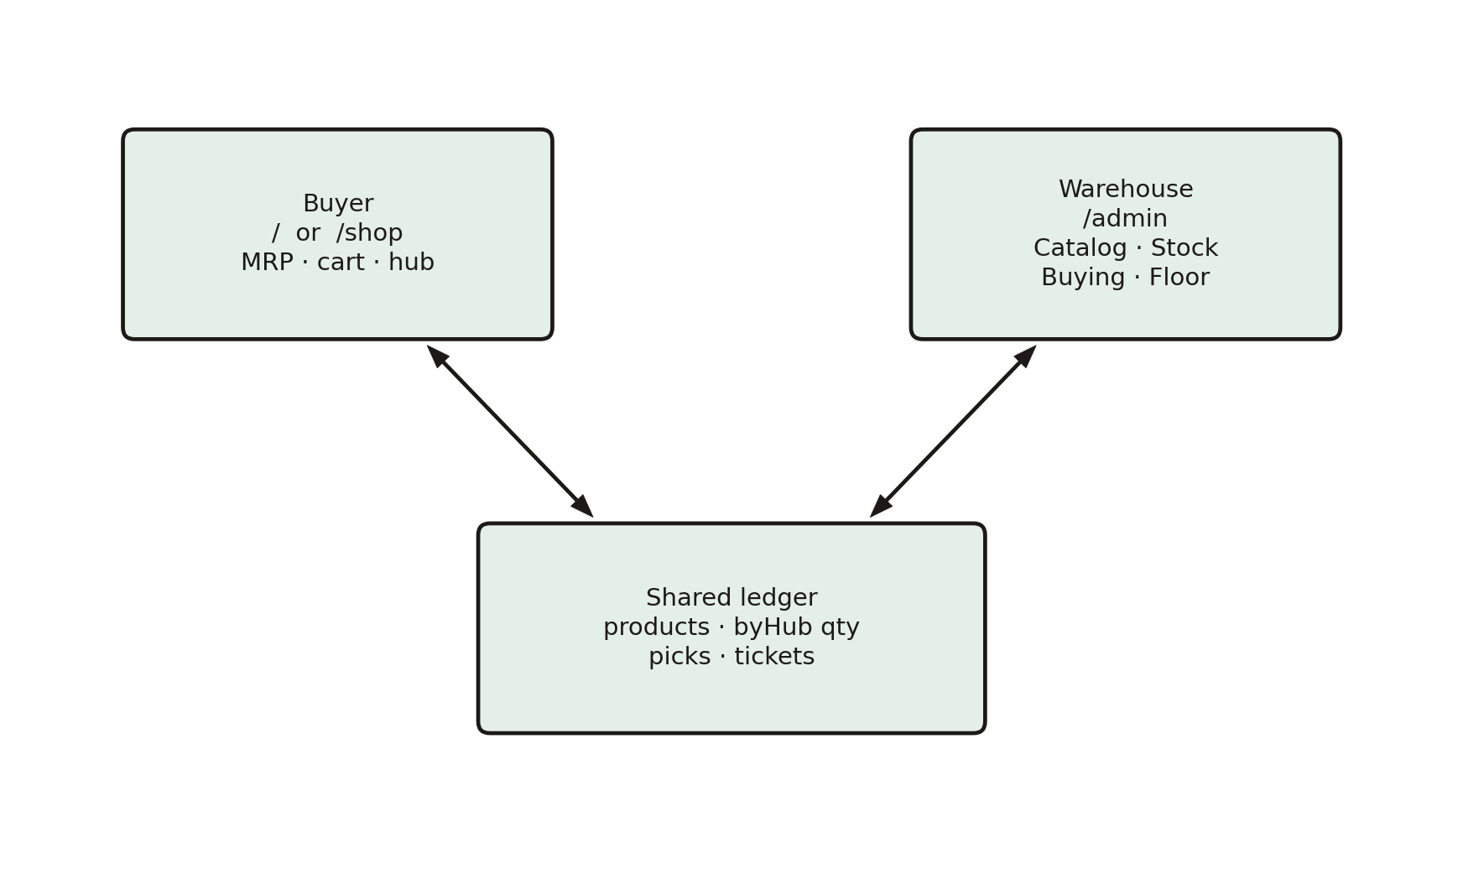
Fig. 1.1 Shop and warehouse sharing one catalogue
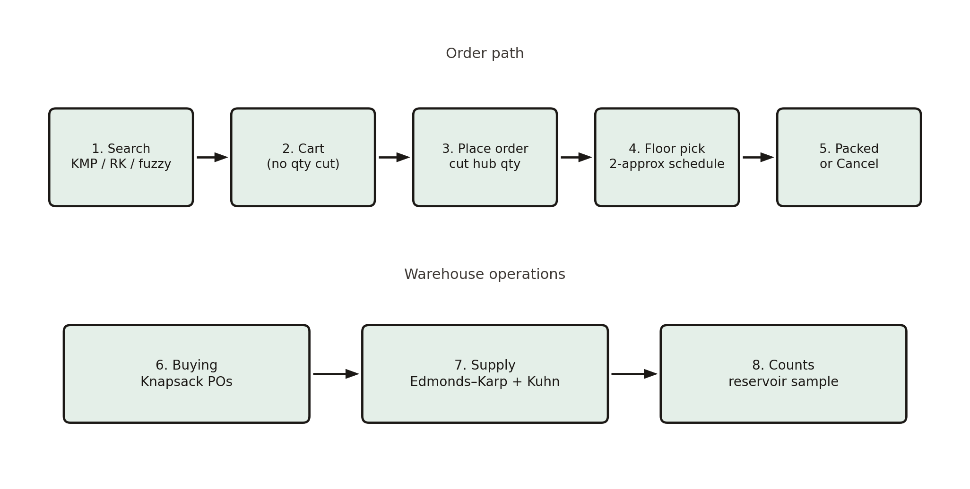
Fig. 1.2 Operational flow of the system
The remainder of this chapter states the problem, the scope and the objectives. Chapter 2 lists requirements. Chapter 3 describes architecture. Chapter 4 records module-wise implementation and pseudocode. Chapter 5 presents results. Chapter 6 records challenges. Chapter 7 concludes.
1.2 Problem statement
Current warehouse inventory systems, especially teaching and small-business tools, typically fail in combination [2]:
Slow, exact-match-only product searching that misses a SKU fragment or a typo; sub-optimal restocking under a hard budget; inefficient manual supplier-to-hub coordination with no view of bottlenecks; no treatment of NP-hard pick scheduling; cycle counts that always inspect the same convenient SKUs; and a split between the shop a buyer sees and the stock a warehouse sees, so a sale does not move the book.
The problem addressed by this work is to design and implement a warehouse inventory system in which search, restock, supplier allocation, pick scheduling and audits are performed by named DSA-3 algorithms, and in which a wholesale buyer and a warehouse operator share one live catalogue split across five hubs.
1.3 Scope of the project
In scope: a demonstration catalogue of about forty-eight SKUs, five hubs (Hyderabad, Mumbai, Chennai, Gurugram, Bengaluru), six suppliers and four docks; the full search pipeline; knapsack restock; Edmonds–Karp flow and Kuhn matching; matching-based pick scheduling; reservoir cycle counts; hub-level stock, substitutes, cancel, pack, transfer and a printable pick list; two URLs; no backend server.
Out of scope by design: authentication, payment gateways, street-level addresses and a production database. Identity on the shop is a company dropdown; deliver-to is a hub. Persistence is a browser ledger so that “/” and “/admin” remain consistent across refresh and across two tabs. Those limits keep the viva on algorithms rather than on operations.
1.4 Objectives
The objectives, carried through to the running application, are:
1. Product search — exact matching with KMP and Rabin–Karp [3], [4] and fuzzy matching with Wagner–Fischer edit distance [5], including live catalogue filter and optional typeahead.
2. Optimal restocking using 0/1 knapsack dynamic programming [1] under a typed spend cap, with purchase orders that raise hub stock.
3. Supplier flow-network modelling with Edmonds–Karp [6] and min-cut bottleneck detection, plus bipartite assignment of suppliers to hubs with Kuhn’s algorithm [8].
4. NP-hard order scheduling via a matching-based 2-approximation for P||Cmax [9], with a dock board, hub filter, Packed action and printable pick list.
5. Randomised cycle counts via reservoir sampling [10], with posted counts writing back to the book.
6. A buyer storefront and a warehouse console on two URLs sharing one ledger: MRP versus unit cost, deliver-to hub, immediate stock cut on checkout, cancel-to-restore, pack-to-complete, and hub-to-hub transfer. The product UI does not display student names, roll numbers or the guide.
2. SYSTEM REQUIREMENTS
This chapter records what the system must do and under what constraints, including a brief note on prior work. Traditional WMS products answer search with SQL LIKE, restock with human judgement and ignore makespan bounds [2]. Basic scripts scan strings in O(n·m). RFID stacks improve identity capture but not allocation. The gap this project fills is the combination of typo-tolerant search, budget-optimal restock, max-flow supplier analysis and a 2-approximation for pick makespan in one inspectable application.
2.1 Functional Requirements
FR1 A user on “/” can search, browse, add to cart, choose a deliver-to hub, place an order and cancel it.
FR2 A user on “/admin” can search the same catalogue, adjust stock per hub, run buying, inspect supplier flow, schedule picks, pack picks, print a pick list and post a cycle count.
FR3 Placing an order decrements quantity at the chosen hub and appends Floor pick jobs immediately.
FR4 Search returns both SSD SKUs for the query “ssd”, does not auto-pick a suggestion on Enter, and tolerates mild typos.
FR5 Restock honours a spend cap; decreasing the amount does not force a zero or trap the caret.
FR6 Stock can be moved between hubs; Packed greys a pick and removes it from the dock board.
FR7 Demo data can be reset without reinstalling the application.
2.2 Non-Functional Requirements
NFR1 Usability: the warehouse has four tabs only (Catalog, Stock, Buying, Floor); the shop has Shop, Cart and My orders.
NFR2 Reliability of the ledger: shop and admin show the same on-hand numbers after a sale, a restock, a move or a cancel, including across two browser tabs.
NFR3 Scalability of algorithms: KMP and reservoir are linear in catalogue size; knapsack is O(n·W); Edmonds–Karp is polynomial on the small supplier graph [1], [6], [10].
NFR4 Response time: search and checkout complete in interactive time on a dual-core machine with 4 GB RAM for the demonstration catalogue.
NFR5 Maintainability: each algorithm lives in src/algorithms/ as a pure function so that a viva can open one file per question.
2.3 Hardware and software specifications
Item | Minimum | Recommended
Processor | Intel i3 / AMD Ryzen 3, dual-core | Quad-core
RAM | 4 GB | 8 GB (large knapsack W)
Storage | 500 MB free | 1 GB free
Display | 1366 × 768 | 1920 × 1080

Software: Windows 10/11, macOS or Linux; Node.js 20 or newer; a current Chrome, Edge, Firefox or Safari browser; Visual Studio Code; Git. The implementation language is JavaScript (ES modules) with React 19 and Vite 8. There is no database server and no authentication or payment service. The original proposal mentioned Java; the delivered system is a web SPA so that shop and warehouse can share one process, which is required by FR3.
3. SYSTEM DESIGN
3.1 High-level Architecture Diagram
The application is a single React tree. A pathname router renders the shop or the warehouse. Both read and write one StoreProvider. Mutations persist to localStorage and broadcast to other tabs. There is no REST backend. Fig. 3.1 is the architecture; Fig. 3.2 is the search pipeline inside Catalog and Shop.
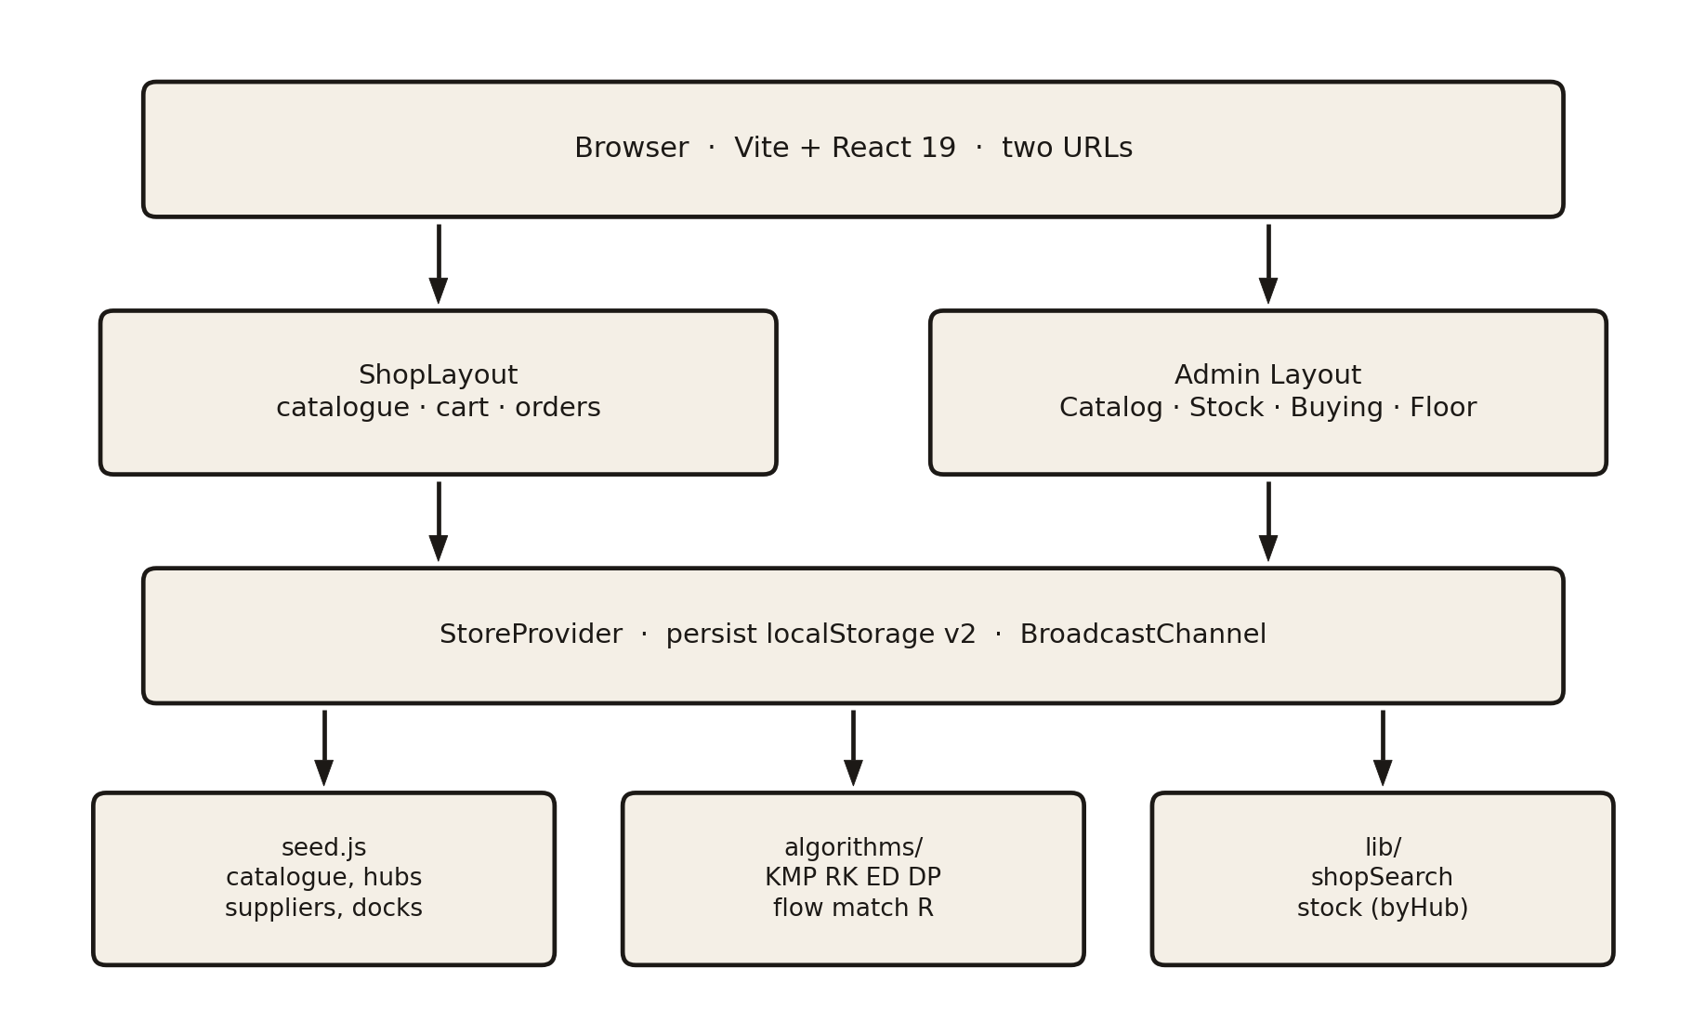
Fig. 3.1 High-level architecture
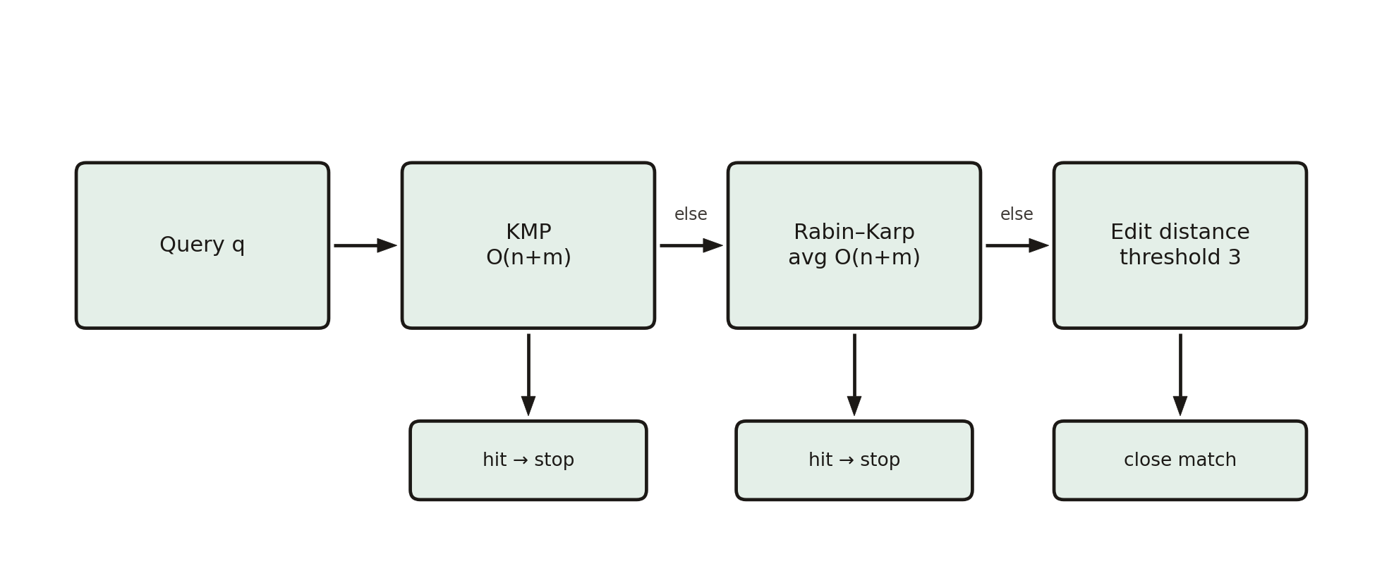
Fig. 3.2 Search pipeline (KMP → Rabin–Karp → edit distance)
3.2 Description of each layer
Presentation layer
ShopLayout owns search, deliver-to city, company dropdown, cart and My orders. Layout owns the four admin tabs, the low-stock and picks pills, and Reset demo. Product cards show the actual on-hand integer at the relevant hub so that a sale is visible without opening a modal. Floor inbound pulses, hub chips, Packed and Print sit on the existing Picks page rather than on a fifth tab.
State layer
A product carries sku, name, category, unitCost, mrp, minStock, location, home warehouseId and byHub, a map from hub id to on-hand. The scalar qty is the sum of byHub. A pick job is {id, sku, qty, processingMin, priority, customer, productName, hubId, status} with status open or packed. A buyer ticket groups lines, hub, total and pickIds. Cancel walks pickIds, restores each line to that hub and drops the jobs.
Algorithm layer
src/algorithms/ contains Knuth–Morris–Pratt [3], Rabin–Karp [4], Wagner–Fischer [5], 0/1 knapsack [1], Edmonds–Karp [6], Kuhn matching [8], the matching-based scheduler [9] and reservoir sampling [10]. src/lib/shopSearch.js sequences the three search passes. src/lib/stock.js owns hub arithmetic and substitutes. Seed data is src/data/seed.js.
Why these techniques are suitable
KMP and Rabin–Karp replace O(n·m) scans for exact lookup. Edit distance is the standard model of typos. 0/1 knapsack is the right DP once restock is “take this lot or skip it” under a rupee cap. Max-flow is the right model of supplier capacity into hubs; the min-cut names the bottleneck. P||Cmax is NP-hard for m ≥ 2, so a 2-approximation is the honest algorithmic claim [9]. Reservoir sampling is the one-pass uniform sample required for an unbiased cycle count [10].
4. IMPLEMENTATION
4.1 Module-wise implementation
Catalog / Shop search
Keystrokes set the query, open optional suggestions and live-filter the grid. Enter searches the typed text; only a click adopts a suggestion. Exact KMP hits win; otherwise Rabin–Karp; otherwise fuzzy with a close-match flag. The shop interprets quantity at the deliver-to hub. A dry hub sheet offers other hubs and same-category substitutes.
Stock
Cards are the default (photograph, stepper, Edit, Move, Reorder) with a List toggle. Hub chips select which byHub cell the stepper edits. Move transfers a typed quantity from one hub to another. Needs-attention filters low or empty cells.
Buying
Buy builds knapsack items from SKUs below minimum (or pinned), runs DP under the spend cap and Place POs add restockQty to each home hub. Supply runs Edmonds–Karp on the source–supplier–hub–sink graph and Kuhn matching on allowed lanes.
Floor
Picks shows inbound pulses from shop checkouts, hub chips, a dock Gantt from the 2-approximation, Packed (grey the row, drop from the board) and Print pick list. Counts draws k SKUs with reservoir sampling; posting writes counted quantity through the home hub.
Shop cart and orders
Add to cart does not cut stock. Place order takes min(requested, on-hand at the hub), writes byHub, prepends pick jobs, posts an inbound pulse and files a ticket. Cancel restores that hub and deletes the jobs.
4.2 Front-end logic (UI rendering, state management)
React 19 function components subscribe to StoreContext. Pathname state chooses ShopLayout or Layout without remounting the provider, so in-app Warehouse → / Shop → keep the ledger. persist() snapshots products, orders, tickets and inbound. A storage listener and BroadcastChannel apply another tab’s snapshot without replacing the local cart. Typeahead is a filtered list; it is not a controlled auto-complete that hijacks Enter.
4.3 Application interface (shared ledger)
There is no remote HTTP API. The store is the application interface. Callers invoke addToCart, placeOrder, cancelOrder, bumpQty, transferStock, applyRestock, packOrder, applyAuditCounts and resetDemo. That choice satisfies FR3 (a sale must update admin stock in the same process) and NFR2 (two URLs, one catalogue).
4.4 Pseudocode of core algorithms
Knuth–Morris–Pratt (exact search) [3]
COMPUTE-LPS(pattern)
m ← length(pattern); lps[0..m-1] ← 0; len ← 0; i ← 1
while i < m
if pattern[i] = pattern[len] then len ← len+1; lps[i] ← len; i ← i+1
else if len ≠ 0 then len ← lps[len-1]
else lps[i] ← 0; i ← i+1
return lps
KMP-SEARCH(text, pattern)
lps ← COMPUTE-LPS(pattern); i ← 0; j ← 0
while i < n
if text[i] = pattern[j] then i ← i+1; j ← j+1
if j = m then record hit; j ← lps[j-1]
else if i < n and text[i] ≠ pattern[j]
if j ≠ 0 then j ← lps[j-1] else i ← i+1
Time is O(n + m). LPS never rewinds the text.
0/1 knapsack restock [1]
KNAPSACK(items[1..n], W)
for i ← 0 to n do for c ← 0 to W do dp[i][c] ← 0; take[i][c] ← false
for i ← 1 to n
for c ← 0 to W
dp[i][c] ← dp[i-1][c]
if w_i ≤ c and dp[i-1][c-w_i] + v_i > dp[i][c]
dp[i][c] ← dp[i-1][c-w_i] + v_i; take[i][c] ← true
reconstruct selected items from take[n][W]
Time and memory are O(n·W). Value is urgency × units-short × demand; weight is restock cost in rupees.
Edmonds–Karp max-flow [6]
EDMONDS-KARP(G, s, t)
flow ← 0
while BFS finds an s–t path P in the residual graph
Δ ← min residual capacity on P
augment P by Δ; flow ← flow + Δ
min-cut ← vertices reachable from s in the residual graph
return flow, min-cut
Time is O(V·E²). Saturated edges leaving the source side are bottleneck suppliers.
Matching-based 2-approximation for P||Cmax [9]
SCHEDULE(jobs, m docks)
LB ← max( max p_j , ceil(Σ p_j / m) )
match the m longest jobs onto docks with Kuhn (prefer faster docks)
for remaining jobs in LPT order
assign to the currently least-loaded dock (time / speed)
return assignment, Cmax
Any list schedule on identical machines satisfies Cmax ≤ 2·OPT. Packed jobs leave the instance; hub chips restrict it to one city.
Reservoir sampling, Algorithm R [10]
RESERVOIR(stream, k)
R ← first k items
for i ← k+1 to n
j ← random integer in 1..i
if j ≤ k then R[j] ← stream[i]
return R // P(item in R) = k/n
Time is O(n), one pass. The Counts tab uses this sample as the SKUs to count.
Place order (hub cut)
PLACE-ORDER(cart, hub)
lines ← empty
for each (sku, qty) in cart
take ← min(qty, byHub[sku][hub])
if take > 0 then byHub[sku][hub] ← byHub[sku][hub] − take
append line and a pick job (status open)
if lines empty then reject
else ticket ← {lines, hub, total}; inbound pulse ← ticket
persist ledger
5. RESULTS
Results are reported against the naïve or manual baseline stated in the proposal. Table 5.1 is the comparison. Figures 5.1–5.10 are screenshots of the running Meridian application (Vite development server, Chromium, demonstration catalogue) — the wholesale shop at “/” and the warehouse at “/admin” — not schematic drawings.
Operation | Traditional | Implemented | Improvement
Exact SKU/name lookup | O(n·m) linear scan | O(n+m) KMP / Rabin–Karp [3], [4] | Single pass; “ssd” lists both SSDs
Typo-tolerant search | Not available | Wagner–Fischer, threshold 3 [5] | New capability
Restock under a cap | Manual / greedy | O(n·W) 0/1 knapsack [1] | Optimal for modelled value
Supplier allocation | Manual | Edmonds–Karp O(V·E²) [6]; Kuhn O(V·E) [8] | Capacity-aware; min-cut bottlenecks
Pick scheduling | Not available | Matching + LPT, Cmax ≤ 2·OPT [9] | Dock board, print list
Cycle count sample | Convenience sample | Reservoir R, P = k/n [10] | Unbiased k-subset
Sale visibility | Batch / next day | Checkout cuts hub qty in the same store | Shop and admin agree immediately

Table 5.1 Traditional versus implemented operations
Fig. 5.1 is the buyer storefront. Selling price (MRP) is shown, not warehouse unit cost. The header holds search, deliver-to city (Hyderabad), the buying company, Orders and Cart. Category chips and “Moving today” cards print the live hub count (“16 in Hyderabad”, “Out in Hyderabad”) so a sale is visible without opening a sheet.
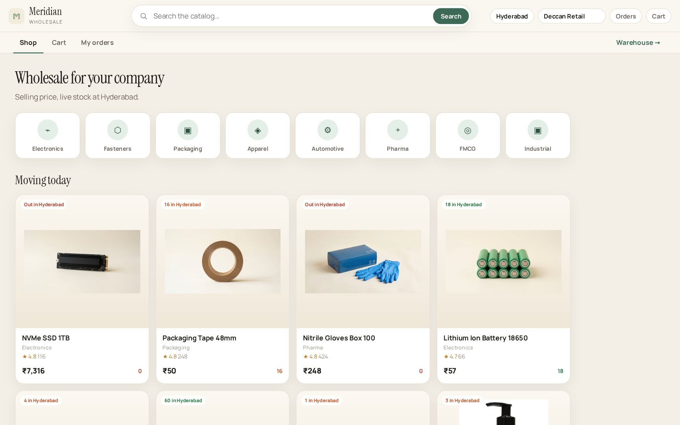
Fig. 5.1 Meridian wholesale shop (URL / )
Fig. 5.2 is the search for the typed query “ssd”. Typeahead lists both NVMe SSD SKUs while the operator is still typing; the grid live-filters to the same two cards. Enter does not auto-pick the highlighted suggestion — it searches the typed text, which is the requirement that both SSDs appear together [3], [4].
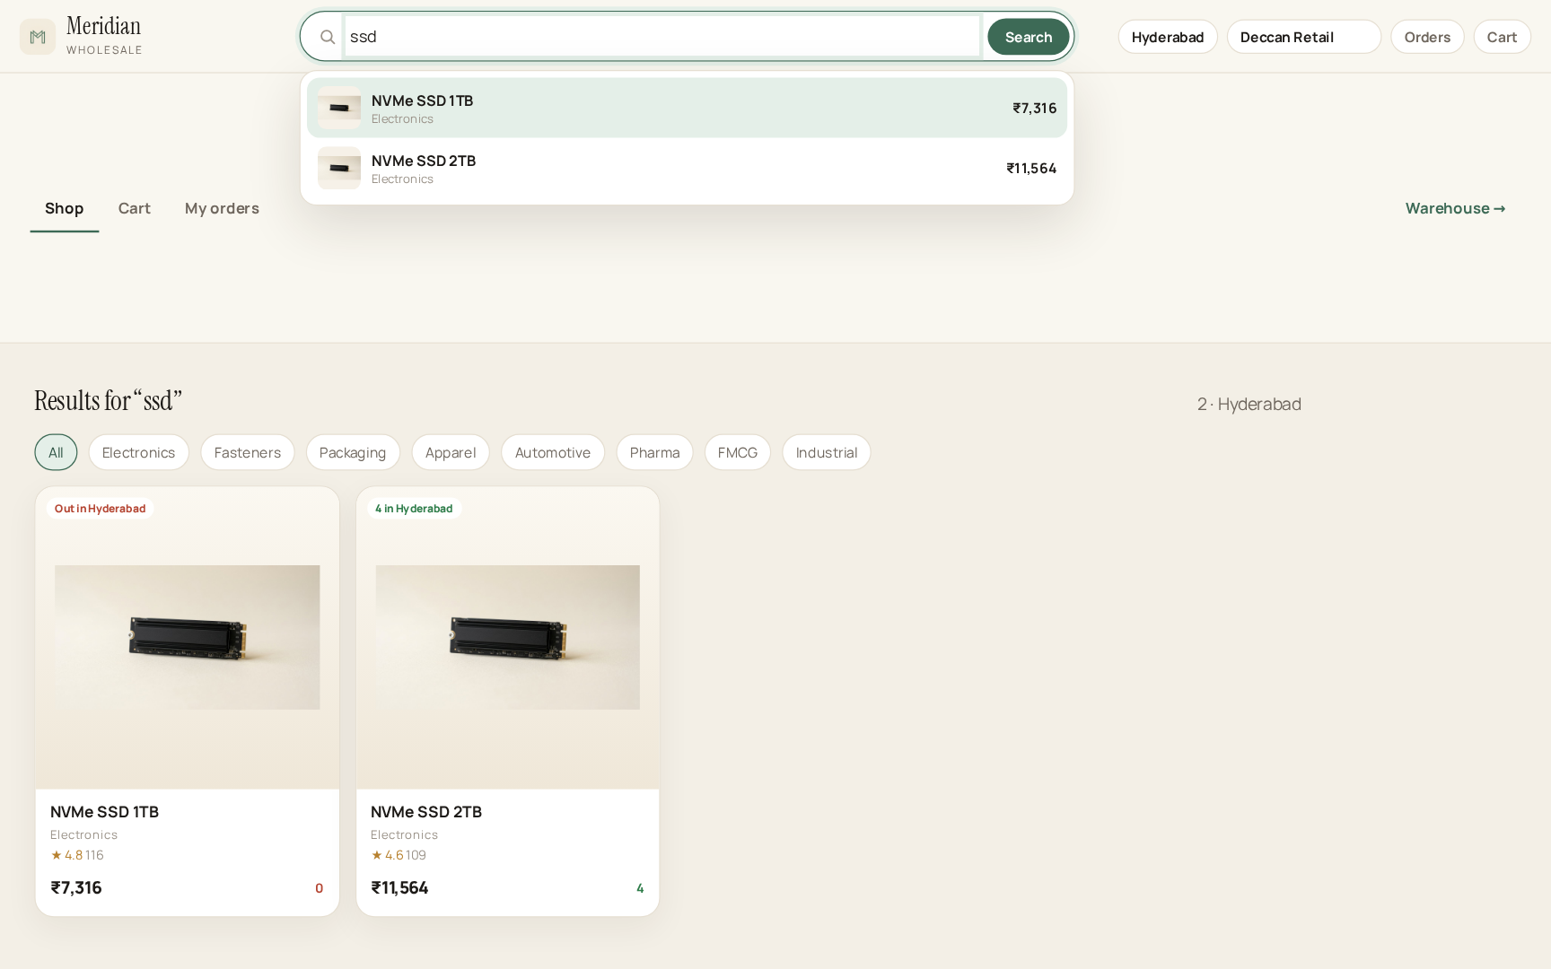
Fig. 5.2 Live search for “ssd” listing both SSDs
Fig. 5.3 is a product sheet opened from the grid (Packaging Tape 48mm). Quantity, MRP and “16 available in Hyderabad” are shown. Add to cart does not cut stock; only Place order does, matching FR3.
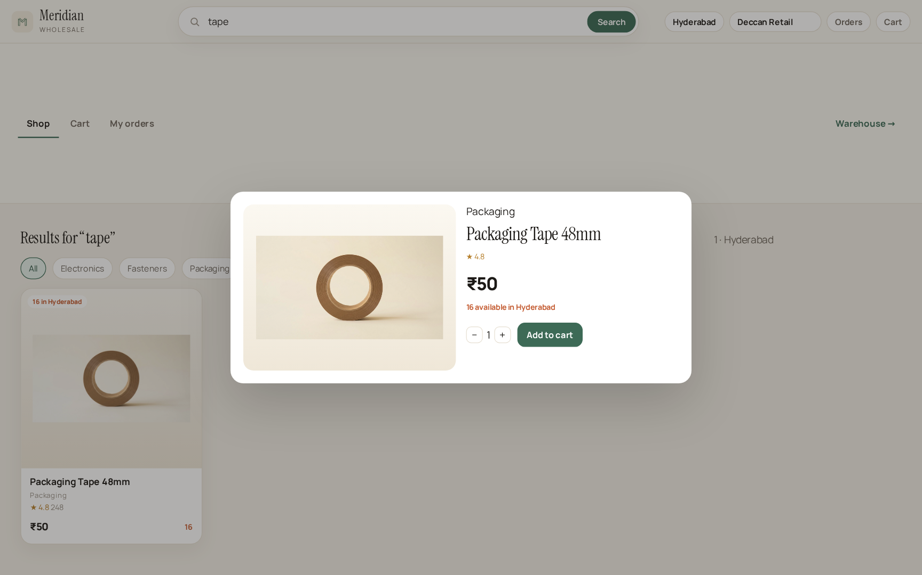
Fig. 5.3 Product sheet and Add to cart
Fig. 5.4 is Cart. Deliver-to is a hub (Hyderabad Hub), not a street form. The toast confirms the add; Place order will decrement Hyderabad quantity and insert Floor pick jobs in the same ledger the warehouse reads.
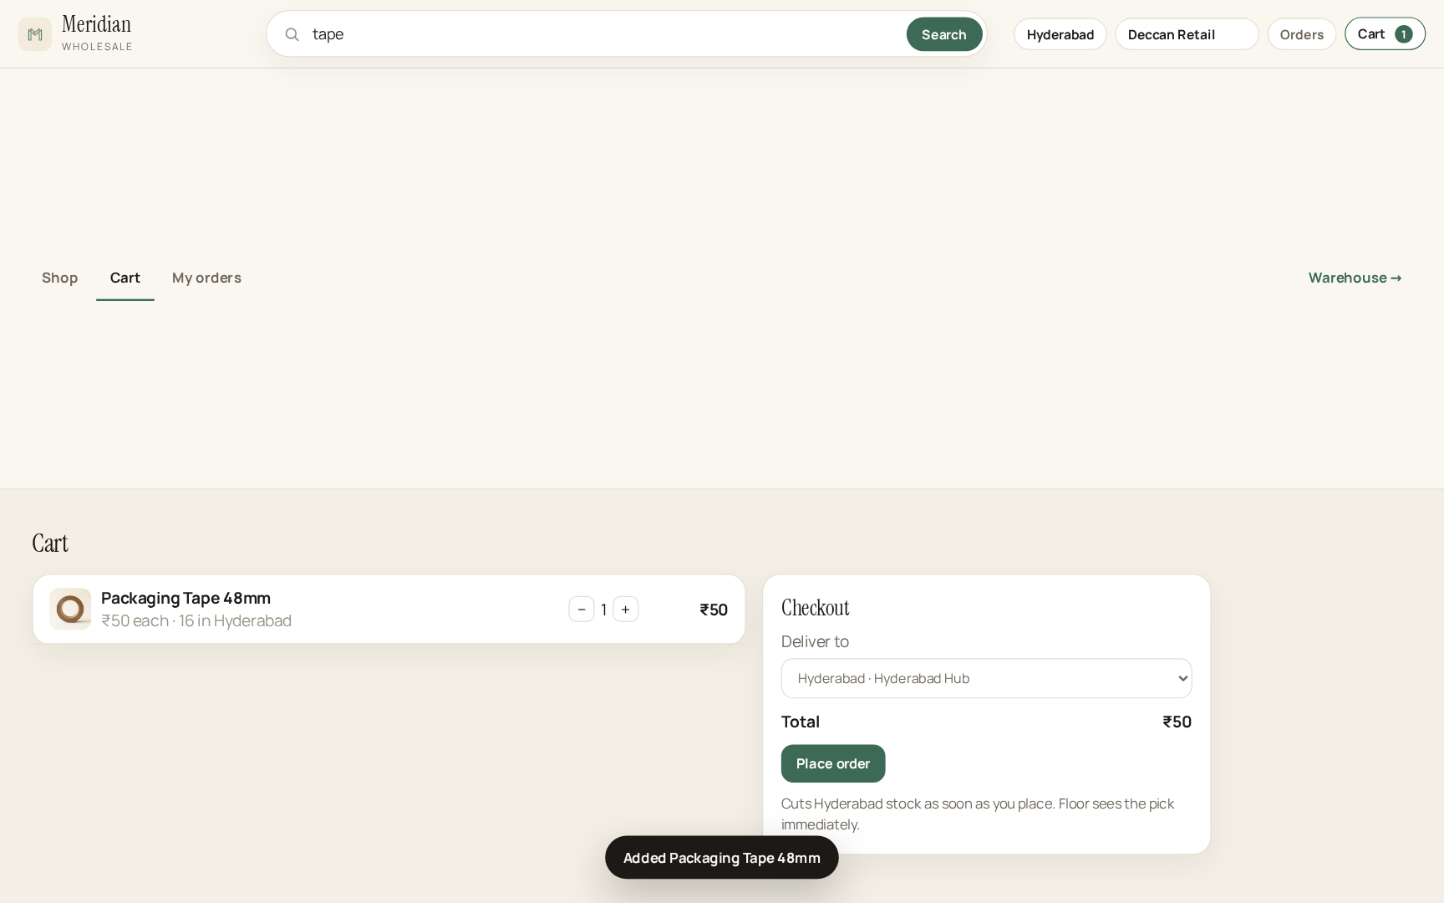
Fig. 5.4 Cart, deliver-to hub and Place order
Fig. 5.5 is My orders after checkout. Ticket SO-627485 is filed as placed against Deccan Retail at Hyderabad. Cancel · restore stock walks the pick ids and puts the quantity back on that hub.
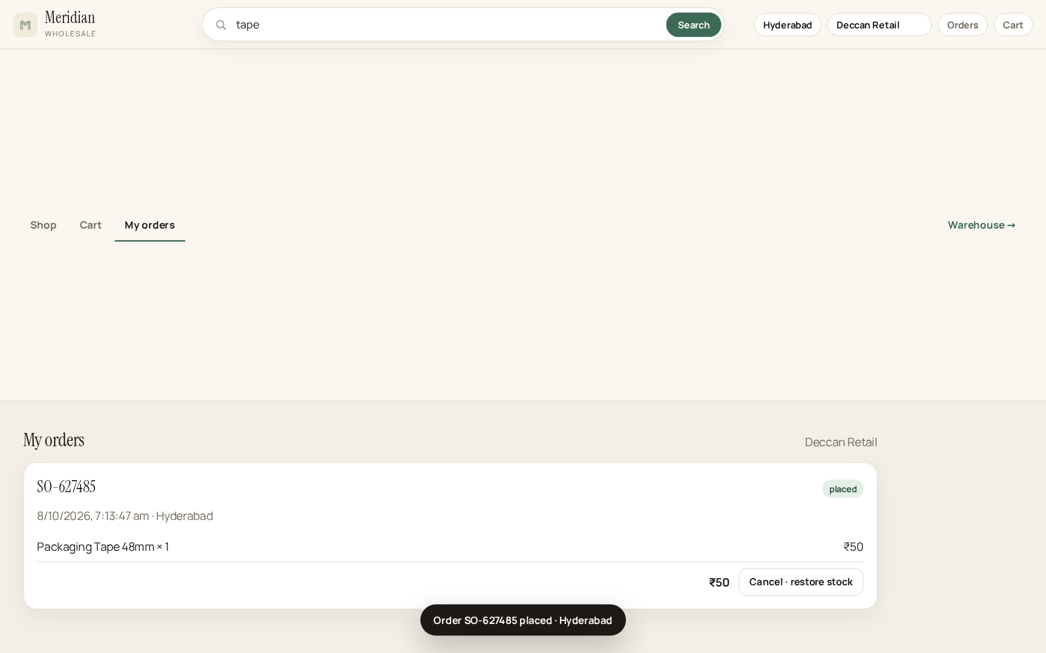
Fig. 5.5 My orders after checkout
Fig. 5.6 is the warehouse Catalog at “/admin”. The same photographs and SKUs appear, but the price is unit cost (₹6,200 for the 1 TB SSD versus MRP ₹7,316 on the shop) and the badge is warehouse on-hand (“9 left”). Low-stock and open-pick pills sit in the header.
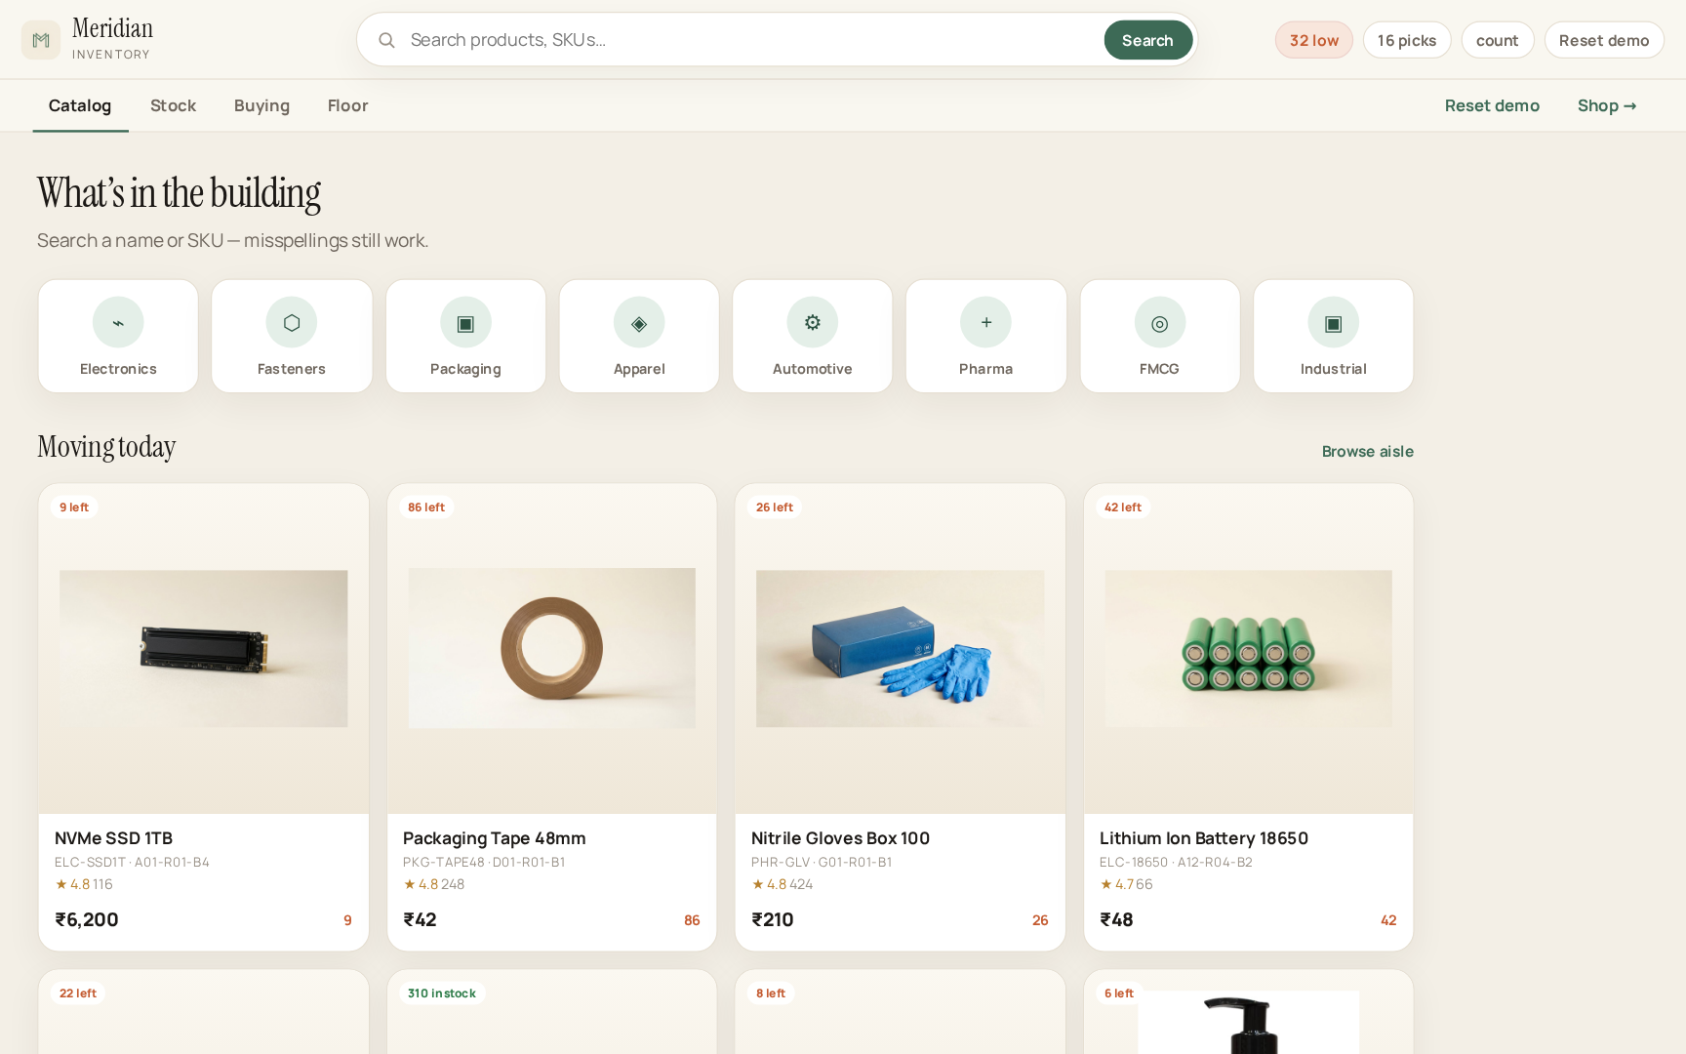
Fig. 5.6 Warehouse Catalog (URL /admin)
Fig. 5.7 is Stock. Cards match Catalog (photograph, SKU, bin) with a +/− stepper on the card, min-stock, and Edit / Move / Reorder. Hub chips select which byHub cell the stepper edits. A List toggle is available; Cards is the default.
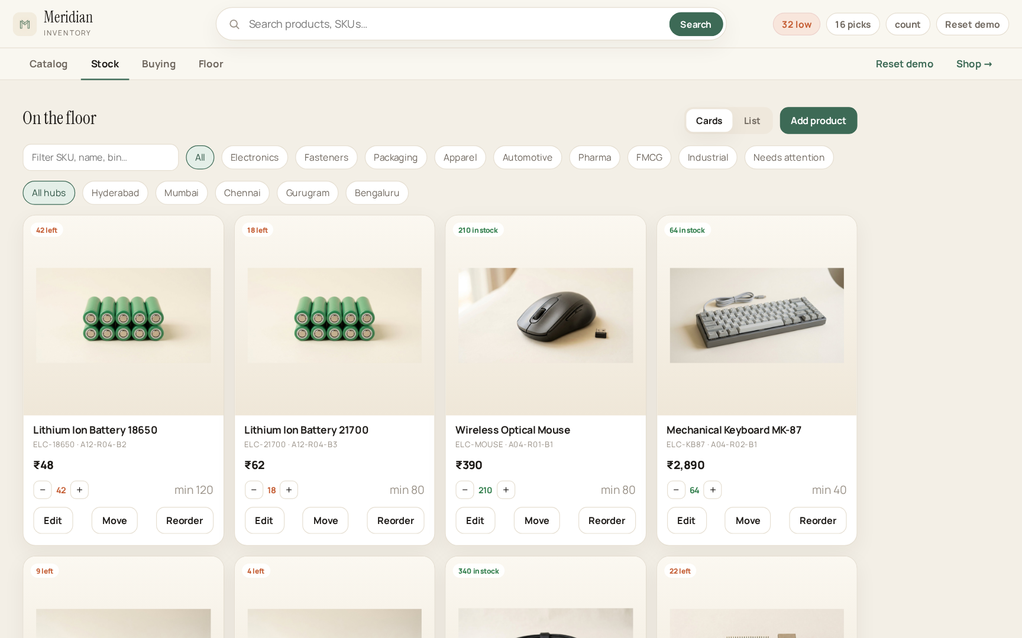
Fig. 5.7 Warehouse Stock cards with hub quantity
Fig. 5.8 is Buying. SKUs below minimum are scored and selected by 0/1 knapsack under the typed spend cap (₹25,000). The cart on the right is the reconstructed DP solution (lots and costs); Place POs write restockQty onto each home hub [1], [11].
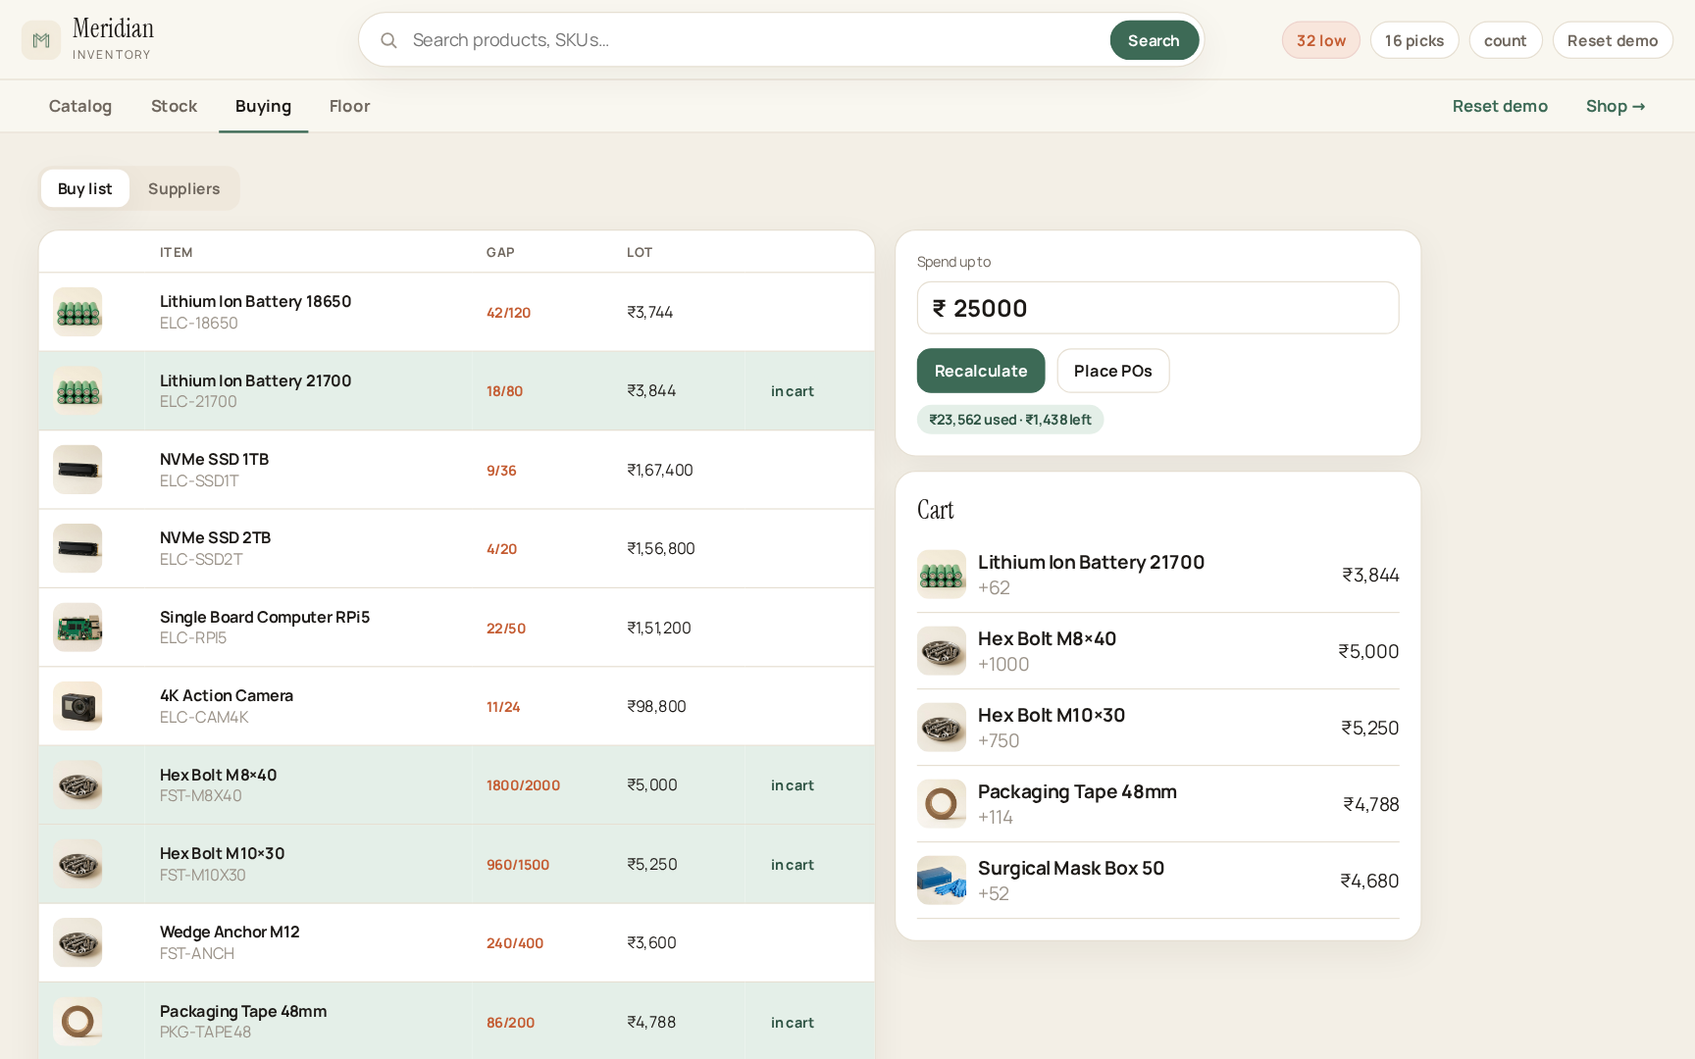
Fig. 5.8 Buying — 0/1 knapsack restock
Fig. 5.9 is Floor → Picks. The dock board is the matching-based 2-approximation for P||Cmax [9]: four docks, Gantt bars sized by pick minutes, Packed completing a job. Open picks (16) and last-dock finish (148 min) are the makespan view used in the viva.
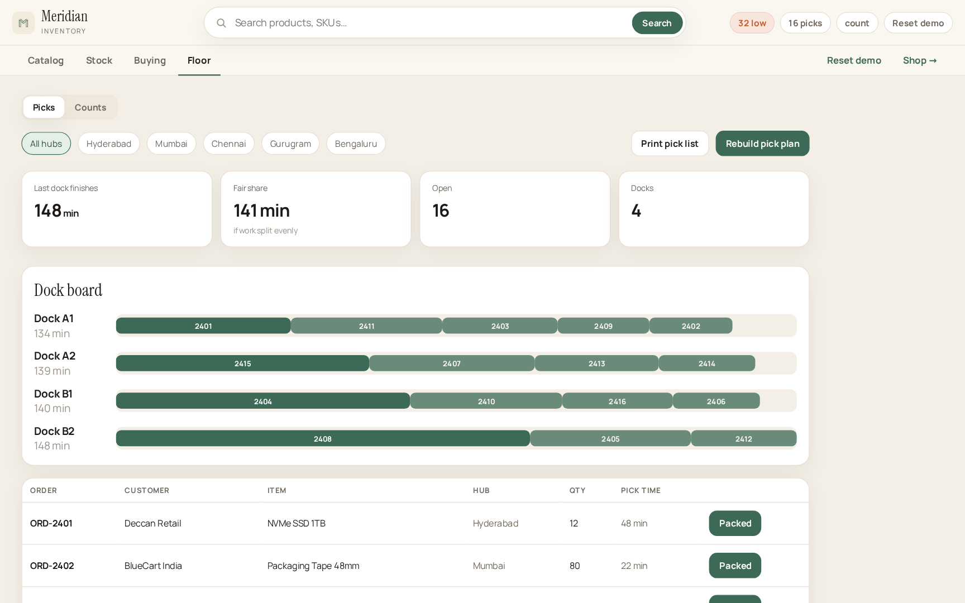
Fig. 5.9 Floor dock board (P||Cmax schedule)
Fig. 5.10 is Floor → Counts. Eight SKUs were drawn with Vitter’s reservoir algorithm R so that each catalogue item has probability k/n of appearing [10]. Post to stock writes the counted quantity through the home hub.
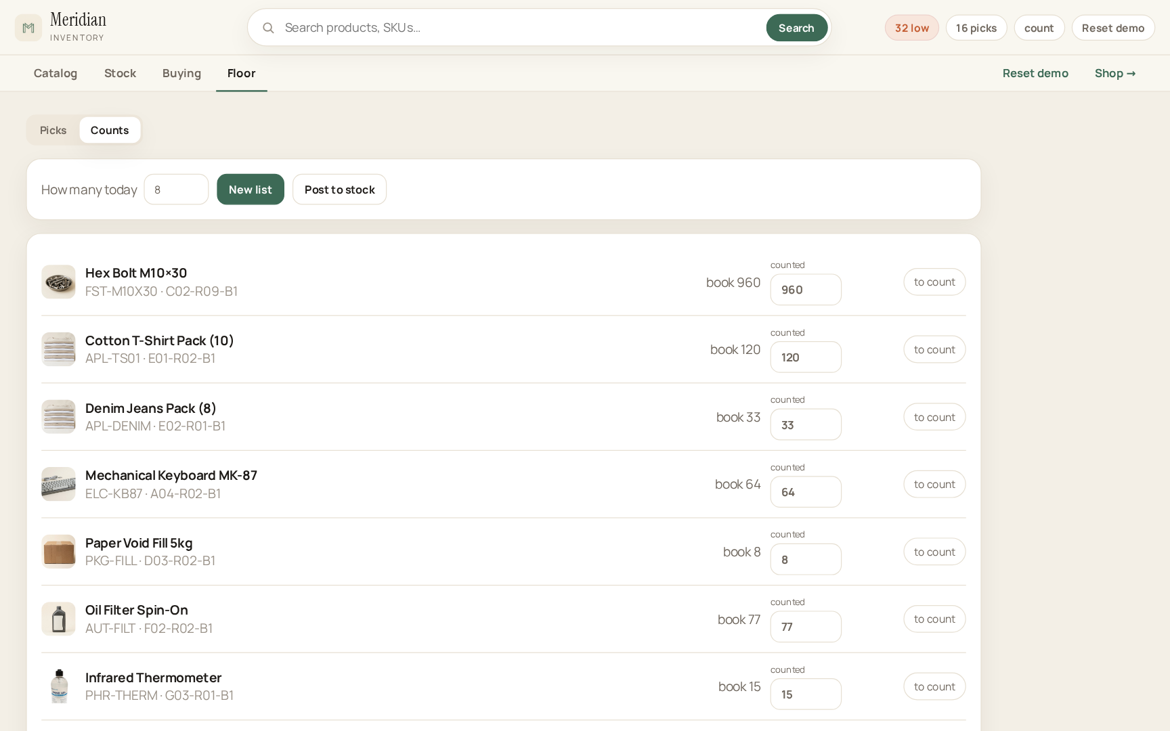
Fig. 5.10 Cycle-count sample (reservoir sampling)
Manual scenario tests on the Vite server (npm run dev) covered: Enter on “ssd” without auto-picking a suggestion; add-to-cart without cutting qty; Place order to Hyderabad dropping that hub and raising Floor; Stock +/− and Place POs appearing on the shop; dry-hub substitutes; cancel restoring stock; Packed greying a row; Move 6 units Hyderabad → Mumbai; reservoir k = 8 posted back to the book; Reset demo restoring seed. All of those paths passed on the demonstration catalogue.
Qualitatively, a two-minute viva script — search ssd, order to Hyderabad, open /admin Floor, pack, filter Mumbai, move stock, reset — exercises every algorithm except flow, which is one click on Buying → Supply. That density comes from refusing extra pages.
6. CHALLENGES & LIMITATIONS
6.1 Issues faced during development
Two URLs were first implemented as two layouts over one React store. Opening “/” and “/admin” as separate addresses still remounted the tree and reset seed quantities, so a shop sale did not appear in admin. Catalogue cards said only “In stock”, so a drop from 42 to 38 was invisible. Enter on the search bar adopted the highlighted suggestion, so the query “ssd” never listed both SSDs. The spend field snapped to 0 and trapped the caret when the operator decreased the cap. Too many top-level pages made the warehouse feel like a folder of labs.
6.2 Solutions applied
A versioned localStorage ledger plus a storage/BroadcastChannel sync keeps shop and admin on one catalogue across refresh and tabs. Cards print the integer on-hand at the hub. Enter always searches the typed query; click-only adopts a suggestion; typing also live-filters the grid. The spend box is a digit string, not a forced number. Admin was cut to four tabs with inner segments for Buying and Floor.
6.3 Limitations of the System
The ledger lives in the browser; clearing site data resets history (Reset demo is intentional). Knapsack is O(n·W) in the rupee cap; an enormous budget will wait. There is no login and no payment. Flow is max-flow, not min-cost. The catalogue is teaching-scale. Those are accepted limits of a 25CS2103E mini project, not unfinished screens.
7. CONCLUSION & FUTURE WORK
7.1 Conclusion
The Warehouse Inventory System shows that the DSA-3 syllabus — string matching, dynamic programming, network flow, bipartite matching, approximation for NP-hard scheduling, and randomised sampling — can drive a warehouse and a wholesale shop rather than a folder of disconnected labs [1], [2]. Replacing exact-match search and manual tracking with these techniques improves search flexibility, restocking optimality, supplier coordination and pick makespan, with bounds that can be written on a board in the viva.
The implemented application makes that claim inspectable. Two URLs share one hub-level ledger. Checkout, cancel, pack, move, knapsack purchase orders and reservoir counts all write the same products array. The interface stays operational. The report names every algorithm; the screen does not have to. The work meets the objectives in Section 1.4 within the scope in Section 1.3.
7.2 Future Work
Suffix automaton or suffix-array indexing for faster multi-pattern search as the catalogue grows [1]. Min-cost max-flow for cheapest procurement rather than max-flow only. Dinic’s algorithm for larger supplier graphs [6]. Predictive restocking that feeds knapsack values from demand history. Parallel reduce for multi-hub audits. Optional staff login and a durable server ledger if the project ever leaves the laptop. None of these are required to argue that the present system meets its objectives.
7.3 Skills learned during development
Implementing KMP, rolling hashes, edit distance, knapsack reconstruction, BFS augmenting paths, DFS matching, list scheduling and reservoir sampling from the recurrences, without a graph library. Mapping each of those to a screen a storekeeper would recognise. Keeping a product short (four warehouse tabs, three shop pages) while still covering the syllabus. Writing a shared ledger so that a demo on two URLs does not lie about stock. Documenting the work in the department’s 2026-27 format, with citations in the text [1].
REFERENCES
[1] T. H. Cormen, C. E. Leiserson, R. L. Rivest and C. Stein, Introduction to Algorithms, 3rd ed. Cambridge, MA, USA: MIT Press, 2009.
[2] J. Kleinberg and É. Tardos, Algorithm Design. Boston, MA, USA: Addison-Wesley, 2006.
[3] D. E. Knuth, J. H. Morris and V. R. Pratt, “Fast pattern matching in strings,” SIAM J. Comput., vol. 6, no. 2, pp. 323–350, 1977.
[4] R. M. Karp and M. O. Rabin, “Efficient randomized pattern-matching algorithms,” IBM J. Res. Dev., vol. 31, no. 2, pp. 249–260, 1987.
[5] R. A. Wagner and M. J. Fischer, “The string-to-string correction problem,” J. ACM, vol. 21, no. 1, pp. 168–173, 1974.
[6] J. Edmonds and R. M. Karp, “Theoretical improvements in algorithmic efficiency for network flow problems,” J. ACM, vol. 19, no. 2, pp. 248–264, 1972.
[7] L. R. Ford and D. R. Fulkerson, “Maximal flow through a network,” Can. J. Math., vol. 8, pp. 399–404, 1956.
[8] H. W. Kuhn, “The Hungarian method for the assignment problem,” Naval Res. Logist. Quart., vol. 2, pp. 83–97, 1955.
[9] R. L. Graham, “Bounds on multiprocessing timing anomalies,” SIAM J. Appl. Math., vol. 17, no. 2, pp. 416–429, 1969.
[10] J. S. Vitter, “Random sampling with a reservoir,” ACM Trans. Math. Softw., vol. 11, no. 1, pp. 37–57, 1985.
[11] S. Martello and P. Toth, Knapsack Problems: Algorithms and Computer Implementations. Chichester, UK: Wiley, 1990.

