Instructor: Nebojsa Conkic  
Date: 10/19/2017

Assignment1

**DBS501**

Group Member:

Shan Zhang, #113004154

XiaoChen Wang, #015297153

Anthony Nguyen

Contents

Answer:

Q1 2

Q2 4

Q3 6

Q4 8

Answer: 10

Q1 – output 10

Q2-output 12

Q3-output 14

Q4-ouput 18

# Q1

SET SERVEROUTPUT ON

SET VERIFY OFF

ACCEPT ctyid PROMPT 'Enter value for country:'

DECLARE

v_ctyid VARCHAR2(30) := '&ctyid';

v_count NUMBER(5);

v_ctyname countries.country_name%TYPE;

v_ctynameb VARCHAR2(5);

v_charprovince VARCHAR2(50);

v_char VARCHAR2(5);

r_locations locations%ROWTYPE;

BEGIN

SELECT LENGTH(street_address), city INTO v_count, v_ctyname FROM locations WHERE state_province IS NULL AND UPPER(country_id) = UPPER(v_ctyid);

SELECT substr(v_ctyname,1,1) INTO v_ctynameb FROM dual;

IF v_ctynameb in ('A', 'B', 'E', 'F') THEN

v_char := '*';

ELSIF v_ctynameb in ('C', 'D', 'E', 'H') THEN

v_char := '&';

ELSE

v_char := '#';

END IF;

FOR i IN 1..v_count LOOP

v_charprovince := v_charprovince || v_char;

END LOOP;

UPDATE locations SET state_province = v_charprovince WHERE state_province IS NULL AND UPPER(country_id) = UPPER(v_ctyid);

DBMS_OUTPUT.PUT_LINE('City '|| v_ctyname || ' has modified its province to ' || v_charprovince);

EXCEPTION

WHEN NO_DATA_FOUND THEN

DBMS_OUTPUT.PUT_LINE('This country has NO cities listed.');

WHEN TOO_MANY_ROWS THEN

DBMS_OUTPUT.PUT_LINE('This country has MORE THAN ONE City without province listed.');

WHEN OTHERS THEN

DBMS_OUTPUT.PUT_LINE('Other errors');

END;

/

SELECT * FROM locations WHERE substr(state_province,1,1) in ('*', '&', '#');

ROLLBACK;

/

# Q2

--1, add column

-- ALTER TABLE countries ADD (flag VARCHAR2(7));

SET SERVEROUTPUT ON

SET VERIFY OFF

ACCEPT inputregid PROMPT 'Enter value for region: ';

DECLARE

v_cid countries.country_id%TYPE;

v_cname countries.country_name%TYPE;

v_rid countries.region_id%TYPE;

v_regid NUMBER := &inputregid;

v_cnt NUMBER;

v_flag VARCHAR2(30);

cursor c_rid is

SELECT c.country_id, c.REGION_ID

FROM countries c LEFT JOIN locations l ON c.country_id = l.country_id

WHERE l.city IS NULL AND c.region_id in (select region_id from regions)

order by c.region_id, c.country_name;

BEGIN

SELECT c.country_id, c.country_name, c.REGION_ID

INTO v_cid, v_cname, v_rid

FROM countries c

LEFT JOIN locations l ON c.country_id = l.country_id

WHERE l.city IS NULL AND region_id = v_regid;

DBMS_OUTPUT.PUT_LINE('In the region '|| v_regid || ' there is ONE country ' || v_cname || ' with NO city.');

SELECT count(*) INTO v_cnt

FROM countries c LEFT JOIN locations l ON c.country_id = l.country_id

WHERE l.city IS NULL;

DBMS_OUTPUT.PUT_LINE('Number of countries with NO cities listed is: ' || v_cnt);

FOR r in c_rid LOOP

v_flag := 'Empty_' || r.region_id;

UPDATE countries SET flag = v_flag WHERE region_id = r.region_id AND country_id = r.country_id;

END LOOP;

EXCEPTION

WHEN NO_DATA_FOUND THEN

DBMS_OUTPUT.PUT_LINE('This region ID does NOT exist: '|| v_regid);

WHEN TOO_MANY_ROWS THEN

DBMS_OUTPUT.PUT_LINE('This region ID has MORE THAN ONE country without cities listed: '|| v_regid);

WHEN OTHERS THEN

DBMS_OUTPUT.PUT_LINE('Other errors');

END;

/

SELECT c.*

FROM countries c

LEFT JOIN locations l ON c.country_id = l.country_id

WHERE l.city IS NULL and c.flag is not null

order by c.region_id, c.country_name;

ROLLBACK;

/

# Q3

--1, add column

-- ALTER TABLE countries ADD (flag VARCHAR2(7));

SET SERVEROUTPUT ON

SET VERIFY OFF

ACCEPT inputregid PROMPT 'Enter value for region: ';

DECLARE

v_regid NUMBER := &inputregid;

v_cnt NUMBER;

v_flag VARCHAR2(30);

cnt NUMBER := 0;

CURSOR c1 IS

SELECT c.country_id, c.country_name, c.REGION_ID

FROM countries c LEFT JOIN locations l ON c.country_id = l.country_id

WHERE l.city IS NULL AND region_id = v_regid;

CURSOR c2 IS

SELECT c.country_id, c.country_name, c.REGION_ID

FROM countries c LEFT JOIN locations l ON c.country_id = l.country_id

WHERE l.city IS NULL AND c.region_id in (select region_id from regions)

ORDER BY c.country_name;

TYPE countryname IS TABLE OF countries.country_name%TYPE INDEX BY VARCHAR2(30);

countryname_list countryname;

idx integer := -4;

BEGIN

FOR r in c1 LOOP

cnt := cnt + 1;

END LOOP;

IF cnt = 0 THEN

DBMS_OUTPUT.PUT_LINE('This region ID does NOT exist: '|| v_regid);

ELSE

FOR r2 in c2 LOOP

v_flag := 'Empty_' || r2.region_id;

UPDATE countries SET flag = v_flag WHERE region_id = r2.region_id AND country_id = r2.country_id;

idx := idx + 5;

countryname_list(idx) := r2.country_name;

DBMS_OUTPUT.PUT_LINE('Index Table Key: '||idx||' has a value of '||countryname_list(idx));

END LOOP;

DBMS_OUTPUT.PUT_LINE('======================================================================');

DBMS_OUTPUT.PUT_LINE('Total number of elements in the Index Table or Number of countries with NO cities listed is: ' || countryname_list.COUNT);

DBMS_OUTPUT.PUT_LINE('Second element (Country) in the Index Table is: '|| countryname_list(countryname_list.FIRST + 5));

DBMS_OUTPUT.PUT_LINE('Before the last element (Country) in the Index Table is: '|| countryname_list(46));

DBMS_OUTPUT.PUT_LINE('======================================================================');

FOR r3 in c1 LOOP

DBMS_OUTPUT.PUT_LINE('In the region '|| v_regid || ' there is ONE country ' || r3.country_name || ' with NO city.');

END LOOP;

DBMS_OUTPUT.PUT_LINE('======================================================================');

DBMS_OUTPUT.PUT_LINE('Total Number of countries with NO cities listed in the Region '||v_regid||' is: '|| cnt);

END IF;

END;

/

SELECT c.*

FROM countries c LEFT JOIN locations l ON c.country_id = l.country_id

WHERE l.city IS NULL and c.flag is not null

ORDER BY c.region_id, c.country_name;

ROLLBACK;

/

# Q4

SET SERVEROUTPUT ON

SET VERIFY OFF

ACCEPT inputdesc PROMPT 'Enter the piece of the course description in UPPER case: ';

ACCEPT inputlname PROMPT 'Enter the beginning of the Instructor last name in UPPER case: ';

DECLARE

CURSOR c1 is

SELECT course.course_no cno, course.DESCRIPTION cdes, section.section_id secid, instructor.last_name ilname, section.section_no secno

FROM course, section, instructor

WHERE course.course_no = section.course_no

AND section.instructor_id = instructor.instructor_id

AND UPPER(DESCRIPTION) LIKE UPPER('%&inputdesc%')

AND last_name LIKE UPPER('&inputlname%')

ORDER BY 1 desc;

v_count_secid NUMBER;

CURSOR c2(v_section_id NUMBER) is

SELECT COUNT(*) ecount

FROM enrollment

WHERE section_id = v_section_id;

row_cnt NUMBER := 0;

BEGIN

FOR r1 IN c1

LOOP

DBMS_OUTPUT.PUT_LINE('Course No: ' || r1.cno ||' '|| r1.cdes ||' with Section Id: '

|| r1.secid || ' is taught by '|| r1.ilname || ' in the Course Section: ' || r1.secno);

FOR r2 in c2(r1.secid)

LOOP

DBMS_OUTPUT.PUT_LINE(' This Section Id has an enrollment of: '|| r2.ecount);

DBMS_OUTPUT.PUT_LINE('***********************************************************************************************************');

row_cnt := row_cnt + r2.ecount;

END LOOP;

END LOOP;

IF row_cnt = 0 THEN

DBMS_OUTPUT.PUT_LINE('There is NO data for this input match between the course description piece and the surname start of Instructor. Try again!');

ELSE

DBMS_OUTPUT.PUT_LINE('This input match has a total enrollment of: ' || row_cnt || ' students.');

END IF;

END;

/

# Answer:

# Q1 – output

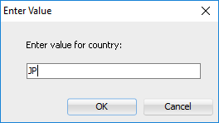

City Hiroshima has modified its province to &&&&&&&&&&&&&&&

PL/SQL procedure successfully completed.

LOCATION_ID STREET_ADDRESS POSTAL_CODE CITY STATE_PROVINCE CO

----------- ---------------------------------------- ------------ ------------------------------ ------------------------- --

1300 9450 Kamiya-cho 6823 Hiroshima &&&&&&&&&&&&&&& JP

Rollback complete.

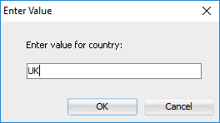

City London has modified its province to ##############

PL/SQL procedure successfully completed.

LOCATION_ID STREET_ADDRESS POSTAL_CODE CITY STATE_PROVINCE CO

----------- ---------------------------------------- ------------ ------------------------------ ------------------------- --

2400 8204 Arthur St London ############## UK

Rollback complete.

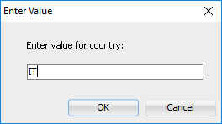

This country has MORE THAN ONE City without province listed.

PL/SQL procedure successfully completed.

no rows selected

Rollback complete.

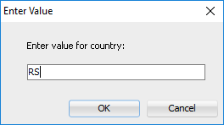

This country has NO cities listed.

PL/SQL procedure successfully completed.

no rows selected

Rollback complete.

# Q2-output

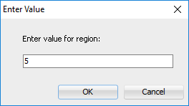

This region ID does NOT exist: 5

PL/SQL procedure successfully completed.

no rows selected

Rollback complete.

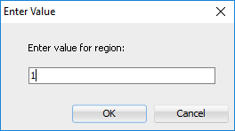

This region ID has MORE THAN ONE country without cities listed: 1

PL/SQL procedure successfully completed.

no rows selected

Rollback complete.

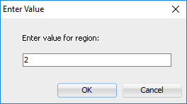

In the region 2 there is ONE country Argentina with NO city.

Number of countries with NO cities listed is: 11

PL/SQL procedure successfully completed.

CO COUNTRY_NAME REGION_ID FLAG

-- ---------------------------------------- ---------- -------

BE Belgium 1 Empty_1

DK Denmark 1 Empty_1

FR France 1 Empty_1

AR Argentina 2 Empty_2

HK HongKong 3 Empty_3

EG Egypt 4 Empty_4

IL Israel 4 Empty_4

KW Kuwait 4 Empty_4

NG Nigeria 4 Empty_4

ZM Zambia 4 Empty_4

ZW Zimbabwe 4 Empty_4

11 rows selected.

Rollback complete.

# Q3-output

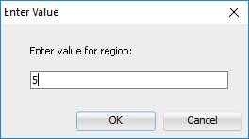

This region ID does NOT exist: 5

PL/SQL procedure successfully completed.

no rows selected

Rollback complete.

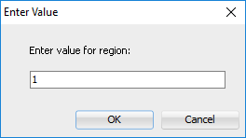

Index Table Key: 1 has a value of Argentina

Index Table Key: 6 has a value of Belgium

Index Table Key: 11 has a value of Denmark

Index Table Key: 16 has a value of Egypt

Index Table Key: 21 has a value of France

Index Table Key: 26 has a value of HongKong

Index Table Key: 31 has a value of Israel

Index Table Key: 36 has a value of Kuwait

Index Table Key: 41 has a value of Nigeria

Index Table Key: 46 has a value of Zambia

Index Table Key: 51 has a value of Zimbabwe

======================================================================

Total number of elements in the Index Table or Number of countries with NO cities listed is: 11

Second element (Country) in the Index Table is: Belgium

Before the last element (Country) in the Index Table is: Zambia

======================================================================

In the region 1 there is ONE country France with NO city.

In the region 1 there is ONE country Belgium with NO city.

In the region 1 there is ONE country Denmark with NO city.

======================================================================

Total Number of countries with NO cities listed in the Region 1 is: 3

PL/SQL procedure successfully completed.

CO COUNTRY_NAME REGION_ID FLAG

-- ---------------------------------------- ---------- -------

BE Belgium 1 Empty_1

DK Denmark 1 Empty_1

FR France 1 Empty_1

AR Argentina 2 Empty_2

HK HongKong 3 Empty_3

EG Egypt 4 Empty_4

IL Israel 4 Empty_4

KW Kuwait 4 Empty_4

NG Nigeria 4 Empty_4

ZM Zambia 4 Empty_4

ZW Zimbabwe 4 Empty_4

11 rows selected.

Rollback complete.

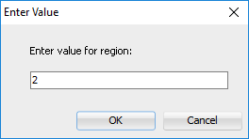

Index Table Key: 1 has a value of Argentina

Index Table Key: 6 has a value of Belgium

Index Table Key: 11 has a value of Denmark

Index Table Key: 16 has a value of Egypt

Index Table Key: 21 has a value of France

Index Table Key: 26 has a value of HongKong

Index Table Key: 31 has a value of Israel

Index Table Key: 36 has a value of Kuwait

Index Table Key: 41 has a value of Nigeria

Index Table Key: 46 has a value of Zambia

Index Table Key: 51 has a value of Zimbabwe

======================================================================

Total number of elements in the Index Table or Number of countries with NO cities listed is: 11

Second element (Country) in the Index Table is: Belgium

Before the last element (Country) in the Index Table is: Zambia

======================================================================

In the region 2 there is ONE country Argentina with NO city.

======================================================================

Total Number of countries with NO cities listed in the Region 2 is: 1

PL/SQL procedure successfully completed.

CO COUNTRY_NAME REGION_ID FLAG

-- ---------------------------------------- ---------- -------

BE Belgium 1 Empty_1

DK Denmark 1 Empty_1

FR France 1 Empty_1

AR Argentina 2 Empty_2

HK HongKong 3 Empty_3

EG Egypt 4 Empty_4

IL Israel 4 Empty_4

KW Kuwait 4 Empty_4

NG Nigeria 4 Empty_4

ZM Zambia 4 Empty_4

ZW Zimbabwe 4 Empty_4

11 rows selected.

Rollback complete.

# Q4-ouput

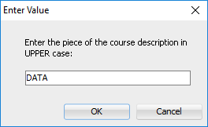 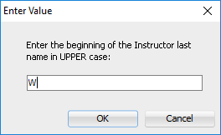

There is NO data for this input match between the course description piece and the surname start of Instructor. Try again!

PL/SQL procedure successfully completed.

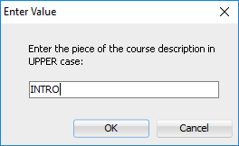 

Course No: 240 Intro to the Basic Language with Section Id: 102 is taught by Wojick in the Course Section: 2

This Section Id has an enrollment of: 1

***********************************************************************************************************

Course No: 120 Intro to Java Programming with Section Id: 149 is taught by Wojick in the Course Section: 4

This Section Id has an enrollment of: 1

***********************************************************************************************************

Course No: 25 Intro to Programming with Section Id: 88 is taught by Wojick in the Course Section: 4

This Section Id has an enrollment of: 5

***********************************************************************************************************

This input match has a total enrollment of: 7 students.

PL/SQL procedure successfully completed.

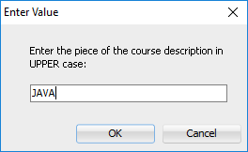 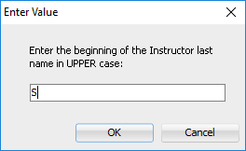

Course No: 124 Advanced Java Programming with Section Id: 127 is taught by Schorin in the Course Section: 2

This Section Id has an enrollment of: 1

***********************************************************************************************************

Course No: 122 Intermediate Java Programming with Section Id: 153 is taught by Smythe in the Course Section: 2

This Section Id has an enrollment of: 3

***********************************************************************************************************

Course No: 120 Intro to Java Programming with Section Id: 150 is taught by Schorin in the Course Section: 5

This Section Id has an enrollment of: 3

***********************************************************************************************************

This input match has a total enrollment of: 7 students.

PL/SQL procedure successfully completed.