**Report**

The file describes the working of the source code files and the test files.

**Algorithm**

The initialization of the gui is done through the new_gui_OpeningFcn

. This function calls the display_time function which initializes the graphics objects, the graphics objects and call the start_timer function. The start_timer in turn calls the timer_loop call back function, which actually is used to update the clock. The feeds from the GUI’s call back edit and push buttons are used to obtain current data (time) and start/stop mode respectively.

**Source Code**

start_timer.m

This function initializes the timer

timer_loop.m

This is the call back function which updates the second, minutes and hour hand

display_time.m

This function is used to initialize graphics object.

display_timeSim.m

This function is used to display the graphics objs and clock graphics

new_gui.m

This is the graphics source file

push_buttom.sim.

This is the simulation code for the Start/ Stop button

edit_feed_hrTest.m

This is the simulation for the hours input (edit field) and is used in testing.

edit_feed_minTest.m

This is the simulation for the mins input (edit field) and is used in testing.

edit_feed_secTest.m

This is the simulation for the sec input (edit field) and is used in testing.

**Test Code**

start_timerTest.m

This function test start_timer() function

display_timeTest.m

This was function was used test display_timeSim.

new_guiTest.m

This function was designed to test new_gui

push_buttomTest.sim.

This is the test code for the simulated Start/ Stop button.

edit_typeTest.m

This is the test code for the entered time, type checking.

**Execution**

1. Unzip the file at a location (say Desktop)
2. Navigate to inside this folder through MATAB
3. To run the clock: run new_gui.m

(I have used MATLAB Guide to build the GUI & tested on 2013b)

The clock has default value 12:00:00, as soon as the clock is initialized its ticking.

Press start button to stop it and the same again to start it. The clock resumes from the previous time.To update data/ time in any of the fields, enter valid time data in each field and press enter

(The input value gets registered only on pressing ‘Enter’ after entering data in the edit box)

To application is stopped by closing it.

1. To run tests.

results = runtests('start_timerTest.m')

results = runtests('push_buttonTest')

results = runtests('edit_typeTest.m')

results = runtests('display_timeTest.m')

results = runtests('new_guiTest.m')

% this test is not developed completely, hence, please close the clock gui after the test.

**Conclusion**

All tests mentioned above run as per expected, apart from the new_guiTest which requires further simulated testing.

**References:**

<http://www.mathworks.com/help/matlab/examples/graphics-objects.html?searchHighlight=XData%20graphics>

<http://www.mathworks.com/help/matlab/ref/pause.html?searchHighlight=pause>

<http://www.mathworks.com/help/matlab/ref/timer-class.html>

<http://www.mathworks.com/help/matlab/gui-building-basics.html>

<http://www.mathworks.com/matlabcentral/fileexchange/5527-my-clock>

<http://in.mathworks.com/matlabcentral/fileexchange/20528-analog-clock>

<http://stackoverflow.com/questions/21005698/how-to-use-timer-in-matlab>

Screen Captures.

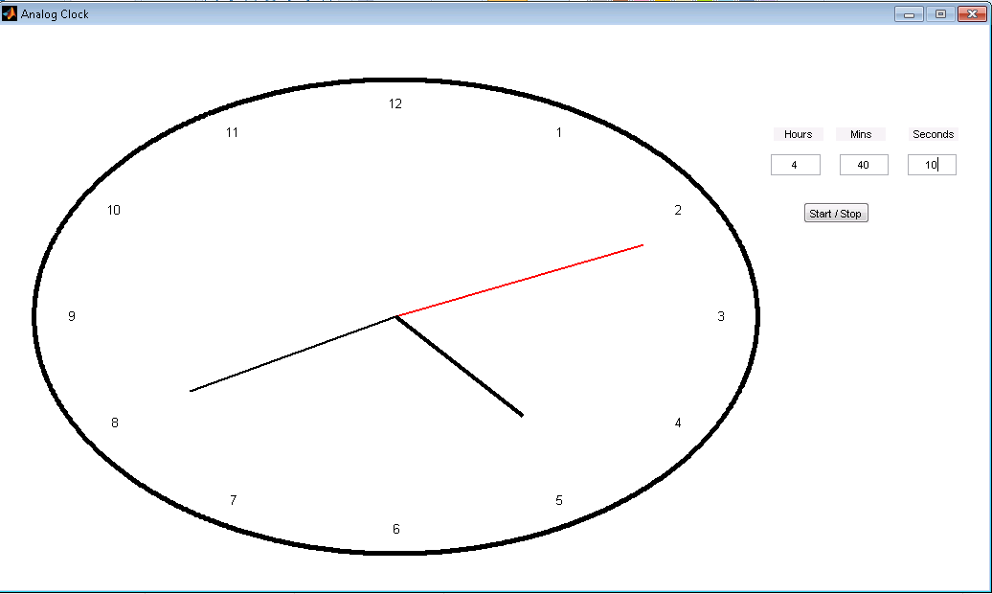

The second hand drifted away as I captured the screen capture.