Painter
GAM100 Game Concept Document
by TEAM 416
경민재 (Minjae Kyung), 박하은 (Haeun Park)

High Concept
“Painter” is a 2D platformer game, about a boy, who suddenly cannot see the color, going on an adventure to get back the color he lost. The player can break through the monsters and obstacles by changing the color of them.

Summary
The player can throw the color ball to the enemy/block to move forward. If the player has the same color as the enemy/block, the player can defeat the enemy or pass through the blocks. If the enemy/block hit by the color ball, the color of the color ball adds to the color of the enemy/block’s color. This game is not based on an RGB LED color mix. So the mix of the red, green, and blue is not white. Is black.

Game Mechanics
By using the arrow keys on the keyboard, the player can move around and jump. The player can throw the color ball to the blocks/enemies by pressing the spacebar key. If the ball hits the block/enemy, the color of the ball adds to the block/enemy hit by the ball. The player can pass through the block if the color of the block and player is the same. If the player and enemy have the same color, the player can defeat the enemy by step on the enemy.
<Color Add Chart>
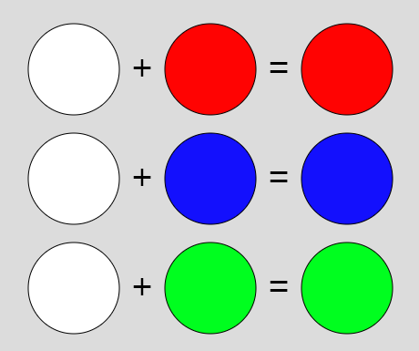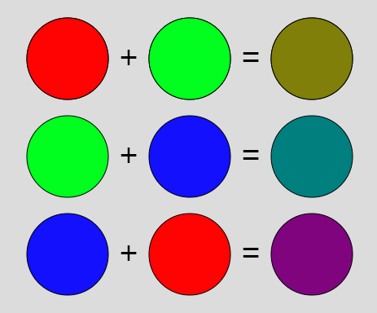

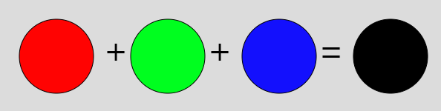

Characters
Player can jump, throw the color ball and get into the block if the player has the same color with block.

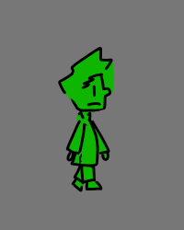 → Character appearance. (But in prototype, it’s just a rectangle.)
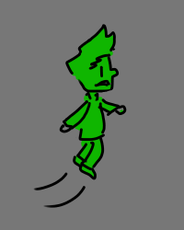→ Player can over the cliff, or defeat the enemy by jump.
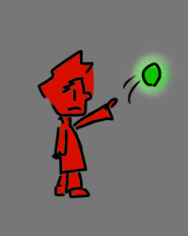→ Player can throw the ball that changes the color of the blocks/enemies.
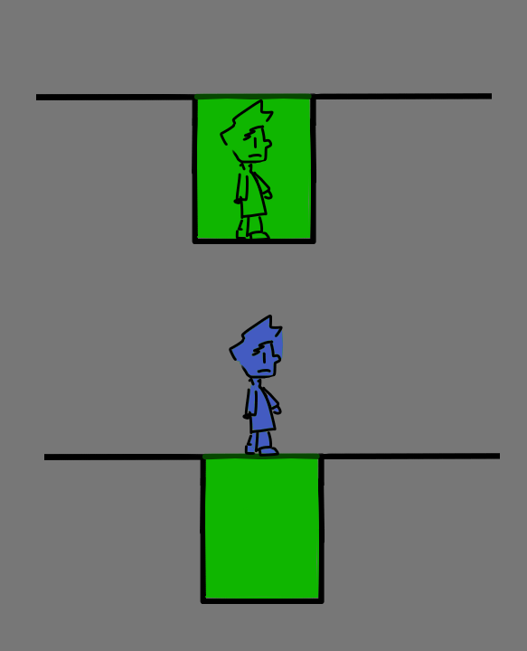
→ Player can get into the block if the player has the same color with block.

Environment

Blocks
  - Cliff
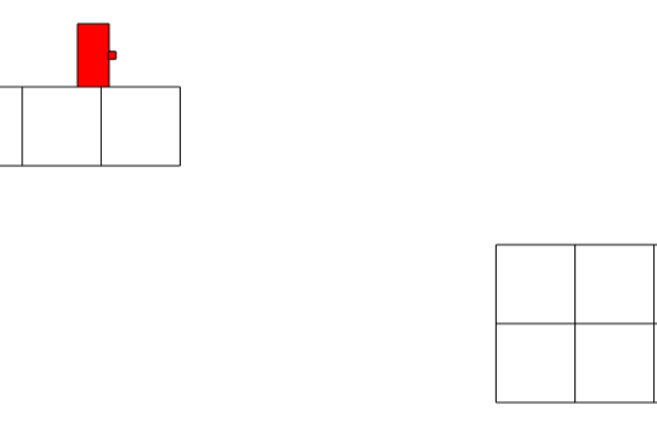 → If player fall down to cliff, player will die.

  - Tricks
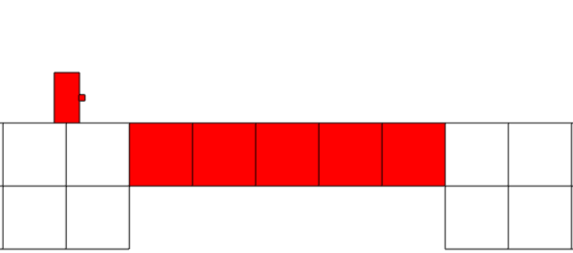→ This may looks like normal bridge that
helps the player to over the cliff,
but actually this is the trick.
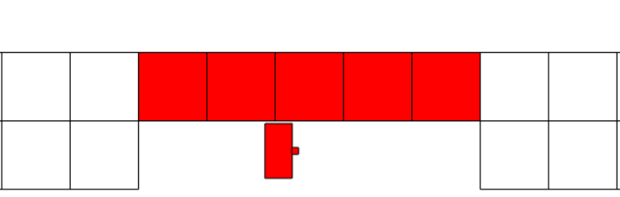 → As player has same color of the bridge,
If player try to cross the bridge,
player will fall down and die.

  - Wall
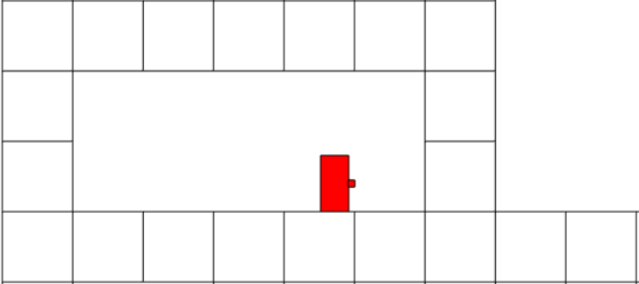 → If the player is blocked by the wall,

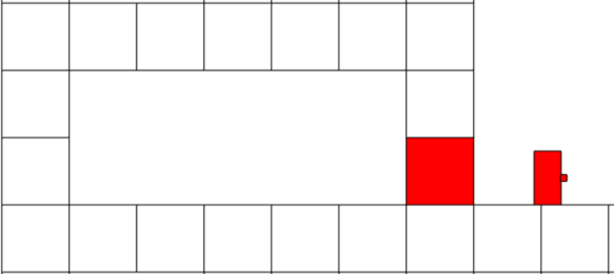 → Player can pass through the wall by painting the wall throwing the color ball

Enemies
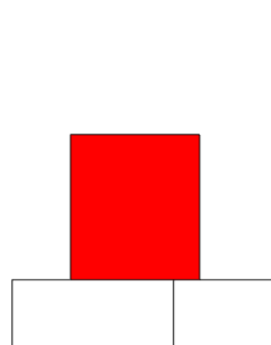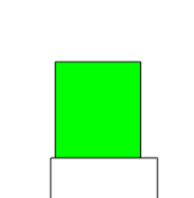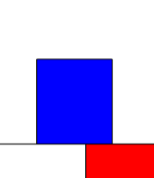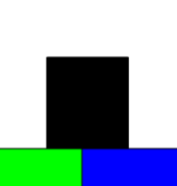

In prototype four different colored(red, green, black) enemies exist. If Player collide with enemy, player will die. But if player has same color with enemy, player can defeat the enemy by step on them.

refer to the “color add chart”

