| FAST National University |
| --- |
| **Matrix Operations**  **Midterm** |
|  |

**Computer Organization and Assembly Language**

| **Student Name** |  |
| --- | --- |
| **Registration #** |  |
| **Instructor** | Hazoor Ahmad |
| **Class** | CS3 |
| **Section** | A, D, H, H |
| **Semester** | Fall 2022 |

Fast School of Computing

FAST-NU, Lahore, Pakistan

# Activity 1

## **Assembly Language Code**

[org 0x0100]; we will see org directive later

mov ax, 5 ; AX = 5

mov bx, 10 ; BX = 10

add ax, bx ; AX = AX + BX

mov bx, 15 ; BX = 15

add ax, bx ; AX = AX + BX

mov ax, 0x4c00 ;terminate the program

int 0x21

## **Debugging Screenshots**

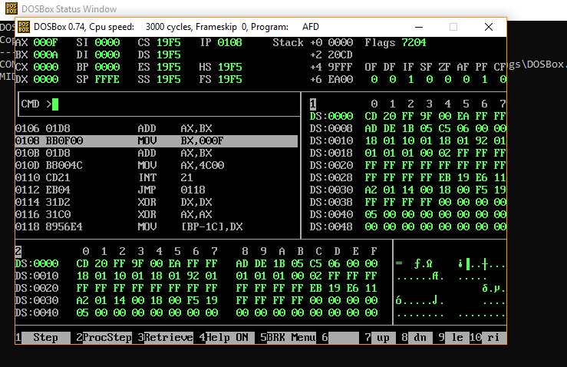

# Activity 2

## **Assembly Language Code**

[org 0x0100]; we will see org directive later

mov ax, 5 ; AX = 5

mov bx, 10 ; BX = 10

add ax, bx ; AX = AX + BX

mov bx, 15 ; BX = 15

add ax, bx ; AX = AX + BX

mov ax, 0x4c00 ;terminate the program

int 0x21

## **Debugging Screenshots**

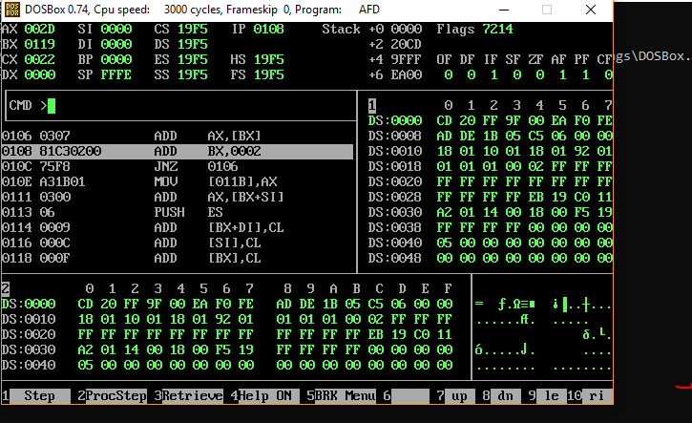

# Activity 3

## **Assembly Language Code**

[org 0x0100]; we will see org directive later

mov ax, 5 ; AX = 5

mov bx, 10 ; BX = 10

add ax, bx ; AX = AX + BX

mov bx, 15 ; BX = 15

add ax, bx ; AX = AX + BX

mov ax, 0x4c00 ;terminate the program

int 0x21

## **Debugging Screenshots**

