Course Title: Computer Organization and Assembly Language

Task: Term Project

Section: BCS-3A, BCS-3B

**_____________________________________________________________________________**

**Phase III – Control movement of vehicle using arrow keys**

**Deadline: Friday 18th November, 2022**

In the third phase of the project, you are required to control the movement of the vehicle using the arrow keys as described below:

1. The car should move in a straight line if the top arrow key is pressed.
2. The car should be able to turn right/left if right/left arrow key is pressed.
3. If the down key is pressed, then the car should stop.

You may consider a simple track for this phase (i.e., square or rectangle), and you have to constantly update the background, and steering using the code that was developed in Phase-II.

As shown in the figure below, on top left corner, there should be a map that shows the current location of the vehicle on the track.

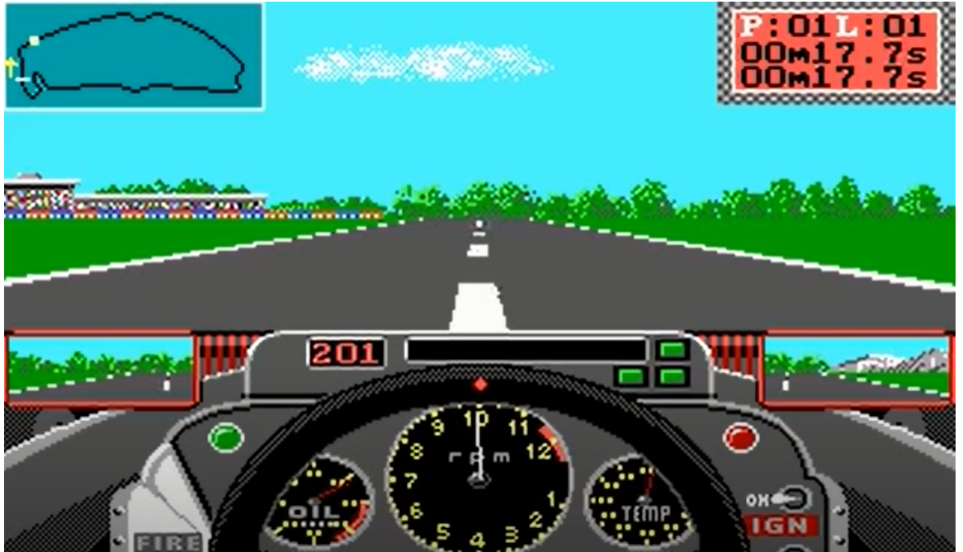

If the vehicle goes out of track, then it would stop. However, you have to bring it back on the track for restarting the race.

Furthermore, please clearly list any assumptions that you may make to implement this phase.

(Weightage: 3%)